Trout Stream Classification Checklist (revised 2/2016)
(This completed checklist should accompany any trout stream classification changes. Check the items as appropriate and attach comments if desired.)

Stream name: Kelly Brook County: Oconto WBIC: 443800

Define the portion of the stream to be classified. Please provide both a written description and the coordinate locations of the upstream and downstream beginning and end points.

The section of Kelly Brook proposed to be classified as a Class I trout stream begins at the crossing of White Lake Road (T29N – R18E Sec 12) and extends downstream to the CTH B crossing (T29N – R19E Sec 35). Total stream miles to be classified is approximately 8 miles.

This written description should reference permanent, unambiguous landmarks that would allow a person unfamiliar with the area to locate the points (e.g., dams, road crossings, stream confluences, county lines, section lines, township lines)

Please provide coordinate locations:

Upstream point coordinates: -88.25369, 45.01094 (site L on Figure 1)
Downstream point coordinates: -88.16475, 44.95144 (site E on Figure 1)

__X__ Fish survey (including relative abundance, length distribution, and age structure) and habitat survey completed on water to be classified. Survey on file at Green Bay and Peshtigo (office location) & WDNR Fish Management Database
__X__ Fish team supervisor and district fisheries supervisor have approved the classification.
Date__9/15/2020__
__X__ Fish Biologist has consulted with the following staff in their office or district
__X__ Permit Drafter Name__Crystal von Holdt________________ Date__9/1/2020_____ Concerns No
__X__ Water Resource Specialist Name__Andrew Hudak________ Date__9/8/2020_____ Concerns No
__X__ Water Management Specialist Name__Crystal von Holdt___ Date__9/1/2020_____ Concerns No
__X__ Drinking and Groundwater staff Name___Sara Fry________ Date__9/22/2020____ Concerns No
__X__ Public notice published in local newspaper or other media. Date__9/23/2020_____
__X__ Notice sent to all clerks of the county, town, city, or village in which the stream is located.
Date__9/21/2020__

__X__ Notice sent to legislators in the affected districts. Date___9/16/2020____
__X__ Notice sent to chairpersons of legislative committees with jurisdiction for natural resources
issues. Date__9/21/2020____

____ No hearing requested 30 days after public notice.

____ Hearing requested, held, and classification recommended. Date__________

Signed:
___________________________________ Date: ______________
Fisheries Biologist

Approved:
_________________________________Date: ______________
Fish Team Supervisor

___________________________________ Date: ______________
District Fisheries Supervisor

Kelly Brook
Kelly Brook is a 27.7 mile hard water fourth order stream having slight alkalinity that originates at the outlet of Peterson Lake in southern Oconto County. Kelly Brook is a tributary to Little River (Oconto Co.) and is currently not a classified trout stream. Watershed land use is primarily agriculture with some forest. Most of the watershed is under private ownership with only a small portion of public lands.
Onset HOBO® Water Temp Pro v2 temperature logging devices (accuracy ± 0.36º F at 32-122º F) were deployed in late spring until early fall during several years at two locations: Janik Road and Fireside Road (see map). At Janik Road, temperature data was collected annually from 2014 to 2019 during summer months. At Fireside Road, temperature data was collected in 2014, 2017, and 2019 during summer months. Water temperature was recorded every half hour. Maximum daily average thresholds for trout was considered to be 74 deg F for a 7 day interval, and 72.5 deg F for a 14 day interval (Wehrly et al. 2007). Seven and 14-day maximum daily mean temperatures were below threshold values related to trout survival at both sites during all years of temperature monitoring.
Monthly average temperatures were below 68 F during the months of June and August. This is considered a threshold temperature for brook trout tolerance (Becker 1983). July average temperatures for some years exceeded 68 F but only by 1-2 degrees.
In the WDNR Surface Water Data Viewer, the upper portion of Kelly Brook is considered “cool-warm headwater” or “warm headwater”, while the majority of the stream is “warm mainstem”. These classifications are based on Wisconsin’s Riverine and Lake Natural Communities which represent analyzed products from a USGS/DNR Bureau of Science Services model created based on predicted flow and temperatures.
There are no records of brook trout or brown trout stocking in Kelly Brook. Stocking records include rainbow trout (1984), smallmouth bass (1987), and northern pike (1987). There are no classified trout streams that connect with Kelly Brook.
Fisheries surveys have been conducted on Kelly Brook during the summers of 1982, 1987, 2000, 2001, 2002, 2008, 2017, 2018, and 2019. More extensive stream shocking efforts in 1982 and 1987 yielded low trout numbers, but sizes of brook trout captured ranged from 1.5 – 11.0 inches. Of the 18 stream shocking surveys between those two years, four showed low abundance of trout, and the rest showed no trout presence. One of two stream shocking surveys conducted in 2000 showed trout presence, in low abundance, including some young-of-year brook trout. There was no presence of trout in surveys conducted in 2001 and beyond, until 2018. WDNR Water Resources staff Andy Hudak completed stream shocking surveys in 2018 at three sites (Belgian Road, CTH K, and CTH A). Zero trout were captured at Belgian Road, and 45 brook trout ranging from 47-295 mm were captured at CTH K, along with one 411 mm brown trout. At CTH A, 134 brook trout ranging from 44-392 mm were captured. The presence of multiple year classes of brook trout in those surveys prompted additional surveys in 2019 at the same three sites, along with seven other sites. Locations where brook trout were captured during stream shocking surveys since 2000 are shown in Figure 1. Habitat surveys were completed by Water Resources staff at 10 sites in 2018-2019. Habitat ratings for low gradient streams were either “good” or “excellent” at each site.
Classifying the proposed reach of Kelly Brook from White Lake Road downstream to CTH B as a Class I trout stream is supported by:
- Water temperature monitoring over several years revealed suitable temperatures for trout
- Fish surveys resulted in multiple year classes of brook trout, including young-of-year and adult trout at several sites within the reach proposed for classification
- Suitable habitat ratings for trout, as either “good” or “excellent”

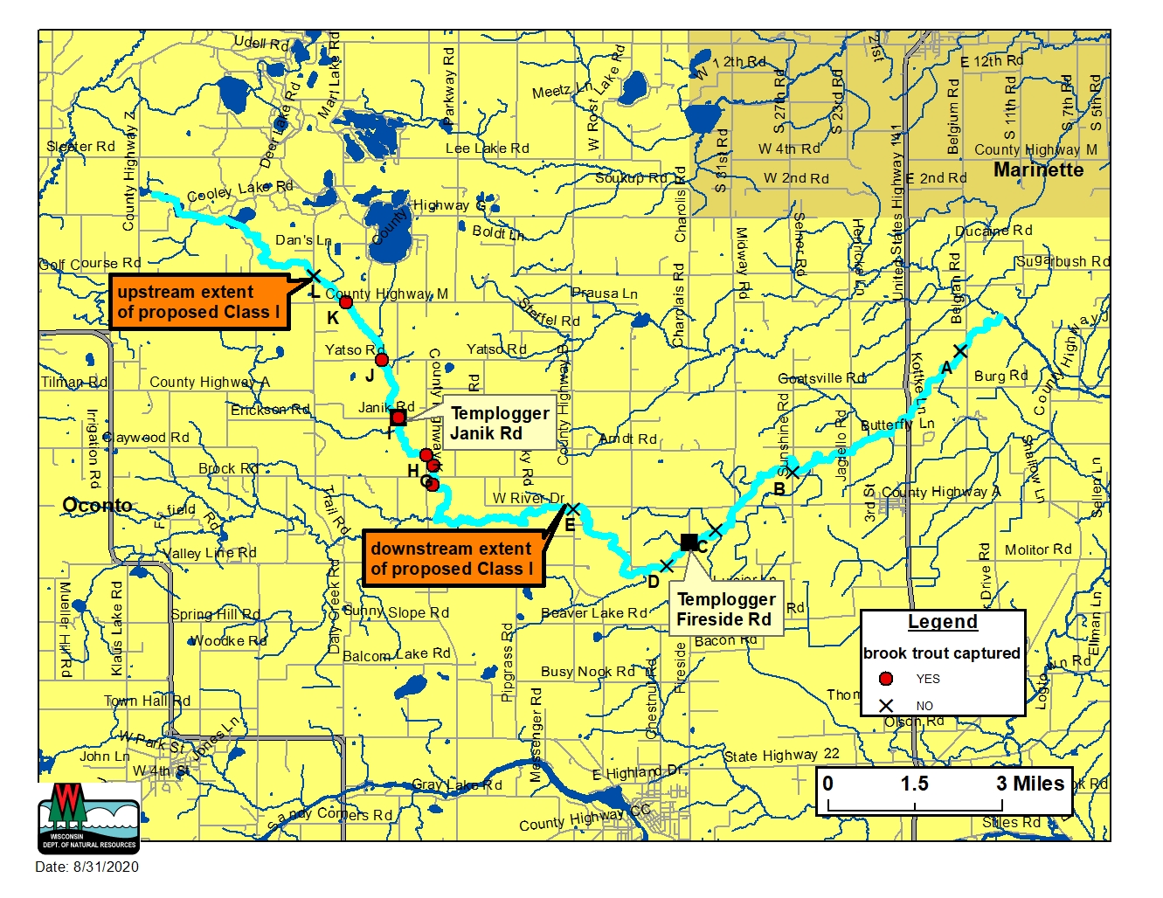
Figure 1. Kelly Brook (light blue) with fish survey stations (A-L) and templogger locations. The segment proposed for classification is between White Lake Road (upstream; site L) and CTH B (downstream; site E). Total stream miles to be classified is approximately 8 miles.

Site | Road crossing | Number Brook Trout captured (2000-2019)
A | Belgian Rd | 0
B | Sunshine Rd | 0
C | Fireside Rd | 0
D | S. Porcupine Lake Rd | 0
E | CTH B | 0
F | Downstream CTH A | 186
G | Downstream CTH K | 18
H | Upstream CTH K | 89
I | Janik Rd | 7
J | Yatso Rd | 1
K | CTH M | 1
L | White Lake Rd | 0

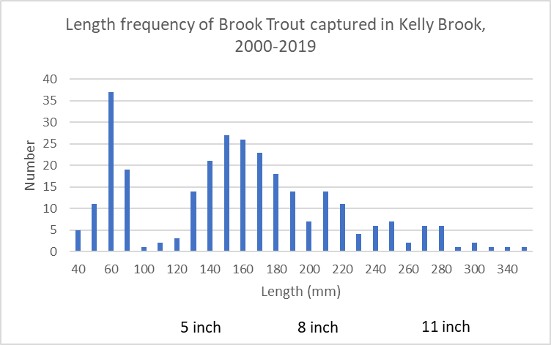
2 inch

Wehrly, K.E., L. Wang, and M. Mitro. 2007. Field-based estimates of thermal tolerance limits for trout: incorporating exposure time and temperature fluctuation. Transactions of the American Fisheries Society 136:365-374.
Becker, G.C. 1983. Fishes of Wisconsin. University of Wisconsin Press, Madison, WI. 1052 pp.

