Internal Loading, Big Lake, Polk County, WI, WBIC: 2615900
In shallow lakes there is intense interaction at the water sediment interface. Therefore, understanding sediment water interactions is crucial to understanding the nutrient dynamics of shallow lakes such as Big Lake (Scheffer, 1998). An analysis of the hypolimnetic nutrients of Big Lake has implications for best management actions.
The most significant form of inorganic phosphorus is orthophosphate. Much emphasis has been placed on the evaluation of the nutrient phosphorus because of its fundamental importance in lakes systems. The types of phosphorus commonly evaluated are soluble reactive phosphorus, soluble unreactive phosphorus, particulate reactive phosphorus, and particulate unreactive phosphorus (Wetzel, 2001). Often analysis is done for total phosphorus.
A substantial source of available phosphorus in shallow lakes, such as Big Lake, is the sediment. Release of phosphorus from the sediment into the water column depends on the composition of the sediment and the concentration of the phosphorus in the water column. Phosphorus release can vary strongly depending on the conditions at the sediment water interface (Scheffer, 1998) (Kaiserli, A., Voutsa, D., and Samara, C., 2002) (Gonsiorczyk, T., Casper, P., and Koschel, R., 1998).
Phosphorus found in the sediments of lakes is often precipitated with clays, aluminum, and iron compounds. Work on Wisconsin lake sediments and the Great Lakes indicate that phosphorus in the sediments is predominately apatites (phosphate minerals), organic phosphorus, and orthophosphate bonded to iron compounds. However, as the oxygen content near the sediment declines, there is a release of phosphorus, iron, and manganese to the water column (Wetzel, 2001).
The concentration of phosphorus in the water column tends to correlate well with the ratio between phosphorus and iron concentrations (P:Fe) in the sediment. It has been found where the P:Fe ratio is lower than 1: 10, the correlation with lake water becomes weak (Scheffer 1998). The ratio of P to Fe in the hypolimnetic water of Big Lake ranges from 3:1- 1:32 indicating a strong correlation between the sediment P pool and the water column phosphorus concentration during certain times. The mobilization of recently deposited P seems to be the driving force of P-release in eutrophic lakes such as Big Lake (Gonsiorczyk et.al. 1998). However, there is a limited amount of knowledge of the mechanisms behind internal loading in shallow lakes (Søndergaard et.al. 2001). Water samples analyzed from near the water-sediment interface do indeed show an increase in phosphorus during the open water season, indicating an internal release of P.

Figure 2. Hypolimnetic soluble reactive phosphorus in Big Lake 2016

Figure 1. Hypolimnetic total phosphorus in Big Lake 2016
Internal P-loading may delay the recovery of a lake once the external P-loading sources are reduced; therefore it is important that the fraction of available phosphorus (iron and manganese bound) is evaluated for predicting internal P-loading. The major factors controlling P release are dissolved oxygen, nitrates, sulfates, and pH (Kaiserli et.al. 2002).
Concentrations of nutrient binding elements, such as iron, depend greatly on the redox potential of the sediment. A redox reaction is the flow of electrons between an oxidized and reduced state (for example iron moving from Fe³⁺ to Fe²⁺ and vice versa) the state of these elements is very important for the ability to bind to nutrients, particularly phosphorus (P).
Iron is a very important micronutrient in aquatic systems. It is essential for aquatic organisms in many ways including: electron transport in oxidation-reduction systems of photosynthesis and respiration, it can be responsible for enzyme activation, and an oxygen carrier in nitrogen fixation in cyanobacteria (blue-green algae).
Iron exists in solution in two different forms; either ferrous (Fe²⁺) or ferric (Fe³⁺). The amounts of iron in solution in lakes and the rate of oxidation of Fe²⁺ to Fe³⁺ that is oxygenated water are dependent on pH, reduction potential, and temperature. Ferrous iron tends to be more soluble than ferric. Under anaerobic conditions with low redox potential, in productive lakes (such as Big Lake) bacteria often reduce sulfate to sulfide which decreases the concentration of Fe²⁺ through the formation of insoluble FeS. This, iron sulfide formation can reduce the abundance of Fe compounds that can complex to phosphorus and promote release of phosphorus from the sediment (Wetzel 2001). If enough FeS precipitates you can remove enough Fe to get iron poor water making phosphorus more available for algae uptake. This is sometimes called the Sulfur Trap.
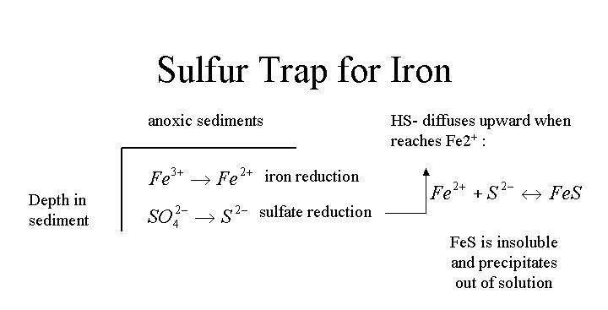
Figure 3. The sulfur-iron trap

Iron bonds (complexes) with many organic compounds (e.g. detritus), which greatly alters the solubility and availability to organisms. Under anoxic conditions in the surface sediment and overlying water these complexes are reduced and phosphorus is released. The release rate from sediments doubles if the sediments are disturbed (though activities such as power boating for example) (Wetzel 2001). However, the oxygen concentration and temperature of the water column of Big Lake seem to remain relatively stable throughout the growing season. Constant mixing could significantly add to the internal load even during sort periods of anoxia. For instance, there appears to be a significant release event around the 4th of July.
Figure 4. Dissolved oxygen profiles Big Lake 2016

Figure 5. Temperature profiles Big Lake 2016

Figure 6. Hypolimnetic iron concentrations in Big Lake 2016

Sulfur is utilized by all living organisms in both inorganic and organic forms. Sources of sulfur compounds to natural waters include solubilization from rock, fertilizers, precipitation and dry deposition. Most (about 90%) of the total sulfur content in lake basins is found in the organic matter of mineral soil. Therefore much of the loading of sulfur compounds to lakes is in the form of sulfate and soluble organic sulfur compounds (Wetzel 2001).
The cycling of sulfur entails the different sulfur chemical species under various conditions, the biotic influences, and sulfur transport within the lake. The predominant form of sulfur in water is sulfate; nearly all assimilation of sulfur is as sulfate.
Sulfur that reacts with metals to form metal sulfides are extremely insoluble, so when Fe⁺² is released from the sediment, it reacts vigorously with S to form FeS. Because the FeS is so insoluble iron is not available to bind with phosphorus (Wetzel 2001). This appears to be occurring in Big Lake, sulfate concentrations go down significantly after what appears to be a release of iron from the sediment on July 5th.
Figure 7. Hypolimnetic sulfate concentrations in Big Lake 2016

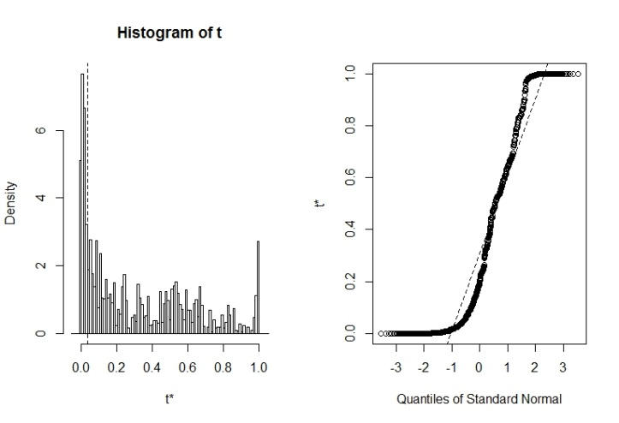
The data collected gives the appearance that there is a significant internal load occurring in Big Lake. However the lack of the appearance of anoxia based on citizen monitoring is troublesome (there could however be a very thin anoxic layer of water near the sediment water interface that would be very difficult to sample). The data was analyzed using the statistical program R to examine relationships between the different parameters. The data was bootstrapped 4,999 times and linear regressions were done. 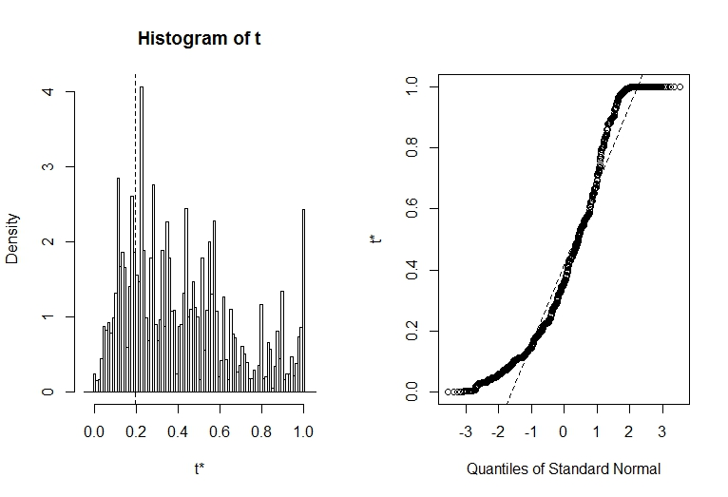
Figure 8. Relationship of sulfate and total phosphorus to iron

The most significant relationship appears to be the concentration of total phosphorus to TP:SO₄. This gives the indication that iron is releasing phosphorus and precipitating back to the sediment as FeS. However, the confidence intervals do show quite a bit of variation.
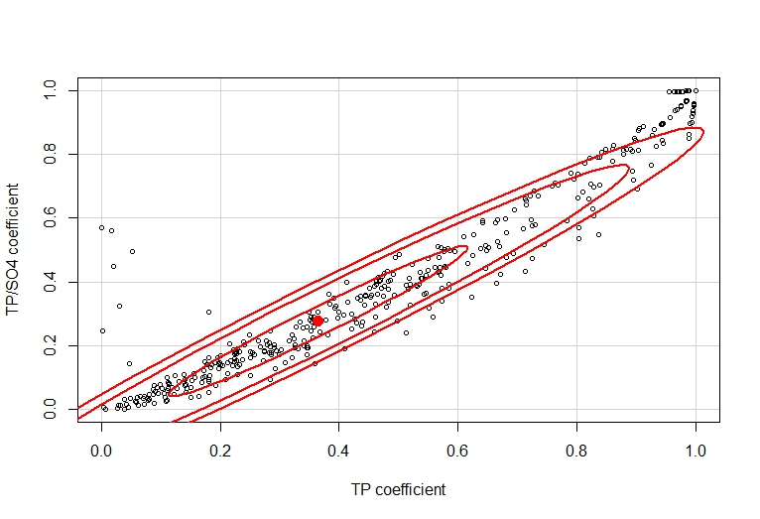
Figure 8. Relationship of total phosphorus and TP:SO⁴. Ellipsoids represent 0.5, 0.95, and 0.99 confidence intervals from the outside ellipse to the inner most ellipse. The red point represents the center of the dataset

When the data is used to model internal loading from the sediment it suggests a significant net internal load as part of the nutrient budget. Net internal load (L_{int-1}) consists of sediment released P that is diminished by subsequent settling. Gross internal load (L_{int}) is the total quantity of sediment released P using the equation:
L_{int-1} = (P_t₂ x V__{t2} – P__{t1} x V__{t1}) / (A_{o}),
Where t₁ is the initial date and t₂ is the date at the end period (Julian day), P_t is the correspondent P concentration, and V_t is the correspondent lake volume, and A_{o} is the lake surface area; the internal load was predicted to be 202 kg (445 lbs.) or 46.2 percent of the load. This model uses in situ increases of P concentration throughout the summer period. Because lake levels were not monitored in 2016, they were not considered (Nürnberg et al 2012).
All data collected and modeling indicates that the internal loading component of the nutrient budget is very significant. The senescence (dying back) of Potamogeton crispus (CLP) may contribute slightly, but likely the main release mechanism is the release of phosphorus bound to iron because of changes in redox potential at the sediment water interface and sediment resuspension.
Because of the importance of the sediment phosphorus pool in Big Lake further study of sediment release is warranted. In situ sediment release rates should be measured with benthic flux chambers over a series of years in several locations to accurately calculate actual P release from the sediment, or in incubation chambers. In addition, sediment cores should be collected and species of phosphorus should be fractioned using sequential extractions (Engstrom and Wright 1984). Water column phosphorus can be reconstructed using diatoms, hypolimnetic oxygen concentrations can be reconstructed using chironomid head capsules, and cyanobacteria (blue-green algae) communities can be reconstructed with the use of fossilized pigments (Williamson et al 2016) (Juckem and Robertson 2013). The timing and magnitude of change is unknown and should be understudy before consideration of sediment amendments such as alum or other drastic management techniques are used.

References
Engstrom, D. R. & Wright, H. E. (1984): Chemical stratigraphy of lake sediments as a record of environmental change. – In: Haworth, E. Y. & Lund J. W. G. (eds): Lake Sediments and Environmental History. – Leicester University Press, Leicester, pp. 11–68
Gonsiorczyk, T., Casper, P., and Koschel, R. (1998). Phosphorus-Binding Forms in the Sediment of an Oligotrophic and an Eutrophic Hardwater Lake of the Baltic Lake District (Germany). Wat. Sci. Tech., 37(3), 51-58.
Juckem, P. J., and Robertson, D.M. 2013 Hydrology and water quality of Shell Lake,
Washburn County, Wisconsin, with special emphasis on the effects of diversion
and changes in water level on the water quality of a shallow terminal lake: U. S.
Geological Survey Scientific Investigation Report 2013-5181, 77 p., 2 app.,
http://dx.doi.org/10.3133/sir20135181.
Kaiserli, A., Voutsa, D., and Samara, C. (2002). Phosphorus Fractionation in Lake Sediments--Lakes Vovi and Koronia, N. Greece. Chemosphere, 46, 1147-1155.
Nürnberg, G. K., Tarvainen, M., Ventela, A., and Sarvala, J. (2012). Internal phosphorus
load estimation during biomanipulation in a large polymictic and mesotrophic
lake. Inland Waters, 2, 147-162
Søndergaard, M., Jensen, J.P., Jeppesen, E. (2001). Retention and internal loading of phosphorus in Shallow, Eutrophic Lakes. The Scientific World, 1, 427-442.
Scheffer, M. (1998). Ecology of Shallow Lakes. London: Chapman & Hall.
Wetzel, R. G. (2001). Limnology Lake and River Ecosystems Third Edition. San Diego, California: Academic Press.
Williamson, J., Edlund, M. B., and Ramstack Hobbs, J., and Burge, D. R. L. 2016. A
Paleolimnological Study of Big Blake Lake, Polk County, Wisconsin. Final Report
to Big Blake Lake Protectionand Rehabilitation District. Polk County Land and
Water Resources Department, Balsam Lake, WI.

