Vermont Creek Pre-Post BMP Evaluation Final Report
Jean Unmuth – DNR Water Quality Section
In Cooperation with Pete Jopke, Dane County Land Conservation
Assisted by UW-Platteville: Elliot Momchilovich, Andrew Meiborg

Overview and Methods
Vermont Creek is listed as a 303 d impaired stream in approximately a four mile stretch from the mouth upstream. The stream was listed as impaired for degraded biological community, degraded habitat and elevated temperature, with sediment and total suspended solids listed as the pollutants, and the general condition was listed as poor. In 2015, Vermont Creek (WBIC: 1249200) in Dane County was monitored to evaluate more recent agricultural best management practices (BMP’s) implemented by Dane County Land Conservation between approximately and 2008 and 2013. BMP’s implemented were stream bank stabilization, shaping and seeding, in stream habitat structures, and culvert retrofit to accommodate passage for stream biota. The goal was to restore biological habitat, control sediment, and reduce nonpoint source pollution, which would enhance water quality and fish habitat.
Four sites were chosen for the 2015 monitoring for fish, habitat, and a water quality using a YSI proplus meter. Continuous instream water temperature was collected using Onset PRO V2 meters, between June 1 and October 12 at a reference site in the non-impaired stream segment, and in the impaired segment at a BMP site. Monitoring data collected prior to 2015 at additional sites was also included within this report to evaluate stream health as a whole, and data collected over the past 5 years is used to evaluate whether the stream should be removed from the impaired list. Monitoring sites are listed in Table 1, and locations are shown in Figures 1 and 2. Three reference (non-BMP) sites were compared to five BMP sites, and BMP sites were compared Pre-to - Post implementation years.
Table 1. Vermont Creek monitoring sites from downstream to upstream.
Site # | Site Name | SWIMS ID | Survey Dates | BMP or Reference Site
1 | CTY. RD. KP | 10011931 | 20-Jun-2006  7-Sep-2006 | Non-BMP
2 | PARRELL’S | 10034044 | 12-Jul-2011  21-Jul-2015 | BMP
3 | DANZ CULVERT | 10009346 | 14-Jul-2006 | BMP
4 | MICHAELIS ROAD | 10015267 | 12-Jul-2011 | BMP
4 | MICHAELIS ROAD | 10012507 | 12-Jul-2011  21-Jul-2015 | BMP
5 | CTH JJ. | 10016009 | 20-Jul-2015 | BMP
6 | COWAN PICNIC AREA | 10014195 | 20-Jun-2006 | BMP
7 | VERMONT CHURCH ROAD | 10012508 | 13-Jun-2006 | Reference
8 | DNR PARKING LOT WINDY ACRES WAY | 10009749 | 20-Jun-2006  20-Jul-2015 | Reference

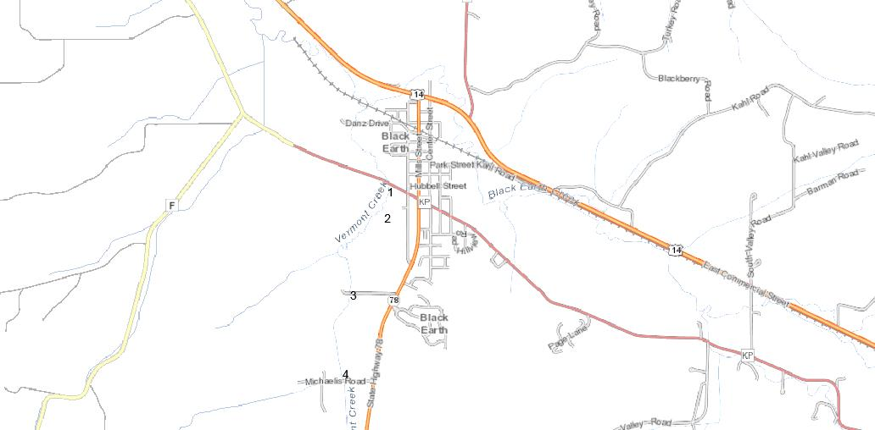
Figure 1. Vermont Creek Downstream Sites Map
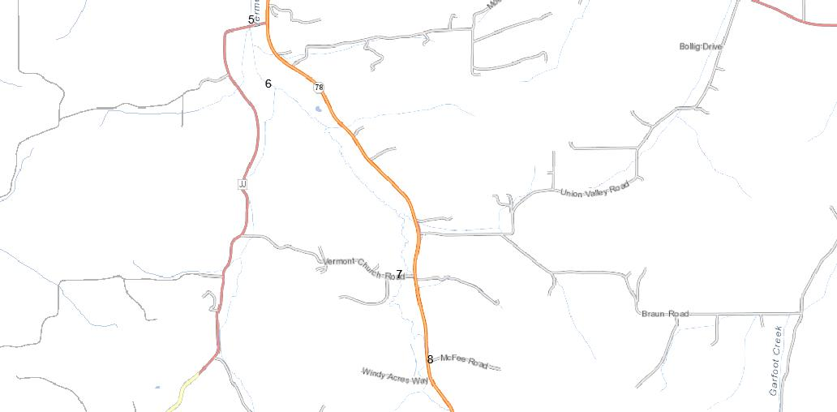
Figure 2. Vermont Creek Upstream Sites Map
For the four sites we monitored in 2015, we collected fish using towboat stream electrofishing equipment, cool-cold water calculator used to evaluate fish for indexes of biotic integrity (FIBI). Qualitative habitat information, flow was collected using a Marsh-Mcburney meter, and instantaneous temperature, dissolved oxygen, pH and conductivity was collected using a YSI multi-meter. Dane County collected six total phosphorus samples and 5 total suspended solids samples at CTH-KP, and samples were processed by the State Lab of Hygiene. Continuous instream water temperature was collected using Onset PRO V2 meters, between June 1 and October 12 at a reference site in the upper ¼ of the watershed and at a BMP site in the lower ¼ of the watershed . Macroinvertebrates were collected at the DNR lot near Windy Acres Way and at Michaelis Road. FIBI and habitat, and macroinvertebrate scores and ratings were summarized for the 10 years prior to 2015 and reported herein.
FIBI Results
Nine species of fish were found at the four sites sampled in 2015 (Table 2). Note that electrofishing during 2015 monitoring was difficult at all but the DNR lot near Windy Acres Way site. This is because the other sites had very deep water and shallow riffles were rarely found, making it easy for fish to move upstream or around our equipment. FIBI ratings were good to excellent at all locations, regardless of whether they were BMP, non-BMP or reference sites (Tables 3 & 4). The single rating of “Good” during year 2011 was at the Michaelis Road site. While brown trout (Salmo trutta) were captured at all four sites sampled during 2015, young of the year trout were chiefly found higher up in the watershed at the DNR lot near Windy Acres Way. Trout ranged from 2.7” to 17.2” and the largest trout was captured at the Parrell site. Vermont Creek has been stocked with mainly Brown trout every year since 1991, and in the past five years nearly 5,000 fingerlings and 331 adult brood stock were put in the stream, Other fish species collected during 2015 monitoring were white sucker (Catostomus commersonii), and mottled sculpin (Cottus bairdii) which dominated the catch with hundreds of young of the year of each species found at most sites. For cold water fish species at all the four sites combined, 92% were sculpin. Of the cold water fishes (trout and sculpin), 92% were sculpin.
Table 2. List of fish species captured during 2015 Vermont Creek monitoring.
Brown Trout | Salmo trutta
Blacknose Dace | Rhinichthys atratulus
Brook Stickleback | Culaea inconstens
Common Shiner | Luxilus cornutus
Creek Chub | Semotilus atromaculatus
Fathead Minnow | Pimphales promelus
Green Sunfish | Lepomis cyanellus
Mottled Sculpin | Cottus bairdii
White Sucker | Catostomus commersonii

Table 3. Vermont Creek FIBI scores and ratings in BMP areas in pre- and post- implementation years.
 | Location | Date | Cool-cold IBI Score |  | Rating
Non-BMP Sites | CTH-KP | 20-Jun-06 | 70 |  | Excellent
 | CTH-KP | 7-Sep-06 | 90 |  | Excellent
Pre- BMP Sites | DANZ Culvert | 14-Jul-06 | 90 |  | Excellent
 | Cowan Picnic Area | 20-Jun-06 | 70 |  | Excellent
 | Michaelis Rd | 14-Jul-06 | 90 |  | Excellent
Post- BMP Sites | Michaelis Rd | 12-Jul-11 | 60 |  | Good
 | Michaelis Rd | 21-Jul-15 | 80 |  | Excellent
 | CTH-JJ | 20-Jul-15 | 80 |  | Excellent
 | Parrell's | 12-Jul-11 | 80 |  | Excellent
 | Parrell's | 21-Jul-15 | 80 |  | Excellent

Table 4. Vermont Creek FIBI scores and ratings at reference sites.
Location | Date | Cool-cold IBI Score |  | Rating
DNR Lot Windy Acres Way | 20-Jun-06 | 90 |  | Excellent
DNR Lot Windy Acres Way | 20-Jul-15 | 70 |  | Excellent
Vermont Church Rd | 13-Jun-06 | 80 |  | Excellent

Habitat Results
Reference and Non-BMP sites had habitat ratings of fair to good in the downstream most and upstream most stream segments (Table 5). The fair ratings at CTH-KP and at the DNR lot were mainly due to moderate stream bank erosion, a lack of pools and riffle habitat, and fine sediments common in the stream channel. All BMP sites had a ratings of good to excellent, with the exception of the Michaelis Road site which had a fair rating only in 2006, however the site showed improvement over time, after BMP’s were installed, with a rating of good in 2011, and a rating of excellent in 2015. Of the aquatic plant species found in Vermont Creek, white water crowfoot (Ranunculus aquatilus) and water starwort (Calltriche palustris) were most abundant, followed by common waterweed (Elodea Canadensis), sago pondweed (Stuckenia pectinate), leafy pondweed (Potomageton foliosus), and curly-leaf pondweed (Potamogeton crispus).
Table 5. Vermont Creek Habitat Scores and Ratings in Reference and BMP sites Pre – and Post –Implementation from downstream to upstream.
Location | BMP or Reference Site | Date | Habitat Score | Habitat Rating
CTH-KP | Non-BMP | 7-Sep-06 | 45 | Fair
Parrell's | BMP | 12-Jul-11 | 67 | Good
Parrell's | BMP | 21-Jul-15 | 67 | Good
Danz Culvert | BMP | 14-Jul-06 | 50 | Good
Michaelis Rd. | BMP | 14-Jul-06 | 30 | Fair
Michaelis Rd. | BMP | 12-Jul-11 | 72 | Good
Michaelis Rd. | BMP | 21-Jul-15 | 83 | Excellent
CTH-JJ | BMP | 20-Jul-15 | 83 | Excellent
Vermont Church Rd | Reference | 13-Jun-06 | 68 | Good
DNR lot near Windy Acres Way | Reference | 20-Jul-15 | 48 | Fair

Macroinvertebrates
Macroinvertebrates were collected during 2015 from DNR lot site in the stream segment that is not listed as impaired (reference site), and one site in the impaired segment at Michaelis Road. In addition samples collected from 4 different sites in the impaired stream segment during fall of 2006 and again during winter 2012, were included to assess stream health using the macroinvertebrate Index of biotic integrity (MIBI). All sites showed improvement from either poor to fair or from fair approaching good (Figure 3), meaning less organic pollution has occurred between pre- and post- BMP’ years. The non-BMP site at CTH-KP showed the least amount of improvement between years due to a lack of rocky substrate near the stream mouth. The highest MIBI score was from the upper non-impaired stream segment located at the DNR Lot.

Figure 3. Vermont Creek Macroinvertebrate Scores.

Water Temperatures
Continuous temperatures were collected during the summer 2015 at CTH-KP in a cool–cold main stem natural community stream segment near the mouth, and in a cool–cold headwater natural community segment at the DNR public access lot near Windy Acres Way. The expected maximum daily mean temperature for a cool–coldwater fish community waters should fall between 20.7 – 22.0 degrees celcius. Temperatures falling below 22.0 celcius indicates the stream should be able to support more of a cold water natural fish community. Both sites had temperatures cold enough to support a cold water fish community. During the warmest month, the mean of the maximum daily temperature at CTH-KP and at the DNR public access near Windy Acres Way was 20.7 and 20.3 degrees C, respectively. In early August the highest temperature recorded at CTH-KP for a single reading was 24.3 degrees celcius, and at The DNR public access lot the highest temperature for a single reading was 23.8 degrees.
Phosphorus, Total Suspended Solids, and Transparency
Six monthly total phosphorus (TP) samples were collected, and five monthly total suspended solids were collected at the CTH-KP site. The median TP was 106.4 ug/L. Based on the lower 90% confidence interval results of 95.69 ug/L, TP in Vermont creek may exceed the fish and aquatic life criteria for phosphorus of 75 ug/L. But since all FIBI and recent MIBI (2012) data scores were not in the “poor” category, biological evidence does not corroborate the fish and aquatic life use impairment. Therefore, it should be listed as impaired under subcategory 5P only for the pollutant TP. The median of five samples of suspended solids (TSS) collected near the stream mouth were relatively low at 15.6 mg/L. The highest value occurred in October when TSS was 20 mg/L, but the TP was relatively low on the same date (Figure 4).

Figure 4. Vermont Creek total suspended solids and total phosphorus value.
Vermont Creek has good water clarity as evidenced by the low suspended solids (TSS) collected at the CTH-KP site and low turbidity values of <10 NTU’s during 2015 at all sites.
Dissolved Oxygen, pH, Conductivity
These parameters were collected instantaneously only once during habitat assessment. Dissolved oxygen was adequate, and similar between sites, ranging from 9.6 – 12.0 mg/L. pH was within an acceptable range, and similar between sites, ranging from 7.8 – 8.1 SU. Conductivity was similar between sites, ranging from 625-637 mg/L.
Summary and Recommendations
The fish index of biotic integrity (FIBI) and habitat assessment information collected over the past ten years in the impaired stream segment, indicates that the stream is in good condition. FIBI at all sites rated good or excellent. Habitat ratings ranged from fair to excellent, and in all recent agricultural BMP implementation sites rated good or excellent. Using historic macroinvertebrate data collected at four sites within the impaired stream segment in 2006 and comparing them to 2012 and 2015 data, it appears that the macroinvertebrate index of biotic integrity (MIBI) scores have improved with all sites rating fair, and three of the four sites approaching the fair to good transition line. The only site that rated excellent was in the upper part of the watershed in the non-impaired stream segment. Based on biological indicators and habitat assessments from pre – to Post BMP’s, it appears that BMP’s were effective.
Water temperature data, FIBI and MIBI information indicate that the stream is meeting the fish and aquatic life designated use. The stream natural community classifications is cool-cold headwater and mainstem, and the fish data indicates it is meeting the classification. The fish and aquatic life condition of Vermont Creek, is currently listed as poor, but that status should be changed by the Department. Biological evidence indicates the fish and aquatic life condition is good, and in fact the poor rating in 2006 for two macroinvertebrate samples, have improved to fair, with one of those samples approaching a rating of good. In addition the temperature data shows the stream can support cool-cold water fish communities.
The impaired listing for degraded biological community, degraded habitat, elevated stream temperatures, and suspended solids should be removed from the list. However, phosphorus results indicate the stream exceeds the criteria, likely due to excessive sediment. Since the biology meets the designated use for fish and aquatic life, but the phosphorus exceeds the criteria, the stream should be listed as impaired only for sediment and phosphorus according to Wiscalm guidance.
To help reduce instream phosphorus and sedimentation, stream segments ments historically ditched and having high vertical eroding banks combined with poor riparian vegetated buffer habitat, would have to be stabilized. However, this means willing landowners, who were previously approached by Dane County during the BMP installation period, but unwilling to cooperate. In those stream segments a lack of cooperation means ongoing sedimentation and elevated phosphorus levels.

