Northern Wild Rice (Zizania palustris)
Bed Mapping Survey
Minong Flowage - WBIC: 2692900
Douglas County, Wisconsin

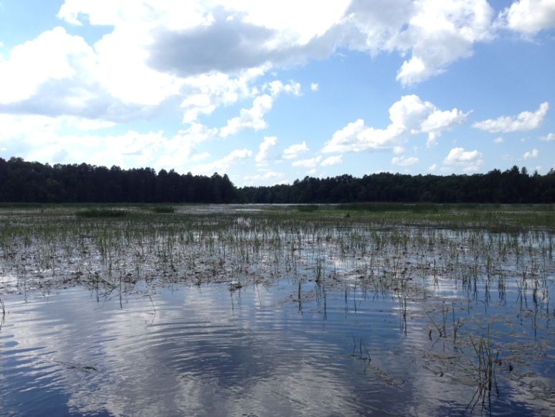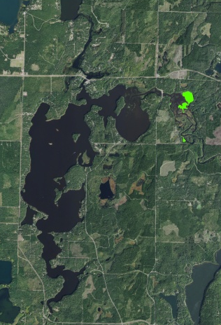
Extremely Low Density Rice East of Smith’s Bridge (Berg 2017) Minong Flowage Aerial with 2017 Rice Beds

Project Initiated by:
The Minong Flowage Association, Lake Education and Planning Services, LLC, and the Wisconsin Department of Natural Resources

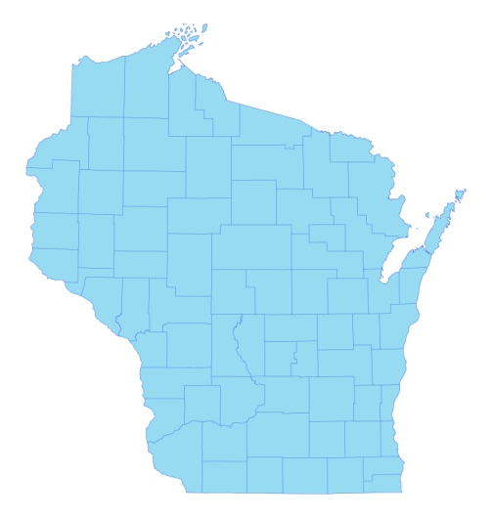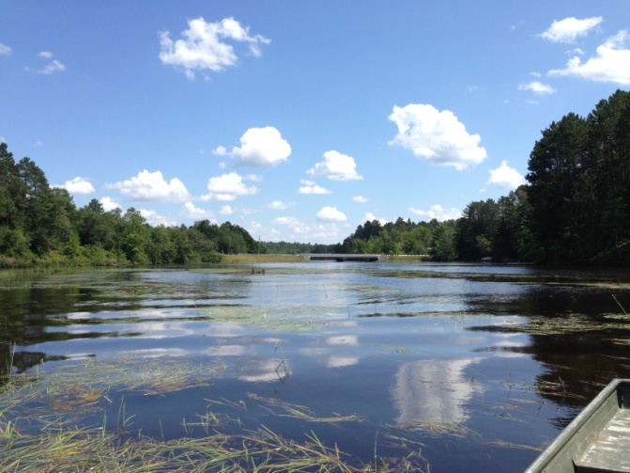
* Minong Flowage
Handful of Rice Plants among Bur-reeds West of Smith’s Bridge (Berg 2017)

Survey Conducted by and Report Prepared by:
Endangered Resource Services, LLC
Matthew S. Berg, Research Biologist
St. Croix Falls, Wisconsin
July 31, 2017
TABLE OF CONTENTS

Page
LIST OF FIGURES……………….………………………………………….…….. ii
LIST OF TABLES………………..…………………………………………..…….. iv
INTRODUCTION.…..……..………………………………………………………. 1
BACKGROUND AND STUDY RATIONALE…………………….……………... 1
METHODS………………………………… ………………………………………. 3
RESULTS AND DISCUSSION…..………………………………………..……..... 3
Northern Wild Rice Summary.………..……………………………………. 3
Rice West of Smith’s Bridge…..……..…………………………………….. 4
Rice East of Smith’s Bridge……..…….………………………….………... 7
PAST AND PRESENT INDIVIDUAL BED DESCRIPTIONS………….…..……. 10
Minong Flowage West of Smith’s Bridge.…………………………………. 10
Minong Flowage East of Smith’s Bridge.………………………………….. 13
LITERATURE CITED ……………………….…………………………………….. 23
APPENDIXES.…….……………………………………………………………….. 24
I: 2014, 2016, and 2017 Wild Rice Beds West of Smith’s Bridge.………….….. 24
II: 2014, 2016, and 2017 Wild Rice Beds East of Smith’s Bridge.………….…... 28

LIST OF FIGURES

Page #
Figure 1: Sept. 2013 EWM Coverage/Terrestrial EWM Rosettes Bed 19.………... 1

Figure 2: 2008 Wild Rice Density and Distribution/2013 Rice and EWM East of
Smith’s Bridge ……………………………………………………………..………. 2

Figure 3: Rake Fullness Ratings……………………………………….…….…….. 3

Figure 4: Rice Beds West of Smith’s Bridge 8/17/14, 7/30/16, and 7/31/17…….... 6

Figure 5: Rice Beds East of Smith’s Bridge 8/17/14, 7/30/16, and 7/31/17.………. 9

Figure 6: Low Density Rice in Beds 1 and 3 – 8/17/14.…………………..……….. 10

Figure 7: Canopied EWM in Former Rice Bed 3 Facing Southeast – 7/30/16.……. 10

Figure 8: Canopied EWM in Former Rice Beds 1 and 2 Facing SE – 7/31/17……. 11

Figure 9: Canopied EWM in Former Rice Bed 3 Facing South – 7/31/17…...……. 11

Figure 10: Short-stemmed Bur-reed and Pickerelweed North of Channel in Former
Bed 2 Facing North – 7/31/17………………………………………………………. 11

Figure 11: Bed 4 Facing Northwest – 8/17/14 and Bed 5 Facing East – 7/30/16.…. 12

Figure 12: Scattered Rice Blades in Former Bed 4 Facing East – Former Bed 5
Facing Southeast – 7/31/17…………………………………………………………. 12

Figure 13: Bed 8 Facing Smith’s Bridge 8/17/14 –
From Smith’s Bridge Facing East 7/30/16…….……………………………..…….. 13

Figure 14: Scattered Rice in Beds 7 and 8 Growing among
Short-stemmed bur-reed – 7/31/17…………………………………………………. 13

Figure 15: Scattered Rice with Interspersed EWM Plants – 7/30/16.……………... 14

Figure 16: Bed 9 – Scattered Rice with Interspersed EWM Plants –
Former Bed 10 Overrun with Other Emergents – 7/31/17…………………………. 14

Figure 17: Dense Rice in the Center of Bed 11 – 8/17/14…………………………. 15

Figure 18: Low Density Rice with EWM in Bed 11 – 7/30/16………………..…... 15

LIST OF FIGURES (cont’)

Page #
Figure 19: Northwest End of Former Bed 11 Facing South – 7/31/17.………..…... 16

Figure 20: Central Lobe of Former Bed 11 Facing South – 7/31/17.…………..….. 16

Figure 21: Southern Lobe of Former Bed 11 Facing East – 7/31/17…………..…... 16

Figure 22: Northwest and Northern Shorelines of Bed 12 – 8/17/14…………….... 17

Figure 23: Uprooted Clumps and Scattered Floating-leaf Stage Rice –
Northwest and Northern Shorelines of Bed 12 – 7/30/16..………….…………….... 17

Figure 24: Northern Shoreline of Former Bed 12 Facing East – 7/31/17………..… 17

Figure 25: North End of Bed 12 Facing Northeast and Southeast – 7/30/16.……... 18

Figure 26: Northeast Bay of Bed 12 Facing East – 7/31/17…………………...…... 18

Figure 27: Bed 12 Facing Southeast and South – 8/17/14……………………….... 19

Figure 28: Southern Edge of Bed 12 in 2014 (left) and 2016 (right)……….……... 19

Figure 29: Southeast Corner of Bed 12 Facing Northwest – 7/31/17.…..……..…... 19

Figure 30: Former South/Southwest Border of Bed 12 Facing Northeast – 7/31/17 20

Figure 31: Western Border of Bed 12 Facing Southwest/North – 7/31/17…....…... 20

Figure 32: Shoreline Ribbon of Rice in Bed 13 Facing North – 7/31/17….…..…... 20

Figure 33: Western/Southern Border of Former Bed 14 Facing South – 7/31/17…. 21

Figure 34: Eastern Edge of Bed 15 Facing South – 8/17/14 and 7/30/16…...…….. 21

Figure 35: Eastern Edge of Bed 15 Facing South/West – 7/31/17………….....…... 22

Figure 36: Northwest Corner of Bed 15 – 8/17/14 and 7/30/16…………………… 22

Figure 37: Northwest Corner of Bed 15 – 7/31/17………………………………… 22

Figure 38: Bed 16 Facing South – 8/17/14 and 7/30/16…….………………….….. 23

Figure 39: Bed 16 Facing South – 7/31/17…………………………………….…… 23

LIST OF TABLES

Page #
Table 1: Wild Rice Bed Mapping Summary - West of Smith’s Bridge
Minong Flowage, Douglas County August 17, 2014……………….……………… 4

Table 2: Wild Rice Bed Mapping Summary - West of Smith’s Bridge
Minong Flowage, Douglas County July 30, 2016……………………………….…. 4

Table 3: Wild Rice Bed Mapping Summary - West of Smith’s Bridge
Minong Flowage, Douglas County July 31, 2017……………………………….…. 5

Table 4: Wild Rice Bed Mapping Summary - East of Smith’s Bridge
Minong Flowage, Douglas County August 17, 2014…………………….……….... 7

Table 5: Wild Rice Bed Mapping Summary - East of Smith’s Bridge
Minong Flowage, Douglas County July 30, 2016………………………….………. 8

Table 6: Wild Rice Bed Mapping Summary - East of Smith’s Bridge
Minong Flowage, Douglas County July 31, 2017………………………….………. 8

INTRODUCTION:
The Minong Flowage (WBIC 2692900) is a 1,564-acre eutrophic/mesotrophic stratified drainage lake located in north-central Washburn County and south-central Douglas County, Wisconsin in the Towns of Minong and Wascott (T42N R13W S13 SW NE). It reaches a maximum depth of 21.5ft near the dam on the far south end and has an average depth of approximately 9ft. The bottom is predominately sand and sandy muck in the south basin and organic muck in the northern bays. Water clarity is very poor to poor with Secchi disc readings averaging 4.1ft from 1994-2017 (WDNR 2017).

BACKGROUND AND STUDY RATIONALE:
Eurasian water-milfoil (Myriophyllum spicatum) (EWM) was first identified in the Minong Flowage in 2002. Since 2009, the Minong Flowage Association (MFA) under the direction of Lake Education and Planning Services, LLC (LEAPS) has been actively managing the infestation using herbicide treatments and manual removal as outlined in the flowage’s Wisconsin Department of Natural Resources (WDNR) approved Aquatic Plant Management Plan (APMP). Unfortunately, despite this management, by 2012 EWM had spread to the Northern wild rice (Zizania palustris) beds along the river inlet channels, and it showed steady annual expansion both east and west of Smith’s Bridge.

In April/May 2013, the flowage was drawn-down 5ft to perform maintenance on the dam. Due to a delay in finishing the repair/reconstruction, the flowage was not refilled until March/April 2014. Despite being subjected to extended desiccation over the summer of 2013, EWM managed to survive as tiny terrestrial rosettes that could quickly regrow once water levels rose (Figure 1). Fortunately, the extended period of freezing over the winter ultimately killed these terrestrial plants, and the rapid rise in water levels in the spring resulted in the elimination of the majority of EWM from the flowage – at least temporarily.

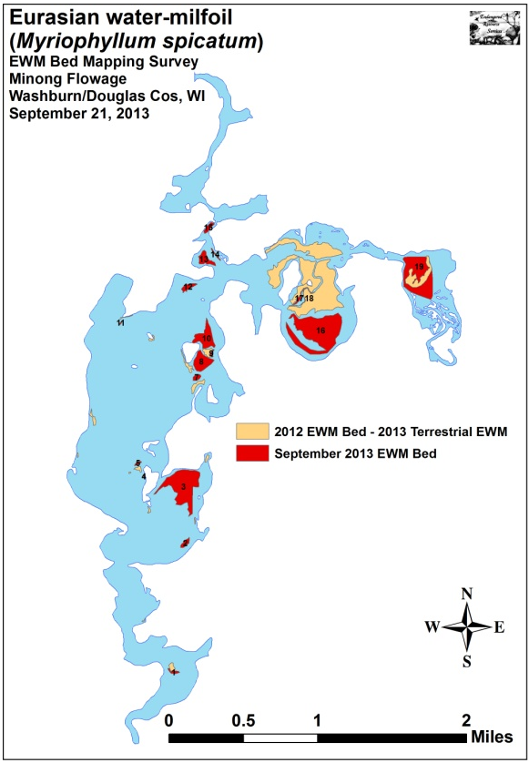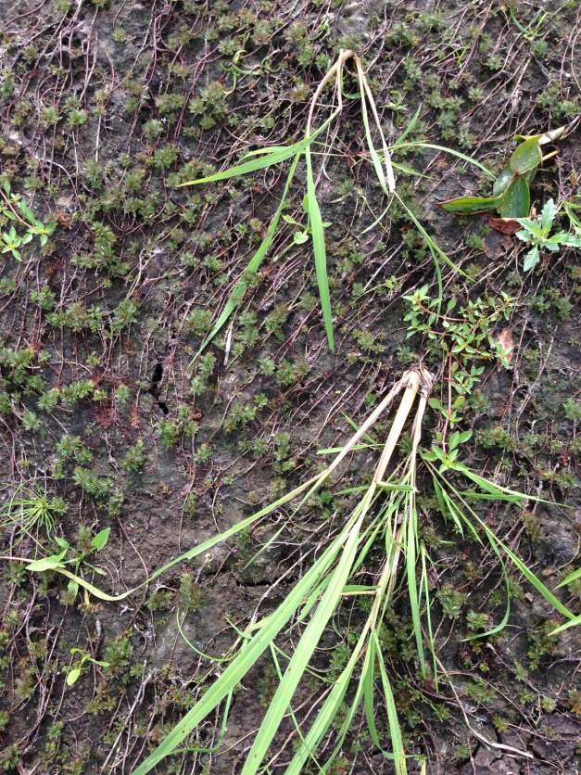
Figure 1: Sept. 2013 EWM Coverage/Terrestrial EWM Rosettes Bed 19
The drawdown also meant that the flowage’s wild rice beds in the north-central and eastern bays were subjected to these conditions (Figure 2). General concern about what impact this might have on the beds coupled with a desire to gather baseline information on the total acreage, density, and distribution of the rice post-drawdown prompted the WDNR (Pamela Toshner – personal communication) and the MFA to request an initial delineate of all rice beds on the flowage on August 17, 2014. That survey found that the rice survived the drawdown quite well, although other species of submergent plants (including EWM) were almost entirely eliminated.

A fall Eurasian water-milfoil survey in 2015 showed EWM was rapidly recolonizing the rice beds. Because of this, the WDNR and MFA requested a follow-up rice bed mapping survey on July 30, 2016. However, prior to that survey, on July 11-12th more than a foot of rain fell within the Totagatic watershed and produced historic flooding. These flood waters caused the Colton Flowage Dam to fail sending a wall of water downstream into the Minong Flowage. Our survey on July 30th ultimately found that this event significantly altered the braided channels in the delta area where the river enters the Minong Flowage. We also noted that the majority of standing rice anywhere near the river channel was swept away including all rice west of Smith’s Bridge. East of the bridge, the only surviving rice of significant density was in sheltered bays. Some late-germinating individuals were still present in the channels, but they were just entering the floating-leaf stage at the time of our survey. With limited time left in the growing season, it seemed unlikely they would survive to set grain bringing the short-term future of the rice beds in doubt, and prompting the WDNR and the MFA to request another follow-up survey. This report is the summary analysis of that survey conducted on July 31, 2017.

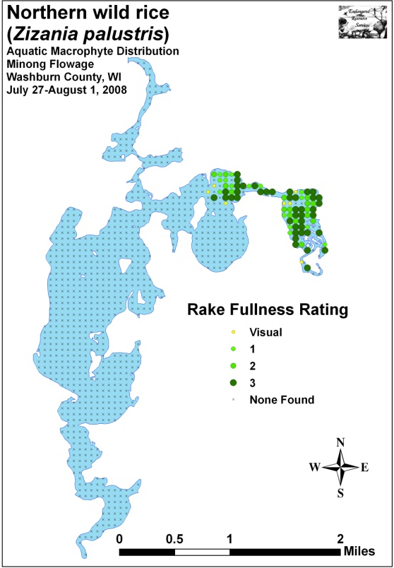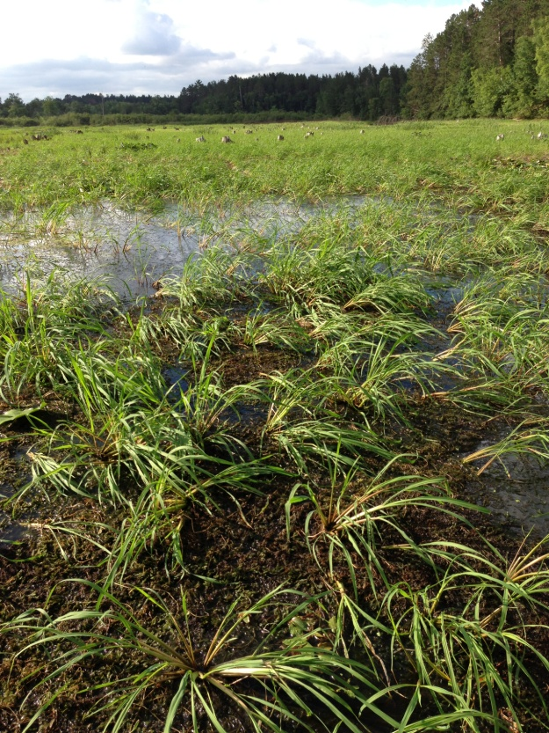
Figure 2: 2008 Wild Rice Density and Distribution/
2013 Rice and EWM East of Smith’s Bridge

METHODS:
During the survey, we searched the entire visible littoral zone of the Minong Flowage for wild rice beds. Normally, a bed is defined as an area where wild rice makes up greater than 50% of all aquatic plants. However, as one of the goals of the survey was to document change since the last survey and because rice density can be extremely variable from year to year, this definition was expanded in 2014, 2016, and 2017 to include all areas that supported continuous rice plants. Because of this broader definition, we also recorded the range and mean level of rice growth within each area using the WDNR’s standard 1-3 rake fullness scale (Figure 3), estimated its human harvest potential (none/low/moderate/high), and took representative pictures of the rice at each location.

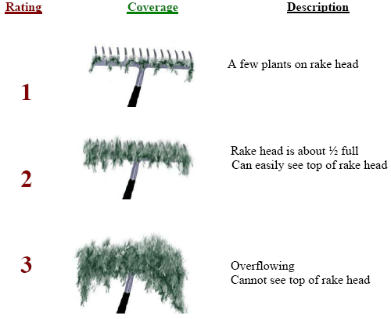
Figure 3: Rake Fullness Ratings (UWEX 2010)

Using a Garmin 76CSX GPS unit, we recorded a string of waypoints that circled around the edges of the beds. These data were then mapped using ArcMap 9.3.1. We also used the WDNR’s Forestry Tools Extension to determine the acreage of each bed to the nearest hundredth of an acre.

RESULTS AND DISCUSSION:
Northern Wild Rice Summary:

In August 2014, we mapped 16 beds with continuous wild rice plants that covered 87.08 acres on either side of Smith’s Bridge. They ranged in size from 0.18 acres (Bed 6) to 37.93 acres (Bed 12). Following the flood, our 2016 survey found only four of these beds remained. They totaled 32.33 acres with the smallest (Bed 9) being 0.73 acre and the biggest (Bed 12) covering 24.37 acres. Collectively, this was a nearly 63% decline in total distribution from the original survey.

Although we mapped six areas in 2017, they covered a total of just 22.52 acres with Bed 12 (20.31 acres) accounting for over 90% of that area. This was a further 30% decline in distribution from 2016 and a nearly 75% reduction from the initial 2014 acreage. Perhaps of greater short-term concern, a resident flock of between four and five Canada goose (Branta canadensis) families that numbered 30-40 adult and juvenile birds had cropped every single rice plant we saw within and outside of these beds. No plants were in flower, and we didn’t see a single seed head when we returned to the area in the fall to check back on the beds. Because of this, we expect the only rice that will germinate in 2018 will be latent grains in the substrate.

Rice West of Smith’s Bridge:
The 2014 survey found six areas with rice West of Smith’s Bridge that totaled 23.81 acres (Figure 4) (Table 1). None of them were true beds or suitable for human harvest as rice densities were never greater than a rake fullness of 2 or averaged higher than a rake fullness of 1. Most plants had been cropped by geese, and it seemed unlikely that they would recover enough to set seed. Areas previously identified as having rice north of Bed 2 had only very widely scattered plants as this area was now dominated by Cattails (Typha spp.) and Ericaceous brush (Appendix I).

Table 1: Wild Rice Bed Mapping Summary
West of Smith’s Bridge - Minong Flowage, Douglas County
August 17, 2014

Bed Number | Area in Acres | Rake Fullness Range | Mean Rake Fullness | Human Harvest Potential
1 | 0.54 | <1-2 | 1 | None
2 | 11.47 | <1-2 | 1 | None
3 | 5.45 | <1-2 | 1 | None
4 | 3.29 | <1-2 | 0 | None
5 | 2.87 | <1-1 | 0 | None
6 | 0.18 | <1-2 | 1 | None
Total Rice | 23.81

In 2016, we found that the flood had completely eliminated the rice crop west of the bridge (Figure 4) (Table 2). In addition to the loss of rice, there were few surviving emergents of any kind along the channel. A natural pinch-point in the flowage, it appeared that strong currents had scoured the bottom throughout most of the former beds (Appendix I).

Table 2: Wild Rice Bed Mapping Summary
West of Smith’s Bridge - Minong Flowage, Douglas County
July 30, 2016

Bed Number | Area in Acres | Rake Fullness Range | Mean Rake Fullness | Human Harvest Potential
1 | 0.00 | 0 | 0 | None
2 | 0.00 | 0 | 0 | None
3 | 0.00 | 0 | 0 | None
4 | 0.00 | 0 | 0 | None
5 | 0.00 | 0 | 0 | None
6 | 0.00 | 0 | 0 | None
Total Rice | 0.00

The 2017 survey documented there was virtually no recovery in the rice population west of the bridge (Figure 4) (Table 3). Although other emergents like Northern manna-grass and Short-stemmed were reestablishing along the channel, we found almost no rice here or anywhere else in the former beds. This was especially true in areas that have been nearly completely taken over by Eurasian water-milfoil. In total, we estimated there were perhaps a few 100 individual rice plants, and, because they were so widely scattered, they were essentially unmappable (Appendix I).

Table 3: Wild Rice Bed Mapping Summary
West of Smith’s Bridge - Minong Flowage, Douglas County
July 31, 2017

Bed Number | Area in Acres | Rake Fullness Range | Mean Rake Fullness | Human Harvest Potential
1 | 0.00 | 0 | 0 | None
2 | 0.00 | <<<1 | 0 | None
3 | 0.00 | <<<1 | 0 | None
4 | 0.00 | <<<1 | 0 | None
5 | 0.00 | <<<1 | 0 | None
6 | 0.00 | <<<1 | 0 | None
Total Rice | 0.00

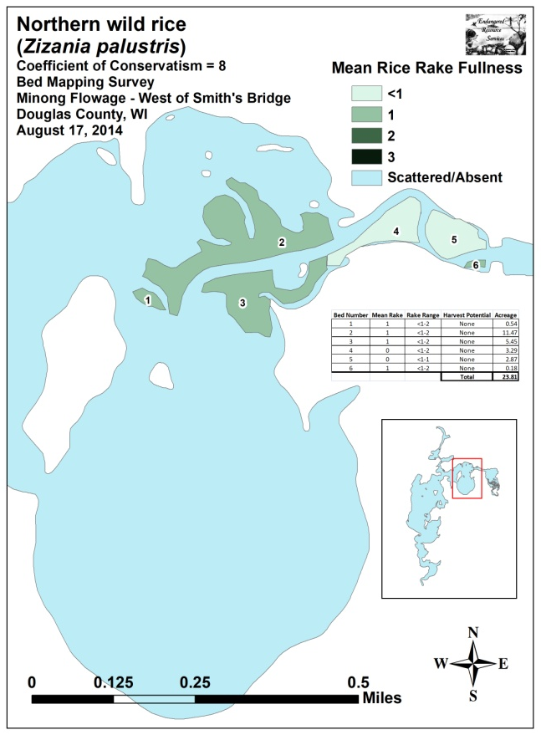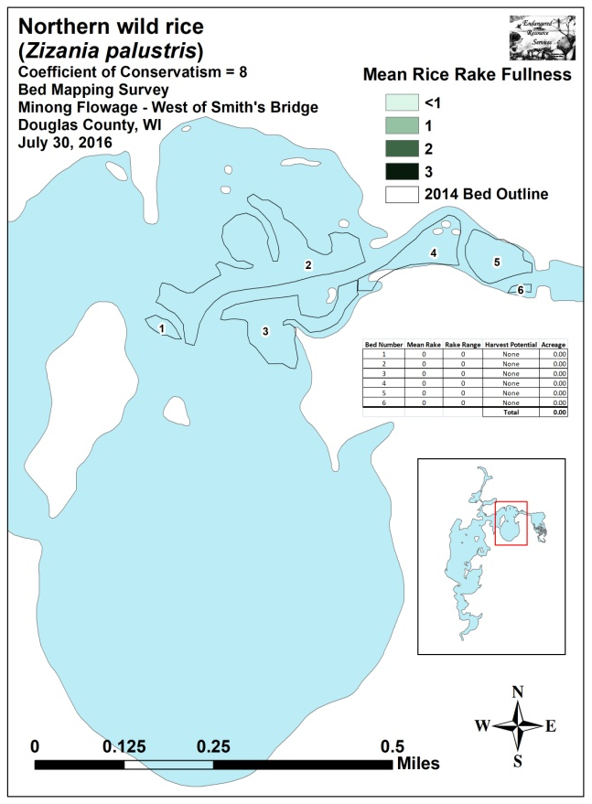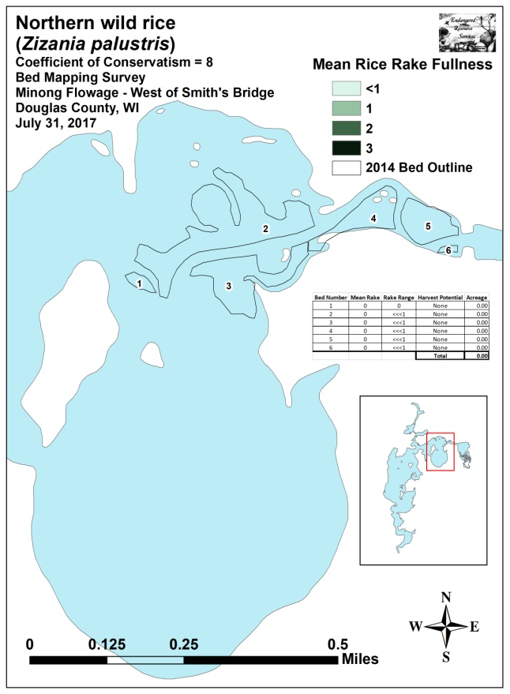
Figure 4: Rice Beds West of Smith’s Bridge
August 17, 2014, July 30, 2016, and July 31, 2017
Rice East of Smith’s Bridge:
In 2014, Beds 7-16 totaled 63.28 acres (Table 4). Covering much of the “delta” and extending up the Totagatic River, these areas have historically supported productive rice beds, but the densities we observed in 2014 were the greatest we had ever seen with the majority of the area having excellent potential for human harvest. When considering the entire area, only the beds nearest Smith’s Bridge had mean rake fullness densities of <2 (Figure 5). We also noted that areas in the northeast bay of Bed 12 that had historically been mixed with large amounts of Pickerelweed (Pontederia cordata) were almost pure rice as the drawdown seemed to have nearly eliminated this species (Appendix II).

After the 2016 flood waters cut new channels in the delta and swept away the majority of standing rice, we found only four surviving beds totaling 32.33 acres (Table 5) (Figure 5). Of these, only Bed 12 had any human harvest potential. In addition to the rice, the flooding eliminated many other emergents leaving broad areas with few to no plants. This ecological void seemed to be benefitting Eurasian water-milfoil as it was actively fragmenting and appeared to be rapidly expanding on the west side of the delta in the area formerly dominated by rice in Bed 11.

We were disappointed to see there was also little recovery in the rice beds east of the bridge during our 2017 survey. Areas where flood waters had swept the rice plants away in 2016 continued to have little or no rice in 2017 suggesting the bottom was scoured of latent grain as well as plants. Even rice in areas that avoided the worst of the flooding (Beds 12 and 16) appeared to be in poor health potentially meaning that 2017 growing conditions might have resulted in a down year for rice regardless of the number of individuals present (Table 6) (Figure 5).

Table 4: Wild Rice Bed Mapping Summary
East of Smith’s Bridge - Minong Flowage, Douglas County
August 17, 2014

Bed Number | Area in Acres | Rake Fullness Range | Mean Rake Fullness | Human Harvest Potential
7 | 1.01 | 1-2 | 1 | Low
8 | 2.00 | 1-3 | 1 | Low
9 | 1.09 | 2-3 | 2 | Moderate
10 | 0.63 | 1-3 | 2 | Moderate
11 | 14.00 | 2-3 | 3 | High
12 | 37.93 | 2-3 | 3 | High
13 | 0.39 | 1-3 | 2 | Low
14 | 1.26 | 1-3 | 2 | Moderate
15 | 2.51 | 2-3 | 3 | High
16 | 2.45 | 2-3 | 3 | High
Total Rice | 63.28

Table 5: Wild Rice Bed Mapping Summary
East of Smith’s Bridge - Minong Flowage, Douglas County
July 30, 2016

Bed Number | Area in Acres | Rake Fullness Range | Mean Rake Fullness | Human Harvest Potential
7 | 0.00 | 0 | 0 | None
8 | 0.00 | 0 | 0 | None
9 | 0.73 | <1-1 | 1 | None
10 | 0.00 | 0 | 0 | None
11 | 5.00 | <<1-2 | 1 | None
12 | 24.37 | <<1-2 | 1 | Low
13 | 0.00 | 0 | 0 | None
14 | 0.00 | 0 | 0 | None
15 | 0.00 | 0 | 0 | None
16 | 2.24 | <1-1 | 1 | None
Total Rice | 32.33

Table 6: Wild Rice Bed Mapping Summary
East of Smith’s Bridge - Minong Flowage, Douglas County
July 31, 2017

Bed Number | Area in Acres | Rake Fullness Range | Mean Rake Fullness | Human Harvest Potential
7 | 0.00 | <<<1-1 | 0 | None
8 | 0.13 | <<<1-1 | <1 | None
9 | 0.22 | <<<1-1 | <1 | None
10 | 0.00 | 0 | 0 | None
11 | 0.00 | <<<1-1 | 0 | None
12 | 20.31 | <<<1-2 | 1 | None
13 | 0.29 | <<1-2 | <1 | None
14 | 0.00 | 0 | 0 | None
15 | 0.09 | <<1-2 | 1 | None
16 | 1.48 | <<1-1 | <1 | None
Total Rice | 22.52

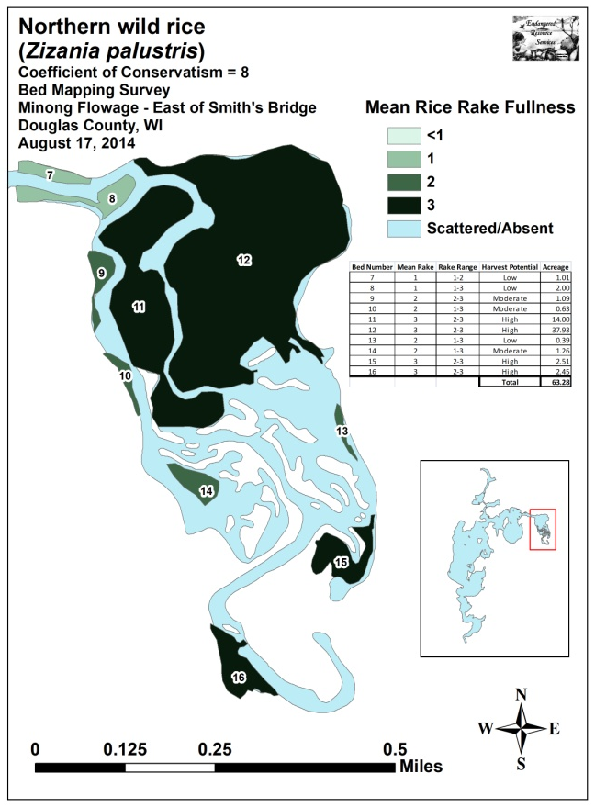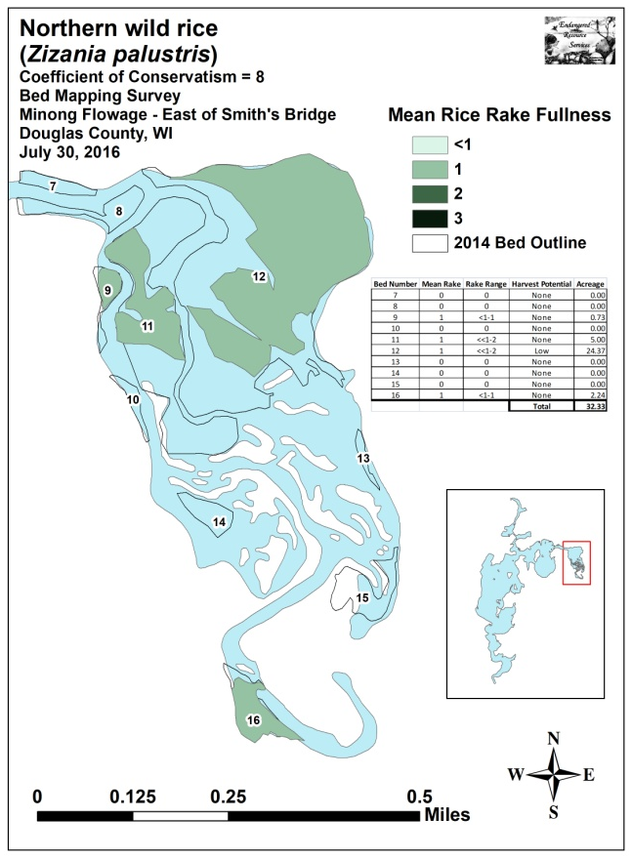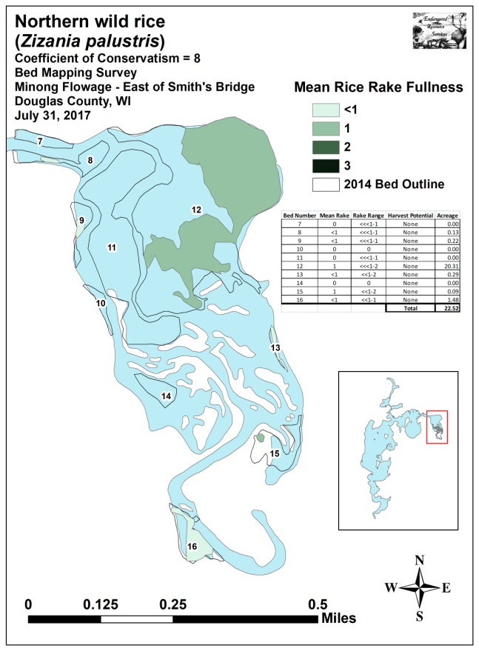
Figure 5: Rice Beds East of Smith’s Bridge
August 17, 2014, July 30, 2016, and July 31, 2017

PAST AND PRESENT INDIVIDUAL BED DISCRIPTIONS:
Minong Flowage West of Smith’s Bridge:
Beds 1, 2, and 3 – In 2014, wild rice was present along the majority of the river channel west of Smith’s Bridge prior to the channel splitting to the west and south near the islands. However, it occurred at low densities, and, technically, did not form true beds anywhere as Short-stemmed bur-reed (Sparganium emersum) and Northern manna grass (Glyceria borealis) tended to be the dominant plants in these areas (Figure 6). At that time, Eurasian water-milfoil was also relatively rare, and almost all EWM plants observed were located directly along the channel.

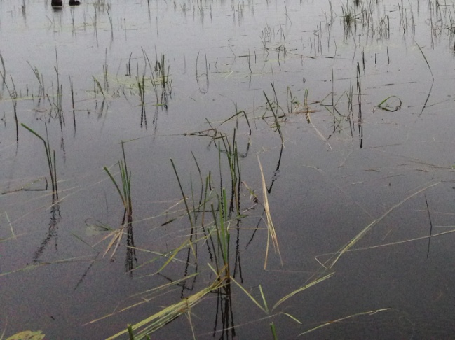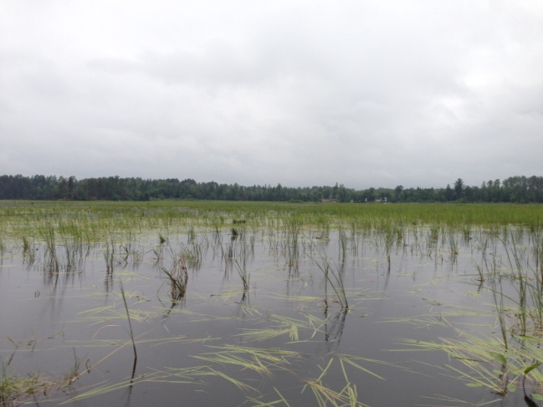
Figure 6: Low Density Rice in Beds 1 and 3 – 8/17/14

Following the flooding in 2016, we found Beds 1-3 had been completely taken over by EWM (Figure 7). The only emergents remaining were Common yellow lake sedge (Carex utriculata), Pickerelweed, Cattails, and some scattered Softstem bulrush (Schoenoplectus tabernaemontani) and Common bur-reed (Sparganium eurycarpum) along the sheltered edges of what had been Beds 2 and 3.

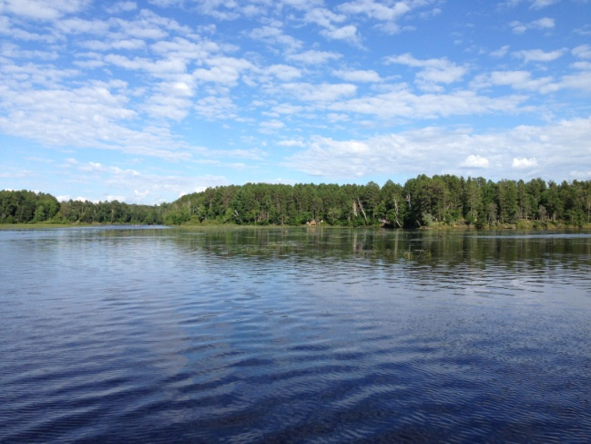
Figure 7: Canopied EWM in Former Rice Bed 3 Facing Southeast -7/30/16

During the 2017 survey, we didn’t see rice anywhere in the area that had been Bed 1 or in the western lobe of Bed 2 (Figure 8). South of the channel in what had been Bed 3, we estimated there were less than 100 rice plants scattered throughout the area that was now a nearly continuous canopied mat of EWM (Figure 9). In the eastern lobes of Bed 2, we saw perhaps 50 surviving rice plants in an area that was otherwise dominated by Pickerelweed (Figure 10).

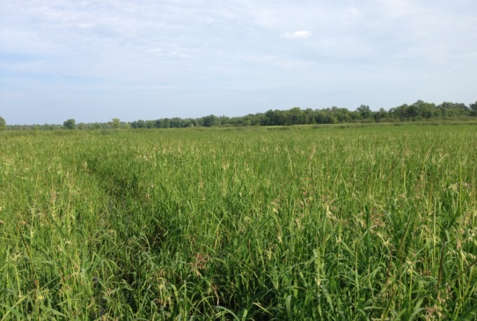
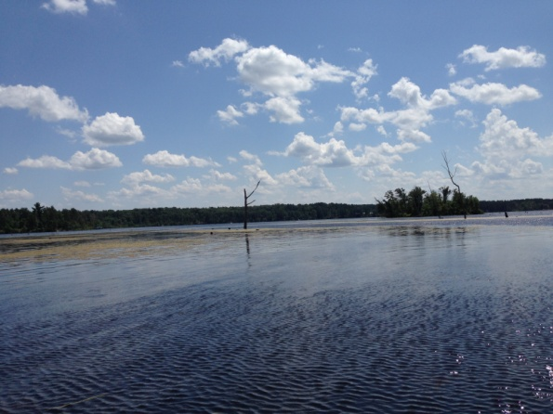
Figure 8: Canopied EWM in Former Rice Beds 1 and 2 Facing SE – 7/31/17

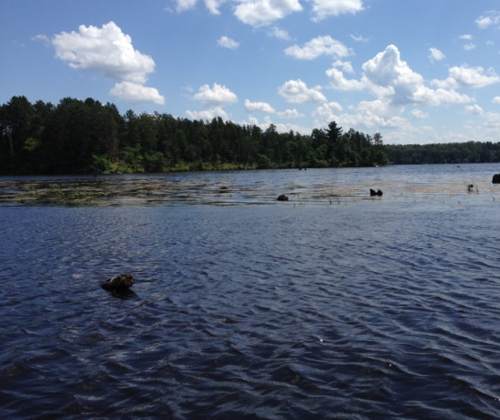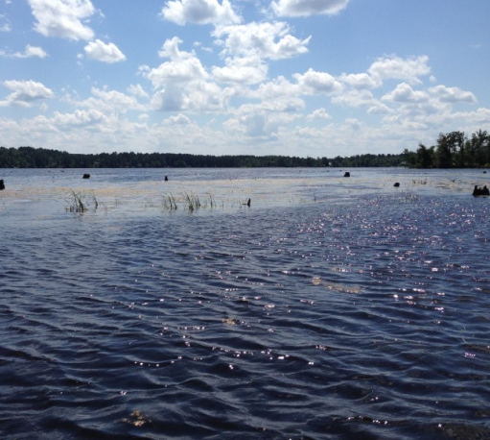
Figure 9: Canopied EWM in Former Rice Bed 3 Facing South – 7/31/17

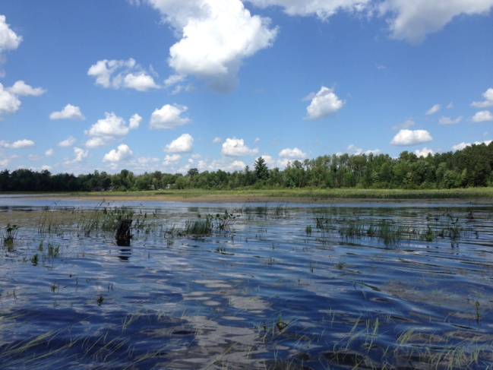
Figure 10: Short-stemmed Bur-reed and Pickerelweed -
North of Channel in Former Bed 2 Facing North – 7/31/17
Beds 4, 5, and 6 – These three shallow sand flats just west of the bridge were historically dominated by rice, albeit at low densities. Following the drawdown, we noted that, although rice plants were still scattered throughout, the area had largely been taken over by Northern manna grass. In 2016, the area was completely scoured, and we found no vegetation of any kind – emergent or submergent (Figure 11). By 2017, the area had recovered somewhat as we found beds of Short-stemmed bur-reed with scattered clusters of Northern manna-grass and Softstem bulrush (Figure 12). However, we counted no more than a few dozen wild rice plants, and all of them had been cropped by geese.

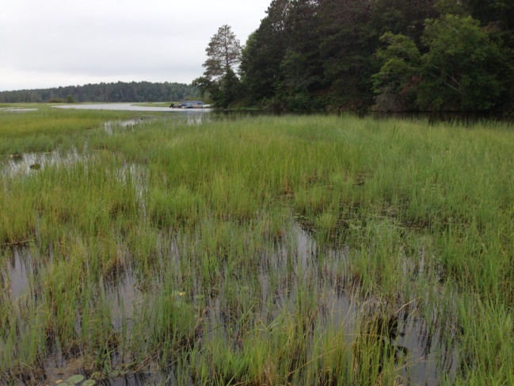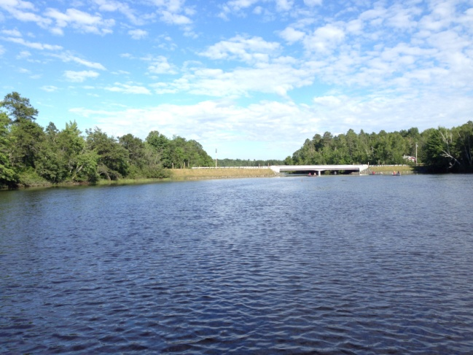
Figure 11: Bed 4 Facing NW – 8/17/14 and Bed 5 Facing East – 7/30/16

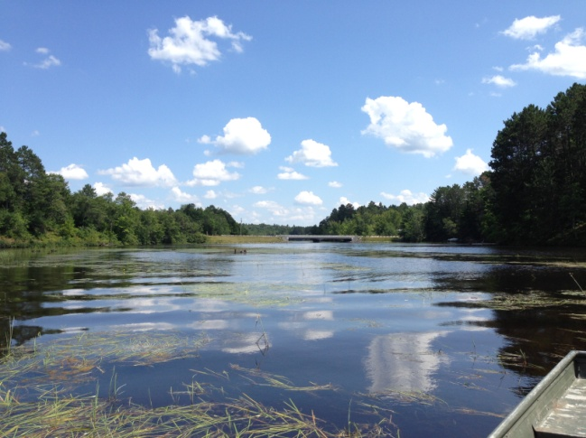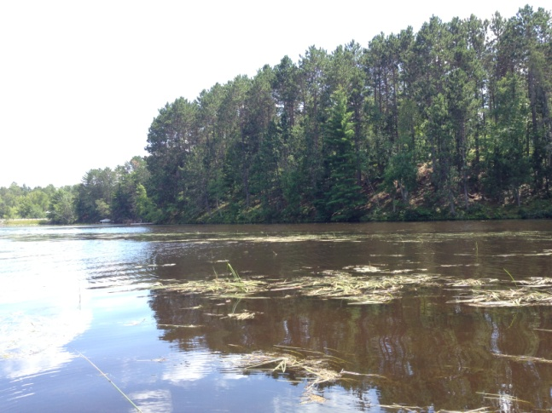
Figure 12: Scattered Rice Blades in Former Bed 4 Facing East –
Former Bed 5 Facing Southeast – 7/31/17

Minong Flowage East of Smith’s Bridge:
Beds 7 and 8 – In 2014, the two beds just east of the bridge on either side of the channel were the poorest in the area; however, there were still significant amounts of rice in these nearly pure stands. The 2016 survey found that, like Beds 1-5 west of the bridge, these areas were scoured clear of all emergent and submergent vegetation (Figure 13).

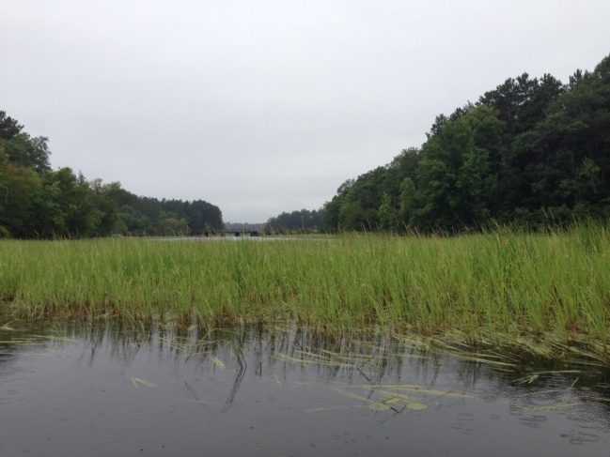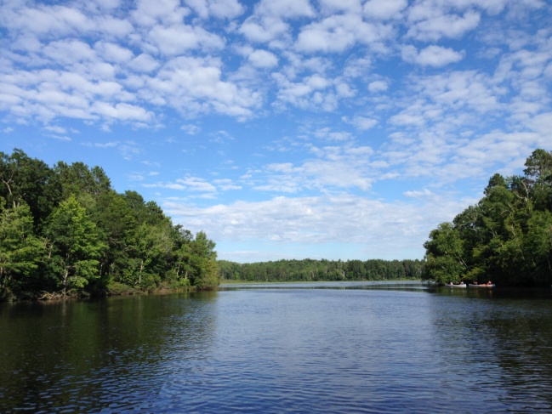
Figure 13: Bed 8 Facing Smith’s Bridge 8/17/14 -
From Smith’s Bridge Facing East 7/30/16

Recovery within these two beds in 2017 was minimal. We estimated there were a total of not more than 20-30 rice plants in all of the area formerly covered by Bed 7, and, because they were so scattered, it was impossible to map them. Although most of Bed 8 was similarly poor, a small area on the eastern side of the bed supported about 100 small goose-cropped plants within a more or less clearly defined border (Figure 14).

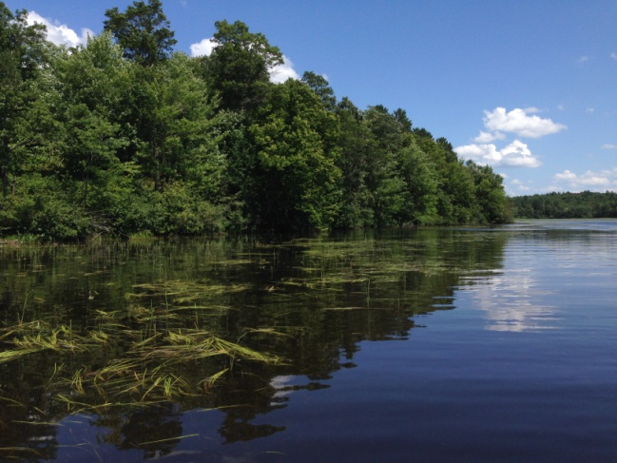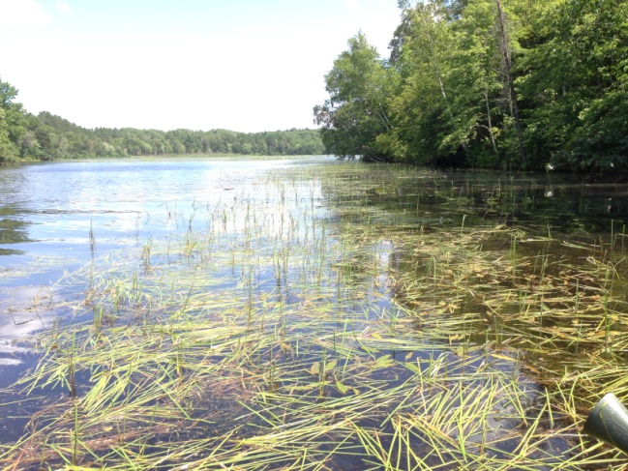
Figure 14: Scattered Rice in Beds 7 and 8 Growing among
Short-stemmed Bur-reed - 7/31/17
Beds 9 and 10 – These two small beds lined the western shoreline of the western channel and were reasonably dense in 2014. Despite their size, they offered at least some human harvest potential. This was not the case in 2016 when we found Bed 10 had been completely scoured away and Bed 9 had only scattered surviving rice plants. We also noted that EWM was now established throughout much of the bed (Figure 15).

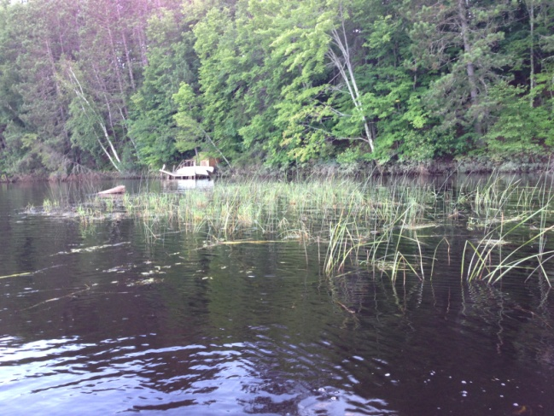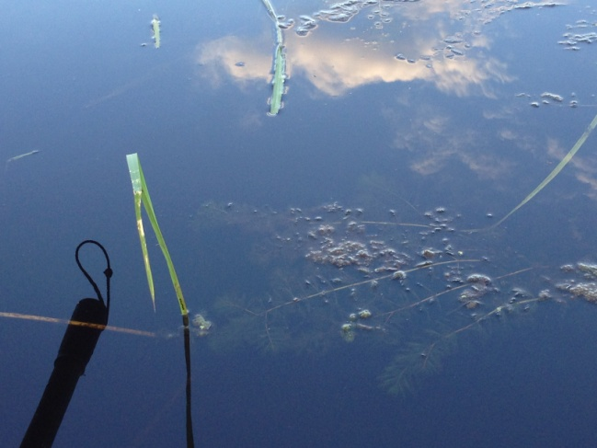
Figure 15: Bed 9 – Scattered Rice with Interspersed EWM Plants - 7/30/16

Bed 9 shrunk further in 2017, and the density also declined. At its former core, there were at most a few 100 goose-cropped rice plants interspersed with low density Eurasian water-milfoil. Likewise, Bed 10 showed no signs of recovery. Although the area now supported dense emergent vegetation, it was dominated by Northern manna-grass, Reed canary grass, and Softstem bulrush with lesser amounts of Pickerelweed and Common bur-reed mixed in (Figure 16). We noted that at most there was a 100 rice plants in the entire former bed, and they were also all goose-cropped.

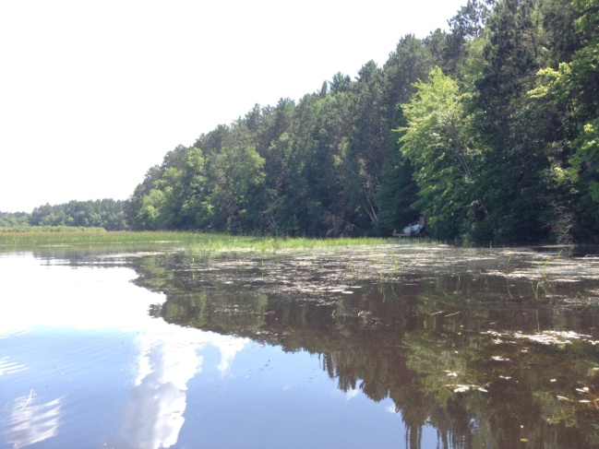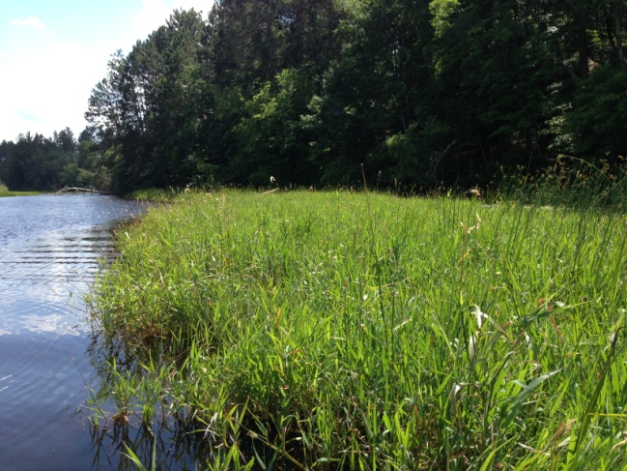
Figure 16: Bed 9 – Scattered Rice with Interspersed EWM Plants – Former Bed 10 Overrun with Other Emergents - 7/31/17
Bed 11 – This area was the second biggest rice bed on the flowage in 2014, and the majority was a solid rake fullness of 3 making it ideal for human harvest (Figure 17). The bed still retained some rice in 2016, but it was low density and of generally poor quality (Figure 18). We also noted that EWM was present throughout with the western edge of the rice being bordered by a solid canopied mat of EWM.

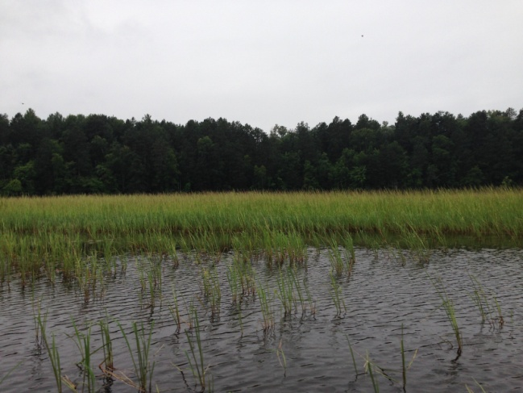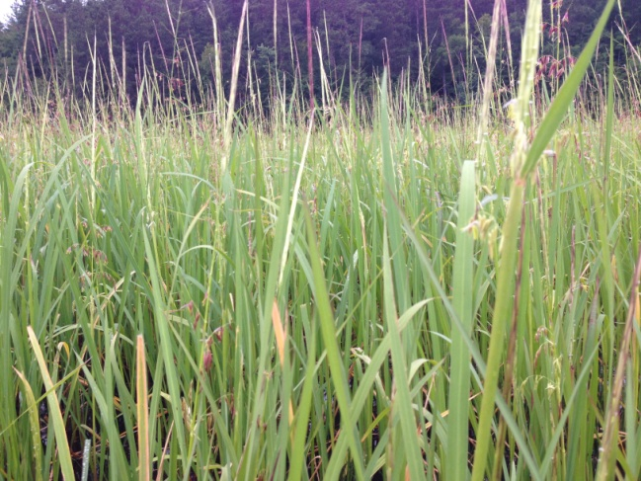
Figure 17: Dense Rice in the Center of Bed 11 – 8/17/14

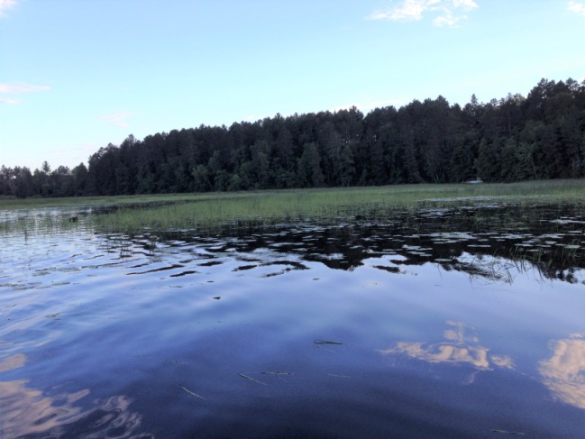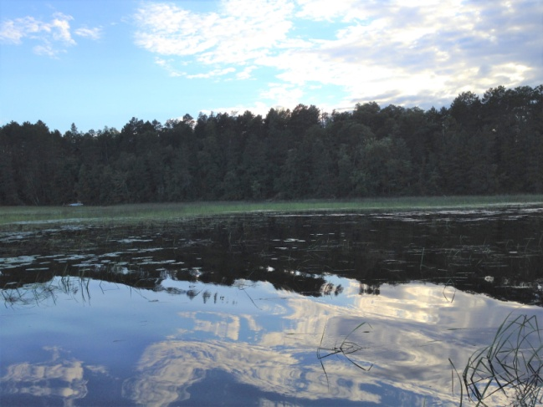
Figure 18: Low Density Rice with EWM in Bed 11 - 7/30/16

Our 2017 survey found that the rice in Bed 11 had suffered a complete failure as we estimated the northern lobe of this area supported between 50 and 100 plants; the central area <200 plants; and we couldn’t find rice anywhere in the southern lobe with the exception of a few scattered plants in the channel itself. Most of the northern half of this area had been largely taken over by EWM. Gaps in the milfoil supported Short-stem bur-reed in its floating leaf form, and, in scattered shallow areas <2ft deep or growing out of stumps, thick blades of Common bur-reed appeared as a scattered emergents (Figure 19). In the central area, Short-stem bur-reed was the dominant plant as EWM was much less common although scattered individuals were still present throughout much of this area (Figure 20). In the southern lobe, shallower areas along the western river channel that had supported impenetrable rice in 2014 had no rice at all. The entire area was now a patchwork of Reed canary grass, Pickerelweed, Softstem bulrush, Short-stem and Common bur-reed, and sedges (Carex spp.) with pools of open water (Figure 21).
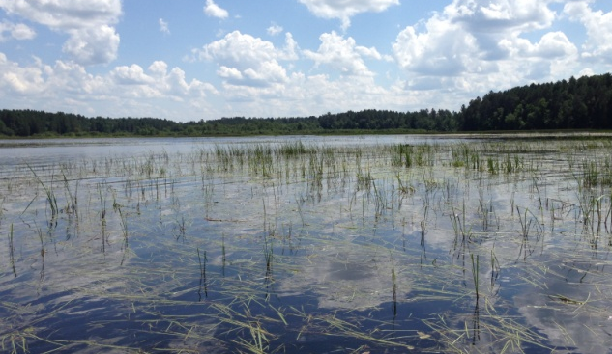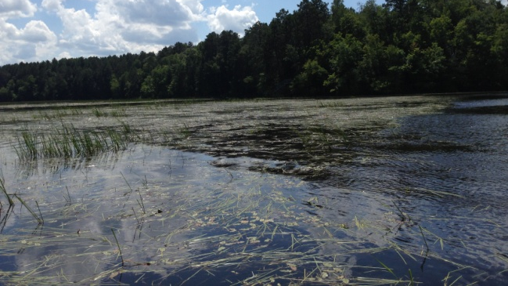
Figure 19: Northwest End of Former Bed 11 Facing South - 7/31/17

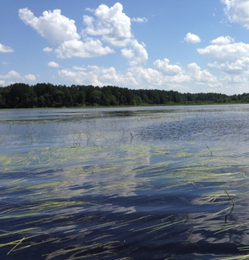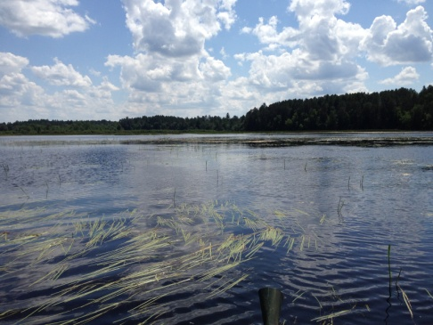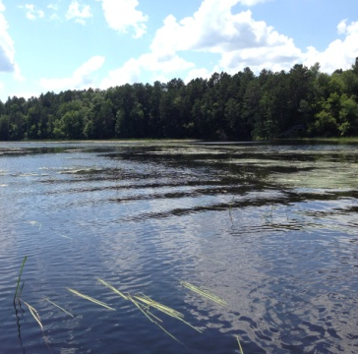
Figure 20: Central Lobe of Former Bed 11 Facing South - 7/31/17

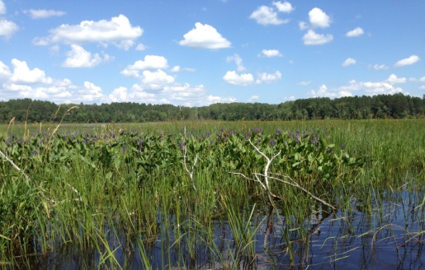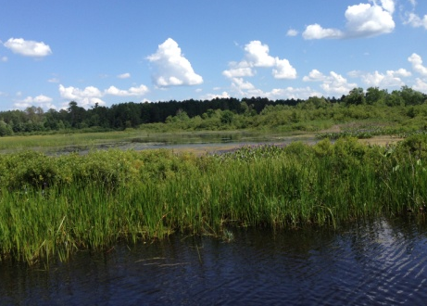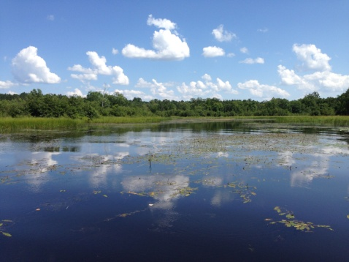
Figure 21: Southern Lobe of Former Bed 11 Facing East - 7/31/17

Bed 12 – Bed 12 dominated the area east of the main river channel in 2014. Following the drawdown, all the secondary channels had silted in making the entire area a continuous rice bed of varying density. On the northwest and north ends of the bed, we found the rice to be especially patchy in 2014 (Figure 22).

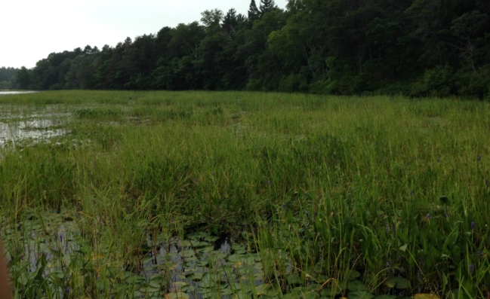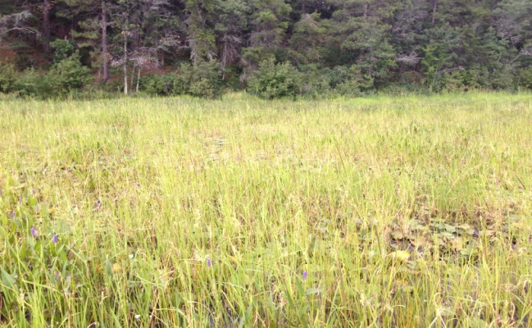
Figure 22: Northwest and Northern Shorelines of Bed 12 – 8/17/14

In 2016, these low density areas were mostly swept away by the floods with only a few scattered plants left along the northern border. An apparent outwash area during the flooding, we also found large numbers of uprooted and rotting rice plants in this area. Although there were a few scattered late-germinating individuals that were just reaching the floating-leaf stage, it seemed unlikely they would survive to set grain (Figure 23). Unfortunately, this area showed no recovery in 2017 as we didn’t see any rice at all, and few plants in general other than Short-stemmed bur-reed (Figure 24).

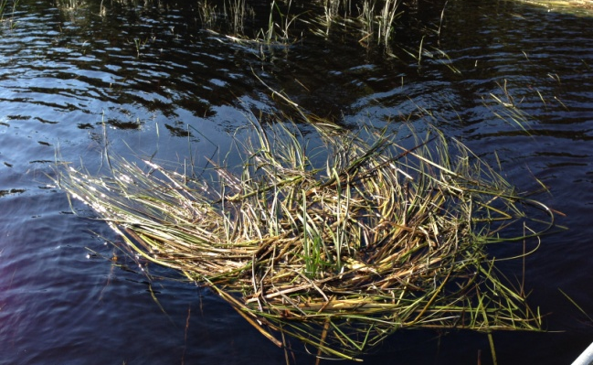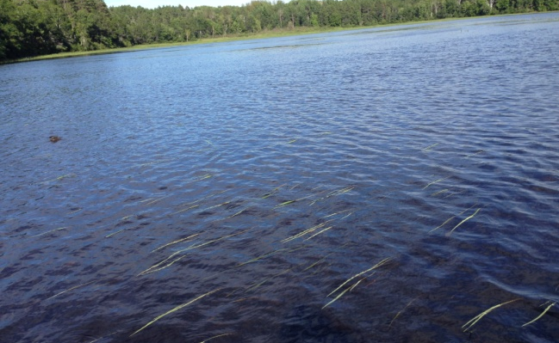
Figure 23: Uprooted Clumps and Scattered Floating-leaf Stage Rice Northwest and Northern Shorelines of Bed 12 – 7/30/16

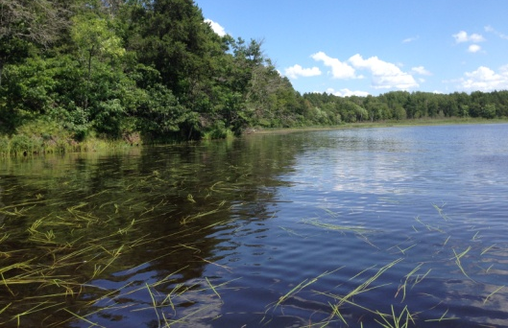
Figure 24: Northern Shoreline of Former Bed 12 Facing East – 7/31/17
Further to the east, the sheltered northeast bay seemed to have weathered the 2016 flood better than any other area as there were still some patches of moderately dense rice (Figure 25). In 2017, it was the only area that had >1.5acres of more or less continuous rice although even here the geese had kept it completely cropped (Figure 26).

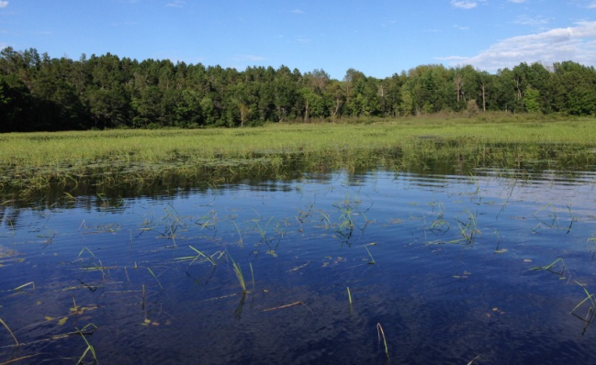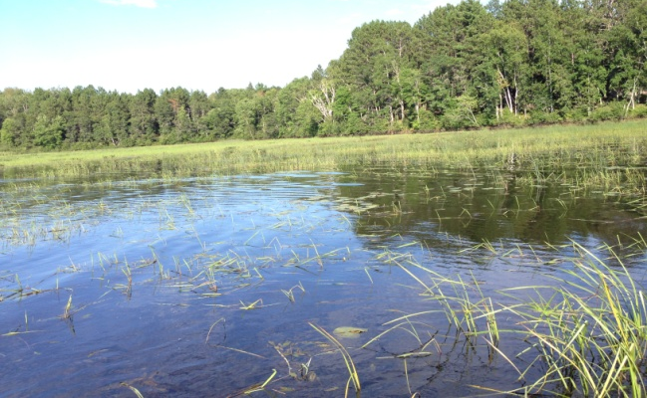
Figure 25: North End of Bed 12 Facing Northeast and Southeast – 7/30/16

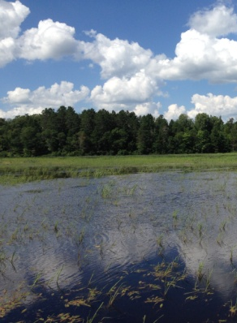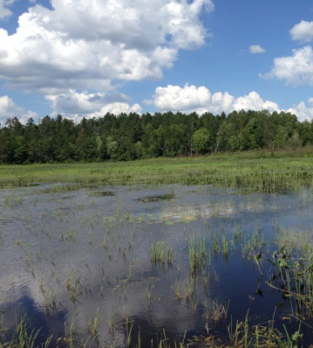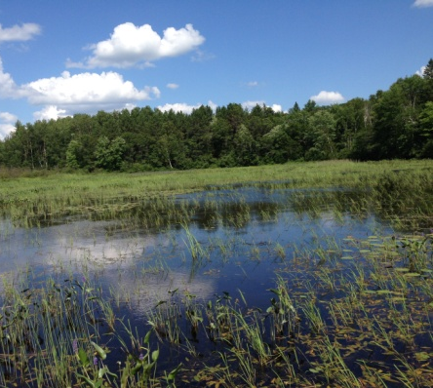
Figure 26: Northeast Bay of Bed 12 Facing East – 7/31/17

In 2014, Bed 12 became increasingly dense to the south (Figure 27) with the majority of the central and southern thirds of the bed being so monotypic and dense that poling through with a canoe at harvest time would have been difficult, but extremely productive. On the southern boundary of the bed, rice plants rapidly declined in density before being replaced entirely by other emergents (primarily horsetail, bulrushes, and bur-reeds). Just north of this southern boundary, and extending all the way to the east, rice continued to be dense and nearly monotypic before abruptly becoming more fragmented at the eastern river channel entrance.

In 2016, the southern boundary of the bed was full of uprooted dead rice, and the majority of what remained had been heavily cropped by geese (Figure 28). This area still contained rice in 2017, and, in some cases it had recolonized areas near the channel that had lost rice in the flood; however, its overall average density was even less than in 2016 (Figure 29). We also documented the continued expansion of other emergents as Softstem bulrush and Reed canary grass now dominated the southern boundary of what had been rice in 2014 (Figure 30). On the western border, the rice was so fragmented near the central channel that it was almost impossible to map (Figure 31).

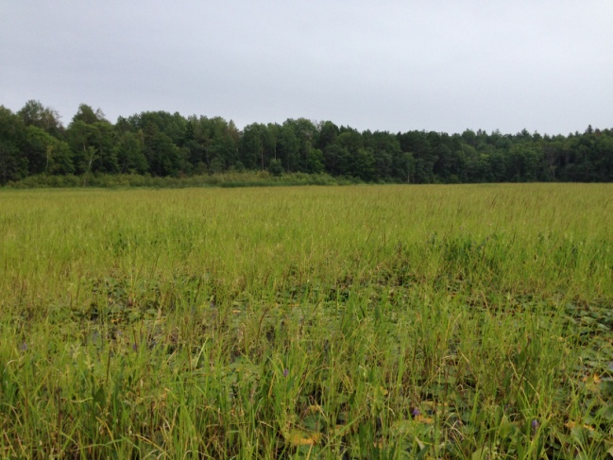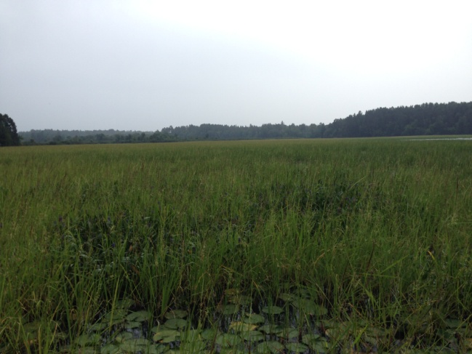
Figure 27: Bed 12 Facing Southeast and South - 8/17/14

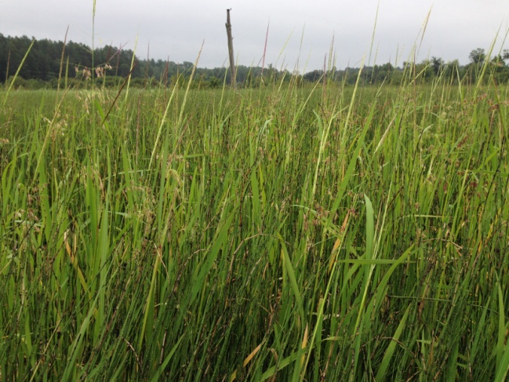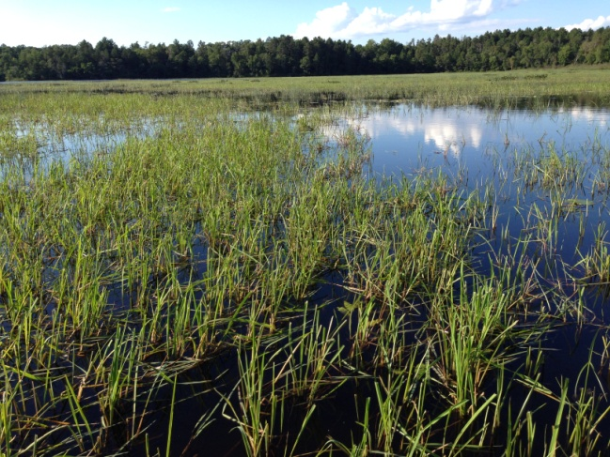
Figure 28: Southern Edge of Bed 12 in 2014 (left) and 2016 (right)

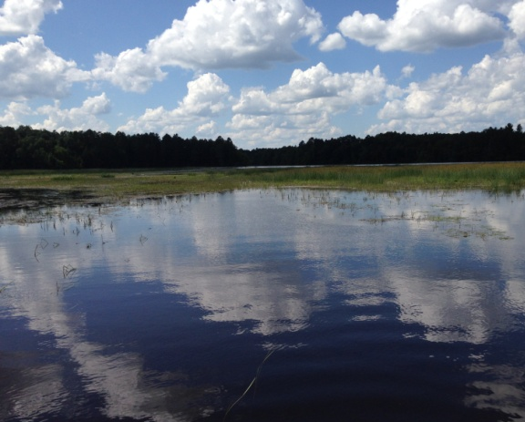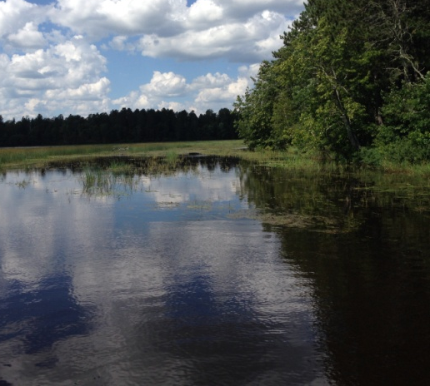
Figure 29: Southeast Corner of Bed 12 Facing Northwest – 7/31/17

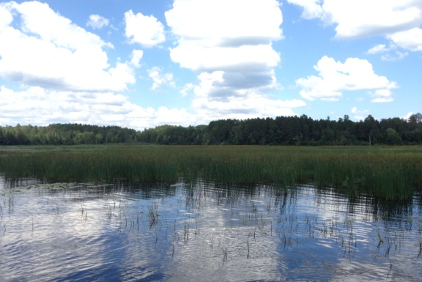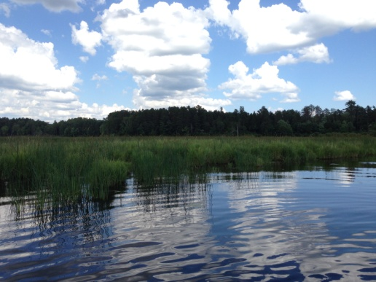
Figure 30: Former South/SW Border of Bed 12 Facing NE – 7/31/17

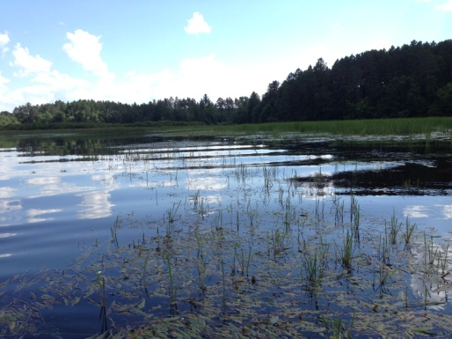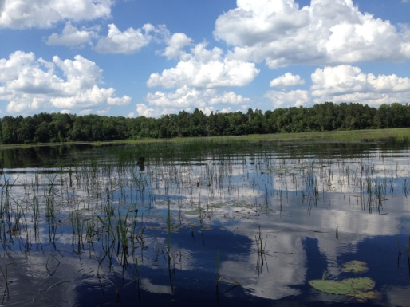
Figure 31: Western Border of Bed 12 Facing Southwest/North – 7/31/17

Bed 13 – In 2014, we found scattered clusters of rice throughout the braided channels entering the Minong Flowage’s east side. However, Bed 13 was the only location where plants were continuous and dense enough to be considered a bed. Like the rest of the channels entering the flowage, these areas were all scoured clear by the flood in 2016. Because of this, we were somewhat surprised to find this area again supported a very low density ribbon of rice along the shoreline in 2017 (Figure 32).

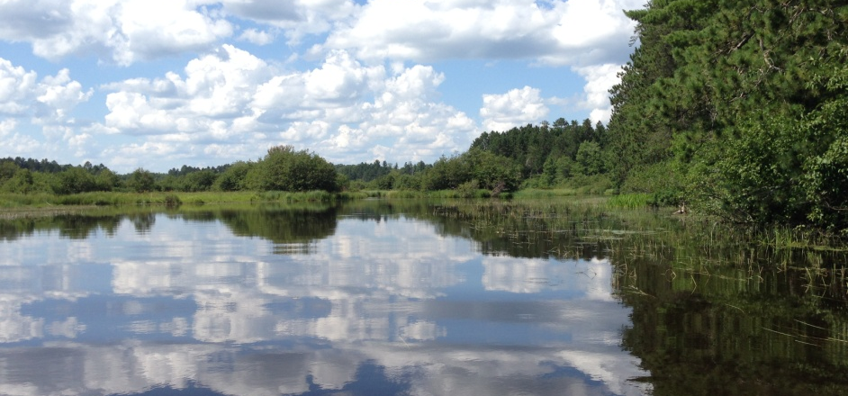
Figure 32: Shoreline Ribbon of Rice in Bed 13 Facing North – 7/31/17

Bed 14 – In 2014, most of the rice in this area was growing over soft sandy muck in water <1ft deep making it essentially impossible to pole or wade along the north border. Following the 2016 flood, the entire channel was blocked by trees making the whole area inaccessible. Scanning the channel with binoculars showed no surviving rice anywhere.

Although we found the channel was again accessible in 2017, the only rice left was a few blades growing within the channel west and south of the former bed (Figure 33). The area that had supported rice in 2014 was now a solid bed of almost monotypic Reed canary grass.

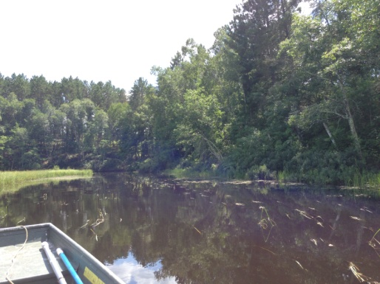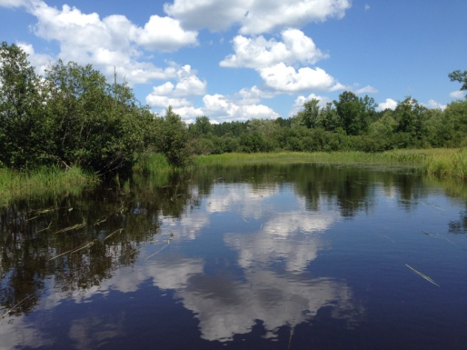
Figure 33: Western/Southern Border of Former Bed 14 – 7/31/17

Beds 15 and 16 – The sloughs with scattered spring-fed pools found just south of the braided channels that enter the Minong Flowage had dense rice in 2014 that was nearly inaccessible; at least at its core. The 2016 survey found a new channel had scoured through Bed 15, and it removed essentially all rice in the area (Figures 34 and 36). By 2017, there was still no rice in the eastern channel entrance and the area had largely been taken over by Pickerelweed (Figure 35). On the western side, a small patch of rice was trying to regrow, but, even in this tucked away area, the geese were finding the plants and continually cropping any new growth (Figure 37).

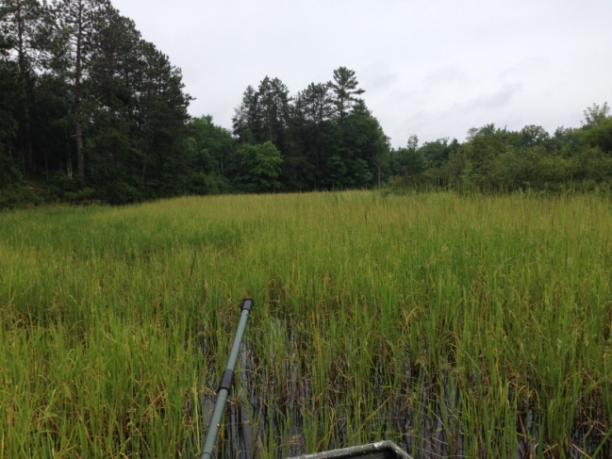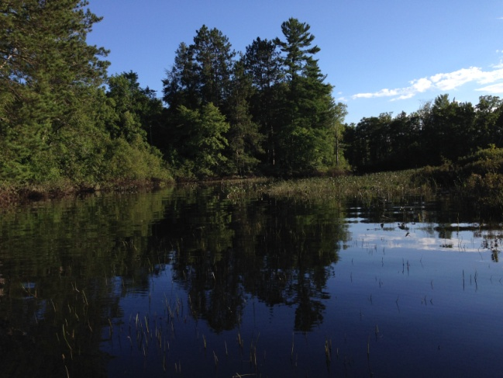
Figure 34: Eastern Edge of Bed 15 Facing South - 8/17/14 and 7/30/16

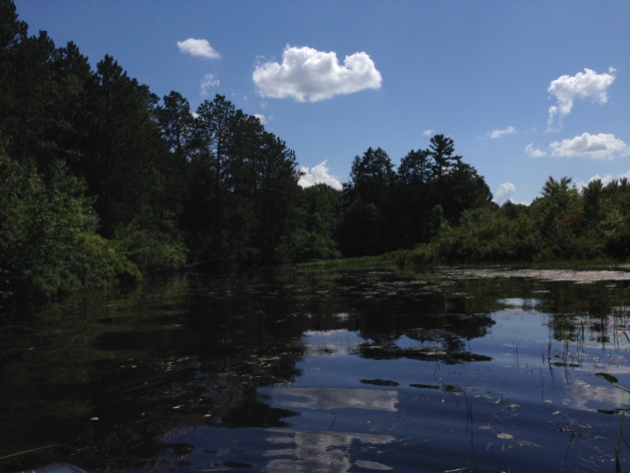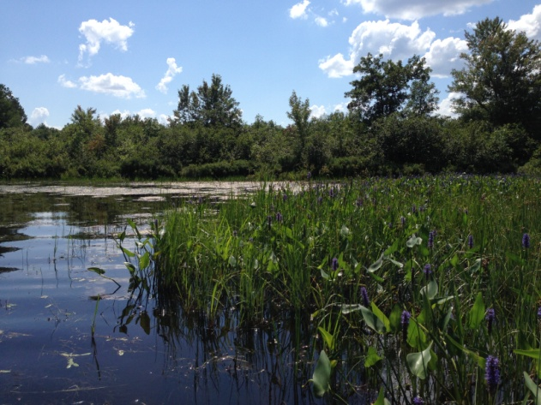
Figure 35: Eastern Edge of Bed 15 Facing South/West – 7/31/17

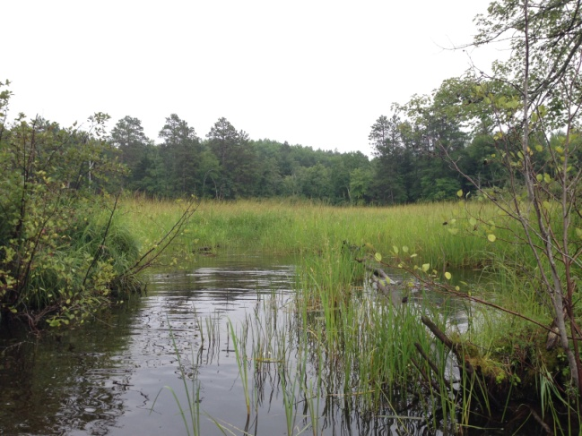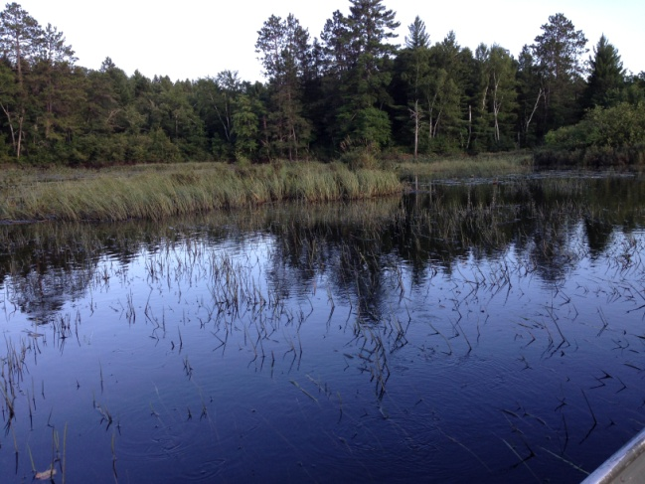
Figure 36: Northwest Corner of Bed 15 – 8/17/14 and 7/30/16

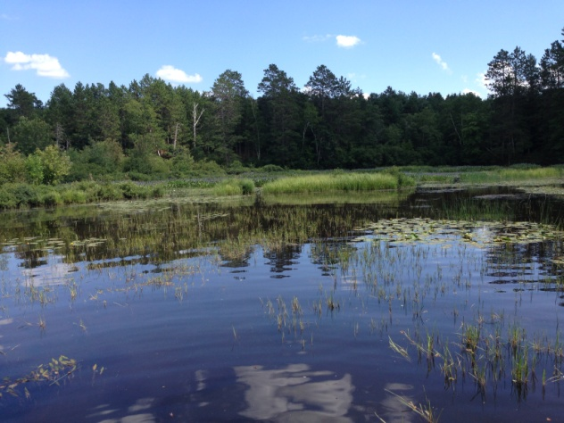
Figure 37: Northwest Corner of Bed 15 – 7/31/17

Bed 16 was at least partially sheltered from the flood waters in 2016 and did have some surviving rice albeit at much lower levels than in 2014 (Figure 38). It contracted further in 2017 with most rice along the western shoreline being replaced by thick mats of Common waterweed (Elodea canadensis) and filamentous algae (Figure 39).

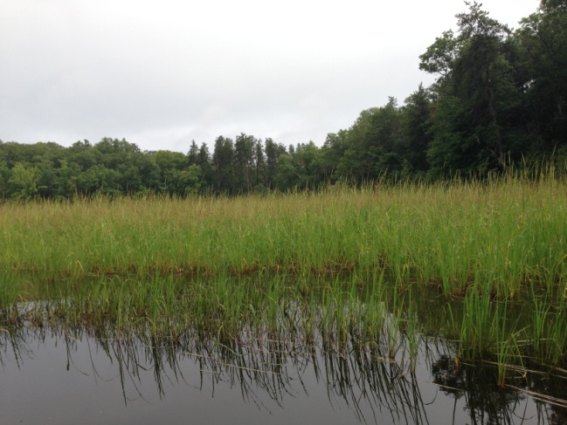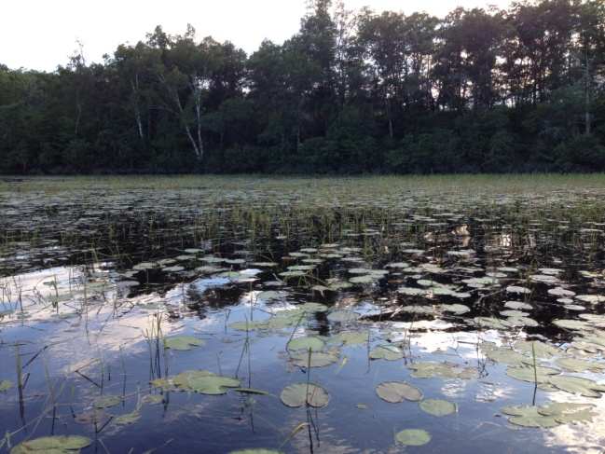
Figure 38: Bed 16 Facing South – 8/17/14 and 7/30/16

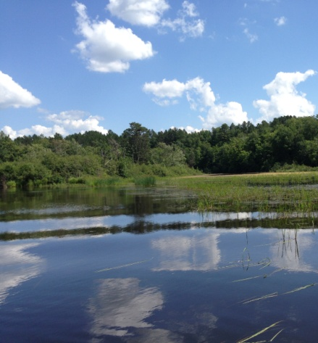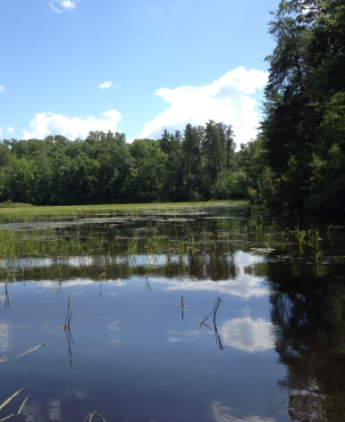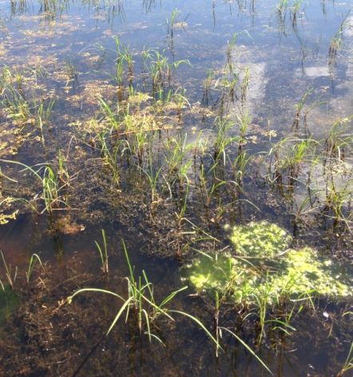
Figure 39: Bed 16 Facing South – 7/31/17

LITERATURE CITED

UWEX Lakes Program. [online]. 2017. Aquatic Plant Management in Wisconsin. Available from http://www.uwsp.edu/cnr-ap/UWEXLakes/Pages/ecology/aquaticplants/default.aspx (2017, November).

WDNR. [online]. 2017. Citizen Monitoring Lake Water Quality Database. Available from http://dnr.wi.gov/lakes/CLMN/Station.aspx?id=663099 (2017, November).

Appendix I: 2014, 2016, and 2017 Wild Rice Beds West of Smith’s Bridge

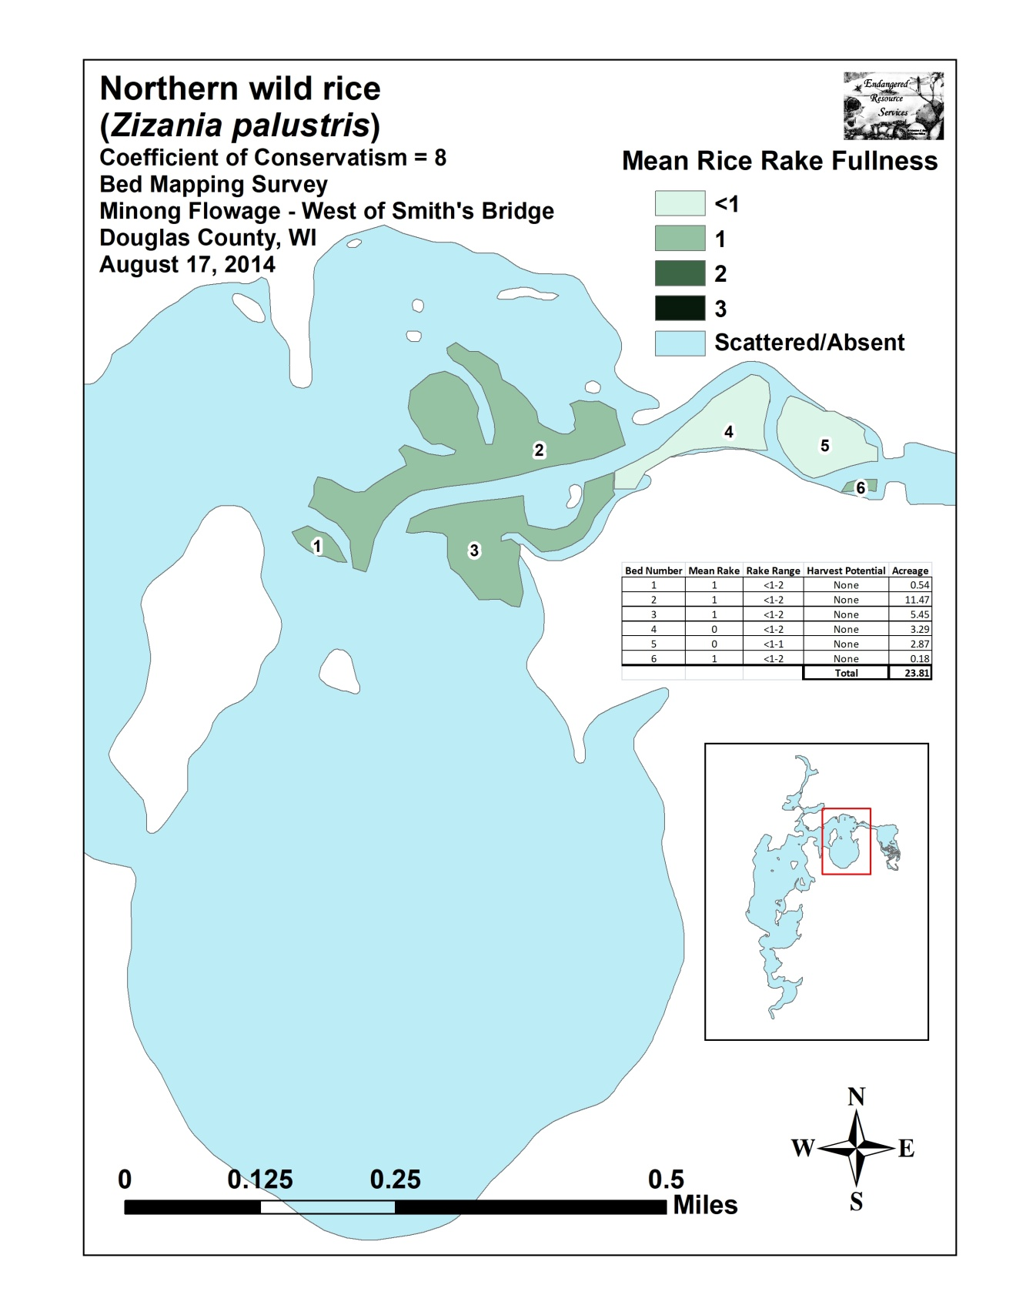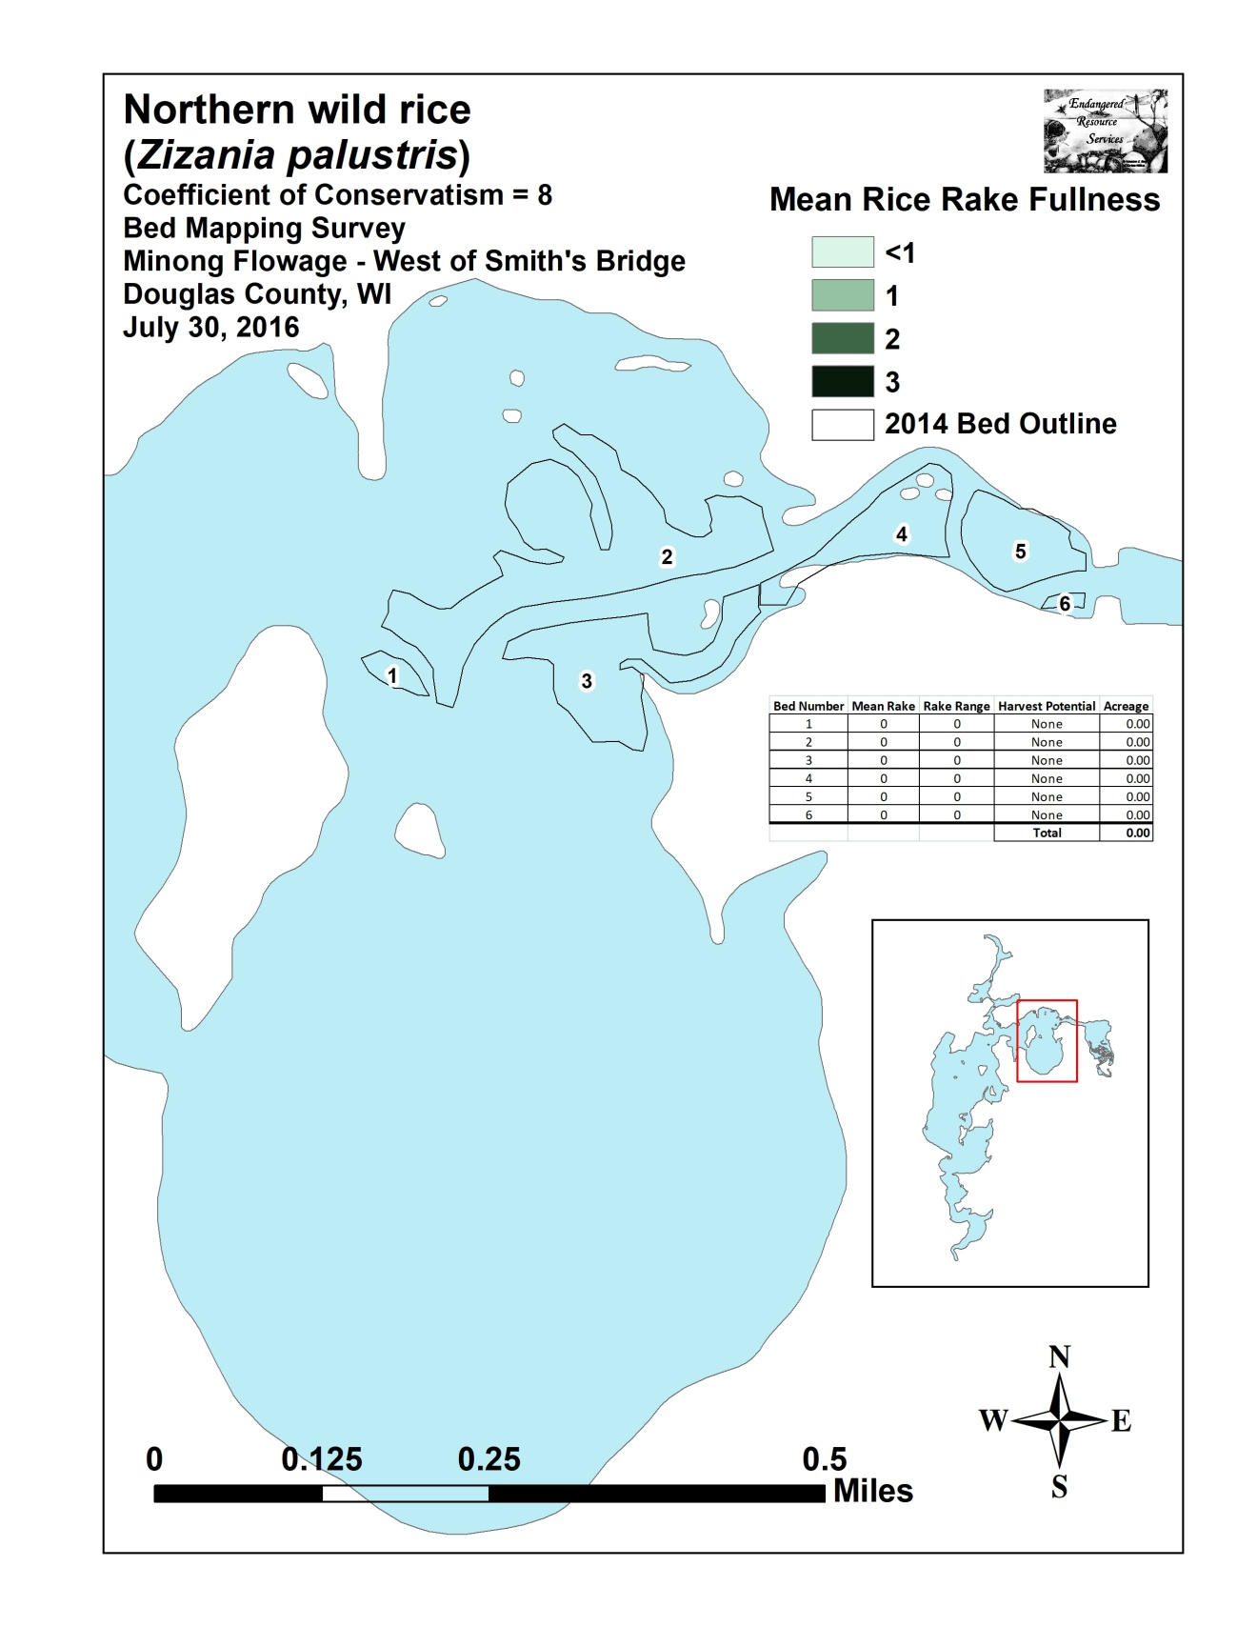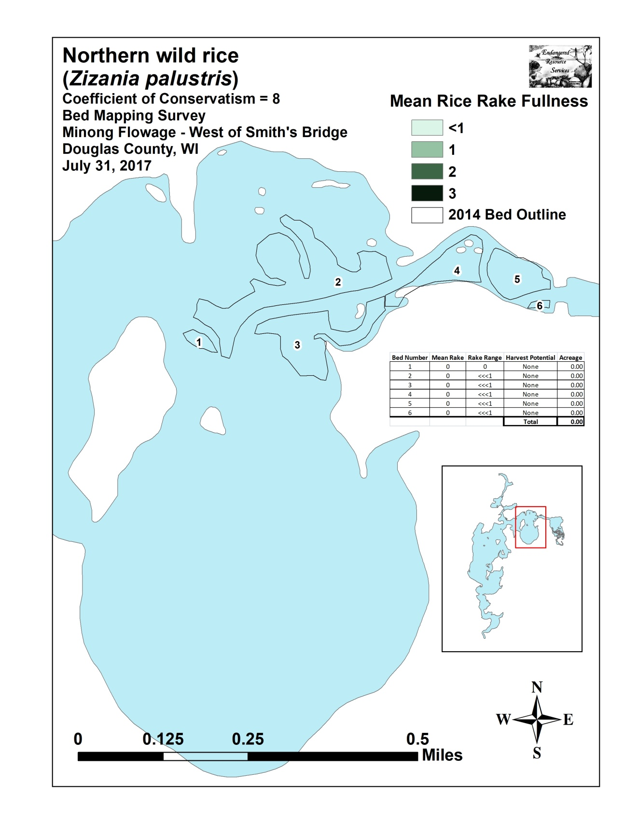

Appendix II: 2014, 2016, and 2017 Wild Rice Beds East of Smith’s Bridge

