UPPER EAU CLAIRE LAKE AQUATIC PLANT MANAGEMENT (APM) SUMMARY

Goals and Objectives
  - Goal: reduce the Curlyleaf pondweed population and prevent the spread within and beyond the lake.
  - Objective: Curlyleaf pondweed will not exceed 1% FOO or 1 acre total area.

Waterbody Description
Upper Eau Claire Lake is a 1024 acre oligotrophic lake located in Bayfield County. It has a maximum depth of 92 feet with a mean depth of 29 feet, with a total shoreline of 9.93 miles miles. Visitors have access to the lake from a public boat landing. Fish include Musky, Panfish, Largemouth Bass, Smallmouth Bass, Northern Pike and Walleye. The Lakes water clarity is clear and has a total alkalinity of 78PPM. The bottom is 50% sand, 30% gravel, 0% rock, and 20% muck.

Water Use Intensity
Recreational use is moderate to high for a northern Wisconsin lake, especially on weekends, although intensity is limited because of its distance from urban areas. The nearest urban areas are Hayward, 20 miles south, and Duluth/Superior 45 miles northwest. There are no public drinking water systems or discharges to the lake.

Management Locations
Curly-leaf pondweed is found in numerous shallow patches in Pease Bay and deep water patch in Pease Bay, as well as numerous patches on the east shore between the island and the main land.

Evaluation of Alternative Methods
Since the locations are small beds nested within a thriving native plant community, manual/mechanical removal is the best management strategy. Chemical control is unlikely to be effective because spot treatments tend to have minimal concentration exposure times resulting in limited control; plus native pondweeds could be harmed. There is no biological control option for curlyleaf pondweed, and physical control is not feasible or likely to be permitted.

Integrated APM Strategy
Continuous volunteer monitoring and annual professional monitoring will measure the success of the BAISS strategy. Manual removal will be encouraged. If monitoring indicates our objectives are not being met, alternative methods, including chemical control will be revisited.
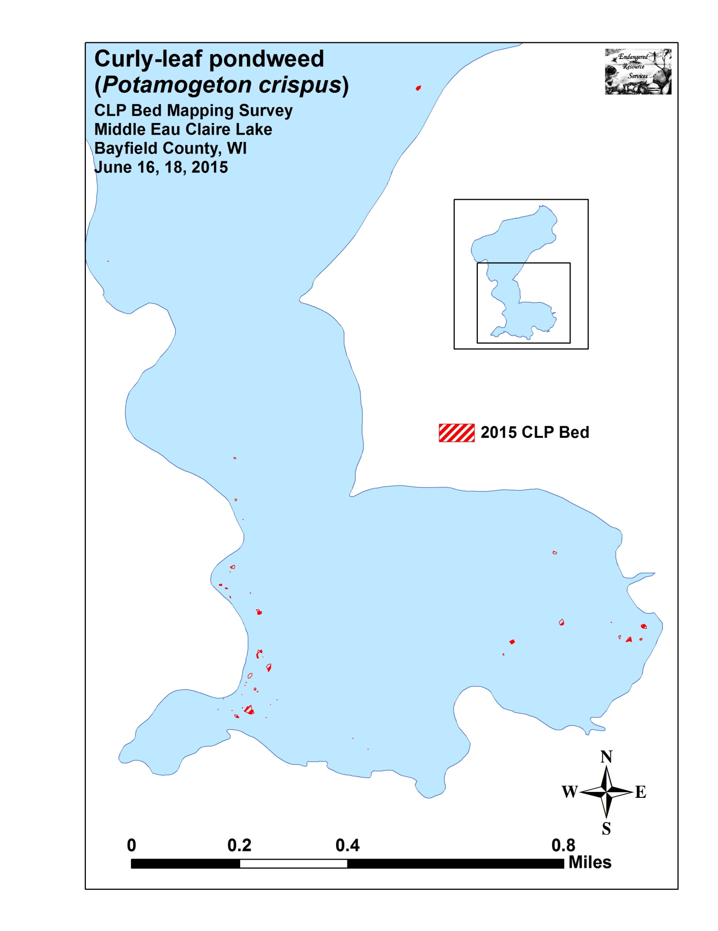Figure 1: 2015 Curly-leaf pondweed locations in Middle Eau Claire Lake, Bayfield County.

