Curly-leaf pondweed (Potamogeton crispus) and
Eurasian water-milfoil (Myriophyllum spicatum)
Pre/Post Herbicide and Fall EWM Bed Mapping Surveys
Little Trade Lake – WBIC: 2639300
Burnett County, Wisconsin

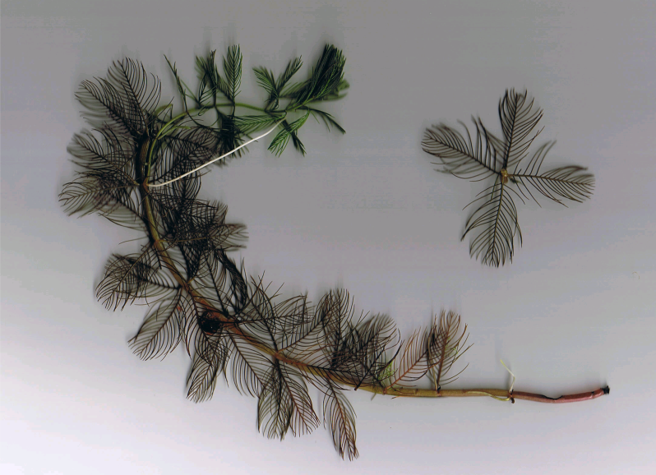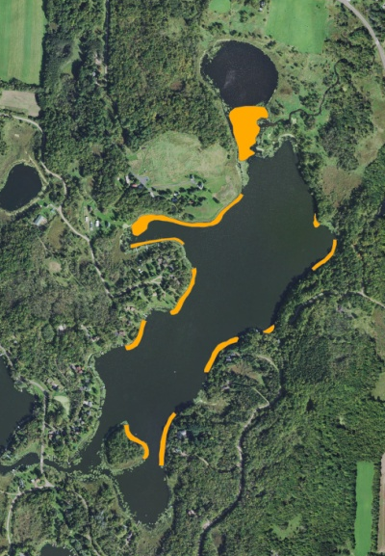
EWM Scan (Berg 2007) 2016 Treatment Areas

Project Initiated by:
Round-Trade Lake Improvement Association, Lake Education and Planning Services, LLC., and the Wisconsin Department of Natural Resources
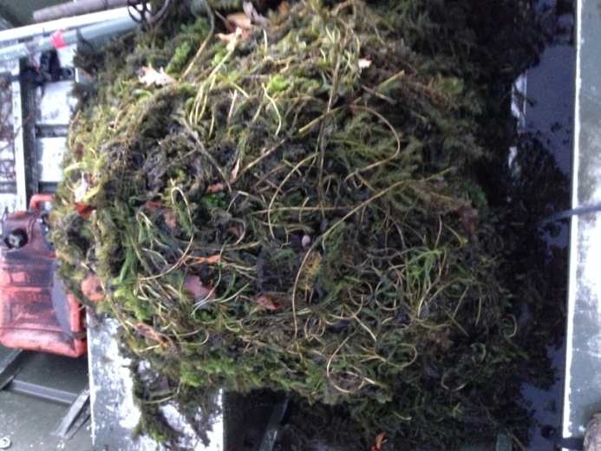
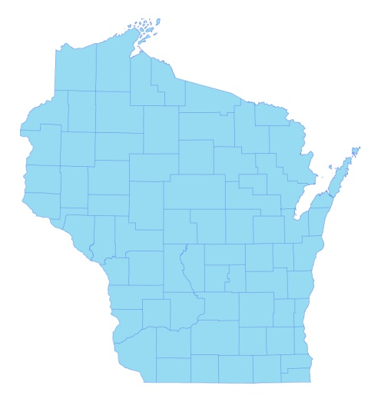

* Little Trade Lake

EWM Raked Out of Little Trade Lake 9/30/16

Surveys Conducted by and Report Prepared by:
Endangered Resource Services, LLC
Matthew S. Berg, Research Biologist
St. Croix Falls, Wisconsin
April 28, June 12, and September 30, 2016
TABLE OF CONTENTS

Page
LIST OF FIGURES ………………..……..………………………………………………... ii

LIST OF TABLES…………………..……..……………………………………………….. iii

INTRODUCTION……….…..……..………………………………………………………. 1

METHODS……………………………………………………………….………………… 2

RESULTS AND DISCUSSION……………………………………………………………. 3

Finalization of Treatment Areas……………………………………………………. 3

CLP/EWM Pre/Post Herbicide Surveys…..………………………………………... 5

Fall EWM Bed Mapping Survey…………………………………………………… 12

Descriptions of Current and Former EWM Beds…....……………………………... 14

LITERATURE CITED……….……………………….……………………………………. 15

APPENDIXES……….…….………………………………………………….……………. 16

I: Survey Sample Points and CLP/EWM Treatment Areas……..……………………… 16

II: Vegetative Survey Data Sheet.………………………………………………………. 19

III: Pre/Post Habitat Variable Maps.………………….……………………………...…... 21

IV: Pre/Post Native Species Richness and Total Rake Fullness.………..……………...... 24

V: CLP and EWM Pre/Post Density and Distribution…………………..……………..... 29

VI: Pretreatment Native Species Density and Distribution…...………………………...... 34

VII: Posttreatment Native Species Density and Distribution…...……………………….... 40

VIII: Fall 2015 and 2016 EWM Bed Maps.……………………………………….………. 51

LIST OF FIGURES

Page
Figure 1: 2016 Spring CLP/EWM Proposed Treatment Areas.……….……………….….. 1
Figure 2: Rake Fullness Ratings……………………………….…….…………………….. 2
Figure 3: Survey Sample Points and Final Treatment Areas……….……………………… 3
Figure 4: Treatment Area Depths and Bottom Substrate….………..……………………… 5
Figure 5: Pre/Post Native Species Richness…………………………..……………….…... 6
Figure 6: Pre/Post Total Rake Fullness………………………………..…………………… 6
Figure 7: Pre/Post CLP Density and Distribution………….…………………………….… 7
Figure 8: Pre/Post Changes in CLP Rake Fullness………………………………………… 7
Figure 9: Pre/Post EWM Density and Distribution ……………………….………………. 8
Figure 10: Pre/Post Changes in EWM Rake Fullness……………………………………... 8
Figure 11: Pre/Post Coontail Density and Distribution …….……………………………... 9
Figure 12: Pre/Post Common Waterweed Density and Distribution .……………………... 9
Figure 13: Pre/Post Macrophyte Changes…………………..……………………………... 10
Figure 14: 2015 and 2016 Fall EWM Bed Maps ……………………………..…………… 12

LIST OF TABLES

Page
Table 1: Spring Treatment Summary – Little Trade Lake – May 17, 201………………… 4

Table 2: Pre/Post Survey Summary Statistics – Little Trade Lake, Burnett County –
April 28 and June 12, 2016…………………………………………………………………. 5

Table 3: Frequencies and Mean Rake Sample of Aquatic Macrophytes
Pretreatment Survey – Little Trade Lake, Burnett County - April 28, 2016..……………… 11

Table 4: Frequencies and Mean Rake Sample of Aquatic Macrophytes
Posttreatment Survey – Little Trade Lake, Burnett County - June 12, 2016………….……. 11

Table 5: Fall Eurasian Water-milfoil Bed and High Density Area Mapping Summary –
Little Trade Lake, Burnett County – September 30, 2016…………………………………. 13

INTRODUCTION:
Little Trade Lake (WBIC 2639300) is a 126 acre drainage lake in southwest/south-central Burnett County, Wisconsin in the Town of Trade Lake (T37N R18W S21 SW SW). It reaches a maximum depth of 19ft in the central basin and has an average depth that is approximately 9ft (the DNR’s stated depth average of 15ft combined depth data from Big Trade and Little Trade Lakes). The lake is eutrophic with Secchi disc readings from 2000-2016 consistently ranging from 2-4ft (WDNR 2016). This very poor water clarity produced a spring littoral zone that extended to 7ft in 2016. The bottom substrate is predominately muck with scattered gravel and sandy areas along the shoreline and around the island (Bush et al. 1968).
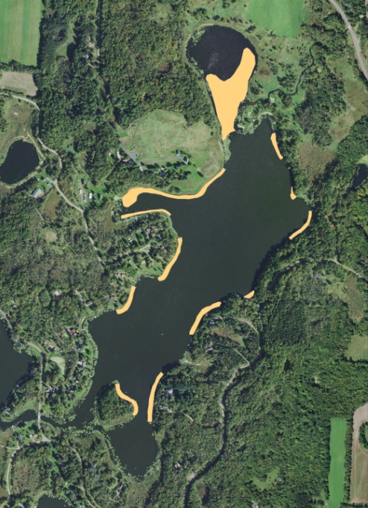
Figure 1: 2016 Spring CLP/EWM Proposed Treatment Areas

In 2009, the Wisconsin Department of Natural Resources (WDNR) confirmed the presence of Eurasian water-milfoil (EWM) (Myriophyllum spicatum) in Little Trade Lake. Since then, the Round-Trade Lake Improvement Association, Inc. (RTLIA), under the direction of Dave Blumer (Lake Education and Planning Services, LLC - LEAPS), has been actively managing the EWM infestation using herbicide treatments and manual removal. Curly-leaf pondweed (Potamogeton crispus), another exotic invasive species, is also abundant in the lake during the spring. In an attempt to decrease both populations, and following evaluation of the 2012 spring CLP and 2015 fall EWM bed mapping surveys, LEAPS proposed chemical treatment in 12 areas totaling 13.18 acres or 10.46% of the lake’s surface area (Figure 1).

On April 28th, we conducted a pretreatment survey to gather baseline data from the scheduled treatment areas and to allow LEAPS to finalize treatment plans. Following the May 17th herbicide application, we completed a June 12th posttreatment survey to evaluate the effectiveness of the treatment. We also conducted a September 30th EWM bed mapping survey to determine where EWM control might be considered in 2017. This report is the summary analysis of these three field surveys.
METHODS:
Pre/Post Herbicide Survey:
LEAPS provided treatment area shapefiles, and we generated pre/post survey points based on the size and shape of the proposed treatment areas. The 160 point sampling grid at 20m resolution approximated to 12 pts/acre - well over the minimum of 4-10 pts/acre required by WDNR protocol for pre/post treatment surveys (Appendix I).

During the surveys, we located each point using a handheld mapping GPS unit (Garmin 76CSx) and used a rake to sample an approximately 2.5ft section of the bottom. All plants on the rake were assigned a rake fullness value of 1-3 as an estimation of abundance, and a total rake fullness for all species was also recorded (Figure 2). Visual sightings of EWM and CLP were noted if they occurred within 6ft of the point. In addition to plant data, we recorded the lake depth using a handheld sonar (Vexilar LPS-1) and the substrate (bottom) type when we could see it or reliably determine it with the rake.

We entered all data collected into the standard WDNR APM spreadsheet (Appendix II). These data were then analyzed using the linked statistical summary sheet and the WDNR pre/post analysis worksheet (UWEX 2010). Pre/post treatment differences were determined to be significant at p<.05, moderately significant at p<.01, and highly significant at p<.005.

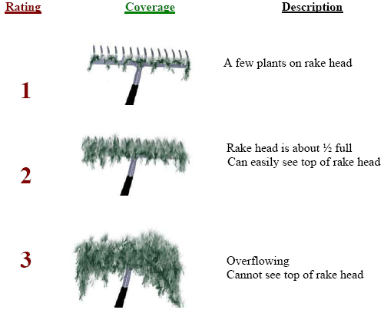
Figure 2: Rake Fullness Ratings

Fall Eurasian Water Milfoil Bed Mapping:
During the fall survey, we searched the entire visible littoral zone of the lake and mapped all known beds of EWM. A “bed” was determined to be any area where we visually estimated that EWM made up >50% of the area’s plants and was generally continuous with clearly defined borders. After we located a bed, we motored around the perimeter of the area, took GPS coordinates at regular intervals, and estimated both the range and mean rake fullness rating of EWM within the bed (Figure 2). Using the WDNR’s Forestry Tool’s Extension to ArcGIS 9.3.1, we used these coordinates to generate bed shapefiles and determine the acreage to the nearest hundredth of an acre. We also took waypoints of EWM plants outside these beds as they were generally few in number.
RESULTS AND DISCUSSION:
Finalization of Treatment Areas:
Initial expectations were to treat 12 beds totaling 13.18 acres. Due to poor control in the past that was likely at least partially due to flowing water resulting in a lack of contact time, it was decided to treat Area 1 with Diquat (Reward) at a rate of 2gal/acre. All other areas were treated with both Endothall (Aquathol K) and 2-4,D (DMA-4) at concentration of 2.5ppm and 3.5ppm respectively (Table 1). Following the pretreatment survey, it was decided to eliminate treatment in the deepest areas around the northern edge of Bed 1 and in all of Bed 12. All other areas were maintained as proposed (Figure 3) (Appendix I). This resulted in a final treatment area of 10.04 acres (7.97% of the lake’s surface area). This was a reduction of just over 25% from initial expectation.

Northern Aquatic Services (Dale Dressel – Dresser) applied herbicide on May 17th. The reported water temperature at the time of treatment was 53°F, the ambient air temperature was 58°F, and winds were out of the west at 3mph.

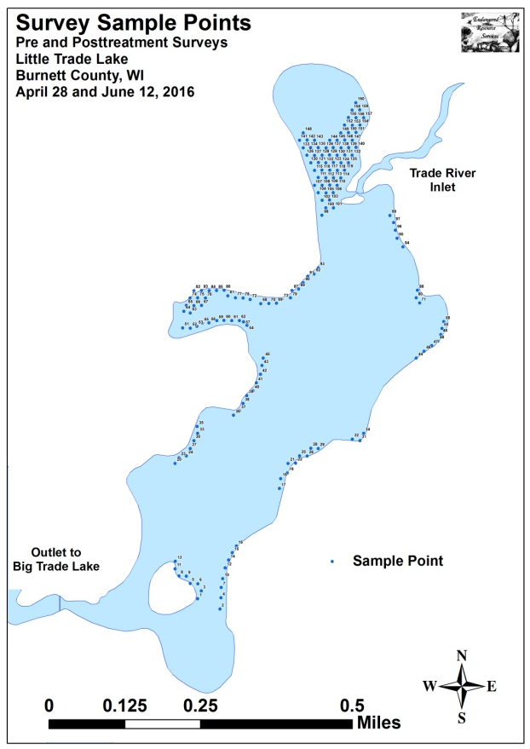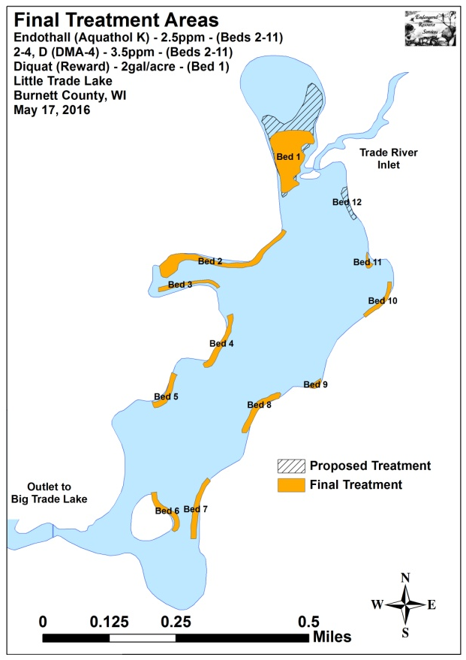
Figure 3: Survey Sample Points and Final Treatment Areas

Table 1: Spring Treatment Summary
Little Trade Lake – May 17, 2016

Treatment Area | Proposed  Acreage | Final Acreage | Difference  +/- | Chemical(s) (Brand) - Dosage
1 | 6.41 | 3.63 | -2.78 | Diquat (Reward) – 2 gal/acre
2 | 2.04 | 2.04 | 0.00 | Endothall (Aquathol K) – 2.5ppm/2-4,D (DMA-4) – 3.5ppm
3 | 0.46 | 0.46 | 0.00 | Endothall (Aquathol K) – 2.5ppm/2-4,D (DMA-4) – 3.5ppm
4 | 0.70 | 0.70 | 0.00 | Endothall (Aquathol K) – 2.5ppm/2-4,D (DMA-4) – 3.5ppm
5 | 0.51 | 0.51 | 0.00 | Endothall (Aquathol K) – 2.5ppm/2-4,D (DMA-4) – 3.5ppm
6 | 0.57 | 0.57 | 0.00 | Endothall (Aquathol K) – 2.5ppm/2-4,D (DMA-4) – 3.5ppm
7 | 0.74 | 0.74 | 0.00 | Endothall (Aquathol K) – 2.5ppm/2-4,D (DMA-4) – 3.5ppm
8 | 0.72 | 0.72 | 0.00 | Endothall (Aquathol K) – 2.5ppm/2-4,D (DMA-4) – 3.5ppm
9 | 0.14 | 0.14 | 0.00 | Endothall (Aquathol K) – 2.5ppm/2-4,D (DMA-4) – 3.5ppm
10 | 0.41 | 0.41 | 0.00 | Endothall (Aquathol K) – 2.5ppm/2-4,D (DMA-4) – 3.5ppm
11 | 0.13 | 0.13 | 0.00 | Endothall (Aquathol K) – 2.5ppm/2-4,D (DMA-4) – 3.5ppm
12 | 0.36 | 0.00 | -0.36 | None
Total Acres | 13.18 | 10.04 | -3.14

CLP/EWM Pre/Post Herbicide Surveys:
The littoral zone extended to 7.0ft during the pretreatment survey and 8.0ft during the posttreatment survey. Mean and median depths for all plants fell from 3.6ft and 4.0ft respectively pretreatment to 3.1ft and 3.0ft posttreatment (Table 2). Most EWM and CLP plants were established over organic muck in the north and western finger bays, and a mixture of sand and gravel along other shoreline areas (Figure 4) (Appendix III).

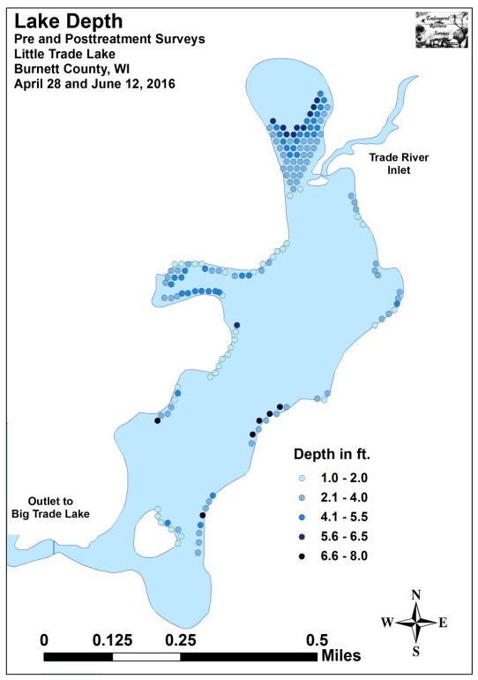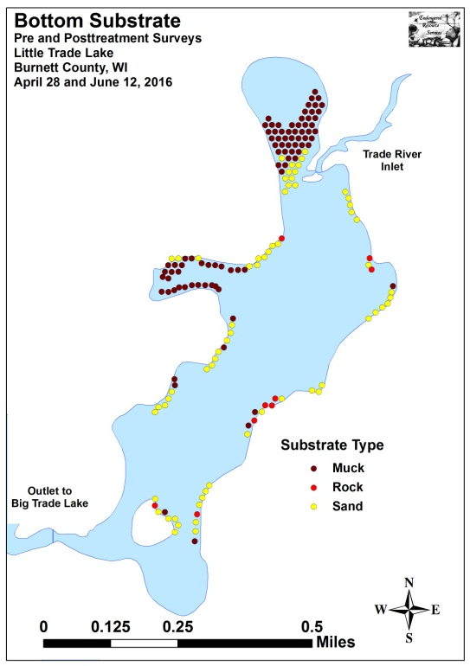
Figure 4: Treatment Area Depths and Bottom Substrate

Table 2: Pre/Post Survey Summary Statistics
Little Trade Lake, Burnett County
April 28 and June 12, 2016
Summary Statistics: | Pre | Post
Total number of points sampled | 160 | 160
Total number of sites with vegetation | 155 | 140
Total number of sites shallower than the maximum depth of plants | 158 | 160
Frequency of occurrence at sites shallower than maximum depth of plants | 98.10 | 87.50
Simpson Diversity Index | 0.70 | 0.73
Mean Coefficient of Conservatism | 3.8 | 4.6
Floristic Quality Index | 7.5 | 13.7
Maximum depth of plants (ft) | 7.0 | 8.0
Mean depth of plants (ft) | 3.6 | 3.1
Median depth of plants (ft) | 4.0 | 3.0
Average number of all species per site (shallower than max depth) | 1.87 | 1.48
Average number of all species per site (veg. sites only) | 1.91 | 1.69
Average number of native species per site (shallower than max depth) | 1.13 | 1.36
Average number of native species per site (veg. sites only) | 1.44 | 1.65
Species richness | 6 | 10
Mean rake fullness (veg. sites only) | 1.95 | 1.74
Diversity within the beds was moderate with a pretreatment Simpson Diversity Index of 0.70 that rose slightly to 0.73 posttreatment. The Floristic Quality Index, a measure of only native species diversity and value, also increased from 7.5 pretreatment to 13.7 posttreatment. Mean native species richness at sites with native vegetation increased from 1.44/site pretreatment to 1.65/site posttreatment. No sites had more than three native species present during the pretreatment survey, and only three sites had more than four species posttreatment (Figure 5). Total rake fullness declined from a moderate 1.95 pretreatment to a low/moderate 1.74 posttreatment (Figure 6) (Appendix IV).

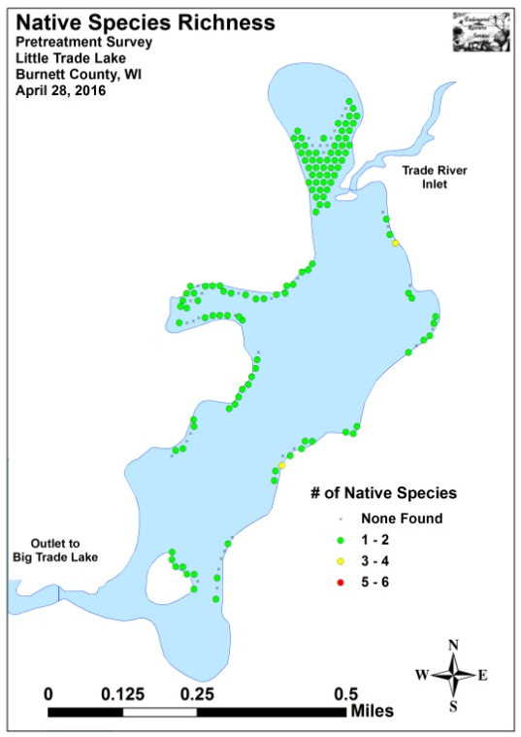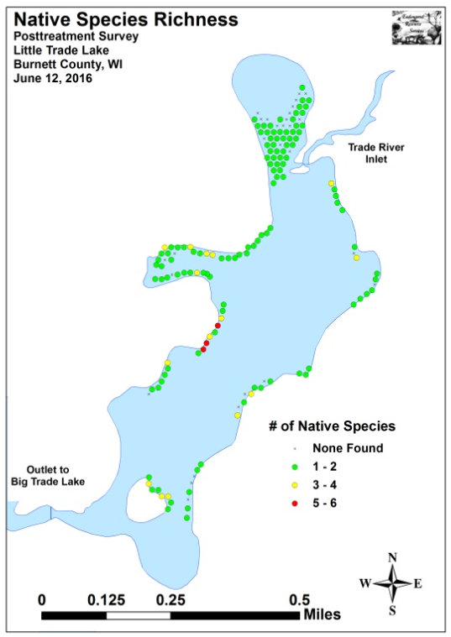
Figure 5: Pre/Post Native Species Richness
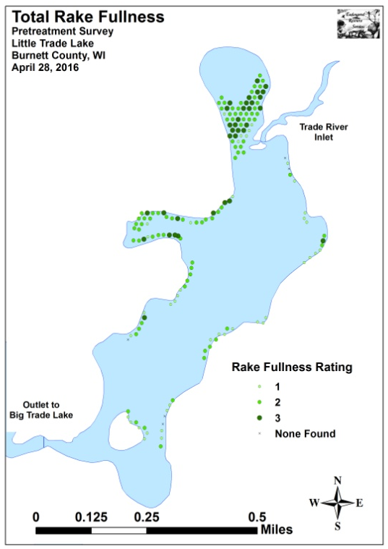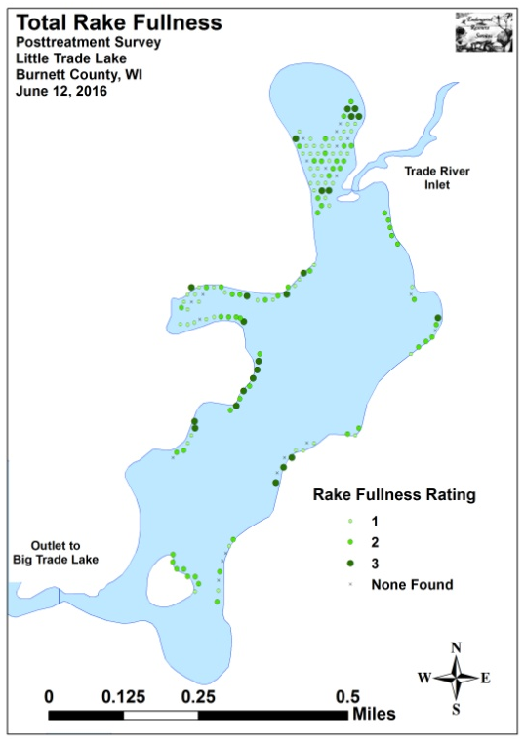
Figure 6: Pre/Post Total Rake Fullness
Curly-leaf pondweed was found at 101 total sites during the pretreatment survey. Of these, 18 had a rake fullness rating of 3, 40 rated a 2, and 43 were a 1 for a mean rake fullness of 1.75. The treatment appeared to have been highly effective as, during the posttreatment survey, we found CLP at just 18 total sites (-82.2%) with four rating a 3, three a 2, and 11 a 1 for a mean rake fullness of 1.61 (Figure 7). This reduction was highly significant overall and for rake fullness 2 and 1. We also found that rake fullness 3 experienced a moderately significant decline (Figure 8) (Appendix V).

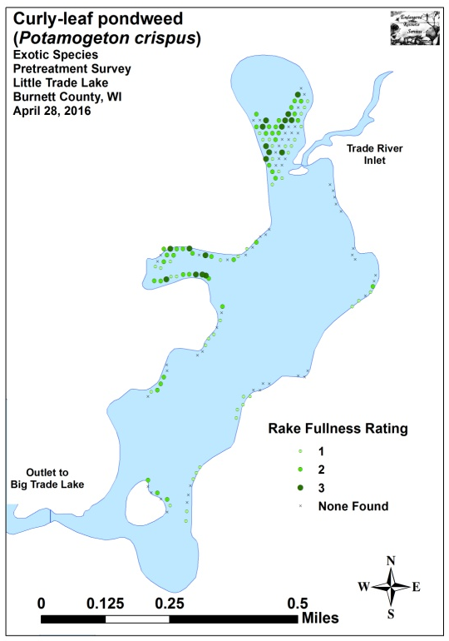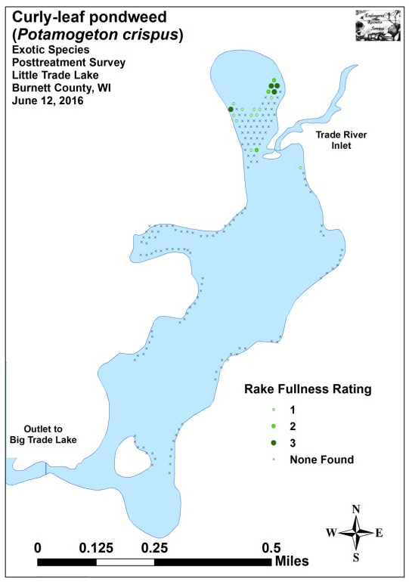
Figure 7: Pre/Post CLP Density and Distribution

-**
-***
-***
-***
Significant differences = * p<.05, ** p<.01, *** p<.005
Figure 8: Pre/Post Changes in CLP Rake Fullness
We found EWM at 17 total sites during the pretreatment survey. Of these, none had a rake fullness rating of 3, five rated a 2, and 12 were a 1 for a mean rake fullness of 1.29. The treatment also seemed to be highly effective at controlling EWM as, during the posttreatment survey, we didn’t find EWM at or between any of the survey points (Figure 9) (Appendix V). This overall decline, as well as the decline in rake fullness 1, was highly significant. The decline in rake fullness 2 was also significant (Figure 10).

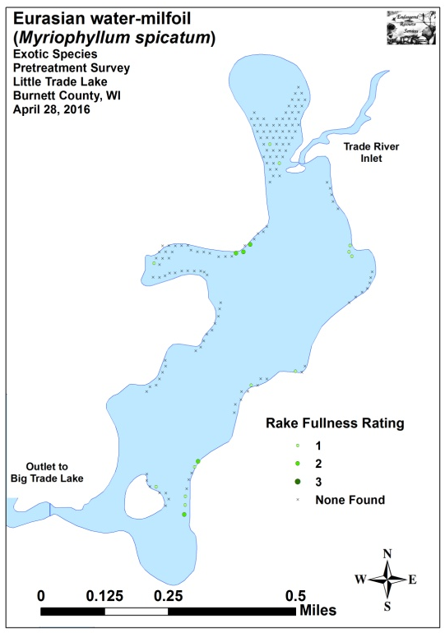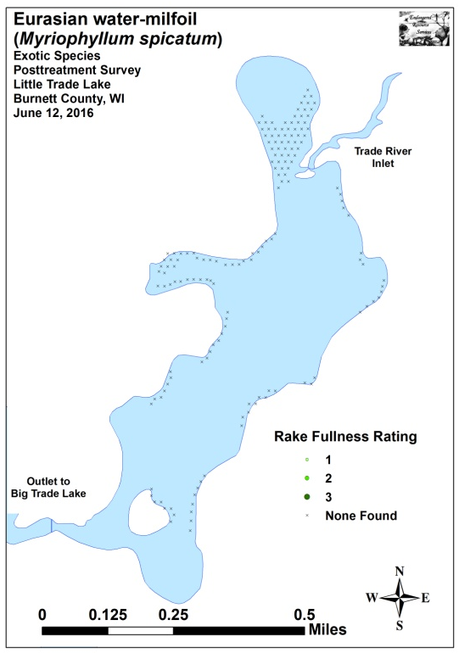
Figure 9: Pre/Post EWM Density and Distribution

-***
-*
-***
Significant differences = * p<.05, ** p<.01, *** p<.005
Figure 10: Pre/Post Changes in EWM Rake Fullness
Coontail (Ceratophyllum demersum), the most common native species, was almost unchanged from 102 sites with a mean rake fullness of 1.55 pretreatment to 105 sites with a mean rake of 1.48 posttreatment (Tables 3 and 4) (Figure 11). Common waterweed (Elodea canadensis), the second most common native species, experienced a significant decline from 71 sites pre to 50 sites post; however, its mean rake (1.52) was unchanged (Figure 12). Conversely, White water lily (Nymphaea odorata) demonstrated a highly significant increase, and filamentous algae, Small duckweed (Lemna minor), Spatterdock (Nuphar variegata), Large duckweed (Spirodela polyrhiza), and Common watermeal (Wolffia columbiana) all had moderately significant increases (Figure 13). Maps for all native species from the pre/posttreatment surveys are available in Appendixes VI and VII.
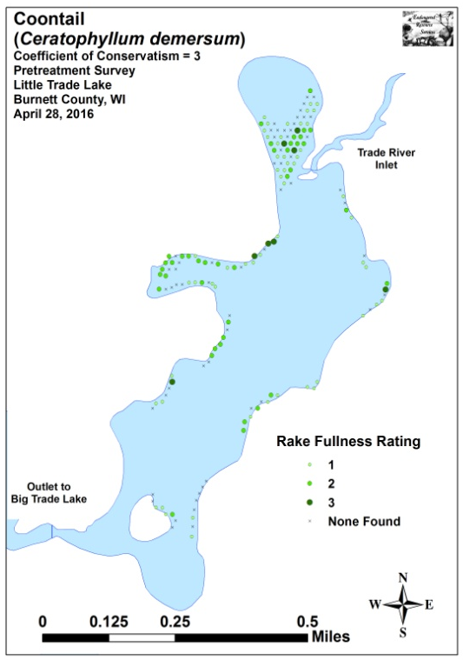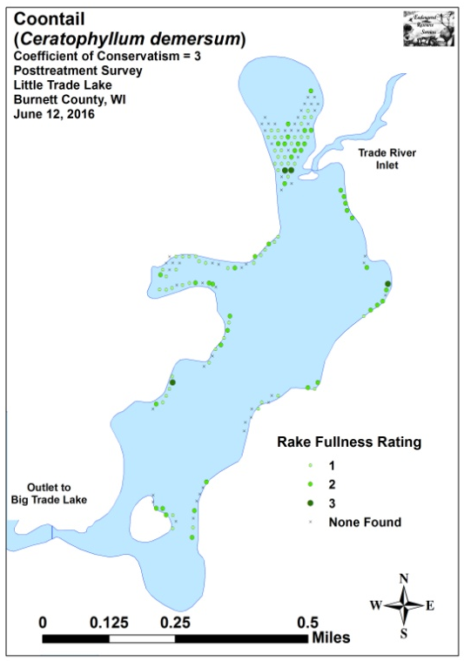
Figure 11: Pre/Post Coontail Density and Distribution
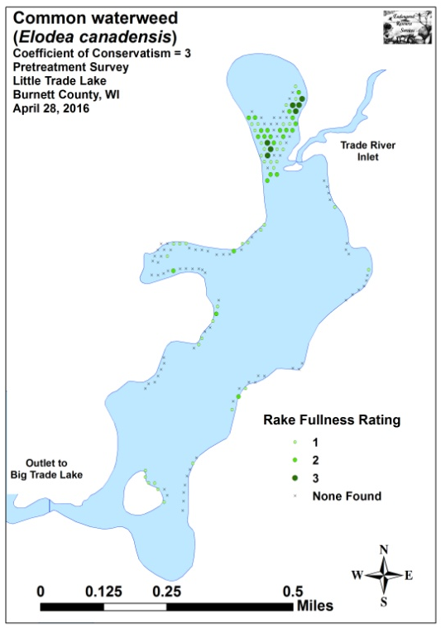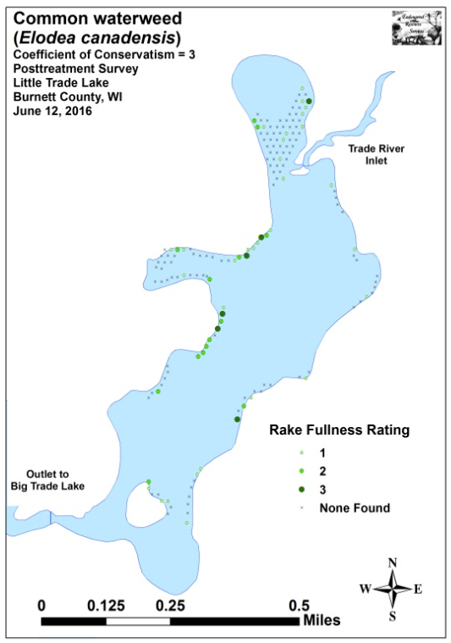
Figure 12: Pre/Post Common Waterweed Density and Distribution
-***
+*
+**
+**
+**
+**
+**
+***
-***
Significant differences = * p<.05, ** p<.01, *** p<.005
Figure 13: Pre/Post Macrophyte Changes
Table 3: Frequencies and Mean Rake Sample of Aquatic Macrophytes
Pretreatment Survey Little Trade Lake, Burnett County
April 28, 2016

Species | Common Name | Total  Sites | Relative Freq. | Freq. in Veg. | Freq. in Lit. | Mean Rake | Visual Sites
Ceratophyllum demersum | Coontail | 102 | 34.46 | 65.81 | 64.56 | 1.55 | 0
Potamogeton crispus | Curly-leaf pondweed | 101 | 34.12 | 65.16 | 63.92 | 1.75 | 0
 | Filamentous algae | 92 | * | 59.35 | 58.23 | 2.07 | 0
Elodea canadensis | Common waterweed | 71 | 23.99 | 45.81 | 44.94 | 1.52 | 0
Myriophyllum spicatum | Eurasian water-milfoil | 17 | 5.74 | 10.97 | 10.76 | 1.29 | 0
Nymphaea odorata | White water lily | 4 | 1.35 | 2.58 | 2.53 | 1.00 | 0

Table 4: Frequencies and Mean Rake Sample of Aquatic Macrophytes
Posttreatment Survey Little Trade Lake, Burnett County
June 12, 2016

Species | Common Name | Total  Sites | Relative Freq. | Freq. in Veg. | Freq. in Lit. | Mean Rake | Visual Sites
 | Filamentous algae | 117 | * | 83.57 | 73.13 | 1.74 | 0
Ceratophyllum demersum | Coontail | 105 | 44.49 | 75.00 | 65.63 | 1.48 | 0
Elodea canadensis | Common waterweed | 50 | 21.19 | 35.71 | 31.25 | 1.52 | 0
Nymphaea odorata | White water lily | 27 | 11.44 | 19.29 | 16.88 | 1.85 | 0
Potamogeton crispus | Curly-leaf pondweed | 18 | 7.63 | 12.86 | 11.25 | 1.61 | 0
Lemna minor | Small duckweed | 9 | 3.81 | 6.43 | 5.63 | 1.67 | 0
Nuphar variegata | Spatterdock | 9 | 3.81 | 6.43 | 5.63 | 2.22 | 0
Spirodela polyrhiza | Large duckweed | 9 | 3.81 | 6.43 | 5.63 | 1.67 | 0
Wolffia columbiana | Common watermeal | 7 | 2.97 | 5.00 | 4.38 | 1.71 | 0
Myriophyllum sibiricum | Northern water-milfoil | 1 | 0.42 | 0.71 | 0.63 | 1.00 | 0
Stuckenia pectinata | Sago pondweed | 1 | 0.42 | 0.71 | 0.63 | 1.00 | 0

* Excluded from Relative Frequency Analysis

Fall EWM Bed Mapping Survey:
On September 30th, 2016, we located and rake removed a total of 175 Eurasian water-milfoil plants. The vast majority appeared to be relatively recently established as they were not canopied, had only a single stem, and had poorly developed root systems. Many of them also occurred as isolated individuals, but we did define eight more or less “high density areas” that had regular plants (Figure 14) (Appendix VIII). In total, these areas covered 0.34 acre or 0.27% of the lake’s total surface. These totals represented a decline of -3.89 acres (-92.0%) from 2015’s fall EWM acreage of 4.23 acres (Table 5).

Taken as a whole, the data suggests the 2016 treatment was highly successful at controlling EWM. As we rake removed all EWM plants found in the lake, it seems likely that there will be limited EWM regrowth in 2017 – at least initially.

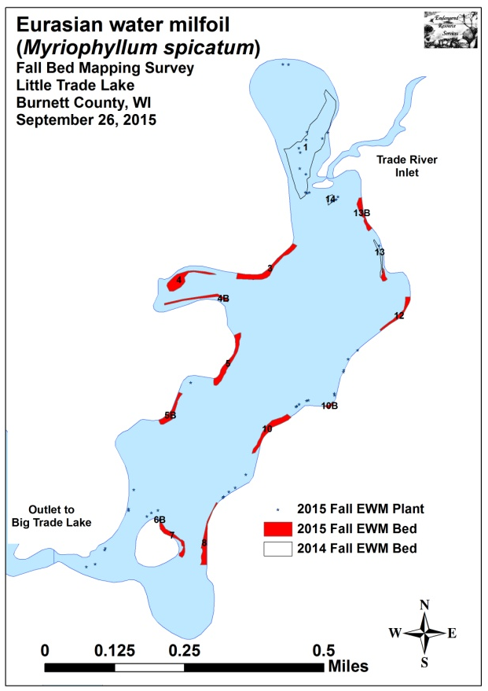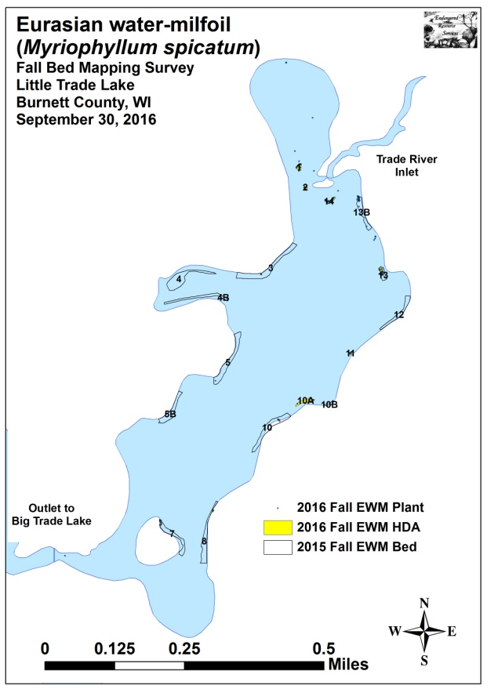
Figure 14: 2015 and 2016 Fall EWM Bed Maps

Table 5: Fall Eurasian Water-milfoil Bed and High Density Area Mapping Summary
Little Trade Lake, Burnett County
September 30, 2016

Bed Number | 2016  Fall Bed/HDA  Acreage | 2015  Fall Bed  Acreage | 2014  Fall Bed  Acreage | 2013  Fall Bed/HDA  Acreage | 2012  Fall Bed  Acreage | 2016  Change in  Acreage | Estimated 2016 Mean Rake Fullness | 2016 Bed Characteristics  And Field Notes
1 | 0.06 | 0 | 3.84 | 4.61 | 2.16 | 0.06 | <<1-2; <1 | Scattered low density plants.
2 | 0.02 | 0 | Merged | Merged | Merged | 0.02 | <1-1; <1 | Scattered low density plants.
3 | 0 | 0.65 | 0.23 | 0.03 | 0 | -0.65 | <<<1 | Three individual plants were found.
4 | 0 | 0.58 | 0 | 0 | 0 | -0.58 | 0 | No plants were found in the area.
4B | 0 | 0.26 | 0 | 0 | 0 | -0.26 | 0 | No plants were found in the area.
5 | 0 | 0.52 | 0 | 0 | 0 | -0.52 | 0 | No plants were found in the area.
5B | 0 | 0.33 | 0 | 0 | 0 | -0.33 | <<<1 | A single plant was removed.
6 | 0 | 0 | 0 | 0 | 0 | 0 | <<<1 | A single plant was removed.
7 | 0.02 | 0.31 | 0 | 0 | 0 | -0.29 | <<1-1; <<1 | Scattered plants on NE tip of island.
8 | 0 | 0.42 | 0 | 0 | 0 | -0.42 | <<<1 | Four individual plants were found.
9 | 0 | 0 | 0 | 0 | 0 | 0 | 0 | No plants were found in the area.
10 | 0 | 0.51 | 0 | 0 | 0 | -0.51 | <<<1 | Five individual plants were found.
10A | 0.11 | 0 | 0 | 0 | 0 | 0.11 | <<1-3; <<1 | Several large clusters found near dock.
10B | 0 | 0.05 | 0 | 0 | 0 | -0.05 | 0 | No plants were found in the area.
11 | 0.01 | 0 | 0 | 0 | 0 | 0.01 | <1-1; <1 | A handful of individual plants.
12 | 0 | 0.26 | 0 | 0 | 0 | -0.26 | 0 | No plants were found in the area.
12B | 0 | 0 | 0 | 0 | 0.02 | 0 | 0 | No plants were found in the area.
12C | 0 | 0 | 0 | <0.01 | 0.08 | 0 | 0 | No plants were found in the area.
13 | 0.05 | 0.08 | 0.14 | <0.01 | 0 | -0.03 | <1-1; 1 | Nearly continuous towers.
13B | 0.02 | 0.26 | 0 | 0 | 0 | -0.24 | <1-3; 1 | Regular canopied towers within the HDA.
14 | 0.05 | 0 | 0.10 | <0.01 | 0.31 | 0.05 | <1-2; 1 | Regular canopied towers within the HDA.
Total | 0.34 | 4.23 | 4.32 | 4.65 | 2.57 | -3.89

Descriptions of Current and Former EWM Beds:
Beds 1 and 2 – Plants were peppered within these two areas. Outside of the HDA polygons, we found just six additional plants in the entire bay.

Beds 3-5B – Three plants were found in Bed 3, and a single plant was found in both Beds 5 and 5B.

Beds 6 and 6B – No EWM plants were seen in either of these areas.

Bed 7 – The only plants found occurred on the northeast end of the island in <2.5ft of water near shore.

Bed 8 – We rake removed four individual plants on the north end of the former bed.

Beds 9 and 10B – No EWM plants were seen in either of these areas.

Bed 10 – A handful of scattered individual plants were the only things seen.

Bed 10A – One of the worst places on the lake, we found several mature towers (5ft tall) at the edge of the littoral zone. They were actively fragmenting, and seemed to be the source population for the additional smaller plants we found near shore as well as around the point.

Bed 11 – This area was little more than a handful of scattered plants.

Beds 12, 12A, 12B, and 12C – No EWM plants were seen in any of these areas.

Bed 13 – We found scattered low density towers peppered across the point. For whatever reason, eliminating EWM from this area seems to be very difficult.

Bed 13B – A few plants were scattered along the length of the shoreline. Within the mapped High Density Area, there were many well established clusters with multiple stems that appeared to be seeding the surrounding area. As most were in only 1-2ft of water, it’s possible they will not survive the winter.

Bed 14 – Scattered canopied plants were found throughout the mapped area. Unlike 13B, they seemed to be more recently established and were easily rake removed.
LITERATURE CITED

Busch, C., C. Olson, L. Sather, and C. Holt. [online]. 1968. Big/Little Trade Lake Map. Available from http://dnr.wi.gov/lakes/maps/DNR/2638700a.pdf (2016, October).

UWEX Lakes Program. [online]. 2010. Aquatic Plant Management in Wisconsin. Available from http://www.uwsp.edu/cnr-ap/UWEXLakes/Pages/ecology/aquaticplants/default.aspx (2016, November).

UWEX Lakes Program. [online]. 2010. Pre/Post Herbicide Comparison. Available from http://www.uwsp.edu/cnr-ap/UWEXLakes/Documents/ecology/Aquatic%20Plants/Appendix-D.pdf (2016, November).

WDNR. [online]. 2016. Little Trade Lake - Citizen Lake Water Quality Monitoring Database. Available from http://dnr.wi.gov/lakes/waterquality/Station.aspx?id=073121 (2017, January).

Appendix I: Survey Sample Points and CLP/EWM Treatment Areas

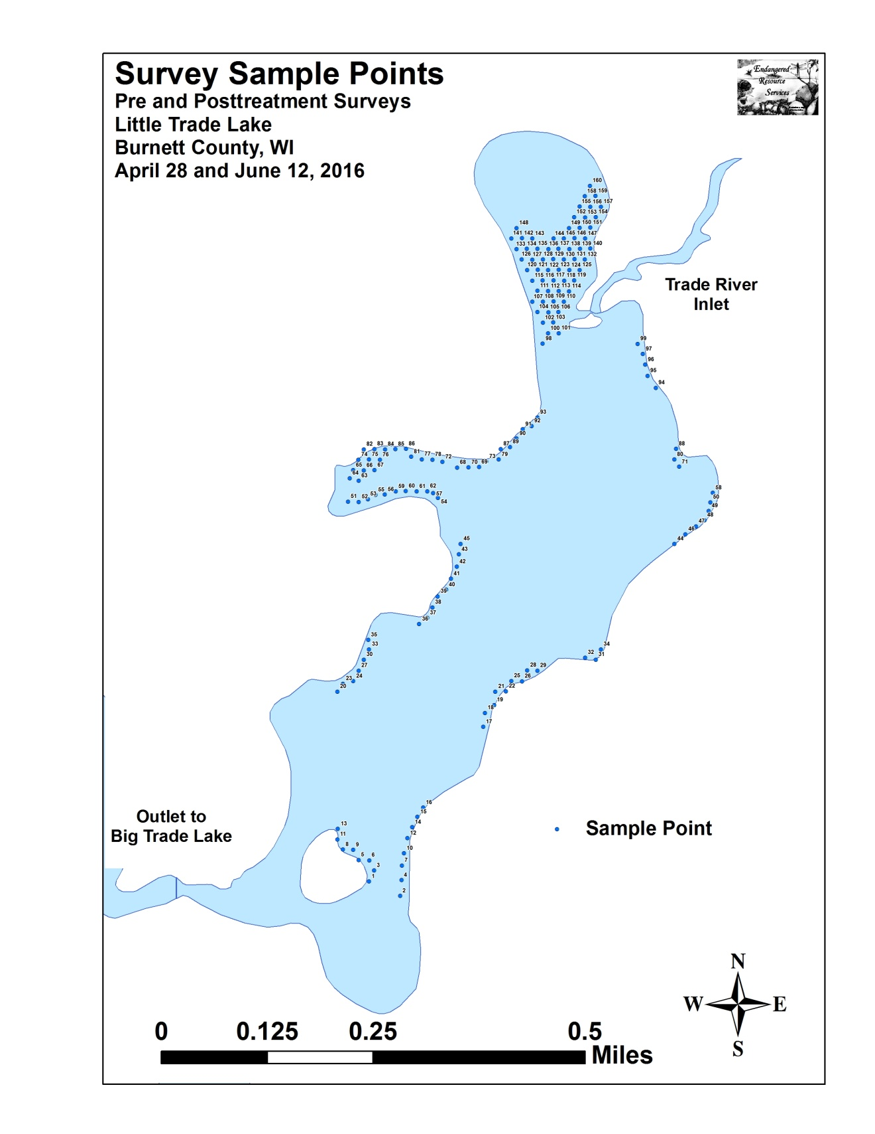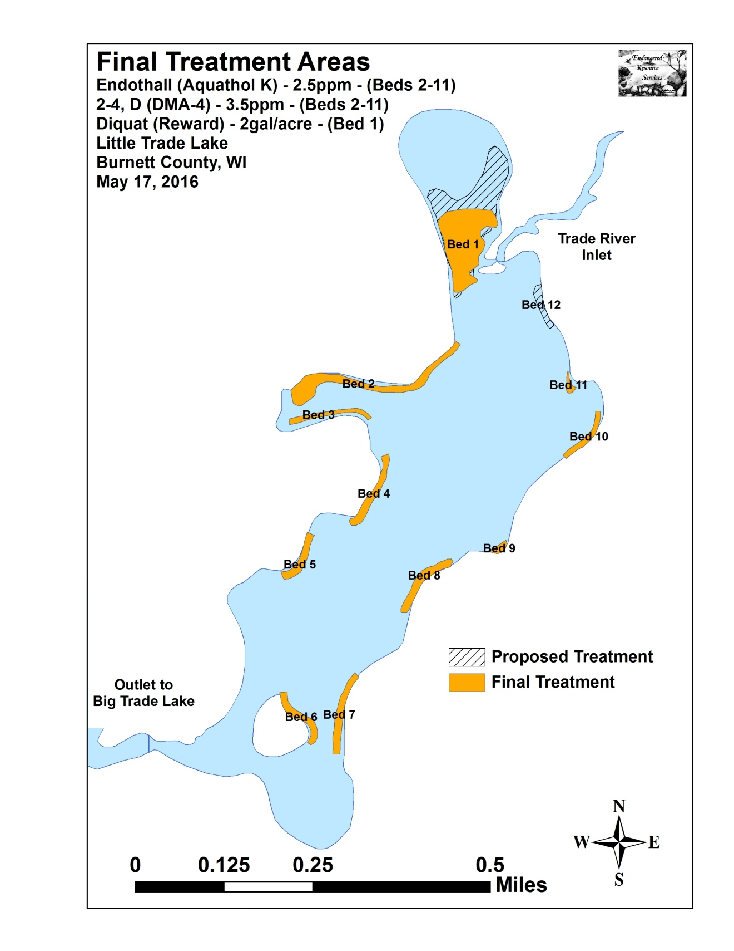

Appendix II: Vegetative Survey Data Sheet

Observers for this lake: names and hours worked by each:
Lake: |  |  |  |  |  |  |  |  | WBIC |  |  |  |  |  |  |  |  | County |  |  |  |  |  | Date:
Site # | Depth (ft) | Muck (M), Sand (S), Rock (R) | Rake pole (P) or rake rope (R) | Total Rake Fullness | EWM | CLP | 1 | 2 | 3 | 4 | 5 | 6 | 7 | 8 | 9 | 10 | 11 | 12 | 13 | 14 | 15 | 16 | 17 | 18 | 19
1
2
3
4
5
6
7
8
9
10
11
12
13
14
15
16
17
18
19
20

Appendix III: Pre/Post Habitat Variable Maps

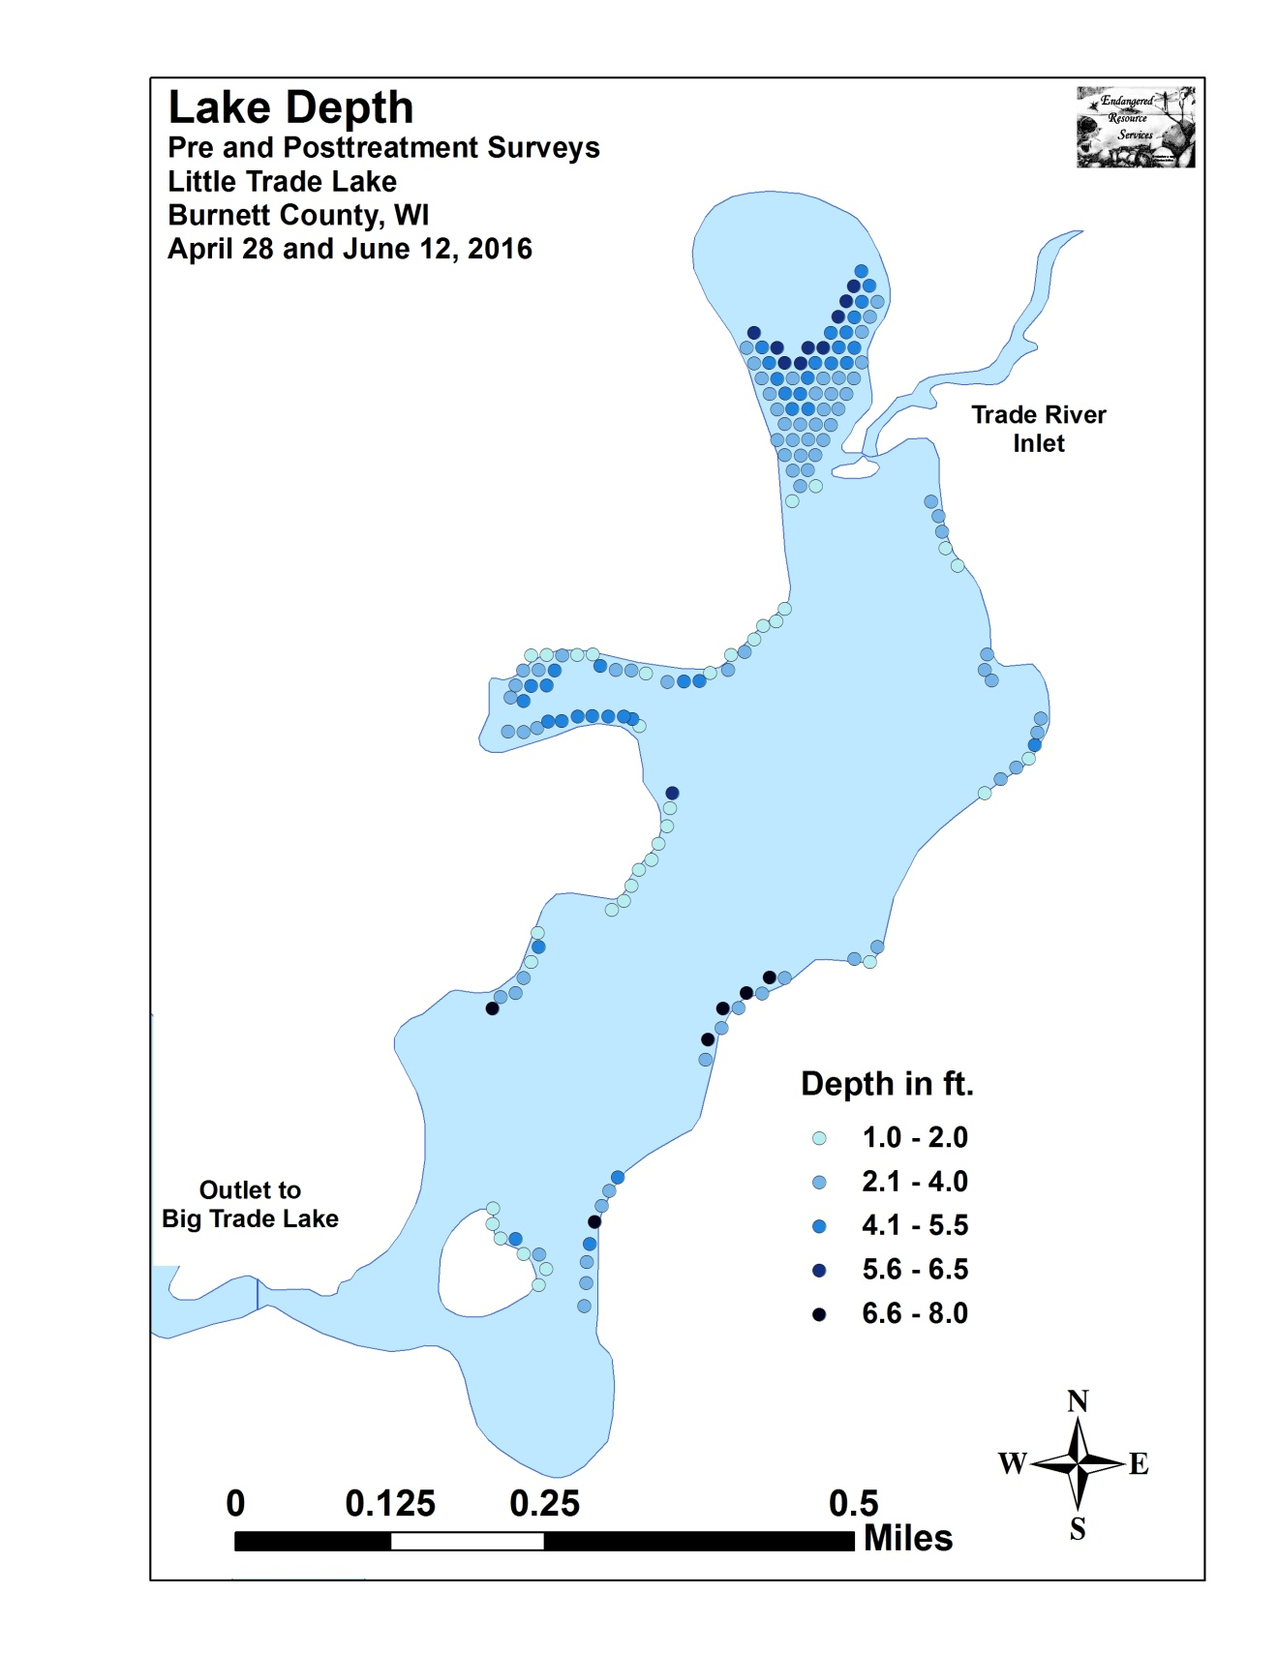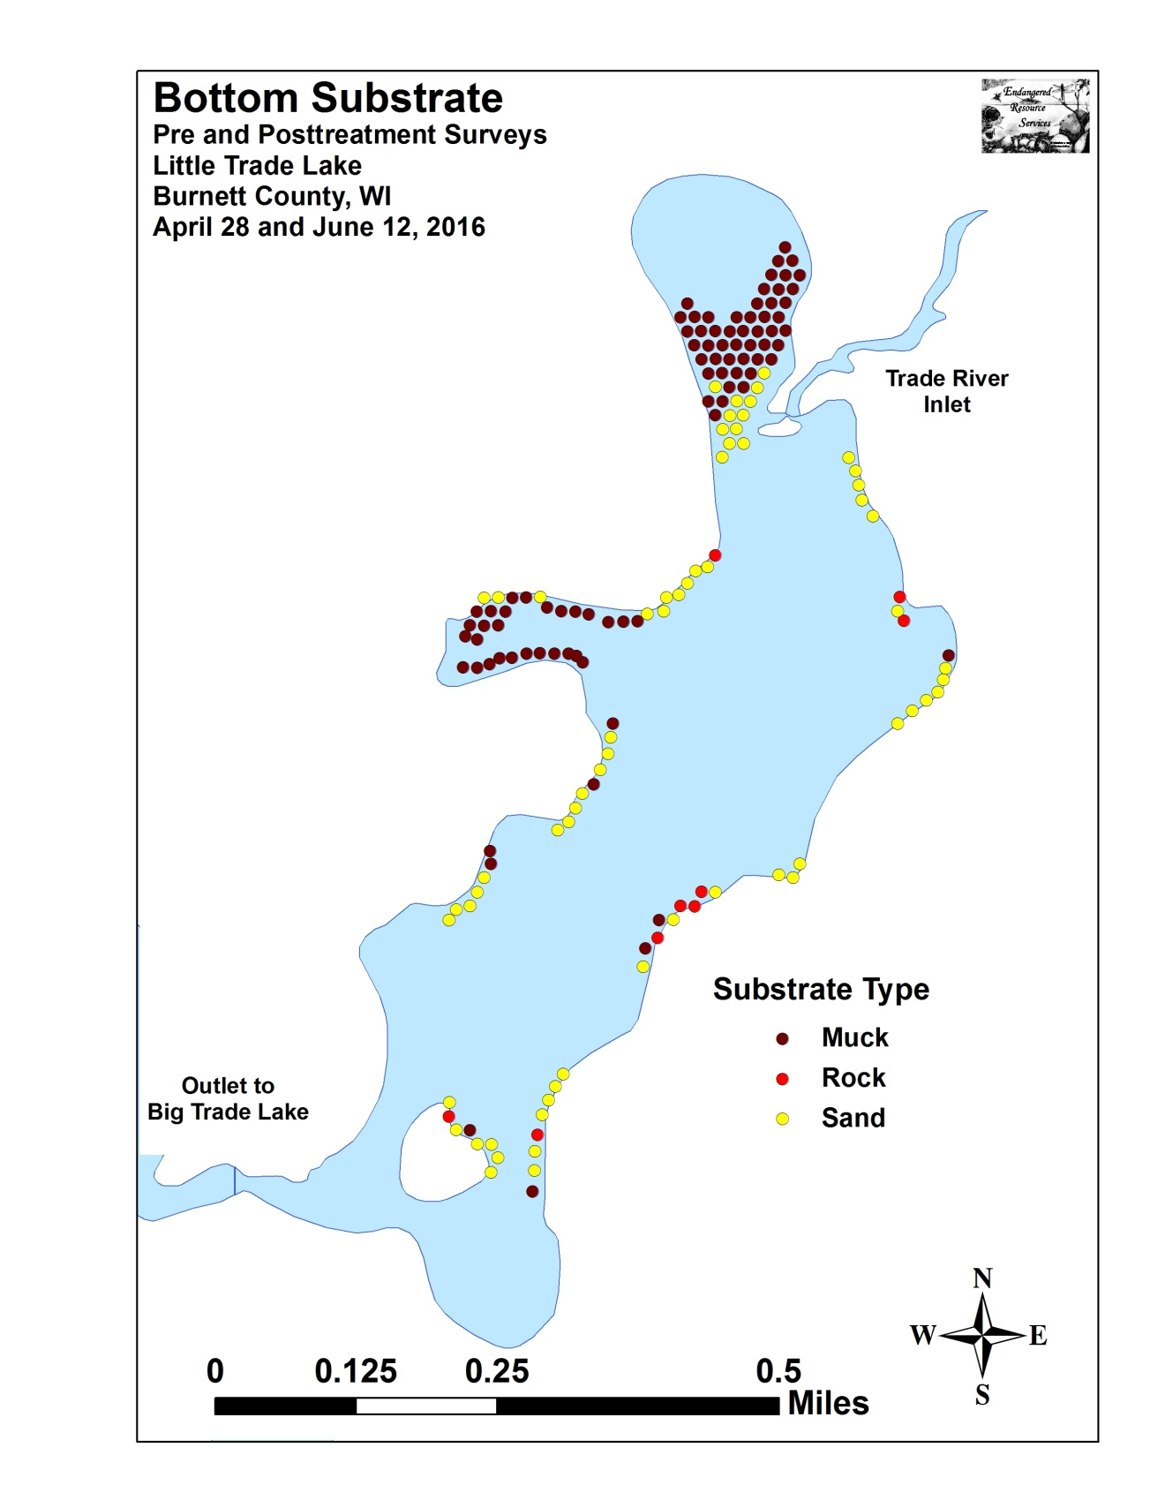

Appendix IV: Pre/Post Native Species Richness and
Total Rake Fullness

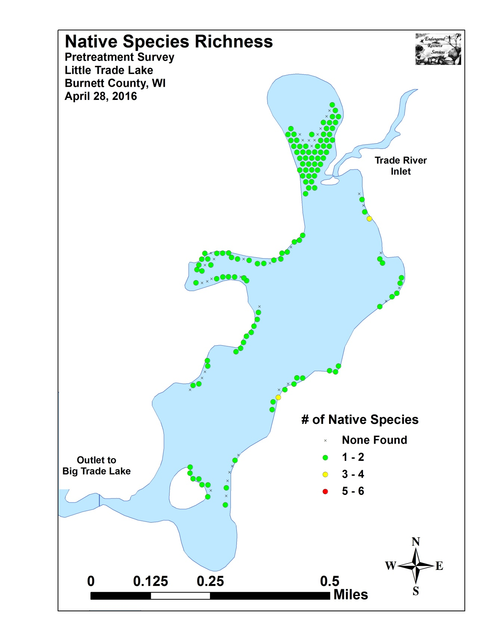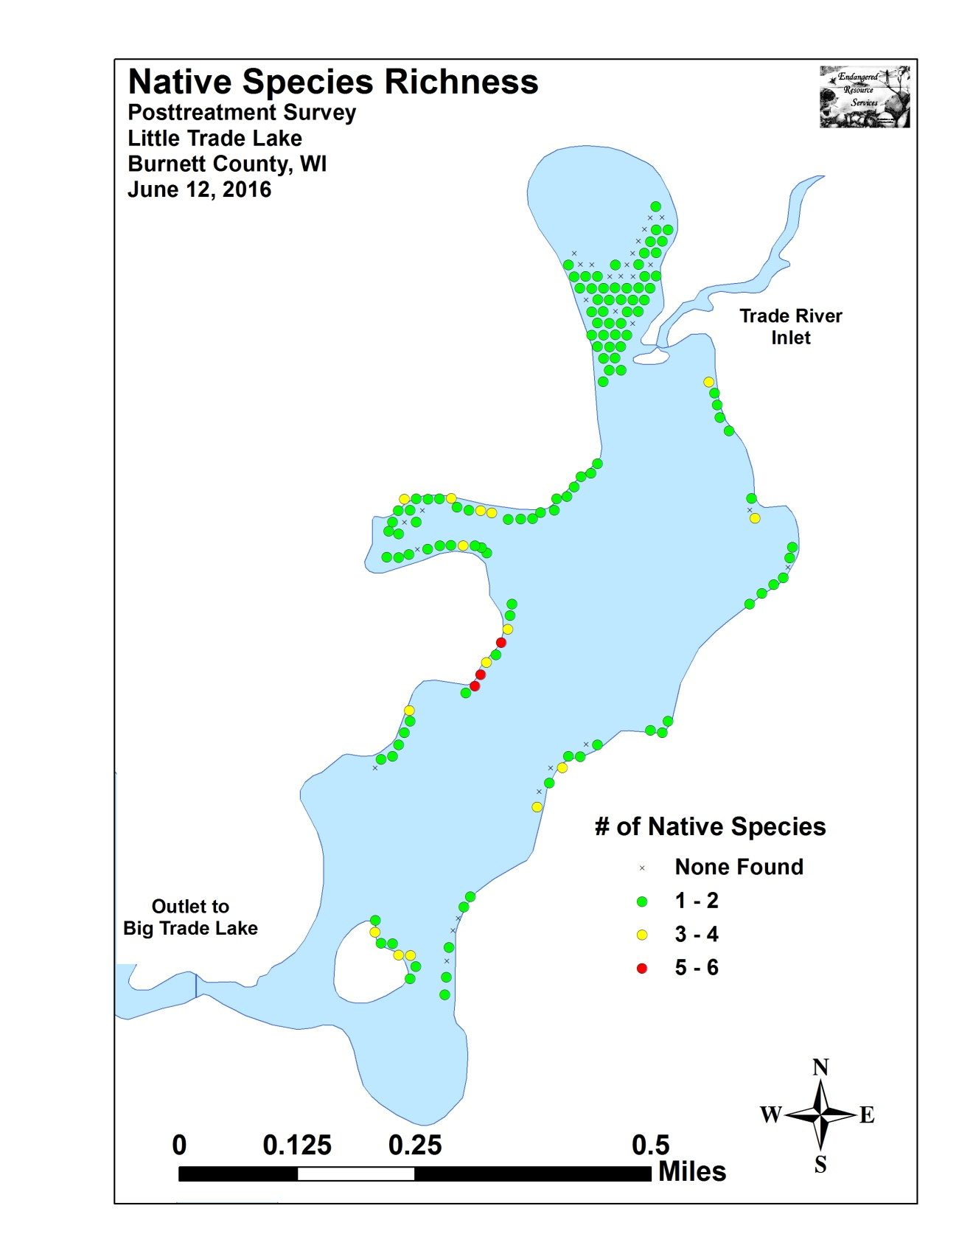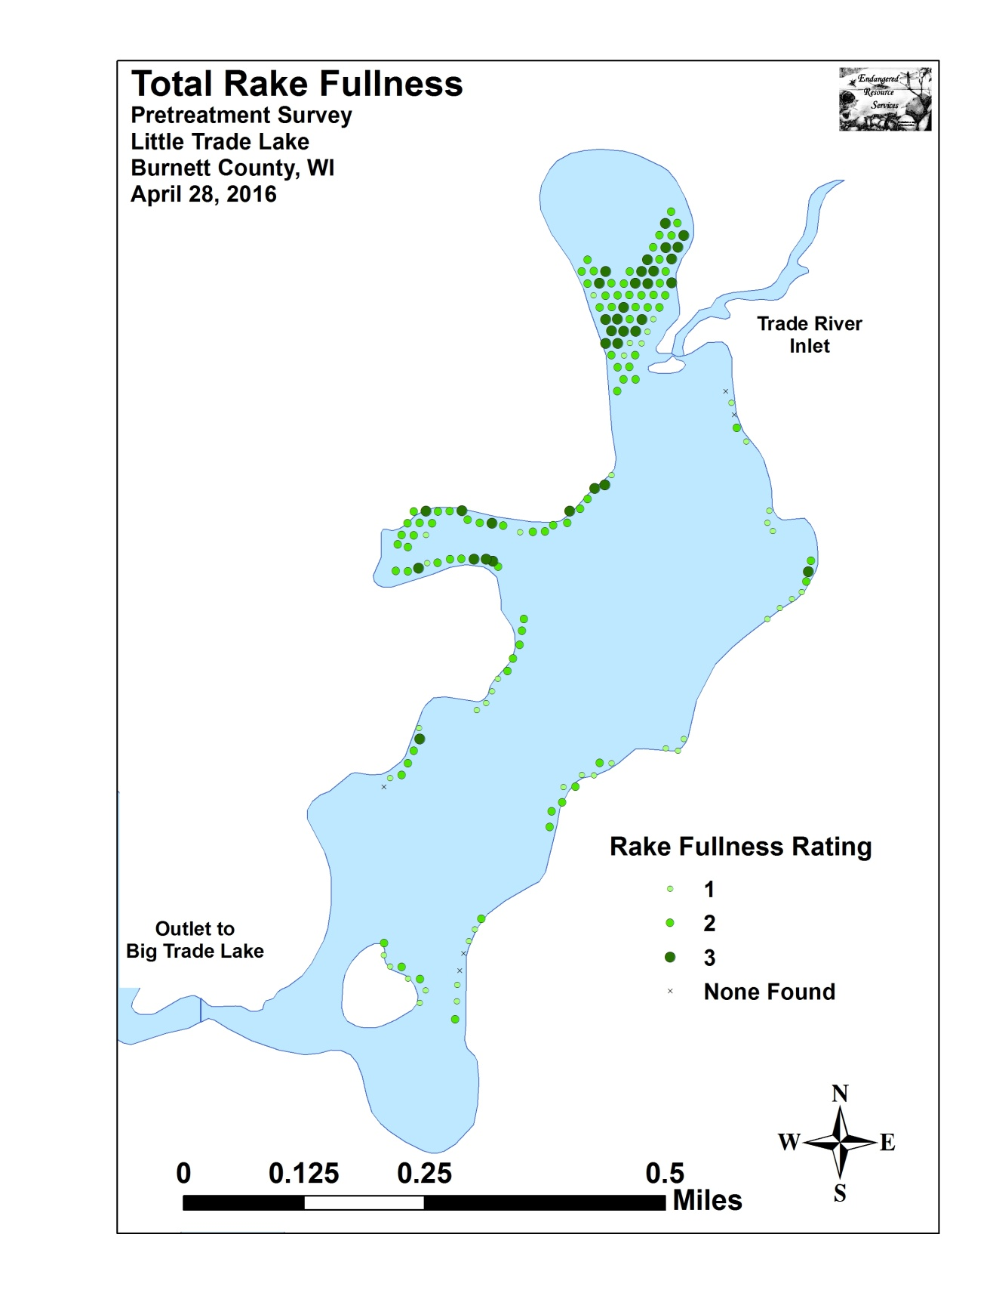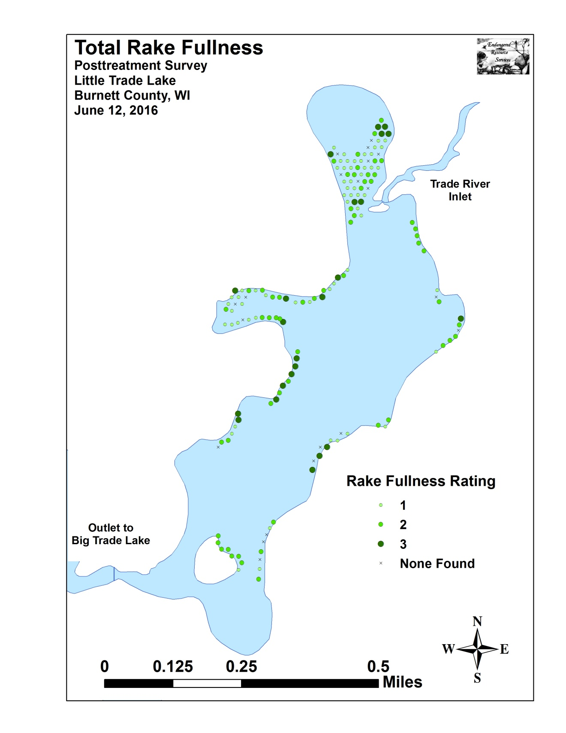

Appendix V: CLP and EWM Pre/Post Density and Distribution

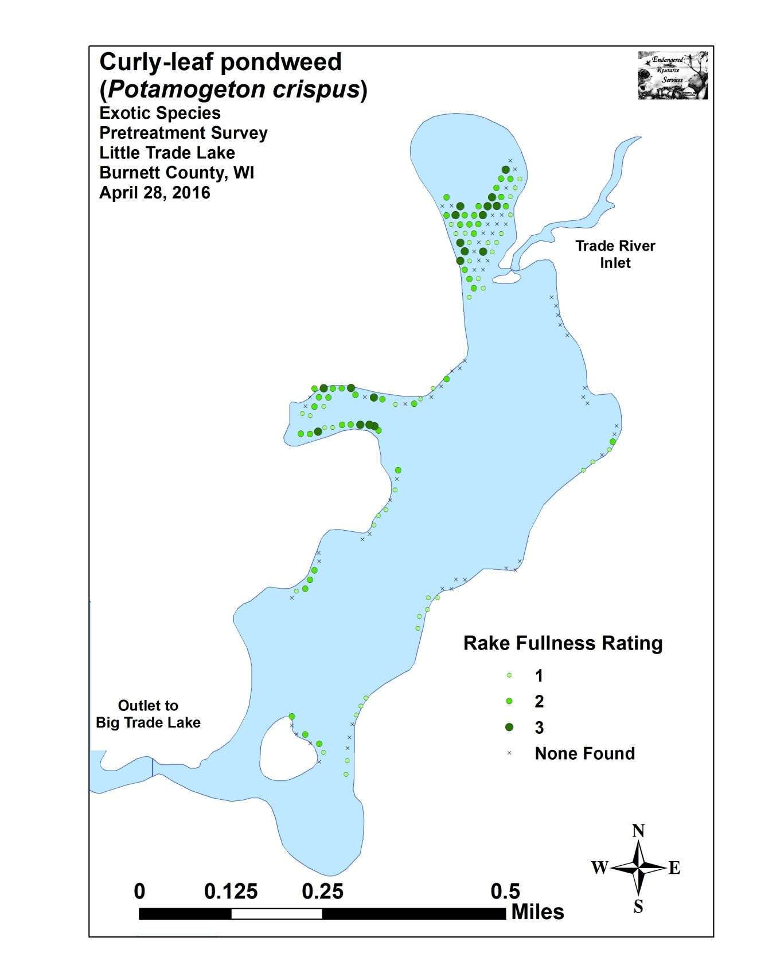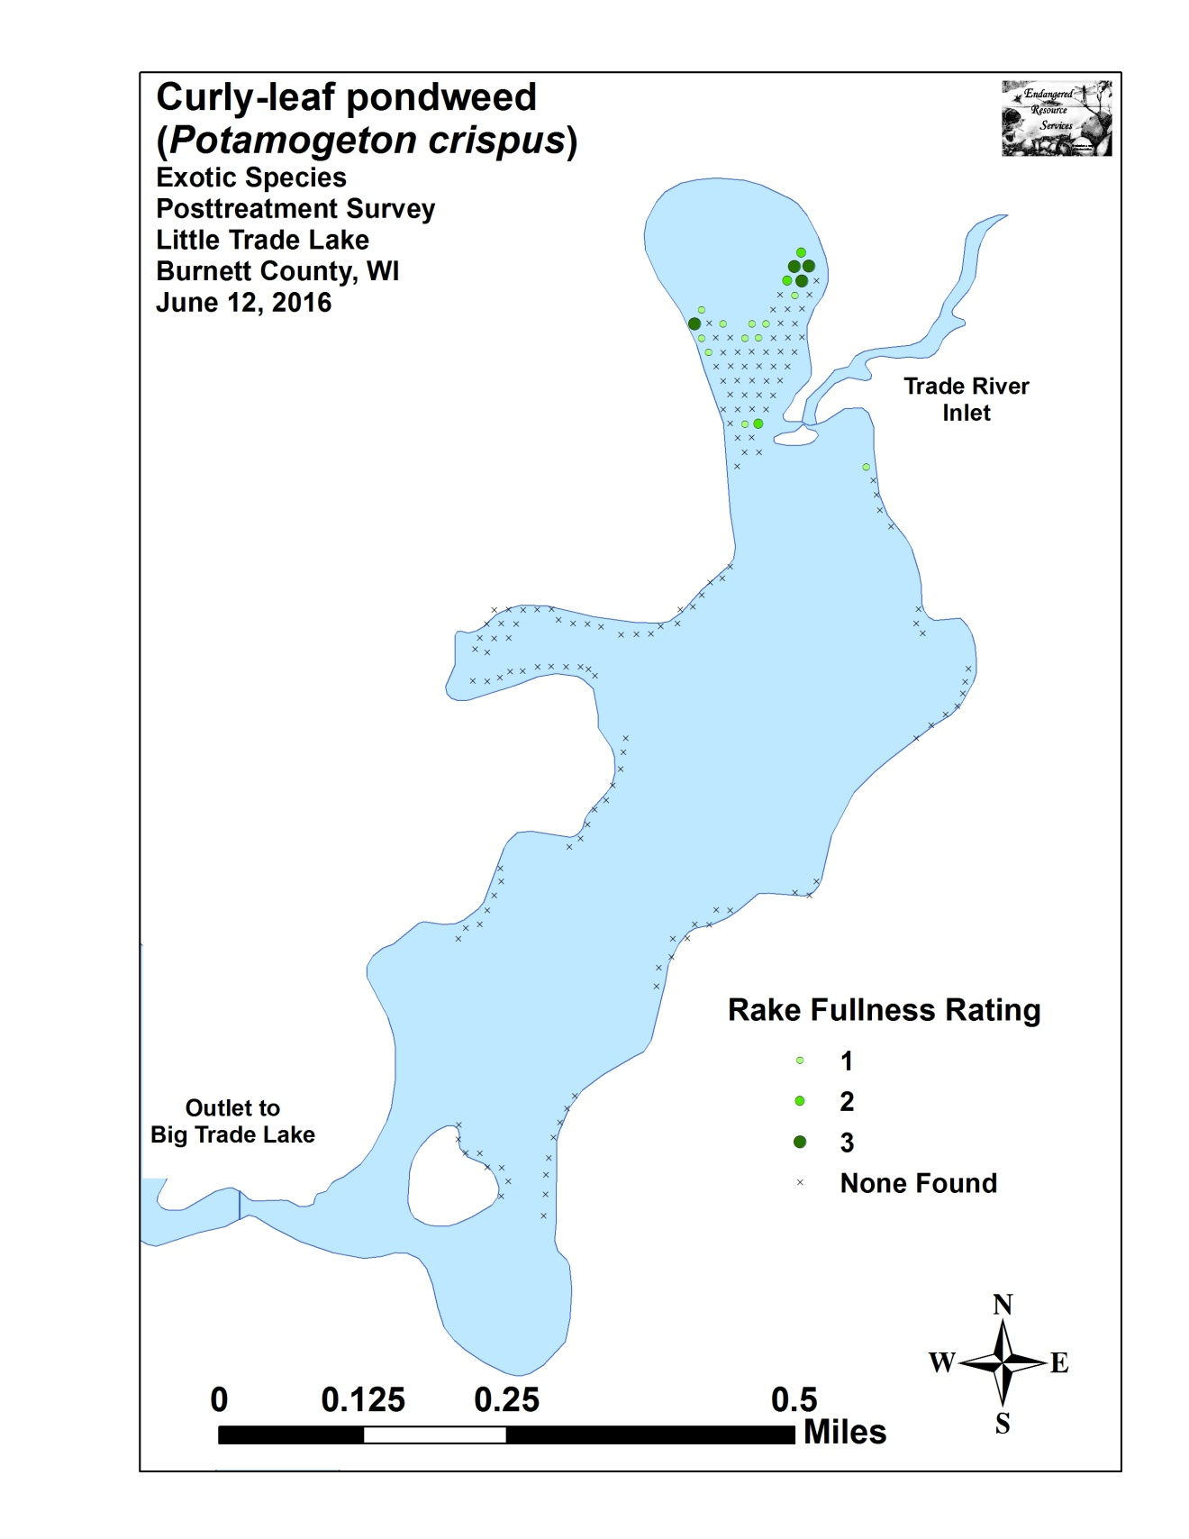
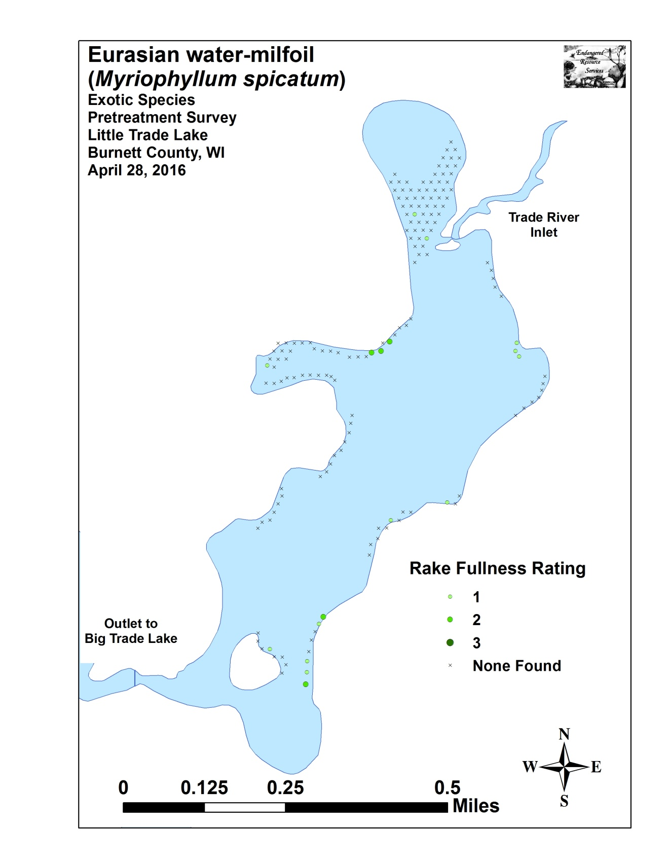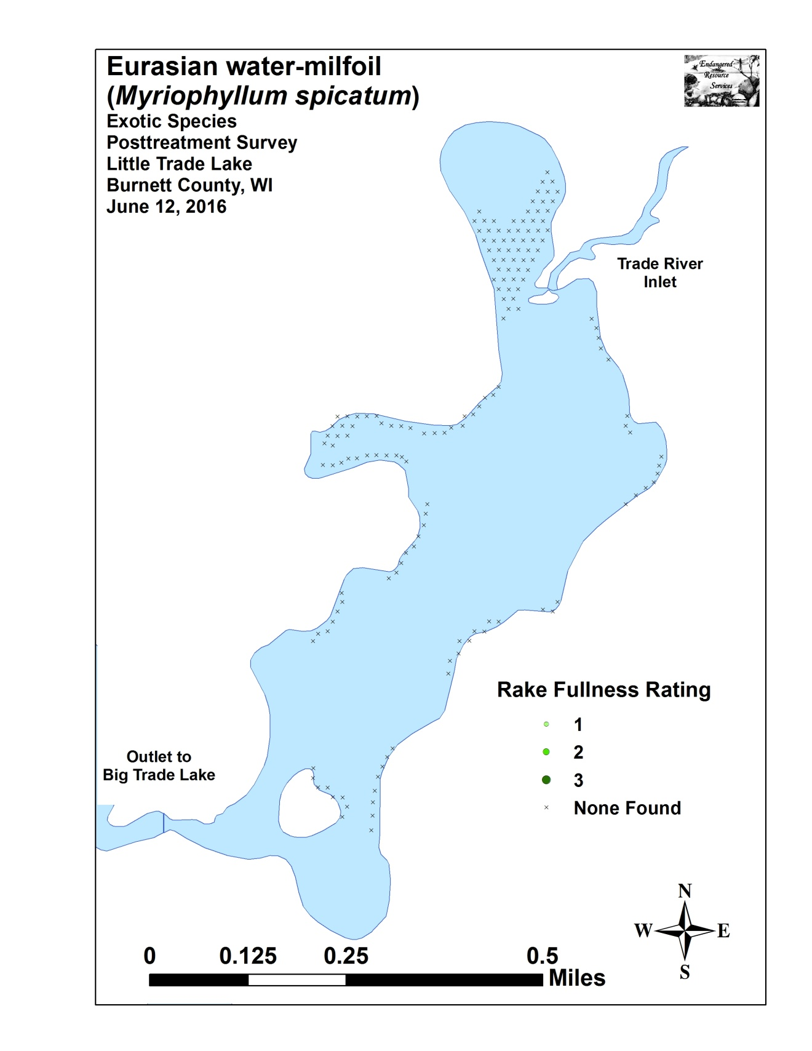

Appendix VI: Pretreatment Native Species Density and Distribution

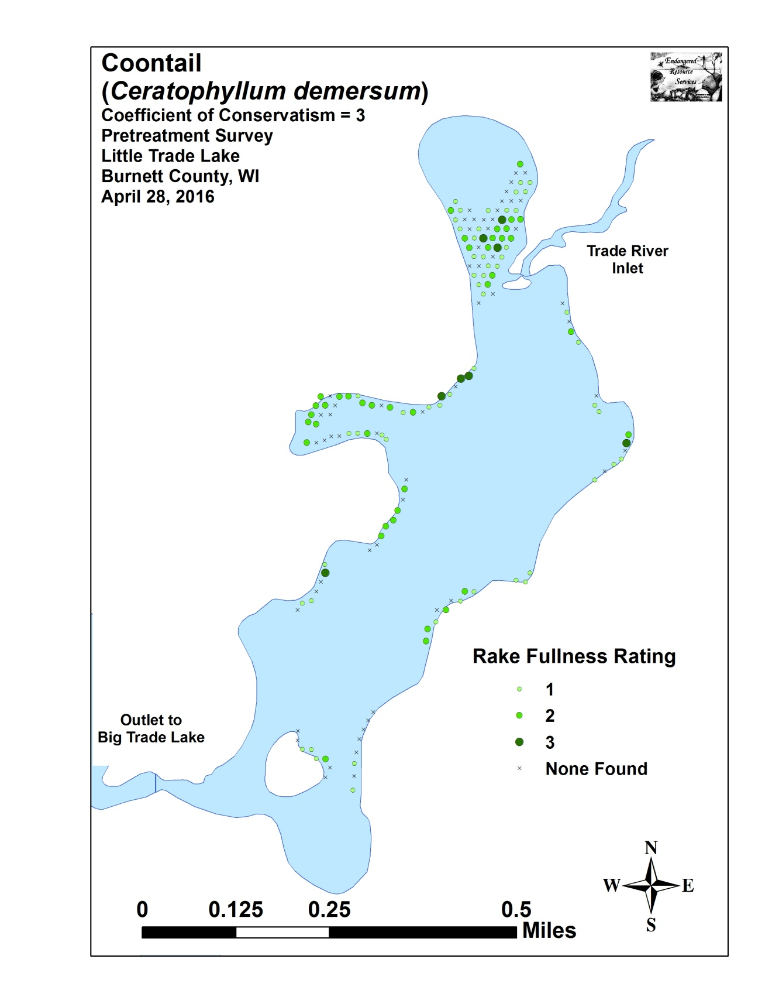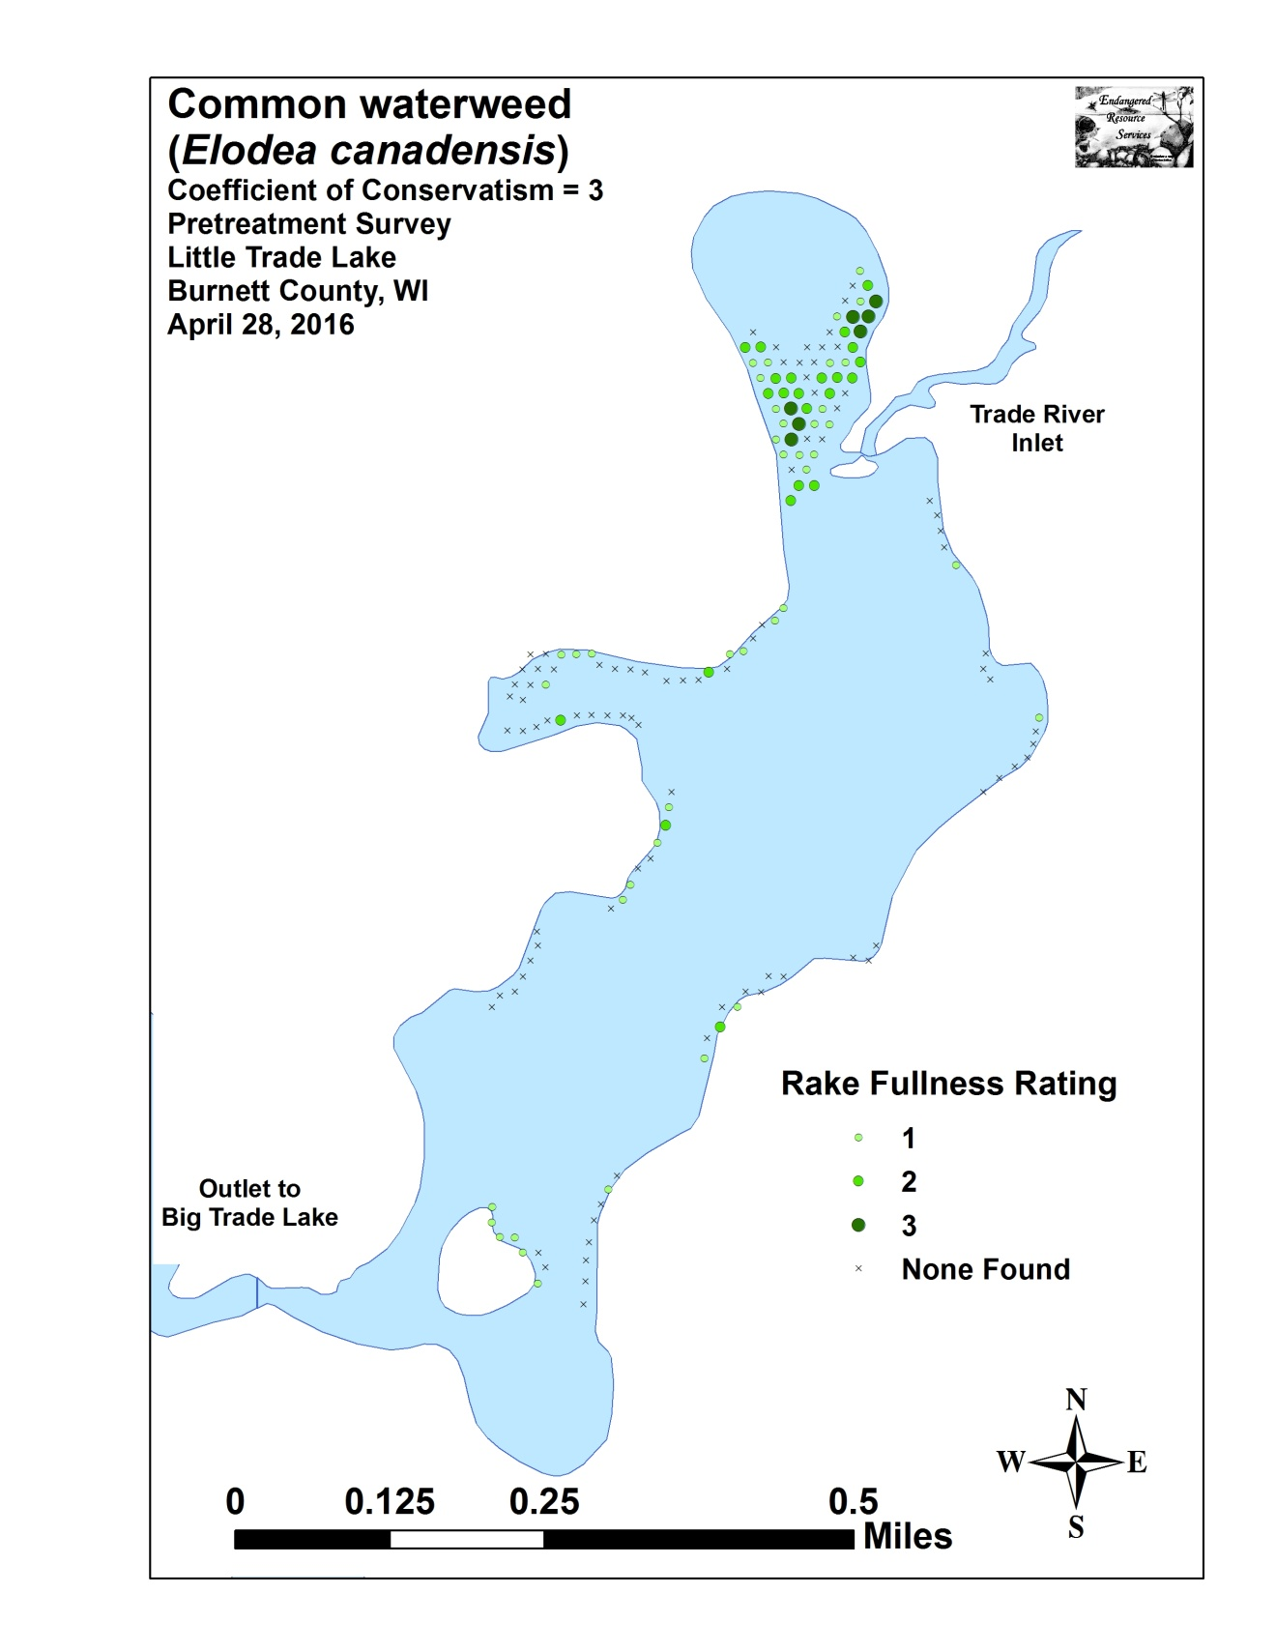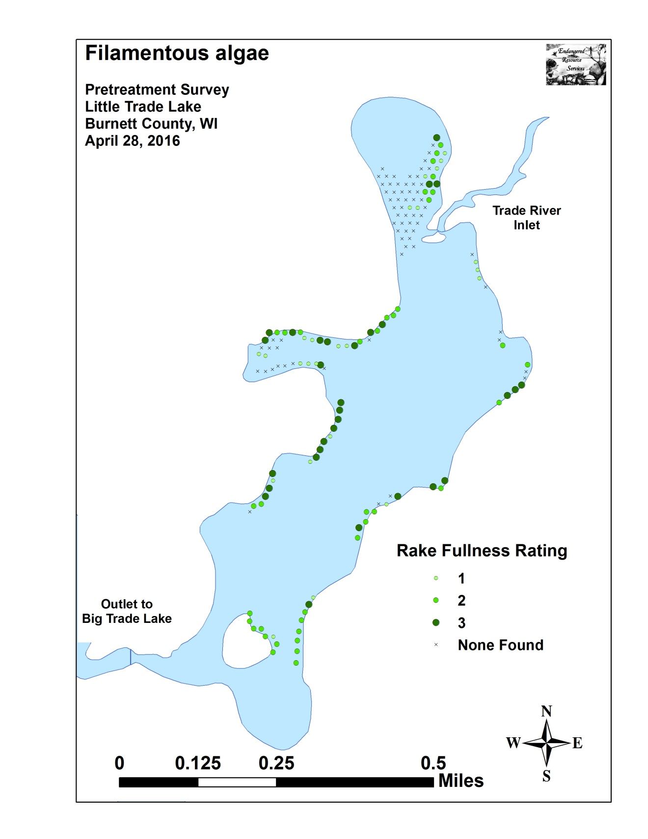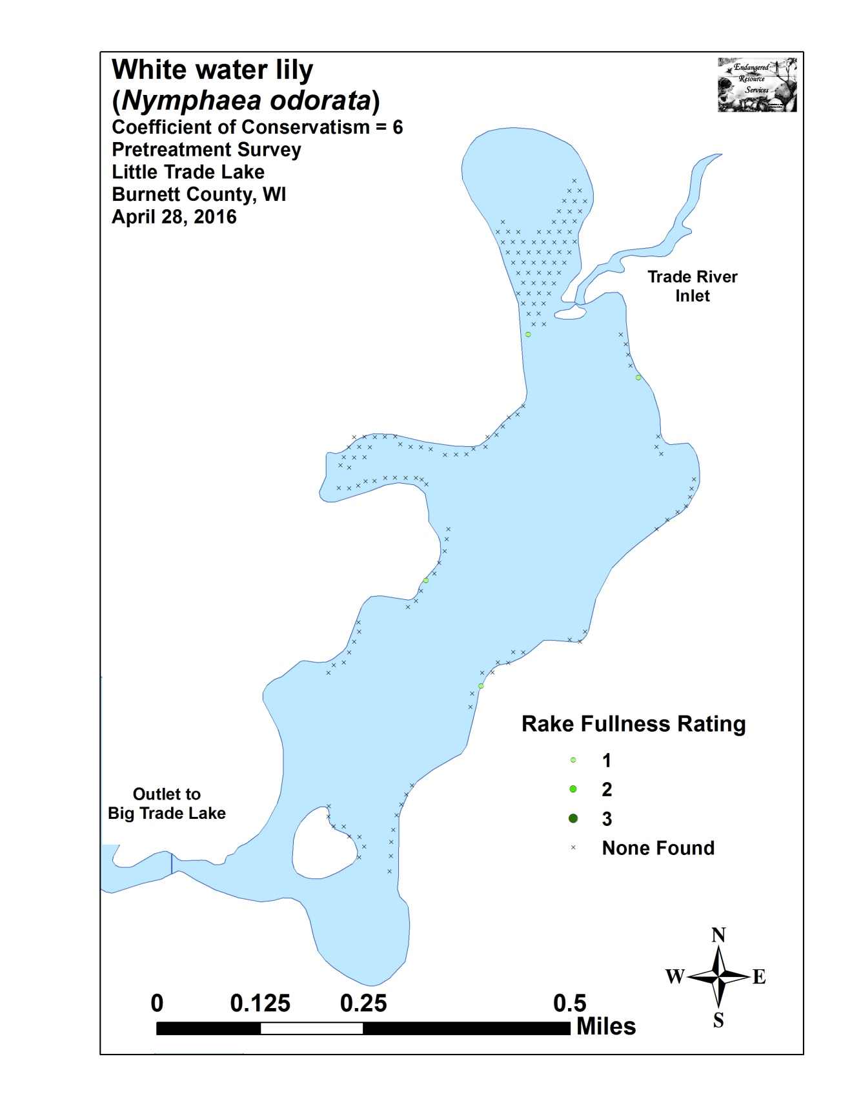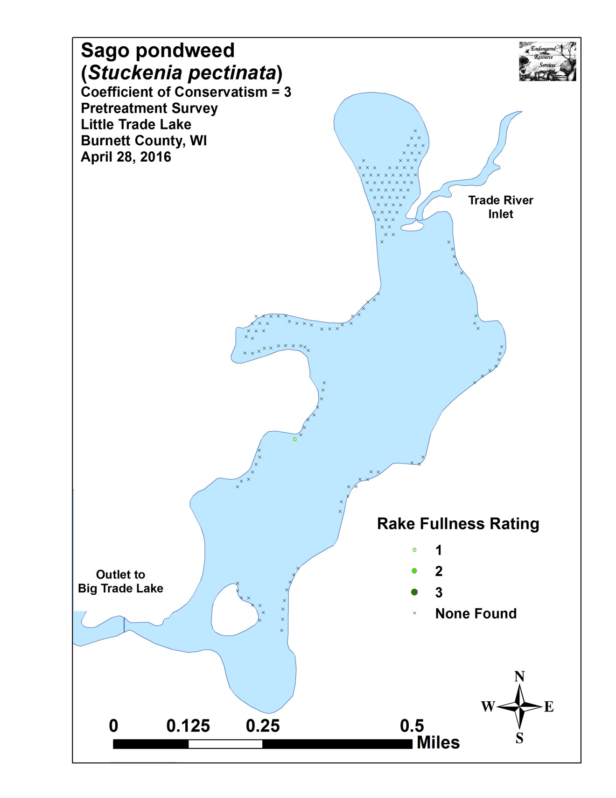

Appendix VII: Posttreatment Native Species Density and Distribution

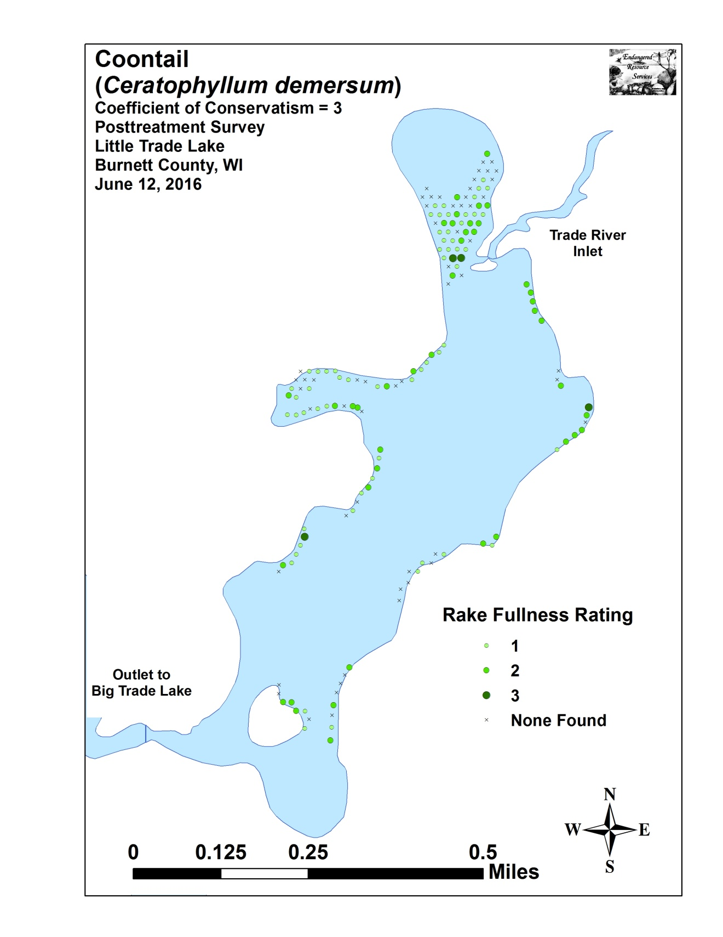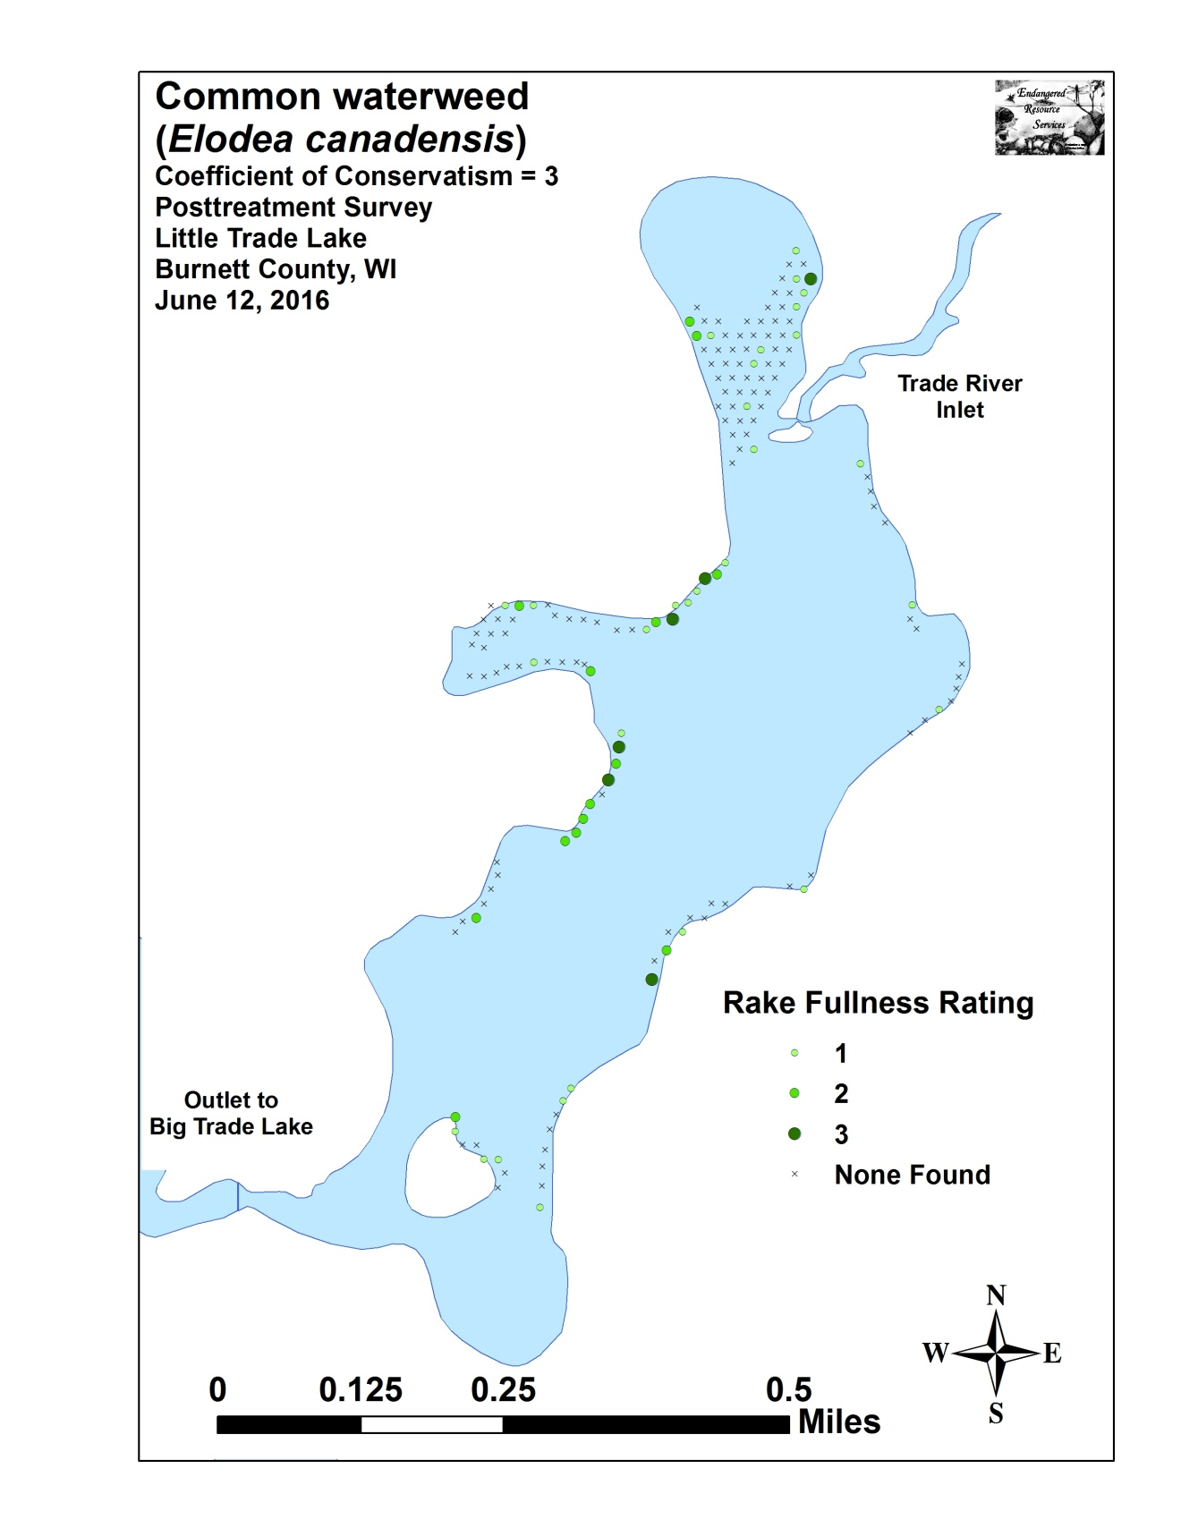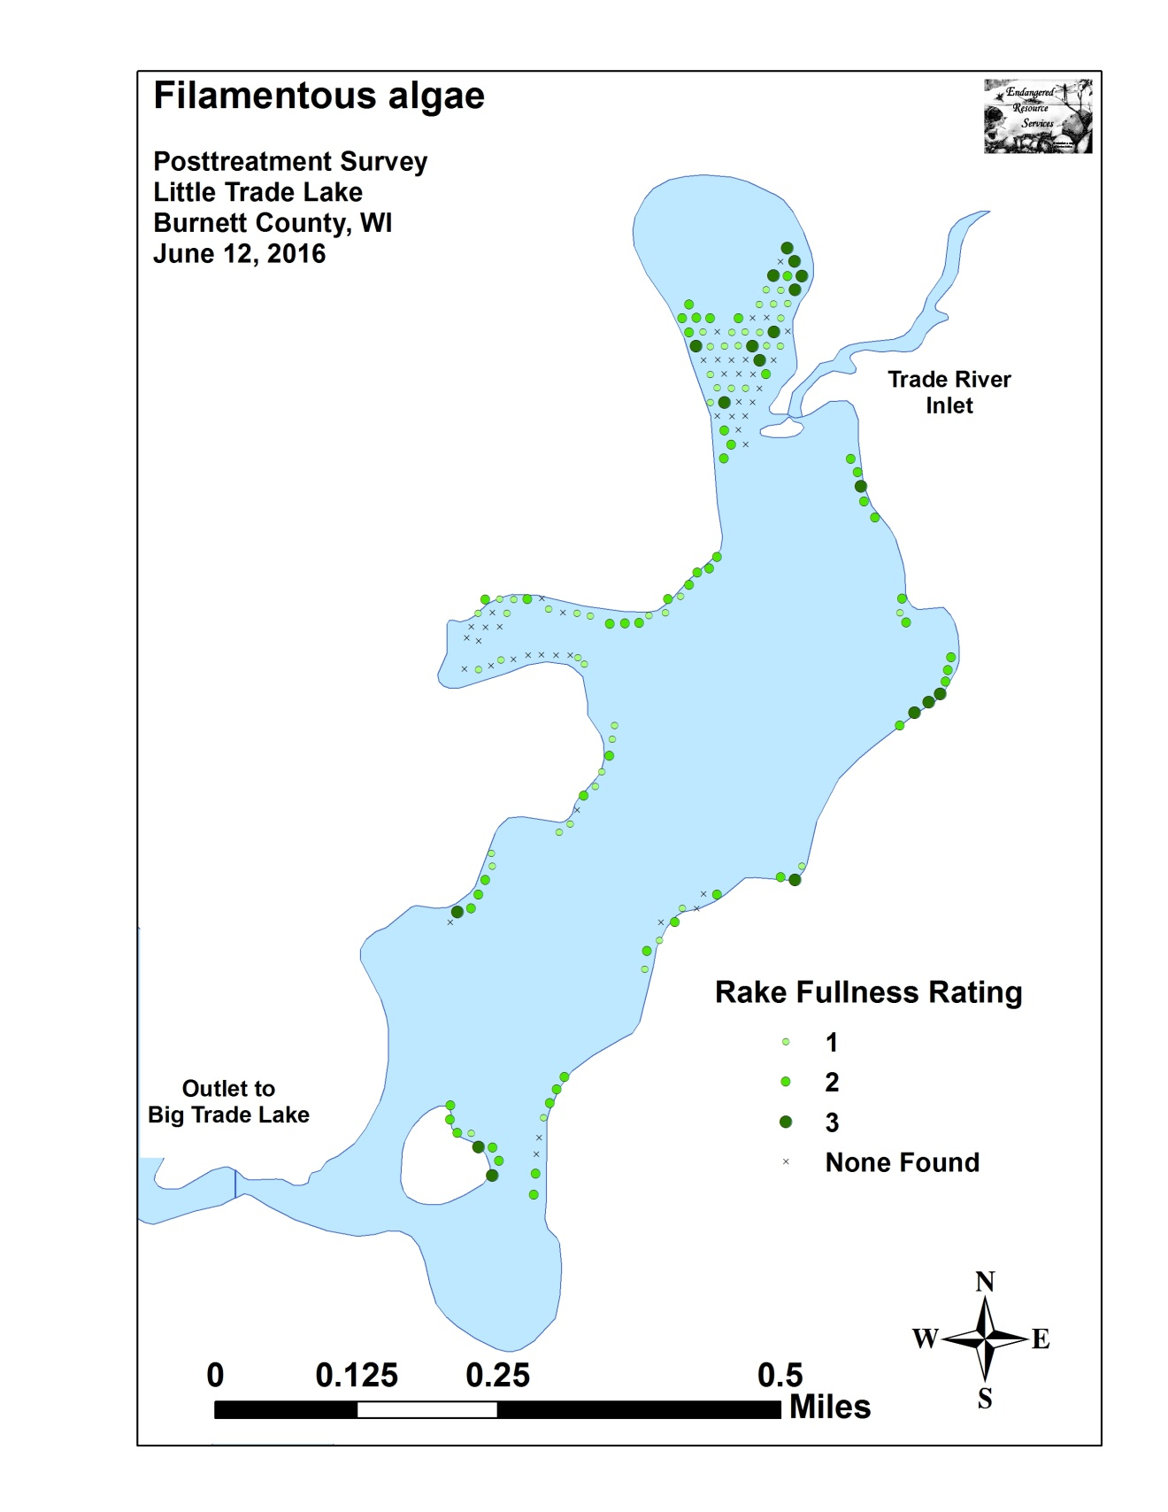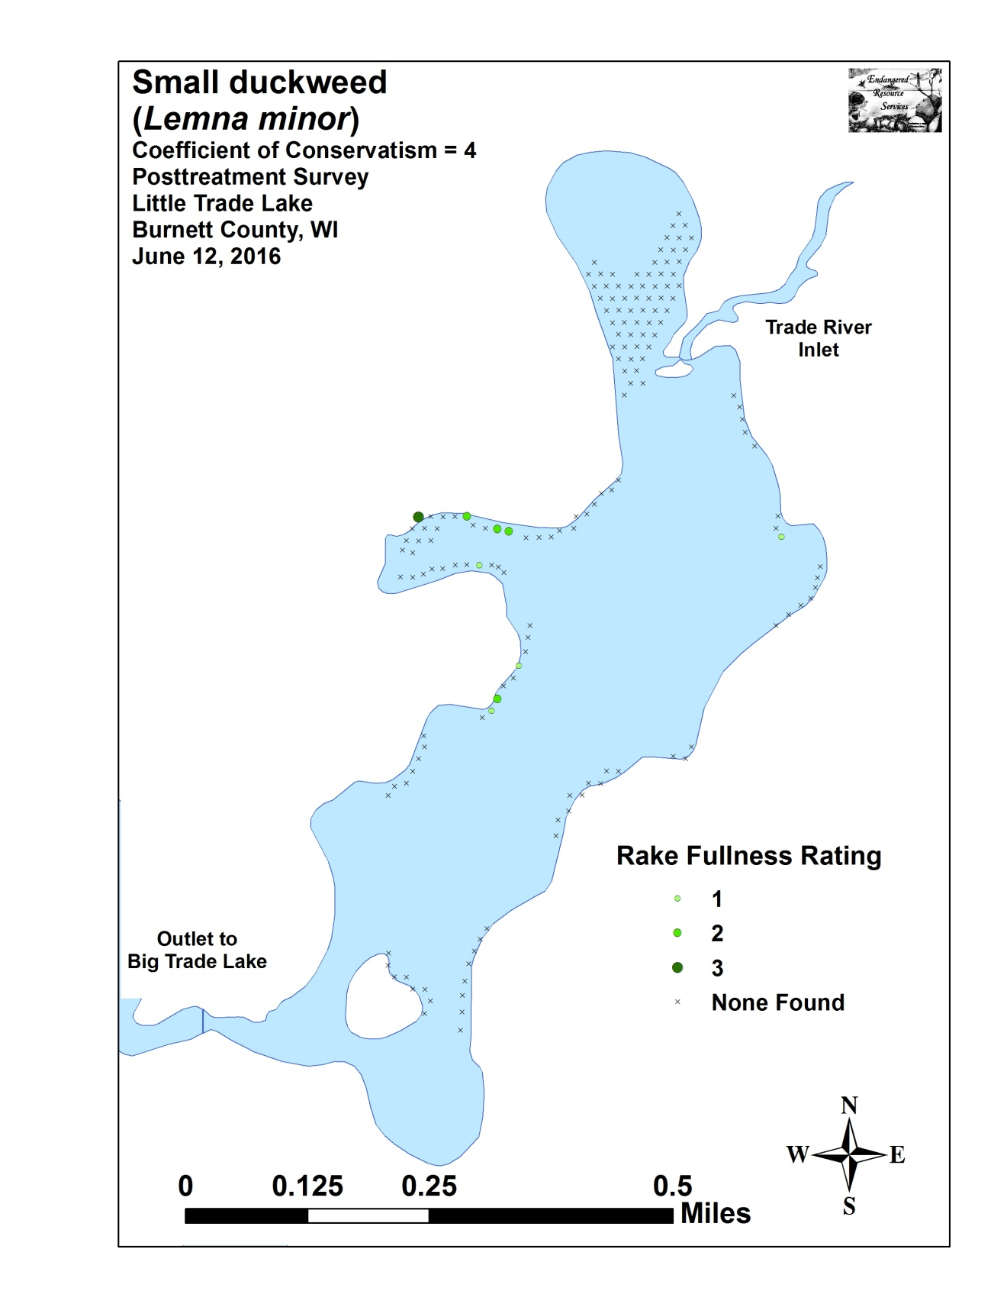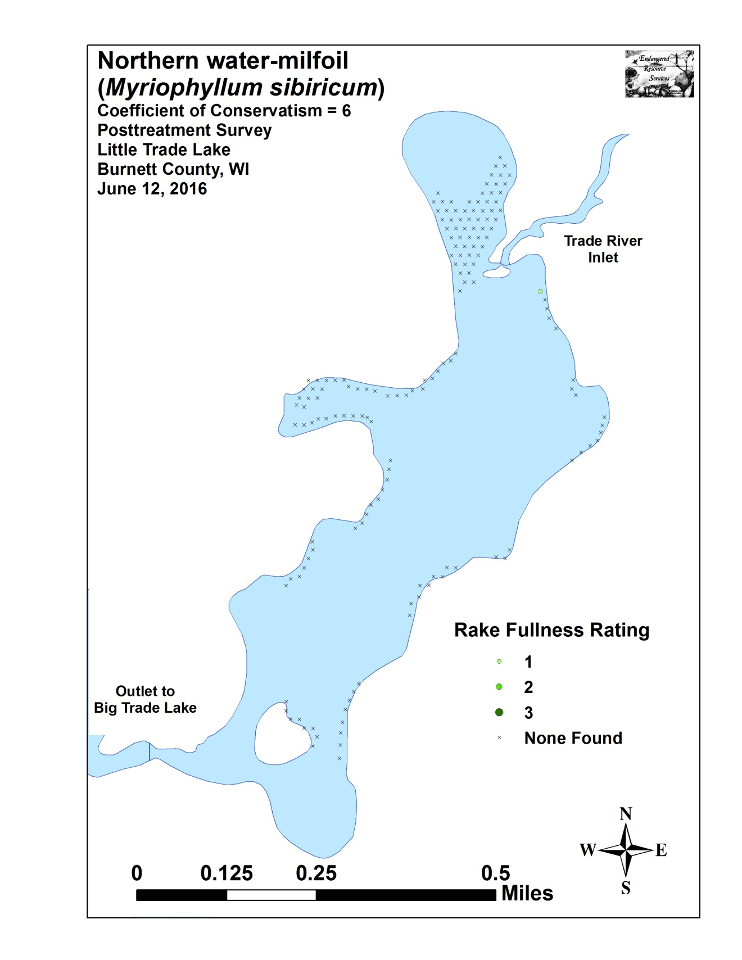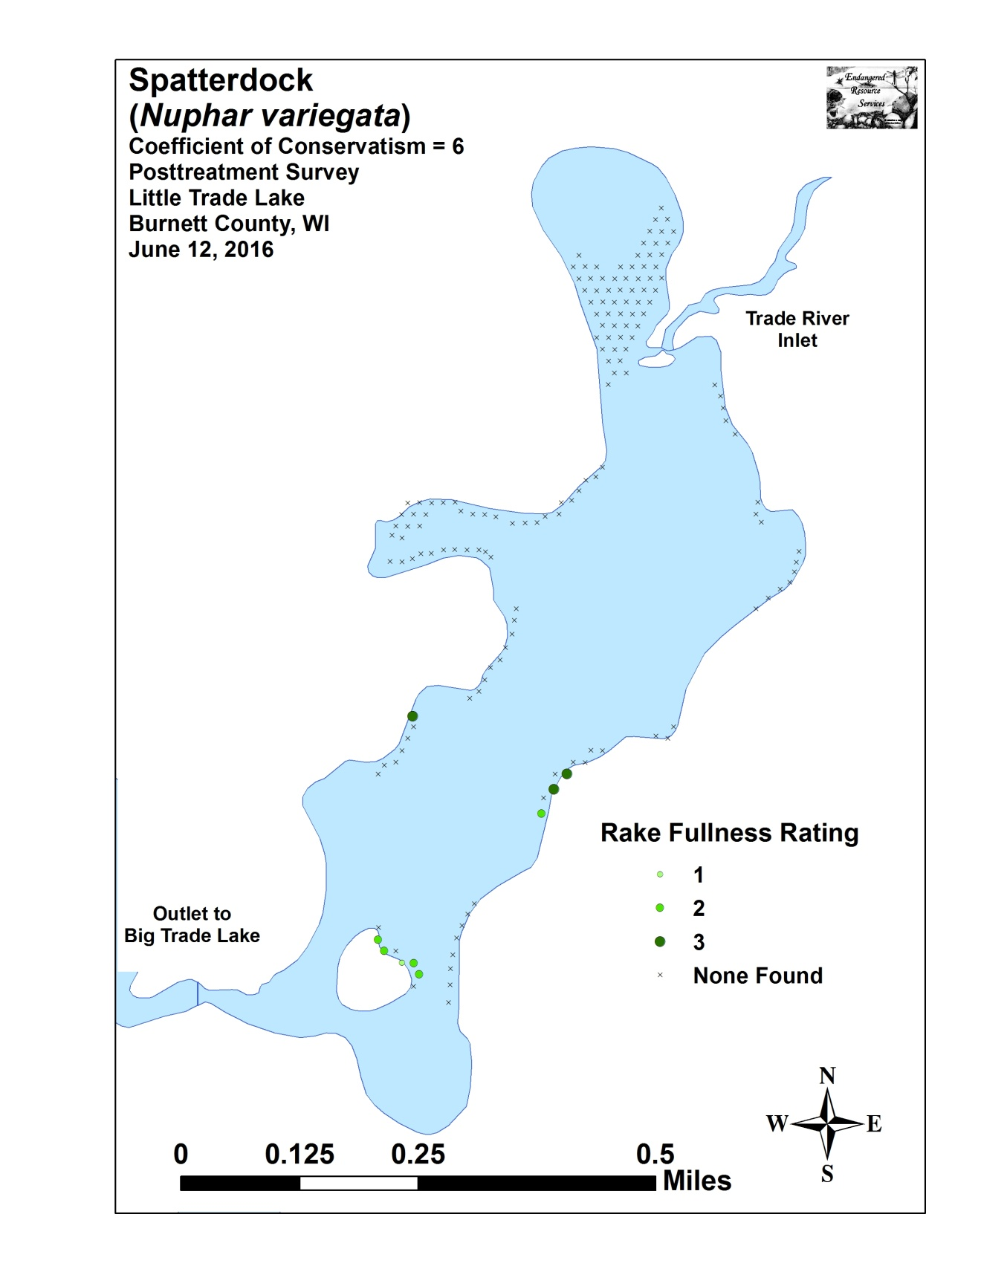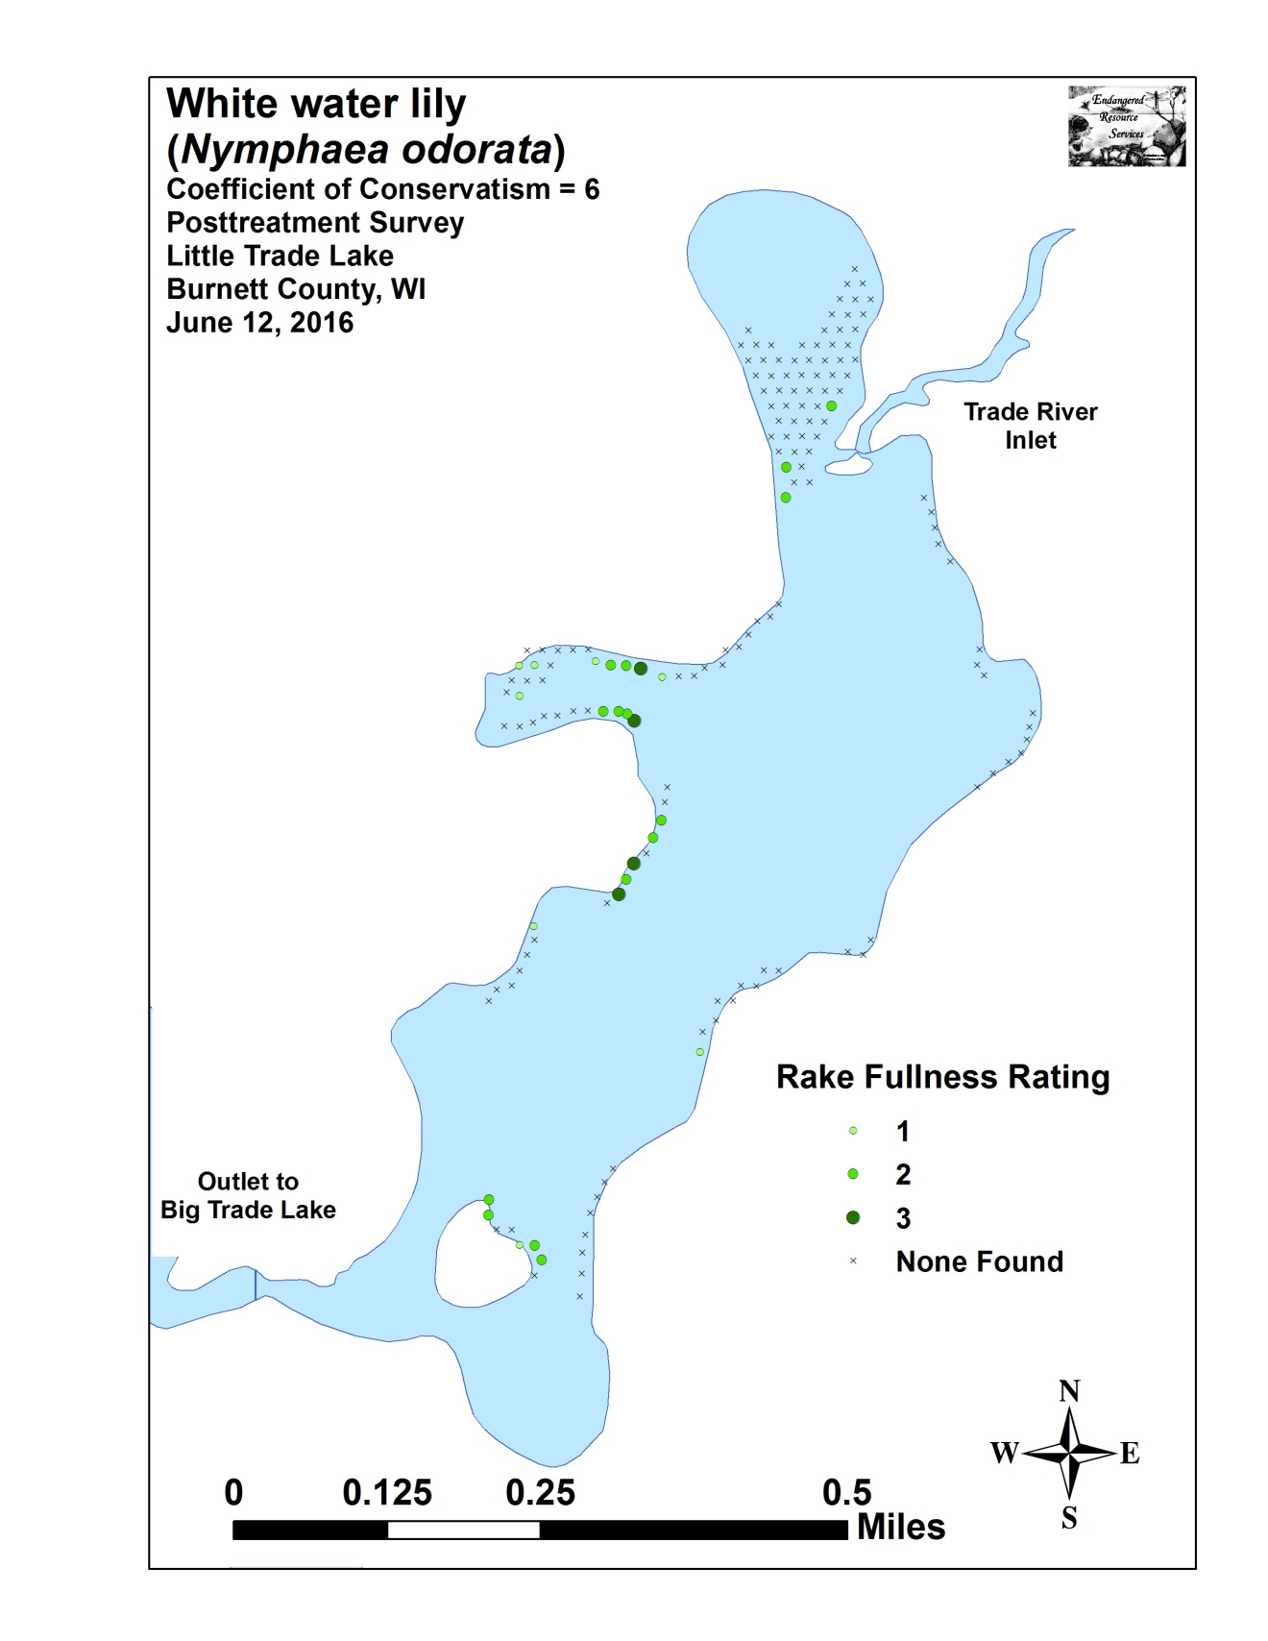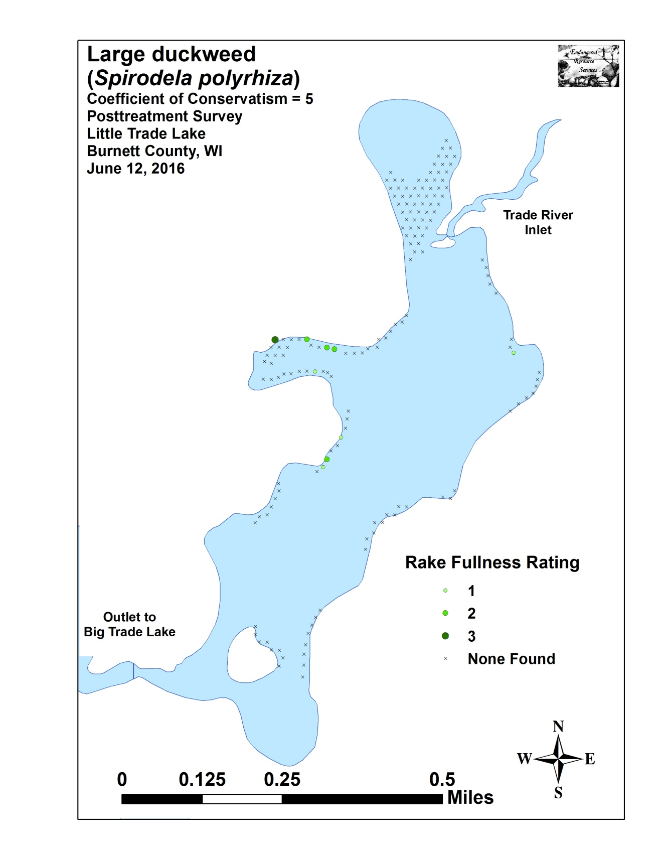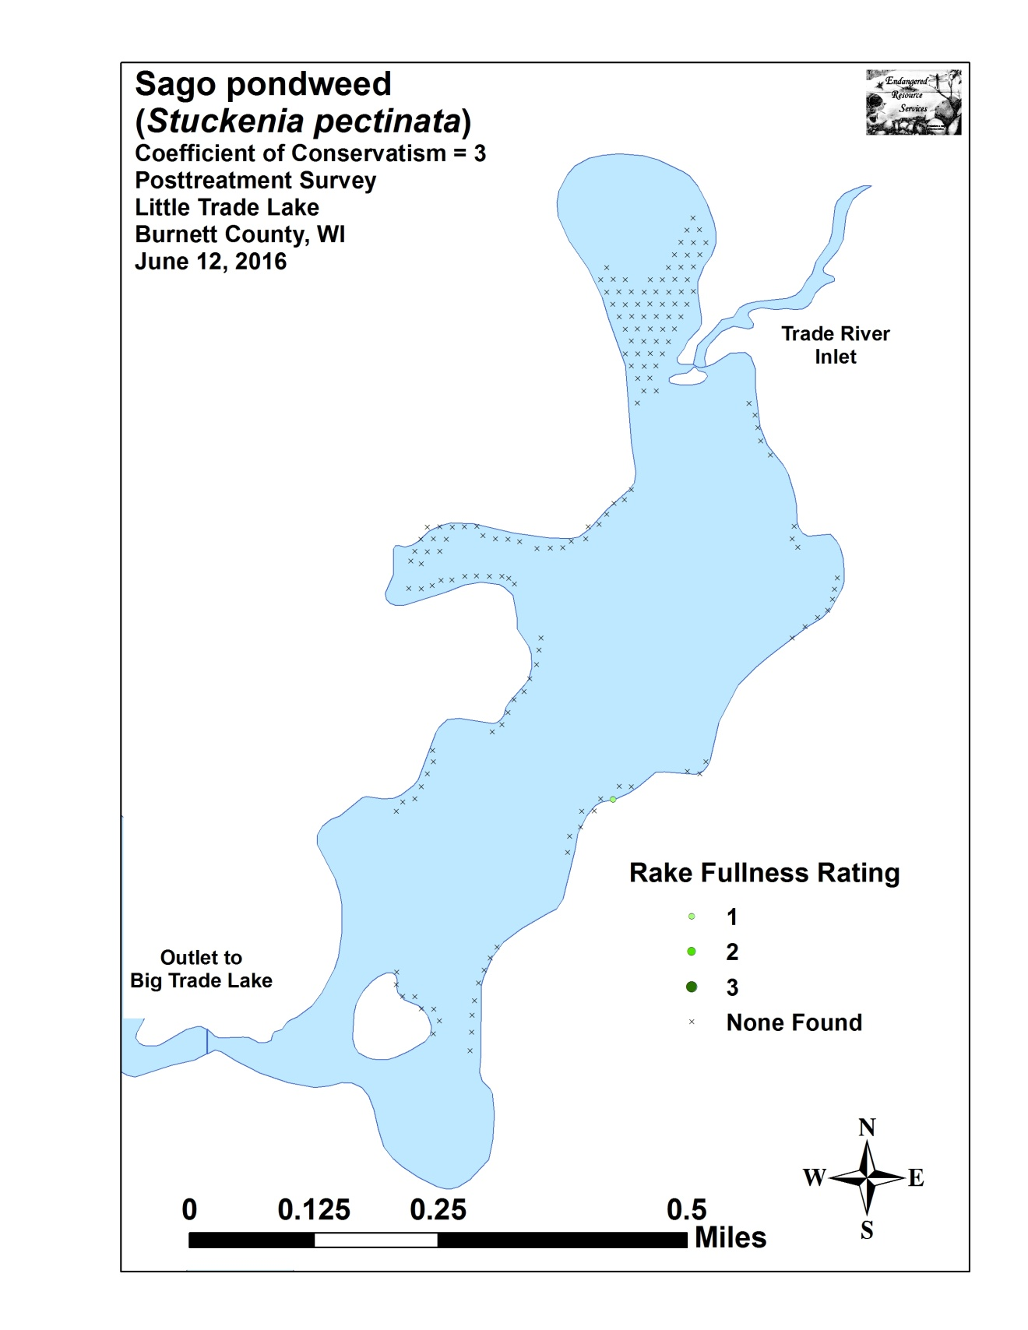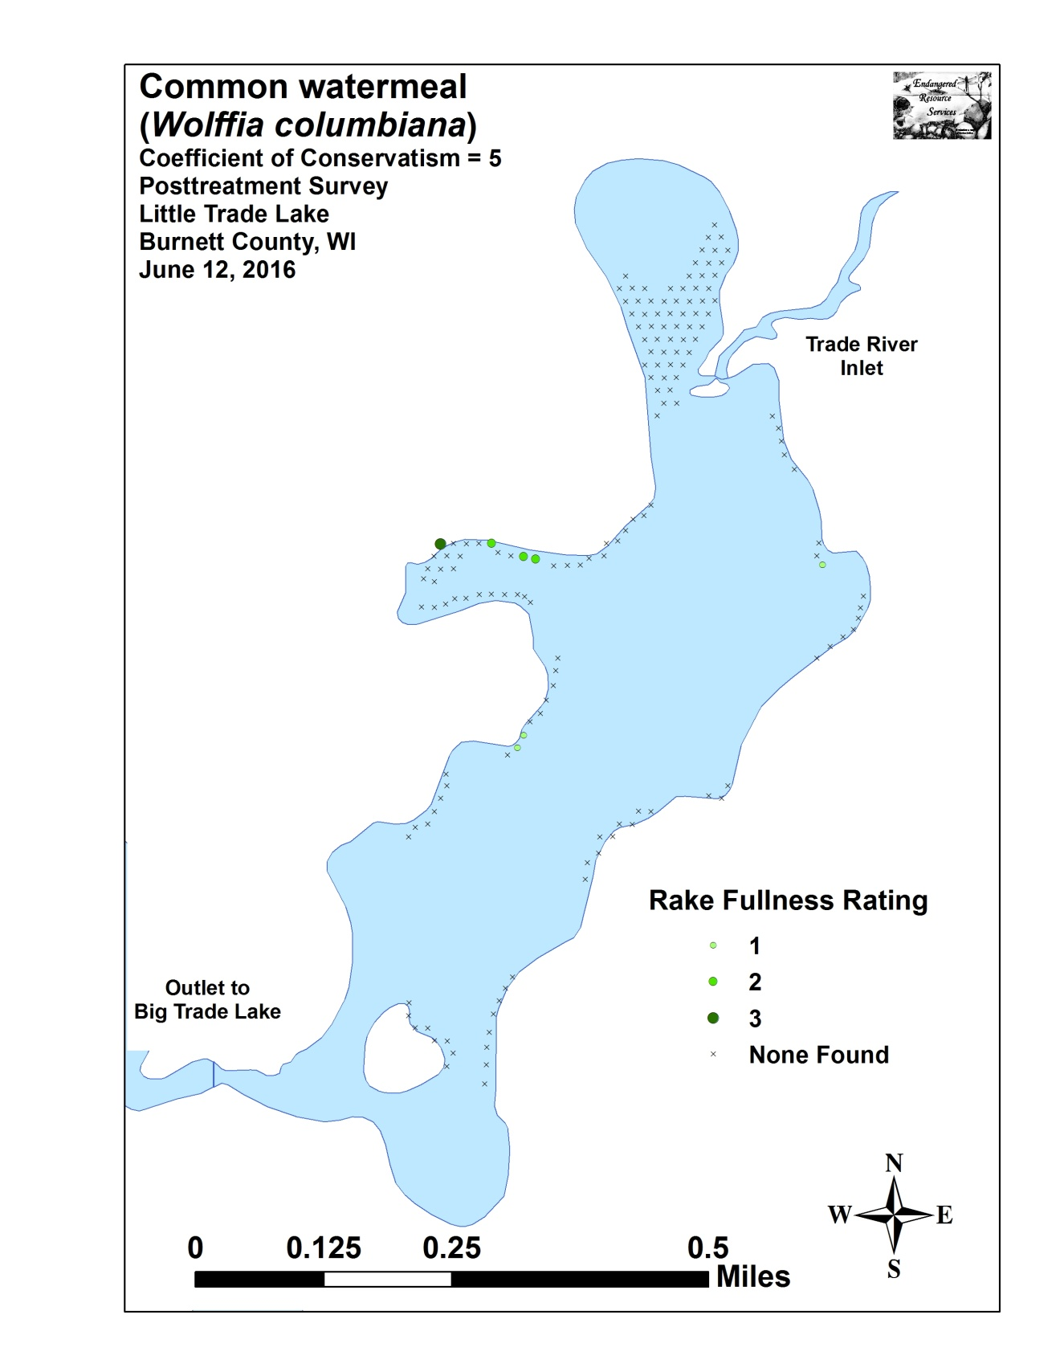

Appendix VIII: Fall 2015 and 2016 EWM Bed Maps
