Eurasian Water-milfoil Bed Mapping Survey
Red Lake (WBIC: 2492100)
Douglas County, Wisconsin

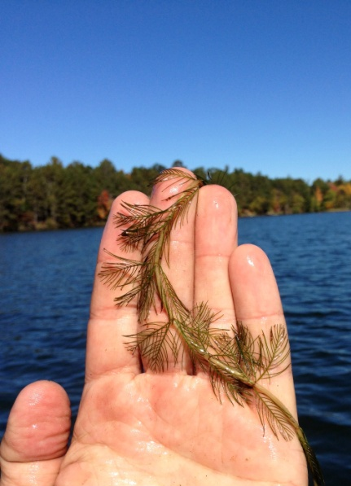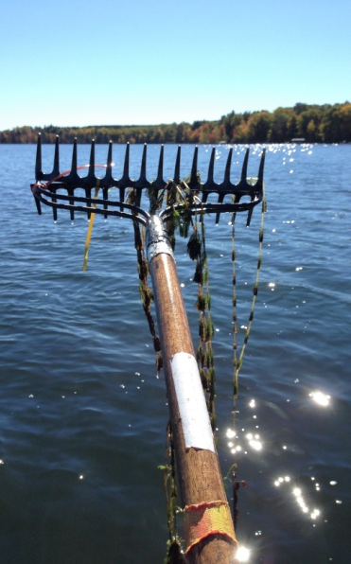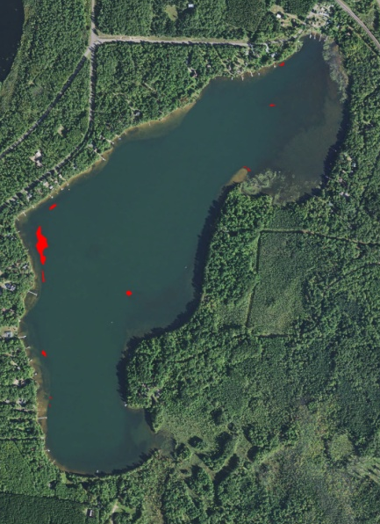
Red Lake Eurasian water-milfoil with >12 leaflet pairs/limp whorls out of water EWM Beds on Red Lake 10/2/16

Project Initiated by:
The Red Lake Association and the
Wisconsin Department of Natural Resources

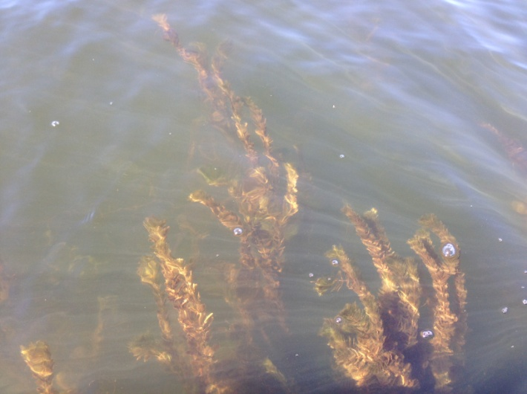
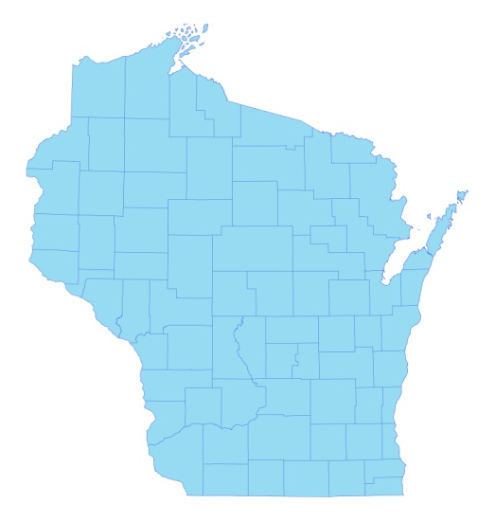

* Red Lake

Canopied EWM on Red Lake’s eastern flat 10/2/16

Survey Conducted by and Report Prepared by:
Endangered Resource Services, LLC
Matthew S. Berg, Research Biologist
St. Croix Falls, Wisconsin
October 2, 2016

TABLE OF CONTENTS

Page
LIST OF FIGURES AND TABLES……………………………………………….. ii
INTRODUCTION …..……..………………………………………………………. 1
METHODS……………………………..…………………………………………... 2
RESULTS ……………………..………………………………………………….... 3
Fall Eurasian Water-milfoil Bed Mapping……….….……………………… 3
Descriptions of EWM Beds.....……………………………………………… 4
DISCUSSION AND CONSIDERATIONS FOR MANAGEMENT…..…..…….… 7
LITERATURE CITED ……………………….…………………………….…….… 9
APPENDIX…. …….…………………………………………………….………….. 10
I: Fall 2016 Eurasian Water-milfoil Bed Map.……………….………………..... 10

LIST OF FIGURES AND TABLES

Page #
Figure 1: Red Lake Bathymetric Map.…………………………………………….. 1
Figure 2: Rake Fullness Ratings ………………………………………………….. 2
Figure 3: 2016 Fall EWM Bed Mapping Survey Transects.…….………................ 3

Figure 4: 2016 Fall EWM Bed Map – EWM Plant from Bed 5..……….………... . 4

Figure 5: Typical EWM Density in Bed 7 – East Midlake Flat…..……….………. 5

Table 1: Fall Eurasian Water-milfoil Bed mapping Summary
Red Lake, Douglas County October 2, 2016…………..……………………….…... 6

Figure 6: EWM and Northern Water-milfoil Identification……...……….……….. 7

Figure 7: Limp Nature of EWM Leaflets along Stem – Stiff Nature of NWM
Leaflets along Stem and Overwintering Turions – October 2016…....……….……. 8

INTRODUCTION:
Red Lake (WBIC 2492100) is a 253 acre stratified seepage lake located in the Town of Wascott in south-central/southeastern Douglas County (T43N R11W S21, 28, 29, 32). The lake reaches a maximum depth of 37ft in the deep hole on the south end of the central basin and has an average depth of 11ft (WDNR 2009). Red Lake is mesotrophic in nature and water clarity is good with Secchi readings averaging 10.9ft from 1993-2016 and 11.5ft in 2016 (WDNR 2016). This produced a littoral zone that extended to at least 20ft in the fall of 2016. The shoreline is dominated by sand with most areas transitioning to sandy muck at depths beyond 10ft. The lake’s only nutrient rich organic muck occurs in areas adjacent to the tamarack bogs near the small bay in the far southeast corner and on the north and south ends of the northeast bay (Holt et al. 1973) (Figure 1).

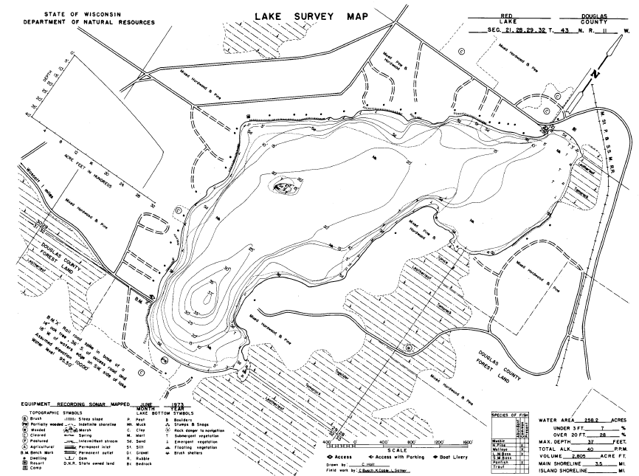
Figure 1: Red Lake Bathymetric Map

On July 25, 2013, at the request of the Red Lake Association (RLA) and the Wisconsin Department of Natural Resources (WDNR), we conducted the original warm-water point-intercept survey of all aquatic plants in Red Lake. This extensive study established base-line data on the richness, diversity, abundance, and distribution of the lake’s aquatic plant populations. At that time, we also found no evidence of Eurasian water-milfoil (Myriophyllum spicatum) (EWM), an invasive exotic aquatic plant, anywhere in the lake.

Unfortunately, in July 2016, biologists from the Great Lakes Indian Fish & Wildlife Commission (GLIFWC) found a few EWM plants near the public boat landing on the lake’s southwest side and near the Red Lake Resort in the northeast bay. A follow-up survey by WDNR also found plants in these areas. In order to quantify the level of infestation, the WDNR and RLA requested that we systematically search the lake and, if possible, rake remove any EWM found. This report is the summary analysis of that survey conducted on October 2, 2016.
METHODS:
Fall Eurasian Water-milfoil Bed Mapping:
We searched the visible littoral zone of the lake in overlapping visual transects and mapped all known beds of EWM. A “bed” was determined to be any place where we visually estimated that EWM made up >50% of the area’s plants and was generally continuous with clearly defined borders. After we located a bed, we motored around the perimeter of the area; took GPS coordinates at regular intervals; estimated the rake range and mean rake fullness rating of EWM within the bed (Figure 2); recorded the depth range and mean depth EWM was growing at, and noted whether it was canopied or not. Using the WDNR’s Forestry Tool’s Extension to ArcGIS 9.3.1, we then generated bed shapefiles with these coordinates and determined the acreage to the nearest hundredth of an acre. As this was a new infestation, we also marked and attempted to rake remove any individual plants found outside the beds as they were generally few in number.

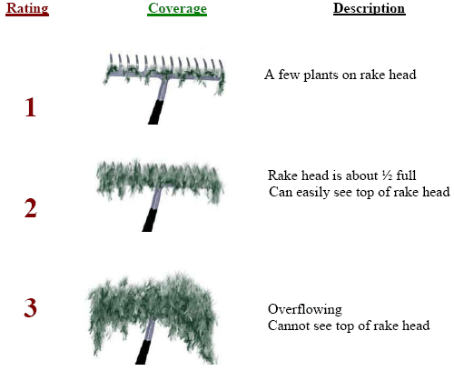
Figure 2: Rake Fullness Ratings

RESULTS:
Fall Eurasian Water-milfoil Bed Mapping:
During the survey, we had bright overhead sun, and winds were calm or nearly calm making for excellent survey conditions as it allowed us to easily find canopied beds. Overall clarity, however, was only fair as the water was somewhat “milking”, and we could only see the bottom clearly in 5-7ft meaning short plants in deep water may have gone unnoticed. In total, we searched over 34km (21 miles) of transects within Red Lake’s visible littoral zone (Figure 3).

Figure 3: 2016 Fall EWM Bed Mapping Survey Transects

Along these transects, we located and mapped ten Eurasian water-milfoil beds ranging in size from <0.01 acre (Beds 1 and 2) to 0.83 acre (Bed 5) (Figure 4) (Appendix I). In total, these beds covered 1.18 acres or approximately 0.45% of the lake’s surface area (Table 1). The vast majority of plants in Beds 1-7 were established in 8-11ft over sandy muck on the outer edge of the rooted littoral zone. At least early on in the infestation, this appeared to be the ecological niche where EWM had a significant competitive advantage and was having the easiest time establishing. Once well-established, as in Beds 4 and 5, EWM continued to expand inward as we documented it in increasingly shallow waters down to 4ft deep in these areas.

In the northeastern bay where there were extensive native plant beds, Eurasian water-milfoil was much less common. It is possible EWM was having a harder time establishing in this more competitive environment, but it also may have simply been that these were early pioneer plants and there hadn’t been enough time for them to expand beyond the few micro-beds and satellite plants we found.

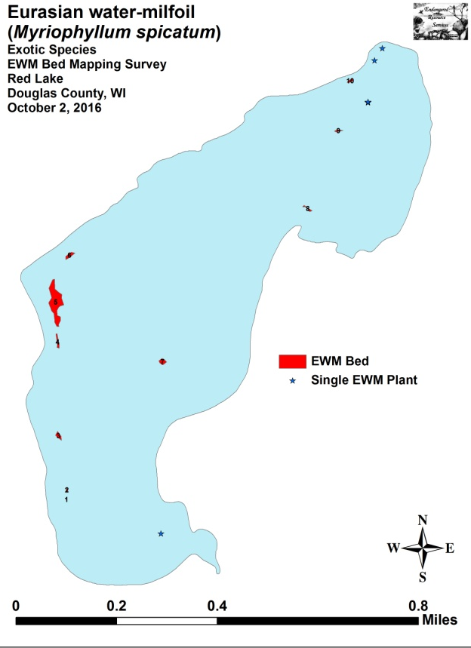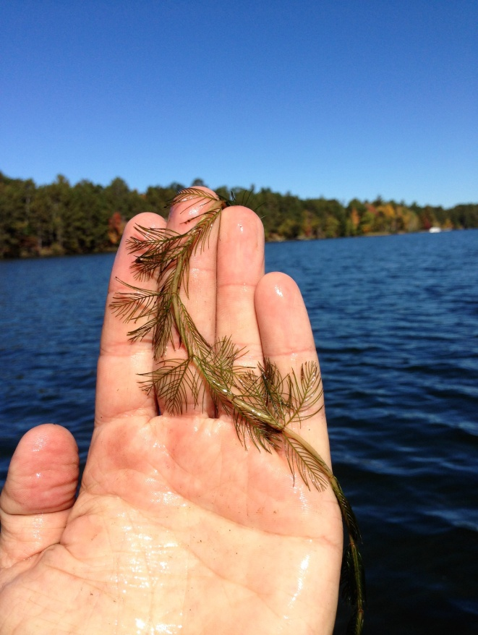
Figure 4: 2016 Fall EWM Bed Map – EWM Plant from Bed 5

Descriptions of EWM Beds:
Beds 1, 2 and 3 – Although the shoreline and associated shallow sand flats along the western shoreline meander back and forth, the drop-off into 10ft+ tends to be rather sudden and is much more linear from north to south. Along this edge in 8-11ft of water, we found three small beds of EWM growing in a relatively narrow band to the edge of the rooted plant littoral zone (Coontail (Ceratophyllum demersum) and Nitella (Nitella flexilis) were found in up to 20ft, but they lack roots and tend to lie flat along the bottom in this type of deep water habitat). Interestingly, Common loons (Gavia immer) were seen foraging around each of these beds. As in other lakes with low levels of EWM, we’ve learned that loons can be reliable help in finding small beds of EWM in deep water as the vertical structure EWM provides tends to hold bait fish which the loons key in on.

Bed 4 – Although most of this bed’s EWM was growing along the 8-10ft contour ring, plants were spreading inward toward the shallows, and we found regular scattered towers in as little as 4ft of water. Located directly south of Bed 5, these two areas were almost connected, and, because of this, we expect pioneer sprouts will eventually grow to merge them into one large bed if left unchecked.

Bed 5 – We found this bed to be by far the worst area on the lake. At its core on the north end, EWM formed a solid canopied mat in 8-11ft, was full of prop-clipped plants, and was becoming an impairment to navigation that forced boaters to go around rather than through. Although the canopied bed ended abruptly on the outer edge, similar to Bed 4, scattered towers were found spreading into the shallow flats to the west.
Bed 6 – This appeared to be the youngest deep-water bed in the lake as the overall mean density was low and plants were often difficult to locate as most of them were at least 3-4ft below the surface. Raking around the perimeter revealed that there were other short new pioneer plants just beyond what we can see. This raised the possibility and perhaps likelihood that there are additional plants/micro-beds that are just out of view along the 8-11ft bathymetric ring between Beds 4, 5, and 6.

Bed 7 – This bed was the second worst area on the lake in term of both size and density. Canopied at its core in 9ft of water (Figure 5), several plants had been prop-clipped, and, with an abundance of similar habitat in the broad eastern flat of the lake, we believe this bed has to potential to expand rapidly in 2017.

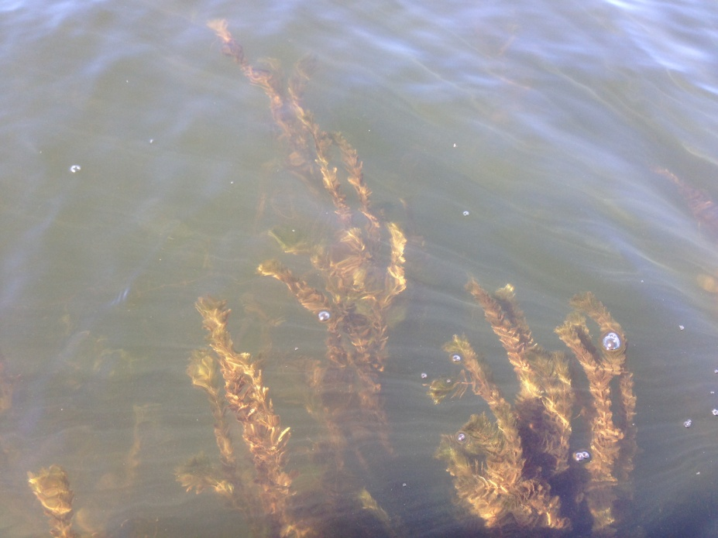
Figure 5: Typical EWM Density in Bed 7 – East Midlake Flat

Beds 8, 9 and 10 – These three micro-beds occurred in the northeast bay in generally shallow water from 5-7ft deep. Each was more of a cluster of EWM towers than a solid bed. In general, most plants were only a couple of feet tall and had not canopied, contained one or just a few stems, and had a poorly developed root system. All of these factors suggested to us they were likely recent pioneer plants. Because of this presumed recency, and because we saw many floating EWM fragments that had been blown into this bay by the prevailing southwest winds, it is possible, and perhaps likely that many more EWM “sprouts” will appear here by spring 2017.
Table 1: Fall Eurasian Water-milfoil Bed Mapping Summary
Red Lake, Douglas County
October 2, 2016

Bed Number | 2016  Area in Acres | Canopied | Depth Range and Mean Depth (ft) | Rake Range and Mean  Rake Fullness | Field Notes
1 | <0.01 | Near | 9-11; 10 | 2-3; 2 | EWM about 2ft below surface
2 | <0.01 | Near | 8-10; 9 | 1-3; 1 | EWM about 2ft below surface; majority in 9ft
3 | 0.06 | Near | 8-10; 9 | 1-3; 1 | EWM about 2ft below surface; majority in 9ft
4 | 0.06 | Near | 4-10; 9 | 2-3; 2 | Scattered inner border becoming dense in 8-10ft
5 | 0.83 | Yes | 4-11; 9 | <1-3; 2 | Worst area; highest density on north end of bed
6 | 0.07 | Near | 9-11; 10 | <1-3; 1 | Most EWM 3-4ft below surface; plants 6-7ft tall
7 | 0.07 | Yes | 8-10; 9 | 1-3; 2 | Small dense bed canopied at core in 9ft
8 | 0.03 | Near | 5-7; 6 | <<1-1; 1 | EWM 2ft below the surface – no assoc. deep bed
9 | 0.03 | Near | 5-7; 6 | <<1-1; 1 | Scattered towers – no associated deep bed
10 | 0.03 | Near | 5-7; 6 | <<1-2; 1 | Most EWM 2-3ft below the surface
Total | 1.18

DISCUSSION AND CONSIDERATIONS FOR MANAGEMENT:
Eurasian water-milfoil is well-established in Red Lake making eradication an unrealistic expectation. With this in mind, controlling its spread in the most cost effective manner possible while simultaneously minimizing its impact on the lake’s aquatic ecosystem will likely be the lake association’s primary goal moving forward. To meet this goal in the short term, we believe that some form of management is warranted in early 2017. If chemical treatment is decided upon, one of the challenges will be that most EWM is established in 8-11ft of water and immediately adjacent to areas that routinely plunge to over 20ft making dilution a significant concern. How to best manage these conditions will require a group discussion between the WDNR, the lake association, and a potential applicator.

Also complicating control is the fact that Red Lake has a significant amount of the very similar looking Northern water milfoil (Myriophyllum sibiricum) – a valuable native plant that provides important fish habitat and is likely to be heavily impacted by chemical treatment. NWM is widely distributed throughout the lake’s rooted littoral zone, but does best over sandy and organic muck. Despite its superficial resemblance to EWM, Northern water milfoil can be told apart by its leaflets numbering <24 that are usually held rigidly at 90 degree angles off the stem when out of water. Conversely, EWM normally has >26 leaflets that fall limp against the stem when out of water (Figure 6). EWM also tends to have a bright red growth tip on the top of the plant whereas NWM has a bright lime green growth tip. NWM on Red Lake is often mixed with other plants, is seldom bed-forming, and rarely canopies on the surface; whereas EWM was often found in nearly monotypic beds that excluded most native species and canopied even in deep water. In the fall, NWM also forms winter buds on the tips of shoots whereas EWM has none. These buds were readily visible during the October survey (Figure 7).

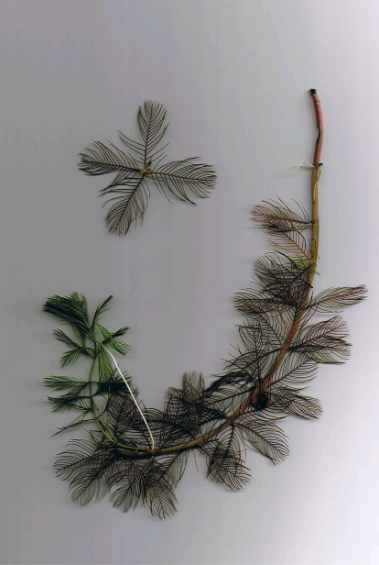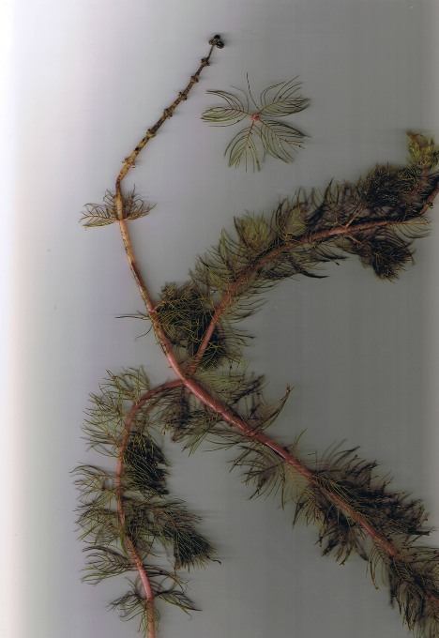
Eurasian water milfoil
Northern water milfoil
Figure 6: EWM and Northern Water-milfoil Identification (Berg 2007)
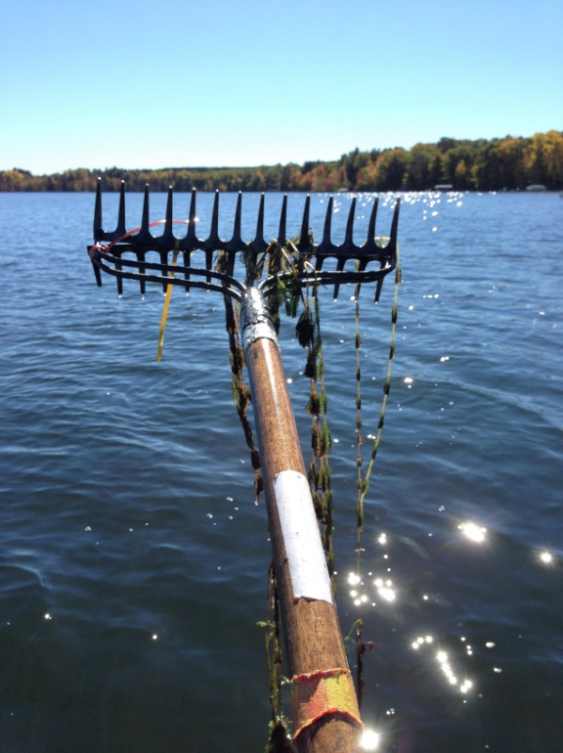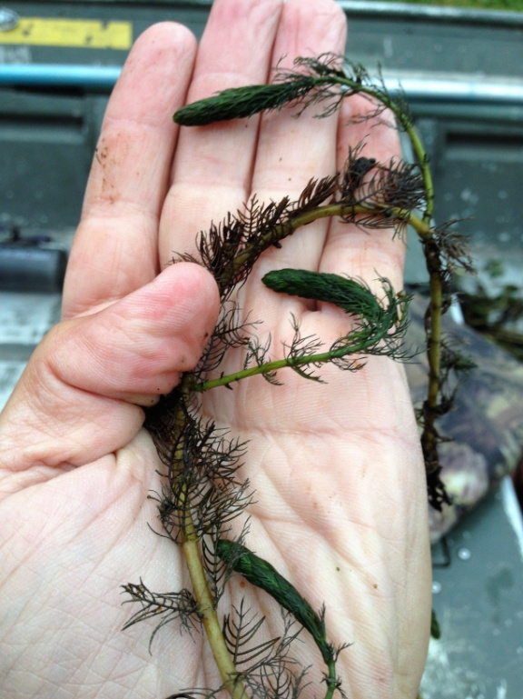
Figure 7: Limp Nature of EWM Leaflets along Stem –
Stiff Nature of NWM Leaflets along Stem and Overwintering Turions
October 2016

Although EWM currently occupies only a small percentage of the lake’s surface area and is much less common than NWM, the results of our survey suggest it is spreading rapidly. Based on the number of beds already established as well as the number of floating fragments we observed on the lake, we believe it is likely that even more EWM will be found during the 2017 growing season. Based on this expectation, we encourage all residents on Red Lake to be on the lookout for new beds and promptly contact us (saintcroixdfly@gmail.com and/or 715-338-7502) with a picture, specimen, description of, and/or preferably GPS coordinates of anything they find that looks suspicious. These locations could then be added to the existing map for management consideration.

LITERATURE CITED

Holt, C, C. Busch, K. Cable, and L. Sather. [online]. 1973. Red Lake Bathymetric Map. http://dnr.wi.gov/lakes/maps/DNR/2492100a.pdf (2016, October).

WDNR. [online]. 2016. Wisconsin Lake Citizen Monitoring Data for Red Lake - Douglas County. Available http://dnr.wi.gov/lakes/waterquality/Station.aspx?id=163383 (2016, October).

Appendix I: Fall 2016 Eurasian Water-milfoil Bed Map

