TARGETED WATERSHED ASSESSMENT
FOR THE
SOUTH FISH CREEK WATERSHED, 2015

Introduction

The South Fish Creek watershed is located in Bayfield County, Wisconsin (figure 1). The watershed center is located about 8 miles southwest of the City of Ashland. South Fish Creek merges with North Fish Creek to form Fish Creek, which flows for 1.3 miles and discharges into Chequamegon Bay of Lake Superior.

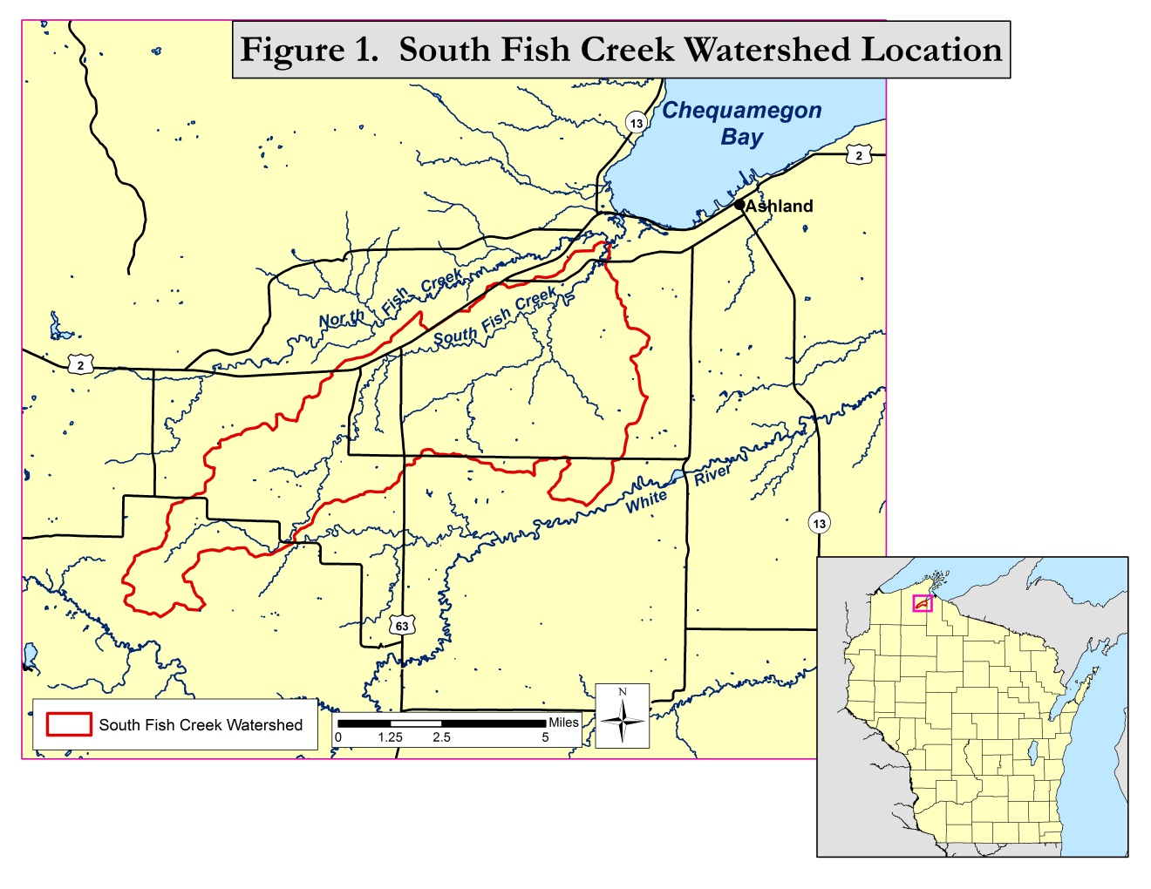

A targeted watershed assessment was conducted in 2015 to establish baseline conditions for the watershed streams. A confined animal feeding operation (CAFO) is proposed for the watershed and may have the potential to substantially alter current stream conditions.(delete?)

Watershed Characteristics

Watershed Size and Land Use

The South Fish Creek watershed has an area of 42.4 mi² (27,128 acres). Watershed land use is shown in figure 2 and table 1. Slightly more than half (58.7%) of the watershed has undeveloped land uses (forest, wetland, grassland/herbaceous). Pasture/hay is the largest developed land use (33.8%). Only 2.9% of the watershed is cultivated cropland.

Watershed Soils

Watershed soils are shown in figure 3 and table 2. The four most common soil mapping units are:

- 480B (34.5%) Portwing-Herbster complex
- 580B (20.6%) Sanborg-Badriver complex
- 756B (8.2%) Superior-Sedgwick complex
- 713B (8.2%) Kellogg-Allendale-Ashwabay complex

The two most common units (480B and 580B; 55% of watershed) have surficial soil textures of silt loam or clay loam. An underlying clay layer begins 9 to 17 inches below the soil surface. Depth to water table ranges from 0 to 12 inches below the surface. The runoff class is high.

The third and fourth most common units (756B and 713B; 16% of watershed) have coarser surficial textures ranging from fine sandy loam to loamy sand. For the Superior-Sedgwick complex (756B) - an underlying clay layer begins at 14 to 16 inches below the surface; depth to water table is 6 inches below the surface; runoff class is very high. For the Kellogg-Allendale-Ashwabay complex (713B) – an underlying clay or silty clay layer begins at 26 to 45 inches below the surface; depth to water table is 6 to 30 inches below the surface; runoff class is very low.

Hydrologic soil groups are shown in figure 4. The majority of soils are included in hydrologic soil group D. These are soils having a very slow infiltration rate and a high runoff potential when thoroughly wetted. The widespread presence of shallow subsurface clay layers in the watershed is the primary cause of this condition.

Watershed Hydrology

Due to the shallow subsurface clay layers, South Fish Creek flows are dominated by surface runoff. Relatively small contributions to streamflow are from groundwater discharge. This produces a flashy stream with very high flows following runoff events and very low base flows. During 2015 South Fish Creek was observed to have no surface flow above County highway F during most of the summer and early fall. Only standing pools of water were present. Base flow near the Creek mouth was only 1.5 cfs on August 8th, 2015. (Northland College operated a continuous flow gaging station on South Fish Creek at Colby Road (6.8 miles upstream of the stream mouth) during 2014 and 2015. Flow records for that station will be available in the near future. (and unnamed trib at Colby Rd)).

Stream Assessment Methods

Six monitoring sites for the watershed (figure 5) were selected to conduct fish community surveys, macroinvertebrate sampling, and water quality monitoring.

Fish communities were assessed by electrofishing with one or two backpack shockers, depending on stream width at the site. As many fish as possible were captured with a single upstream pass. Station lengths were 35 times the mean stream width, with a minimum length of 100 meters. Fish captured were counted and identified to species. Fish community data was used to determine the natural community of the stream, and to calculate biotic indices.

Macroinvertebrate communities were assessed by collecting kick samples from riffles, using a 500 um mesh D-frame net. Samples were preserved in 85% ethanol and were processed by UW – Superior’s Aquatic Biomonitoring Lab. Macroinvertebrates were counted and identified to the lowest possible taxa. Biotic indices and other statistics were generated.

Water samples were collected and field parameters were measured following standard DNR protocols. Water samples were preserved, as needed, and shipped on ice to the Wisconsin State Lab of Hygiene for analysis. Field parameters measured were:

- Temperature
- pH
- Dissolved Oxygen
- Conductivity
- Transparency (using a transparency tube)

Lab parameters tested were:

- Total Phosphorus
- Total Nitrogen
- Total Suspended Solids

Water quality field and lab parameters were measured on one summer date, at the time of the fish surveys. Field parameters were also measured on a second date, when aquatic macroinvertebrate samples were collected. More extensive water quality monitoring was conducted at three of the stream sites by Northland College during 2015. That data will be available in the near future.

Findings

Fish Surveys

A summary of fish survey data is shown in table 3. Full fish survey data and natural community assessments are shown in table 4.

Four of the seven sites had intermittent flow, and no surface flow was occurring at the time of the surveys. Fish were restricted to standing pools of water. Some limited sub-surface flow between pools was probably seeping through stream channel bed materials (hyporheic flow).

The number of fish species found ranged from 6 to 19. The two sites with the least species (6 and 8) are intermittent flow sites. The site with the most species (South Fish Creek at STH 137; 19 species) is the most downstream site. It has the most flow and is closest to downstream water bodies such as Fish Creek and Chequamegon Bay.

Fish communities at all sites were dominated by forage fish species. The majority of forage fish were cool water (thermally transitional) species. Game fish or sport fish were uncommon. One brown trout was captured at South Fish Creek at Colby Road. One brown trout was also captured at South Fish Creek at STH 137. That site survey also captured one walleye, six yellow perch, and eight rock bass.

Young of year forage fish were observed at all sites including standing pools in intermittent segments. This indicates intermittent stream segments serve as nursery areas for these species.

Fish populations at all sites indicated cool water natural communities are present. Six of the sites are headwater communities, while the most downstream site (South Fish Creek at STH 137) is a mainstem community. A cool-warm or a cool-cold headwater natural community could be applied to four of the sites. Current DNR protocol does not effectively separate these two fairly similar communities in many cases.

Fish index of biotic integrity (IBI) scores ranged from 60 to 100, with ratings of fair to excellent. The “small stream” IBI (Lyons 2006) was applied to the six headwater sites. The cool-warm IBI (Lyons 2012) was applied to the mainstem site (South Fish Creek at STH 137). The IBI is an index that compares the existing structure, composition, and functional organization of the fish community with regional and habitat-specific expectations derived from comparable high quality ecosystems (Lyons, et al. 1996). IBI ratings of fair, good, or excellent indicate moderate to low levels of impairment to fish communities are currently resulting from human disturbances.

The majority of fish captured at all sites (56 - 93%) are considered to be “tolerant” to environmental degradation. The four sites with intermittent flows have the highest percentages of tolerant fish (84-93%). The most downstream site (South Fish Creek at STH 137) with the most flow has the lowest percentage of tolerant fish (56.5%). A high percentage of tolerant fish is a common feature of many small Lake Superior tributary streams with watersheds strongly influenced by clayey soils. These streams have very low base flows or are intermittent, and have chronic turbidity from suspended clay. These conditions, which are to some extent naturally occurring, are probably a primary reason for the high percentages of tolerant fish.

Macroinvertebrate Samples

Macroinvertebrate sample results are summarized in table 5. Macroinvertebtate index of biotic integrity (MIBI) values ranged from 4.48 to 7.88, with condition categories ranging from fair to excellent. The two most downstream sites (South Fish Creek at STH 137, and South Fish Creek at Colby Road) had the highest MIBI’s.

Hilsenhoff biotic index (HBI) values ranged from 3.02 to 7.01, with condition categories ranging from excellent to fairly poor. HBI’s reflect the amount of organic loading and the resultant availability of oxygen at a site. The site with the poorest HBI (South Fish Creek at CTH E) had no flow for several weeks in late summer and early fall. It also has a narrow channel with an abundance of reed canary grass overhanging channel edges. These factors probably contributed to the relatively poor HBI value.

Species richness ranged from 24 to 36 species. (any patterns?)

%EPT, %Chironomidae…

Water Quality

Water quality data collected during fish surveys and macroinvertebrate sampling is shown in table 6. (More extensive water quality monitoring was conducted at three of the stream sites by Northland College during 2015. Those three sites are South Fish Creek at STH 137, South Fish Creek at Colby Road, and Unnamed tributary to South Fish Creek at Colby Road. That data will be summarized and added to this report when available.)

Total phosphorus (TP) concentrations ranged from 110 – 262 ug/l. All samples exceed Wisconsin’s stream standard for TP concentration of 75 ug/l. Intermittent stream sites with standing pools of water had higher TP concentrations than the perennial stream sites with flowing water. Sample collection dates vary, which limits comparisons. However, this does indicate that TP is not settling out in standing pools. TP may be largely attached to suspended clay particles which have extremely long settling times. Biological activity by fish and wildlife might also contribute to sediment resuspension in pools.

Total nitrogen (TN) concentrations were moderate and ranged from 0.5 to 1.5 mg/l. Intermittent stream sites with standing pools of water also had higher TN concentrations than the perennial stream sites with flowing water.

Total suspended solids concentrations were moderate to high ranging from 5.6 – 29.3 mg/l and are probably largely due to suspended clay. Transparency measurements were low to moderate ranging from 18 to 89 cm, and are again largely influenced by suspended clay.

Summer dissolved oxygen concentrations ranged from 1.6 to 10.3 mg/l. The intermittent stream sites with standing pools of water had dissolved oxygen concentrations less than 5 mg/l (1.6 - 4.3mg/l), the water quality standard. The site with the lowest dissolved oxygen concentration (Unnamed tributary to South Fish Creek at Colby Rd.; 1.6 mg/l) had a good fish population present, including numerous young of year fish.

Conductivities were variable, ranging from 108 to 364 umhos/cm. Some of the variability is due to relative water contributions from surface runoff and groundwater. Runoff typically has much lower conductivities than groundwater. The pH values ranged from 6.5 to 8.2.

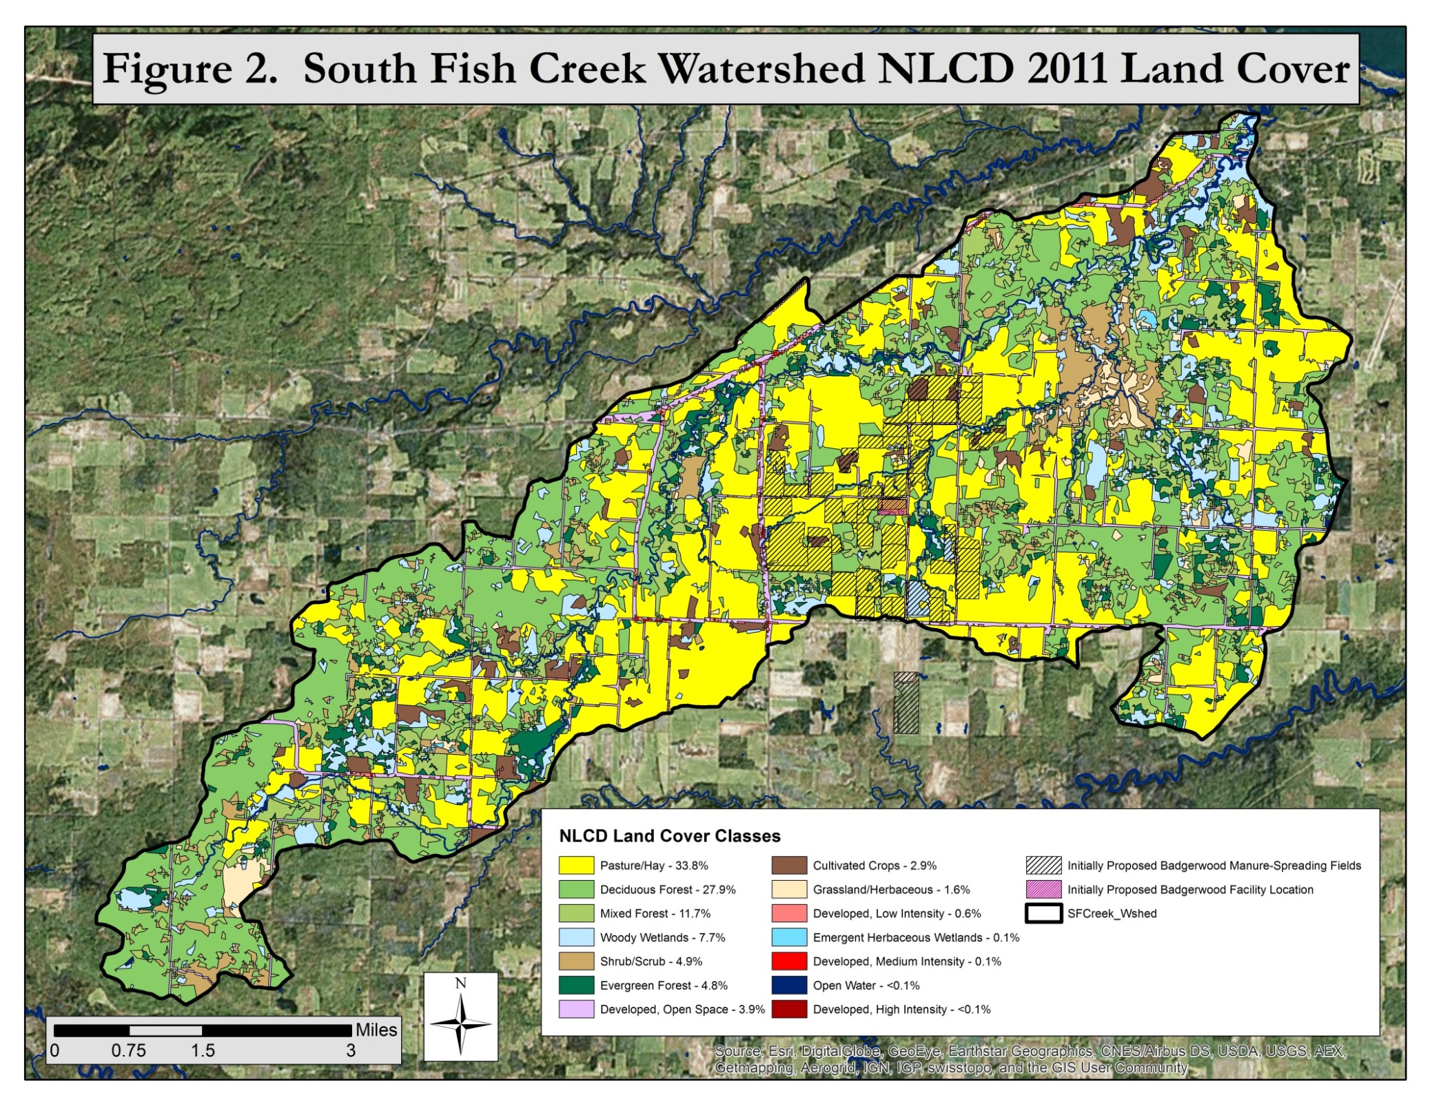
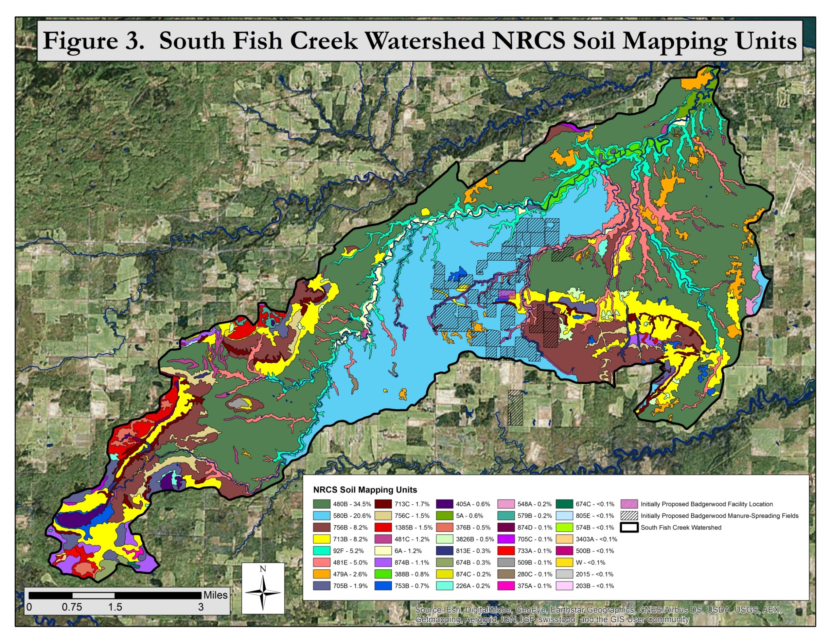
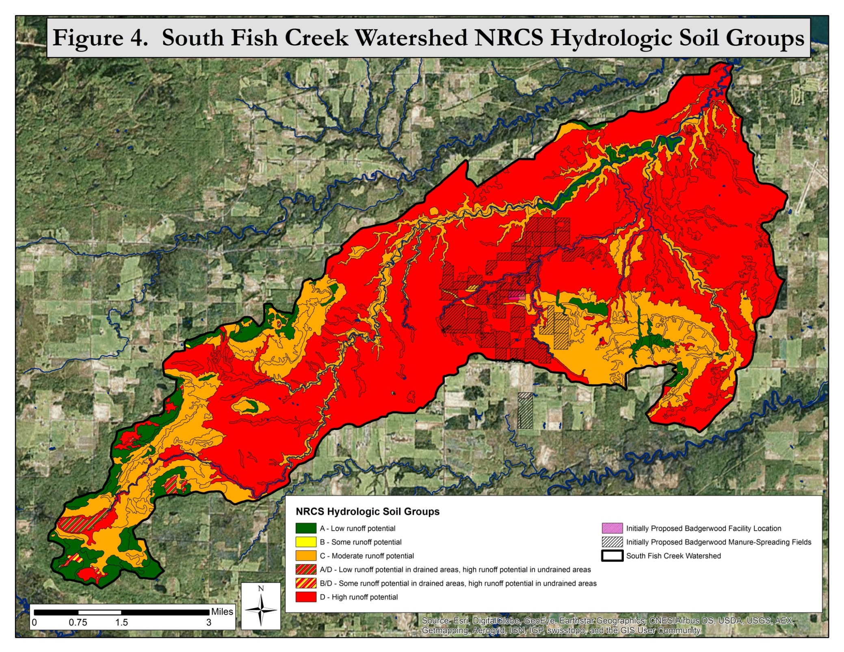
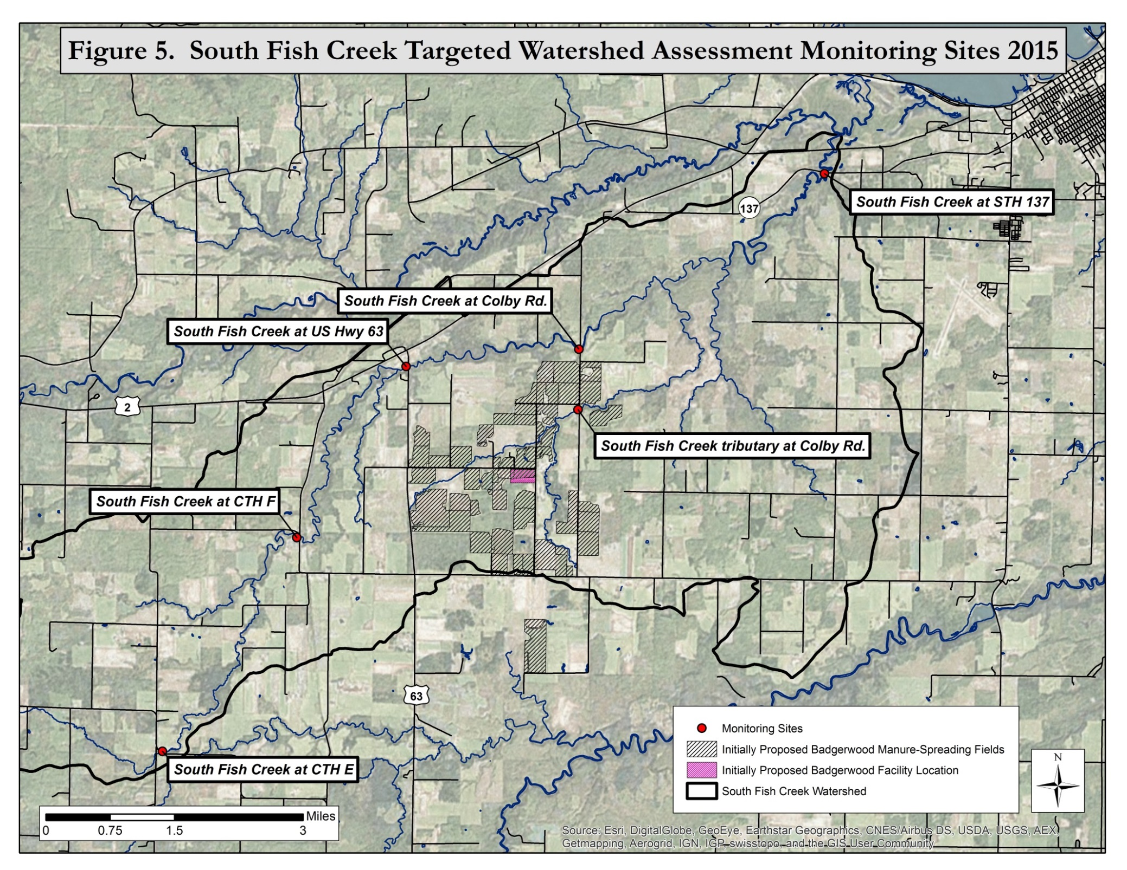
Table 1. South Fish Creek Watershed NLCD Land Cover Class Percent and Area Covered in 2011. (See Figure 2)
Land Cover Class | Percent Cover | Area (km²)
Pasture/Hay | 33.8 | 37,093.7
Deciduous Forest | 27.9 | 30,626.1
Mixed Forest | 11.7 | 12,839.1
Woody Wetlands | 7.7 | 8,403.4
Shrub/Scrub | 4.9 | 5,366.9
Evergreen Forest | 4.8 | 5,264.0
Developed, Open Space | 3.9 | 4,317.6
Cultivated Crops | 2.9 | 3,208.2
Grassland/Herbaceous | 1.6 | 1,758.5
Developed, Low Intensity | 0.6 | 656.9
Emergent Herbaceous Wetlands | 0.1 | 129.5
Developed, Medium Intensity | 0.1 | 78.5
Open Water | <0.1 | 29.1
Developed, High Intensity | <0.1 | 10.8

Table 2. South Fish Creek Watershed NRCS Soil Mapping Unit Percent and Area Covered. (See Figure 3)
NRCS Soil  Mapping Unit | Percent Cover | Area (km²)
480B | 34.5 | 37,847.6
580B | 20.6 | 22,591.8
756B | 8.2 | 9,002.6
713B | 8.2 | 8,955.6
92F | 5.2 | 5,762.8
481E | 5.0 | 5,449.6
479A | 2.6 | 2,811.9
705B | 1.9 | 2,080.2
713C | 1.7 | 1,856.0
756C | 1.5 | 1,623.4
1385B | 1.5 | 1,614.7
481C | 1.2 | 1,282.9
6A | 1.2 | 1,269.8
874B | 1.1 | 1,224.4
388B | 0.8 | 924.6
753B | 0.7 | 775.0
405A | 0.6 | 678.0
5A | 0.6 | 604.4
376B | 0.5 | 516.3
3826B | 0.5 | 508.7
813E | 0.3 | 351.9
674B | 0.3 | 303.1
874C | 0.2 | 264.5
226A | 0.2 | 233.9
548A | 0.2 | 205.7
579B | 0.2 | 195.9
874D | 0.1 | 154.0
705C | 0.1 | 150.2
733A | 0.1 | 111.0
509B | 0.1 | 107.6
280C | 0.1 | 100.3
375A | 0.1 | 71.4
674C | <0.1 | 37.1
805E | <0.1 | 28.4
574B | <0.1 | 27.9
3403A | <0.1 | 26.2
500B | <0.1 | 11.5
W | <0.1 | 10.8
2015 | <0.1 | 8.0
203B | <0.1 | 2.9

TABLE 3. SOUTH FISH CREEK FISH SURVEY DATA SUMMARY
Site | Flow Status | SWIMS Station# | Survey Date | No. of Species | Best-fitting Natural Community | IBI Applied | IBI Score | IBI Rating | % Tolerant Individuals
South Fish Ck. @ CTH E | intermittent | 10043949 | 08/12/2015 | 11 | cool-warm or cool-cold headwater | small stream | 90 | good | 93.4
South Fish Ck. @ Benoit Rd | intermittent | 10038083 | 08/06/2012 | 9 | cool-warm headwater | small stream | 60 | fair | 88.2
South Fish Ck. @ CTH F | intermittent | 10043950 | 08/12/2015 | 8 | cool-warm or cool-cold headwater | small stream | 100 | excellent | 83.6
South Fish Ck. @ STH 63 | perennial | 10044095 | 08/28/2015 | 11 | cool-warm headwater | small stream | 80 | good | 69.1
South Fish Ck. @ Colby Rd | perennial | 043056 | 08/13/2015 | 10 | cool-warm or cool-cold headwater | small stream | 80 | good | 78.5
South Fish Ck. @ STH 137 | perennial | 043095 | 08/13/2015 | 19 | cool-warm mainstem | cool-warm | 90 | excellent | 56.5
Unnamed trib to South Fish Ck. @ Colby Rd. | intermittent | 10043551 | 07/23/2015 | 6 | cool-warm or cool-cold headwater | small stream | 70 | good | 85

TABLE 4. |  |  |  |  | Key to guild abbreviations
SOUTH FISH CREEK 2015 FISH SURVEYS AND NATURAL COMMUNITY ASSESSMENTS |  |  |  |  | Thermal: C – Coldwater, T – Transitional, W - Warmwater
(Surveys are in order from US to DS with the tributary station listed last) |  |  |  |  | Size: S – Small, M – Medium, L – Large
 |  |  |  |  | Tolerance: IT – Intolerant, IM – Intermediate, T - Tolerant
South Fish Creek |  |  |  |  | Thermal |  | Size |  | Tolerance
40m US CTH E |  | 08/12/2015 |  |  | Guild | Observed | Guild | Observed | Guild | Observed
SWIMS sta. no. 10043949 |  | Station length 115m (distance shocked = 80m) |  |  | Coldwater | 0.0% | Small | 90.0% | Intolerant | 0.0%
Comment: Fish restricted to standing pools of water. No surface flow occurring. |  |  |  |  | Transitional | 89.4% | Medium | 10.0% | Intermediate | 6.6%
Fish Species | Number | Thermal | Size | Tolerance | Warmwater | 10.6% | Large | 0.0% | Tolerant | 93.4%
black bullhead | 1 | W | M | T | Model-predicted natural community |  |  | Coldwater (4 of 9 tests passed)
brook stickleback | 35 | T | S | T | Temp Result |  | Coldwater: 0 is less than the minimum of 25
central mudminnow | 304 | T | S | T |  |  | Transitional: 89.4 is more than the maximum of 75
common shiner | 24 | W | M | IM |  |  | Warmwater: 10.6 is more than the maximum of 5
creek chub | 42 | T | S | T | Stream Size Result |  | OK
fathead minnow | 22 | W | S | T | Tolerance Result |  | Intolerant: 0 is less than the minimum of .01
finescale dace | 3 | T | S | IM |  |  | Tolerant: 93.4 is more than the maximum of 25
golden shiner | 1 | W | M | T | Best Alternative NC |  | Cool-Cold Headwater and Cool-Warm Headwater (7 of 9 tests passed)
johnny darter | 2 | T | M | IM | IBI Used |  | Small Stream
pearl dace | 1 | T | S | IM | IBI Score |  | 90 (Good)
white sucker | 17 | T | M | T
Total number of individuals | 452
Total number of species | 11
South Fish Creek |  |  |  |  | Thermal |  | Size |  | Tolerance
60m US CTH F |  | 08/12/2015 |  |  | Guild | Observed | Guild | Observed | Guild | Observed
SWIMS sta. no. 10043950 |  | Station length 135m (distance shocked = 90m) |  |  | Coldwater | 1.3% | Small | 77.4% | Intolerant | 1.3%
Comment: Fish restricted to standing pools of water. No surface flow occurring. |  |  |  |  | Transitional | 92.1% | Medium | 22.6% | Intermediate | 15.1%
Fish Species | Number | Thermal | Size | Tolerance | Warmwater | 6.6% | Large | 0.0% | Tolerant | 83.6%
brook stickleback | 16 | T | S | T | Model-predicted natural community |  |  | Cool-Cold Headwater (8 of 9 tests passed)
central mudminnow | 11 | T | S | T | Temp Result |  | OK
common shiner | 30 | W | M | IM | Stream Size Result |  | OK
creek chub | 237 | T | S | T | Tolerance Result |  | Tolerant: 83.6 is more than the maximum of 75
johnny darter | 39 | T | M | IM | Best Alternative NC |  | Cool-Cold Headwater (8 of 9 tests passed) and
mottled sculpin | 6 | C | S | IT |  |  | Cool-Warm Headwater (8 of 9 tests passed)
western blacknose dace | 83 | T | S | T | IBI Used |  | Small Stream
white sucker | 34 | T | M | T | IBI Score |  | 100 (Excellent)
Total number of individuals | 456
Total number of species | 8

TABLE 4, CONT.
South Fish Creek |  |  |  |  | Thermal |  | Size |  | Tolerance
80m US STH 63 |  | 08/28/2015 |  |  | Guild | Observed | Guild | Observed | Guild | Observed
SWIMS sta. no. 10044095 |  | Station length 140m |  |  | Coldwater | 0.9% | Small | 52.5% | Intolerant | 0.9%
Fish Species | Number | Thermal | Size | Tolerance | Transitional | 72.5% | Medium | 47.5% | Intermediate | 30.0%
bluntnose minnow | 7 | W | M | T | Warmwater | 26.6% | Large | 0.0% | Tolerant | 69.1%
central mudminnow | 6 | T | S | T | Model-predicted natural community |  |  | Coldwater (6 of 9 tests passed)
common shiner | 67 | W | M | IM | Temp Result |  | Coldwater: .9 is less than the minimum of 25
creek chub | 116 | T | S | T |  |  | Warmwater: 26.6 is more than the maximum of 5
fathead minnow | 9 | W | S | T | Stream Size Result |  | OK
hornyhead chub | 2 | W | M | IM | Tolerance Result |  | Tolerant: 69.1 is more than the maximum of 25
johnny darter | 17 | T | M | IM | Best Alternative NC |  | Cool-Warm Headwater (9 of 9 tests passed)
longnose dace | 10 | T | M | IM | IBI Used |  | Small Stream
mottled sculpin | 3 | C | S | IT | IBI Score |  | 80 (Good)
western blacknose dace | 34 | T | S | T
white sucker | 49 | T | M | T
Total number of individuals | 320
Total number of species | 11
South Fish Creek |  |  |  |  | Thermal |  | Size |  | Tolerance
30m US Colby Rd. |  | 08/13/2015 |  |  | Guild | Observed | Guild | Observed | Guild | Observed
SWIMS sta. no. 043056 |  | Station length 160m |  |  | Coldwater | 3.0% | Small | 75.0% | Intolerant | 2.7%
Fish Species | Number | Thermal | Size | Tolerance | Transitional | 87.9% | Medium | 25.0% | Intermediate | 18.8%
brown trout | 1 | C | M | IM | Warmwater | 9.1% | Large | 0.0% | Tolerant | 78.5%
common shiner | 17 | W | M | IM | Model-predicted natural community |  |  | Coldwater (5 of 9 tests passed)
creek chub | 164 | T | S | T | Temp Result |  | Coldwater: 3.0 is less than the minimum of 25
fathead minnow | 2 | W | S | T |  |  | Transitional: 87.9 is more than the maximum of 75
hornyhead chub | 15 | W | M | IM |  |  | Warmwater: 9.1 is more than the maximum of 5
johnny darter | 18 | T | M | IM | Stream Size Result |  | OK
longnose dace | 19 | T | M | IM | Tolerance Result |  | Tolerant: 78.5 is more than the maximum of 25
mottled sculpin | 10 | C | S | IT | Best Alternative NC |  | Cool-Cold Headwater and Cool-Warm Headwater (8 of 9 tests passed)
western blacknose dace | 103 | T | S | T | IBI Used |  | Small Stream
white sucker | 23 | T | M | T | IBI Score |  | 80 (Good)
Total number of individuals | 372
Total number of species | 10

TABLE 4, CONT.
South Fish Creek |  |  |  |  | Thermal |  |  | Size |  |  |  |  |  |  | Tolerance
50m US STH 137 |  | 08/13/2015 |  |  | Guild | Observed |  | Guild |  | Observed |  |  |  |  | Guild |  |  | Observed
SWIMS sta. no. 043095 |  | Station length 245m |  |  | Coldwater | 0.2% |  | Small |  | 25.1% |  |  |  |  | Intolerant |  |  | 3.6%
Fish Species | Number | Thermal | Size | Tolerance | Transitional | 65.1% |  | Medium |  | 69.1% |  |  |  |  | Intermediate |  |  | 39.9%
blacknose shiner | 10 | T | M | IT | Warmwater | 34.7% |  | Large |  | 5.8% |  |  |  |  | Tolerant |  |  | 56.5%
bluntnose minnow | 31 | W | M | T | Model-predicted natural community |  |  |  |  | Coldwater (6 of 9 tests passed) and cool-cold mainstem (8 of 9 tests passed)
brassy minnow | 1 | T | S | IM | (DS portion of shocked reach is designated as Cool-Cold Mainstem while US portion is designated as Coldwater on the SWDV)
brook stickleback | 1 | T | S | T |  |  | Coldwater |  |  |  |  |  |  |  |  |  |  |  | Cool-cold mainstem
brown trout | 1 | C | M | IM | Temp Result |  | Coldwater: .2 is less than the minimum of 25 |  |  |  |  |  |  |  |  |  |  |  | Warmwater: 34.7 is more than the maximum of 25
central mudminnow | 6 | T | S | T |  |  | Warmwater: 34.7 is more than the maximum of 5
common shiner | 86 | W | M | IM | Stream Size Result |  | OK |  |  |  |  |  |  |  |  |  |  |  | OK
creek chub | 105 | T | S | T | Tolerance Result |  | Tolerant: 56.5 is more than the maximum of 25 |  |  |  |  |  |  |  |  |  |  |  | OK
fathead minnow | 1 | W | S | T | Best Alternative NC |  | Cool-Warm Mainstem (9 of 9 tests passed)
hornyhead chub | 45 | W | M | IM | IBI Used |  | Cool-Warm
johnny darter | 45 | T | M | IM | IBI Score |  | 90 (Excellent)
logperch | 3 | W | L | IM
longnose dace | 1 | T | M | IM
rock bass | 8 | W | L | IT
trout-perch | 11 | T | L | IM
walleye | 1 | T | L | IM
western blacknose dace | 12 | T | S | T
white sucker | 127 | T | M | T
yellow perch | 6 | T | L | IM
Total number of individuals | 501
Total number of species | 19

TABLE 4, CONT.
South Fish Creek trib. |  |  |  |  | Thermal |  | Size |  | Tolerance
20m US Colby Rd. |  | 07/23/2015 |  |  | Guild | Observed | Guild | Observed | Guild | Observed
SWIMS sta. no. 10043551 |  | Station length 100m (distance shocked = 75m) |  |  | Coldwater | 0.0% | Small | 54.3% | Intolerant | 0.0%
Comment: Fish restricted to standing pools of water. No surface flow occurring. |  |  |  |  | Transitional | 88.6% | Medium | 45.7% | Intermediate | 15.0%
Fish Species | Number | Thermal | Size | Tolerance | Warmwater | 11.4% | Large | 0.0% | Tolerant | 85.0%
brook stickleback | 35 | T | S | T | Model-predicted natural community |  |  | Coldwater (4 of 9 tests passed)
common shiner | 16 | W | M | IM | Temp Result |  | Coldwater: 0 is less than the minimum of 25
creek chub | 39 | T | S | T |  |  | Transitional: 88.6 is more than the maximum of 75
johnny darter | 5 | T | M | IM |  |  | Warmwater: 11.4 is more than the maximum of 5
western blacknose dace | 2 | T | S | T | Stream Size Result |  | OK
white sucker | 43 | T | M | T | Tolerance Result |  | Intolerant: 0 is less than the minimum of .01
Total number of individuals | 140 |  |  |  |  |  | Tolerant: 85.0 is more than the maximum of 25
Total number of species | 6 |  |  |  | Best Alternative NC |  | Cool-Cold Headwater (7 of 9 tests passed) or Cool-Warm Headwater (7 of 9 tests passed)
 |  |  |  |  | IBI Used |  | Small Stream
 |  |  |  |  | IBI Score |  | 70 (Good)

TABLE 5. SOUTH FISH CREEK WATERSHED MACROINVERTEBRATE SAMPLE RESULTS
Site | SWIMS Station # | Sampling Date | Macroinvertebrate Index of Biotic Integrity (MIBI) | MIBI Condition Category | Hilsenhoff Biotic Index (HBI) | HBI Condition Category | Species Richness | % EPT* Individuals | % EPT* Genera | % Chironimidae Individuals
South Fish Ck. @ STH 137 | 043095 | 09/10/2015 | 7.88 | excellent | 5.6 | fair | 28 | 25 | 19 | 67
South Fish Ck. @ Colby Rd | 043056 | 09/10/2015 | 7.2 | good | 3.27 | excellent | 35 | 66 | 41 | 9
South Fish Ck. @ STH 63 | 10044095 | 09/10/2015 | 5.59 | good | 3.02 | excellent | 28 | 55 | 33 | 17
South Fish Ck. @ CTH F | 10043950 | 10/30/2015 | 5.38 | good | 5.58 | fair | 31 | 66 | 17 | 16
South Fish Ck. @ CTH E | 10043949 | 10/30/2015 | 6.86 | good | 7.01 | Fairly poor | 36 | 8 | 14 | 36
Un. Trib. to South Fish Creek @ Colby Rd. | 10043551 | 10/30/2015 | 6.03 | good | 4.66 | good | 22 | 50 | 18 | 23
South Fish Ck. @ Benoit Rd | 10038083 | 10/26/2012 | 4.48 | fair | 5.81 | fair | 24 | 7 | 13 | 28
* EPT = ephemeroptera (mayflies), plecoptera (stoneflies), trichoptera (caddisflies)
Complete sample result information is available on DNR's SWIMS data base.

TABLE 6. SOUTH FISH CREEK WATER QUALITY DATA COLLECTED DURING 2015 FISH SURVEYS AND MACROINVERTEBRATE SAMPLING
Site | Date | SWIMS Station # | Flow (cfs) | TP (ug/l) | TN (mg/l) | TSS (mg/l) | Cond. (umhos/cm) | D.O. (mg/l) | Transparency (cm) | pH (s.u.) | Temp. (C)
Fish Survey Data
STH 137 | 08/13/2015 | 043095 | 1.5 | 142 | 0.544 | 8 | 317 | 10.3 | 59 | 8.2 | 22.3
Colby Rd | 08/13/2015 | 043056 | 0.4 | 110 | 0.502 | 5.6 | 269 | 7.9 | 81 | 7.8 | 22.1
STH 63 | 08/28/2015 | 10044095 | 0.8 | 136 | 0.903 | 15 | 238 | 8.6 | 41 | 7.5 | 16.1
CTH F | 08/12/2015 | 10043950 | 0 | 262 | 1.2 | 29.3 | 236 | 4.3 | 18 | 7.3 | 17.8
CTH E | 08/12/2015 | 10043949 | 0 | 165 | 1.52 | 13.3 | 326 | 4.3 | 35 | 7.3 | 20.9
Trib @ Colby Rd | 07/23/2015 | 10043551 | 0 | 219 | 1.11 | 5.6 | 364 | 1.6 | 77 | 7 | 18.2
Macroinvertebrate Sampling Data
STH 137 | 09/10/2015 | 043095 |  |  |  |  | 254 | 8.6 | 60 |  | 16.3
Colby Rd | 09/10/2015 | 043056 |  |  |  |  | 203 | 9.6 | 89 |  | 17.1
STH 63 | 09/10/2015 | 10044095 |  |  |  |  | 204 | 9.1 | 75 |  | 16.4
CTH F | 10/30/2015 | 10043950 |  |  |  |  | 206 | 9 | 33 | 7.3 | 6.4
CTH E | 10/30/2015 | 10043949 |  |  |  |  | 108 | 9.5 | 29 | 6.5 | 6.5
Trib @ Colby Rd | 10/30/2015 | 10043551 |  |  |  |  | 319 | 7.5 | 78 | 7.4 | 6.7

