Eurasian Water-milfoil (Myriophyllum spicatum) Pre/Post Herbicide and Fall Bed Mapping Surveys
Minong Flowage - (WBIC: 2692900)
Washburn and Douglas Counties, Wisconsin

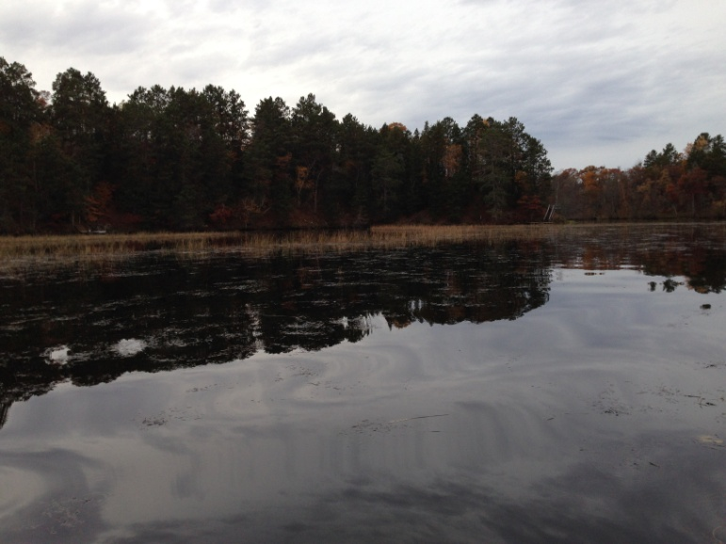
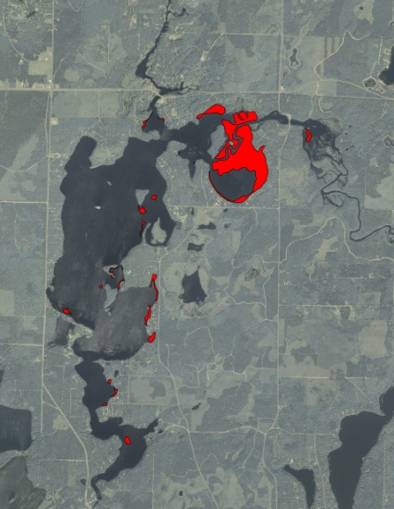
Canopied EWM mixed with wild rice east of Smiths Bridge 10/16/16 Fall EWM beds 10/16/16
Project Initiated by:
Minong Flowage Association, Lake Education and Planning Services, LLC and the Wisconsin Department of Natural Resources
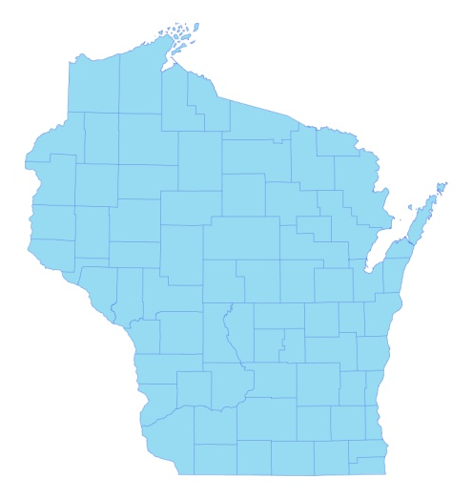
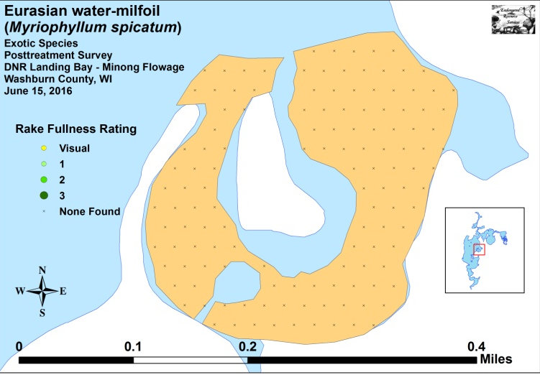

* Minong Flowage

Posttreatment EWM in WDRN Boat Landing Bay 6/15/16

Surveys Conducted by and Report Prepared by:
Endangered Resource Services, LLC
Matthew S. Berg, Research Biologist
St. Croix Falls, Wisconsin
April 29, June 15, and October 16, 2016
TABLE OF CONTENTS

Page
LIST OF FIGURES.………………..……..………………………………………………... ii

LIST OF TABLES..………………..……..………………………………………………... iii

INTRODUCTION……….…..……..………………………………………………………. 1

METHODS……………………………………………………………….………………… 2

RESULTS AND DISCUSSION……………………………………………………………. 3

Finalization of Treatment Area.……………………………………………………. 3

EWM Pre/Post Herbicide Surveys…..……………………………………………... 4

Fall EWM Bed Mapping Survey…………………………………………………… 12

Descriptions of Current and Former EWM Beds…….…………………………….. 14

LITERATURE CITED……….……………………….……………………………………. 16

APPENDIXES……….…….………………………………………………….……………. 17

I: Survey Sample Points and EWM Treatment Areas……..…………………………… 17

II: Vegetative Survey Data Sheet.………………………………………………………. 20

III: Pre/Post Habitat Variable Maps.………………….……………………………...…... 22

IV: Pre/Post Native Species Richness and Total Rake Fullness.………..……………...... 25

V: EWM and CLP Pre/Post Density and Distribution…………………..……………..... 30

VI: Pretreatment Native Species Density and Distribution…...………………………...... 35

VII: Posttreatment Native Species Density and Distribution…...……………………….... 44

VIII: Fall 2015 and 2016 EWM Bed Maps.……………….………………………………. 56

LIST OF FIGURES

Page
Figure 1: 2015 Fall EWM Beds………………………...…………………….……….…… 1
Figure 2: Rake Fullness Ratings……………………………….…….…………………….. 2
Figure 3: 2016 Survey Sample Points and Final Treatment Areas………………………… 3
Figure 4: Treatment Area Depths and Bottom Substrate….………..……………………… 4
Figure 5: Pre/Post Native Species Richness…………………………..…………………… 5
Figure 6: Pre/Post Total Rake Fullness………………………………..…………………… 5
Figure 7: Pre/Post EWM Density and Distribution ……………………….………………. 6
Figure 8: Pre/Post Changes in EWM Rake Fullness………………………………………. 6
Figure 9: Pre/Post CLP Density and Distribution ……………………….………………. .. 7
Figure 10: Pre/Post Changes in CLP Rake Fullness……………………………………….. 7
Figure 11: Pre/Post Common Waterweed Density and Distribution …….………………... 8
Figure 12: Pre/Post Coontail Density and Distribution …………….……………………... 8
Figure 13: Pre/Post Macrophyte Changes…………………..……………………………... 11
Figure 14: 2013, 2014, 2015 and 2016 Fall EWM Beds.……………………..…………… 12
Figure 15: Canopied EWM Mixed in with Wild Rice East of Smith’s Bridge 10/16/16..… 15

LIST OF TABLES

Page
Table 1: EWM Control Summary – Minong Flowage – May 16, 2016………….…..….... 3

Table 2: Pre/Post Survey Summary Statistics – Minong Flowage, Washburn County
April 29 and June 15, 2016……………………………………………………………….… 4

Table 3: Frequencies and Mean Rake Sample of Aquatic Macrophytes Pretreatment
Survey – DNR Boat Landing Bay - Minong Flowage, Washburn County - April 29, 2016. 9

Table 4: Frequencies and Mean Rake Sample of Aquatic Macrophytes Posttreatment
Survey – DNR Boat Landing Bay - Minong Flowage, Washburn County - June 15, 2016.. 10

Table 5: Fall Eurasian Water-milfoil Bed Mapping Summary –
Minong Flowage, Washburn and Douglas Counties – October 16, 2016………………….. 13

INTRODUCTION:
The Minong Flowage (WBIC 2692900) is a 1,564-acre eutrophic/mesotrophic drainage flowage located in north-central Washburn County and south-central Douglas County, Wisconsin in the Towns of Minong and Wascott (T42N R13W S13 SW NE). It reaches a maximum depth of 21.5ft near the dam on the far south end and has an average depth of approximately 9ft. The bottom is predominately sand and sandy muck in the south basin and organic muck in the northern bays. Secchi readings from 1994-2016 have averaged no more than 3-6ft under normal summer conditions (WDNR 2016). This poor to very poor clarity produced a littoral zone that extended to a maximum of 7ft in 2016.
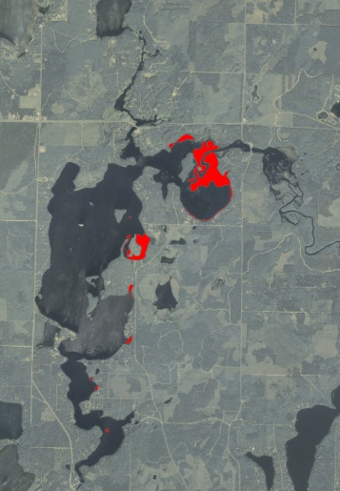
Figure 1: 2015 Fall EWM Beds

Eurasian water-milfoil (Myriophyllum spicatum) (EWM) was first identified in the Minong Flowage in 2002. From 2009-2011, the Minong Flowage Association (MFA), under the direction of Dave Blumer (Lake Education and Planning Services, LLC - LEAPS), actively managed the infestation using herbicide treatments and manual removal as outlined in the flowage’s Wisconsin Department of Natural Resources (WDNR) approved Aquatic Plant Management Plan (APMP). Treatment was suspended in 2012, but the 5ft drawdown to repair the dam in spring 2013 and extended period of freezing over the winter appeared to have killed all surviving terrestrial EWM beds. The subsequent refill in spring 2014 also eliminated most surviving aquatic individuals as the flowage’s stained water prevented sufficient light penetration to allow these plants to survive. Unfortunately, EWM quickly began recolonizing shallow habitats that were now largely devoid of any native plants/competition. In fall 2014, we found and mapped ten EWM beds totaling 14.02 acres, and, by fall 2015, this had grown to 11 beds covering 90.36 acres (Figure 1). After analyzing the bed maps, the MFA and LEAPS outlined plans to use herbicide treatment to control EWM in the WDNR boat landing bay on the flowage’s east side. Including buffer zones, the treatment area covered 26.90 acres or approximately 1.72% of the flowage’s surface area. On April 29th, we conducted a pretreatment survey to gather baseline data from the scheduled treatment area and to allow LEAPS to finalize treatment plans. Following the May 16th herbicide application, we conducted a June 15th posttreatment survey to evaluate the effectiveness of the treatment. We also conducted an October 16th bed mapping survey to determine where EWM control might be considered in 2017. This report is the summary analysis of these three field surveys.
METHODS:
Pre/Post Herbicide Surveys:
LEAPS provided the treatment area shapefile, and we generated pre/post survey points based on the size and shape of the proposed treatment area. The 131 point sampling grid approximated to 4.9 pts/acre – slightly more than the minimum of 4-10 pts/acre required by WDNR protocol for pre/post treatment surveys (Appendix I).

During the surveys, we located each point using a handheld mapping GPS unit (Garmin 76CSx) and used a rake to sample an approximately 2.5ft section of the bottom. All plants on the rake were assigned a rake fullness value of 1-3 as an estimation of abundance, and a total rake fullness for all species was also recorded (Figure 2). Visual sightings of EWM and Curly-leaf pondweed (Potamogeton crispus), another exotic species, were noted if they occurred within 6ft of the point; however, visuals of other species were not recorded as they do not figure into the pre/posttreatment calculation. In addition to plant data, we recorded the depth using a metered rake and the substrate (bottom) type.

We entered all data collected into the standard WDNR APM spreadsheet (Appendix II). Count data were then analyzed on the linked statistical summary sheet and the WDNR pre/post Chi-square analysis worksheet (UWEX 2010) while differences in means were analyzed using t-tests. Pre/post treatment differences were determined to be significant at p < .05, moderately significant at p < .01, and highly significant at p < .005.
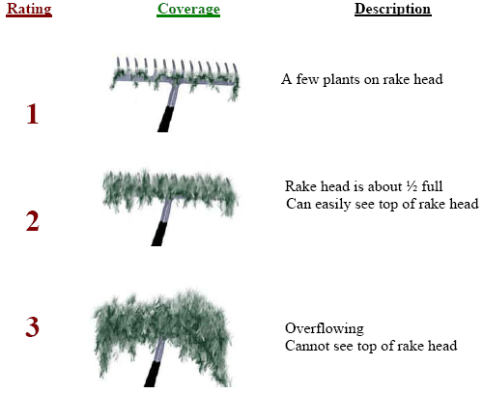
Figure 2: Rake Fullness Ratings

Fall Eurasian Water-milfoil Bed Mapping:
During the fall bed mapping survey, we searched the lake’s entire visible littoral zone. By definition, a “bed” was determined to be any area where we visually estimated that EWM made up >50% of the area’s plants, was generally continuous with clearly defined borders, and was canopied, or close enough to being canopied that it would likely interfere with boat traffic. After we located a bed, we motored around the perimeter of the area taking GPS coordinates at regular intervals. We also estimated the rake density range and mean rake fullness of the bed (Figure 2), the maximum depth of the bed, whether it was canopied, and the impact it was likely to have on navigation (none – easily avoidable with a natural channel around or narrow enough to motor through/minor – one prop clear to get through or access open water/moderate – several prop clears needed to navigate through/severe – multiple prop clears and difficult to impossible to row through). These data were then mapped using ArcMap 9.3.1, and we used the WDNR’s Forestry Tools Extension to determine the acreage of each bed to the nearest hundredth of an acre (Table 5).
RESULTS AND DISCUSSION:
Finalization of Treatment Area:
Initial expectations were to chemically treat a single EWM bed totaling 26.90 acres. Following the pretreatment survey which showed EWM continued to survive throughout the majority of the WDNR boat landing bay, it was decided to maintain the treatment as proposed (Figure 3) (Appendix I). Treatment occurred on May 16th with Northern Aquatic Services (D. Dressel) applying 2, 4-D (DMA-4) at a rate of 1.5ppm (Table 1). Water temperature at the time of the treatment was reported to be 51° with winds out of the west/northwest at 2-7mph.

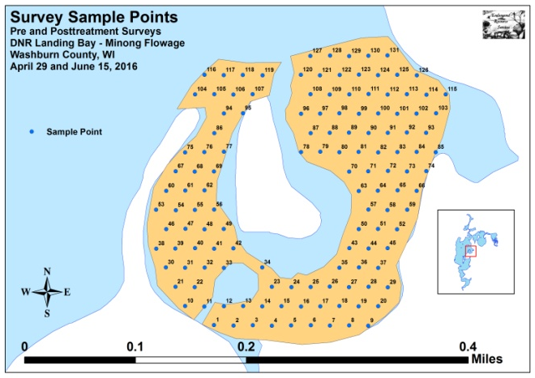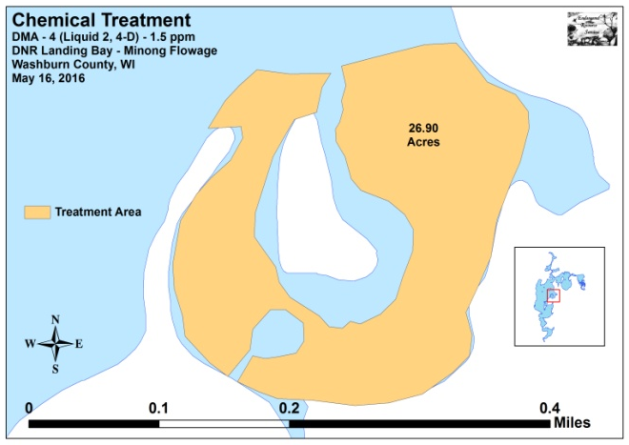
Figure 3: 2016 Survey Sample Points and Final Treatment Areas

Table 1: EWM Control Summary
DNR Boat Landing Bay - Minong Flowage, Washburn County
May 16, 2016

Bed  Number | Proposed  Acreage | Final  Acreage | Difference  +/- | Herbicide Type  and Rate
6 | 26.90 | 26.90 | 0.00 | DMA – 4 (2, 4-D) – 1.5ppm
Total Acres | 26.90 | 26.90 | 0.00

EWM Pre/Post Herbicide Surveys:
The littoral zone in the treatment area extended to at least 6.0ft during the pretreatment survey and 6.5ft during the posttreatment survey (Figure 4). Mean and median depths for all plants were 4.3ft and 4.5ft respectively pretreatment before rising slightly to 4.5ft and 5.0ft posttreatment (Table 2). EWM was established over mucky or firm sand (Figure 4) (Appendix III).

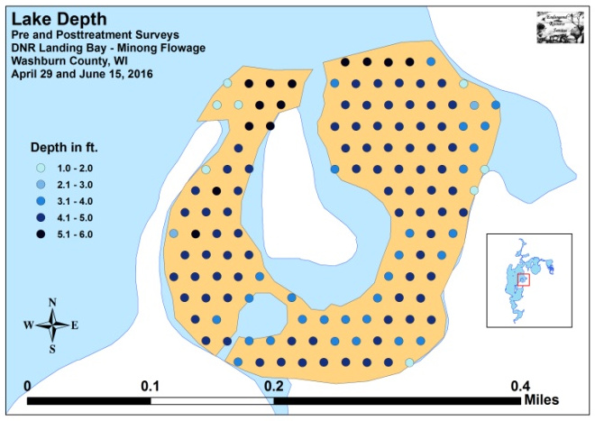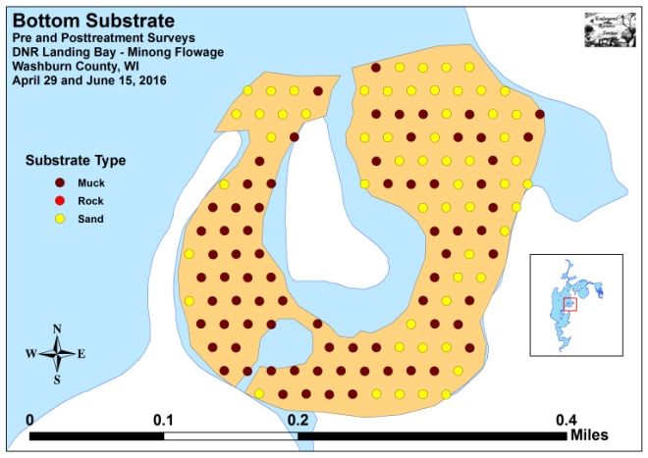
Figure 4: Treatment Area Depths and Bottom Substrate

Table 2: Pre/Post Survey Summary Statistics
Minong Flowage, Washburn County
April 29 and June 15, 2016
Summary Statistics: | Pre | Post
Total number of points sampled | 131 | 131
Total number of sites with vegetation | 97 | 92
Total number of sites shallower than the maximum depth of plants | 131 | 129
Frequency of occurrence at sites shallower than maximum depth of plants | 74.05 | 71.32
Simpson Diversity Index | 0.74 | 0.76
Mean Coefficient of Conservatism | 5.7 | 5.5
Floristic Quality Index | 15.1 | 18.1
Maximum depth of plants (ft) | 6.0 | 6.5
Mean depth of plants (ft) | 4.3 | 4.5
Median depth of plants (ft) | 4.5 | 5.0
Average number of all species per site (shallower than max depth) | 1.37 | 1.59
Average number of all species per site (veg. sites only) | 1.86 | 2.23
Average number of native species per site (shallower than max depth) | 0.80 | 1.48
Average number of native species per site (native veg. sites only) | 1.33 | 2.10
Species richness | 9 | 12
Mean rake fullness (veg. sites only) | 1.55 | 1.55

Initial diversity within the bed was moderate with a Simpson Index of 0.74, and this was almost unchanged at 0.76 posttreatment. The Floristic Quality Index, a measure of only native species, also increased only slightly from 15.1 pre to 18.1 post. Mean native species richness at sites with native vegetation was 1.33/site pretreatment, and this metric experienced a highly significant (p<0.001) increase to 2.10/site posttreatment (Figure 5). Species richness also increased from 9 species pretreatment to 12 species posttreatment. Mean total rake fullness at sites with vegetation was unchanged at 1.55 for both the pre and posttreatment (Figure 6) (Appendix IV).

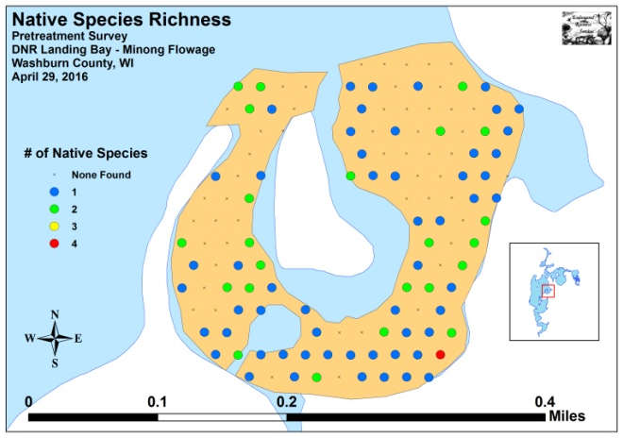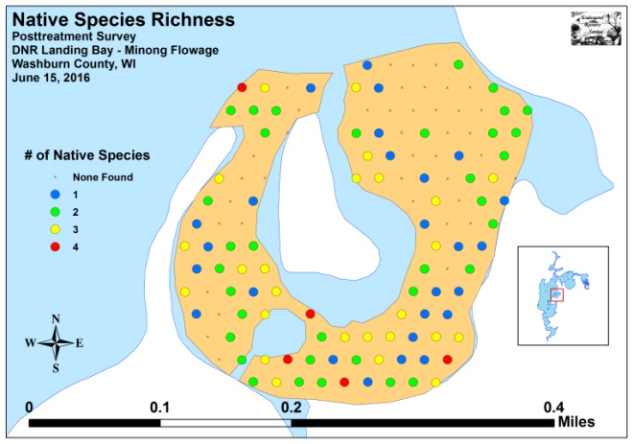
Figure 5: Pre/Post Native Species Richness

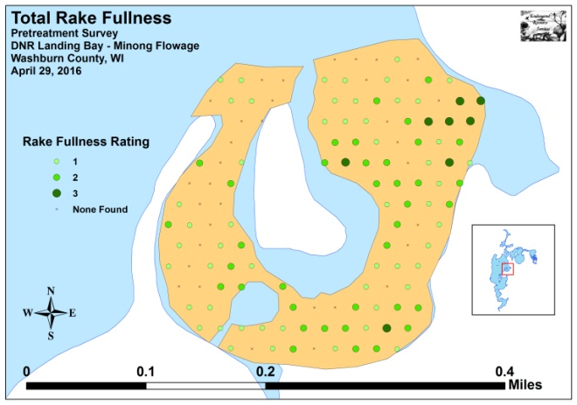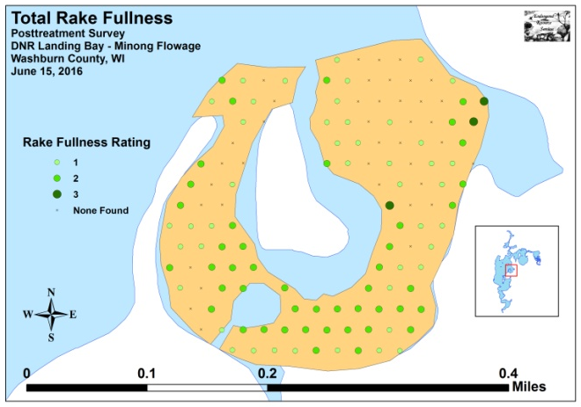
Figure 6: Pre/Post Total Rake Fullness

We found Eurasian water-milfoil at 55 total sites during the pretreatment survey. Of these, four had a rake fullness rating of 3, 21 rated a 2, and 30 were a 1 for a mean rake fullness of 1.53. We also recorded EWM as a visual at eight points (Figure 7). During the posttreatment survey, we didn’t find any EWM anywhere in the bay either in the rake or inter-point (Tables 3 and 4) (Appendix V). Our findings demonstrated a highly significant reduction in total EWM as well as rake fullness 1 and 2; a moderately significant reduction in visual sightings; and a significant reduction in rake fullness 3 (Figure 8).

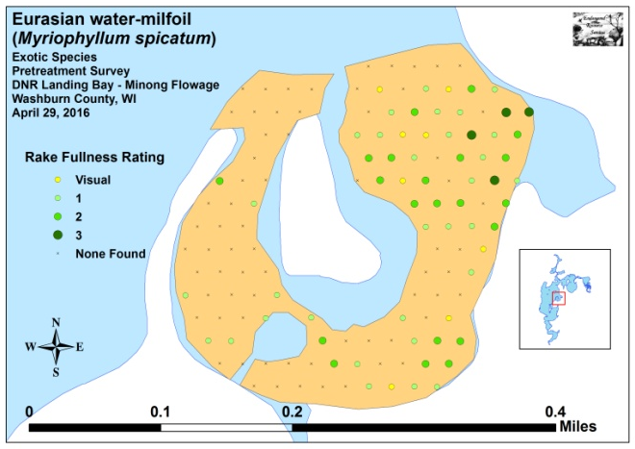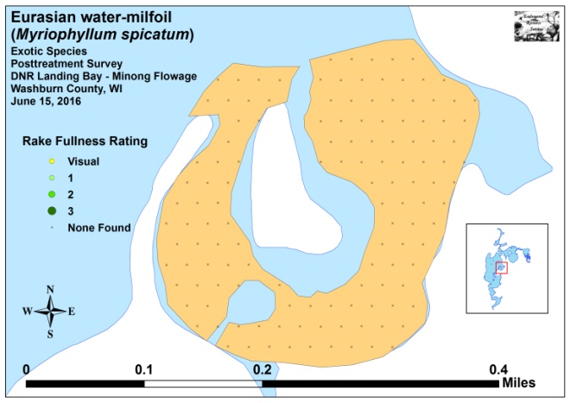
Figure 7: Pre/Post EWM Density and Distribution
_**
_*
_***
_***
_***
Significant differences = * p < .05, ** p < .01, *** p < .005
Figure 8: Pre/Post Changes in EWM Rake Fullness
Curly-leaf pondweed was present at 20 total sites during the pretreatment survey. Of these, none had a rake fullness rating of 3, five rated a 2, and 15 were a 1 for a mean rake fullness of 1.25 (Figure 9). During the posttreatment survey, CLP was present at 14 points of which three had a rake fullness of 2 and the remaining 11 were a 1 for a mean rake fullness of 1.21 (Tables 3 and 4) (Appendix V). As 2,4-D is not expected to be toxic to monocots like CLP, it’s not surprising that none of these differences were significant (Figure 10).

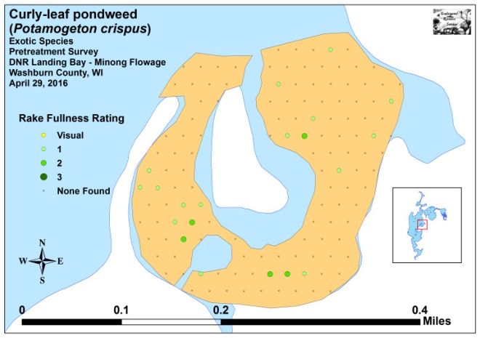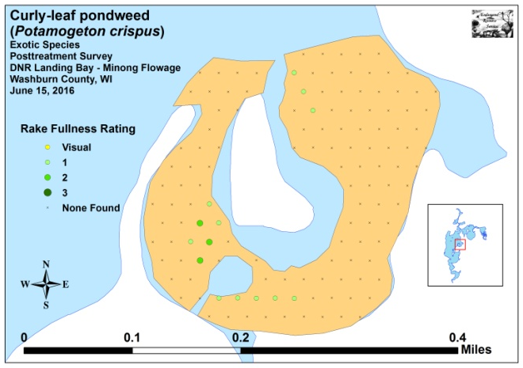
Figure 9: Pre/Post CLP Density and Distribution

Significant differences = * p < .05, ** p < .01, *** p < .005
Figure 10: Pre/Post Changes in CLP Rake Fullness
Common waterweed (Elodea canadensis), the most common native species in both the pretreatment (66 sites – mean rake fullness 1.33) and posttreatment surveys (80 sites – mean rake fullness 1.48), experienced a nearly significant increase in both distribution (p=0.08) and density (p=0.06) following treatment (Tables 3 and 4) (Figure 11). Coontail (Ceratophyllum demersum), the third most common native species pretreatment (16 sites – mean rake fullness 1.25) experienced a highly significant increase in distribution to become the second most common native species posttreatment (42 sites – mean rake fullness 1.23) (Figure 12). In addition to Coontail, Small pondweed (Potamogeton pusillus) and Ribbon-leaf pondweed (Potamogeton epihydrus) experiences moderately significant increases, and Flat-stem pondweed (Potamogeton zosteriformis) demonstrated a significant increase (Figure 13). Other than EWM, no species experienced significant declines. Maps for all native species from the pre and posttreatment surveys are available in Appendixes VI and VII.

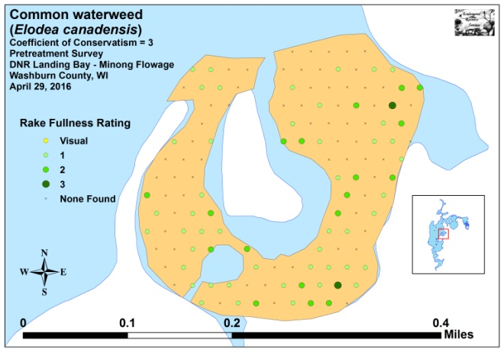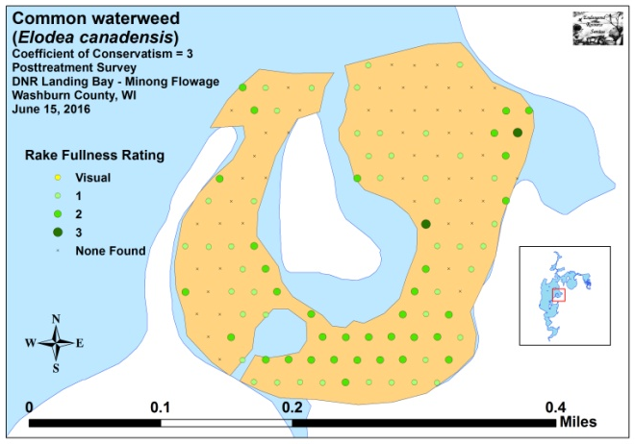
Figure 11: Pre/Post Common Waterweed Density and Distribution

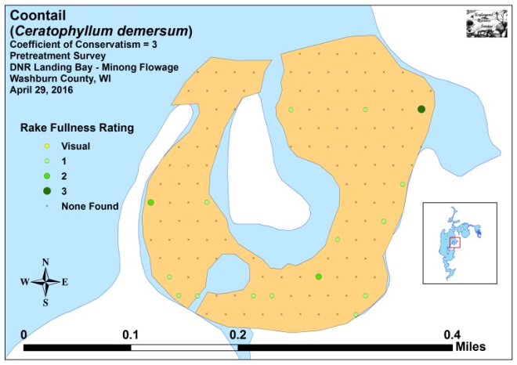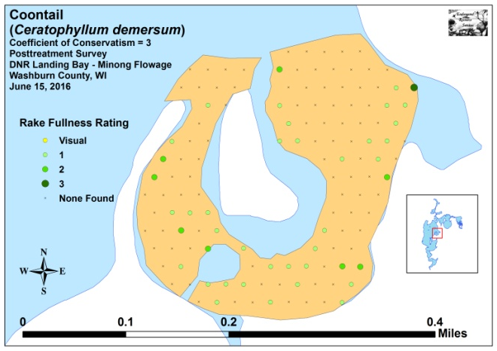
Figure 12: Pre/Post Coontail Density and Distribution
Table 3: Frequencies and Mean Rake Sample of Aquatic Macrophytes
Pretreatment Survey - DNR Boat Landing Bay - Minong Flowage, Washburn County
April 29, 2016

Species | Common Name | Total  Sites | Relative Freq. | Freq. in Veg. | Freq. in Lit. | Mean Rake | Visual Sightings
Elodea canadensis | Common waterweed | 66 | 36.67 | 68.04 | 50.38 | 1.33 | 0
Myriophyllum spicatum | Eurasian water-milfoil | 55 | 30.56 | 56.70 | 41.98 | 1.53 | 8
Potamogeton crispus | Curly-leaf pondweed | 20 | 11.11 | 20.62 | 15.27 | 1.25 | 0
Potamogeton pusillus | Small pondweed | 19 | 10.56 | 19.59 | 14.50 | 1.11 | 0
Ceratophyllum demersum | Coontail | 16 | 8.89 | 16.49 | 12.21 | 1.25 | 0
 | Aquatic moss | 2 | * | 2.06 | 1.53 | 1.00 | 0
Heteranthera dubia | Water star-grass | 1 | 0.56 | 1.03 | 0.76 | 1.00 | 0
Nitella sp. | Nitella | 1 | 0.56 | 1.03 | 0.76 | 1.00 | 0
Potamogeton robbinsii | Fern pondweed | 1 | 0.56 | 1.03 | 0.76 | 1.00 | 0
Potamogeton zosteriformis | Flat-stem pondweed | 1 | 0.56 | 1.03 | 0.76 | 1.00 | 0

* Excluded from relative frequency analysis

Table 4: Frequencies and Mean Rake Sample of Aquatic Macrophytes
Posttreatment Survey - DNR Boat Landing Bay - Minong Flowage, Washburn County
June 15, 2016

Species | Common Name | Total  Sites | Relative Freq. | Freq. in Veg. | Freq. in Lit. | Mean Rake | Visual Sightings
Elodea canadensis | Common waterweed | 80 | 39.02 | 86.96 | 62.02 | 1.48 | 0
Ceratophyllum demersum | Coontail | 42 | 20.49 | 45.65 | 32.56 | 1.24 | 0
Potamogeton pusillus | Small pondweed | 40 | 19.51 | 43.48 | 31.01 | 1.03 | 0
Potamogeton crispus | Curly-leaf pondweed | 14 | 6.83 | 15.22 | 10.85 | 1.21 | 0
Potamogeton epihydrus | Ribbon-leaf pondweed | 9 | 4.39 | 9.78 | 6.98 | 1.22 | 0
Heteranthera dubia | Water star-grass | 5 | 2.44 | 5.43 | 3.88 | 1.00 | 0
Potamogeton zosteriformis | Flat-stem pondweed | 5 | 2.44 | 5.43 | 3.88 | 1.20 | 0
Najas flexilis | Slender naiad | 3 | 1.46 | 3.26 | 2.33 | 1.00 | 0
Nuphar variegata | Spatterdock | 2 | 0.98 | 2.17 | 1.55 | 1.50 | 0
Stuckenia pectinata | Sago pondweed | 2 | 0.98 | 2.17 | 1.55 | 1.00 | 0
Vallisneria americana | Wild celery | 2 | 0.98 | 2.17 | 1.55 | 1.00 | 0
Nymphaea odorata | White water lily | 1 | 0.49 | 1.09 | 0.78 | 1.00 | 0

* Excluded from relative frequency analysis
+*
+**
+***
+**
-***
Significant differences = * p < .05, ** p < .01, *** p < .005
Figure 13: Pre/Post Macrophyte Changes

Fall EWM Bed Mapping Survey:
On October 16th, we located and mapped 24 beds on the flowage ranging in size from 0.09 acre (Bed 5D) to 75.32 acres (Bed 16) (Figure 14) (Appendix VIII). In total, they covered 125.58 acres (Table 5). This was 35.22 acres more than the 90.36 acres mapped in 2015 – a 39% increase. It was also 111.56 acres more than 2014’s 14.02 acres. The bulk of this expansion occurred in Serenity Bay, within the Northern wild rice (Zizania palustris) beds east of Smith’s Bridge, and along the eastern shoreline of the south basin. The WDNR public boat landing bay (Beds 6 and 7), the only area to experience chemical control in 2016, remained free of EWM.

Most of the flowage’s EWM beds are still quite low density and unlikely to significantly impair navigation as the mean rake fullness of most beds was <1 or 1. The beds were, however, all canopied, actively fragmenting, and monotypic or nearly monotypic. With little competition from other species, we expect the rapid expansion of EWM in both distribution and density seen in 2016 to continue in 2017.

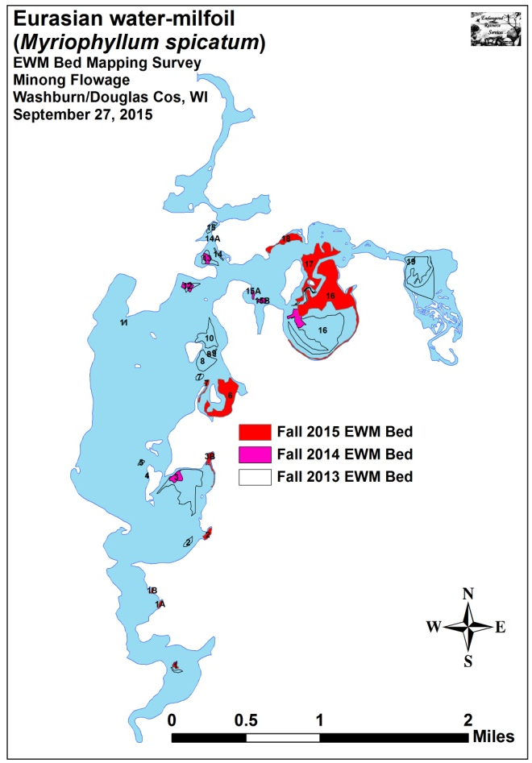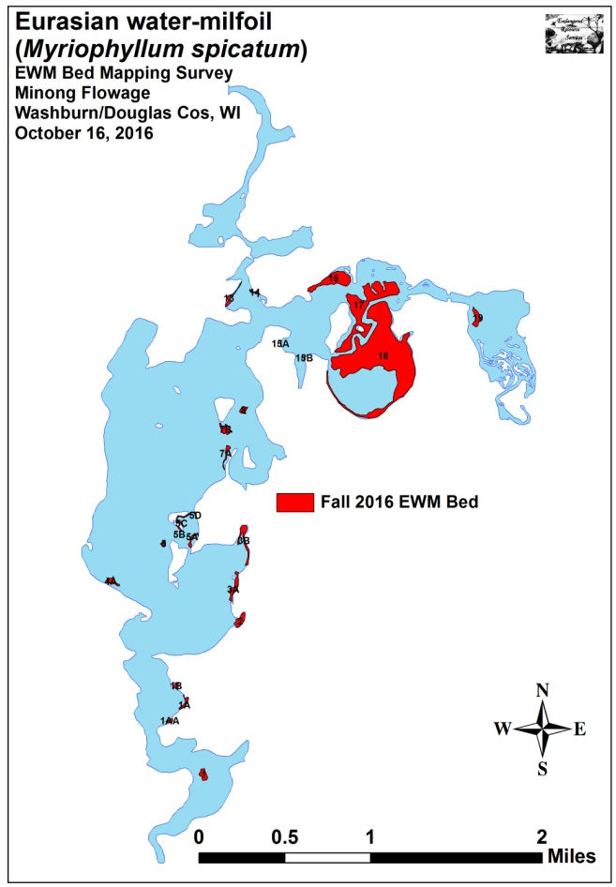
Figure 14: 2013, 2014, 2015, and 2016 Fall EWM Beds

Table 5: Fall Eurasian Water-milfoil Bed Mapping Summary
Minong Flowage, Washburn and Douglas Counties
October 16, 2016
Bed Number | 2016  Area in Acres | 2015  Area in Acres | 2014  Area in Acres | 2016  Change in  Acreage | Est. 2016 Range and Mean Rake Fullness | 2016 Nav. Impair. | 2016 Field Notes
1 | 1.40 | 0.50 | 0.32 | 0.90 | <1-3; 2 | Minor | Nearly continuous bed over majority of bar.
1AA | 0.33 | 0 | 0 | 0.33 | <<1-1; <1 | None | Regular towers with gaps between.
1A | 0.81 | 0.58 | 0 | 0.23 | <<1-2; <1 | Minor | Regular towers with gaps between.
1B | 0.48 | 0.31 | 0 | 0.17 | <1-2; 1 | None | Regular towers.
2 | 1.80 | 1.40 | 0 | 0.40 | <1-2; 1 | Minor | Merging regular towers.
3 | 0 | 0 | 2.68 | 0 | 0 | None | No EWM found.
3A | 2.06 | 0 | 0 | 2.06 | <<<1-2; <<1 | None | Nearly continuous towers.
3B | 2.55 | 1.96 | 1.42 | 0.59 | <<1-2; 1 | Minor | Regular towers.
4 | 0 | 0 | 0 | 0 | 0 | None | No EWM found.
4A | 1.05 | 0 | 0 | 1.05 | <<<1-1; <<1 | None | Scattered but regular towers.
5 | 0.30 | 0 | 0 | 0.30 | <<1-1; <1 | None | Scattered but regular towers.
5A, B, C, D | 1.49 | 0 | 0 | 1.49 | <<1-1; <1 | None | Regular towers.
6 | 0 | 16.39 | 0 | -16.39 | 0 | None | No EWM found.
7 | 0 | 1.23 | 0 | -1.23 | 0 | None | No EWM found.
7A | 0.75 | 0 | 0 | 0.75 | <<1-1; <1 | None | Regular towers.
7B | 1.46 | 0 | 0 | 1.46 | <<1-1; <1 | None | Regular towers.
8 | 0.76 | 0.18 | 0 | 0.58 | <<<1-2; <1 | None | Scattered but regular towers.
9 | 0 | 0 | 0 | 0 | 0 | None | No EWM found.
10 | 0 | 0 | 0 | 0 | 0 | None | No EWM found.
11 | 0 | 0 | 0 | 0 | 0 | None | No EWM found.
12 | 0 | 0 | 1.90 | 0 | 0 | None | No EWM found.
13 | 0.85 | 0 | 1.57 | 0.85 | <<<1-2; <1 | None | Nearly continuous towers.
14 | 0.31 | 0 | 0.05 | 0.31 | <<<1-2; <1 | None | Regular towers.
15 | 0 | 0 | 0 | 0 | 0 | None | No EWM found.
15A | 0.10 | 0 | 0.57 | 0.10 | <<1-1; <1 | None | Regular towers.
15B | 0.09 | 0 | 0.85 | 0.09 | <<1-1; <1 | None | Regular towers.
16 | 75.32 | 43.08 | 4.58 | 32.24 | <<1-3; 1 | Minor | Solid mat in <4ft on north side of bay.
17 | 24.27 | 19.43 | 0 | 4.84 | <<<1-3; 1 | Minor | Merging towers north and west of channel.
18 | 7.61 | 5.30 | 0 | 2.31 | <<1-3; 1 | Minor | Merging regular towers.
19 | 1.80 | ----- | 0.10 | 1.80 | <<1-3; 2 | Moderate | Expanding mat of plants among rice.
Total | 125.58 | 90.36 | 14.02 | +35.22

Descriptions of Current and Former EWM Beds:
Bed 1 – Moderate density EWM was established throughout the sandbar. The area covered was almost triple of what we mapped in 2015, and almost five times what was mapped in 2014.

Beds 1AA, 1A, and 1B – We found low density EWM in each of these sand-bottomed bays. The beds were monotypic, and there were essentially no native plants anywhere.

Bed 2 – The EWM in this bay was low density, but plants were merging and will likely become a minor navigation impairment if it isn’t already. There continues to be a limited amount of Coontail and Common waterweed mixed in.

Beds 3 and 4 – We found no EWM anywhere in these areas.

Beds 3A and 3B – After reestablishing in the bay in 2015, Bed 3B continued to spread south along the shoreline. Bed 3A was very low density and is probably better referred to as a High Density Area. Outside of the bay, we saw almost no native plants in the area.

Beds 4A and 5 – Low density EWM has again establishing in the shallow flat north of the county campground. Likewise, the flat west of the island also had EWM again.

Beds 5A-D – These beds sprang up in an area that has never had continuous EWM in the past. They occurred in 1-4ft of water and made a nearly continuous ring around the bay.

Beds 6 and 7 – The treatment area continued to be EWM free into the fall.

Beds 7A, 7B, and 8 – 7A and 7B recolonized most of the area they had occupied prior to the drawdown, and Bed 8 continued to expand from its limited coverage seen in 2015.

Beds 9, 10, 11, and 12 – We found no EWM in any of these former beds.

Beds 13 and 14 – Bed 13 was rapidly reestablishing in the bay south of the channel, and EWM was found growing closer to shore than we’ve ever seen it in the past. Bed 14 continues to be a narrow area of low density plants that likely isn’t bothering anyone.

Beds 15A and 15B – We found scattered regular towers were recolonizing these areas. Fortunately, the finger bay continued to be free of EWM.

Beds 16 and 17 – Both of these beds continued their expansion in 2016. Bed 16 was extremely narrow along the south shore of Serenity Bay, and EWM was rarely seen in water deeper than 4ft in this area. However, on the south border of the main area of the bed, we regularly saw plants growing to 7ft. This could mean plants are expanding laterally as water clarity appears to have prevented plants from sprouting from fragments at these depths in the past. On the north end of Bed 16 and in all of Bed 17, EWM continues to expand and thicken among the stumps in these shallow flats.

Bed 18 – Density in this area was similar to Beds 16 and 17. This bed seems to be the product of prevailing winds from the south blowing fragments to the north as the densest areas were near the shore in shallow water with the bed becoming increasingly fragmented to the south.

Bed 19 – EWM in this area underwent a rather dramatic expansion during a year where the rice was largely eliminated by flood waters. The resulting bed we found among the rice remnants is now among the worst on the flowage (Figure 15). Unfortunately, it is also the furthest upstream.

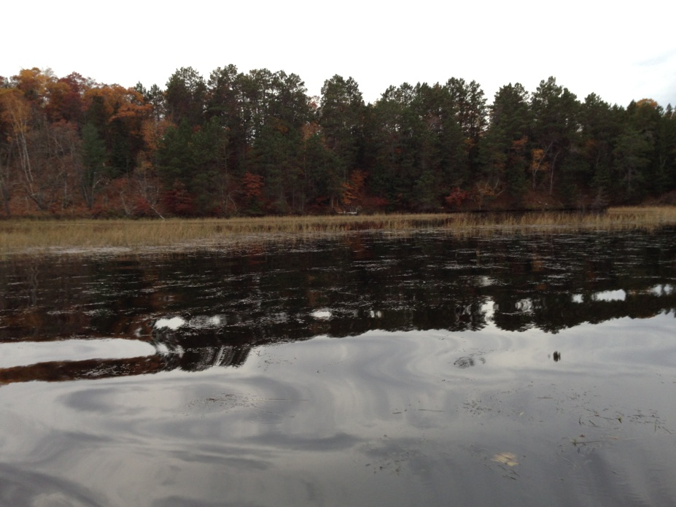
Figure 15: Canopied EWM Mixed in with Wild Rice
East of Smith’s Bridge 10/16/16

LITERATURE CITED

Pokorny, N., C. Busch, L. Sather, and C. Holt. [online]. 1966. Minong Flowage Map. Available from http://dnr.wi.gov/lakes/maps/DNR/2692900a.pdf (2016, October).

UWEX Lakes Program. [online]. 2010. Aquatic Plant Management in Wisconsin. Available from http://www.uwsp.edu/cnr/uwexlakes/ecology/APMguide.asp (2014, September).

UWEX Lakes Program. [online]. 2010. Pre/Post Herbicide Comparison. Available from http://dnr.wi.gov/org/water/fhp/lakes/PrePostEvaluation.pdf (2016, October).

WDNR. [online]. 2016. Minong Flowage - Citizen Lake Water Quality Monitoring Database. Available from http://dnr.wi.gov/lakes/lakepages/LakeDetail.aspx?wbic=2692900&page=waterquality (2016, October).

Appendix I: Survey Sample Points and EWM Treatment Areas
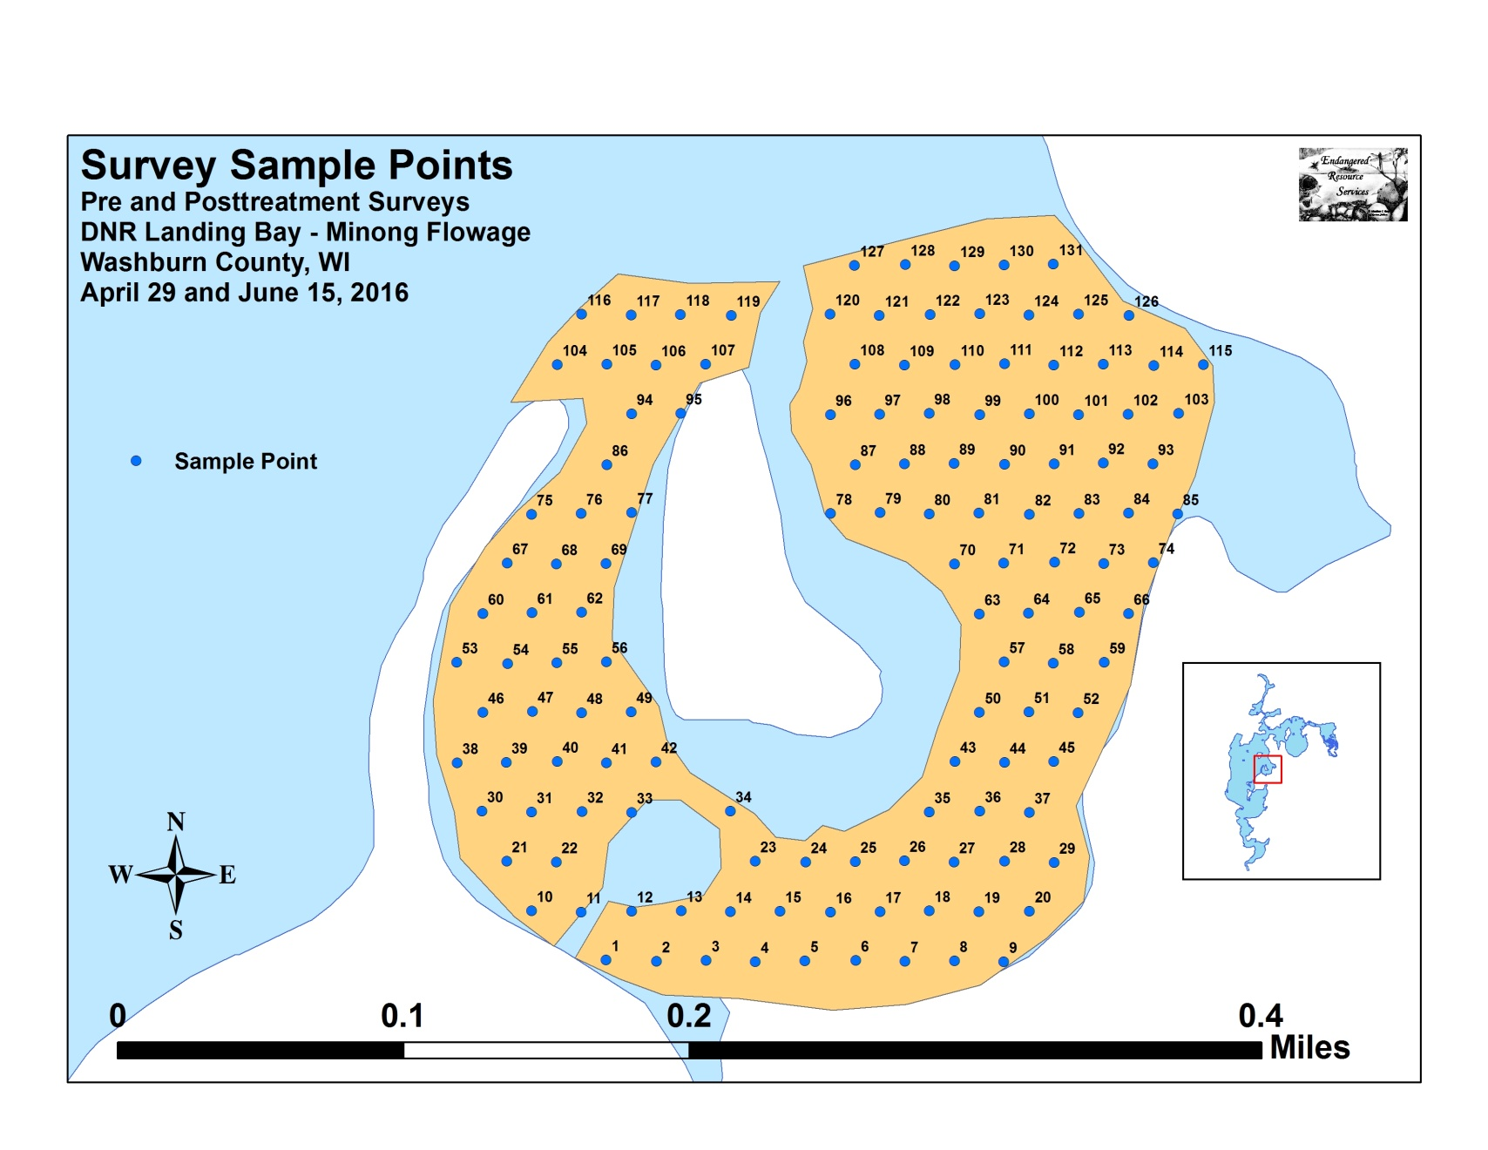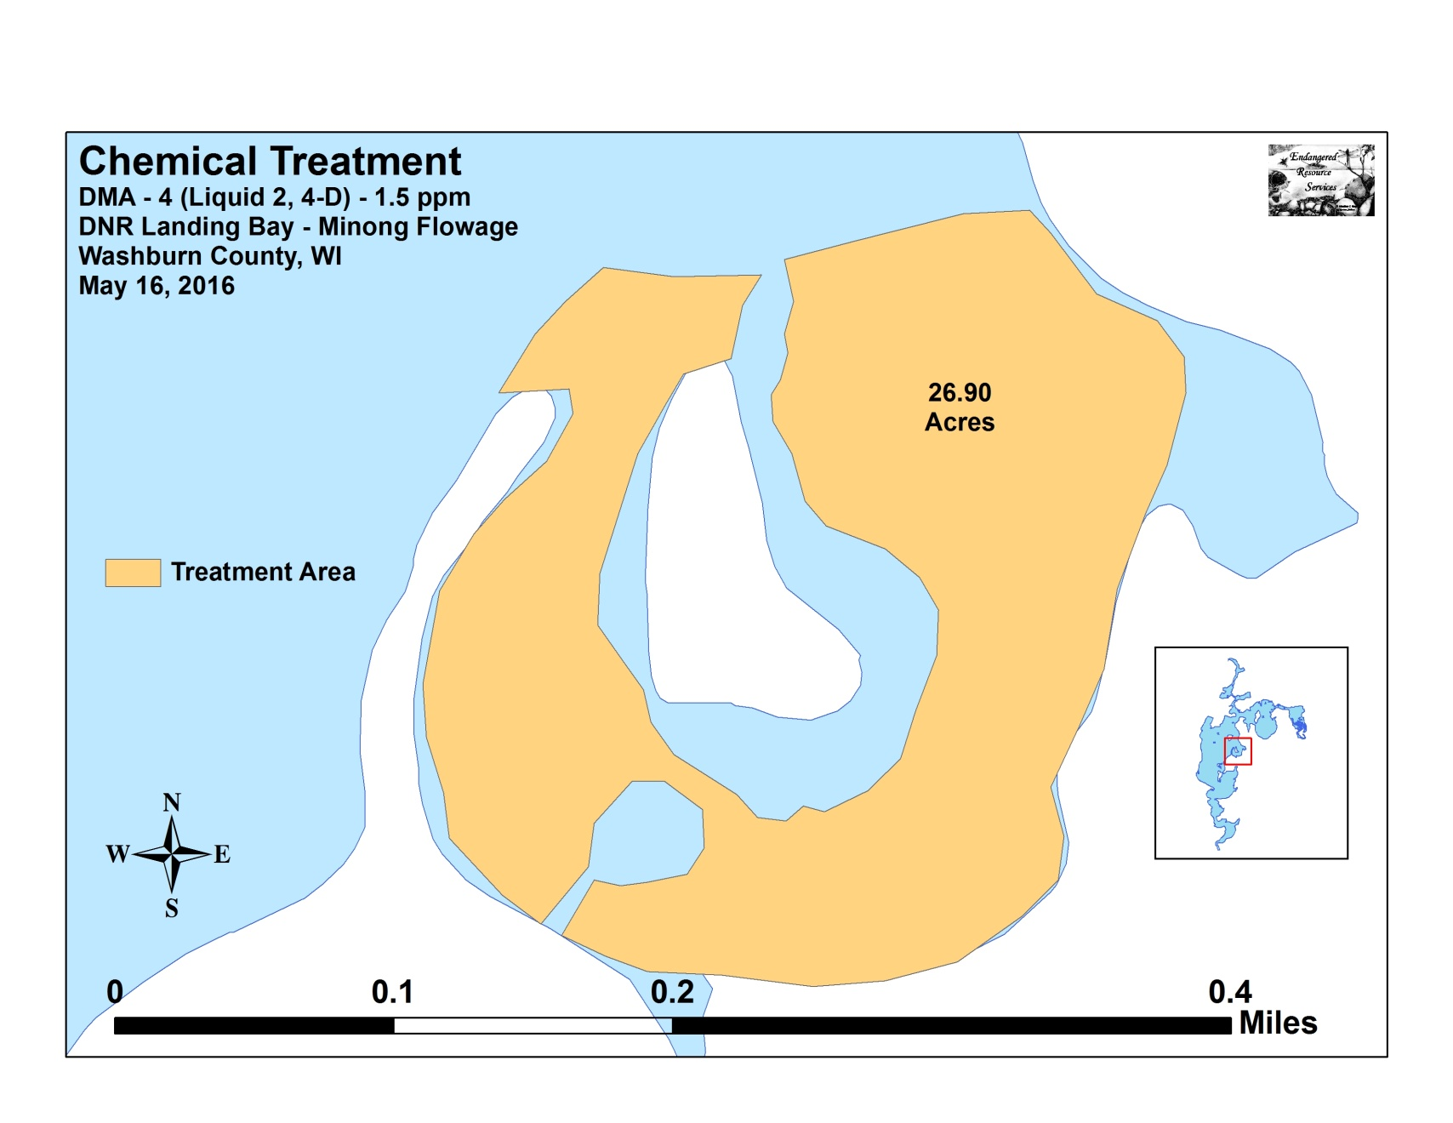

Appendix II: Vegetative Survey Data Sheet

Observers for this lake: names and hours worked by each:
Lake: |  |  |  |  |  |  |  |  | WBIC |  |  |  |  |  |  |  |  | County |  |  |  |  |  | Date:
Site # | Depth (ft) | Muck (M), Sand (S), Rock (R) | Rake pole (P) or rake rope (R) | Total Rake Fullness | EWM | CLP | 1 | 2 | 3 | 4 | 5 | 6 | 7 | 8 | 9 | 10 | 11 | 12 | 13 | 14 | 15 | 16 | 17 | 18 | 19
1
2
3
4
5
6
7
8
9
10
11
12
13
14
15
16
17
18
19
20

Appendix III: Pre/Post Habitat Variable Maps
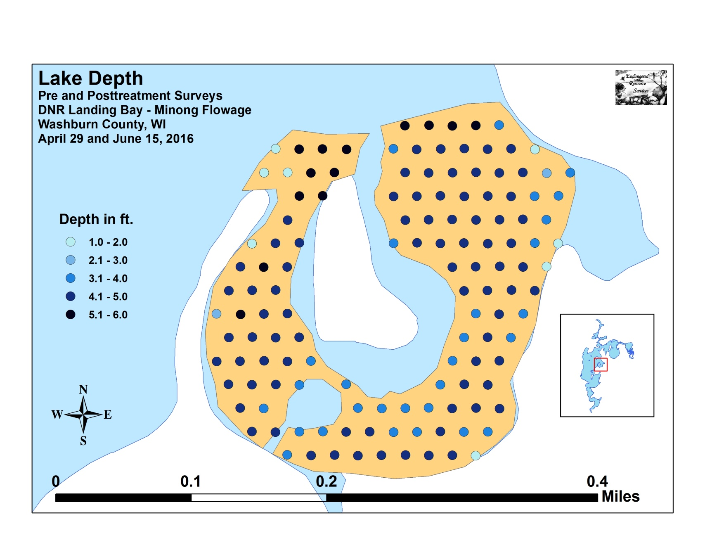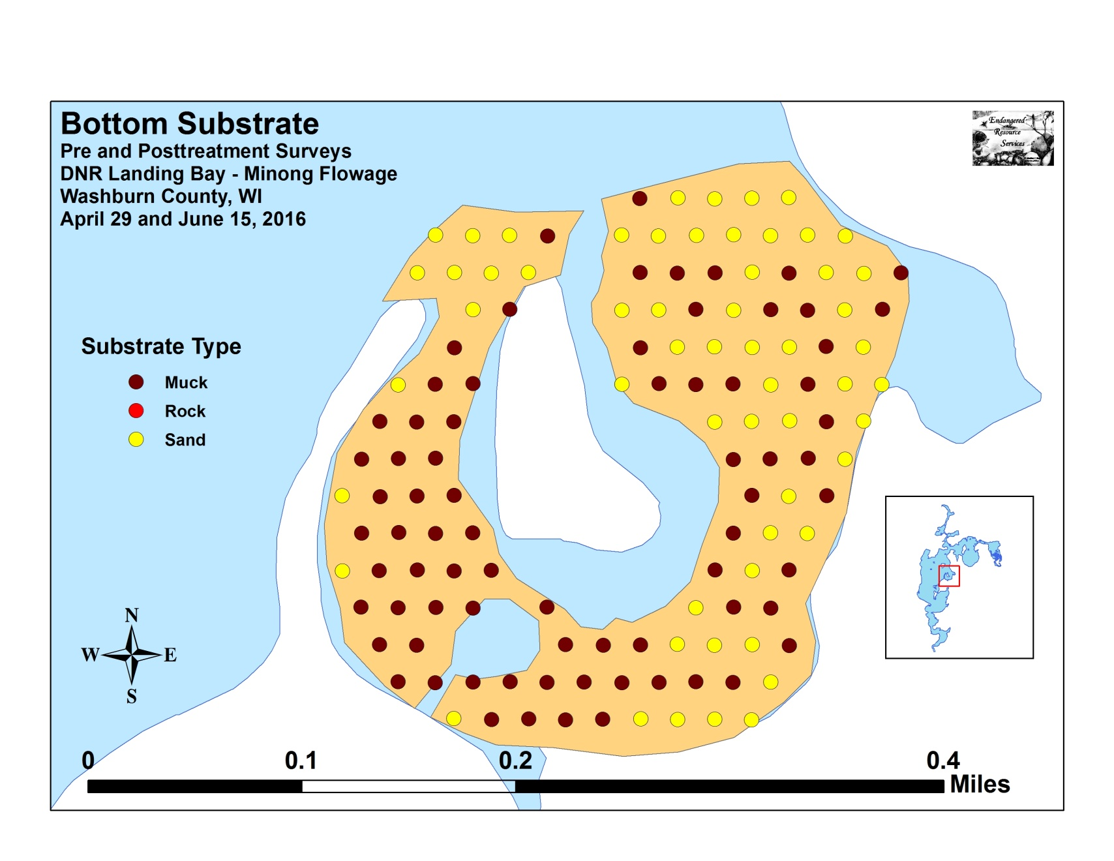

Appendix IV: Pre/Post Native Species Richness and
Total Rake Fullness
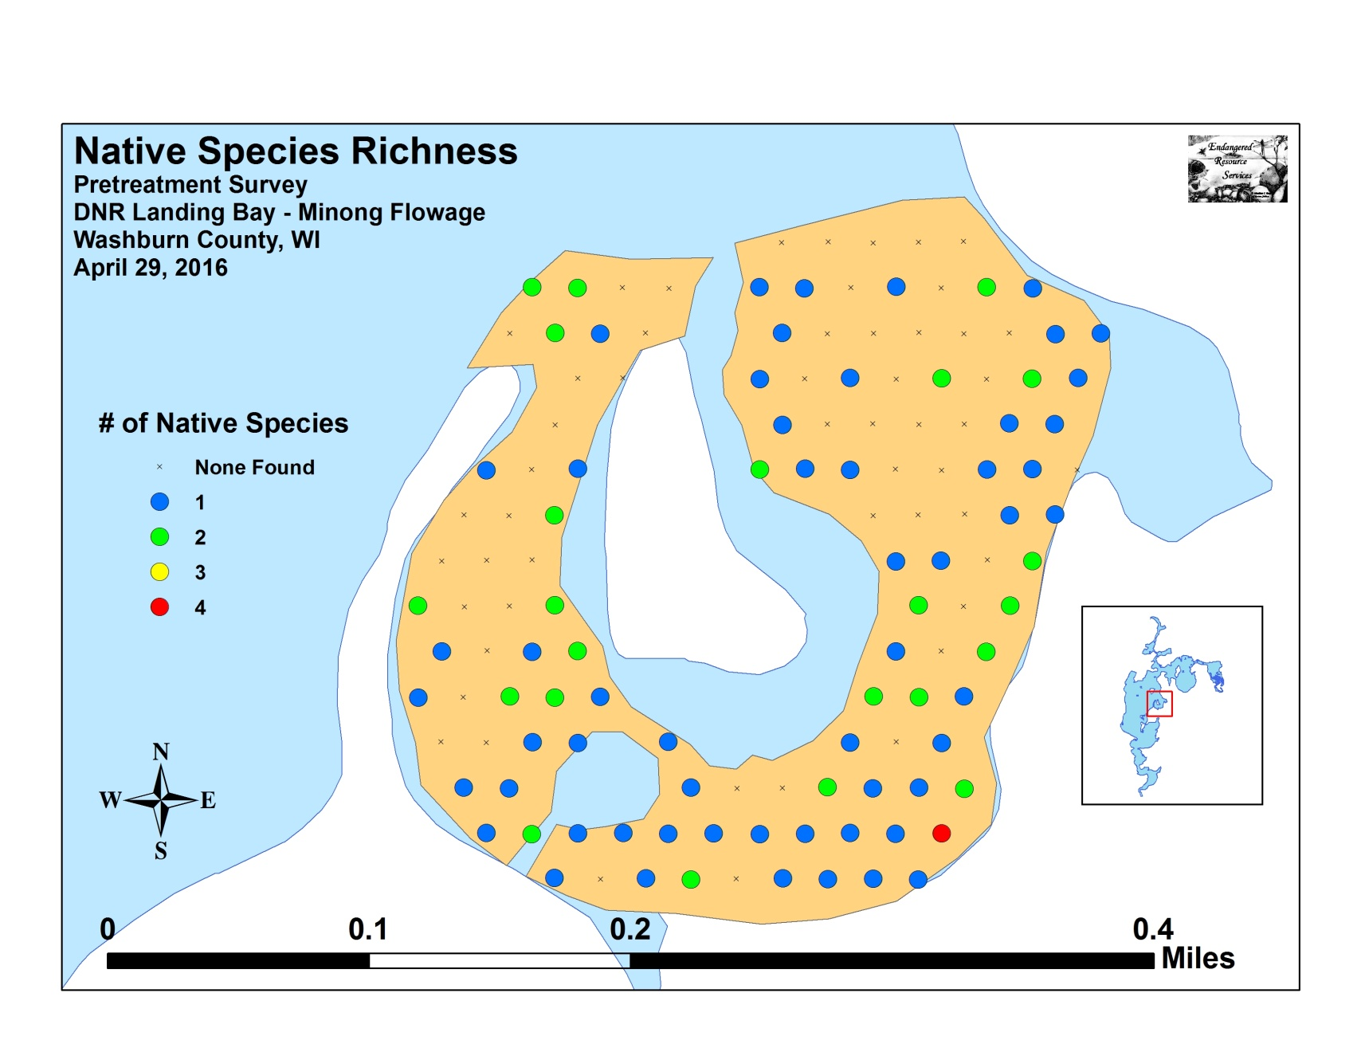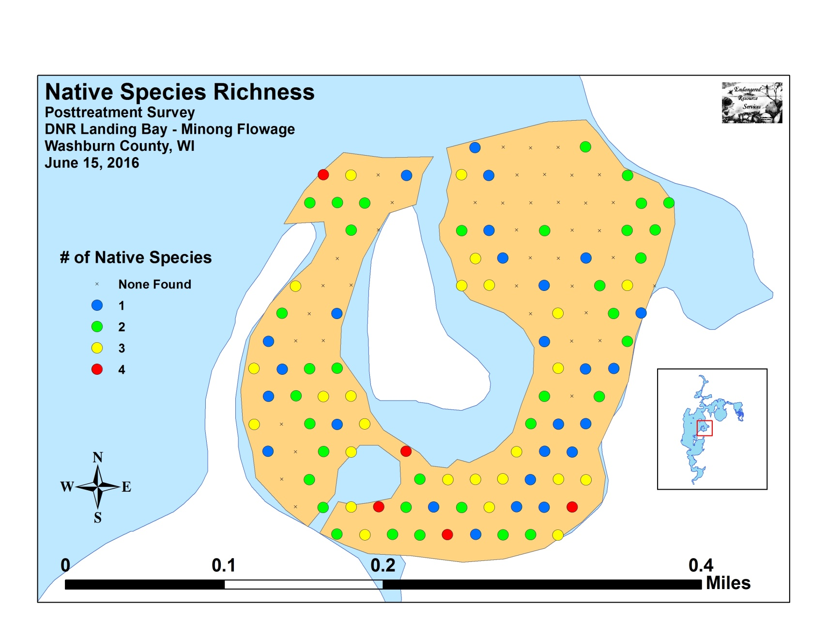
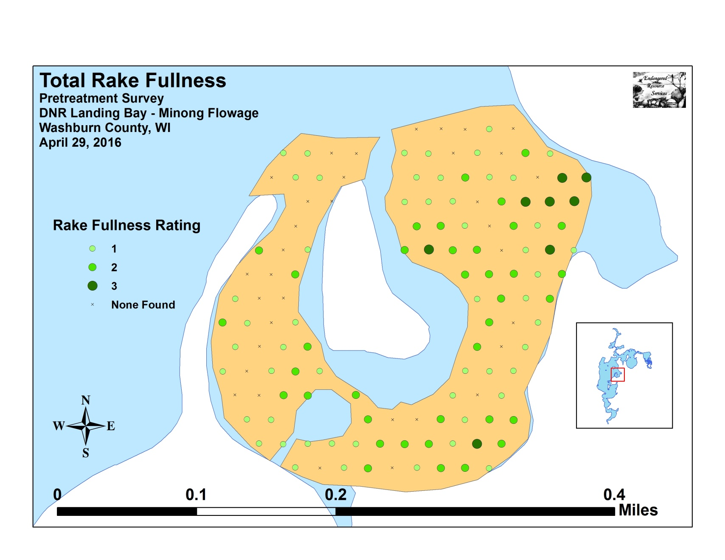
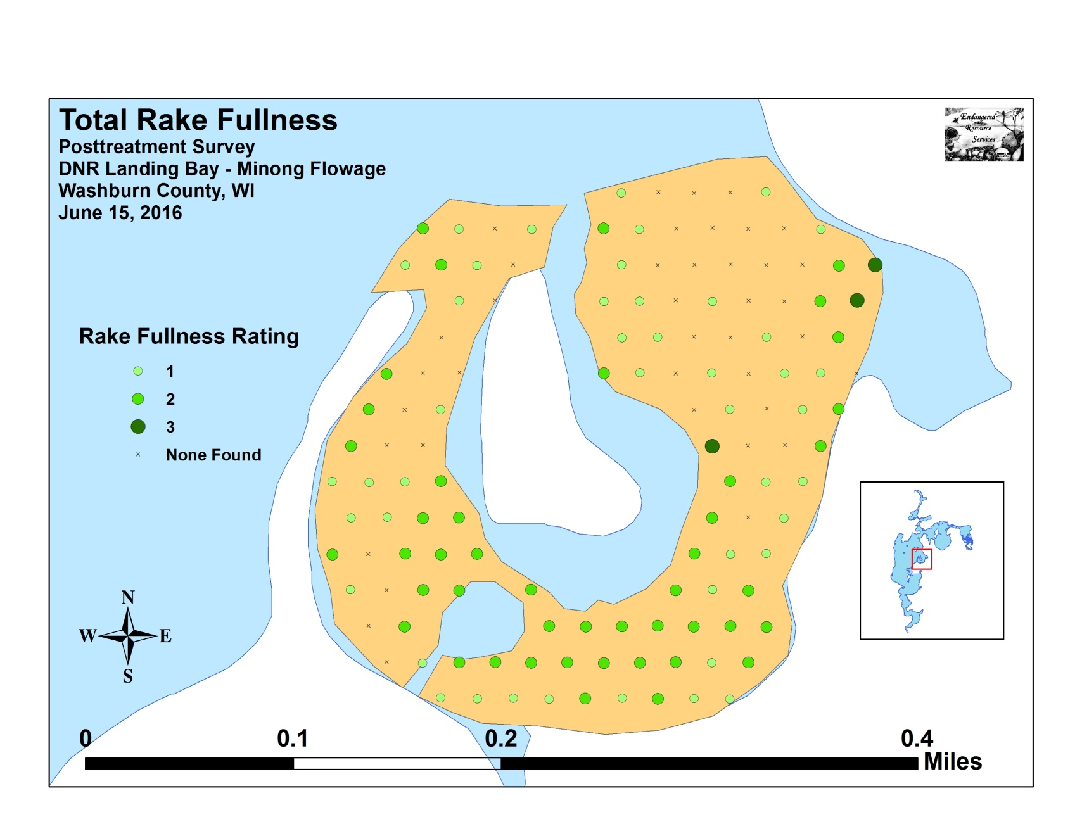

Appendix V: EWM and CLP Pre/Post Density and Distribution
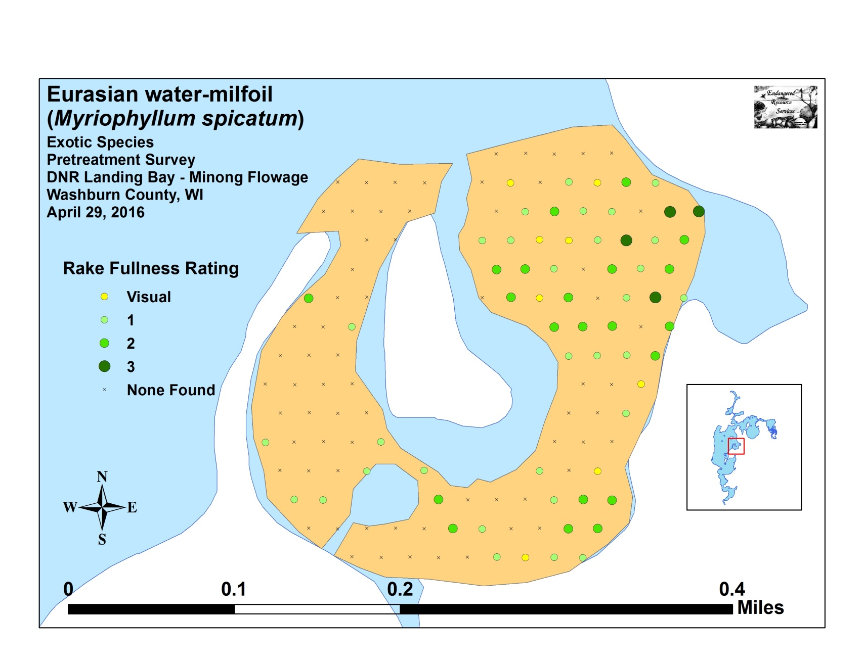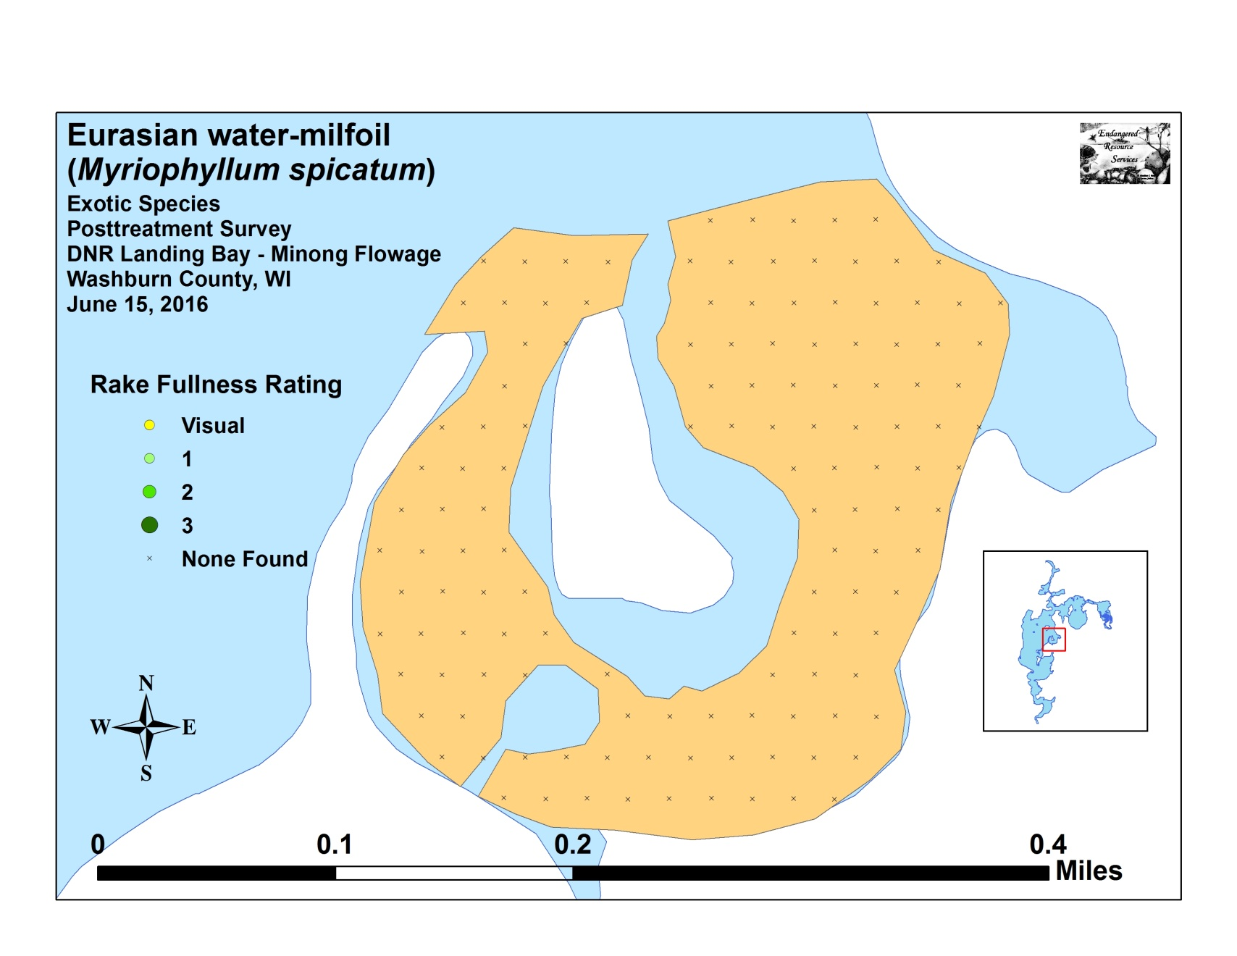
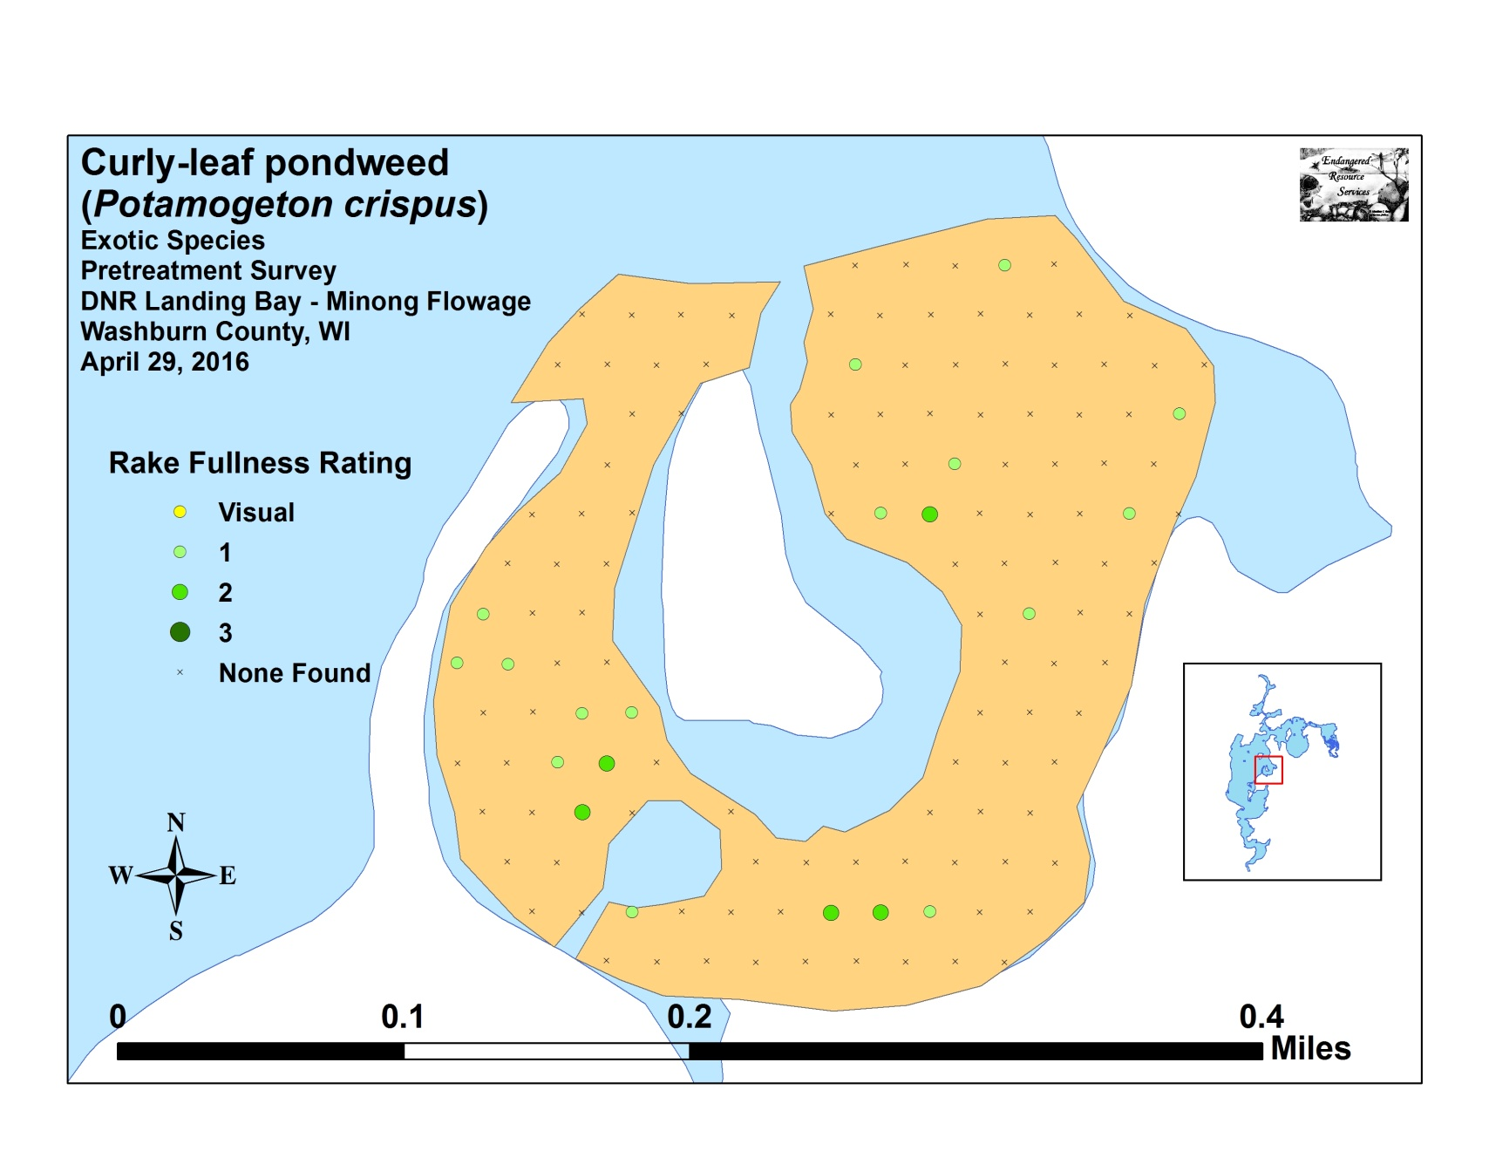
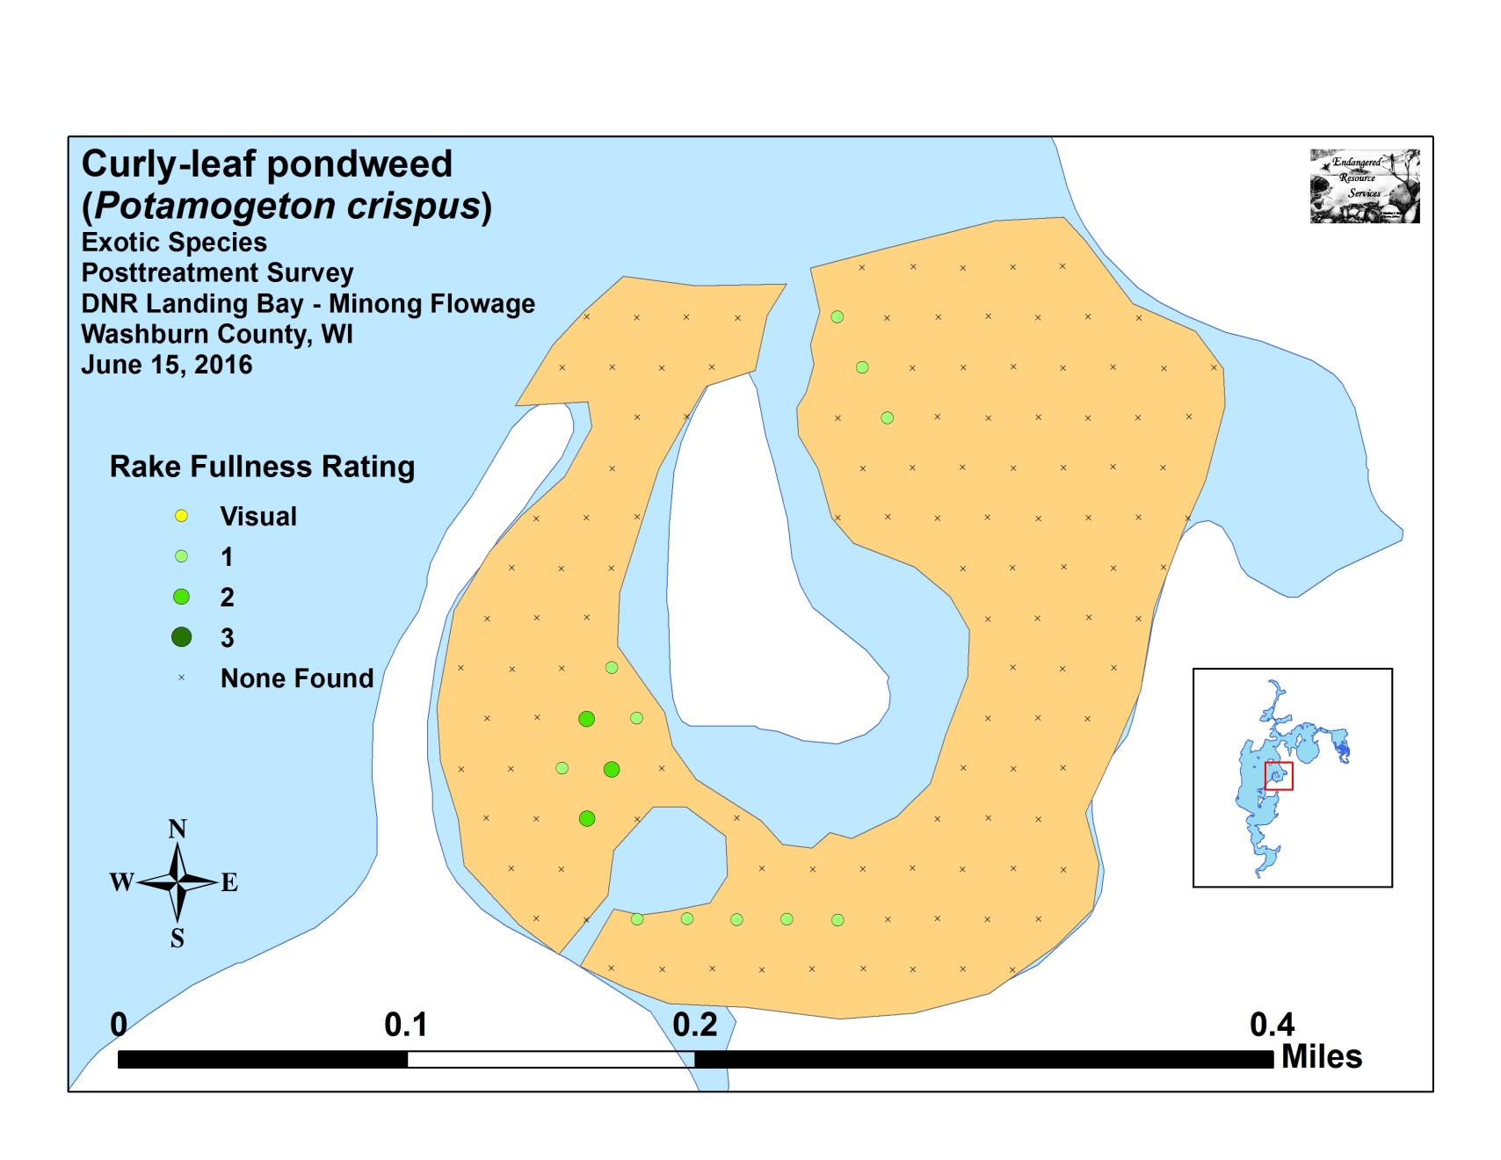

Appendix VI: Pretreatment Native Species Density and Distribution
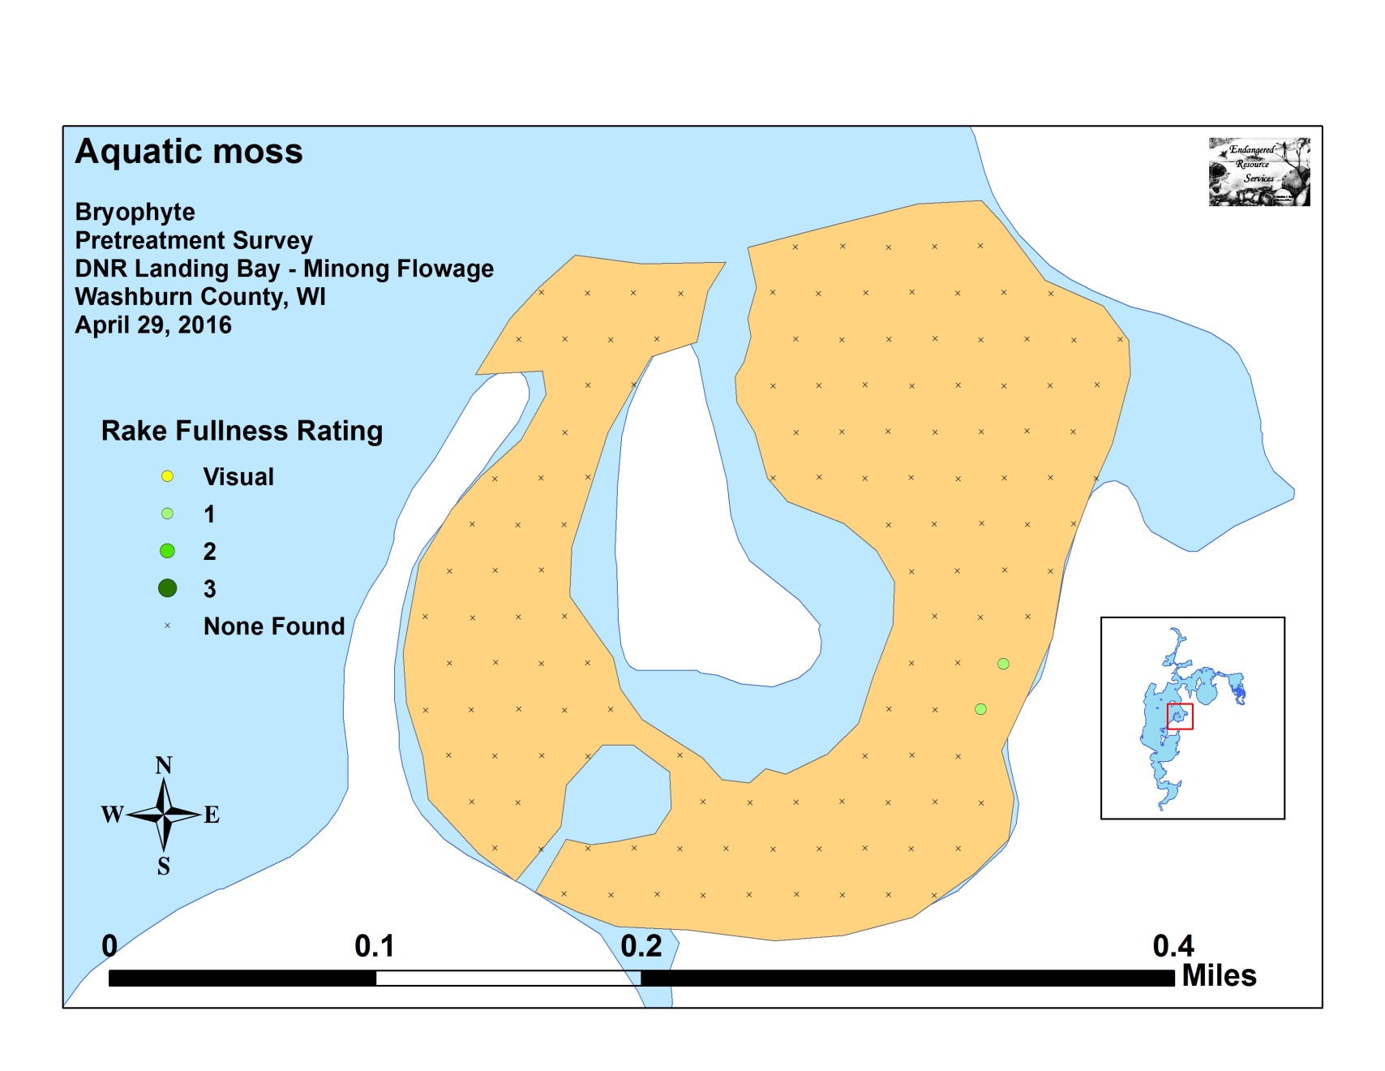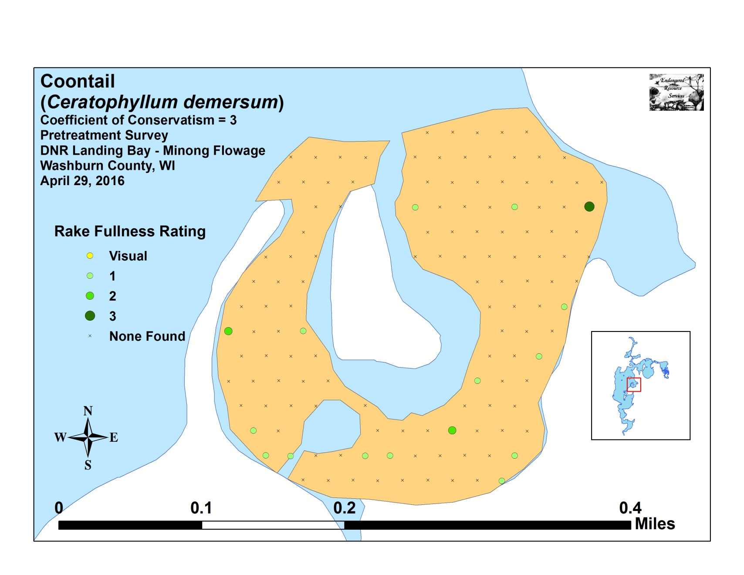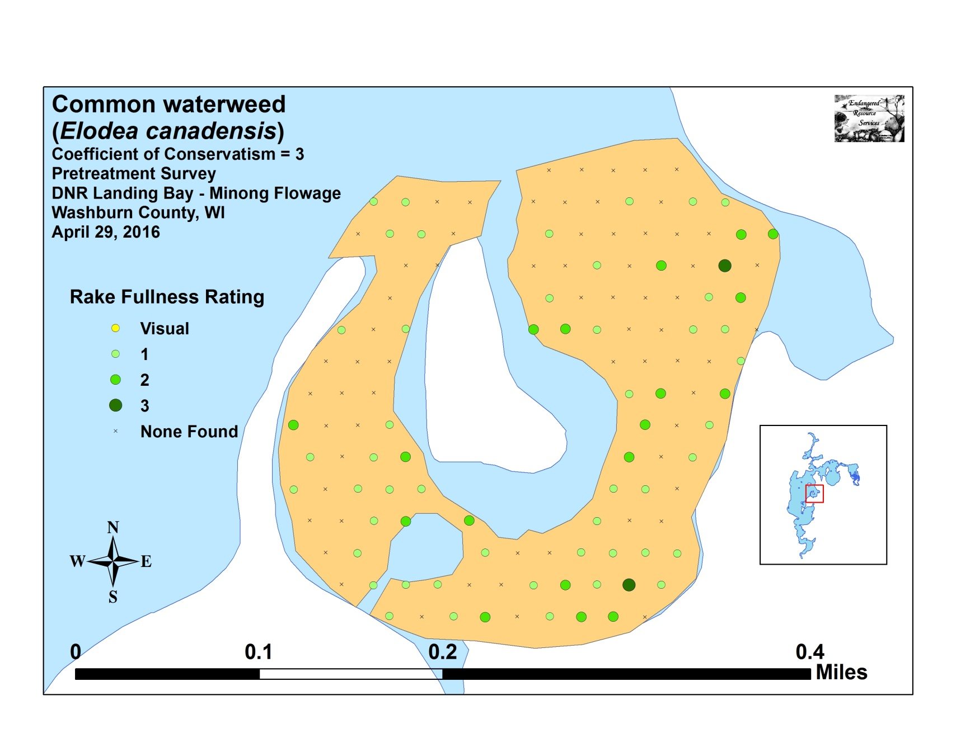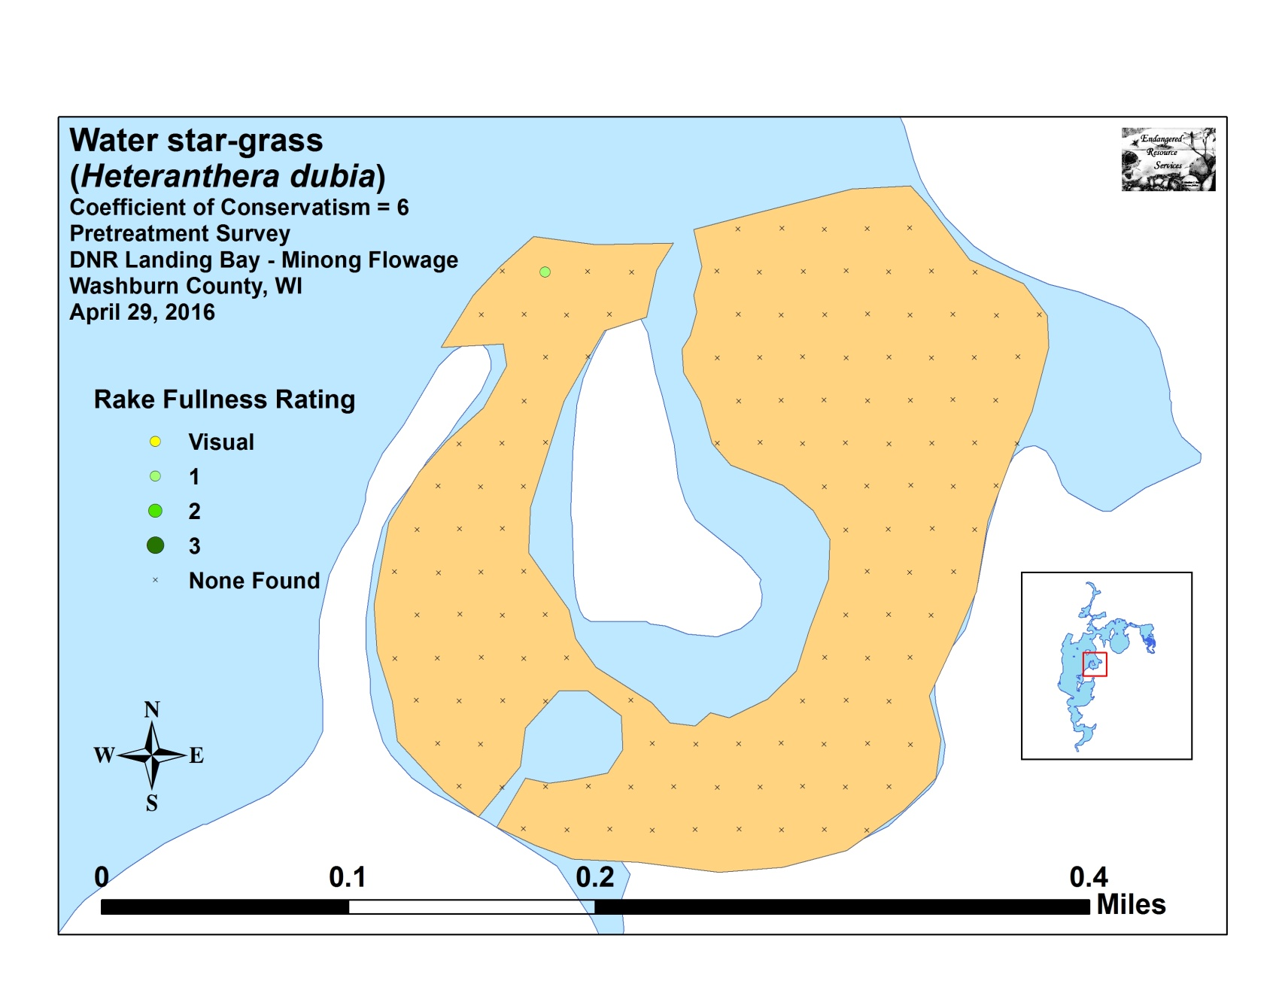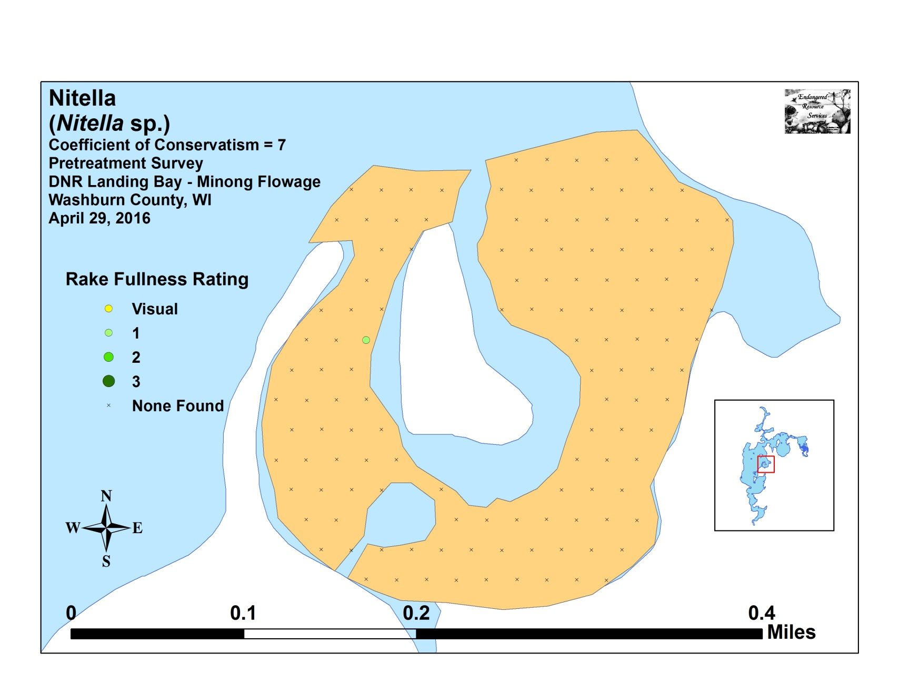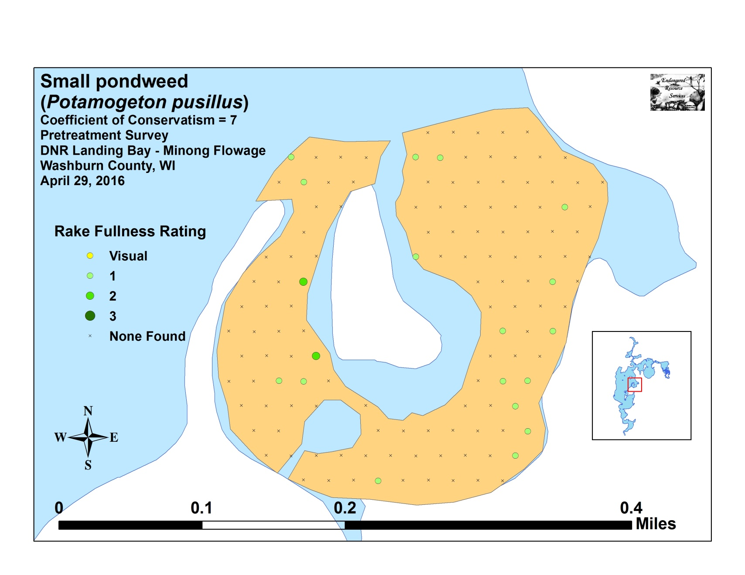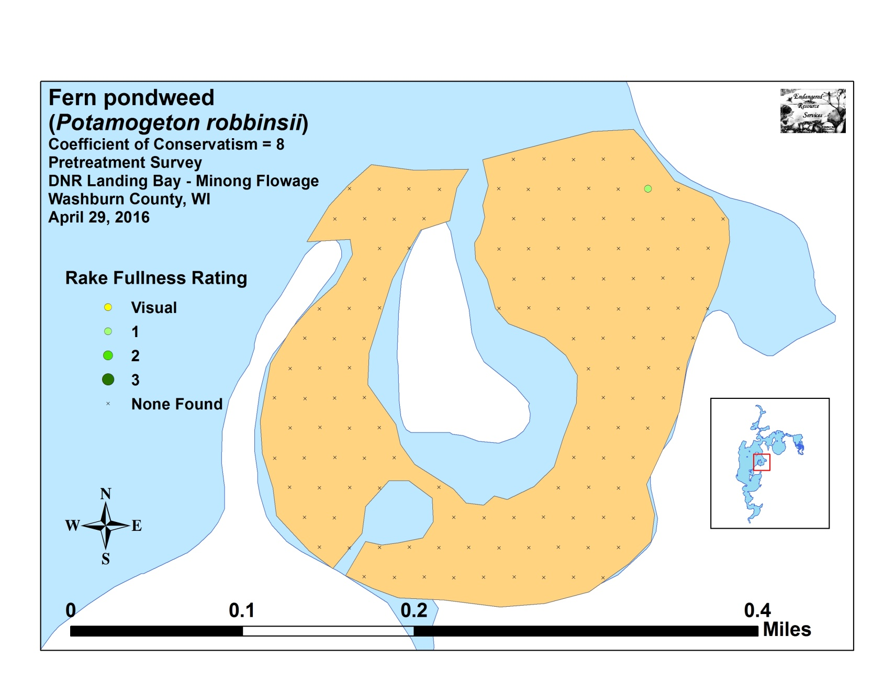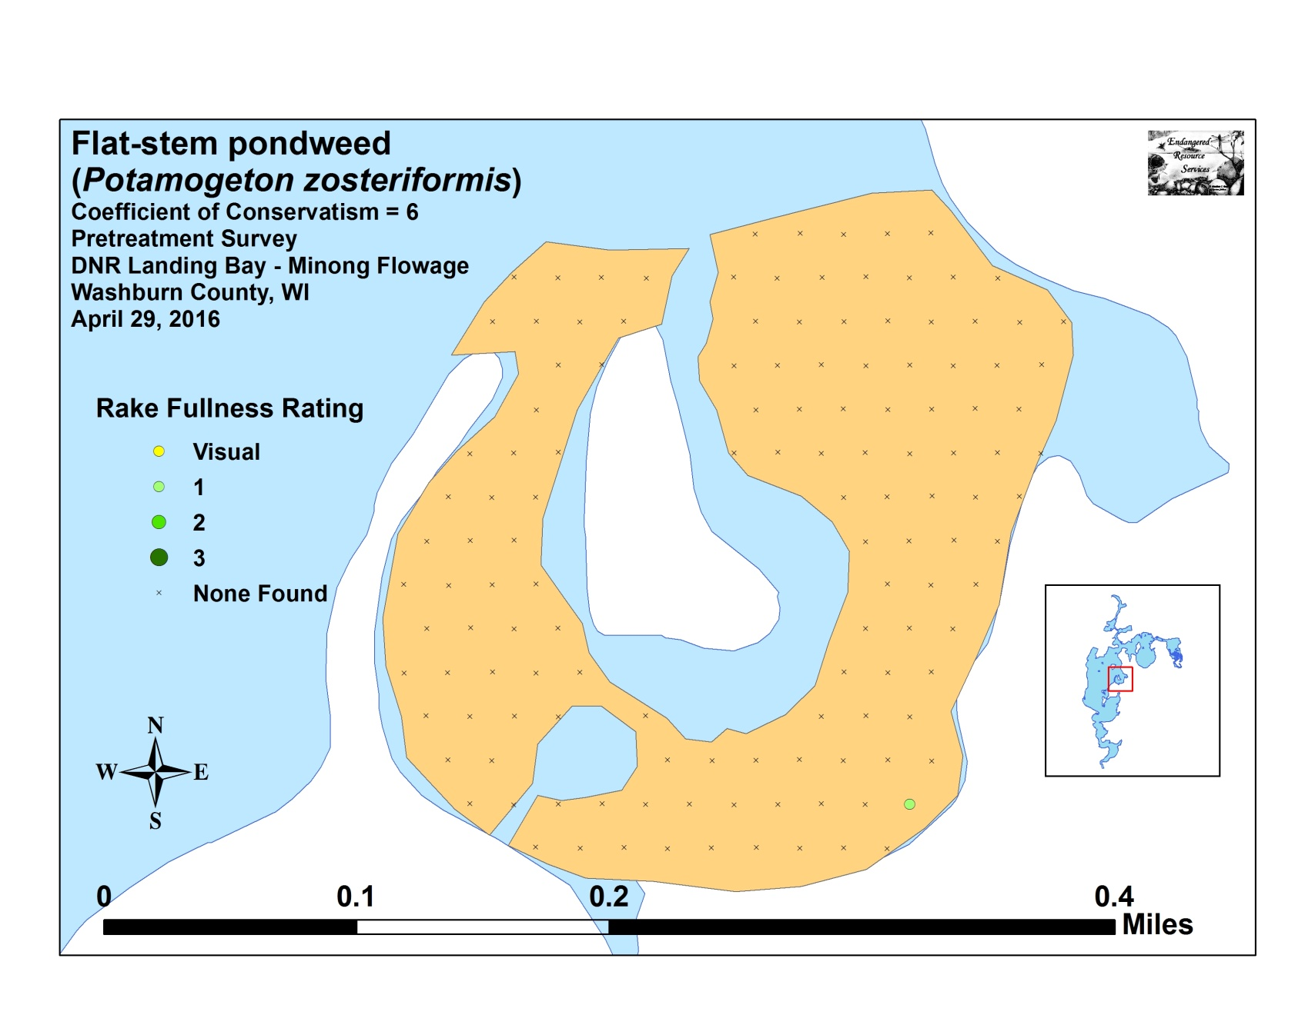

Appendix VII: Posttreatment Native Species Density and Distribution
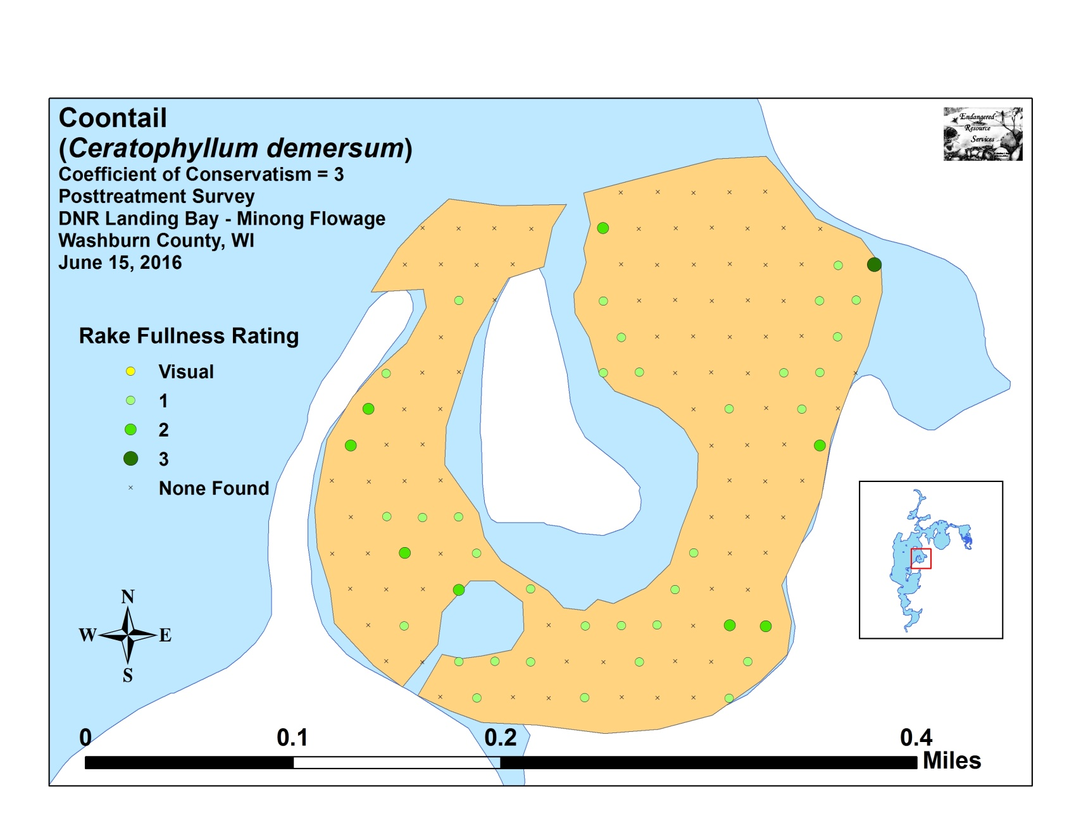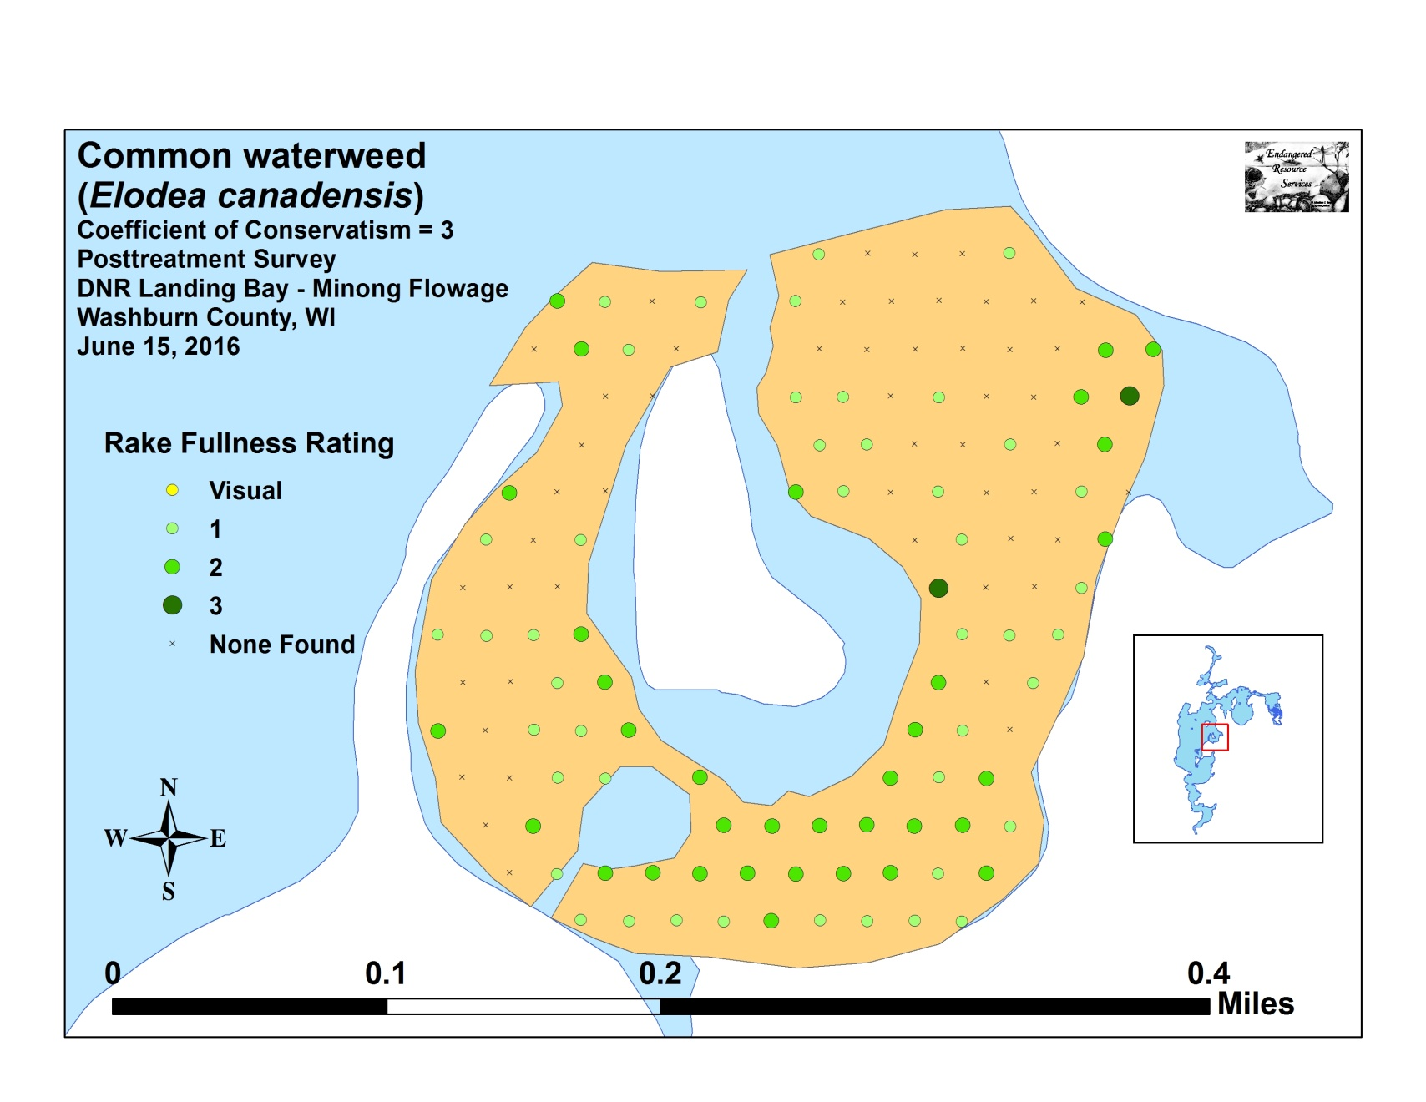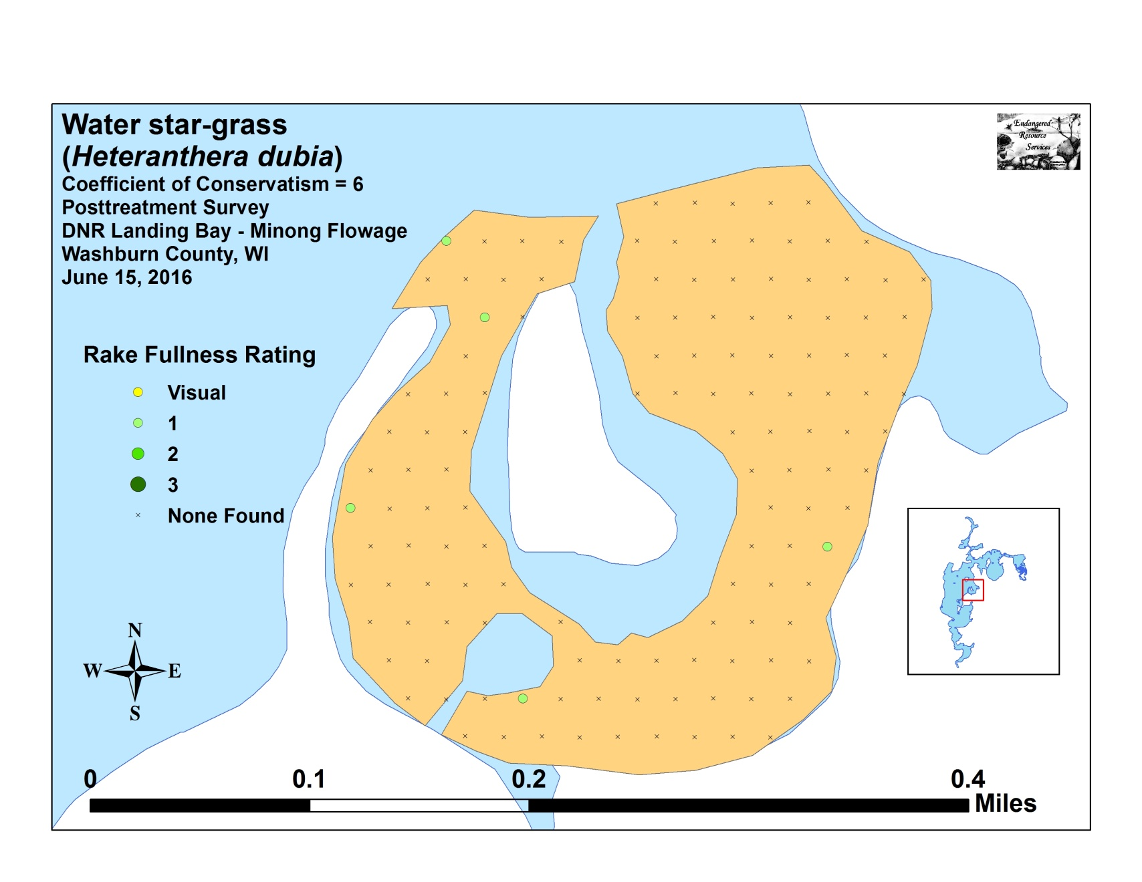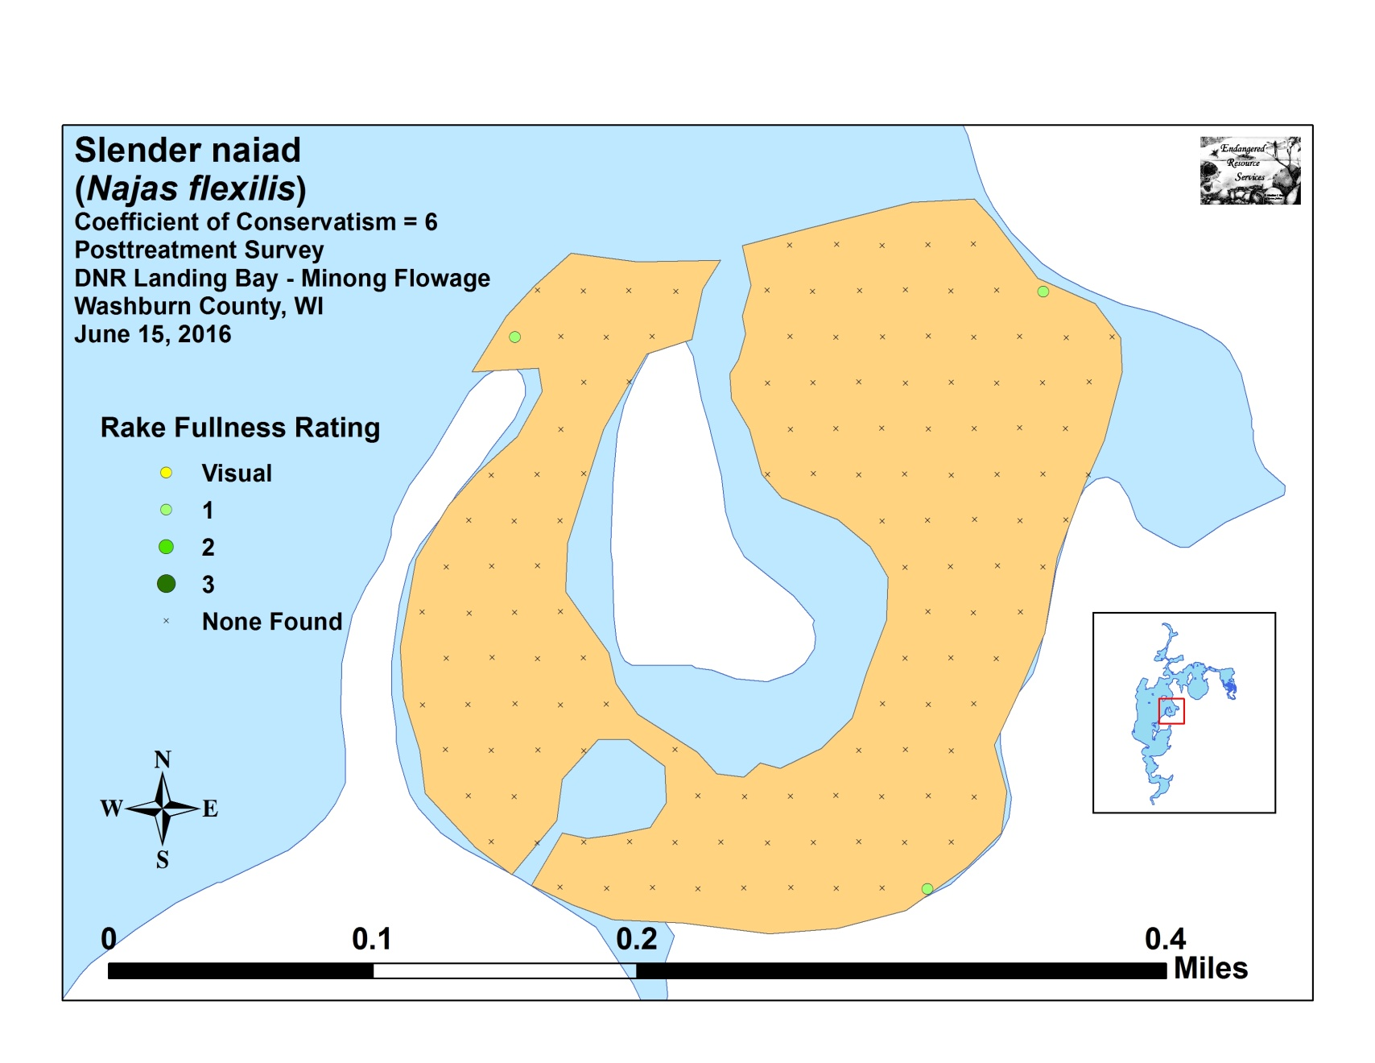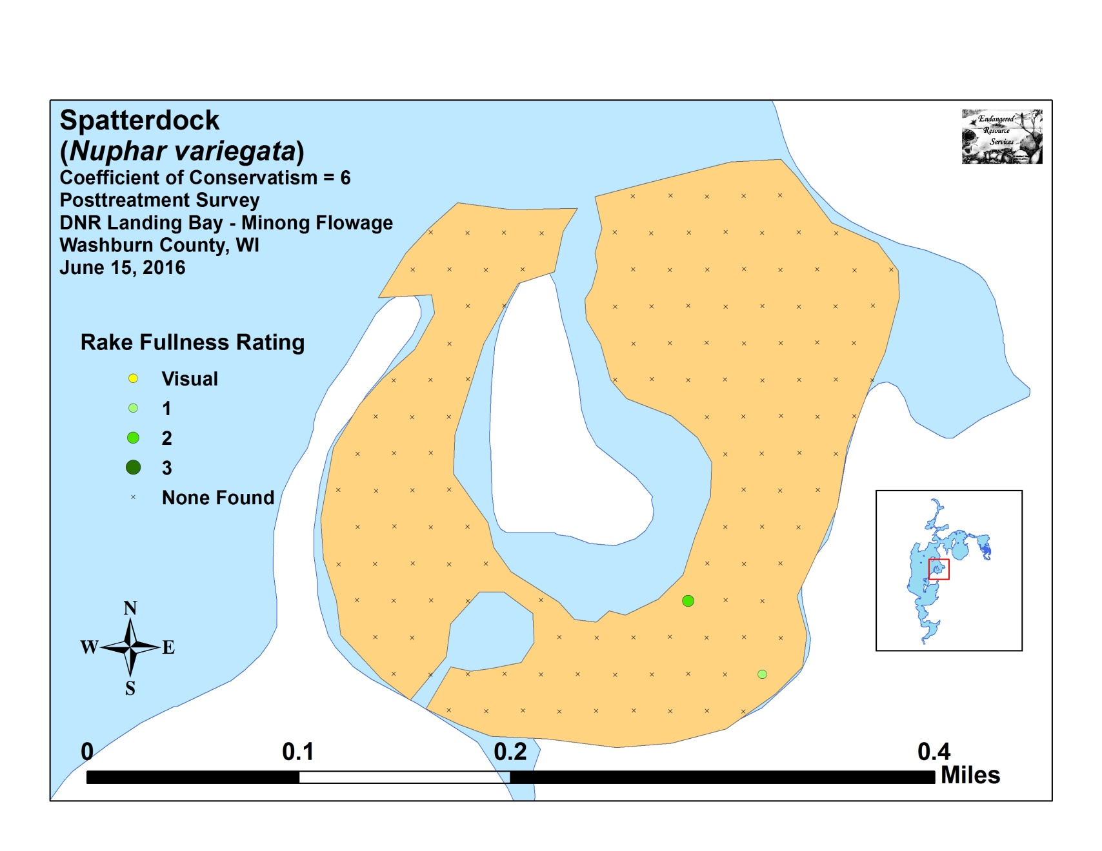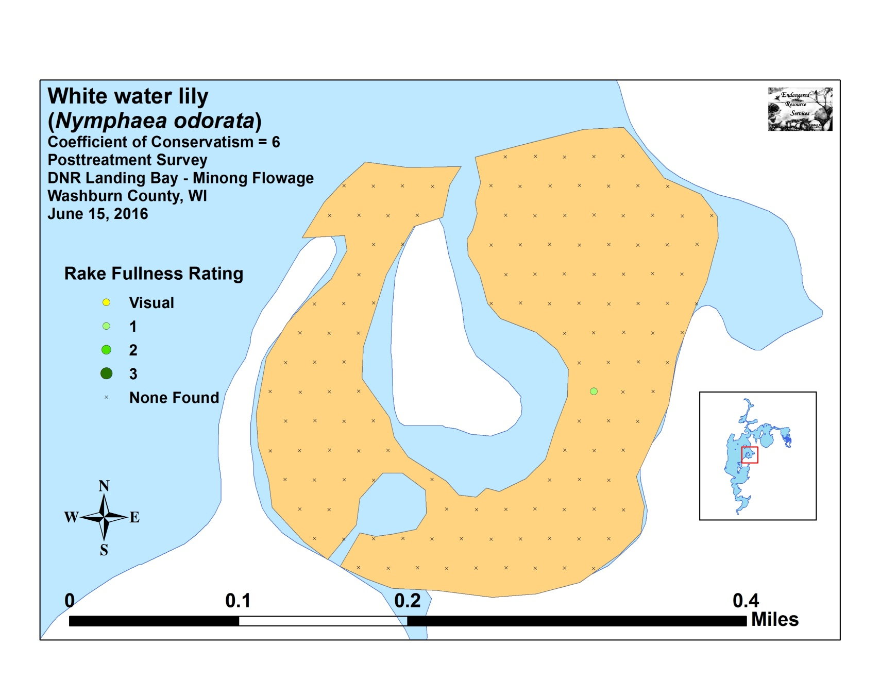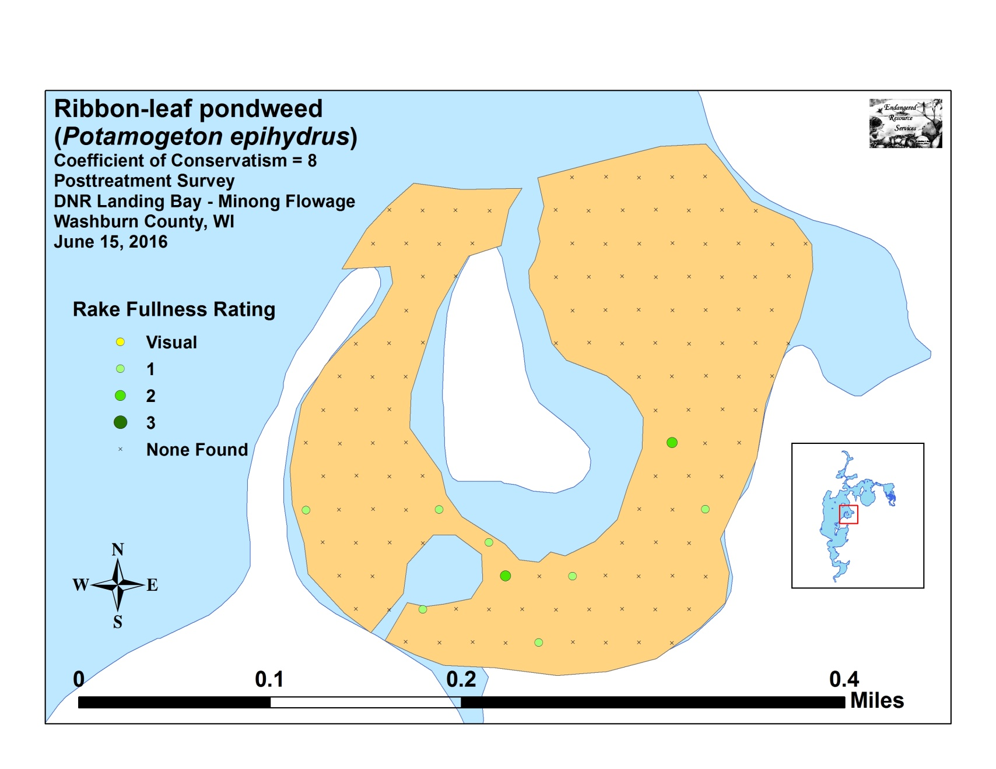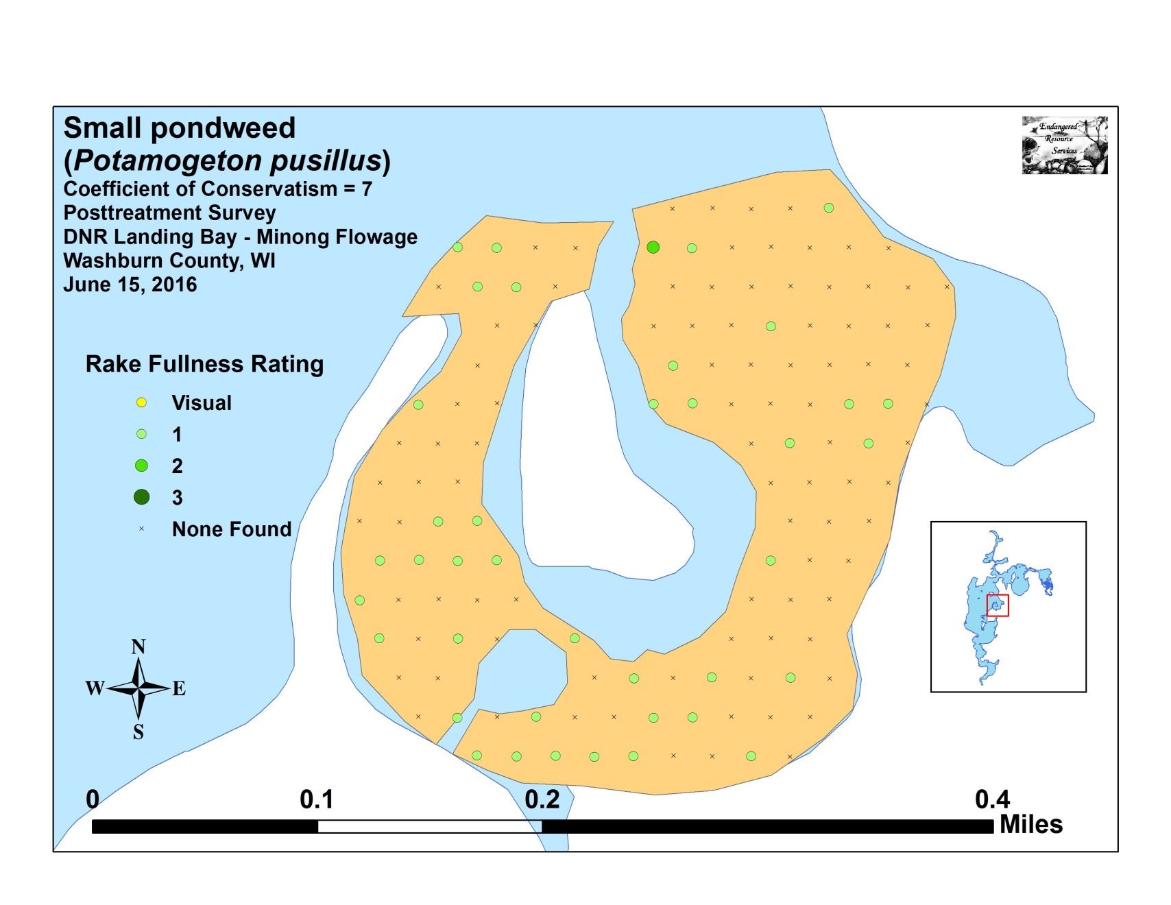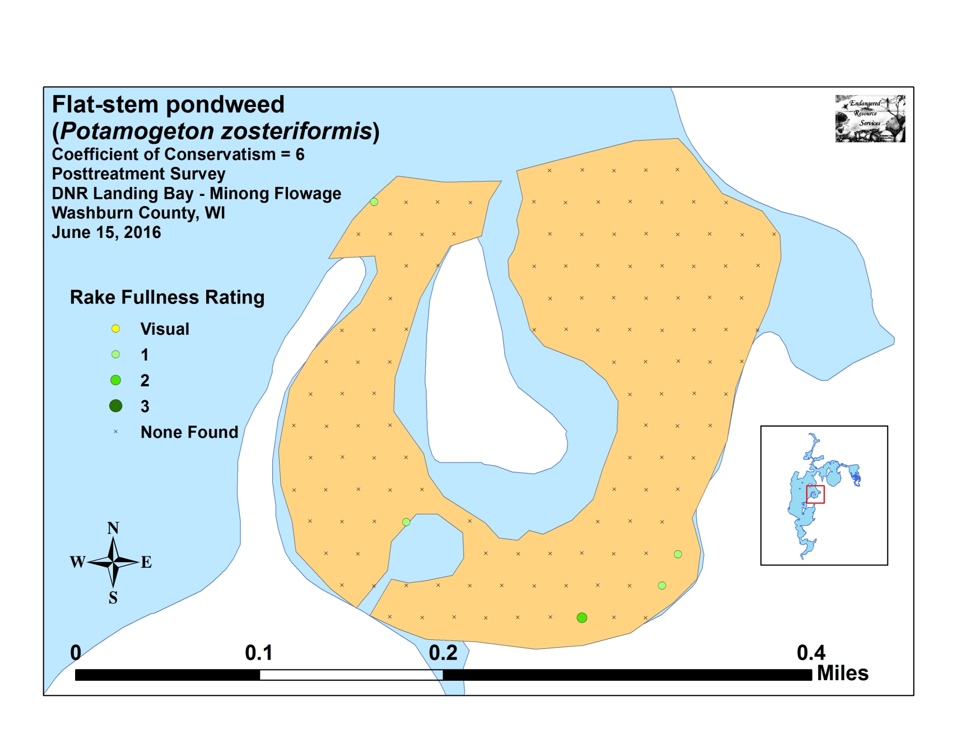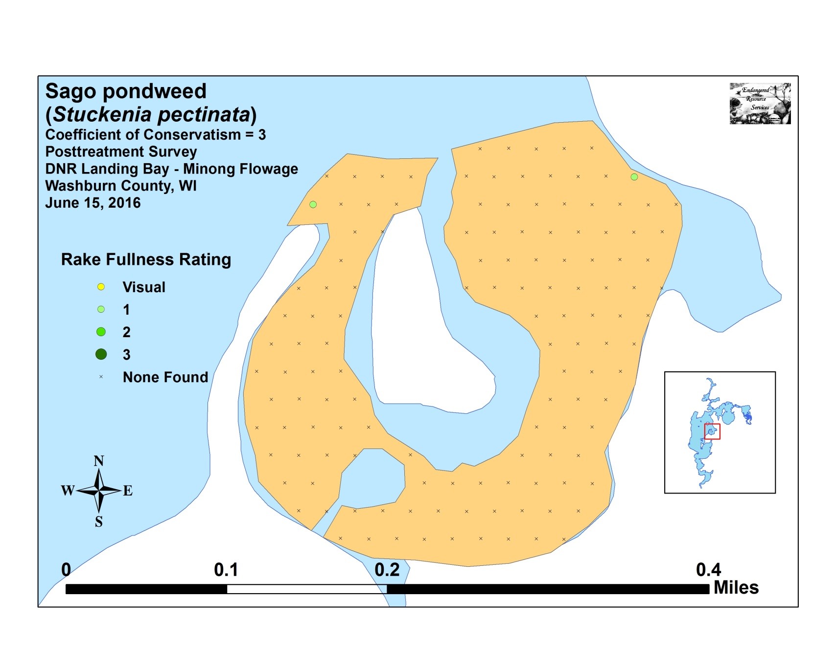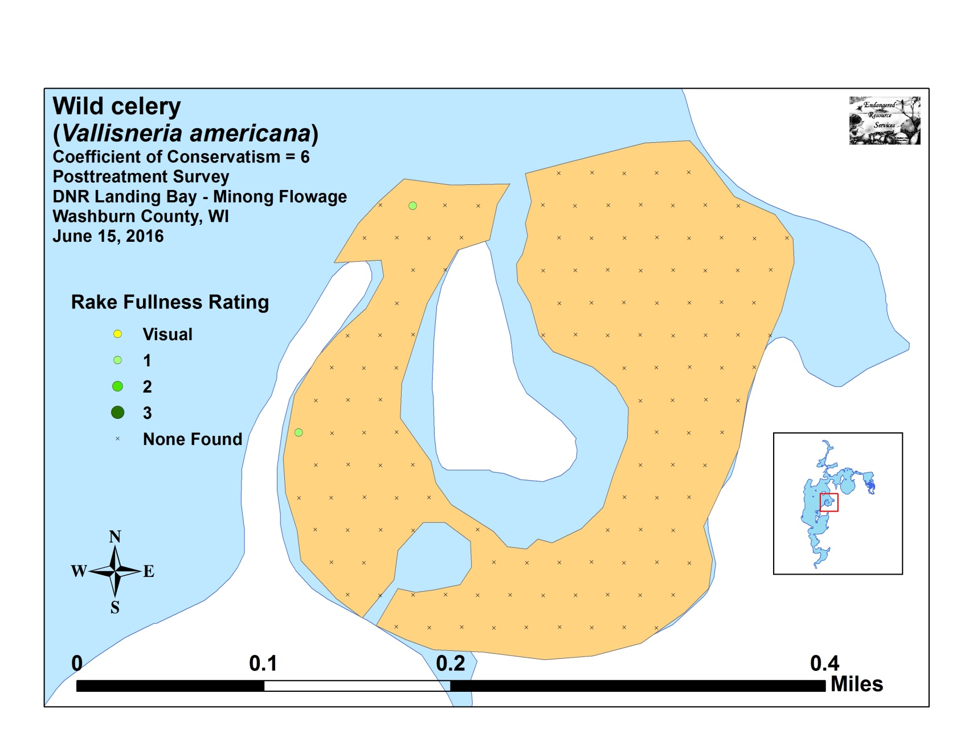

Appendix VIII: Fall 2015 and 2016 EWM Bed Maps
