Faxon Creek Water Quality Assessment
and 303d Listing Determination

Craig Roesler – DNR, Spooner
January 29, 2014

Introduction

Faxon Creek is a small urban stream located in the City of Superior in Douglas County (figure 1and 2). The creek is also locally known as Central Park Creek, and is officially an unnamed stream (WBIC 2843700). It has a length of 3.2 miles and has 3 small unnamed tributaries. Observations during 2008-10 showed that streamflow was perennial downstream of the first tributary confluence near 28th Street, and intermittent upstream of the confluence. The lower 0.4 mile of the stream flows underground through a 10 feet diameter culvert from the northeast end of Central Park to its outfall in Superior Bay. There was a short section of open channel just above Marina Drive during the monitoring period, but this section is now also underground.

Watershed soils are clay and impervious surfaces are widespread, resulting in rapid runoff. Flooding above the Central Park culvert has been a problem. Bank erosion is present along much of the channel. A fair amount of the stream corridor is vegetated.

Faxon Creek monitoring was conducted during 2008-2010 by DNR Superior office staff to assess water quality conditions and to determine if the creek should be placed on Wisconsin’s 303d list of impaired waters. (Faxon Creek and the Faxon Creek tributary are both recommended for placement on the 303d list; see discussion on p. 12)

Methods

Four sites on Faxon Creek and one tributary site were monitored (table 1and figure1).

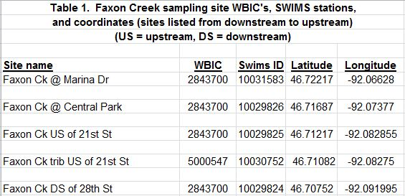

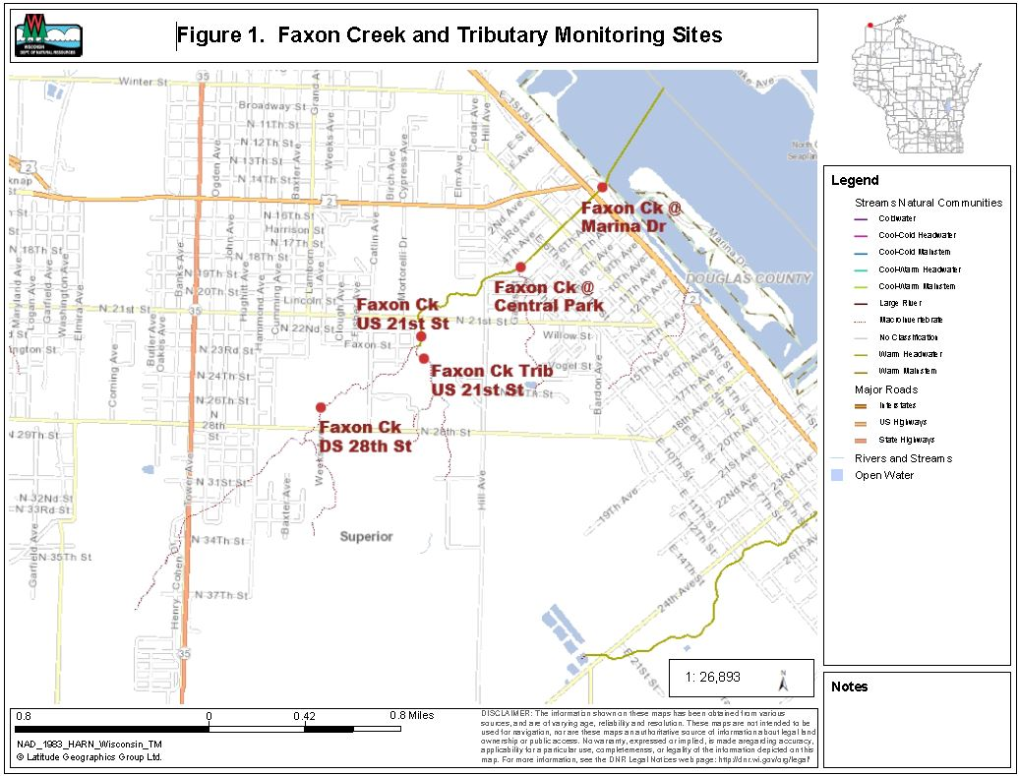

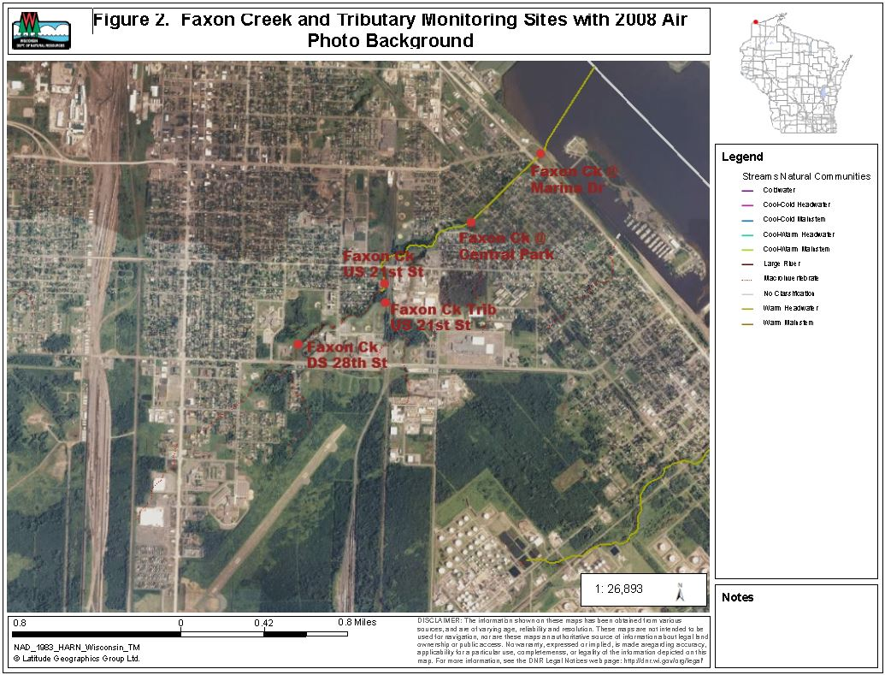

Monitoring was done for fish and macroinvertebrate communities, water chemistry, and sediment chemistry. The range of monitoring at each site varied (table 2).

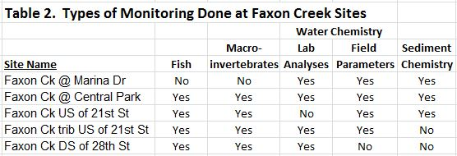

Fish communities were assessed by electrofishing with a single anode backpack shocker. As many fish as possible were captured with a single upstream pass. Station lengths were 35 times the mean stream width, with a minimum length of 100 meters. Fish captured were counted and identified to species. Fish community data was used to determine the natural community of the stream, and to calculate potentially appropriate biotic indices.

Macroinvertebrate communities were assessed by collecting kick samples from riffles, using a 500 um mesh D-frame net. Samples were preserved in 85% ethanol and were processed by UW – Stevens Point’s Aquatic Biomonitoring Lab. Macroinvertebrates were counted and identified to the lowest possible taxa. Biotic indices and other statistics were generated.

Water samples were collected and field parameters were measured following standard DNR protocols. Water samples were preserved, as needed, and shipped on ice to the Wisconsin State Lab of Hygiene for analysis. Field parameters measured were:
- Temperature
- pH
- Dissolved Oxygen
- Conductivity
- Transparency (using a transparency tube)
Lab parameters were:
- Total Phosphorus
- Ammonia – N
- Total Kjeldahl N
- Nitrate plus Nitrite – N
- Total Suspended Solids
- Turbidity

Sediment samples were collected using two methods. Grab samples were collected using a petite ponar dredge. Trap samples were collected by embedding a quart jar in the stream bottom and allowing passing bed load sediment to gradually fill the jar until an adequate sample volume was obtained. Sediment samples were shipped on ice to the Wisconsin State Lab of Hygiene for analysis. Sediment lab parameters were:
- PAH’s (polycyclic aromatic hydrocarbons), 20 compounds
- TOC (total organic carbon)
- % solids
- % sand, silt, and clay
- Oil and grease
- Metals (cadmium, chromium, copper, lead, mercury, nickel, and zinc)

Findings and Discussion

Fish Communities

Complete fish survey results are contained in appendix A. Fish survey IBI’s (index of biotic integrity) are summarized in table 3, below.

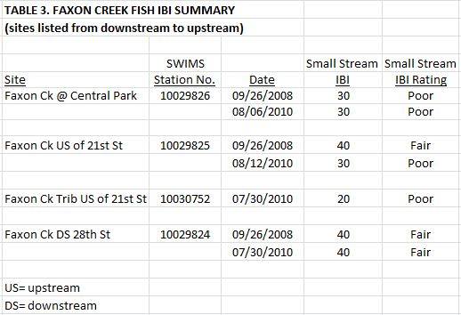

A total of five fish species were found at the sites surveyed. The species and percent of the total catch were:

- Creek Chub, 46%
- Brook Stickleback, 26%
- White Sucker, 20%
- Fathead Minnow, 7%
- Black Bullhead, 0.4%

All these species are considered tolerant to environmental disturbances. Three species (brook stickleback, fathead minnow, black bullhead) are also considered tolerant to low dissolved oxygen concentrations.

The thermal preference of the three most abundant species (creek chub, brook stickleback, white sucker) is transitional (cool water). The thermal preference of fathead minnows and black bullheads is warm water.

The model-predicted natural stream community for lower Faxon Creek from its confluence with the tributary upstream of 21st Street to its mouth is a warm headwater stream. The model-predicted natural stream community for the remainder of Faxon Creek and its tributaries is a macroinvertebrate stream. The fish communities found indicate the model-predicted natural stream communities are inaccurate. All stations on Faxon Creek and the surveyed tributary have fish communities that indicate a cool-warm headwater stream is the appropriate natural stream community.

Four of the seven fish surveys had small stream IBI ratings of poor, with the other three surveys having IBI ratings of fair (table 3). Two sites on Faxon Creek and the Faxon Creek tributary site had one or more poor small stream IBI ratings. Current WISCALM guidance uses the small stream IBI to rate all warm and cool headwater streams for potential 303d listing.

The fish communities found are indicative of cool-warm headwater conditions. The cool-warm IBI ratings for all survey sites were poor.

Macroinvertebrate Communities

Macroinvertebrate IBI’s (MIBI’s) at the three mainstem Faxon Creek sites were variable, ranging from poor to excellent and averaged fair to good (table 4). The Faxon Creek tributary site had two samples with poor MIBI’s and one sample with a fair MIBI, and averaged poor.

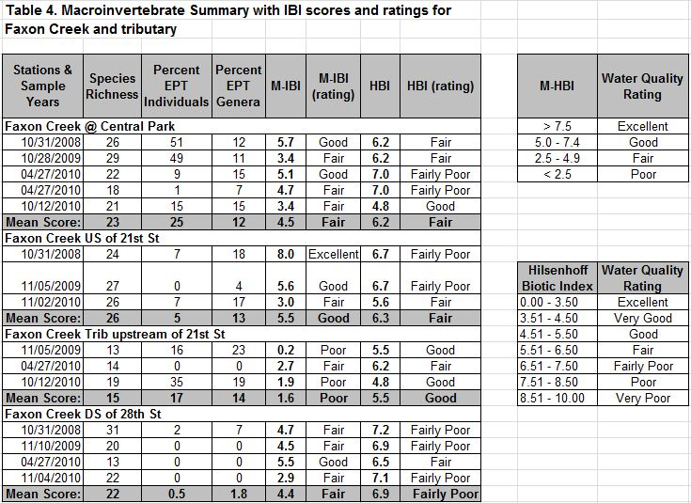

Hilsenhoff’s biotic index (HBI) ratings range from fairly poor to good. HBI’s are mostly influenced by organic matter loading and the resultant dissolved oxygen concentrations. The HBI’s suggest dissolved oxygen stress to macroinvertebrates is moderate. The Faxon Creek site downstream of 28th Street has the poorest HBI and highest dissolved oxygen stress. The fish community at this site also suggests higher dissolved oxygen stress. It is composed of a much higher percentage of individuals that are tolerant to low dissolved oxygen concentrations (84%) than the other sites. Wetland drainage, which has a high biochemical oxygen demand (BOD) may be contributing to dissolved oxygen stress at this site.

Water Chemistry

Faxon Creek water chemistry data is shown in tables 5, 6, and 7.

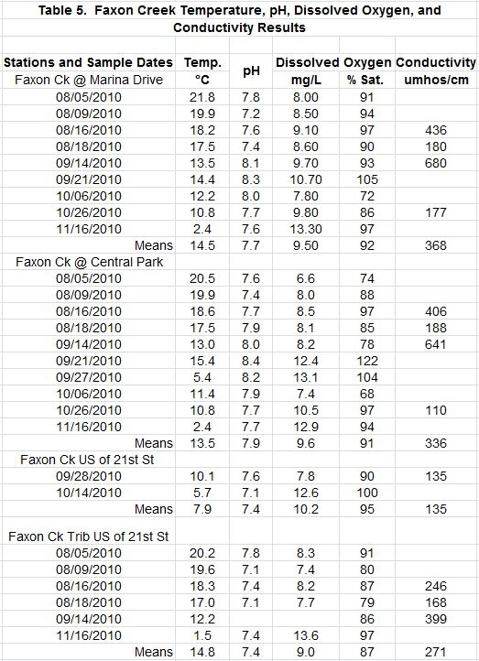

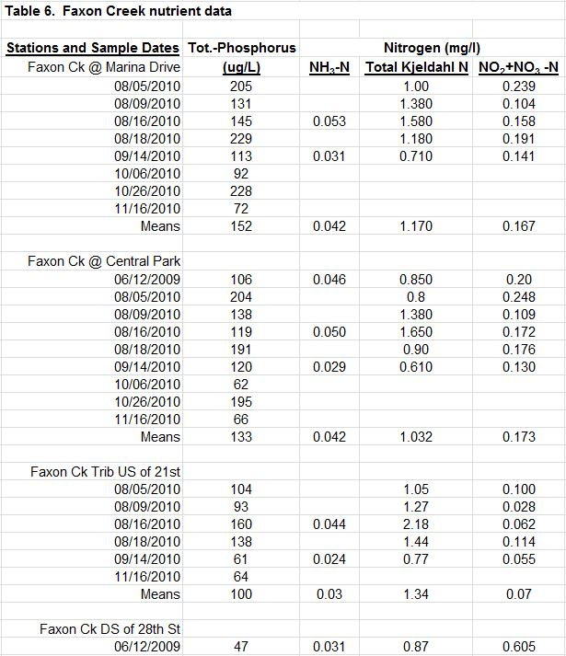

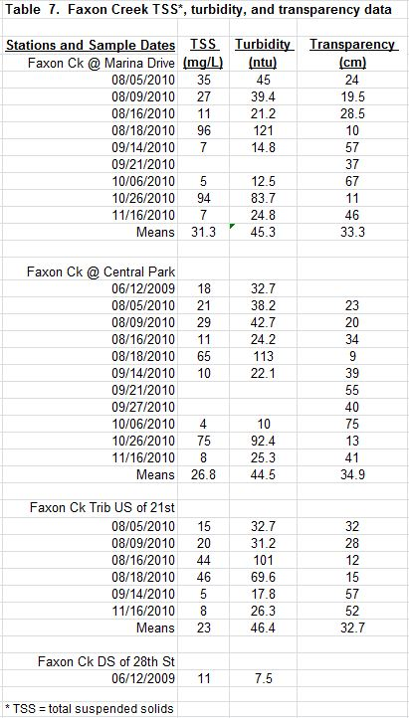

Daytime dissolved oxygen concentrations ranged from 7.4 -13.1 mg/l and were 70% saturated or more, for all but one measurement (table 5). pH values ranged from 7.1 – 8.4 .

Conductivities varied widely from 110 – 641 umhos/cm. Conductivity is typically low when surface runoff is dominating stream flow and high when groundwater discharge is dominating stream flow.
Total phosphorus (TP) concentrations are high with means ranging from 104 – 152 ug/l for the three sites with multiple samples (table 6). TP concentrations generally increase from upstream sites to downstream sites. Wadable stream TP concentrations greater than 75 ug/l indicate impaired conditions for 303d listing. However, the 75 ug/l threshold is based on the mean of six monthly samples collected during May through October. Faxon Creek sampling did not follow this collection schedule, so can’t be used to directly determine if the threshold is exceeded. The high TP concentrations found suggest that it is likely the threshold would be exceeded if appropriately scheduled samples were collected.

Ammonia concentrations are fairly low and do not indicate toxicity concerns. Most nitrogen is present in the organic form (total Kjeldahl nitrogen minus ammonia). Total nitrogen concentrations (total Kjeldahl nitrogen plus nitrate and nitrite nitrogen) are moderately high, with means ranging from 1.2 – 1.4 mg/l.

Total suspended solids (TSS) concentrations and turbidity are high (table 7). TSS concentration means range from 23 - 31 mg/l for the three sites with multiple samples. Turbidity ranges from 44 – 46 ntu for these sites. High TSS concentrations and turbidity are likely due partly to the flushing of particulates with runoff from paved surfaces in the watershed. The clay soils in the watershed are also easily eroded from stream banks, construction sites, and other areas of disturbed soil. High peak flows due to rapid runoff contribute to erosion of stream banks and beds.

With high TSS concentrations and turbidity, transparency is low. Transparency measurements range from 11 – 75 cm (4 – 30 in) with means from 33 – 35 cm (13 – 14 in).

Sediment Chemistry

Sediment chemistry results are shown in table 8. Sediment samples were mostly sand, which comprised 73 – 93% of the solids. Total organic carbon (TOC) concentrations were fairly low ranging from 0.37 – 1.53%. All twenty of the polycyclic aromatic hydrocarbon (PAH) compounds that were tested for, were present in at least some of the samples. Total PAH₁₈ concentrations were greater than the threshold effects concentration (TEC) but less than the midpoint effects concentration (MEC) in all samples. The sample collected from Faxon Creek upstream of 21st Street on 10/14/2010 had the highest PAH concentrations, with four compounds exceeding the MEC, and one compound exceeding the probable effects concentration (PEC). This sample also had the lowest TOC concentration which magnifies the TOC normalized PAH concentrations.

This sample also had the highest lead concentration (174 mg/kg), which exceeds the lead PEC. Most other metal concentrations were less than the TEC’s, with some exceeding TEC’s but less than MEC’s.

The range of sediment contaminants found is fairly typical for a stream heavily influenced by urban runoff. Biological impacts are difficult to determine. The fact that most contaminant concentrations only exceed TEC’s suggests impacts may be low.

Conclusions

Faxon Creek is an urban stream subject to the stresses resulting from a highly developed watershed. Erodible clay soils contribute to the stream’s problems. Stream concerns include:

- High peak flows resulting from rapid runoff from impervious surfaces and clay soils.
- Scouring of stream bed and bank erosion resulting from high peak flows.
- Low base flows resulting from limited groundwater discharge.
- Lack of buffer strips along much of the stream length.
- Lower 0.4 mile of stream is contained in an underground culvert, eliminating habitat.
- Outfall of the stream is a perched culvert limiting fish entrance from Superior Bay.
- High TSS and turbidity, and low transparency resulting from the flushing of particulates with runoff from paved surfaces in the watershed and erosion of clay soils.
- High bed load of sand and silt, reducing the substrate quality for fish and macroinvertebrates.
- High TP concentrations.
- Significant presence of PAH’s and metals in stream sediment.
- Probable spikes in chloride concentrations due to runoff of road salt (this was not monitored in this project).

A primary goal of this project was determining if Faxon Creek should be placed on Wisconsin’s 303d list of impaired waters. WISCALM guidance indicates at least two samples of one biological assemblage (fish or macroinvertebrates) collected in different calendar years and having “poor” ratings are required to list a stream as impaired.

Fish surveys for Faxon Creek at Central Park produced small stream IBI ratings of “poor” in 2008 and 2010. This satisfies the minimum biological requirements for placing Faxon Creek on the 303d list. 303d listing of the creek is also supported by a variety of other information:

- A “poor” small stream fish IBI rating for Faxon Creek upstream of 21st Street in 2010.
- Sampled fish populations were comprised of 100% tolerant species at all Faxon Creek sites.
- A “poor” macroinvertebrate IBI for Faxon Creek downstream of 28th Street in 2009.
- High TP concentrations, averaging 133 - 152 ug/l at 2 sites; this suggests the 75 ug/l threshold would likely be exceeded if the necessary May – October samples were collected.
- High TSS, averaging 27 - 31 mg/l at 2 sites; low transparency, averaging 33 – 35 cm at 2 sites.
- Significant concentrations of PAH’s and metals are present in stream sediment.

The Faxon Creek tributary upstream of 21st Street had macroinvertebrate IBI ratings of “poor” in 2009 and 2010. This satisfies the minimum biological requirements for placing this Faxon Creek tributary on the 303d list. 303d listing of the tributary is also supported by a variety of other information:

- A “poor” small stream fish IBI in 2010.
- Sampled fish populations wer comprised of 100% tolerant species.
- High TP concentration, averaging 100 ug/l; this suggests the 75ug/l threshold may be exceeded if the necessary May – October samples were collected.
- High TSS, averaging 23 mg/l; low transparency, averaging 33cm.

