Mercury Concentrations in Burrowing Mayfly Nymphs (Hexagenia limbata) in the St. Louis River Estuary

Craig Roesler, Wisconsin Dept. of Natural Resources

Abstract

The St. Louis River Estuary (SLRE) is located at the lower end of the St. Louis River between Wisconsin and Minnesota. Past industrial and shipping activity significantly contributed to the contamination of the estuary. Burrowing mayfly nymphs (Hexagenia limbata) were sampled at 80 sites to determine density, total mercury (TotHg) tissue concentration and methyl mercury (MeHg) tissue concentration. Samples were collected at three categories of sites: random sites, sites with previous sediment samples with > 0.8 mg/kg TotHg concentrations in sediment, and sites previously sampled for dragonfly (Odonata) nymphs that had high mercury concentrations. Isopods (Caecidotea sp.) were sampled at some sites where Hexagenia was not present. Hexagenia density at random sites was 2.7 times higher than the mean density found in 1995, indicating improved conditions in the estuary. Hexagenia density was lower at sites with high TotHg concentrations in sediment than at random sites suggesting that mercury and/or other co-contaminants are restricting Hexagenia populations in these areas. Hexagenia tissue TotHg and MeHg concentrations were lower at sites with high sediment mercury concentrations than at random sites suggesting contributions to Hexagenia mercury concentrations by industrial legacy deposits of mercury is minimal. Small Hexagenia had higher TotHg and MeHg concentrations than large Hexagenia. Differences in feeding habits may explain this. Small Hexagenia probably have shallower burrows and may feed more on recently settled detritus and phytoplankton at the sediment surface. These materials have been found to have higher mercury concentrations than sediment in other studies. Large Hexagenia probably have deeper burrows and may feed more on bulk sediment. Isopods generally had slightly higher TotHg and MeHg concentrations than Hexagenia. This may also be due to feeding more at the sediment surface where food sources tend to have higher mercury concentrations.

Introduction

The St. Louis River Estuary (SLRE) is located at the lower end of the St. Louis River between Wisconsin and Minnesota (figure 1). The SLRE has an area of 12,000 acres and extends upriver 22 miles from the Wisconsin Lake Superior entry to the Fond du Lac dam. Past industrial activity such as steel mills, saw mills, oil refining, coal tar and coking operations, and paper mills as well as the shipping of coal, grain, iron ore and taconite significantly contributed to the contamination of the area. Sediment contaminants include polycyclic aromatic hydrocarbons (PAH’s), other toxic organic chemicals, and metals, including mercury (WI DNR 1999). The SLRE is included in a Great Lakes Area of Concern (AOC) designated in 1987 due to recognized pollution problems. Progress towards improved water quality has been made in recent decades with upgraded wastewater treatment and removal of contaminated sediment from some locations.

The upstream end of the SLRE is more riverine and undeveloped, while the lower end transitions to a harbor with a heavily developed shoreline, regular dredging, and shipping traffic. Lake Superior seiches influence the entire length of the SLRE and cause back-flows and water level fluctuations. Seiche peaks commonly occur at eight hour intervals.

Historically, fish samples taken from the SLRE exceeded mercury concentration standards established by Minnesota and Wisconsin for the consumption of sport fish. The goal of the AOC is to have fish consumption advisories for the SLRE no more restrictive than for inland lakes and streams. Currently Wisconsin fish consumption advisories for the SLRE are more restrictive for the consumption of walleyes >22 in. and crappies, yellow perch, and carp. Mercury concentrations in fish result from the bioaccumulation of methyl mercury through the food chain.

Hexagenia limbata (Ephemeroptera: Ephemeridae) is a burrowing mayfly that is widely distributed in the SLRE and is a large component of the benthic invertebrate biomass. It is a common prey item in the diets of many fish species. Hexagenia nymphs were sampled in the estuary in 2015 to determine distribution, density, total mercury and methyl mercury tissue concentrations. Isopods were sampled and tested for mercury at some sites where Hexagenia was not present. This information will document the current Hexagenia population in the SLRE and will contribute toward an understanding of mercury bioaccumulation in the SLRE food chain.

Methods

Site selection

Eighty-four sites were pre-selected for sampling. Three categories of sites were identified (random, high sediment mercury, and high biota mercury sites).

Fifty sites were randomly selected (Hoffman 2015) using a Generalized Random Tessellation Stratified (GRTS) design. GRTS design is randomized, but spatially balanced, and avoids clustered spatial patterns that can occur with simple random designs. Half of the sites were selected in deep channel areas (> 3 m) and half were selected in shallow flats areas (< 3 m). Four additional back-up sites were also randomly selected. These 54 sites were designated as “random” sites.

Fifteen sites were selected (Hoffman 2015) in locations found to have high total mercury concentrations in sediment (> 0.8 mg/kg) during previous sampling. These fifteen sites were designated as “high mercury sediment” sites.

Figure 1. St. Louis River Estuary Location
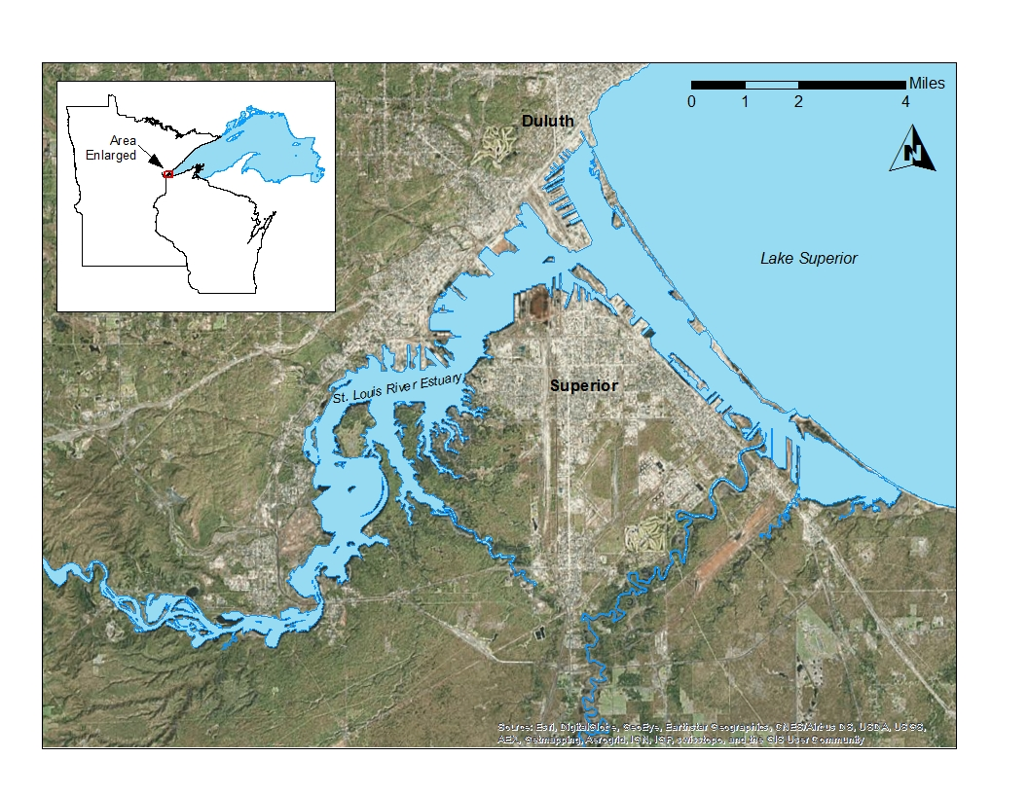

Fifteen additional sites were selected (Johnson 2015) in locations found to have high methyl mercury concentrations in dragonfly (Odonata) nymphs during previous sampling in 2014. These sites were chosen to potentially create a linkage between dragonfly nymph data and Hexagenia nymph data. These fifteen sites were designated as “high mercury biota” sites.

Most samples were collected at the pre-selected site coordinates. Samples could not be collected at sixteen pre-selected sites due to substrate conditions. Some had hard sand or dense woody debris substrate that prevented sample collection with a petite Ponar sediment sampler. Some sites (especially “high mercury biota” sites) were very near to shorelines with emergent vegetation and had a high content of coarse organic matter in the sediment making them unsuitable habitat for Hexagenia nymphs. The sixteen sites were re-located to the nearest location with suitable substrate for sampling. In some cases isopods were also collected at the pre-selected site (see below). Twelve of the sixteen re-located sites were within 100 m of the pre-selected site coordinates. Four of the re-located sites were greater than 100 m (141-281 m) of the pre-selected site coordinates.

The locations of sampled sites are shown in figure 2. The site categories of sampled sites are indicated (random, high mercury sediment, and high mercury biota sites).

Sample collection

Most samples were collected with a stainless steel petite Ponar sediment sampler which samples a 15.2 cm x 15.2 cm area (0.023 m²). At most sites five Ponar grabs were collected and processed to allow a quantitative measure of Hexagenia nymph density. At sites where no living organisms were observed and oil sheens or other evidence of contamination were observed, sampling was discontinued after three Ponar grabs. Net (3mm mesh) grabs of sediment were made at some sites when additional Hexagenia specimens were needed or where isopods were being sampled.

Grab samples were field processed by rinsing with river water over two stacked sieves. A bilge pump with an attached hose was suspended over the side of the boat to provide a flow of river rinse water. The upper sieve had a 4 mm pore size. The lower sieve had a 1 mm pore size.

The number of large (> 20mm body length; tip of frontal projection to base of caudal filaments), medium (10-19 mm) and small (5-9 mm) Hexagenia nymphs were recorded for each ponar grab. Counts of other organisms found were also recorded. Only generalized identifications of other organisms were made (chironomids, native mussels, etc.). Only Hexagenia specimens were saved.

Hexagenia nymphs were placed in river water in polyethylene sample bottles. Nymphs were held alive in river water overnight to allow gut purging (depuration). Holding times were 17-22 hours. After the holding period, specimens were placed in mercury free bottles provided by the Wisconsin State Laboratory of Hygiene. De-ionized water was added to partially fill the bottles and samples were then frozen prior to being shipped to the lab.

Large Hexagenia nymphs (> 20 mm) were collected for testing at all sites where an adequate mass could be obtained (0.5 g wet weight). Medium (10-19mm) or small (5-9 mm) Hexagenia nymphs were collected where large Hexagenia nymphs could not be obtained. Sample sets of large, medium, and small Hexagenia were collected at eight sites to allow a comparison of the three size ranges.

Hexagenia nymphs were identified using a key by Klubertanz (2016). All burrowing nymphs examined were found to be Hexagenia limbata. Some smaller, non-burrowing mayfly nymphs were found at some sites, but these could clearly be separated while sampling.

Isopods were collected at some sites where Hexagenia nymphs were not present (primarily “high biota mercury” sites). These sites were usually near-shore and had a high content of coarse organic matter in the sediment making them unsuitable for Hexagenia nymphs. Isopods were usually sampled with net grabs, and manual picking of specimens from bulk sediment samples. Further handling and processing of isopods was the same as used for Hexagenia nymphs. Isopods were identified to genus using a key by Williams (1976).

Figure 2.
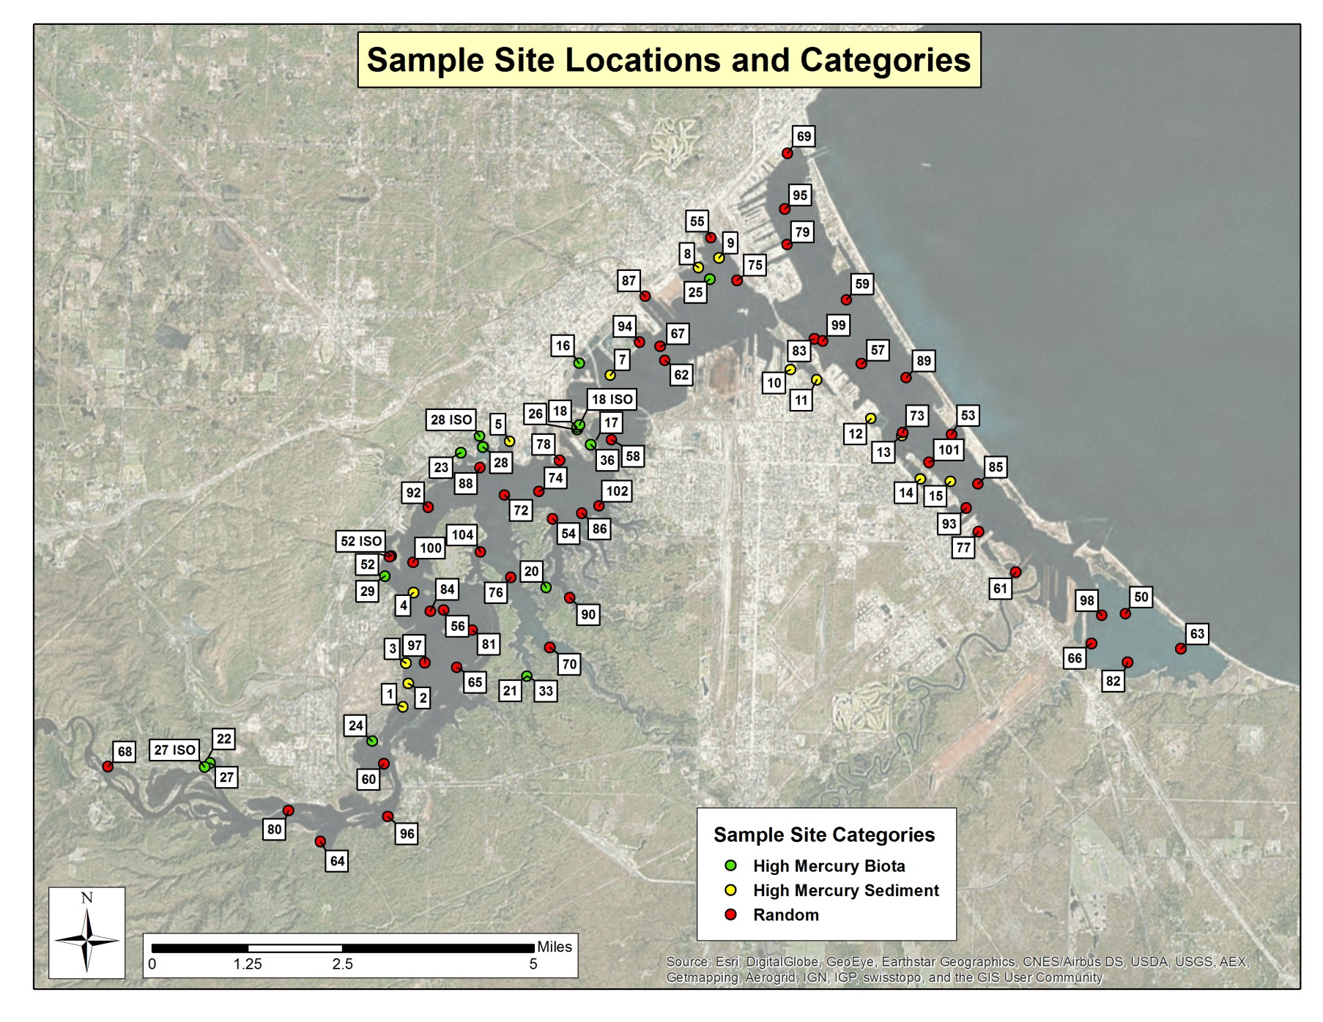

Lab Analyses for total mercury and methyl mercury

Samples were analyzed by the Wisconsin State Laboratory of Hygiene (Eichhorst et al. 2016). Hexagenia nymphs and isopods were freeze-dried and then homogenized with a mortar and pestle. For total mercury analyses, samples were digested in 10 mL acid-washed Teflon vials using 5.00 mL 30% H₂SO₄/ 70% HNO3 (v/v) and heated to 95ºC for 3 hours. For methyl mercury analyses, samples were digested in 10 mL acid-washed Teflon vials using 5.00 mL 25% KOH in methonol (mass/mass) and heated to 45ºC for 24 hours.

Analyses were performed using a Cold Vapor Atomic Fluorescence Spectrophotometer (Brooks Rand model 3). All internal and external QA/QC were acceptable.

Results and Discussion

Hexagenia limbata biology

Hexagenia limbata has a one or two year life cycle in North America, with two year life cycles being more common at this latitude. (Schloesser and Hiltunen 1984). The length/frequency distribution of 291 nymphs collected in early June was examined (figure 3) to determine if two year-class cohorts could be readily separated by size. While two length groupings appear to be present, there is no distinctive break between the groupings. Size overlap of Hexagenia nymph cohorts has been observed in several other studies (Heise and Flannagan 1987).

Several reasons for cohort size overlap have been offered including the presence of multiple cohorts in the population, inadequate sample sizes, differential growth of the sexes, delayed hatching of the eggs, and the wide variability in the growth rate of individuals from the same egg mass (Hunt 1953). Differential growth of the sexes, and wide variability in the growth rate of individuals from the same egg mass are likely the causes of the poor year-class cohort separation in the SLRE Hexagenia population.

Figure 3.

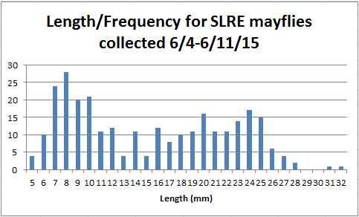

Growth rates of burrowing mayflies have been shown to be strongly regulated by degree-days above a minimum threshold temperature. A variety of minimum threshold temperatures for growth have been postulated, and degree days required to reach maturity have also varied among different geographical populations (Tokeshi 1985, Heise et al. 1987). Growth rates and timing of adult emergence can vary from year to year due to water temperature.

For 2015 on the SLRE, evidence of adult emergence was observed from June 19th to July 20th, with peak emergence occurring from July 3rd to July 7th. Evidence of emergence included floating exuviae (molted nymphal skins), live adults, and recently died floating adults. For 2013 on the SLRE, photo documentation of adult emergence was found for July 11th (Schmude 2015).

Hexagenia nymphs create u-shaped burrows, usually within the top few centimeters of sediment. Burrows are ventilated by undulatory body and gill movements (Rasmussen 1988). Preferred substrate is a mixture of finely particulate materials that permits the nymphs to burrow and is sufficiently cohesive to prevent the burrows from collapsing (Hunt 1953, Wright and Mattice 1981).

Edsall et al. (2004) described suitable substrate in the SLRE as clay or mixtures of clay and sand. For the 2015 survey, highest Hexagenia nymph densities were found in substrates described as clayey silt or silt. Lower densities were found in substrates as sand content increased. Lower densities were also found in substrates described as soft silt, such as that found in much of Pokegama Bay. This high water content, non-cohesive sediment probably presents problems due to burrow collapse.

Hexagenia nymphs are reported to feed on bulk sediment (Zimmerman et al. 1975, Charbonneau and Hare 1998) and are generally considered detritivores. However, they are also reported to filter feed and frequently leave their burrow to feed on surface debris (Pennak 1978). Sierszen et al. (2004) concluded that Hexagenia in Allouez Bay (a part of the SLRE) relied on phytoplankton (presumably settled) as a food source. This was based on carbon and nitrogen isotope ratios and microscopic examination of seston. They also concluded that Hexagenia in the west Fish Creek wetland (a Lake Superior wetland not in the SLRE) relied on detrital seston (presumably settled) as a food source. Phytoplankton was essentially absent in the Fish Creek wetland. The mean chlorophyll a concentration in the SLRE during 2015 was 3.7 ug/l (RTI 2016). This indicates low to moderate phytoplankton levels occur in the SLRE and could be a partial food source for Hexagenia.

Isopod biology

Isopods are often considered to be detritivores (Parkman and Meili 1993)( Sierszen et al. 2004). Carbon and nitrogen isotope ratios and microscopic examination of seston in two Lake Superior wetlands (outside of the SLRE) indicated isopods rely on sedimented seston as their primary food source (Sierszen et al. 2004). Phytoplankton was essentially absent in these two wetlands. Pennak (1978) describes isopods as scavengers “since they have been observed eating dead and injured animals of all kinds and both green and decaying leaves, grass, and aquatic vegetation.”

Most isopod specimens collected in the SLRE were 2 mm in length, with some individuals up to 4 mm in length. Specimens saved and identified from one site were Caecidotea sp. Three species of Caecidotea are known to occur in the SLRE – C. communis, C. intermedia, and C. racovitzai (Schmude 2016).

Hexagenia densities

Hexagenia densities are shown in figure 4. Mean Hexagenia density for the 51 random sites was 163.0/m² (S. E. = 20.2). There was a general pattern of declining densities moving from upstream to downstream sites. Density showed a weak inverse correlation with water depth (r² = 0.22).

Breneman et al. (2000) observed a similar pattern of Hexagenia density in 1995 with the exception of a higher density in Allouez Bay (1995 mean 229.7, n = 9 vs. 2015 mean 74, n = 5). Breneman et al. (2000) also noted a “decline” in benthic communities moving from upstream to downstream sites. Only a small portion of the change was explained by sediment chemistry. Change was best explained by physical habitat features. Water depth and distance downstream from the headwaters were the two predictor variables that explained most of the variance associated with the benthic community. Sediment disturbance due to ship traffic and channel dredging in the harbor area in the downstream portion of the SLRE was felt to contribute to declining benthic communities.

Breneman et al. (2000) sampled 89 sites randomly selected from a hexagonal grid system in 1995. A 500 um mesh sieve was used. Densities were based on triplicate petite Ponar
grabs. The mean density found for Hexagenia sp. was 53.6 /m². All samples were collected during June 7th to June 28th.

In 2015, sampling for Hexagenia densities occurred from June 4th to June 25th. Densities were based on five Ponar grabs instead of the three Ponar grabs used in 1995. Mean densities found in 2015 were compared for the first three Ponar grabs, and five Ponar grabs (n =48). Mean density for five Ponar grabs was slightly lower (- 9 %) than mean density for three Ponar grabs. The difference was not significant at the 95% confidence level. This indicates surveys based on three Ponar grabs are comparable to surveys based on five Ponar grabs.

The 1995 survey used a 0.5 mm screen mesh while the 2015 survey used a 1.0 mm screen mesh. The smallest Hexagenia nymphs present during the 2015 survey were 5 mm in length. With caudal filaments, total length was 7 mm. Observations during sieving indicated that while it was possible for the smallest nymphs to pass the screen, they rarely did, and no significant loss of nymphs is believed to have occurred.

1995 survey sites were 2/3 class 1 shallow sites (< 5.5m) and 1/3 class 2 deep sites (> 5.5 m). In the 2015 survey, the mean density for shallow sites (192.2/m²; n = 41) was significantly different from the mean density for deep sites (42.2/m²; n= 10) at the 95% confidence interval. Weighting 2015 density means to 2/3 shallow sites and 1/3 deep sites produces a density estimate of 142.2/m².

The 2015 depth-weighted mean Hexagenia density (142.2 /m²) is 2.7 times greater than the 1995 density (53.6/m²). This indicates a continuing improvement in the Hexagenia population in the SLRE. Anecdotal reports of larger numbers of emerged adult Hexagenia being observed in recent years also suggest improvements (Brady 2016).

Edsall et al. (2004) also conducted a random survey of Hexagenia in the SLRE in 2002 and found a mean density of 33.7/m². However, differences in methods do not allow a valid comparison to the 1995 or 2015 surveys. The major difference was the use of a 3.2 mm sieve size which would have resulted in the loss of many smaller nymphs. Sampling was done July 2nd to 11th, which may also have resulted in more 2 year old nymphs lost due to emergence.

Figure 4.
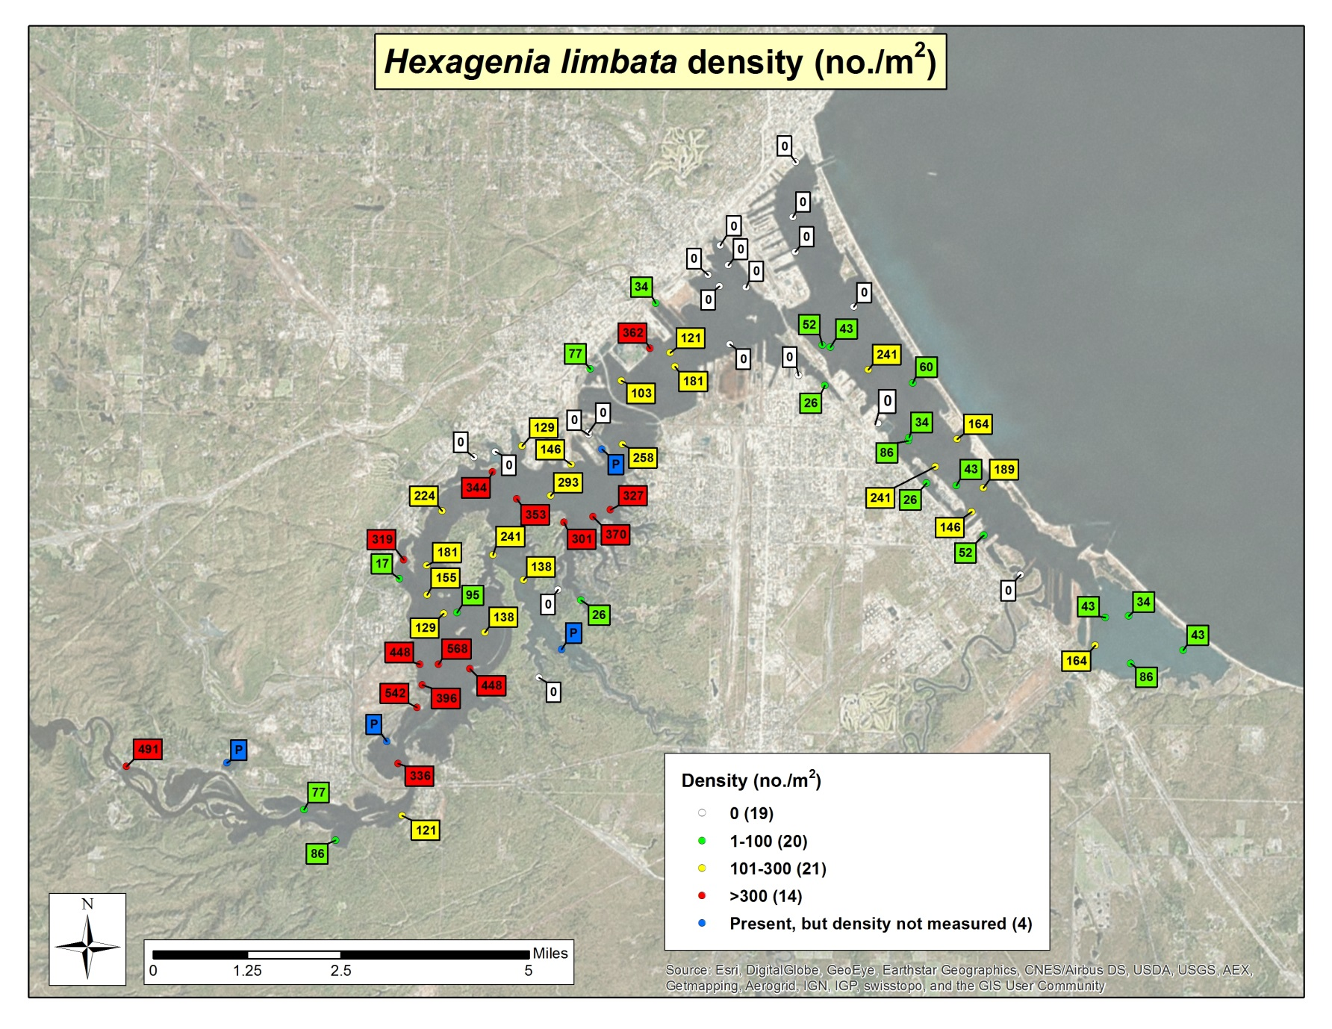

In 2015, Hexagenia densities were lower at “high mercury sediment” sites (mean = 68.0/m²) than at “random” sites (mean = 163.0/m²). The difference was significant at the 95% confidence level. This suggests that mercury and/or other co-contaminants are restricting Hexagenia populations in areas with known sediment contamination.

Hexagenia and isopod mercury concentrations

Hexagenia and isopod median concentrations for total mercury (TotHg), methyl mercury (MeHg), and percent methyl mercury (%MeHg; the percent of TotHg present as MeHg) are shown in table 1. Results are sorted by site type and organism/size.

Median TotHg concentrations for Hexagenia ranged from 49.9 – 92.8 ng/g. Median TotHg concentrations for Isopods ranged from 90.8 – 107.0 ng/g. Similar invertebrates sampled elsewhere were found to have the following TotHg concentrations:
- Hexagenia in Sargent and Richie Lake at Isle Royale had 107.3 ng/g and 76.1 ng/g, respectively (Gorski et al.).
- Hexagenia in ten Mississippi River pools downstream of Minneapolis/St. Paul ranged from 41 – 134 ng/g, with a mean of 89 ng/g (Beauvais et al. 1995).
- Unidentified mayflies in two Maryland streams had a mean of 53 ng/g (Mason et al. 2000).
- Unidentified mayflies in Quebec lakes and reservoirs had concentrations ranging from 76 – 610 ng/g (Tremblay and Lucotte 1997).
- Unidentified mayflies in two Ontario lakes had mean concentrations of 128.4 and 151.0 ng/g (Wong et al. 1997).
- Isopods (Asellus aquaticus) in Swedish lakes had concentrations ranging from 63 – 394 ng/g (Parkman and Meili 1993).

Median MeHg concentrations for Hexagenia ranged from 12.3 – 37.9 ng/g. Median MeHg concentrations for Isopods ranged from 43.2 – 54.8 ng/g. Similar invertebrates sampled elsewhere were found to have the following MeHg concentrations:
- Hexagenia in Sargent and Richie Lake at Isle Royale had 15.5 ng/g and 14.3 ng/g, respectively (Gorski et al.).
- Unidentified mayflies in two Maryland streams had a mean of 17 ng/g (Mason et al. 2000).
- Unidentified mayflies in Quebec lakes and reservoirs had concentrations ranging from 10 – 330 ng/g (Tremblay and Lucotte 1997).

Median %MeHg percentages for Hexagenia ranged from 28.4 – 40.0%. Median %MeHg percentages for Isopods ranged from 47.6 – 55.7%. Similar invertebrates sampled elsewhere were found to have the following %MeHg percentages:
- Hexagenia in Sargent and Richie Lake at Isle Royale had 14.4 % and 18.7 %, respectively (Gorski et al.).
- Unidentified mayflies in two Maryland streams had a mean of 32% (Mason et al. 2000).

Table 1.

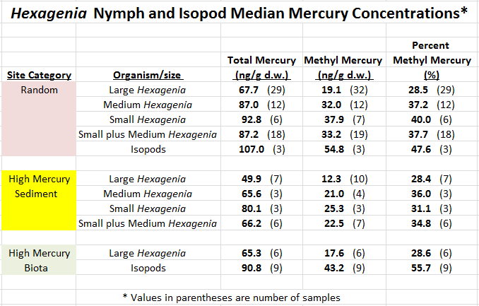

SLRE mercury concentrations in other organisms and substrates

MeHg concentrations in Aeshnidae dragonfly nymphs in the SLRE are also available (Jeremiason et al. 2015). MeHg concentrations ranged from 153 to 285 ng/g at 15 sites. This is about ten times higher than MeHg concentrations found in Hexagenia nymphs. Dragonfly nymphs are predators. Due to the bioaccumulation of MeHg through the food chain, dragonfly nymphs are often found to have higher mercury concentrations than invertebrates at lower levels in the food chain (Mason et al. 2000, Gorski et al. 2003, Tremblay and Lucotte 1997).

SLRE sediment samples were collected in 2015 from locations chosen to be representative of the spatial variation of mercury concentrations and associated parameters (RTI et al. 2016). This sampling found that:
- TotHg ranged from 14 – 500 ng/g, with a mean of 187 ng/g
- MeHg ranged from < 0.17 – 3.3 ng/g, with a mean of 1.37 ng/g
- %MeHg ranged from 0.33 – 4.02 %

SLRE Hexagenia have TotHg concentrations that are roughly half of this mean value for sediment TotHg.

SLRE Hexagenia have MeHg concentrations that are nine to twenty-seven times the mean value for sediment MeHg. Hexagenia are clearly bioaccumulating MeHg to concentrations far higher than sediment MeHg concentrations. This bioaccumulation also produces much higher %MeHg in Hexagenia than in sediment.

SLRE water column sampling conducted in 2015 (RTI et al. 2016) found TotHg concentrations averaged 3.66 ng/L (filtered TotHg = 2.25 ng/L; particulate TotHg = 1.41ng/L) and MeHg concentrations averaged 0.192 ng/l (filtered MeHg = 0.15 ng/L; particulate MeHg = 0.192 ng/L). High flows which tend to have higher mercury concentrations were not well represented.

Hexagenia size influence on mercury concentrations

The influence of Hexagenia size categories (large, > 20 mm; medium, 10-19 mm; small, 5-9 mm; small plus medium, 5-19 mm) and sample site categories (random, high mercury sediment, high mercury biota) on mercury concentrations is examined in table 2.

Large Hexagenia had significantly lower TotHg and MeHg concentrations than smaller Hexagenia (small, medium, and small plus medium). There were no significant differences for %MeHg for Hexagenia size categories.

Increasing mercury concentration with increasing length, as is often seen in fish, might suggest the opposite would be expected. However the relationship of mercury concentrations to invertebrate size can be variable. Mason et al. (2000) found that TotHg concentration was inversely related to body weight for unspecified mayflies and found no strong trend for MeHg. TotHg concentrations were found to be inversely related to body weight in caddisfly larvae (Snyder and Hendricks 1995). Parkman and Melei (1993) found that TotHg in Chaoborus in some lakes decreased to a minimum before emergence.

Table 2.

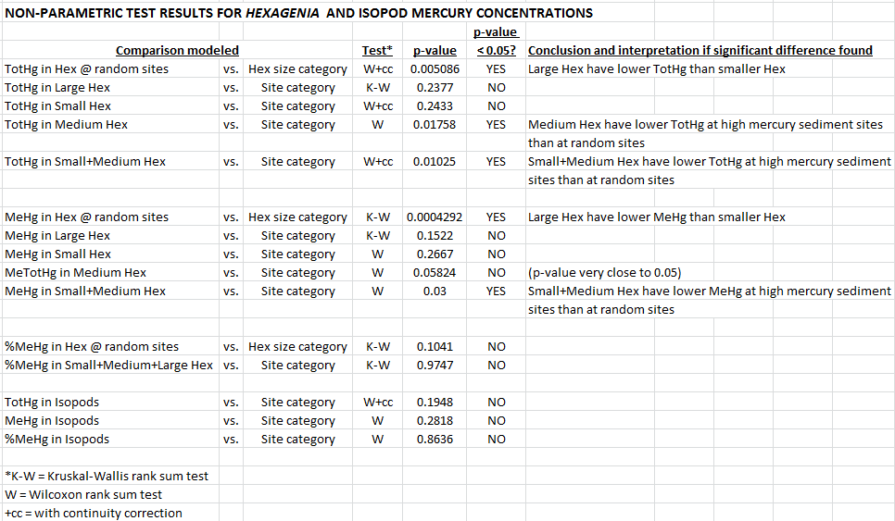

An organism’s mercury concentration is largely controlled by diet (Wong et al. 1997, Parkman and Meili 1993). Differences in feeding habits with season have been shown to affect TotHg concentrations in caddisfly larvae depending on the relative proportions of algae or detritus in their diet (Snyder and Hendricks 1995). Two deposit feeding Chironomus species were found to have differing mercury concentrations attributed to different feeding strategies (Parkman and Meili 1993). Carbon/nitrogen ratios indicated the species with the higher mercury concentration ingested more recently deposited fresh organic matter probably at the sediment surface, which may have contained more mercury or at least more bioavailable mercury.

Dietary differences between small and large Hexagenia might account for their differences in mercury concentrations. Smaller Hexagenia may feed more frequently at the sediment surface on settled detritus particles and phytoplankton algae which probably have a higher MeHg content than sediment. Suspended particulate matter in natural lakes in Quebec was found to have a seven times higher MeHg concentration than the sediment (Plourde et al. 1997). Large Hexagenia, which probably burrow deeper, may feed more heavily on bulk sediment.

Site category influence on mercury concentrations

Median TotHg and MeHg concentrations are lower for all size categories of Hexagenia at high mercury sediment sites than at random sites (table 1). The site category differences are significant (p < 0.05) for TotHg in medium Hexagenia and small plus medium Hexagenia (table 2). The site category differences are significant (p < 0.05) for MeHg in small plus medium Hexagenia, and very nearly significant (p = 0.05824) in medium Hexagenia.

This suggests that locally sourced anthropogenic mercury in sediment is not contributing to higher mercury concentrations in Hexagenia. Lower mercury concentrations in Hexagenia at high mercury sediment sites suggests mercury or other co-contaminants in these sediments might suppress methylation of inorganic mercury by bacteria.

Isopod mercury concentrations

Isopods were not sampled from high mercury sediment sites. Mercury concentrations in isopods from high mercury biota sites and random sites were not significantly different, although sample sizes were small. Isopods were found to have higher median TotHg and MeHg concentrations and higher median %MeHg than Hexagenia (table 1). This is probably largely due to dietary differences. Isopods feed at the sediment surface and are more likely to consume algae, aquatic macrophyte tissue, and freshly deposited detritus which probably have a higher mercury content than sediment.

Acknowledgements

Thanks are given for the assistance and support provided by:
Terry Eichhorst, Christa Dahman, Patrick Gorski (WI State Lab of Hygiene) for mercury analytical work.
Rachel Peacher (WI DNR) for GIS mapping, data compilation, and sample collection.
Tim Parks (WI DNR) for statistical analyses.
Joel Hoffman (EPA/UM-Duluth) for selection of random and high mercury sediment sites, project development and advice.
Nathan Johnson (UM-Duluth) for selection of high mercury biota sites and sample collection.
Dan Fraser (UM-Duluth), Michelle Wheeler, Joe Graham, Cherie Hagen (WI DNR) for sample collection
Kurt Schmude (UW-Superior) for providing invertebrate identification keys and advice.
EPA Great Lakes Restoration Initiative for providing project funding.

REFERENCES

Beauvais, S.L., Wiener, J.G., Atchison, G.J. 1995. Cadmium and mercury in sediment and burrowing mayfly nymphs (Hexagenia) in the Upper Mississippi River, USA. Arch. Environ. Contam. Toxicol. 28, 178-183

Brady, V.J. 2016. Personal communication. Research Associate, Center for Water and the Environment, Natural Resources Research Institute, University of Minnesota, Duluth

Breneman, D., Richards, C., Lozano, S. 2000. Environmental influences on benthic community structure in a Great Lakes embayment. J. Great Lakes Res. 26(3), 287-304

Charbonneau, P., and Hare, L. 1998. Burrowing behavior and biogenic structures of mud-dwelling insects. J. North Am. Benthol. Soc. 17, 239-249

Edsall, T.A., Gorman, O.T., Evrard, L.M. 2004. Burrowing mayflies as indicators of ecosystem health: status of populations in two western Lake Superior embayments. Aquatic Ecosystem Health & Management. 7(4), 507-513

Eichhorst, T.A., Dahman, C., and Gorski, P. 2016. Wisconsin State Laboratory of Hygiene.

Gorski, P.R., Cleckner, L.B., Hurley, J.P., Sierszen, M.E., Armstrong, D.E. 2003. Factors affecting enhanced mercury bioaccumulation in inland lakes of Isle Royale National Park, USA. The Science of the Total Environment, 304, 327-348

Heise, B.A., and Flannagan, J.F. 1987. Life histories or Hexagenia limbata and Ephemera simulans (Ephemeroptera) in Dauphin Lake, Manitoba. J. N. Am. Benthol. Soc. 6(4), 230-240

Hoffman, J. 2015. Personal communication. Research Biologist, E.P.A.; Adjunct Assistant Professor, University of Minnesota, Duluth

Hunt, B.P. 1953. The life history and economic importance of a burrowing mayfly, Hexagenia limbata, in southern Michigan lakes. Bull. Inst. Fish. Res. 4, 1-151. Michigan Dept. of Conservation, Ann Arbor

Jeremiason, J., Johnson, N., Fraser, D. 2015. Hg in dragonfly larvae in the St. Louis River Estuary. Unpublished data in powerpoint. Gustavus Adolphus College and University of Minnesota, Duluth

Johnson, N. 2015. Personal communication. Associate Professor of Civil Engineering, University of Minnesota, Duluth
Klubertanz, T. 2016. Mayfly larvae of Wisconsin. University of Wisconsin Extension Press (in press)

Mason, R.P., Laporte, J.M., Andres, S. 2000. Factors controlling bioaccumulation or mercury, methylmercury, arsenic, selenium, and cadmium by freshwater invertebrates and fish. Arch. Environ. Contam. Toxicol. 38, 283-297

Parkman, H. and Meili, M. 1993. Mercury in macroinvertebrates from Swedish forest lakes: influence of lake type, habitat, life cycle, and food quality. Can. J. Fish. Aquat. Sci. 50, 521-533

Pennak, R.W. 1978. Fresh-water invertebrates of the United States. Wiley-Interscience Publication, second edition

Plourde, Y., Lucotte, M., Pichet, P. 1997. Contributions of suspended particulate matter and zooplankton to MeHg contamination of the food chain in midnorthernQuebec (Canada) reservoirs. Can. J. Fish. Aquat. Sci. 54, 821-831

Rasmussen, J.B. 1988. Habitat requirements of burrowing mayflies (Ephemeridae:Hexagenia) in lakes, with special reference to the effects of eutrophication. J. N. Am. Benthol. Soc. 7(1), 51-64

RTI International, Great Lakes Environmental Center, University of Wisconsin – Madison. 2016. St. Louis River Water Column Mercury Monitoring and Sediment Mobility Assessment. (draft report)

Schloesser, D.W. and Hiltunen, J.K. 1984. Life cycle of a mayfly Hexagenia limbata in the St. Mary’s River between Lakes Superior and Huron. J. Great Lakes Res. 10(4), 435-439

Schmude, K.L. 2015. Personal communication. Associate Professor, Dept. of Natural Sciences; Senior Scientist, Lake Superior Research Institute. University of Wisconsin – Superior

Schmude, K.L. 2016. Personal communication. Associate Professor, Dept. of Natural Sciences; Senior Scientist, Lake Superior Research Institute. University of Wisconsin – Superior

Sierszen, M.A., Morrice, J.A., Moffet, M.F., West, C.W. 2004. Benthic versus planktonic foundations of three Lake Superior coastal wetland food webs. J. Great Lakes Res. 30(1), 31-43

Snyder, C.D. and Hendricks, A.C. 1995. Effect of seasonally changing feeding habits on whole-animal mercury concentrations in Hydropsyche morose (Trichoptera: Hydropsychidae). Hydrobiology 299, 115-123.

Tremblay, A., and Lucotte, M. 1997. Accumulation or total mercury and methyl mercury in insect larvae of hydroelectric reservoirs. Can. J. Fish. Aquat. Sci. 54, 832-841

WI DNR. 1999. Lake Superior Basin Water Quality Management Plan. WI Dept. of Natural Resources, PUBL-WT-278-99-REV

Williams, W.D. 1976. Freshwater isopods (Asellidae) of North America. USEPA, Water pollution control research series 18050 ELD05/72, second printing, 45pp.

Wong, A.H., McQueen, D.J., Williams, D.D., Demers, E. 1997. Transfer of mercury from benthic invertebrates to fishes in lakes with contrasting fish community structures. Can. J. Fish. Aquat. Sci. 54, 1320-1330

Wright, L.L., Mattice, J.S. 1981. Effects of temperature on adult size and emergence success of Hexagenia limbata under laboratory conditions. J. Freshwat. Ecol. 1, 27-39

Zimmerman, M.C., Wissing, T.E., Rutter, R.P. 1975. Bioenergetics of the burrowing mayfly, Hexagenia limbata, in a pond system. Verh. Int. Verein. Theor. Angew. Limnol. 19, 3030-3049

