Lake Ripley Watershed Monitoring Summary 2020-2021
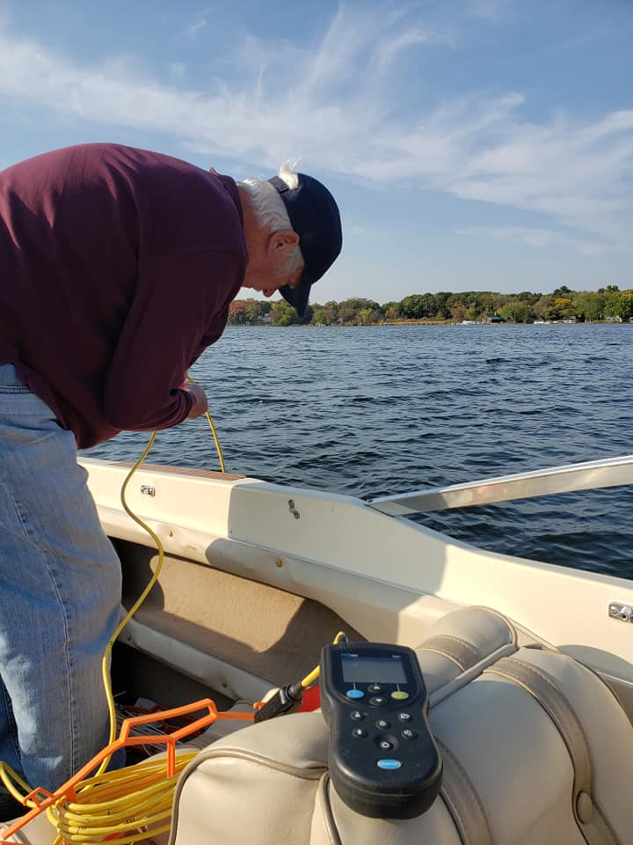

Report written by: Dwight Osmon

Introduction

Lake Ripley receives a significant amount of its water, nutrient loading and sediment loading from its watershed via the inlet stream. The goal of the 2020-2021 monitoring program was to identify areas of the watershed where wetland restoration, improvements, and other management actions will improve water quality by potentially reducing nutrient and sediment loading.

Methods and Data Collection

Water quality was measured according to DNR protocols at 4 monitoring stations (Hwy 18, Preserve Central, County Road A and Ripley Road) during 2020 and 2021. Samples were collected as a surface grab, at a depth of 0.5’. The frequency of sampling was monthly, March through May and October, and then bi-weekly June through September.

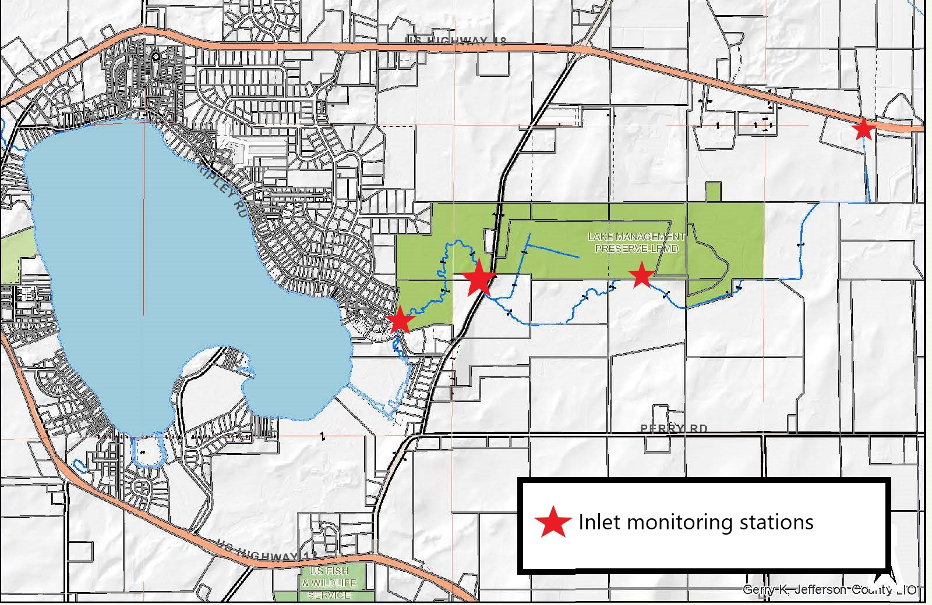
Figure 1: Map showing where the four monitoring stations are located. From west to east the stations are: Ripley Road, CTH-A, Preserve Central, and Hwy 18.

All samples were analyzed for total phosphorus (TP), total suspended solids (TSS), dissolved oxygen (DO), turbidity, temperature, pH, and conductivity. The District’s pH/conductivity probe failed on July 13, 2021, preventing the District from measuring those parameters after that date. Flow was recorded at the two most downstream sites (CTH A and Ripley Road) in addition to the other water quality parameters.

The field equipment used during this project were the: Swoffer Model 2100 flow meter, Hannah Model HI 9812-5 pH/Conductivity Multi-parameter Probe, HACH LDO Dissolved Oxygen Probe and Lamotte 2020we Turbidity Meter. All field equipment was calibrated on the day of sampling according to manufacturer instructions.

Results and Discussion

The following subsections summarize the water quality data collected in 2020-2021.

Total Phosphorus

The mean total phosphorus (mg/l) for all sampling events is shown below. The overall average for all sites in 2020 was 0.123 mg/l compared to 0.111 mg/l for 2021. The nutrient criteria goal for surface waters of 0.075 mg/l was exceeded in both years.

Figure 1 compares sites for the 2020-2021 sampling seasons. In both years there is a general increase in total phosphorus concentrations as water moves closer to the lake, with the highest values closest to Lake Ripley at Ripley Road. In both years there is a relatively large increase of total phosphorus between the Preserve Central and Hwy A site and between the Hwy A site and Ripley Road. This suggests that there are significant sources of nutrient loading in the watershed between these two sets of monitoring locations. Possibilities include contributions from the Preserve’s wetland scrape and/or bank erosion in the Preserve between the Preserve Central site and Hwy A. Between Hwy A and Ripley Road, it is possible that the small inlet ditch entering the creek from the north is carrying runoff from adjacent farm fields.

Figure 1 - Site Comparison for Total Phosphorus
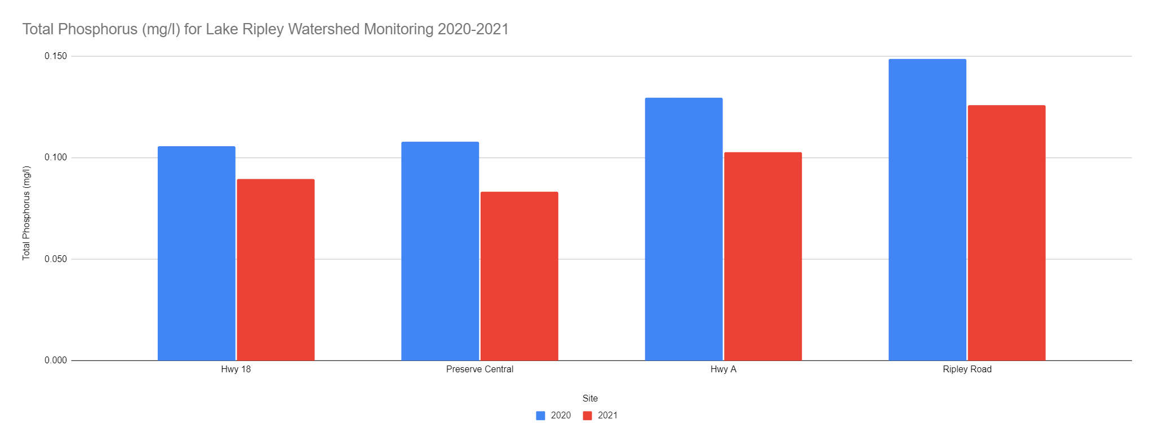

Figure 2 shows total phosphorus value by date and site. The relatively high values for Ripley Road in the summer of 2021 were collected around large rain events (~4 inches of rain in 48 hours) at the Hwy A and Ripley Road sites suggesting an optimal location to manage total phosphorus would be downstream of Hwy A and the confluence of the aforementioned small drainage ditch and upstream of Ripley Road.

Figure 2 - Site and Seasonal Comparison for Total Phosphorus
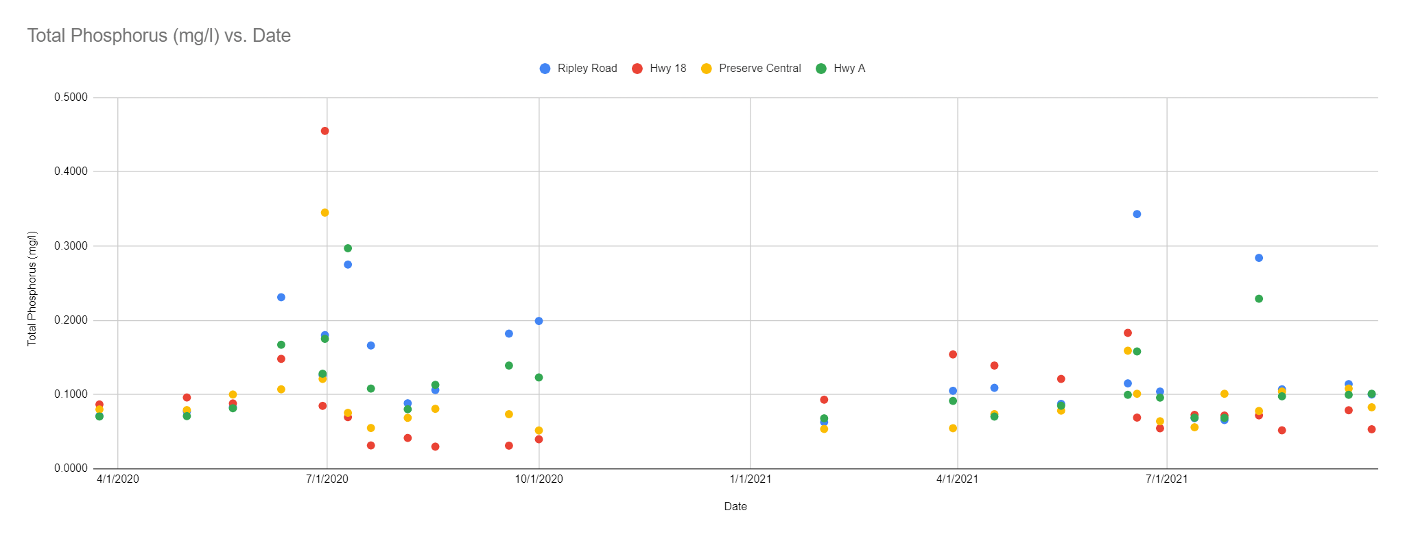

Total Suspended Solids

Figure 3 compares total suspended solids by site for 2020-2021. Total suspended solids were overall, roughly 30% lower in 2021 versus 2020. This is likely due to a relatively dry summer in 2021. There are no obvious patterns between sites.

Figure 3 - Site Comparison for Suspended Solids
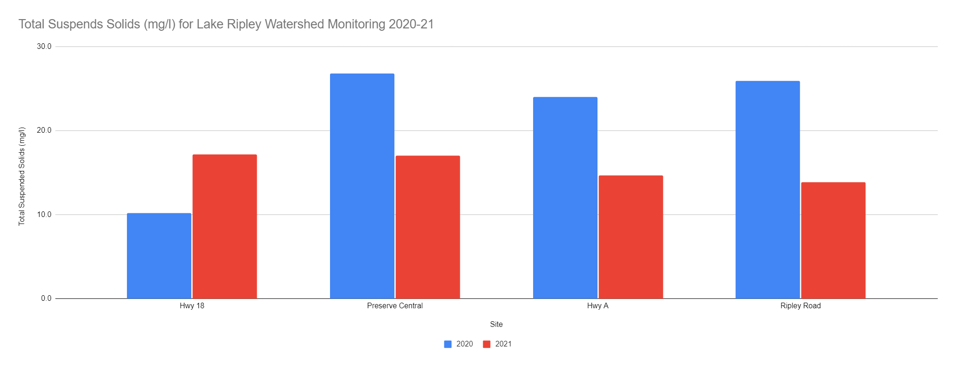

Figure 4 shows the seasonal patterns for total suspended solids. In general, total suspended solids concentration appears to be driven by precipitation events in the summer and slightly elevated in the spring and fall.

Figure 4 - Site and Seasonal Comparison for Total Suspended Solids

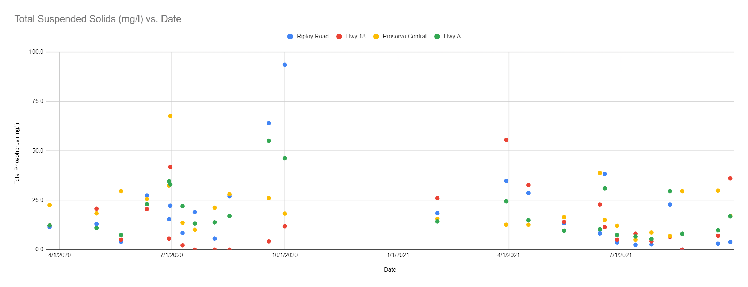

Dissolved Oxygen

Table 1 shows the summary for dissolved oxygen levels at all sites for 2020 and 2021. Dissolved oxygen levels are not a concern and within expected ranges for all sites. The greatest fluctuations occurred at the Hwy 18 site. This site is full of silt and is adjacent to a small pool full of duckweed and algae. In summer, the values alternate between a supersaturated state (200%) and relatively low levels (50%) which is typical for small streams impacted by agricultural runoff. This impact was not observed at the remaining sites further downstream.

Table 1 - Dissolved Oxygen

Site | Dissolved Oxygen (mg/l)
Year | 2020 | 2021
Hwy 18 | 11.0 | 6.9
Preserve Central | 7.7 | 7.8
Hwy A | 7.7 | 8.6
Ripley Road | 7.6 | 8.7

Water Temperature

The average water temperature data is summarized in Table 2. Water temperature changed seasonally with warmer temperatures occurring in the summer months.

Table 2 - Average Water Temperature

Site | Water Temperature (C)
Year | 2020 | 2021
Hwy 18 | 18.2 | 17.3
Preserve Central | 15.6 | 16.4
Hwy A | 17.8 | 16.8
Ripley Road | 18.3 | 17.8

Turbidity

Table 3 shows the turbidity data for 2020-2021. The turbidity was generally low at all sites. Higher values were detected during and following storm events. The higher values detected at the Preserve Central site are likely due to large amounts of silt on the streambed and/or bank erosion.

Table 3 - Turbidity

Site | Turbidity (NTU)
Year | 2020 | 2021
Hwy 18 | 3.2 | 3.6
Preserve Central | 8.7 | 7.4
Hwy A | 7.8 | 4.9
Ripley Road | 7.1 | 5.1

Conductivity

Table 4 summarizes the conductivity data for 2020-2021. The values are similar at all sites and typical for the area. The 2021 measurements are higher than 2020. This is likely due to very low stream flow in 2021 composed mostly of groundwater base flow (Table 6).

Table 4 - Conductivity

Site | Conductivity (uS/cm)
Year | 2020 | 2021
Hwy 18 | 547.0 | 625.0
Preserve Central | 537.3 | 626.7
Hwy A | 548.2 | 606.7
Ripley Road | 520.0 | 613.3

pH

The pH values for 2020-2021 are shown in Table 5. The pH is stable year round ranging from 7.4-7.7 and similar at all sites.

Table 5 - pH

Site | pH
Year | 2020 | 2021
Hwy 18 | 7.7 | 7.5
Preserve Central | 7.4 | 7.5
Hwy A | 7.5 | 7.7
Ripley Road | 7.6 | 7.6

Stream Flow

Table 6 shows the stream flow measurements for 2020-2021. The Hwy 18 site is not monitored for flow. In 2021, flow monitoring at the Preserve Central site was added to the regular monitoring schedule. Flow generally increases from upstream to downstream. The 2020 flow was higher than 2021. The relatively low values in 2021 are due to low precipitation levels for most of the year.

Table 6 - Stream Flow

Site | Stream Flow (cfs)
Year | 2020 | 2021
Hwy 18 | - | -
Preserve Central | - | 1.7
Hwy A | 5.1 | 2.1
Ripley Road | 5.9 | 2.2

Conclusion

Based on the 2020-2021 monitoring data, the primary concerns for the Lake Ripley tributary are total phosphorus, total suspended solids and stream flow.

Phosphorus reaching Lake Ripley from the tributary creek contributes to undesirable conditions such as increased algae density in the water column and increased aquatic plant growth. The current annual averages generally exceed 0.100 mg/l. Management actions to reduce total phosphorus in the creek would benefit Lake Ripley.

Total suspended solids are an issue during rain events. The baseline values are relatively low, but during storms the total suspended solids increase rapidly, delivering sediments to Lake Ripley. The location where the inlet reaches the lake is extremely silted in from years of sediments reaching the lake.

Stream flow is highly dependent on rainfall in the Lake Ripley watershed. While it is not possible to increase base flow during dry periods, it is possible to manage high flows by increasing the watershed storage capacity.

To reduce total phosphorus, total suspended solids, and mitigate high flows, a plan to allow water from large rain events to settle into the existing wetlands downstream from the Hwy A monitoring site and upstream of Ripley Road should be developed. This would allow for settling to occur and reduce the amount of phosphorus and sediments reaching the lake. Ongoing efforts to control erosion in the watershed should be continued to limit the amount of total suspended solids and total phosphorus.

