FINAL BUTTERFLY DOCK GRANT REPORT
FLOW AIS AND TIMBERLAND INVASIVE PARTNERSHIP
DEREK THORN, ABBY VOGT
DECEMBER 2022

The Butterfly Dock Project worked on in 2021 and 2022 was a joint project between the Timberland Invasive Partnership (TIP) and FLOW AIS both of Lumberjack Resource Conservation and Development Council. The coordinators of the project were Alix Bjorklund (TIP), Derek Thorn, (FLOW AIS) and Abby Vogt (TIP). The project involved monitoring fourteen different sites along Daly Creek and the Kelly Brooke System in Gillett, Oconto County. These sights were selected and monitored by Bjorklund with reference to an initial Butterfly Dock population found at the furthest downstream location. Samples of the Butterfly Dock population were taken for species confirmation. Each of the sites were monitored twice a year, once in the spring, and once in the fall and one of the fourteen sites was treated with Rodeo via a backpack sprayer application by Bjorklund in June of 2021. After the treatment was complete, the Butterfly Dock population at the site was not found during the other three monitoring times, indicating eradication. All other thirteen sites did not show any sign of a Butterfly Dock population throughout the four monitoring checks. The monitoring data was entered into SWIMS after the field season was complete. No restoration efforts were needed.
FLOW AIS Coordinator Derek Thorn Presented a PowerPoint presentation on Butterfly Dock at the Upper Midwest Invasive Species Conference (UMISC) in October. The presentation was a joint effort between Thorn, Ramona Shackelford of the Northwoods Cooperative Weed Management Area, out of Bayfield Wisconsin and Matt Walrath, the Invasive Species Program Manager of the Upper Sugar River Watershed Association.
The presentation focused on the taxonomy of Butterfly Dock, its travel throughout the state of Wisconsin, and management efforts in Oconto, Bayfield, and Dane County. Walrath and Thorn showed before and after images of butterfly Dock infestation treatments in Oconto and Dane County. The presentation was well received by all in attendance. Attendees did not have many questions about the scope of each individual project
In conclusion, both TIP and FLOW concluded the project to be a success. This thought was due to the treatment site having no recurring population growth and other thirteen sites not having any signs of a Butterfly Dock population. The structure of the project seemed to work well with duties being split fairly evenly between Bjorklund, Thorn, and Vogt. Each coordinator brought a different valued skillset to the project. If future collaboration work were to come up, TIP and FLOW would be happy to work together again.

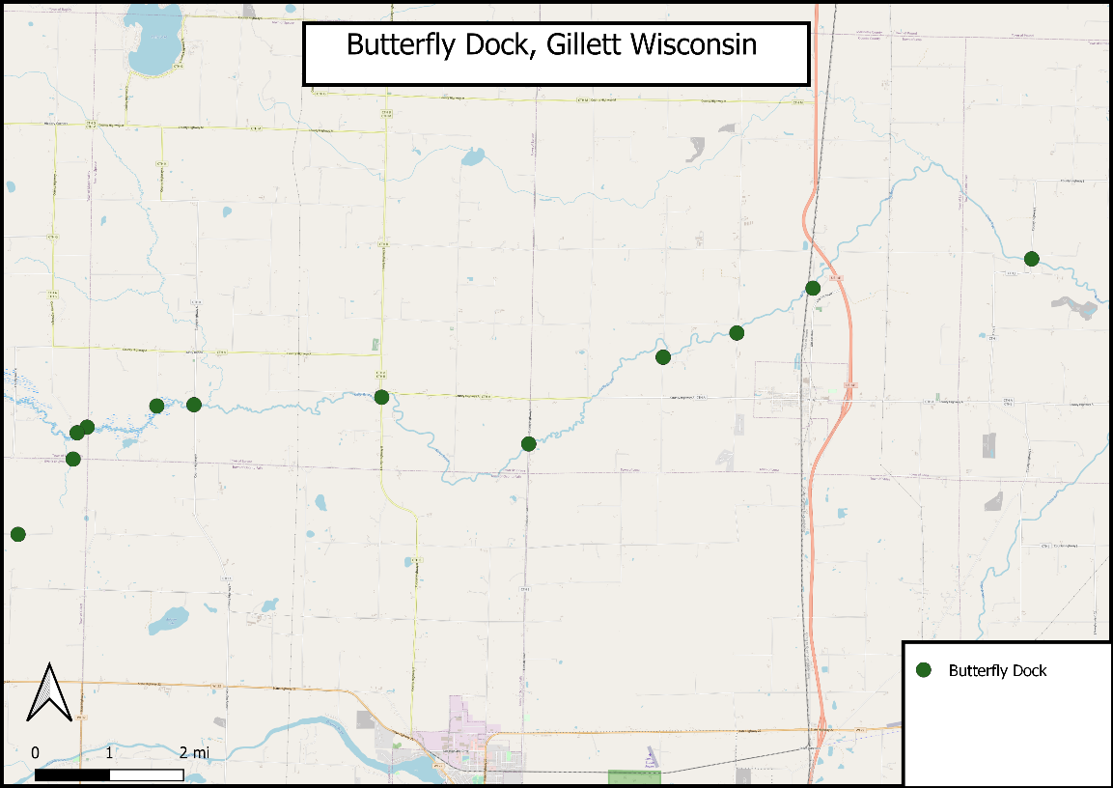

Figure 1Map of fourteen Butterfly Dock monitoring sites in Gillett, Oconto County.
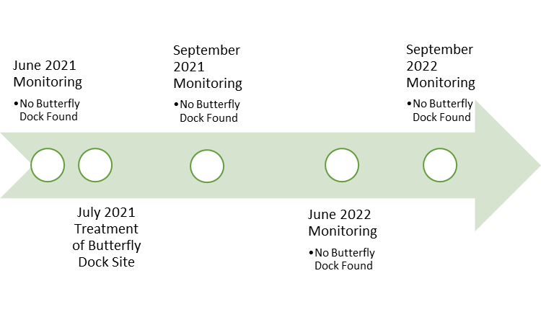
Figure 2 Timeline of Monitoring and Treatment of Butterfly Dock sites throughout the life of the grant.

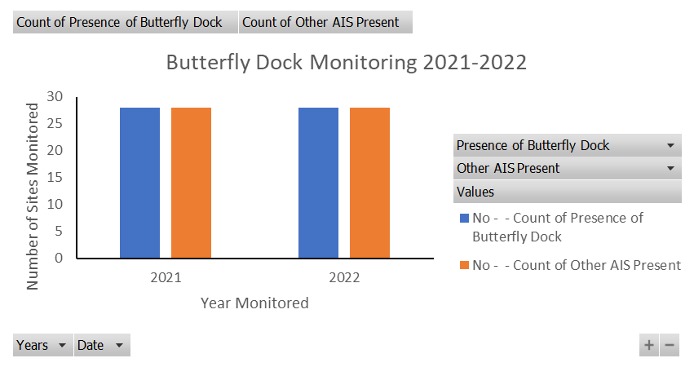

Figure 3: Data table of Butterfly Dock monitoring in 2021and 2022. You can see the total amount of sites monitored per year,28 (14 different sites, monitored twice a year) No Butterfly Dock or Other AIS were found throughout the entirety of the project.

Photos From Project

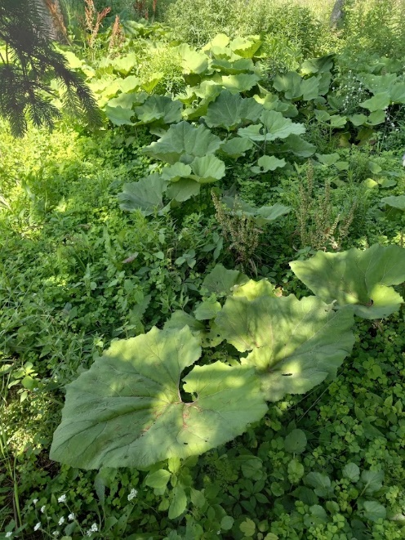
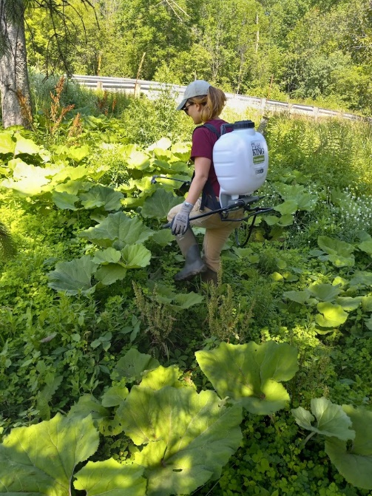

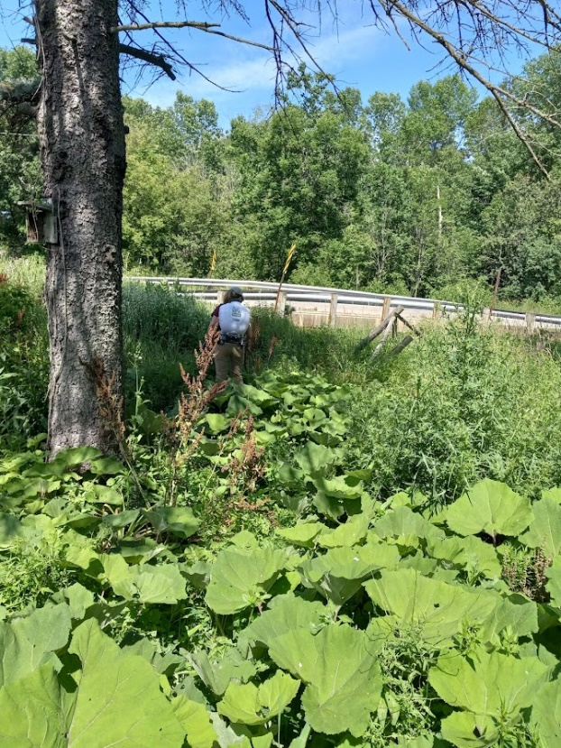
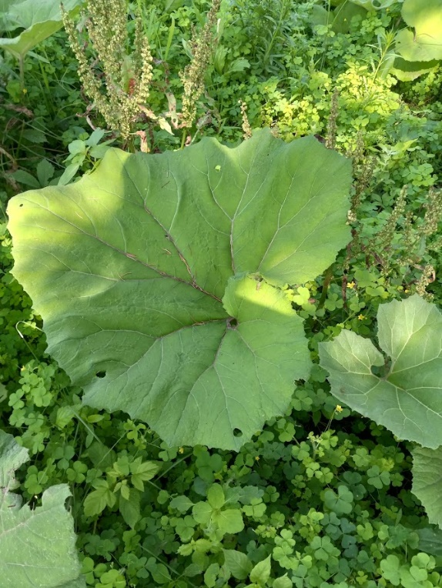

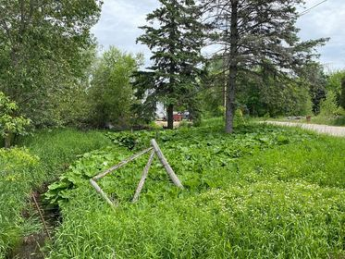

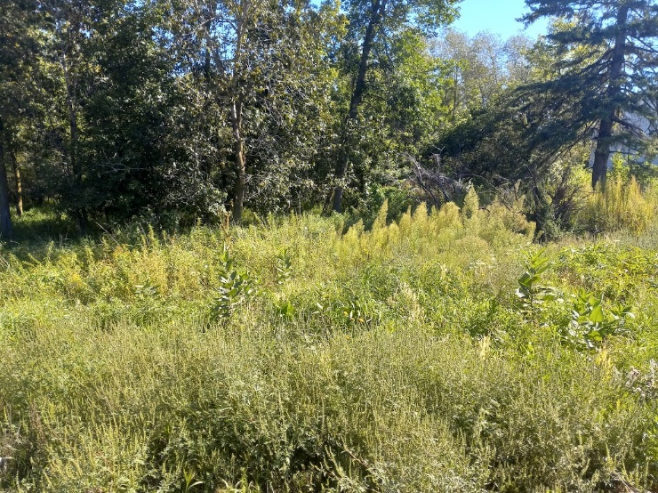
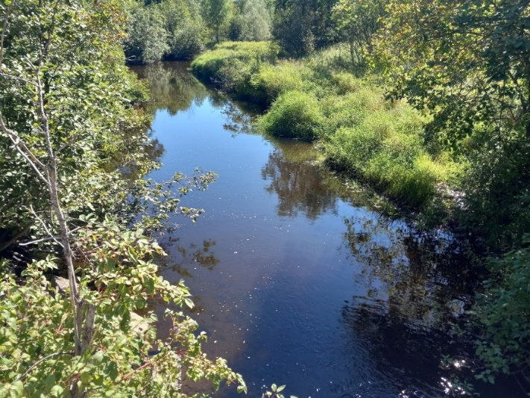

Picture Descriptions

#1-4 from the treatment day
#3 photo of butterfly dock leaf
#5 photo of butterfly dock population
#6 site photo of treatment area after treatment was complete
#7 photo of one of the 13 sites that did not have and butterfly population through the grant period

