Watershed and Lake Modeling
The Wisconsin Lake Modeling Suite (WiLMS) was used to model current conditions for Big Blake Lake, verify monitoring, and estimate land use nutrient loading for the watershed. Phosphorus is the key parameter in the modeling scenarios used in WiLMS because it is the limiting nutrient for algal growth in most lakes.
Based on average evaporation, precipitation, and runoff coefficients for Polk County soils and land use, WiLMS determined the annual nonpoint source load of phosphorus to Big Blake Lake as 7,432 kilograms per year (16,380 pounds), the direct drainage to the lake minus the tributaries was calculated to be 132 kilograms per year (291 pounds).
Big Blake Lake Nutrient Budget
Source | P Load kg/yr
Row Crop | 50
Pasture/Grass | 5
Residential | 23
Rural Residential | 2
Roads | 12
Wetland | 1
Forest | 6
Septic | 8.22
Atmospheric Deposition | 25
Lost Creek | 1218.5
Straight River | 6081.2

The land use for the entire watershed was obtained from Purdue University Agricultural Biological Engineering Department’s Long Term Hydrologic Impact Analysis (L-THIA). ArcGIS was then used to clip the subwatersheds of the basin and the direct drainage to the lake was modeled using in-situ phosphorus loading from the tributaries modeled as a point sources and the direct drainage land use. Because the outlet of the lake was breeched in 2014 scenarios were modeled for the three years of the study with several different scenarios.
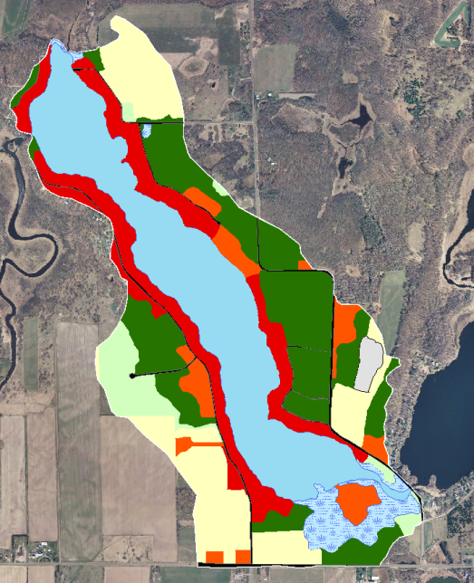
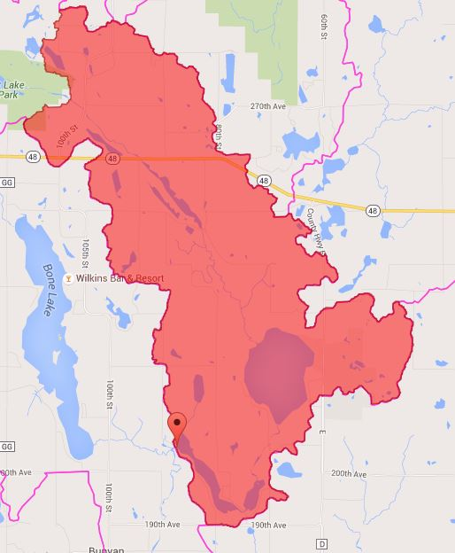
L-THIA watershed vs. the direct drainage to Big Blake Lake
The internal load for Big Blake Lake was estimated using in-situ data and four methods were used to estimate internal loading.
The first method was a complete total phosphorus mass budget. This method calculated the annual internal phosphorus load under the L-THIA scenario to be 149 kg (327 lbs.) in 2013, -375 kg (-827 lbs) in 2014, and -311 kg (-686 lbs.) in 2015. The annual internal phosphorus load under the direct drainage scenario was estimated to be 3,943 kg (8,649 lbs.) in 2013, -2,350 kg (-5,181 lbs.) in 2014, and -2,275 kg (-5,016 lbs.) in 2015.
In the second method the internal load was estimated from growing season in situ phosphorus increases. This method estimated a sediment release rate of -2.8 mg/m²-day in 2013, 0.00 mg/m²-day in 2014, and 1.9 mg/m²-day in 2015. The internal load was calculated annually in both the L-THIA and direct drainage scenarios to be -57 kg (-127 lbs.) in 2013, 0 kg (0 lbs) in 2014, and 53 kg (117 lbs.) in 2015.
The third method estimated the internal load from in situ phosphorus increases in the fall. The annual load was calculated to be 233 kg (513 lbs.) with a sediment release rate of 17 mg/m²-day in both the 2013 L-THIA and direct drainage scenarios. In 2014 the L-THIA scenario estimated the sediment phosphorus release rate to be 4.9 mg/m²-day with an annual internal load of 82 kg (180 lbs.) annually. In the 2014 direct drainage scenario the sediment release rate was calculated to be -0.3 mg/m²-day with an annual loading rate of -5 kg (-11 lbs.). The 2015 L-THIA model calculated a sediment phosphorus release rate of 13.5 mg/m²-day with an annual load of 153 kg (337 lbs.), while the 2015 direct drainage model predicted an annual internal load of 64 kg (140 lbs.) with a sediment release rate of 5.6 mg/m²-day.
The fourth method used the average of the calculated phosphorus release rates (7.1 mg/m²-day) and anoxic sediment area. This calculated the internal load to be 87 kg (193 lbs.) of phosphorus annually in both 2013 scenarios. The release rate for the 2014 L-THIA model was calculated to be 2.4 mg/m²-day with a loading rate of 33 kg (73 lbs.) annually. In the 2014 direct drainage scenario the sediment release rate was calculated to be -0.2 mg/m²-day, however, the model predicted the annual loading rate to be the same. The release rate for the 2015 L-THIA model was calculated to be 7.7 mg/m²-day with a loading rate of 119 kg (263 lbs.) annually. In the 2015 direct drainage scenario the sediment release rate was calculated to be 3.8 mg/m²-day and also predicted the annual loading rate to be the same. This is unlikely an invalid method for Big Blake Lake.

The 1984 Nurnberg model is commonly used to estimate the effects of the internal load for a lake. The Nurnberg total phosphorus model is ($P=\frac{L_{Ext}}{q_{s}}\left(1-R\right)+\frac{L_{Int}}{q_{s}}$ where $R=\frac{15}{18+q_{s}}$) where P is the predicted mixed lake total phosphorus concentration, L is the areal total phosphorus load (mg/m²-yr.), R is the fraction of inflow total phosphorus retained in the lake, and q_{s} is the areal water loading or surface overflow rate. The model predicts the internal load to be between 577 kg to -95 kg (or burying phosphorus in the sediment), these numbers were derived by using annual, growing season, and fall increases in water column phosphorus concentrations.

The Osgood Index of mixing $I= z/{\sqrt{{km}^{2}}}$ (where z is mean depth) is a measure of the lake volume in relation to wind fetch. The chance for mixing hypolimnetic (bottom water) with epilimnetic (surface water) increases as the ratio of volume to fetch decreases. Lakes with an Osgood Index of less than 6-7 usually have a summer surface water total phosphorus that exceeds the concentration predicted from external loading. Big Blake Lake has an Osgood Index of 3.
The likely scenario is that the internal loading varies both seasonally and annually depending on growth of curly-leaf pondweed (Potamogeton crispus) and residence time of the water. Because the outlet was breached and the lake stratified at different depths and different times the internal loading calculations proved to be problematic. However, taking all calculations and scenarios into account, the internal load on Big Blake Lake likely is between 40-120 kg on an annual basis.
The data derived from the different loading scenarios can be used to predict the average concentration of phosphorus in the lake’s water column.
The model that fit every scenario was the 1977 Reckhow model $P= \frac{L}{{0.17z+1.13z}/{T_{w}}}$ where P is the predicted mixed lake total phosphorus concentration, L is the areal total phosphorus load (mg/m²-yr.), T_{w} is the lakes hydraulic retention time, and z is the lakes mean depth. The model fit best in the 2014 direct drainage scenario, likely because the hydraulic retention time was greatly reduced and there was less mixing. The model was used to run several scenarios across all three of the lake study years using the nonpoint and point source loading to the lake and 10, 20, and 40 % reductions in total phosphorus inputs to the water column.

 | 2013 L | 2013 D | 2014 L | 2014 D | 2015 L | 2015 D
External | 77.91 | 24.76 | 77.91 | 44.57 | 77.91 | 37.3
External + Internal | 87.37 | 25.43 | 79.78 | 44.57 | 84.98 | 37.55
10% Reduction | 79.58 | 22.96 | 71.98 | 40.12 | 77.19 | 33.82
20% Reduction | 71.79 | 20.48 | 64.19 | 35.66 | 69.4 | 30.09
40% Reduction | 56.21 | 15.53 | 48.61 | 26.74 | 53.81 | 22.63

Because the water chemistry and hydraulic loading and retention time were so different from 2013-2015 combined models were put together and run for both the direct drainage scenario and the L-THIA scenario. It was determined that the combined L-THIA model would be used to address nutrient reductions and management scenarios as the hydraulic loading was normalized.
In the combined L-THIA scenario the 1979 Reckhow general lake model fit best. The general lake model is $P=\frac{1000L}{11.6+1.2q_{s}}$ where L is the areal loading in mg/m²-yr. and q_{s} is the annual areal water loading or surface overflow rate.
The internal load using this scenario was determined to be 68.9 kg (151.8 lbs). When this value was input into the model and phosphorus values were back calculated there was a 2% difference between the predicted versus the observed phosphorus values (57 µg/l vs. 56 µg/l). This can be used to determine appropriate nutrient reduction scenarios.
When there is a 15% nonpoint source phosphorus reduction the water column total phosphorus is predicted to be reduced to 48 µg/l. When a 20% nonpoint source reduction is achieved, the model predicts the water column total phosphorus concentration to be 45 µg/l. Finally with a 30% reduction the predicted water column concentration is 40 µg/l. Phosphorus values under 45 would reduce both chlorophyll a and the presence of cyanobacteria blooms based on in-situ data collected and paleolimnological analysis.

