Pokegama, Little Pokegama, and Red Rivers Water Quality Assessment and 303d Listing Determination

Jason Hayes - DNR, Superior
April 2, 2014

Introduction

The headwaters of the Pokegama River originate just over the Minnesota/Wisconsin border and from there it flow for nearly 26 miles before discharging into Pokegama bay which then joins with the St. Louis River (Figure 1). The watershed is characterized by red clay which contributes to large amounts of sediment and turbidity in the watershed. The river tends to incise and form steep clay banks that are prone to slippage. The river has been previously identified as an important spawning ground for walleye, northern pike, white suckers, and burbot (Pratt 1996).

The Little Pokegama River runs for just over eight miles parallel to the Pokegama and empties into the upstream portion of Spirit Lake on the St. Louis River. The headwaters of the Little Pokegama are located in the Pokegama-Carnegie wetland area.

The Red River flows for approximately 7.4 miles and originates in Jay Cook State Park in Minnesota. From there it flows northeast into Wiscsonsin. The Red River watershed is fairly wide with a number of unnamed tributaries that flow into it. The watershed is characterized by steep red clay topography. The banks can reach up to 300 ft. in places. The red clay soil of the watershed is highly susceptible to bank slumping.

Monitoring on the Pokegama, Little Pokegama, and Red Rivers was conducted during 2012-2013 by DNR Superior office staff. The monitoring was conducted to assess Biology, water quality conditions, and temperature regime, and to determine if these rivers should be placed on the Wisconsin 303d list. (303d listing discussion is on pp. 15-16 . The lower Pokegama River site is recommended for placement on the “Watch” list. No other listings are recommended.)

Methods

Six sites total were monitored, two on the Pokegama River, two on the Red River, one on the Little Pokegama River, and an additional water quality site in Pokegama Bay (table 1, figure 1).

Table 1. Pokegama, Little Pokegama, and Red Rivers Monitoring Sites
Site name | WBIC | Swims ID | Latitude | Longitude
Pokegama River @ Cemetery Rd. | 2844000 | 10032640 | 46.661957 | -92.118866
Pokegama River @ Railroad Tracks | 2844000 | 10037303 | 46.639927 | -92.116585
Little Pokegama River @ Hwy 105 | 2845200 | 10015473 | 46.65973 | -92.16693
Red River @ Railroad Tracks | 5000984 | 10029330 | 46.60895 | -92.286514
Red River @ Mouth | 2845800 | 10037522 | 46.645603 | -92.2379
Pokegama Bay | 2844000 | 10028981 | 46.68536 | -92.15749

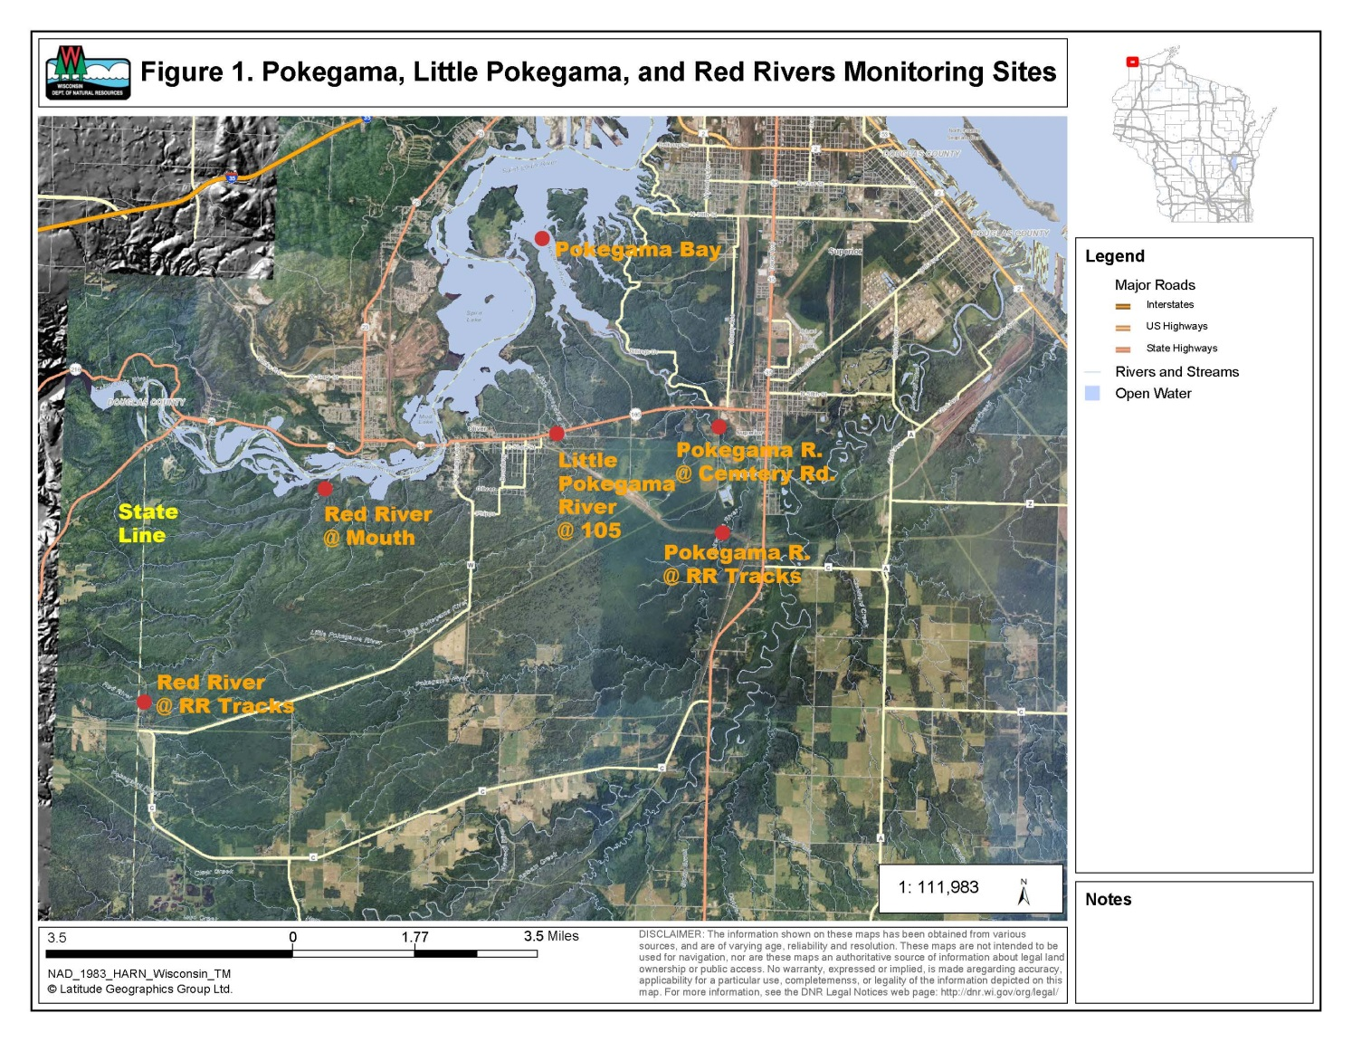

Monitoring was done for fish, macroinvertebrates, and water chemistry. Additionally water temperature data was recorded hourly with HOBO data loggers. This data was collected at all sites except for the Pokegama Bay site where only water chemistry was collected.

Fish Communities were assessed by electrofishing. Either a single anode backpack shocker or a dual anode stream shocker was used to capture fish depending on stream size. The fish were collected in a single upstream pass. The station lengths were 35 times the mean steam width with a minimum length of 100 meters and a maximum length of 400 meters. Fish captured were counted identified to species and released. The collected data was used to determine the natural community of the streams and to calculate the appropriate biotic indices (IBI’s).

Macroinvertebrate communities were assessed by collecting kick samples from riffles, using a 500 um mesh D-frame net. Samples were preserved in 85% ethanol and were processed by UW – Stevens Point’s Aquatic Biomonitoring Lab. Macroinvertebrates were counted and identified to the lowest possible taxa. Biotic indices and other statistics were generated.

Water samples were collected and field parameters were measured following standard DNR protocols. Water samples were preserved, as needed, and shipped on ice to the Wisconsin State Lab of Hygiene for analysis. Field parameters measured were:
- Temperature (°C)
- pH
- Dissolved Oxygen (mg/L)
- Conductivity (µmhos/cm)
- Transparency (cm)
Lab parameters were:
- Total Phosphorus (µg/L)
- Total Suspended Solids (mg/L)

Temperature data was recorded with HOBO data loggers. These data loggers were fixed in place in the stream with lengths of rebar. The loggers recorded water temperature hourly.

Findings and Discussion

Fish Communities

Fish survey IBI’s are summarized in table 2, below.

Table 2. | Lake Superior Warm Water Streams |  | Small  Streams |  | Cool-Warm Streams
Sample Site | IBI Rating | IBI | IBI Rating | IBI | IBI Rating | IBI
Pokegama R. at  Cemetery Rd |  |  |  |  | Excellent | 80
Pokegama R. at Railroad Tracks |  |  | Good | 60
Little Pokegama R.  at Hwy 105 |  |  | Excellent | 90
Red River at Mouth | Good | 60
Red River  at Railroad Tracks |  |  | Very Poor | 10

A total of nine fish species were collected at the monitoring station on the Little Pokegama River. 70.6% of collected individuals were species tolerant to low dissolved oxygen caused by organic pollution, 17.1% had intermediate tolerance, and 12.3% were pollution intolerant species. An analysis of the temperature guild of the fish species found shows that 11.1% of individuals collected were warm water species, 76.6% were intermediate, and 12.3% were cold water species. The model-predicted natural community for the Little Pokegama is Coldwater, however the fish community sampled at this station is more consistent with a cool-cold headwater.

A total of 18 fish species were collected at the Pokegama R. at Cemetery Rd. station. Of the collected individuals 48.1% were pollution tolerant, 43.4% had intermediate tolerance, and 8.5% were intolerant of pollution. 49.1% of individuals fell into the Warmwater temperature guild, 50.9% were transitional, and Coldwater species were entirely absent. The model-predicted natural community for this station is a cool-cold headwater. The fish community sampled at this station was more consistent with a Cool-Warm temperature regime rather than Cool-Cold. The size composition was more consistent with a mainstem stream with 34% of species being large river species, and 45.3% being intermediate. A more fitting natural community would be Cool-Warm mainstem.

A total of 12 fish species were collected from the Pokegama River at the railroad tracks. 58.1% of collected individuals were pollution tolerant, 41.9% had intermediate tolerance, and there were no intolerant species collected. 46.1% of species collected were warm water species, 53.9% were transitional, and no cold water species were collected. The model-predicted natural community for this station is Cool-Cold Headwater, however the fish community is more consistent with a Cool-Warm Headwater.

Only two species were collected at the Red River at the railroad tracks. Brook Stickleback and Fathead Minnows were the two species collected at this station. Both of these species are warm water species that are tolerant of pollution. The model-predicted natural community for this stream is coldwater. The fish IBI’s for this station are somewhat inconclusive. Only eight fish were captured in the 110 meter station. Twenty-five fish are needed to make a natural community determination. However, the lack of any coldwater species at this station suggests that the natural community would fit better as a Cool-Cold or Cool-Warm headwater.

Fourteen species of fish were collected from the Red River at the mouth. 5.4% of them were pollution tolerant individuals, 94% were intermediate, and 0.6% were intolerant. 96.6% of individuals were warm water species, 2.8% were transitional, and 0.6% were cold water species. The model-predicted natural community of this station is coldwater. In this case the model poorly predicts the fish community which seems most consistent with a warmwater mainstem community.

Macroinvertebrate Communities

The Hilsenhoff Biotic Index (HBI) for the Pokegama River at Cemetery Road was 6.72 which rates it as fairly poor (Table 3). The Macroinvertebrate Index of Biotic Integrity (M-IBI) score was 8.03 which yielded an excellent rating. The HBI is calculated using a number value for each species corresponding to its tolerance to organic pollution. The M-IBI uses tolerance scores as well as several other metrics. The low score on the HBI may be due to a lack of high quality riffle habitat. The stream bottom at this station tended to be flat and comprised of clay and sand. What riffle habitat was present was perched atop more clay and sand and are likely unstable in the case of a high flow event. Under normal flow conditions the flow velocity is slow even at the riffles. This could be preventing intolerant species that would be normally found in the highly oxygenated waters of riffles from colonizing this particular area. The M-IBI takes into account the proportion of different feeding guilds such as filterers, scrapers, and gatherers into account as well as percent EPT (percent Ephemeroptera, Plecoptera, and Trichoptera species). This good macroinvertebrate community composition causes the M-IBI score to be high despite most species present being fairly pollution tolerant.

The HBI score for the Pokegama River at the railroad tracks was 6.11 which rates it as fair. The M-IBI score was 6.58 which rates as good. The HBI scores suggests that there is a moderate amount of organic pollution present. This may be due to this site being located in close proximity to a rail yard. The good M-IBI score is likely due to the large proportion of EPT individuals present and indicates a health macroinvertebrate community.

The Little Pokegama River at highway 105 scored 5.17 on the HBI yielding a good rating, and scored 8.47 on the M-IBI yielding an excellent rating. These scores indicate that organic pollution intolerant individuals are present at this site and that there is a healthy community composition.

The Red River at the mouth scored 5.8 on the HBI and 3.11 on the M-IBI yielding a rating of fair on both IBIs. The low scores on both IBI’s indicate that the macroinvertebrate community at this station is impaired. However, less than 100 macroinvertebrates were collected in the sample, so the IBI’s calculated may be questionable. The scarcity of macroinvertebrates at this station is

Table 3.  Sample Site | HBI | HBI Rating | Species  Richness | Percent EPT  Individuals | Percent EPT  Genera | M-IBI | M-IBI Rating
Pokegama River  at Cemetery Rd. | 6.72 | Fairly Poor | 29 | 50 | 25 | 8.03 | Excellent
Pokegama River  at RR Tracks | 6.11 | Fair | 27 | 55 | 27 | 6.58 | Good
Little Pokegama R.  at Hwy 105 | 5.17 | Good | 33 | 24 | 29 | 8.47 | Excellent
Red River  at of Mouth | 5.8 | Fair | 11 | 3 | 9 | 3.11 | Fair
Red River  at RR Tracks | 6.79 | Fairly Poor | 38 | 6 | 11 | 6.05 | Good
M-IBI | Water Quality  Rating
>7.5 | Excellent
5.0-7.4 | Good
2.5-4.9 | Fair
<2.5 | Poor
Hilsenhoff  Biotic Index | Water Quality  Rating
0.00-3.50 | Excellent
3.51-4.50 | Very Good
4.51-5.50 | Good
5.51-6.50 | Fair
6.51-7.50 | Fairly Poor
7.51-8.50 | Poor
8.51-10.00 | Very Poor

likely due to a lack of habitat, the bottom at this station is comprised of unstable clay on sand and riffles were entirely absent. In early 2012 there was a massive flooding event that caused huge amounts of erosion and deposition. This event likely eradicated any existing habitat in this section of the river this could explain why only a small amount of tolerant individuals were collected from this site.

The Red River at the railroad tracks scored 6.79 on the HBI yielding a rating of fairly poor. This indicates the species present are tolerant of low dissolved oxygen. This is expected as this site was observed to become intermittent during the later parts of the summer and fall which is when the sample was collected. The station scored 6.05 on the M-IBI yielding a good rating. The M-IBI being considerably better than the HBI is likely due to the surprisingly large number of species collected at the station. This indicates that despite the dissolved oxygen challenges there are still large numbers of macroinvertebrates present.

Water Chemistry

Table 4.  Water Quality  Pokegama R.  @ Cemtery Rd | 06/11/2012 | 06/25/2012 | 07/23/2012 | 08/20/2012 | 09/26/2012 | 10/22/2012
Total Phosphorus  (ug/L) | 100 | 108 | 149 | 148 | 159 | 1220
Total Suspended Solids  (mg/L) | 12 | 30 | 7 | 10 | 10 | 12
Turbidity (NTU) | 39.3 | 90.6 | 25.3 | 26.5 | 22.3 | 16.6
Temperature  (Celcius) | 21.8 | 17.7 | 25.2 | 19.4 | 12.4 | 8.2
Disolved Oxygen  (mg/L) | 7.2 | 8.6 | 5.3 | 8.4 | 7.7 | 10.5
pH | 7.8 | 5.9 | 7.1 | 8.2 | 8 | 8
Conductivity  (umhos/cm) | 200 | 133 | 315 | 297 | 317 | 302
T-Tube (cm) | 22 | 10 | 34 | 23 | 38 | 8.2

Water Chemistry data for the Pokegama River at Cemetery Rd. is contained in table 4, above. This station showed elevated levels of phosphorus that exceeded the WisCALM 75 ug/l threshold for streams. This station had the highest phosphorus levels of any station including the upstream station at the railroad and the downstream Pokegama Bay station. The most likely source of this phosphorus is from the Village of Superior wastewater treatment facility which drains to the Pokegama River downstream of the station at the railroad and upsteam of the Cemetery Rd. station.

Table 5.  Water Quality  Pokegama R. @ RR | 06/11/2012 | 06/25/2012 | 07/23/2012 | 08/20/2012 | 09/26/2012 | 10/22/2012
Total Phosphorus  (ug/L) | 71 | 85 | 57 | 97 | 46 | 48
Total Suspended Solids  (mg/L) | 14 | 33 | 11 | 63 | 16 | 13
Turbidity (NTU) | 59.9 | 92.6 | 46.9 | 131 | 38.2 | 30.6
Temperature  (Celcius) | 23.9 | 16.9 | 28.4 | 16.2 | 11.1 | 9.2
Disolved Oxygen  (mg/L) | 8.1 | 8.7 | 5.1 | 6.1 | 9.7 | 11.5
pH | 7.9 | 7.4 | 7 | 7.3 | 8.1 | 8.1
Conductivity  (umhos/cm) | 188 | 122 | 313 | 247 | 228 | 219
T-Tube (cm) | 16 | 10 | 18 | 9 | 40 | 32

The water chemistry data for the Pokegama River at the railroad tracks is contained in table 5, above. The total phosphorus for this station fell below the listing threshold and the other parameters fell within the expected ranges for a stream with a watershed dominated by clay soils. The water chemistry at this station showed low amounts of human impact. This fits well considering the Pokegama River watershed above this point is largely undeveloped.

Table 6.  Water Quality  Pokegama Bay | 06/12/2012 | 06/25/2012 | 07/23/2012 | 08/20/2012 | 09/26/2012 | 10/23/2012
Total Phosphorus  (ug/L) | 97 | 95 | 157 | 138 | 117 | 72
Total Suspended Solids  (mg/L) | 17 | 27 | 45 | 18 | 23 | 12
Turbidity (NTU) | 62 | 102 | 50.1 | 40.9 | 48.4 | 21
Temperature  (Celcius) | 22.9 | 22.5 | 28.6 | 20.9 |  | 9.1
Disolved Oxygen  (mg/L) | 7.8 | 6.6 | 8.14 | 7.5 | 8.7 | 11.7
pH | 7.6 | 5 | 6.75 | 7.8 | 7.7 | 7.8
Conductivity  (umhos/cm) | 124 | 110 | 185 | 189 | 190 | 163
T-Tube (cm) | 17 | 9 | 27 | 24.5 | 20 | 40

The water chemistry for Pokegama Bay is contained in table 6, above. The water chemistry station in Pokegama Bay was added to compare to the stream stations. Pokegama Bay was previously found to have levels of phosphorus exceeding the listing threshold for streams (75 ug/l) and that is confirmed by this data. Total phosphorus levels found in the bay are less than those found at the Cemetery Rd. station on the Pokegama River. Sedimentation enhanced by macrophyte beds in Pokegama Bay and partial mixing with St. Louis River water probably account for this.

Table 7.  Water Quality Little Pokegama R.  @ Hwy 105 | 06/11/2012 | 06/25/2012 | 07/23/2012 | 08/20/2012 | 09/26/2012 | 10/22/2012
Total Phosphorus  (ug/L) | 62 | 81 | 63 | 66 | 66 | 75
Total Suspended Solids  (mg/L) | 21 | 23 | 27 | 24 | 17 | 19
Turbidity (NTU) | 37.3 | 78 | 51.9 | 39.9 | 38.7 | 45.3
Temperature  (Celcius) | 16.6 | 16.5 | 20.2 | 11.6 | 11 | 7.9
Disolved Oxygen  (mg/L) | 6.4 | 9.1 |  | 4.3 | 7.7 | 6.1
pH | 7.4 | 5.7 | 7.1 | 7.9 | 8.3 | 8
Conductivity  (umhos/cm) | 460 | 125 | 481 | 360 | 312 | 260
T-Tube (cm) | 19 | 12.5 | 14 | 11 | 21 | 16

The water chemistry data for the Little Pokegama River at highway 105 is contained in table 7, above. The water chemistry for the Little Pokegama River fell within the expected ranges for a stream with a watershed dominated by clay soils. The average total phosphorus for this station was below the listing threshold. This was expected for this station as the upstream watershed has limited development.

Table 8.  Water Quality  Red River @ Mouth | 06/12/2012 | 06/25/2012 | 07/23/2012 | 08/20/2012 | 09/26/2012 | 10/22/2012
Total Phosphorus  (ug/L) | 66 | 109 | 53 | 58 | 25 | 26
Total Suspended Solids  (mg/L) | 73 | 52 | 34 | 38 | 10 | 13
Turbidity (NTU) | 26.1 | 152 | 52.1 | 52.7 | 21 | 16.9
Temperature  (Celcius) | 19.2 | 15 | 25.6 | 17.3 | 10.3 | 8.1
Disolved Oxygen  (mg/L) | 9.6 | 8.4 | 6.3 | 8.5 | 10.8 | 1.5
pH | 8.2 | 4.1 | 7.8 | 8.2 | 8.1 | 7.5
Conductivity  (umhos/cm) | 537 | 376 | 747 | 580 | 513 | 385
T-Tube (cm) | 31 | 7 | 13 | 15.5 | 37 | 57

The water chemistry for the Red River at the mouth is contained in table 8, above. The total phosphorus for this station was fairly low with the exception of one sample that was influenced by a runoff event. The Red River watershed is primarily state owned land and there is almost no access let alone development. The fact that the Red River is susceptible to large erosion events led to concerns about possible high phosphorus levels, however they seem to be unfounded.

Table 9.  Water Quality  Red River @ RR | 06/13/2012 | 06/25/2012 | 07/23/2012 | 08/20/2012 | 09/26/2012 | 10/23/2012
Total Phosphorus  (ug/L) | 24 | 122 | 48 | 29 | 50 | 115
Total Suspended Solids  (mg/L) | 4 | 263 | 3 | 4 | 7 | 11
Turbidity (NTU) | 7.3 | 205 | 7.8 | 8 | 12.8 | 6.2
Temperature  (Celcius) | 23.9 | 14 | 17.3 | 13.1 | 9 | 8
Disolved Oxygen  (mg/L) | 8.1 | 8.6 | 1.5 | 6.1 | 4 | 11.1
pH | 7.9 | 5.6 | 6.8 | 7.6 | 7.7 | 8.2
Conductivity  (umhos/cm) | 188 | 149 | 489 | 189 | 389 | 426
T-Tube (cm) | 16 | 5 | 45 | 65 | 85 | 48

The water chemistry for the Red River at the railroad tracks is contained in table 9, above. The water chemistry for this station was extremely variable with large spikes and drops in values across the board. The irregular nature of the water chemistry is not surprising considering this station had intermittent flow and conditions changed drastically depending on proximity to rain events. The total phosphorus for this station exceeded 75 ug/l for the June and October samples. However, the other samples were much lower putting the average well below the listing threshold.

Water Temperature

The below graphs 1-5 show the data collected with in-steam temperature loggers. These loggers were left in the streams and recorded the water temperature hourly. The other data for this report was collected during the summer of 2012. The temperature loggers collected data throughout the summer of 2013. The reason for this discrepancy is the first set of temperature loggers were washed away by a major flood event in 2012.

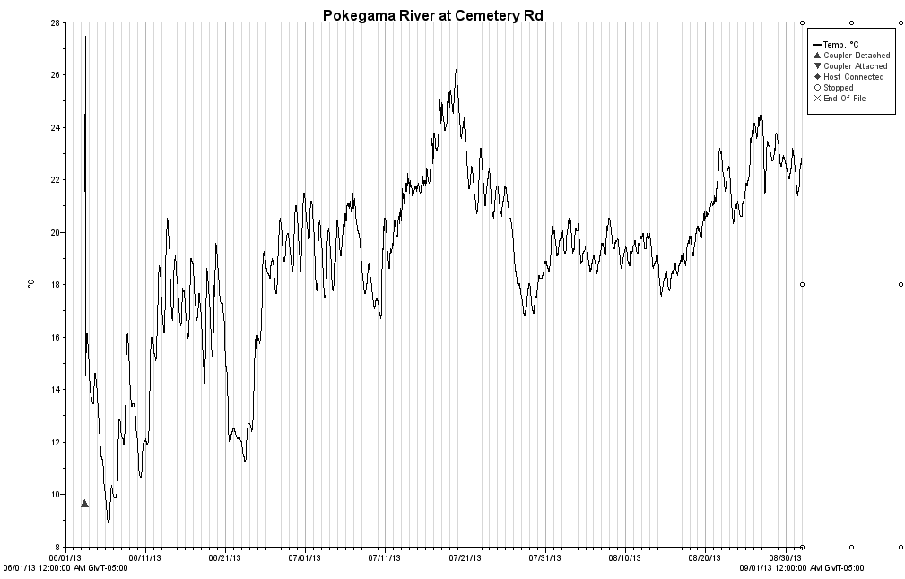
Graph 1.
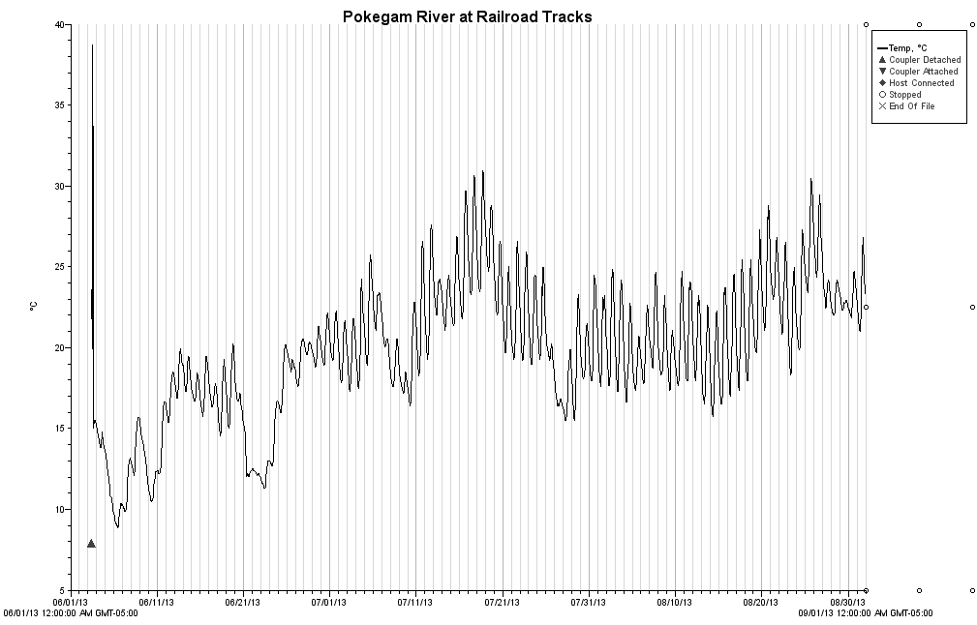
Graph 2.
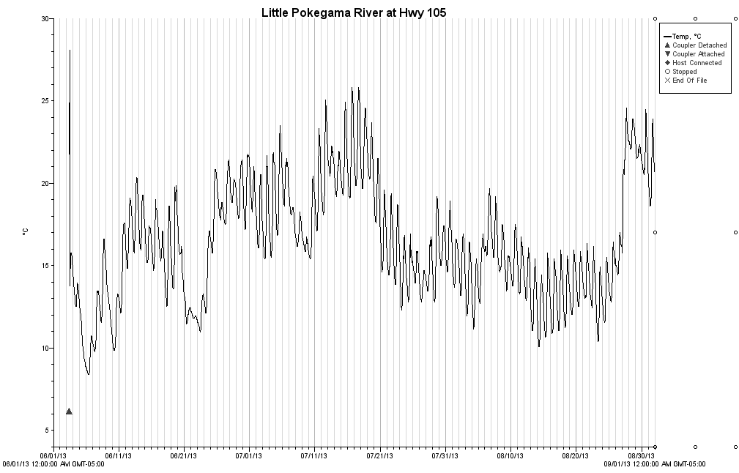
Graph 3.
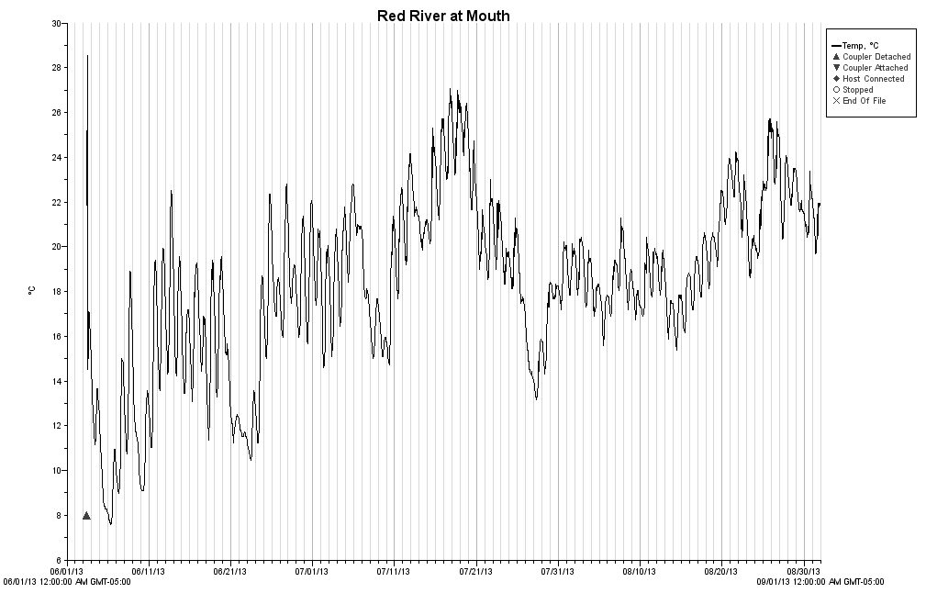
Graph 4.
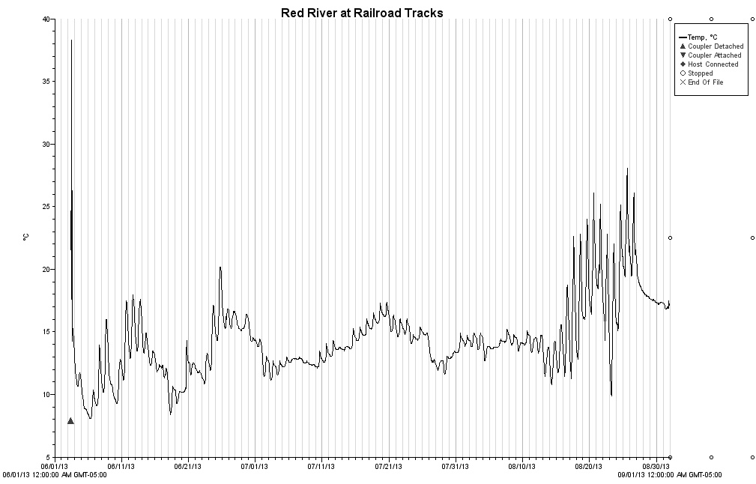
Graph 5.
It is difficult to make a listing decision based on one year of temperature data. It can be used to support conclusions drawn from the other collected data. Model predicted natural communities at all of the stations are either cold water or cool-cold transitional waters. Both Red River stations as well as the Little Pokegama River station are predicted to be cold water natural communities. The expected maximum daily water temperature for cold water streams is 20.7 degrees Celsius. However, the water temperature at these stations exceeds 25 degrees Celsius during the hottest days of the summer.

Both stations on the Pokegama River are predicted to be cool-cold natural communities. The expected maximum daily water temperature for cool-cold water streams is 22.5 degrees Celsius. However, these stations had maximum temperature exceeding 25 degrees Celsius.

Conclusions

Pokegama River at Cemetery Road

The model predicted natural community for the Pokegama River at Cemetery Road is cool-cold headwater. The fish natural community analysis indicates that cool-warm mainstem would be the appropriate natural community classification. The temperature data for the stream also suggests that a cool-warm mainstem is a more appropriate natural community classification. Reclassifying this section of the Pokegama River as a cool-warm mainstem is recommended

The total phosphorus for this station exceeded the WisCALM stream threshold (lower 90% confidence interval of the median exceeds 75ug/l). The source of this high phosphorus is most likely the Village of Superior Wastewater Treatment facility located upstream of this station. While the phosphorus levels exceed the listing threshold, WisCALM guidelines dictate that to list for phosphorus one poor F-IBI or one poor M-IBI is needed. As both the fish and macroinvertebrate IBIs were better than this, listing it is not recommended. The stream should be placed on the Watch Waters list for possible future assessment.

Pokegama River at Railroad Tracks

The model predicted natural community for the Pokegama River at railroad tracks is a cool-cold headwater. The assessment of the fish natural community found it fit a cool-warm headwater better than a cool-cold headwater. Reclassifying it to a cool-warm headwater is recommended. The temperature data for the stream also suggests that a cool-warm headwater is a more appropriate natural community classification.

This station rated good on the small steams F-IBI, it rated good on the M-IBI as well, and fair on the HBI. The median total phosphorus at this station was below the listing threshold. This steam showed low amounts of human impact. Listing this under 303d is not recommended.

Little Pokegama River

The model predicted natural community for the Little Pokegama River is cold water. This is not supported by the collected data. An analysis of the fish community composition shows that the cold water classification does not fit. The temperature data for the stream also suggests that a cool-cold headwater is a more appropriate natural community classification. The best fitting natural community would be cool-cold headwater.

This station rated excellent using the small stream IBI. This stream had a good HBI rating and an excellent M-IBI rating. The median total phosphorus never exceeded the listing threshold. Listing this under 303d is not recommended.

Red River at Mouth

The model predicted natural community for the Red River at the mouth is cold water. The data clearly shows that this station is misclassified. The fish natural community composition is consistent with a warm mainstem based on size guild, temperature guild, and tolerance guild. The temperature data for the stream also suggests that a warm mainstem is a more appropriate natural community classification.

This station rates good with the warm water IBI and received fair ratings on both the HBI and M-IBI. The low macroinvertebrate scores are likely due to the massive habitat disturbance caused by the flooding in spring of 2012. Massive amounts of sediment deposition occurred in this section of the Red River during the flood event and it’s likely that most macroinvertebrates present pre-flood were either buried under sediment or washed out to the St Louis River. While clearly damaged it seems likely the macroinvertebrate community will recover as the river channel redevelops and macroinvertebrates recolonize the area. The median total phosphorus at this site was below the listing threshold. Listing this under 303d is not recommended.

Red River at Railroad Tracks

The model predicted natural community for the Red River at the railroad tracks is cold water. This station was observed to become intermittent in the late summer and fall. The cold water natural community classification for this stream was not supported by the collected data. The temperature data also does not support the cold water natural community prediction. Due to the small sample size of the fish survey it is not possible to accurately reclassify its natural community. An additional fish survey with a sample size of 25 or greater would be needed. It is possible cold water conditions may exist down steam of this station and upstream of the mouth.

A reliable fish IBI was not obtained for this station. Only 8 fish were captured in the 110 meter station. Additional young of year fish were observed at this station but were too small to be captured. This station had a HBI rating of fairly poor and an M-IBI rating of good. The median total phosphorus at this station was below the listing threshold. Listing this under 303d is not recommended.

Pokegama River @ Cemetery Rd. Fish Data
Species Code | Species | Thermal Guild | Fish Size Guild | Tolerance Guild | Count
X15 | Yellow Perch | Transitional | Large | Intermediate | 9
Y01 | Freshwater Drum | Warmwater | Large | Intermediate | 1
L02 | Northern Pike | Transitional | Small | Intermediate | 2
W14 | Black Crappie | Warmwater | Large | Intermediate | 5
X22 | Walleye | Transitional | Large | Intermediate | 4
X26 | Eurasian Ruffe | Transitional | Lake | Intermediate | 3
M33 | Spottail Shiner | Warmwater | Large | Intolerant | 9
Q01 | Trout Perch | Transitional | Large | Intermediate | 3
N09 | White Sucker | Transitional | Medium | Tolerant | 12
M20 | Golden Shiner | Warmwater | Medium | Tolerant | 6
M50 | Creek Chub | Transitional | Small | Tolerant | 14
M28 | Common Shiner | Warmwater | Medium | Intermediate | 9
O05 | Black Bullhead | Warmwater | Medium | Tolerant | 14
K01 | Central Mudminnow | Transitional | Small | Tolerant | 3
X16 | Log Perch | Warmwater | Large | Intermediate | 5
X12 | Johnny Darter | Transitional | Medium | Intermediate | 4
W06 | Pumpkin Seed | Warmwater | Medium | Intermediate | 1
O06 | Yellow Bullhead | Warmwater | Medium | Tolerant | 2
Natural Community: Cool-Cold Headwater |  | Fits NatCom | Station Length- 400 meters
Percent Tolerant | 48.1 | Yes
Percent Intolerant | 8.5 | Yes
Percent Intermediate | 43.4 | Yes
Percent Small | 17.9 | No
Percent Medium | 45.3 | Yes
Percent Large | 34 | No
Percent Warmwater | 49.1 | No
Percent Transitional | 50.9 | Yes
Percent Coldwater | 0 | No

Pokegama River @ RR Fish Data
Species Code | Species | Thermal Guild | Fish Size Guild | Tolerance Guild | Count
M50 | Creek Chub | Transitional | Small | Tolerant | 95
M28 | Common Shiner | Warmwater | Medium | Intermediate | 48
K01 | Central Mudminnow | Transitional | Small | Tolerant | 20
W09 | Blue Gill | Warmwater | Large | Intermediate | 30
N09 | White Sucker | Transitional | Medium | Tolerant | 11
Q01 | Trout Perch | Transitional | Large | Intermediate | 10
X12 | Johnny Darter | Transitional | Medium | Intermediate | 4
M46 | Fathead Minnow | Warmwater | Small | Tolerant | 19
W14 | Black Crappie | Warmwater | Large | Intermediate | 17
M20 | Golden Shiner | Warmwater | Medium | Tolerant | 9
X22 | Walleye | Transitional | Large | Intermediate | 3
U01 | Brook Stickleback | Transitional | Small | Tolerant | 1
Natural Community: Cool-Cold Headwater |  | Fits NatCom | Station Length– 315 meters
Percent Tolerant | 58.1 | Yes
Percent Intolerant | 0 | No
Percent Intermediate | 41.9 | Yes
Percent Small | 50.5 | Yes
Percent Medium | 27 | Yes
Percent Large | 22.5 | No
Percent Warmwater | 46.1 | No
Percent Transitional | 53.9 | Yes
Percent Coldwater | 0 | No

Little Pokegama River at Hwy 105
Species Code | Species | Thermal Guild | Fish Size Guild | Tolerance Guild | Count
M50 | Creek Chub | Transitional | Small | Tolerant | 50
M28 | Common Shiner | Warmwater | Medium | Intermediate | 13
N09 | White Sucker | Transitional | Medium | Tolerant | 88
K01 | Central Mudminnow | Transitional | Small | Tolerant | 22
Q01 | Trout Perch | Transitional | Large | Intermediate | 15
M46 | Fathead Minnow | Warmwater | Small | Tolerant | 15
Z01 | Mottled Sculpin | Coldwater | Small | Intolerant | 31
X12 | Johnny Darter | Transitional | Medium | Intermediate | 15
U01 | Brook Stickleback | Transitional | Small | Tolerant | 3
Natural Community: Coldwater |  | Fits NatCom | Station Length- 165 meters
Percent Tolerant | 70.6 | No
Percent Intolerant | 12.3 | Yes
Percent Intermediate | 17.1 | Yes
Percent Small | 48 | Yes
Percent Medium | 46 | Yes
Percent Large | 6 | Yes
Percent Warmwater | 11.1 | No
Percent Transitional | 76.6 | No
Percent Coldwater | 12.3 | No

Red River @ Mouth Fish Data
Species Code | Species | Thermal Guild | Fish Size Guild | Tolerance Guild | Count
W06 | Pumpkin Seed | Warmwater | Medium | Intermediate | 427
L02 | Northern Pike | Transitional | Small | Intermediate | 2
Y11 | Tubenose Goby | Warmwater | Lake | Intermediate | 1
O08 | Channel Catfish | Warmwater | Large | Intermediate | 2
M46 | Fathead Minnow | Warmwater | Small | Tolerant | 15
X12 | Johnny Darter | Transitional | Medium | Intermediate | 3
M50 | Creek Chub | Transitional | Small | Tolerant | 2
Z02 | Slimy Sculpin | Coldwater | Small | Intolerant | 3
K01 | Central Mudminnow | Transitional | Small | Tolerant | 1
X16 | Log Perch | Warmwater | Large | Intermediate | 1
N09 | White Sucker | Transitional | Medium | Tolerant | 5
M28 | Common Shiner | Warmwater | Medium | Intermediate | 1
O05 | Black Bullhead | Warmwater | Medium | Tolerant | 1
M20 | Golden Shiner | Warmwater | Medium | Tolerant | 1
Natural Community: Coldwater |  | Fits NatCom | Station Length- 400 meter
Percent Tolerant | 5.4 | Yes
Percent Intolerant | 0.6 | Yes
Percent Intermediate | 94 | Yes
Percent Small | 5 | Yes
Percent Medium | 94.2 | Yes
Percent Large | 0.6 | Yes
Percent Warmwater | 96.6 | No
Percent Transitional | 2.8 | Yes
Percent Coldwater | 0.6 | No

Red River @ RR Fish Data
Species Code | Species | Thermal Guild | Fish Size Guild | Tolerance Guild | Count
U01 | Brook Sticklback | Warmwater | Small | Tolerant | 7
M46 | Fathead Minnow | Warmwater | Small | Tolerant | 1
Natural Community: Coldwater |  | Fits NatCom | Station Length- 110 meters
Percent Tolerant | 100 | No
Percent Intolerant | 0 | No
Percent Intermediate | 0 | Yes
Percent Small | 100 | Yes
Percent Medium | 0 | Yes
Percent Large | 0 | Yes
Percent Warmwater | 12.5 | No
Percent Transitional | 87.5 | No
Percent Coldwater | 0 | No

