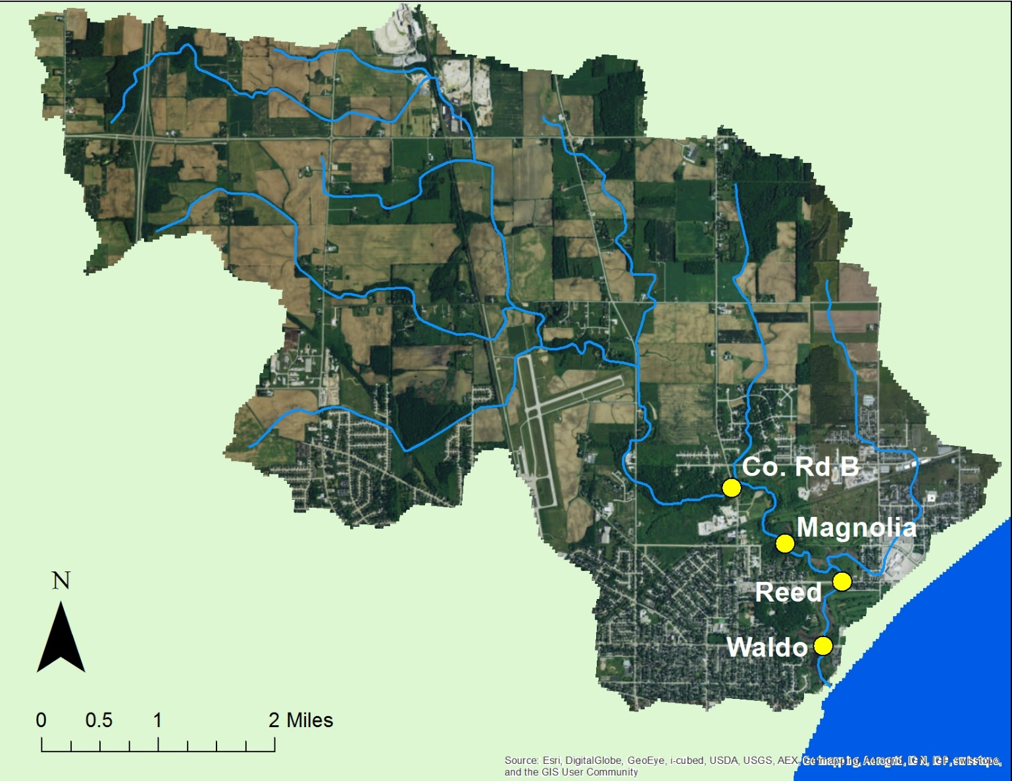

FIGURE 1. Location of water quality sampling sites in the Lower Manitowoc River watershed.

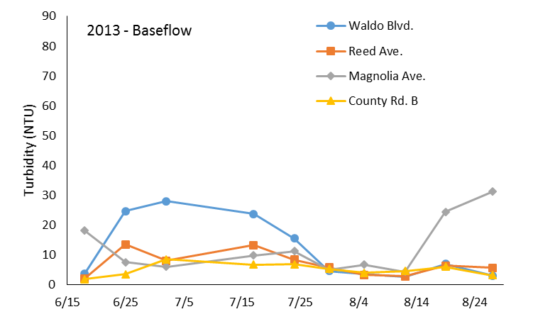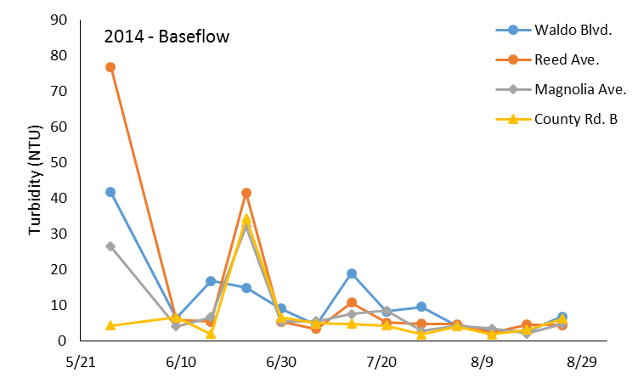
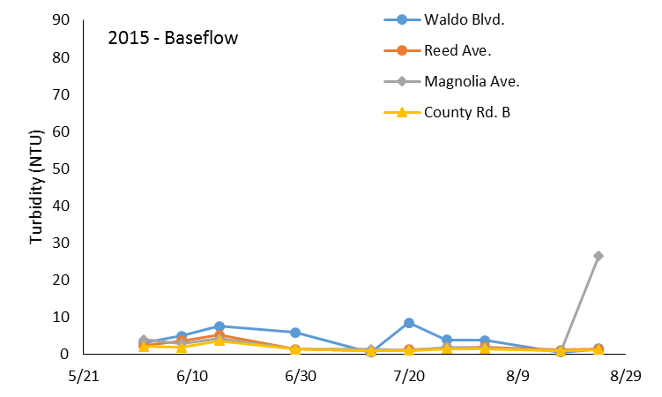
Figure 2. Baseflow turbidity (NTU) for the Little Manitowoc River, Summer 2013 – 2015.

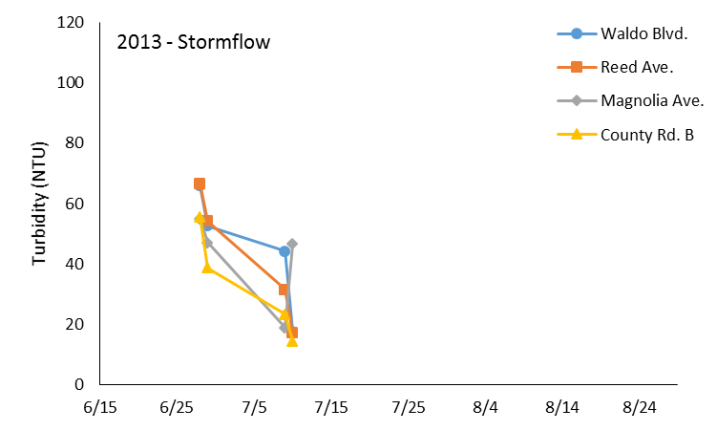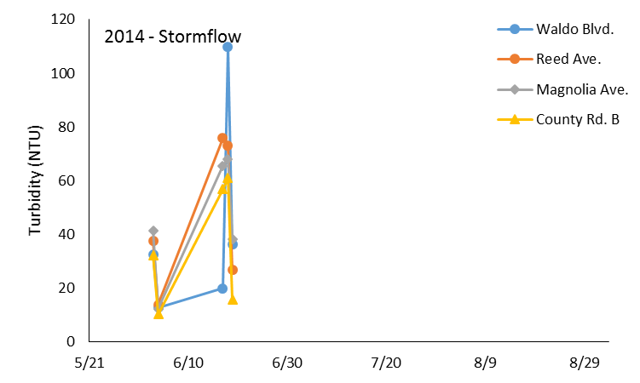
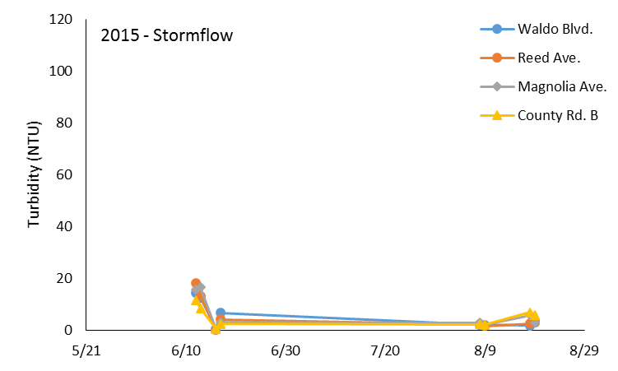
Figure 3. Stormflow turbidity (NTU) for the Little Manitowoc River, Summer 2013 – 2015.
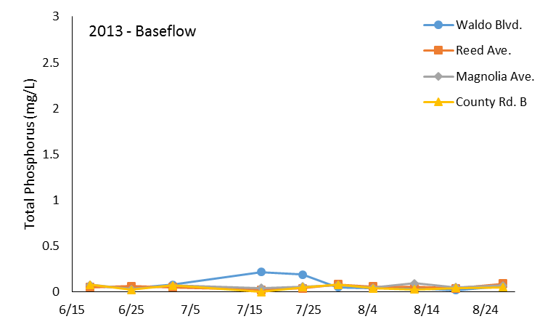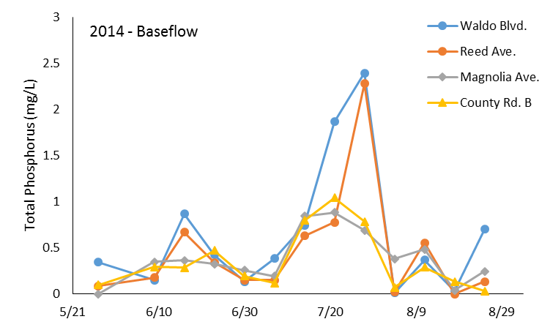
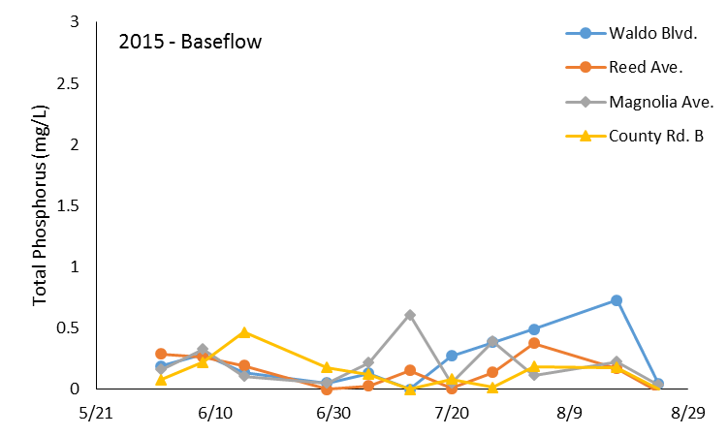
Figure 4. Baseflow total phosphorus concentrations (mg/L) for the Little Manitowoc River, Summer 2013 – 2015.

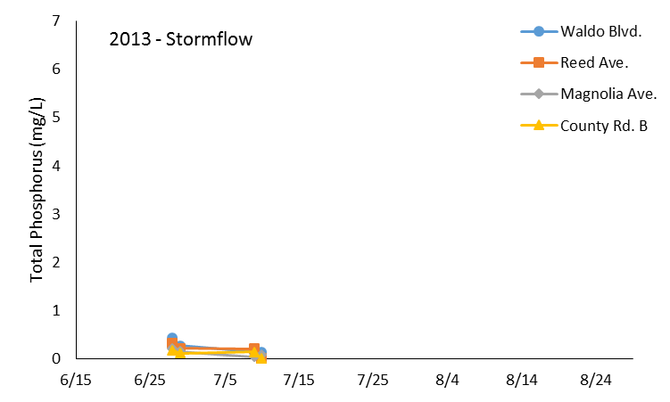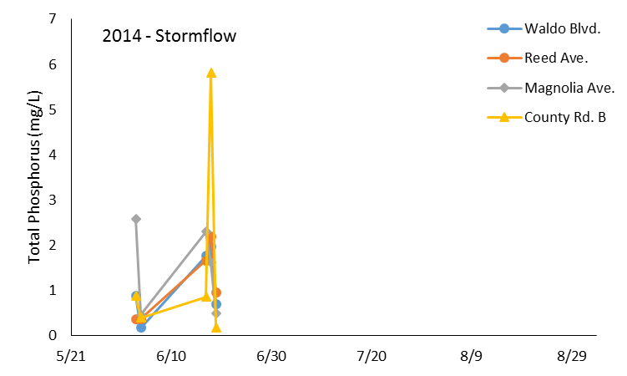
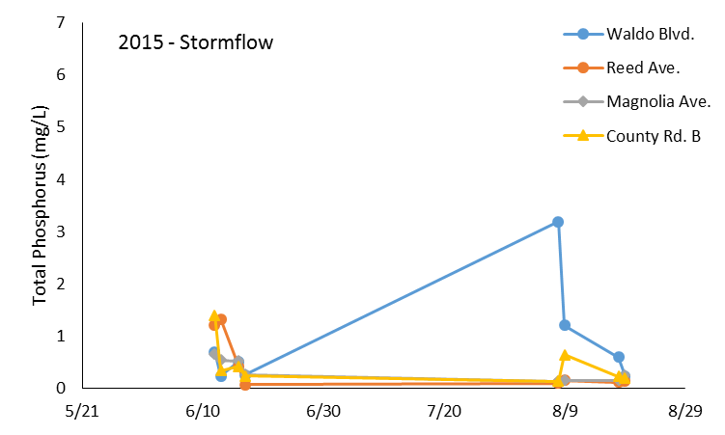
Figure 5. Stormflow total phosphorus concentrations (mg/L) for the Little Manitowoc River, Summer 2013 – 2015.

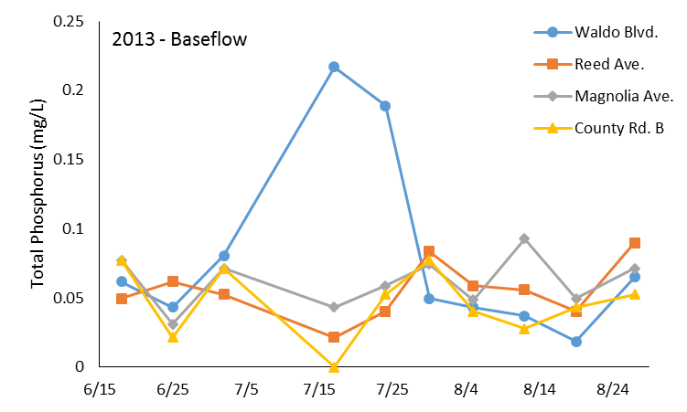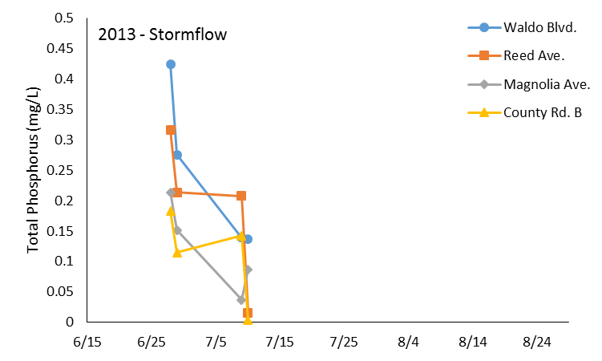
Figure 6. Baseflow and stormflow total phosphorus concentrations (mg/L) for Little Manitowoc River, Summer 2013. Note scale of Y-axis.

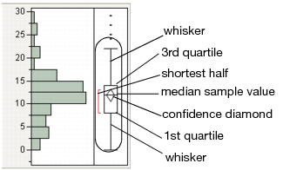

Figure 7. Explanation for total phosphorus distribution graphs in Figures 8 and 9. (JMP Statistical Software. http://www.jmp.com/support/help/Options_for_Continuous_Variables.shtml)

2013
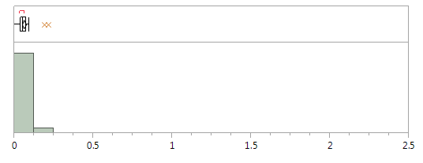
2014
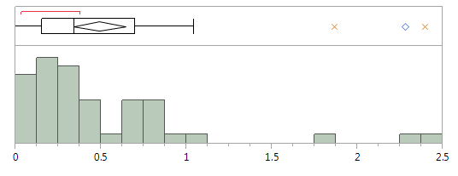
2015
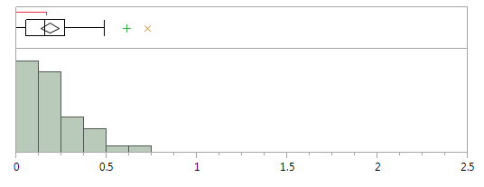
Figure 8. Baseflow frequency distribution of total phosphorus concentrations (mg/L) Little Manitowoc River, Summer 2013-2015 for all four sites.

2013
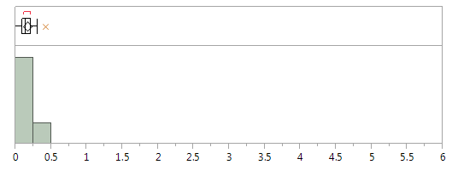

2014
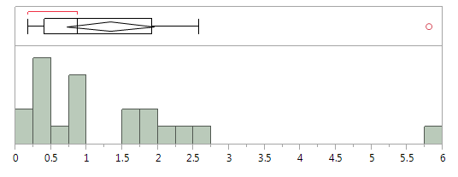

2015
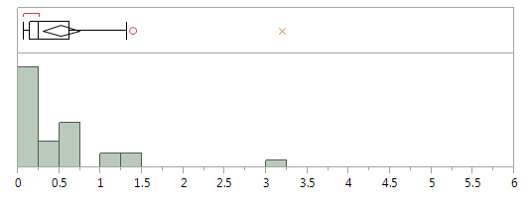

Figure 9. Frequency distribution of total phosphorus concentrations (mg/L) for stormflow Little Manitowoc River, Summer 2013-2015.

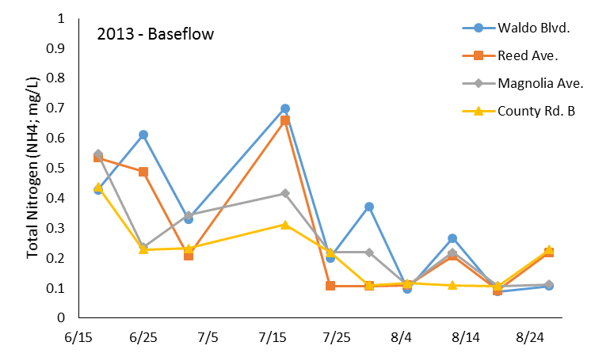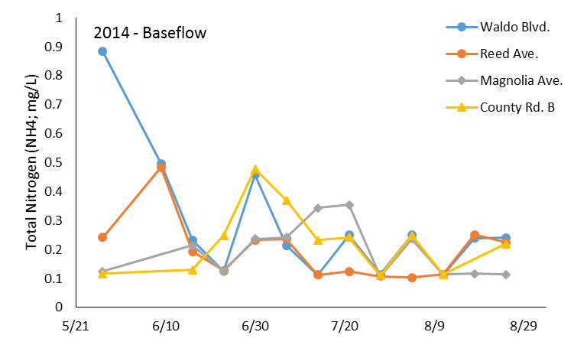
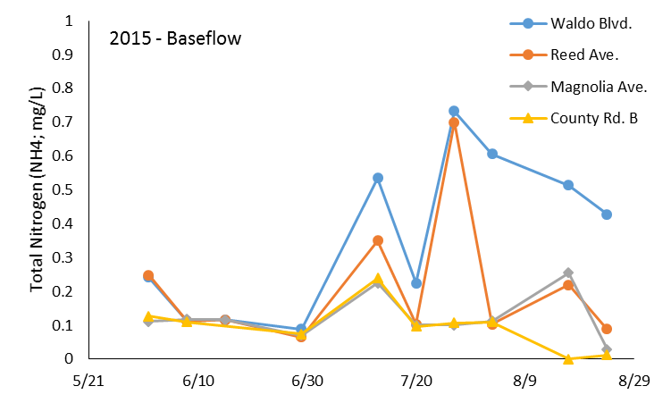
Figure 10. Baseflow nitrogen (NH4:mg/L) concentrations for the Little Manitowoc River, Summer 2013 – 2015.

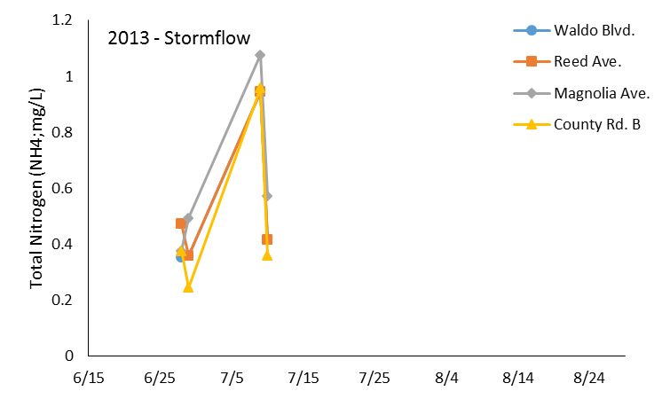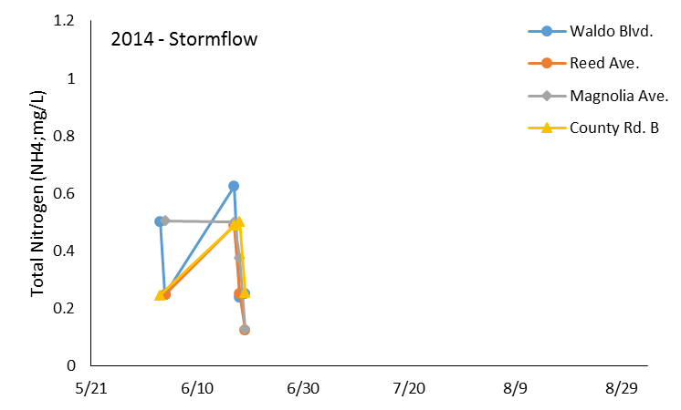
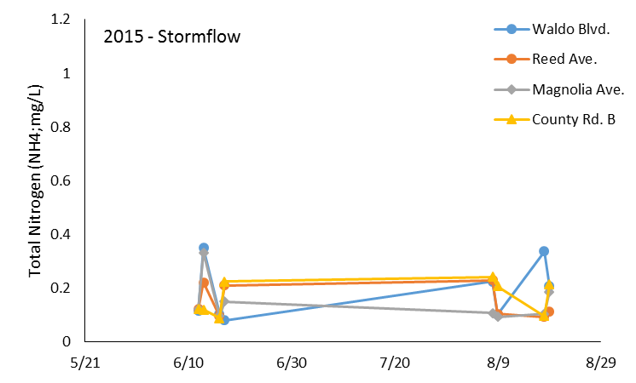
Figure 11. Stormflow nitrogen (NH4:mg/L) concentrations for the Little Manitowoc River, Summer 2013 – 2015.
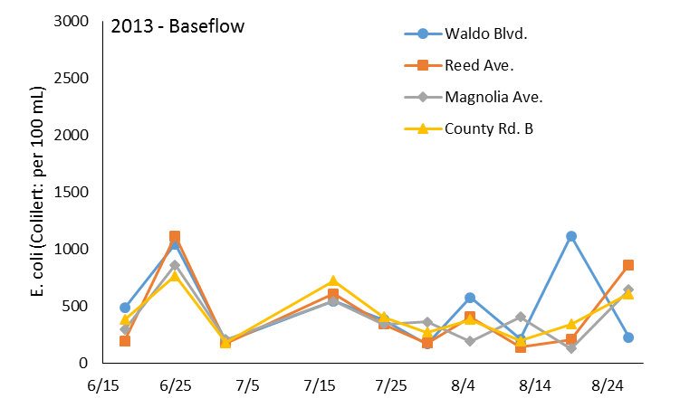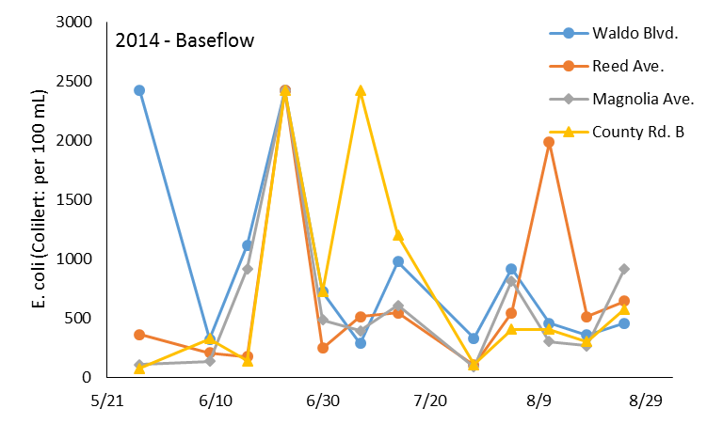
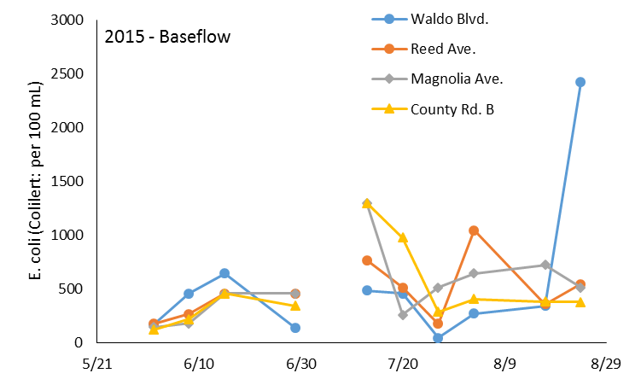
Figure 12. Baseflow E. coli concentrations for the Little Manitowoc River, Summer 2013 – 2015.

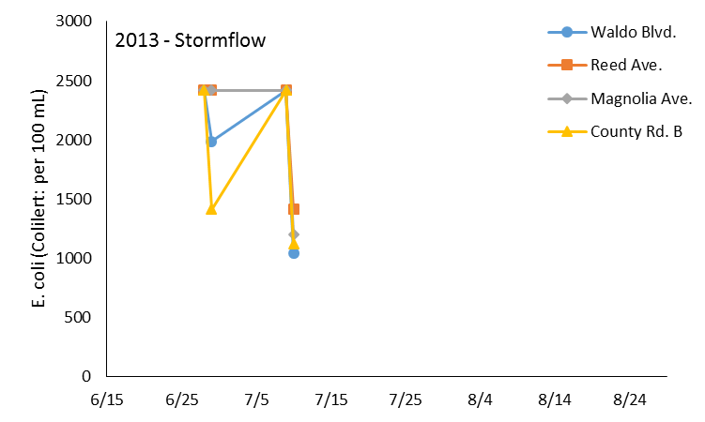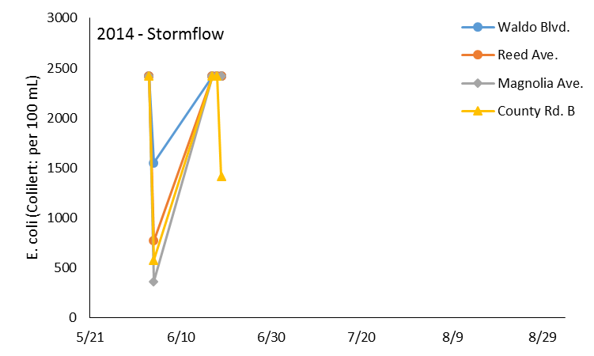
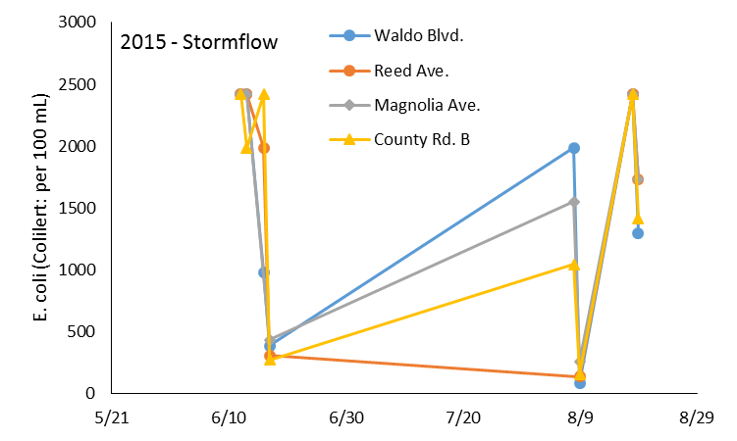
Figure 13. Stormflow E. coli concentrations for the Little Manitowoc River, Summer 2013 – 2015.

