CLAM, WOOD, AND YELLOW RIVER WATER QUALITY AND NUTRIENT AND SEDIMENT LOADS TO THE ST. CROIX RIVER

Craig Roesler – DNR, Spooner
November 25, 2016

Introduction

Watersheds for the Clam, Wood, and Yellow Rivers are located in northwest Wisconsin and cover portions of Burnett, Washburn, Polk, and Barron Counties (figure 1). The three rivers flow into the St. Croix River, which flows through Lake St. Croix further downstream. A TMDL project is underway to reduce nutrient and sediment loading to Lake St. Croix from its watershed. That project is a joint effort between the states of Wisconsin and Minnesota.

The Clam, Wood, and Yellow Rivers were monitored during 2011/12 and 2013 to allow estimation of nutrient and suspended sediment loads delivered to the St. Croix River. The monitoring also documents baseline loading and water quality conditions for their watersheds. This will help determine how and where watershed loads might be reduced. It will also offer a basis of comparison, if future load reduction measures are accomplished.

Figure 1.

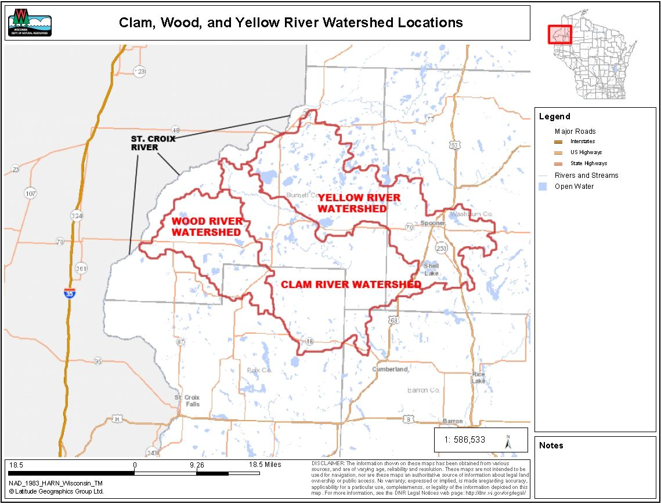

Watershed areas and land use distributions are listed in table 1.

Table 1.

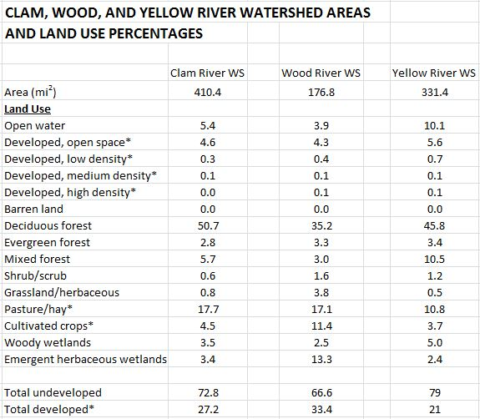

Land Use and Soils

The majority of the area of all three watersheds is undeveloped land. The Yellow River watershed has the most undeveloped land, 79%, and the Wood River watershed has the least undeveloped land, 66.6%. Undeveloped land typically has very low nutrient and sediment export rates.

Over half of the developed land (urban, residential or agricultural) in each watershed is pasture and hayfields. Pasture and hayfields typically have low to moderate nutrient and sediment export rates. The percent of cultivated cropland is very low in the Clam and Yellow River watersheds (4.5 and 3.7%) so this source of nutrients and sediment is small. Cultivated cropland is somewhat higher in the Wood River watershed (11.4 %).

Soils in the Clam River and Yellow River watersheds are mostly sands, sandy loams, and loams with high to moderate infiltration rates, which limits runoff. Soils in the Wood River watershed are more diverse and include areas of clay soil with higher runoff rates.

Point Source Discharges

Each of the watersheds has one or more point source that discharges to surface water. The point sources and their annual total phosphorus (TP) and suspended solids (TSS) discharges during 2015 are:

Clam River watershed - Village of Webster (TP = 227 kg/yr)(TSS = 1,150 kg/yr)
Wood River watershed – Village of Grantsburg (TP = 807 kg/yr)(TSS = 3,452 kg/yr)
Wood River watershed – Burnett Dairy Cooperative (TP = 32 kg/yr)(TSS = 1,407 kg/yr)
Yellow River watershed – WI DNR Gov. Tommy Thompson Fish Hatchery (TP = 113 kg/yr)(TSS = 9,392 kg/yr)

Notable Hydrologic Characteristics

The abundance of lakes in these watersheds also contributes to low nutrient and sediment export rates. Lakes often capture large portions of the nutrients and sediment that flow into them, and prevent their transport further downstream. The Yellow River watershed has the most lakes. Over 10% of the watershed is open water (including stream surfaces). Yellow Lake is a 2,283 acre lake located 7 miles upstream of the mouth of the Yellow River. The lake acts as a final nutrient and sediment trap for the majority of the watershed, before the Yellow River flows into the St. Croix River. Yellow Lake’s storage capacity also buffers high flow peaks for the Yellow River. Storage capacity of the Clam Lakes and Clam River Flowage buffer high flow peaks for the Clam River.

Surface discharge from the Wood River watershed, via the Wood River, to the St. Croix River is only about ½ of what would be expected based on watershed size. This suggests that much of the water yield from the watershed is conveyed as groundwater flow to the St. Croix River. Groundwater usually has low nutrient concentrations and no sediment concentration. This will reduce nutrient and sediment loads from the Wood River watershed to the St. Croix River.

Methods

Sites near the mouths of the Clam, Wood, and Yellow Rivers were sampled on 15 dates during July, 2011 to June, 2012, and on 15 dates during January to December 2013. Sampling dates were distributed thoughout the year, with an attempt made to target 3/4 of the samples to high flow periods.

Water samples were collected and field parameters were measured following standard DNR protocols. Water samples were preserved as needed, and shipped on ice to the Wisconsin State Lab of Hygiene for analysis. Field parameters measured were:
- Temperature
- pH
- Dissolved oxygen
- Conductivity
- Transparency (using a transparency tube)
Lab parameters during 2011/12 were:
- Total phosphorus
- Dissolved phosphorus
- Total Kjeldahl nitrogen
- Ammonia-N
- Nitrate plus nitrite-N
- Total suspended solids
- Turbidity
Lab parameters during 2013 were reduced to:
- Total phosphorus
- Total nitrogen
- Total suspended solids

Daily streamflow data was obtained from dams operated on the Clam and Yellow Rivers by Renewable World Energies, LLC (RWE). The Clam River dam is located at the Clam River Flowage and is 1.1 miles upstream of the Clam River mouth. The Yellow River dam is located near Danbury and is 1.5 miles upstream of the Yellow River mouth. Field streamflow measurements for the three streams were also made on multiple dates to determine if daily flow records from the dams were reliable, and if Wood River flows were watershed areal proportional to Clam River flows.

Daily records for the month of April, 2013 were unavailable for the Yellow River dam. Yellow River dam daily flows for that month were estimated as 83.6% of Clam River dam flows, based on the dam flow relationship for the other 11 months that year.

Clam River dam flow data agreed well with field streamflow measurements and so were not adjusted.

Yellow River dam flow data averaged 16% lower than field streamflow measurements and so was multiplied by 1.16 to produce adjusted daily flows. Yellow River flows were further adjusted by a second factor of 1.16 since 16% of the watershed is downstream of the dam site.

Wood River daily flows were initially estimated to be watershed areal proportional to Clam River dam daily flows. Those estimates were further adjusted by applying the regression equation derived from comparing the watershed areal proportional flows to the field streamflow measurements.

Estimates were made of annual loading to the St. Croix River from the three streams for total phosphorus, total nitrogen, and total suspended solids. Initial estimates were based on flow-weighted mean concentrations and total annual flow. Annual loading estimates for total phosphorus were also made using the FLUX 32 loading estimator (method 8) (Mike Walerak, MN Pollution Control Agency, 2015).

Findings and Discussion

Water Chemistry

Water chemistry results are summarized in table 2.

Table 2.

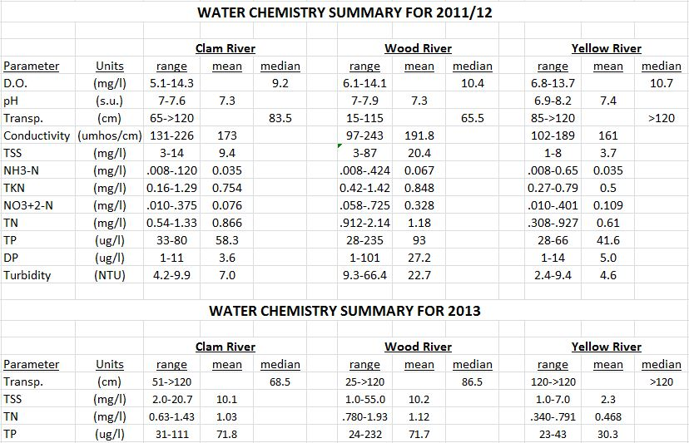

Dissolved oxygen concentrations are good in all three streams, with no concentrations less than 5 mg/l found. Mean values for pH are similar and range from 7.3 to 7.4. Mean conductivity values are also similar and range from 161 to 192 umhos/cm.

The Yellow River had the lowest mean values for nutrient and sediment related parameters. Less watershed development, and more nutrient and phosphorus retention by lakes, especially Yellow Lake, probably account for this. The mean 2011/12 total phosphorus concentration was 41.6 ug/l, and the mean total nitrogen concentration was 0.61 mg/l.

During 2011/12, the Yellow River had a mean total suspended solids concentration of 3.7 mg/l, a mean turbidity of 4.6 ntu’s, and a median transparency of >120 cm.

The Wood River had the highest mean values for nutrient and sediment related parameters. More watershed development and less nutrient and phosphorus retention by lakes contribute to this. The Wood River also transports large amounts of iron floc that originates in the Crex Meadows Wildlife Area. The mean 2011/12 total phosphorus concentration was 93 ug/l, and the mean total nitrogen concentration was 1.18 mg/l.

The Wood River had a 2011/12 mean total suspended solids concentration of 20.4 mg/l, a mean turbidity of 22.7 ntu’s, and a median transparency of 65.5 cm.

The Clam River had intermediate values for nutrient and sediment related parameters. The watershed has an intermediate level of watershed development, and nutrient and phosphorus retention by lakes. The Clam River has been observed to transport large amounts of planktonic algae that originate in Clam Lake and Lower Clam Lake. The mean 2011/12 total phosphorus concentration was 58.3 ug/l, and the mean total nitrogen concentration was 0.866 mg/l.

The Clam River had a mean 2011/12 total suspended solids concentration of 9.4 mg/l, a mean turbidity of 7.0 ntu’s, and a median transparency of 83.5 cm.

Values for nutrient and sediment related parameters were generally similar in the two years of monitoring. Average values for the Clam River were higher in 2013, while average values for the Wood and Yellow Rivers were lower in 2013.

Stream Flow Estimates

Precipitation records for the watersheds were examined to determine the normalcy of precipitation and runoff during the years monitored. Two precipitation monitoring stations present in the watersheds had adequate records. Precipitation was within 5% of normal during the two years (table 3).

Table 3.

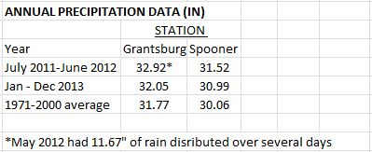

Daily flow estimates from the RWE dams were compared to field measured stream flows to assess their reliability. Dam reported and field measured flows for the Clam River showed good agreement (figure 2) indicating Clam River dam reported flows are reliable.

Dam reported flows for the Yellow River were consistently less than field measured flows (appendix A, FLOW COMP page). To adjust for this, dam reported daily flows for the Yellow River were increased by 16%, the average difference between dam reported flows and field measured flows. Yellow River flows were further adjusted by a second factor of 1.16 since 16% of the watershed is downstream of the dam site.

Wood River flows were initially estimated to be watershed area proportional to Clam River dam reported flows. Field measured flows were than compared to the initial estimates (figure 3). Field measured flows were only about ½ of estimated watershed area proportional flows. The regression equation generated from the comparison was then used to provide daily flow estimates for the Wood River from the Clam River dam reported daily flows. The unexpected low flows for the Wood River suggest that a large portion of drainage from the Wood River watershed may travel to the St. Croix River via groundwater.

Figure 2.

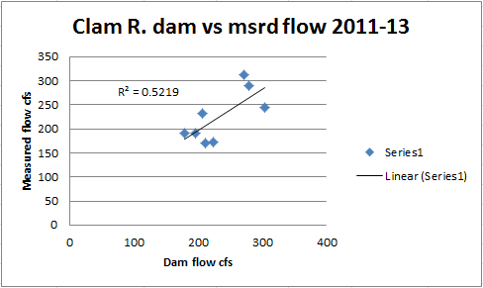

Figure 3.

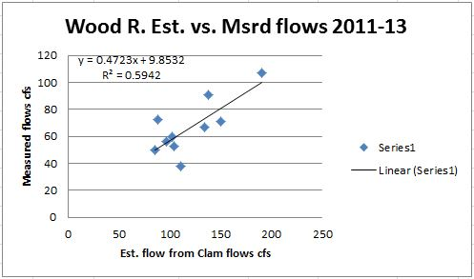

Nutrient and Suspended Sediment Loading Estimates

Mean daily flows were applied to the one year periods to determine annual water yields for each watershed. Annual water yields were multiplied by flow-weighted mean concentrations of total phosphorus, total nitrogen, and total suspended solids to estimate annual loads. Loading estimates are shown in table 4.

Table 4.

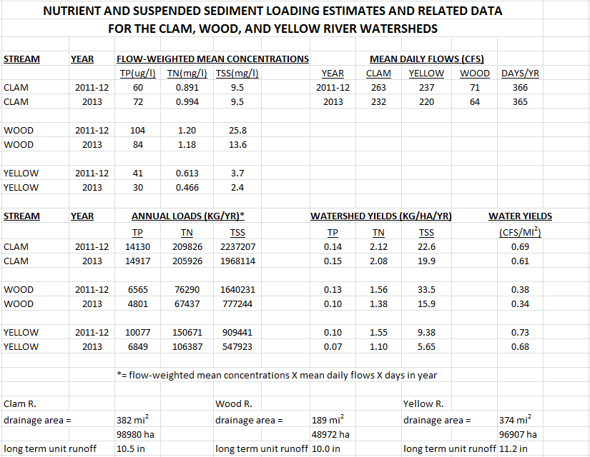

The use of flow-weighted means for load calculations is likely to produce reasonable estimates for these streams since flow and concentrations of TP, TN, and TSS are poorly to moderately correlated. (appendix A, FW MEANS + REGR pages). Flow vs concentration regression R² values for the Yellow River range from <0.01 to 0.03. R² values for the Clam River range from <0.01 to 0.13.

Flow and concentrations of TP and TN are poorly to moderately correlated for the Wood River. R² values for the Wood River range from 0.07 to 0.44. Flow and concentrations of TSS are moderately correlated for the Wood River, with R² values ranging from 0.52 to 0.70.

Watershed TP loads and TP yields generated using FLUX 32 (method 8) are shown in the table below. Loads are also compared to those calculated using the flow-weighted mean approach.

River | Year | FLUX 32 (method 8 )* TP Load (kg/yr) | Flow-wtd. Mean TP Load (kg/yr) | %  Difference | Watershed TP Yield (kg/ha/yr)  for FLUX 32 Load
Clam | 2011/12 | 14,047 | 14,130 | +0.6 | 0.14
Clam | 2013 | 12,743 | 14,917 | +17.1 | 0.13
Wood | 2011/12 | 5,580 | 6,565 | +17.7 | 0.11
Wood | 2013 | 4,177 | 4,801 | +14.9 | 0.09
Yellow | 2011/12 | 8,452 | 10,077 | +19.2 | 0.09
Yellow | 2013 | 6,773 | 6,849 | +1.1 | 0.07

*FLUX 32 outputs provided by Mike Walerak of the MN Pollution Control Agency

Watershed TP loads estimated using flow-weighted means are consistently higher, but within 20% of those estimated using FLUX 32. Watershed TP loads and yields determined with FLUX 32 are likely to be more accurate. Watershed TP yields are low.

Yellow River watershed TP yields (0.07 to 0.09 kg/ha/yr) are similar to those expected for a completely undeveloped watershed. TP sources from the limited development may be balanced by the high TP trapping potential in the watershed (10.1% of the watershed is open water and 7.4% is wetland). The TP load from the single point source in the Yellow River watershed (WI DNR Tommy Thompson Fish Hatchery; 113 kg) is only 1.5% of the average TP load of the river.

Wood River watershed TP yields are also fairly low (0.09 to 0.11 kg/ha/yr). This is largely due to the unusual apparent hydrology. It appears about half the watershed drainage may travel to the St. Croix River via groundwater. If a groundwater TP concentration of 25 ug/l is assumed, an additional TP yield of about 0.03 kg/ha/yr is suggested. TP trapping potential in the watershed is probably substantial with 3.9% open water and 15.8% wetlands. If Wood River watershed water yields were areal proportional to water yields in the adjacent Clam River watershed, then TP yields would be about double (0.18 to 0.22 kg/ha/yr). The TP load from the two point sources in the Wood River watershed (Village of Grantsburg; 807 kg; Burnett Dairy Cooperative; 32 kg) is 17% of the average TP load of the river.

Clam River watershed TP yields are also fairly low (0.13 to 0.14 kg/ha/yr). This is only about 50% higher than that expected for a completely undeveloped watershed. TP trapping potential in the watershed is probably substantial with 5.4% open water and 6.9% wetlands. The TP load from the single point source in the Clam River watershed (Village of Webster; 227 kg) is only 1.7% of the average TP load of the river.

