Tony Evers, Governor
Preston D. Cole, Secretary
Telephone 608-266-2621
Toll Free 1-888-936-7463
TTY Access via relay - 711

State of Wisconsin
DEPARTMENT OF NATURAL RESOURCES
2984 Shawano Avenue
Green Bay WI 54313-6727
March 1, 2019

To whom it may concern:

The DNR monitored East Alaska Lake in Kewaunee County in 2018 to assess water quality conditions. Water chemistry samples were collected three times in the summer along with temperature and dissolved oxygen data. A citizen volunteer collected water clarity and temperature data five times also. This report summarizes the monitoring data and provides an overview of the current condition of East Alaska Lake.

Water Chemistry
The following information is taken from the East Alaska Lake webpage provided by the DNR.
https://dnr.wi.gov/lakes/lakepages/LakeDetail.aspx?wbic=94200

East Alaska Lake - Deep Hole was sampled 9 different days during the 2018 season. Parameters sampled included:
- water clarity
- temperature
- dissolved oxygen
- total phosphorus
- chlorophyll
The average summer (July-Aug) secchi disk reading for East Alaska Lake - Deep Hole (Kewaunee County, WBIC: 94200) was 11.6 feet. The average for the Southeast Georegion was 7.4 feet. Chemistry data was collected on East Alaska Lake - Deep Hole. The average summer Chlorophyll was 4.4 µg/l (compared to a Southeast Georegion summer average of 3165 µg/l). The summer Total Phosphorus average was 11.4 µg/l. Lakes that have more than 20 µg/l and impoundments that have more than 30 µg/l of total phosphorus may experience noticeable algae blooms.

The overall Trophic State Index (based on chlorophyll) for East Alaska Lake - Deep Hole was 46. The TSI suggests that East Alaska Lake - Deep Hole was mesotrophic. Mesotrophic lakes are characterized by moderately clear water but have an increasing chance of low dissolved oxygen in deep water during the summer.

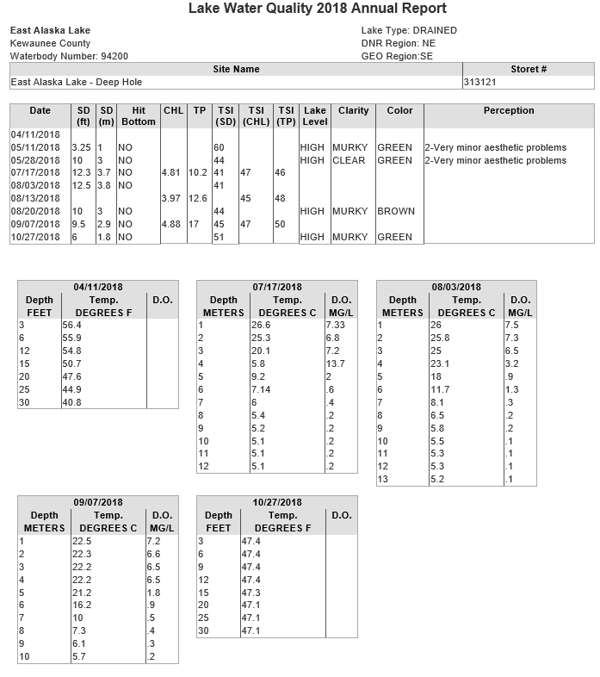
SD = Secchi depth measured in feet converted to meters; Chl = Chlorophyll a in micrograms per liter(ug/l); TP = Total phosphorus in ug/l, surface sample only; TSI(SD), TSI(CHL), TSI(TP) = Trophic state index based on SD, CHL, TP respectively; Depth measured in feet.
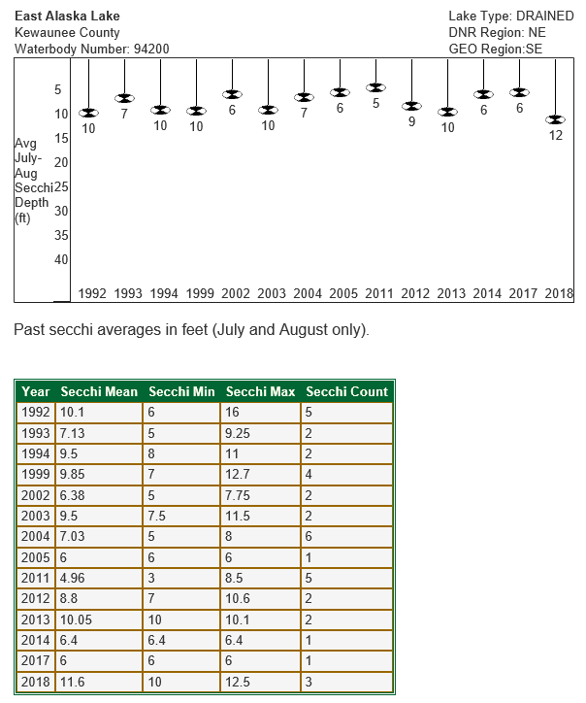
Trophic State Index Graph: East Alaska Lake - Deep Hole, Kewaunee County 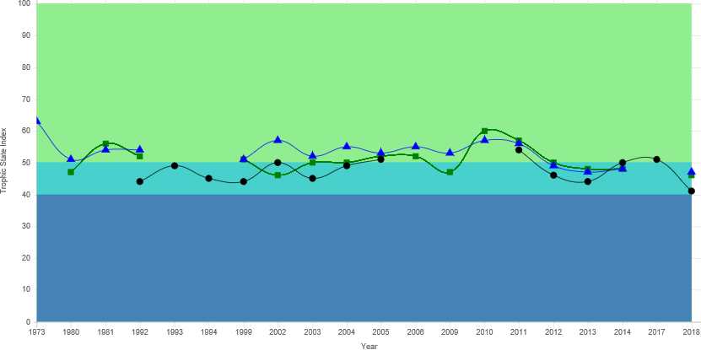
● Secchi TSI ▲ Total Phosphorus TSI ∎ Chlorophyll TSI

TSI | TSI Description
TSI < 30 | Classical oligotrophy: clear water, many algal species, oxygen throughout the year in bottom water, cold water, oxygen-sensitive fish species in deep lakes. Excellent water quality.
TSI 30-40 | Deeper lakes still oligotrophic, but bottom water of some shallower lakes will become oxygen-depleted during the summer.
TSI 40-50 | Water moderately clear but increasing chance of low dissolved oxygen in deep water during the summer.
TSI 50-60 | Lakes becoming eutrophic: decreased clarity, fewer algal species, oxygen-depleted bottom waters during the summer, plant overgrowth evident, warm-water fisheries (pike, perch, bass, etc.) only.
TSI 60-70 | Blue-green algae become dominant and algal scums are possible, extensive plant overgrowth problems possible.
TSI 70-80 | Becoming very eutrophic. Heavy algal blooms possible throughout summer, dense plant beds, but extent limited by light penetration (blue-green algae block sunlight).
TSI > 80 | Algal scums, summer fish kills, few plants, rough fish dominant. Very poor water quality.
Water chemistry sample results from the 2018 field season indicate that the Alum treatment that occurred in 2011 is still holding phosphorus levels at satisfactory levels. The lake remains in a mesotrophic condition and water clarity is good.

This report summarizes the 2018 monitoring results. Past results are available on our website at https://dnr.wi.gov/lakes/lakepages/LakeDetail.aspx?wbic=94200&page=waterquality. If you have any questions regarding the survey results from East Alaska Lake, please feel free to contact me at 920-662-5497 or at holly.stegemann@wisconsin.gov.

Sincerely,

Holly Stegemann
Water Resources Management Specialist
Wisconsin Department of Natural Resources

