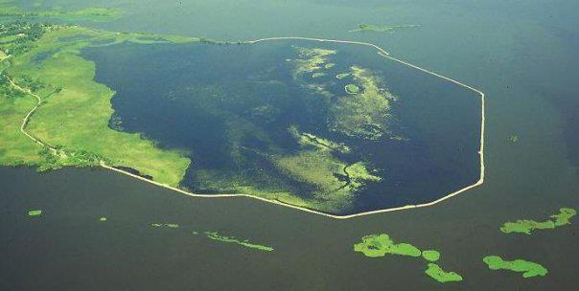
Terrell’s Island - Water Quality Assessment
2014 & 2016

Wisconsin Department of Natural Resources
Ted M. Johnson, Eric D. Evensen, Chris Kolasinski

Introduction
Terrell’s Island is located on Lake Butte des Morts in Winnebago County, Wisconsin. The break wall that created Terrell’s Island was constructed in 1999. The purpose of creating Terrell’s Island was to exclude carp populations and to lessen wind and wave energy that otherwise had been major stressors on emergent and floating leaf aquatic plant communities. Initially the project was very successful, boasting a robust aquatic plant community that provided valuable habitat to fish and wildlife. Over the last decade the habitat and water quality within Terrell’s Island has deteriorated to the extent that the system is now in a turbid algal state. It is not fully understood what exactly caused the decline but it can be assumed that high populations of shore birds, rough fish and little to no water circulation are the prime candidates. Since its decline, several management actions have been taken in hopes of improving the system, all with negligible effect. It was determined basic water quality data would be collected within Terrell’s Island following standard DNR sampling procedures. At the same time, Lake Butte des Morts was also sampled, using the same procedures, to allow for comparisons to be made between the two waterbodies (Figure 1).
Objectives
The main objectives of this study were as follows:
- Collect important water quality data for both Terrell’s Island and Lake Butte des Morts.
- Compare water quality data between the two systems to determine the magnitude of any differences.
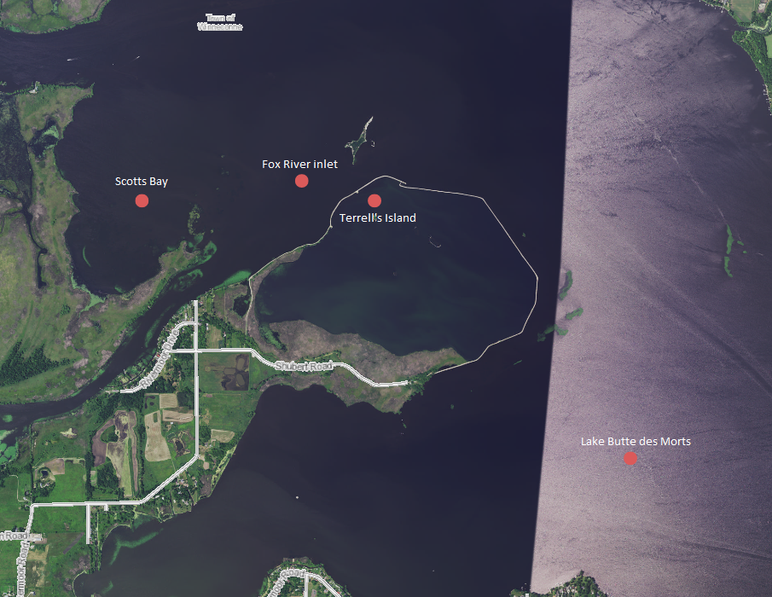
- Utilize this information to help guide future management decisions.
Methods
The project consisted of water quality sampling conducted over two growing seasons; 2014 & 2016. Two stations were sampled in 2014 with one being located within Terrell’s Island (Station 713257) and the second outside of the break wall in Lake Butte des Morts (Figure 1). Water quality parameters sampled were total phosphorus, chlorophyll A, Total Kjeldahl Nitrogen (TKN), nitrite- nitrate, ammonia, secchi, temperature, dissolved oxygen, percent oxygen saturation, pH and conductivity. Four sampling events were conducted with one in the spring and three during the summer.
Figure 1: Sampling Locations during 2014 Terrell's Island Water Quality Assessment
In 2016, the 2014 study was repeated with two main differences. Four total stations were sampled instead of two; one inside the break wall that creates Terrell’s Island (Station 713257) and three outside of the break wall. Two sampling points were selected in Butte des Morts proper (Stations 713255 & 713291) to ensure an adequate representation of the lake and one was located at the mouth of the Fox River to look specifically at river inputs (Station 713258). The second major difference was that nitrite-nitrate was not sampled in 2016 as it was recommended not to do so. All other sampling parameters that were conducted in 2014 were repeated during the 2016 study.

Results
Phosphorus
Total phosphorus concentrations within Terrell’s Island followed the same trend in Lake Butte des Morts increasing throughout the growing season (Figure 2). Average total phosphorus concentrations in Terrell’s Island and outside in Lake Butte des Morts were 0.131 mg/l and 0.079 mg/l, respectively.
Peak phosphorus concentrations in Terrell’s Island were measured on September 19, 2016 when the concentration was .167 mg/l. Lake Butte des Morts recorded its highest concentration of phosphorus on September 19, 2016 when it was measured at .112 mg/l.

Figure 2: Total Phosphorus concentrations measured during Terrell’s Island Water Quality Assessment project

Chlorophyll A
Chlorophyll A concentrations within Lake Butte des Morts experienced little variability over the growing season. Terrell’s Island and the Fox River showed oppose trends with Terrell’s increasing and the Fox River decreasing (Figure 3). Average Chlorophyll A concentrations for Terrell’s Island and Lake Butte des Morts were 69.1 ug/l and 55.9 ug/l, respectively. The highest concentration in Terrell’s Island was measured on September 19, 2016 at 99.1 ug/l. A high value of 75.4 ug/l was measured in Lake Butte des Morts on August 16, 2016.

Figure 3: Chlorophyll A concentrations measured during Terrell's Island Water Quality Assessment project

Secchi Depth
The water clarity was far better in Lake Butte des Morts when compared to Terrell’s Island (Figure 4). The average secchi depth for Lake Butte des Morts in 2014 was 2.26 feet. The average secchi depth for Terrell’s Island was 1.18 feet in 2016. As expected, increased water clarity was measured in the spring and gradually deteriorated over the summer months. Factors affecting water clarity in both systems include Chlorophyll A concentrations, wind driven sediment re-suspension and sediment re-suspension from rough fish.

Figure 4: Secchi depth measured during Terrell's Island Water Quality Assessment project
Nitrogen
Nitrogen concentrations within Terrell’s Island and Lake Butte des Morts can be can be seen below in Figures 5 and 6. Within Terrell’s Island, nitrogen concentrations continued to increase over the summer months while Lake Butte des Morts was not subject to the continued increase over the summer months most likely due to the “flushing” of the system by the Upper Fox River and Wolf River. The average total kjeldahl nitrogen concentration within Terrell’s Island was 1.94 mg/l. The average total kjeldahl nitrogen concentration in Lake Butte des Morts was 1.43 mg/l.

Figure 5: Nitrogen from ammonia measured during Terrell's Island Water Quality Assessment project

Figure 6: Total Kjeldahl Nitrogen measured during Terrell's Island Water Quality Assessment project
Discussion
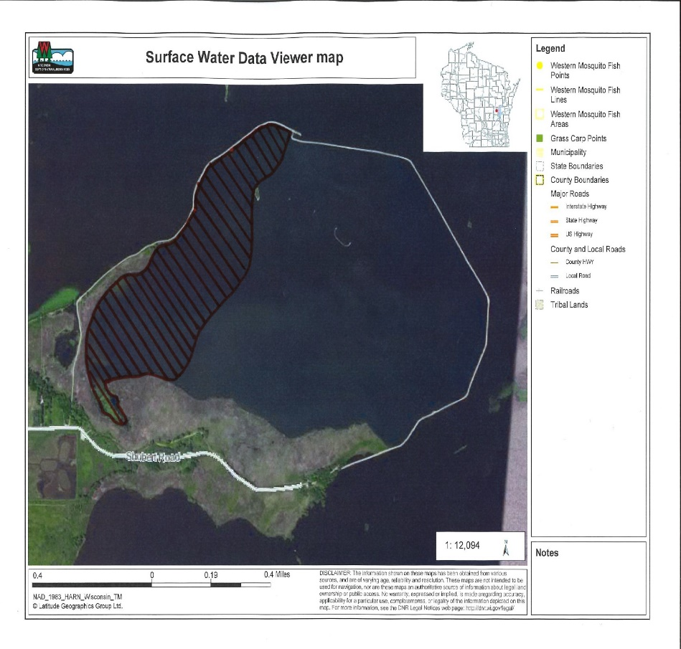
Data collected during the 2016 project shows that the water quality within Terrell’s Island is worse than the water quality of Lake Butte des Morts proper. This is consistent with the data collected in 2014 showing similar trends (Appendix A). Terrell’s Island is basically a lake within a lake that has limited hydraulic flushing and is hyper-eutrophic. The existing internal load of nutrients is further exacerbated by carp perturbation and abundant bird feces. A carp gate was installed on the only entrance to Terrell’s Island in 1998 but has only recently been thought to be functioning properly. Carp surveys were conducted by Wisconsin DNR fishery staff in the late fall of 2015 and very few carp were found. This is likely due to the carp gate being purposefully left open in the early Fall to encourage carp to leave the system. So while it is known that carp prefer to leave Terrell’s Island in the winter, it is unknown whether the carp barrier is functioning as designed to keep carp out of the system. Current plans are to close the gate in the early spring to see if carp can re-enter the system. The electro fishing survey were repeated in the summer of 2016 to determine how effective the carp barrier is and if repairs are needed.
A meander style plant survey was also conducted in 2015 by Wisconsin DNR staff. The survey showed that there are very few aquatic plants left in the system and only three species were found: Water Celery (Vallisneria americana), American Lotus (Nelumbo lutea) and White water lily (Nymphaea odorata).
Figure 7: Areas of plant growth within Terrell's Island
Management actions have also been taken to reduce the number of undesirable Pelicans and Cormorants using the system. Islands created within Terrell’s Island have been shaved down to deter these bird species from nesting and nesting Pelicans have had eggs oiled to deter them from using the site. Wildlife staff believes these actions have helped deter Pelicans and Cormorants from nesting within Terrell’s Island but these birds still use the site as a loafing area.
Some potential options for future management are as follows.
- Partner with the U.S. Army Corp of Engineers to study the system using their Wind-Wave Model. This would help determine the energy dynamics of the system which directly affects the re-suspension of lake bed sediment. It is possible that additional interior islands are needed to further break fetch and promote aquatic plant restoration.
- Conduct a hydraulic analysis to determine if more inter-flow of water is needed between Lake Butte des Morts and Terrell’s Island. Theoretically:
  - If the break wall that creates Terrell’s Island was breached in strategic locations, to allow some additional water interchange, it is likely that nutrient concentrations would be lowered. In addition, the water clarity of Lake Butte des Morts has been shown to be much clearer than that of Terrell’s Island. A combination of clear water interchange along with lowered nutrient levels in a shallow - low energy environment could result in the restoration of the aquatic plant community.

Appendix A
Date | Location | Temp. (°C) | D.O. (mg/L) | pH | Conductivity (us/cm) | D.O. (% Sat.) | Secchi Depth (ft)
05/27/2014 | Terrell's Island | 23.4 | 6.6 | 10.4 | 319 | 77.6 | 2.7
 | Lake Butte des Morts | 23.4 | 5.25 | 9.6 | 395 | 61.7 | 3.6
06/24/2014 | Terrell's Island | 23.8 | 6.66 | 7.94 | 336.1 | 79.3 | 1.75
 | Lake Butte des Morts | 26 | 6.5 | 7.67 | 399 | 80 | 3.75
07/22/2014 | Terrell's Island | 25 | 8.07 | 8.64 | 383.5 | 97.4 | 1
 | Lake Butte des Morts | 25.7 | 12.15 | 8.77 | 430.9 | 147.7 | 2.5
08/18/2014 | Terrell's Island | 22.4 | 9.1 | 8.64 | 374.5 | 105 | 1
 | Lake Butte des Morts | 23.5 | 10.35 | 8.72 | 383.1 | 121.8 | 1.92
05/31/2016 | Terrell’s Island | 23.2 | 9.36 | 8.45 | 359.7 | 109.1 | 1.8
 | Lake Butte des Morts | 23 | 8.24 | 8.62 | 369.7 | 96.1 | 3
 | Scotts Bay | 22.9 | 7.52 | 8.32 | 348.2 | 87.7 | 2.6
 | Fox River inlet | 23.6 | 6.06 | 8.29 | 358.7 | 71.5 | 3.4
07/18/2016 | Terrell’s Island | 25 | 7.85 | 8.84 | 375.7 | 95 | 1
 | Lake Butte des Morts | 24.4 | 10.72 | 9.05 | 353.6 | 127.1 | 2.5
 | Scotts Bay | 24.6 | 10.26 | 8.91 | 337.1 | 123.1 | 3
 | Fox River inlet | 25.7 | 10.11 | 8.75 | 378.9 | 124.2 | 1.9
08/16/2016 | Terrell’s Island | 26.5 | 4.8 | 8.75 | 395.1 | 59.9 | 1.1
 | Lake Butte des Morts | 26.6 | 9.8 | 9.18 | 364.7 | 122.1 | 2
 | Scotts Bay | 26.8 | 9.31 | 9.23 | 349.8 | 116.4 | 2.1
 | Fox River inlet | 27.3 | 9.48 | 9.06 | 385.1 | 115.6 | 1.8
09/19/2016 | Terrell’s Island | 20.8 | 6.95 | 9.23 | 338.2 | 77.7 | 0.8
 | Lake Butte des Morts | 20.8 | 7.64 | 9.12 | 337.4 | 85.5 | 1.8
 | Scotts Bay | 20.7 | 7.93 | 9.49 | 325.0 | 88.6 | 1.5
 | Fox River inlet | 21.2 | 7.10 | 9.05 | 360.9 | 80.0 | 1.5
Table 1: Water quality data collected during Terrell's Island Water Quality Assessment project

Date | Location | Total phos. (mg/L) | Chlorophyll A (ug/L) | Ammonia (mg/L) | TKN (mg/L) | NO3 + NO2 (mg/L)
05/27/2014 | Terrell's Island | 0.0856 | 23.5 | 0.0258 | 1.48 | ND
 | Lake Butte des Morts | 0.068 | 25.6 | 0.0495 | 1.18 | 0.17
06/24/2014 | Terrell's Island | 0.0794 | 15.3 | 0.209 | 1.47 | 0.134
 | Lake Butte des Morts | 0.0831 | 15.4 | 0.0455 | 1.2 | 0.172
07/22/2014 | Terrell's Island | 0.156 | 77.3 | ND | 2.02 | ND
 | Lake Butte des Morts | 0.0999 | 104 | ND | 1.79 | 0.234
08/18/2014 | Terrell's Island | 0.196 | 86.3 | 0.0259 | 2.54 | 0.0277
 | Lake Butte des Morts | 0.0961 | 67.1 | ND | 1.61 | 0.475
05/31/2016 | Terrell’s Island | 0.117 |  |  |  | N/A
 | Lake Butte des Morts | 0.0754 |  |  |  | N/A
 | Scotts Bay | 0.0986 |  |  |  | N/A
 | Fox River inlet | 0.083 |  |  |  | N/A
07/18/2016 | Terrell’s Island | 0.14 | 68.6 | 0.0201 | 1.56 | N/A
 | Lake Butte des Morts | 0.0874 | 69.8 | 0.0161 | 1.56 | N/A
 | Scotts Bay | 0.0533 | 38.5 | 0.0153 | 1.46 | N/A
 | Fox River inlet | 0.0907 | 59.8 | 0.0208 | 1.55 | N/A
08/16/2016 | Terrell’s Island | 0.0986 | 39.5 | 0.328 | 2.14 | N/A
 | Lake Butte des Morts | 0.0382 | 55.1 | 0.0198 | 1.42 | N/A
 | Scotts Bay | 0.0573 | 38.4 | 0.0195 | 1.07 | N/A
 | Fox River inlet | 0.0456 | 75.4 | 0.0222 | 1.55 | N/A
09/19/2016 | Terrell’s Island | 0.167 | 99.1 | 0.0407 | 2.12 | N/A
 | Lake Butte des Morts | 0.107 | 48.8 | 0.0209 | 1.48 | N/A
 | Scotts Bay | 0.0978 | 49.5 | 0.0168 | 1.34 | N/A
 | Fox River inlet | 0.112 | 48.8 | 0.0251 | 1.45 | N/A
Table 2: Water quality data analyzed by SLOH during Terrell's Island Water Quality Assessment project

