CREX MEADOWS WILDLIFE AREA WATER QUALITY CONCERNS

Introduction

Crex Meadows Wildlife Area encompasses more than 30,000 acres of brush prairie, wetland, and forest in Burnett County, Wisconsin, northeast of Grantsburg. Since 1945, the DNR has constructed more than 18 miles of dikes to form more than 15,000 acres of wetland wildlife habitat and about 5,000 acres of deep-water marshes. During fall migration Crex hosts thousands of sandhill cranes, geese, and ducks. It has a number of endangered and threatened species present. It receives more than 100,000 visitors each year.

Drainage from much of the area flows to the south via several tributaries to the North Fork Wood River and the Wood River. The Wood River drains to the St. Croix River which is a National Wild and Scenic River. Lake St. Croix is located downstream on the St. Croix River. A TMDL project is underway for the Lake St. Croix watershed. Wisconsin and Minnesota are working cooperatively on the project with a goal of improving water quality in Lake St. Croix and the St. Croix River, and especially reducing phosphorus loading.

The DNR and the Burnett County Land and Water Conservation Dept. have received complaints about the water quality in the Wood River and its tributaries downstream of Crex Meadows. Frequently turbid water due to an abundance of iron floc (iron hydroxide) is the reason for the complaints. Figure 1, below shows a turbidity plume at the mouth of the Wood River and extending far downstream into the St. Croix River.

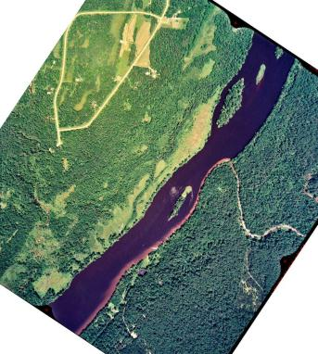

Fig. 1. Turbidity plume in St. Croix River below Wood River mouth in summer 1995.
1990 USGS Report Data

USGS produced a groundwater report for the Crex Meadows area in 1990 (Water-Resources Investigations Report 89-4129). The impetus for the study was concern over basement flooding and the suspicion that Crex Meadows impoundments were elevating water table levels. The report concluded that natural water table fluctuations were responsible. The study also tested 20 monitoring wells for dissolved iron concentrations. A modified water table map from the report is shown in figure 2. There is a water table divide in the Crex Meadows area, with groundwater north of the divide flowing to the north and northwest. South of the divide, groundwater flows to the south and southwest.

Figure 3 shows the distribution of iron concentrations in the monitoring wells. Along with the iron concentrations, each well is identified as being upgradient of impoundments (U), downgradient of impoundments (D), or uncertain gradient status (N). Red-colored well locations had iron concentrations greater than 2 mg/l. Six of the seven wells with iron concentrations greater than 2 mg/l are located downstream of impoundments. The seventh well has been identified as having uncertain gradient status, but may quite possibly also be downgradient of impoundments. Wells downgradient of impoundments have iron concentrations as high as 45 mg/l. All of the upgradient wells have iron concentrations less than 2 mg/l (green-colored well locations).

The average iron concentration of the downgradient wells is 14 mg/l, which is 18 times higher than the average iron concentration of the upgradient wells, 0.8 mg/l (table 1). The average depth of upgradient wells (20.8 ft) is very similar to that for downgradient wells (19.0 ft). There is no significant correlation between well depth and iron concentration (table 2).

Iron Behavior and Mobility

The USGS data suggests that the impoundments (a.k.a. flowages) are causing increased groundwater iron concentrations. The Crex Meadows area is located in an area that was once Glacial Lake Grantsburg. Naturally occurring deposits of iron are present in the soils. Construction of flowages probably results in increased iron mobility. Water levels in the flowages are periodically fluctuated to enhance the growth of emergent and other aquatic vegetation for wildlife, and this may also contribute to increased iron mobility.

Iron in soil or water in the presence of oxygen will usually be present in an oxidized form. Oxidized iron is relatively immobile. It will adhere to soil and will settle out of standing water. When oxygen is removed, iron will convert to its reduced form, which is highly soluble and mobile, and will be released from soil. It can move readily with groundwater.

When soils upgradient of a flowage are inundated, oxygen in the soil is soon consumed by decomposing organic matter, especially in wetland areas where dissolved organic matter is abundant. The iron present in the soils will become reduced and partially migrate into the flowage. In the flowage, the iron will become oxidized and settle to the bottom. In winter, under ice cover, shallow wetland flowages will become anoxic (devoid of oxygen), which will again cause the iron to become reduced and soluble. It can then be freely carried to downgradient groundwater via groundwater discharge from the flowage.

The water level in a flowage will also raise the water table in the soils side-gradient and down gradient of the flowage. This will also cause oxygen loss in these soils and will be an additional source area for contributing iron to the groundwater.

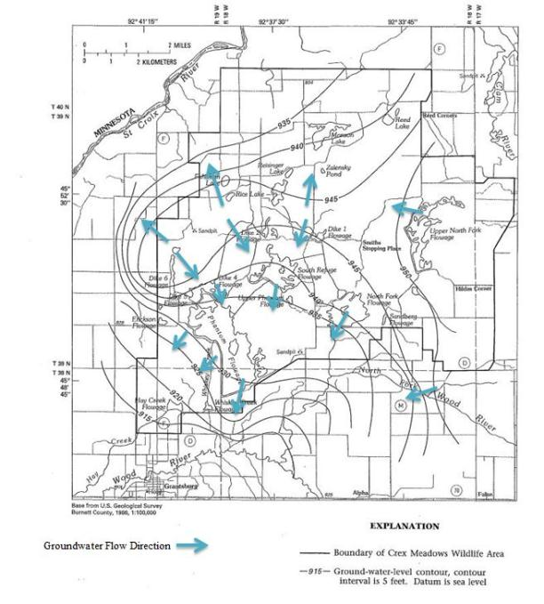

Figure 2. Water table contours and groundwater flow directions in the Crex Meadows area
(base map and contours from USGS,1990).

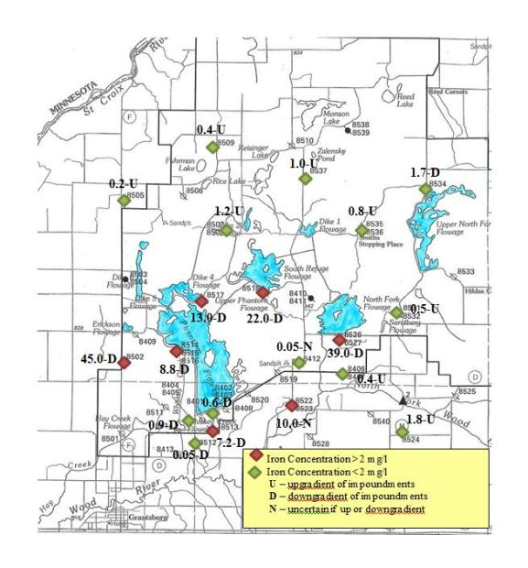

Figure 3. Dissolved iron concentrations in monitoring wells in Crex Meadows area
(base map and iron concentration data from USGS, 1990; “upgradient” wells include all area wells that are not downgradient of impoundments).

TABLE 1
CREX MEADOWS WELL DEPTHS, DISSOLVED IRON CONCENTRATIONS, AND STATISTICS
WELLS UPGRADIENT OF FLOWAGES* |  |  |  | WELLS DOWNGRADIENT OF FLOWAGES
WELL # | DEPTH (FT) | FE CONC (UG/L) |  | WELL # | DEPTH (FT) | FE CONC (UG/L)
8505 | 12 | 220 |  | 8502 | 12 | 45,000
8509 | 12 | 360 |  | 8514 | 54 | 8,800
8537 | 12 | 990 |  | 8517 | 12 | 13,000
8507 | 12 | 1,200 |  | 8518 | 16 | 22,000
8535 | 23 | 770 |  | 8526 | 20 | 39,000
8531 | 57 | 470 |  | 8513 | 18 | 7,200
8406 | 20 | 390 |  | 8512 | 18 | 46
8524 | 18 | 1,800 |  | 8404 | 11 | 940
 |  |  |  | 8402 | 12 | 638
 |  |  |  | 8534 | 12 | 1,700
MEAN = | 20.8 | 775 |  |  | 19 | 13,832
STD DEV = |  | 500 |  |  |  | 15553
90% C.I. = |  | 335 |  |  |  | 9016
*All wells not downgradient, are considered upgradient
WELLS WITH UNCERTAIN GRADIENT STATUS
WELL # | DEPTH (FT) | FE CONC (UG/L)
8412 | 15 | 45
8522 | 35 | 10,000

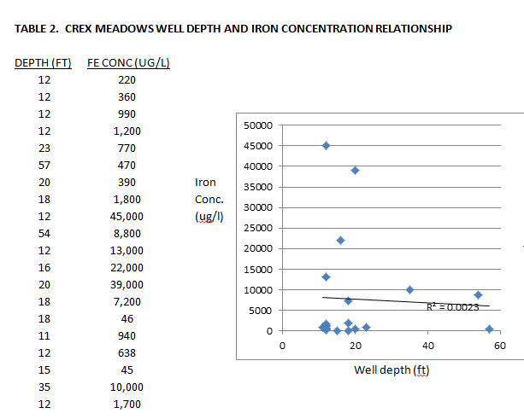

Iron-rich groundwater downgradient of the flowages discharges to streams. Once the iron enters a stream, it is again exposed to oxygen and will form iron floc. Some of the floc will temporarily adhere to stream bottom surfaces and some will become suspended and cause turbidity until it has a chance to settle out.

Iron bacteria can also be involved in the process of iron oxidation and can produce large deposits of iron floc and bacterial slime. These deposits as well as simple iron floc deposits can be scoured during increased stream flows, and then contribute to turbidity. Iron floc formed in the flowages when ice cover is absent may also be released during drawdowns and become a significant source of stream turbidity downstream of Crex Meadows.

Transparency Surveys

Transparency surveys were conducted downstream of the Crex Meadows area on July 15th and September 5th, 2013 (figures 4 and 5). A 120 cm (47 in) transparency tube was used. Transparency tube measurements are very similar to Secchi disk measurements. Both dates were preceded by extended periods of dry weather, so surface runoff was insignificant. The magnitude and timing of flowage water releases were unknown.

On July 15th, the upstream sites on the Wood River at highway 70 (figure 6) and the North Fork Wood River at CTH D were clear, with transparencies greater than 120 cm. The three tributaries
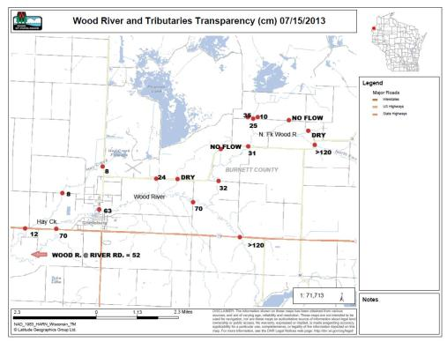

Figure 4. July 15th 2013 transparency survey

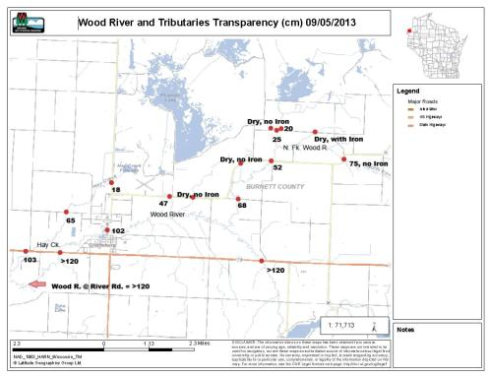

Figure 5. September 5th 2013 transparency survey
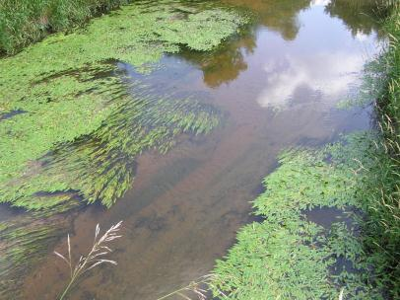

Figure 6. Wood River at Hwy. 70 upstream of Crex Meadows, 7/15/13
Transparency > 120 cm

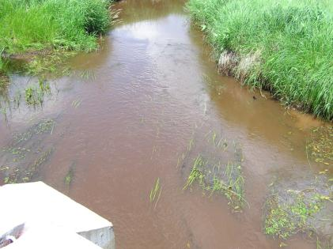

Figure 7. Unnamed tributary to N. Fk. Wood River at Lundquist Rd., 7/15/13
Transparency = 35 cm

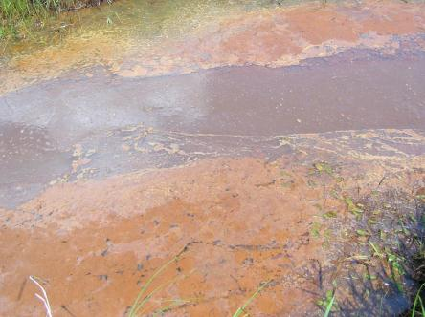

Figure 8. West ditch draining to unnamed tributary in fig. 7, 7/15/13
Transparency = 10 cm

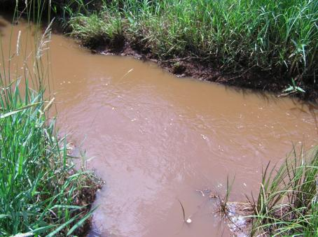

Figure 9. Hay Creek headwater ditch along CTH F, 7/15/13
Transparency = 8 cm

receiving drainage from the flowages had low transparencies, ranging from 8 cm in the Hay Creek headwaters (figure 9) to 25 cm in the unnamed tributary at Lundquist Rd. (figure 7).

Transparencies in the Wood River and the North Fork Wood River declined downstream of these tributaries. North Fork Wood River transparency dropped to 31 cm at CTH D. Wood River transparency dropped to 52 cm at River Rd., about 4 miles southwest of Grantsburg, and 1 mile upstream of the St. Croix River. Stream discharges below the flowages are affecting the transparency of the Wood and North Fork Wood Rivers.

On September 5th the upstream site on the Wood River at highway 70 was again clear, with a transparency greater than 120 cm. The North Fork Wood River at the upstream CTH D site was fairly clear, with a transparency of 75 cm. The reduced transparency at this site may have been due to upstream cattle access. Iron turbidity was not present. Water releases from the flowages were presumably less on this date. The three tributaries receiving drainage from the flowages had somewhat higher transparencies. Transparencies ranged from 18 cm in the Hay Creek headwaters to 47 cm in Whiskey Creek at CTH D. Transparency in the North Fork Wood River was lowered to 52 cm at CTH D. Transparency in the Wood River was lowered to 102 cm at CTH D in Grantsburg. However, transparency in the Wood River returned to greater than 120 cm at both the lower highway 70 site and the River Rd. site.

Phosphorus concerns

The reduction-oxidation cycling of iron can also influence the movement of phosphorus. Phosphorus is commonly bound to oxidized iron. When oxidized iron is reduced, both the iron and the attached phosphorus become soluble and mobile. Also, when oxidized iron (floc) is being transported, the attached phosphorus will also be transported. One water sample was collected from the Hay Creek headwaters ditch along CTH F when iron floc turbidity was high. It had a total phosphorus concentration of 163 ug/l. Wisconsin’s stream water quality standard for total phosphorus is 75 ug/l.

Biological impacts

Besides the obvious aesthetic impairment caused by iron floc and the potential for phosphorus transport, iron floc turbidity and deposition may potentially cause a variety of biological impairments.
Iron floc turbidity may potentially cause:
- Reduced success and survival of sight feeding fish, including many game fish
- Reduced rough fish control by sight feeding fish
- Reduced success and survival of fish feeding birds and mammals
- Reduced aquatic plant growth and resultant loss of fish and macroinvertebrate habitat
- Reduced growth of attached diatoms and other algae films resulting in a lost food base
Iron floc deposits on stream bottoms may potentially cause:
- Loss of suitable coarse spawning substrate needed by many fish species
- Reduction and impairment of macroinvertebrate communities due to blanketing of coarse substrates by iron. This also results in a reduced food base for fish.

Crex Meadows Water Quality Monitoring Project for 2014

To address water quality concerns at Crex Meadows, a monitoring project will be conducted in 2014. The project has several objectives:
- Establish a baseline for the current water quality of streams draining the Crex Meadows
area.
- Document the distribution of iron in area soils, and the mobilization and transport of iron in the area.
- Document the biological communities (fish and macroinvertebrates) that are present in area streams.
- Identify and explore management options that could reduce the transport of iron to downstream waters.

Streams draining Crex Meadows

There are three main discharge points where water leaves Crex Meadows and is carried to downstream rivers (Wood and North Fork Wood Rivers). They are – the Hay Creek headwater ditch, Whiskey Creek, and the unnamed stream south of the North Fork Flowage. Monitoring of these three sites will establish baseline conditions, so benefits of any future practices can be measured. These sites will be monitored for the lab parameters - iron, suspended solids, turbidity, total phosphorus, and color. Field parameters to be measured include – transparency, flow, dissolved oxygen, temperature, pH, and conductivity. It is likely that correlations between transparency and iron, suspended solids, turbidity, and total phosphorus will be established, so any future monitoring could rely heavily on transparency measurements alone.

Soil testing

Soil samples will be collected and tested to determine the areal and vertical distribution of iron in the area. Thirty samples will be tested for %sand, silt, and clay, total organic carbon, bulk density, iron, phosphorus, potassium, calcium, magnesium, sulfur, zinc, manganese, boron, copper, sodium, and aluminum.

Flowage sediment

Eight samples of flowage sediment will be collected in late summer and tested for % sand, silt, and clay, % solids, % volatile solids, iron, and total phosphorus. Observations of thickness and distribution of iron floc dominated sediment will also be made.

Flowage water samples

Sixteen flowage water samples will be collected and tested for total phosphorus and iron. Eight of the samples will be collected under the ice in late winter.

Miscellaneous stream samples

Twenty-five additional stream samples will be collected and tested for total phosphorus and iron. These will be from a variety of sites which might represent local background conditions, or are upstream of flowages.

Fish surveys and macroinvertebrate samples

Fish surveys will be conducted on 13-20 stream segments. Surveys will be done using electro-shocking gear. All species captured will be counted and identified.

Macroinvertebrate samples will be collected from riffles using a kick net at 13 sites. Samples will be submitted to the UW- Stevens Point macroinvertebrate lab for identifications.
Fish survey and macroinvertebrate sampling sites will be selected to represent a range of iron floc turbidity influence.

Report

Late winter flowage sampling in February of March of 2015 is the last planned field work. A project report will be completed by spring of 2015.

