**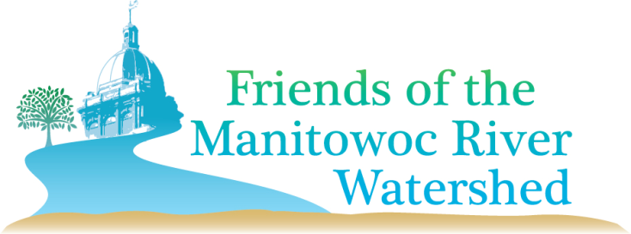*Please Support our Work!***

***Who We Are*:** The Friends of the Manitowoc Watershed (FMRW) is a group of volunteers working to raise awareness about the water quality issues impacting both the Manitowoc River and the land draining into it. We are committed to connecting people to the Manitowoc River in order to increase appreciation, awareness and use of the river through our fun events and educational seminars.

***Mission Statement*:** To provide a unified voice to enhance the Manitowoc River and its watershed.

***Accomplishments***

* 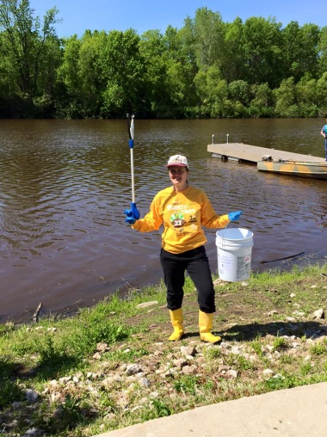Annual spring and fall **Lake** **Michigan beach clean-ups**. At each event, over 100 volunteers work to remove debris from 8-10 beaches in Manitowoc.
* Annual spring **Manitowoc River clean-up**. Volunteers walk the banks and paddle kayaks and canoes to remove debris along the river.
* **Adopted Lower Schuette Park**. At least once a month, we report conditions at the park to the City of Manitowoc’s Adopt-a-Park Program.
* To increase access to both kayaking and the river, we teamed with the City of Manitowoc to raise money for an Americans with Disabilities Act **(ADA) compliant kayak/canoe launch at Lower Schuette Park**, installed in Fall 2015. **We need additional funds for the approach and a kayak/canoe rack!**
* Obtained grant funding to create **four Manitowoc River Guides** in partnership with the Wisconsin Maritime Museum. Covering topics from history to the watershed, these guides can be found at various locations in Manitowoc or can be downloaded from the FMRW webpage at [www.lnrp.org](http://www.lnrp.org). **We need additional support for printing!**
* Each year, a group of young adults attend the **Watershed Ambassadors Summer Camp**, sponsored by FMRW, Wisconsin Maritime Museum, and UW Sea Grant. This camp provides a hands-on educational experience in matters surrounding the Manitowoc River Watershed. **We need your help to update our curriculum!**

**Program of LNRP Logo.tiff**

**LNRP Liaisons:** Board Member Amy Fettes acts as liaison to co-chairs Kim Kettner and Wendy Lutzke (Wisconsin Maritime Museum).

**LNRP Staff Support:** Executive Director, Regional Outreach Coordinator, and Community Relations Coordinator assist with strategic planning and outreach.

**Financial Support:** DNR River Planning Grant, Great Lakes Protection Fund, and Individual Donations.

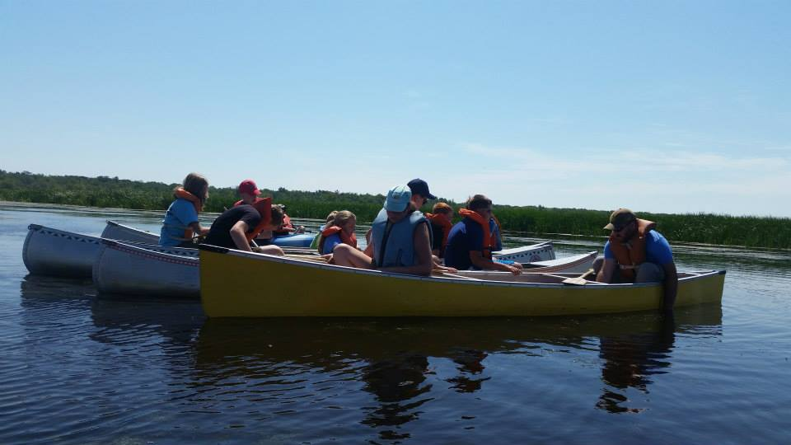

**FMRW Steering Committee**

Currently, our committee is drafting goals to further develop group structure and leadership in 2015/2016, fundraising, and educational and advocacy opportunities. Wendy Lutzke, Kim Kettner, and Amy Fettes currently serve on the Committee.

**Volunteer and Participate**

New FMRW volunteers are always welcome! We offer something for everyone from volunteering for a few hours a year to participating on a regular basis. We will be developing a volunteer interest form and database. If you would like to get involved in any way, please email [fmrwinfo@gmail.com](javascript:smae_decode('aHR0cDovL2ZtcndpbmZvQGdtYWlsLmNvbQ==');).

**Website and Facebook**

Check out the website at www.lnrp.org and follow us on Facebook.

***Thank you for your donation to support the FRIENDS OF THE MANITOWOC RIVER WATERSHED!***

***Mail this form with your check payable to LNRP to PO Box 358, Cleveland, WI 53015. PLEASE PRINT. Or pay by credit card, go to*** [***www.lnrp.org***](http://www.lnrp.org) ***and donate through PayPal (Please mention FMRW in the “Special Instructions to Seller”.)***

Name:_____________________________________________________________________________________________

Address:__________________________________________________________________________________________

City:__________________________________________State:__________________Zip:________________________

Phone: (include area code)______________________________________________________________________

EMAIL: ___________________________________________________________________________________________

(NECESSARY FOR NEWSLETTER & ANNOUNCEMENTS)

*Lakeshore Natural Resource Partnership*

*Cultivating Community & Stewardship from the Ledge to the Lakeshore*

*LNRP, Inc. is a* 501(c)3 *tax-exempt organization*