***Please Support our Work***

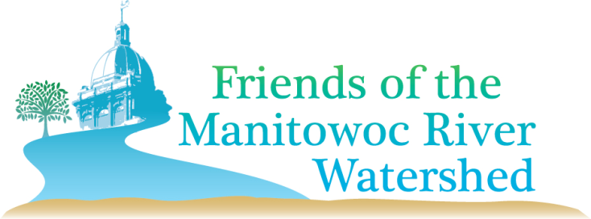**Program of LNRP Logo.tiff*Who We Are*:** The Friends of the Manitowoc Watershed (FMRW) is a group of volunteers working to raise awareness about the water quality issues impacting both the Manitowoc River and the land draining into it. Our mission is to provide a unified voice to enhance the Manitowoc River and its watershed.

**Staff Support:** The Lakeshore Natural Resource

Partnership provides staff support to assist with capacity

building, strategic planning, and outreach.

Go to www.lnrp.org/friends-of-the-manitowoc-river-watershed/

or follow us on Facebook.

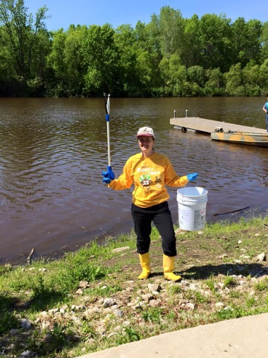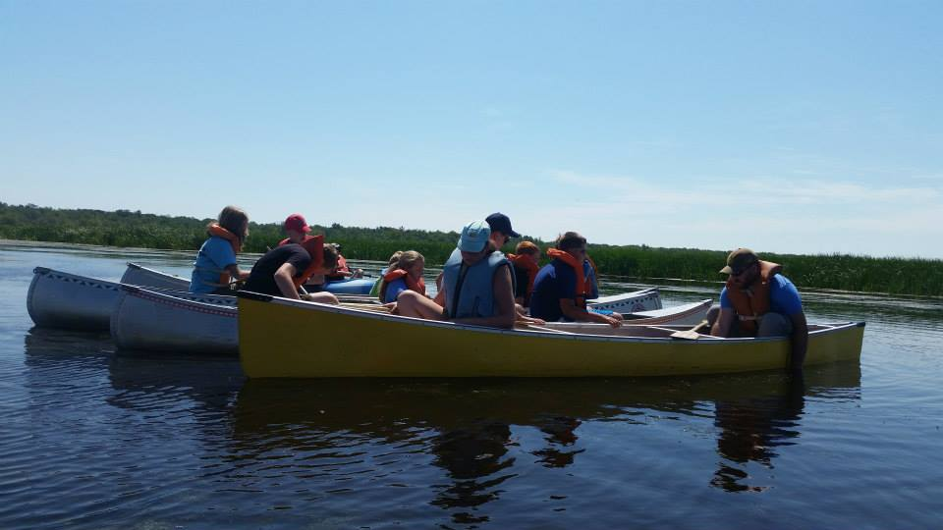

***Thank you for supporting the FRIENDS OF THE MANITOWOC RIVER WATERSHED***

***Mail this form with your check payable to LNRP to PO Box 358, Cleveland, WI 53015. PLEASE PRINT. You can also pay online by going to www.lnrp.org and scroll over Support on the top menu. Choose "Support LNRP and Partners" to make your donation to Friends of the Manitowoc River Watershed. We greatly appreciate your support!***

Name:_____________________________________________________________________________________________

Address:__________________________________________________________________________________________

City:__________________________________________State:__________________Zip:________________________

Phone: (include area code)______________________________________________________________________

EMAIL: ___________________________________________________________________________________________

(NECESSARY FOR NEWSLETTER & ANNOUNCEMENTS

*Lakeshore Natural Resource Partnership*

*Cultivating Community & Stewardship from the Ledge to the Lakeshore*

*LNRP, Inc. is a* 501(c)3 *tax-exempt organization*