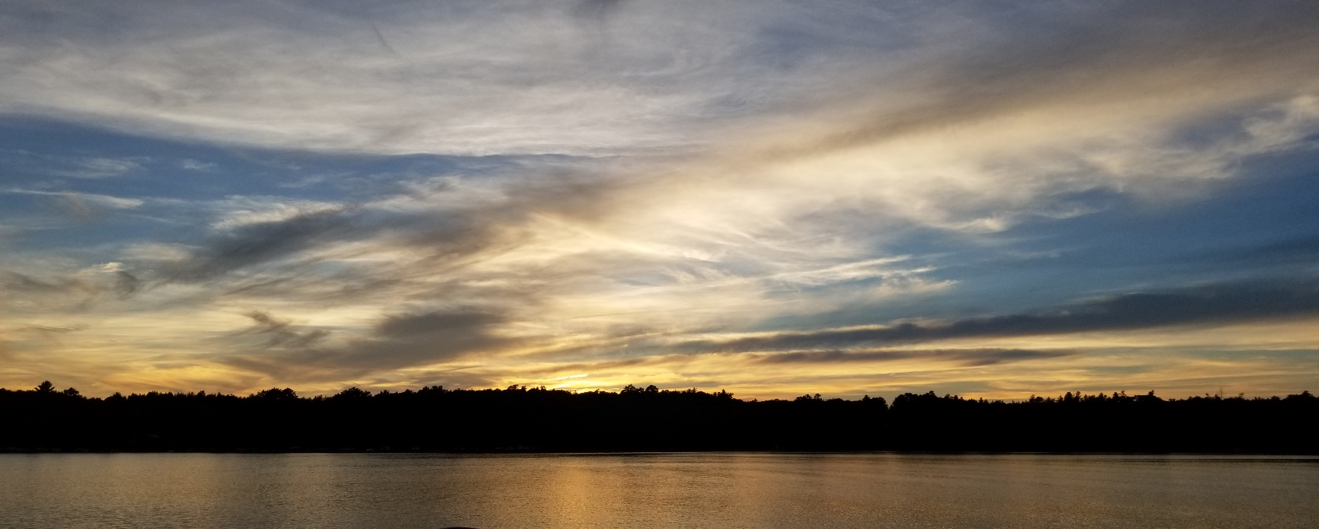
The Cranberry Lake and Flowage Association Newsletter, Spring 2019_v. 5
The Cranberry Lake and Flowage Association (CLFA) is committed to protecting our lake and your investments through the proactive management of Eurasian Water Milfoil and monitoring water quality in our lake.
In this Issue:
1) Welcome back to summer on the lake
2) Membership Update and Meeting Dates & Times
3) Eurasian Water Milfoil Removal Grant Information
4) Facebook

- Welcome back to summer on the lake.
The ice is out, the docks are going in. Can boating, swimming, fishing and fun be far behind? The association has been working hard this winter to enhance the quality of our lake. There is a new kiosk at the landing with information about loon nests, invasive species, and more. Be sure to take a look. Thanks to Rick Haugen for all his hard work in making the kiosk and to Rick H., Rick Maas and Dave Olson for getting it in place.
- Membership Updates and Meeting Dates & Times:
We now have 47 active members in the association. This number is down from past highs, but is higher than the last several years. Joining the association supports the efforts to protect our lake from further increases of invasive species and helps us raise money for EWM treatments, water quality testing, and upkeep of the information at the kiosk. Most importantly, it allows us better access to grants from the Wisconsin DNR as they look at association membership numbers when deciding which lakes get grant monies. Please join using the membership form that will soon be available on our facebook page or talk with one of the association members as they meet land-owners this spring and summer.
Meeting Dates & Times:
The association meets at the 4 Seasons Rec Club in Wascott (by the ballfields) on the third Saturday of the summer months (May through September). Our May meeting is from 8 a.m. to 9 a.m. The June and July meetings start at 9 a.m. and in August we have our annual meeting and picnic which starts at 11 a.m. The picnic will be held at the picnic shelter at the ball fields. The association provides the brats, buns, paper goods and cups. We ask that you bring a dish to share and your own beverages. More information will be available closer to the date of the picnic.

- Eurasian Water Milfoil Removal Grant Information
Management of Eurasian Water Milfoil (EWM) continues to be the priority for the CLFA. This effort is a collaborative effort between the CLFA, Steve Schieffer (lake aquatic specialist who generously volunteers his expertise in mapping the EWM) and the DNR. Using primarily DNR grant money, we have been treating the lake’s EWM invasive species for the past ten years with the chemical 2,4-D. We again treated in 2018 with the remainder of the 2016 DNR grant money.
This past winter an application to the DNR was successfully made to receive 15% of the 2016 grant; this $4119.88 will be used on an experimental May 2019 treatment using an alternative herbicide (diquat). A second application to the DNR was also successfully made to obtain an aquatic education prevention and planning (AEPP) grant. This $4388 grant will be used to fund Steve Schieffer to write an updated Cranberry Lake APMP (aquatic plant management plan) and PIS (point intercept survey) during the summer of 2019. With these current documents in hand we will again be able to apply next winter for new DNR AIS treatment grants.
- Facebook: Like us!
The association has created a facebook page where we all can share information about the lake, learn about the activities of the association, join the association, and see what is going on around the lake and flowage.
You can find this page by entering “Cranberry lake and flowage association” in the search bar on facebook.
Alternatively, the direct URL is: https://www.facebook.com/pg/Cranberry-Lake-and-flowage-association-1097263360449645/posts/?ref=page_internal
Ultimately, we’d like to use this page as a communication tool for all the property owners in and around Cranberry and the flowage. We’ll do our best to keep it updated with information not only about the association, but events and updates on the entire area.
PLEASE GO TO THE PAGE AND LIKE US AND FOLLOW US! Feel free to post pictures, comments or anything relevant to the page. This page is a learning experience for all of us. Our hope is that in time, this will be a valuable information resource for all property owners and friends.
Cranberry Lake & Flowage Association
Board Members:
President: Larry Carlson
cranbolson@gmail.com

Vice President: Stan Blom
cranbolson@gmail.com

Treasurer: Brad White
bwhite@nomadonline.com

Secretary: Marla Olson
cranbolson@gmail.com

Member at Large: Paul Seiferth
Plbtrmail@gmail.com

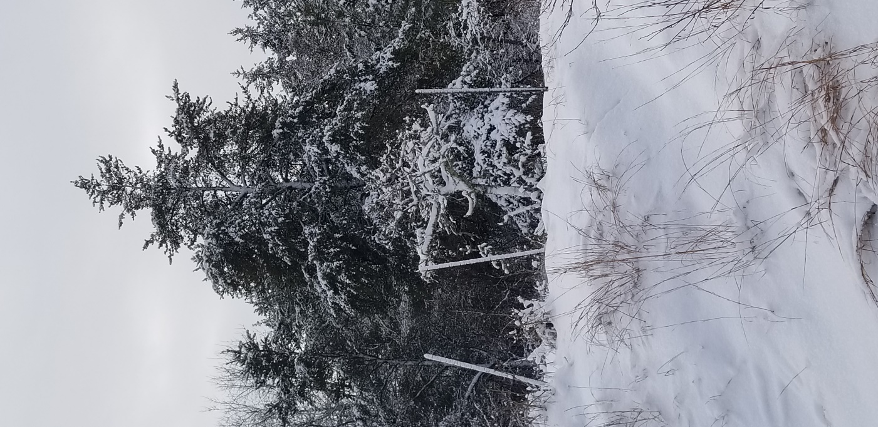

It was a beautiful winter at the lake, but we’re ready for spring!

