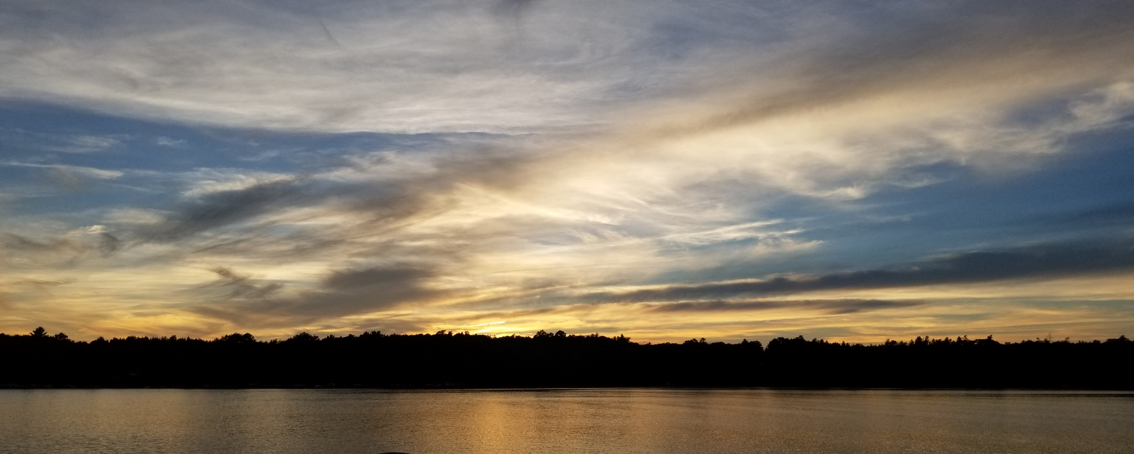

The Cranberry Lake and Flowage Association Newsletter, Spring 2020_v. 6

The Cranberry Lake and Flowage Association (CLFA) is committed to protecting our lake and your investments through the proactive management of Eurasian Water Milfoil and monitoring water quality in our lake.

**In this Issue:**

**1) Welcome to (an unusual) summer on the lake**

**2) Membership Updates and Meetings**

**3) Eurasian Water Milfoil Removal Information**

**4) Facebook**

**5) Support Our Local Restaurants/Businesses  
  
6) Thank you:**

1. **Welcome to what might be an unusual summer on the lake.**Yes, the ice is out and some docks are going in, but will the return of people happen as usual this summer? It’s hard to tell with stay-at-home orders/suggestions in place for many states. We can tell you that there’s no more toilet paper here than there is at your local store (so if/when you come up, be sure to bring a good supply). With fewer people on the shores there have been more bird sighting than usual – Hooded Mergansers and Wood Ducks are nesting here; the Loons are back; and the eagles are building a new nest on the lake. It’s a calmer spring but it is lovely while a bit lonesome. We look forward to see what the summer brings to all of us.  
   **OR: Skipping the stay at home wording:**The ice is out and the docks are slowly goin in as some of the lake residents return to their cabins. We’ve had more bird sighting than usual this year – Hooded Mergansers and Wood Ducks are nesting here; the Loons are back; and the eagles are building a new nest on the lake.
2. **Membership Updates and Meetings:**

We have over 60 active members in the association. Thanks to all who have joined and who have encouraged their neighbors to join. Our current Membership Application can be found at the end of this newsletter as well as on our facebook site.   
Joining the association supports the efforts to protect our lake from further increases of invasive species and helps us raise money for EWM treatments, water quality testing, and upkeep of the information at the kiosk. Most importantly, it allows us better access to grants from the Wisconsin DNR as they look at association membership numbers when deciding which lakes get grant monies. If you have questions about membership, please contact someone on the board, talk to your neighbors who are members or check out the facebook site. talk with one of the association members as they meet land-owners this spring and summer.

**Meeting Dates**The association will continue to meet at 9 a.m. on the third Saturday of the summer months (May through September) but, as with many things these days, they will be held remotely. When the Wisconsin Safer-At-Home order is rescinded we may be able to return to our regular meeting place, the 4 Seasons Rec Club. We will keep you informed about our August annual meeting and picnic which traditionally has started at 11 a.m. at the Wascott ball fields. More information will be available closer to the date of the picnic.

1. **Eurasian Water Milfoil Removal Grant Information**   
   We had good success in our management of Eurasian Water Milfoil (EWM) this past year. Due to the low level of EWM at this point, the CLFA will not be treating for it this year but will continue to monitor its presence in the lake
2. **Facebook: Like us!**  
   The association has created a facebook page where we all can share information about the lake, learn about the activities of the association, join the association, and see what is going on around the lake and flowage.

You can find this page by entering “Cranberry lake and flowage association” in the search bar on facebook.

Alternatively, the direct URL is: <https://www.facebook.com/pg/Cranberry-Lake-and-flowage-association-1097263360449645/posts/?ref=page_internal>

 Ultimately, we’d like to use this page as a communication tool for all the property owners in and around Cranberry and the flowage.  We’ll do our best to keep it updated with information not only about the association, but events and updates on the entire area.

PLEASE GO TO THE PAGE AND LIKE US AND FOLLOW US! Feel free to post pictures, comments or anything relevant to the page. This page is a learning experience for all of us. Our hope is that in time, this will be a valuable information resource for all property owners and friends.

1. **Support Our Local Restaurants/Businesses**Many of our local restaurants are open for take out meals. Please contact them for hours and menu items. The food is still delicious and all of the restaurants are making it as easy as possible to order from them. Thanks!
2. **Thank you:**

To Jeff Blom for his work with Xcel Energy for which we received through which we received a matching fund grant and a monthly stipend.

To Brad White for his work in developing a membership format and for the printing of the 2019 membership plaques.

**Cranberry Lake & Flowage Association  
Board Members:**

Vice President: Stan Blom

[cranbolson@gmail.com](mailto:cranbolson@gmail.com)

Treasurer: Brad White

[bwhite@nomadonline.com](mailto:bwhite@nomadonline.com)

Secretary: Marla Olson

[cranbolson@gmail.com](mailto:cranbolson@gmail.com)

Member at Large: Paul Seiferth

[Plbtrmail@gmail.com](mailto:Plbtrmail@gmail.com)

Past President: Larry Carlson  
[cranbolson@gmail.com](mailto:cranbolson@gmail.com)