**LNRP Newsletter: Spring 2015**

**Rain Garden and Rain Barrel Seminar**

Friends of the Manitowoc River Watershed hosted a free seminar, Wednesday, April 8, at the Wisconsin Maritime Museum to share aesthetic, cost effective ways to slow storm water runoff down with rain barrels and rain gardens.

Jessica Schultz, director of the Fox-Wolf Watershed Alliance in Appleton, provided participants all the information they need to create their own rain gardens to help keep our creeks, streams and rivers cleaner. Using rain ba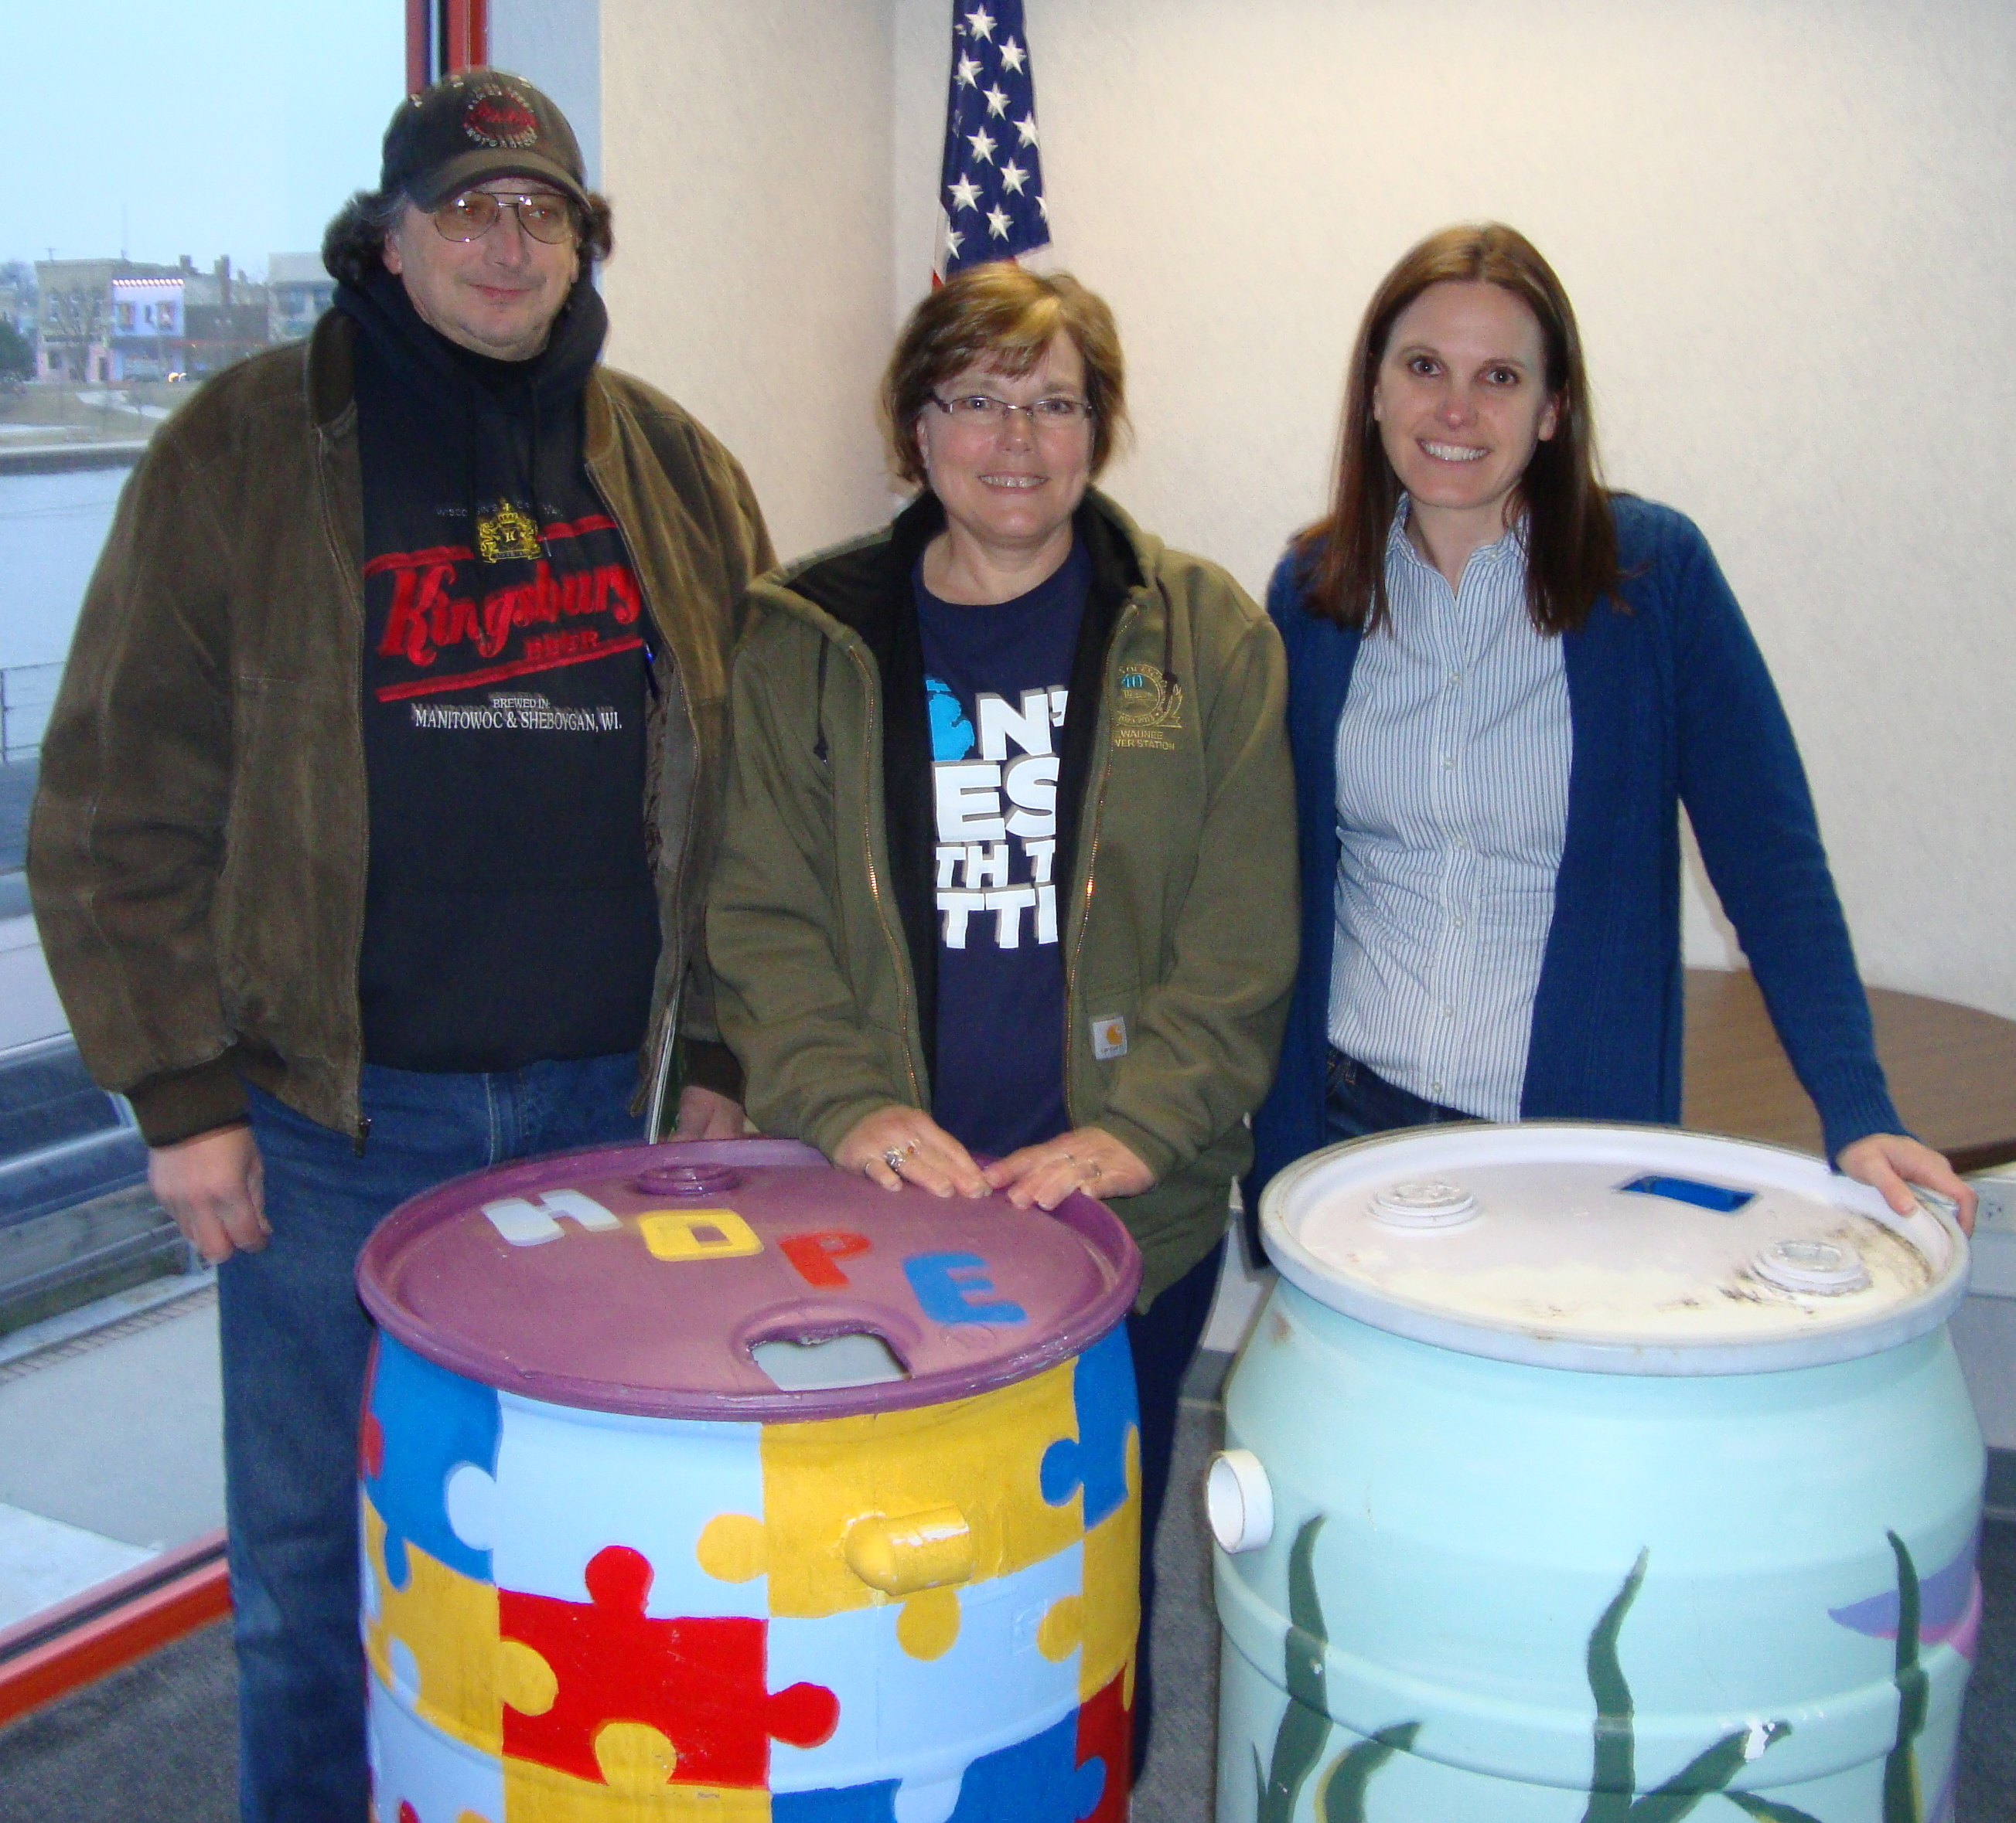rrels to catch and store rainfall, residents can access free water for their gardens and again help reduce pollution from runoff impacting our region’s waterways and ultimately Lake Michigan.

Participants had the opportunity to win two hand-painted rain barrels at the end of the presentation. The volunteer Friend group has hosted educational seminars, beach and river clean-ups and experiential events for Manitowoc County since first forming in 2013 to inspire appreciation of Lake Michigan and the Manitowoc River. The seminar series is funded by a Wisconsin DNR grant and supported by the Lakeshore Natural Resource Partnership.

***Presenter Jessica Schultz (far right) and the two rain barrel winners!***