**LNRP Newsletter: Spring 2015**

**Lower Schuette Park Kayak and Canoe Launch**

The Friends of the Manitowoc River Watershed (FMRW) adopted Lower Schuette Park, in January 2014. The group envisions adding a grill to the shelter area, identifying and removing invasive species, and helping with overall park upkeep including picking up trash and planting additional native species.

The mission of FMRW is to connect people to the Manitowoc River to increase awareness, appreciation and use of the river. To help accomplish that mission, the group developed a plan to increase river access by creating a kayak/canoe launch at Lower Schuette Park. Working with the City of Manitowoc, a successful grant application was submitted to the DNR’s Stewardship Local Assistance Program. Additional funds were provided through the LNRP Stewardship Investment Fund with in-kind services provided by City staff and FMRW volunteers.

A launch will help reduce congestion at the heavily used Manitou Park boat launch, which in turn would reduce the risk of potential conflict between kayak/canoe paddlers and anglers. Also, the kayak launch will provide another access point to the river for both recreation and wellness.

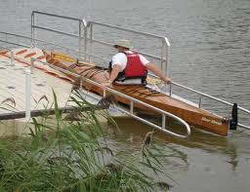So the launch is accessible to a wide range of people, we are installing the EZ Launch – Kayak and Canoe Station that can be made handicap accessible. This type of launch also makes entering and exiting the kayak/canoe easier for seniors and children with a stable platform to hold the kayak, guide rails to stabilize the vessel, and launch rollers that move the kayak easily into and out of the water. The EZ Launch is also a floating platform, allowing it to adjust to changing water levels and be easily removed in the fall to avoid ice damage.

Partner groups who would support the kayak/canoe launch and enhanced river access include the Manitowoc/Two Rivers YMCA, the Manitowoc Marina, Wisconsin Maritime Museum, Friends of the Ice Age Trail, and the Two Rivers Paddling Club.