Scott Walker, Governor
Dan Meyer, Secretary
Telephone 608-266-2621
Toll Free 1-888-936-7463
TTY Access via relay - 711

State of Wisconsin
DEPARTMENT OF NATURAL RESOURCES
810 W. Maple Street
Spooner, WI 54801

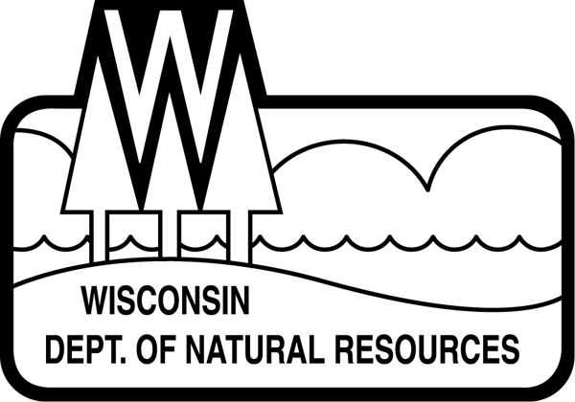
November 2, 2017

Roland Peterson
Apple River Flowage P&R District
235 Craigbrook Way
Fridley, MN 55432

Subject: Apple River Flowage Aquatic Plant Management Plan (APM Plan) Approval Request

Dear Mr. Peterson,

Thank you for your efforts to understand, protect, and improve the Apple River Flowage! This letter is to notify you that the September 2017 APM Plan meets the criteria of Administrative Code NR 109 and thus, the DNR has approved the Plan. Approved management activities in the plan and outlined below are eligible for funding under Lake Management Planning, Lake Protection and Classification, and Aquatic Invasive Species grants subject to the application requirements of those programs.

Approved management recommendations include the following:
- AIS prevention activities including watercraft inspection and volunteer monitoring.
- Species-specific AIS monitoring and management, provided it meets DNR guidelines and approval specifications.
- Educational activities, including AIS workshops, signage, etc.

Please note: The Department reserves the right to inspect nuisance or navigation conditions prior to permitting aquatic plant management activities. Native aquatic plant management activities are not eligible for grant funding. Aquatic plant or algae control activities for the purposes of nuisance relief or navigation are not eligible for grant funding.

Thanks to you and the lake community for continuing to protect and improve the Apple River Flowage.

Sincerely,

Alex Smith
Lake Biologist

CC: Mark Sundeen, Aaron Cole, Mark Hazuga, Victoria Zeigler – WDNR
Cheryl Clemens – Harmony Environmental

