**Geneva Lake, Walworth County (WBIC 758300)**

**Herbicide Concentration Sample Plan, 2019**

**Wisconsin Department of Natural Resources**

Geneva Lake, Walworth County is 5401-acre spring lake with a maximum depth of 135 feet, and a mean depth of 61 feet. Copper (liquid or granular, TBD) and liquid endothall (Hydrothol formulation) is proposed to be applied in a ~0.6-acre enclosure using impermeable vertical barriers on a southern lagoon of the lake. This will be administered in the summer of 2019 to control starry stonewort (*Nitellopsis obtusa*). Herbicide concentration sampling will be conducted within the lagoon to monitor the herbicide concentrations in the hours to days following the application.

Water samples will need to be collected at the sites and depths listed below. Data are in decimal degrees and the datum is WGS84. Wisconsin Department of Natural Resources (DNR) will coordinate with the person(s) conducting the sampling to incorporate the sampling points onto a GPS. A map of the herbicide sample site locations is also included. Samples collected prior to June 21st will be shipped on June 20th overnight to the Wisconsin State Lab of Hygiene to be received by June 21st. Samples collected on and after June 21st will be held in a fridge and will be shipped depending on results.

|  |  |  |  |  |
| --- | --- | --- | --- | --- |
| Geneva Lake, Walworth County - Copper and Endothall Sample Sites | | | | |
| Latitude | Longitude | Site | Sample Depth | Sample Type |
| 42.55824 | -88.46346 | GL1 | Surface (Integrated) | Copper and Endothall surface |
| 42.55807 | -88.46328 | GL2 | Surface (Integrated) | Copper and Endothall surface |
| 42.55850 | -88.46313 | GL3 | Surface (Integrated) | Copper and Endothall surface |



Samples will need to be collected at different time intervals (Days After Treatment - DAT) or

(Hours After Treatment – HAT) for copper, endothall and a full herbicide panel throughout the project

**Treatment Area**

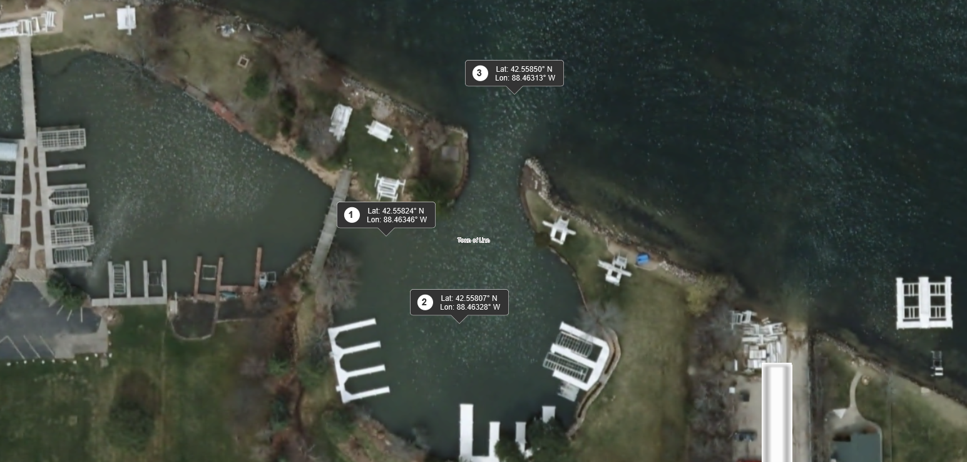

|  |  |  |  |  |
| --- | --- | --- | --- | --- |
| Geneva Lake, Walworth County - Copper and Endothall Sample Intervals | | | | |
|  | Copper | | Endothall | |
| Interval | Sample/interval | Total Samples | Samples/Interval | Total Samples |
| 1 HAT | 3 | 3 | 3 | 3 |
| 2 HAT | 3 | 6 | 3 | 6 |
| 3 HAT | 3 | 9 | 3 | 9 |
| 6 HAT | 3 | 12 | 3 | 12 |
| 24 HAT | 3 | 15 | 3 | 15 |
| 2 DAT | 3 | 18 | 3 | 18 |
| 3 DAT | 3 | 21 | 3 | 21 |
| 4 DAT | 3 | 24 | 3 | 24 |
| 6 DAT | 3 | 27 | 3 | 27 |
| 10 DAT | 3 | 30 | 3 | 30 |

Water samples should be collected using an integrated water sampler for all near-surface samples at sites GL1-GL3. Surface samples are collected by pushing the sampler straight down to an approximate depth of six feet; or in water shallower than six feet, down to approximately one foot above the bottom sediment. The sampler is brought to the surface and emptied into a secondary transfer bottle by pushing open the stop valve at the end of the integrated sampler. Give the transfer bottle a brief stir to mix the contents, and then empty the water from the transfer bottle into the appropriately labeled final sampling bottle. Once in the final sampling bottle, the water sample should be fixed with 3-4 drops of sulfuric acid (using an eye dropper).

Both the integrated sampler and the transfer bottle should be rinsed three times upon arriving at the next sampling location with water from that new sampling location. Samples should be collected at each point using a GPS at each interval listed above. If you cannot collect a sample at the interval listed above, please collect the sample as soon as reasonably possible and record the change. Sample bottles and labels will be provided. Please fill out a data sheet (included) for each sample interval and fill in the shaded boxes including:

Collector Name and Phone Number

Sample Interval, (1 HAT, 3 HAT, 1 DAT, 5 DAT, etc.)

Date (sample collected) Time (sample collected)

Water Temperature (at approximately 3-foot depth or at mid-depth in shallower water sites)

Wind Direction and Speed (i.e. 5 to 10 mph, W SW).

Store the preserved samples in a refrigerator within a dark, enclosed container. When all the sample intervals are completed, please ship the samples along with the data sheets from each sample interval to the SLOH on ice within the provided insulated shipping box.

If you have any questions, please call or email one of the contacts listed below.

|  |  |
| --- | --- |
| **Project specifics, logistics and sampling methods** | |
| Ted Peters (Preferred)  GLEA  [glea@genevaonline.com](mailto:glea@genevaonline.com)  262-245-4532 | Amy Kretlow  WDNR  [Amy.Kretlow@Wisconsin.gov](mailto:Amy.Kretlow@Wisconsin.gov)  262-574-2130 |
| **WDNR Support** | |
| Michelle Nault (DNR Contact)  [Michelle.Nault@wisconsin.gov](mailto:Maureen.Ferry@Wisconsin.gov)  608-513-4587 | Kyle Mosel  [Kyle.mosel@wisconsin.gov](mailto:Kyle.mosel@wisconsin.gov)  608-266-0502 |
| **Wisconsin State Lab of Hygiene** | |
| Kathleen Dax-Klister  [Kathleen.daxklister@slh.wisc.edu](mailto:Kathleen.daxklister@slh.wisc.edu)  Metals Analysis:  Kevin Kaufman  [Kevin.kaufman@slh.wisc.edu](mailto:Kevin.kaufman@slh.wisc.edu)  (608) 224-6282 | Robel Kebede  [robel.kebede@slh.wisc.edu](mailto:robel.kebede@slh.wisc.edu)  608-224-6271  Erin Mani  [Erin.mani@slh.wisc.edu](mailto:Erin.mani@slh.wisc.edu)  (608) 224-6271  Graham Anderson  [Graham.anderson@slh.wisc.edu](mailto:Graham.anderson@slh.wisc.edu)  (608) 224-6281 |

Residual Testing Schedule:

|  |  |  |  |
| --- | --- | --- | --- |
| Interval | Date | Time | Collector: |
| 1 HAT (Hour after treatment) | Tues. June 18, 2019 | 1:00pm | Ted Peters (GLEA) |
| 2HAT | Tues. June 18, 2019 | 2:00pm | Ted Peters (GLEA) |
| 3HAT | Tues. June 18, 2019 | 3:00pm | Ted Peters (GLEA) |
| 6HAT | Tues. June 18, 2019 | 6:00pm | Ted Peters (GLEA) |
| 24HAT (WQ038 for FY 20) | Wed. June 19, 2019 | 12:00pm | Ted Peters (GLEA) |
| 2 DAT (Day after treatment) | Thurs. June 20, 2019 | 12:00pm | Ted Peters (GLEA) |
| 3 DAT | Fri. June 21, 2019 | 12:00pm | Ted Peters (GLEA) |
| 4 DAT | Sat. June 22, 2019 | 12:00pm | Ted Peters (GLEA) |
| 6 DAT | Mon. June 24, 2019 | 12:00pm | Ted Peters (GLEA) |
| 10 DAT | Fri. June 28, 2019 | 12:00pm | Ted Peters (GLEA) |

|  |  |  |  |  |  |  |  |
| --- | --- | --- | --- | --- | --- | --- | --- |
| **Geneva Lake, Walworth County Herbicide Sampling Data Sheets, 2019** | | | | | | | |
|  |  |  | |  |  |  |  |
| Account number: WQ038 | | | | Sample Matrix: Surface water | | | |
| DNR User ID: KRETLA | | | | Project: Herbicide Concentration Monitoring | | | |
|  |  |  | |  |  |  |  |
| WBIC: 758300 | | | | Collector Name: Ted Peters for Amy Kretlow | | | |
|  |  |  | | Phone Number: (262-245-4532) 920-893-8552 | | | |
|  |  |  | |  |  |  |  |
| Test Requested: Copper and endothall per the plan description | | | | | | | |
|  |  |  | |  |  |  |  |
| Sample Interval: | | | | | | | |
| Site | Station ID |  | Sample Depth | Date | Time | Water Temp in F | Wind Direction and Speed |
| GL1 | 10052574 | Copper Surface |  |  |  |  |  |
|  | 10052574 | Endothall Surface |  |  |  |  |  |
| GL2 | 10052576 | Copper Surface |  |  |  |  |  |
|  | 10052576 | Endothall Surface |  |  |  |  |  |
| GL3 | 10048422 | Copper Surface |  |  |  |  |  |
|  | 10048422 | Endothall Surface |  |  |  |  |  |

|  |  |  |  |  |  |  |  |
| --- | --- | --- | --- | --- | --- | --- | --- |
| **Geneva Lake, Walworth County Herbicide Sampling Data Sheets, 2019** | | | | | | | |
|  |  |  | |  |  |  |  |
| Account number: WQ038 | | | | Sample Matrix: Surface water | | | |
| DNR User ID: KRETLA | | | | Project: Herbicide Concentration Monitoring | | | |
|  |  |  | |  |  |  |  |
| WBIC: 758300 | | | | Collector Name: Ted Peters for Amy Kretlow | | | |
|  |  |  | | Phone Number: (262-245-4532) 920-893-8552 | | | |
|  |  |  | |  |  |  |  |
| Test Requested: Copper and endothall per the plan description | | | | | | | |
|  |  |  | |  |  |  |  |
| Sample Interval: | | | | | | | |
| Site | Station ID |  | Sample Depth | Date | Time | Water Temp in F | Wind Direction and Speed |
| GL1 | 10052574 | Copper Surface |  |  |  |  |  |
|  | 10052574 | Endothall Surface |  |  |  |  |  |
| GL2 | 10052576 | Copper Surface |  |  |  |  |  |
|  | 10052576 | Endothall Surface |  |  |  |  |  |
| GL3 | 10048422 | Copper Surface |  |  |  |  |  |
|  | 10048422 | Endothall Surface |  |  |  |  |  |

|  |  |  |  |  |  |  |  |
| --- | --- | --- | --- | --- | --- | --- | --- |
| **Geneva Lake, Walworth County Herbicide Sampling Data Sheets, 2019** | | | | | | | |
|  |  |  | |  |  |  |  |
| Account number: WQ038 | | | | Sample Matrix: Surface water | | | |
| DNR User ID: KRETLA | | | | Project: Herbicide Concentration Monitoring | | | |
|  |  |  | |  |  |  |  |
| WBIC: 758300 | | | | Collector Name: Ted Peters for Amy Kretlow | | | |
|  |  |  | | Phone Number: (262-245-4532) 920-893-8552 | | | |
|  |  |  | |  |  |  |  |
| Test Requested: Copper and endothall per the plan description | | | | | | | |
|  |  |  | |  |  |  |  |
| Sample Interval: | | | | | | | |
| Site | Station ID |  | Sample Depth | Date | Time | Water Temp in F | Wind Direction and Speed |
| GL1 | 10052574 | Copper Surface |  |  |  |  |  |
|  | 10052574 | Endothall Surface |  |  |  |  |  |
| GL2 | 10052576 | Copper Surface |  |  |  |  |  |
|  | 10052576 | Endothall Surface |  |  |  |  |  |
| GL3 | 10048422 | Copper Surface |  |  |  |  |  |
|  | 10048422 | Endothall Surface |  |  |  |  |  |

|  |  |  |  |  |  |  |  |
| --- | --- | --- | --- | --- | --- | --- | --- |
| **Geneva Lake, Walworth County Herbicide Sampling Data Sheets, 2019** | | | | | | | |
|  |  |  | |  |  |  |  |
| Account number: WQ038 | | | | Sample Matrix: Surface water | | | |
| DNR User ID: KRETLA | | | | Project: Herbicide Concentration Monitoring | | | |
|  |  |  | |  |  |  |  |
| WBIC: 758300 | | | | Collector Name: Ted Peters for Amy Kretlow | | | |
|  |  |  | | Phone Number: (262-245-4532) 920-893-8552 | | | |
|  |  |  | |  |  |  |  |
| Test Requested: Copper and endothall per the plan description | | | | | | | |
|  |  |  | |  |  |  |  |
| Sample Interval: | | | | | | | |
| Site | Station ID |  | Sample Depth | Date | Time | Water Temp in F | Wind Direction and Speed |
| GL1 | 10052574 | Copper Surface |  |  |  |  |  |
|  | 10052574 | Endothall Surface |  |  |  |  |  |
| GL2 | 10052576 | Copper Surface |  |  |  |  |  |
|  | 10052576 | Endothall Surface |  |  |  |  |  |
| GL3 | 10048422 | Copper Surface |  |  |  |  |  |
|  | 10048422 | Endothall Surface |  |  |  |  |  |