**LNRP Newsletter: Winter 2016**

**Friends of the Manitowoc River Watershed**

In its second year of adopting Lower Schuette Park, FMRW and the City of Manitowoc successfully installed an ADA-compliant kayak launch which will return to the Manitowoc River as soon as the frost thaws this spring. The group hopes to work on trail maintenance in the park and will use the launch for their annual river clean-up in early spring.

The group also plans to organize annual spring and fall beach clean-ups, with the fall event partnering with the Alliance of the Great Lakes’ multi-state effort. They also help with the annual Watershed Ambassadors Summer Camp held at the Wisconsin Maritime Museum (WMM) in Manitowoc the end of July, offering youth valuable experience in the Manitowoc River watershed; this popular camp helps instill their sense of place within the watershed to become caretakers and spokespeople for the health of this precious natural resource.

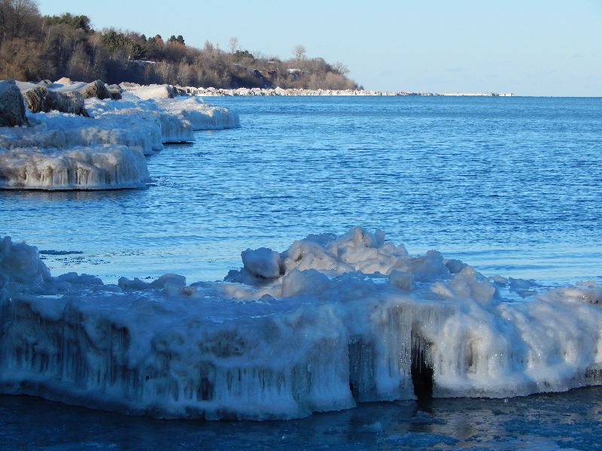On January 30,WMM along with LNRP and the Wisconsin Wetlands Association, will host an event at the Museum on healthy wetlands and how to recognize and care for wetlands on your private property. You can also check out a presentation on the Ice Age Trail, February 27, and the Birds of Lake Michigan, March 19. If you are interested in volunteering for the beach or river clean-ups, contact Kim Kettner at kkettnerm@gmail.com.