**LNRP Newsletter: Fall 2015**

**Watershed Ambassadors Camp**

Thanks to an annual summer program operated through the Wisconsin Maritime Museum and UW Sea Grant, Manitowoc area students, aged 12 to 17, experience five days of intensive, hands-on learning about water quality. The Watershed Ambassadors Camp draws students, many who return each year they are eligible. The ultimate goal: to create the next generation of knowledgeable stewards of our lands and waters.

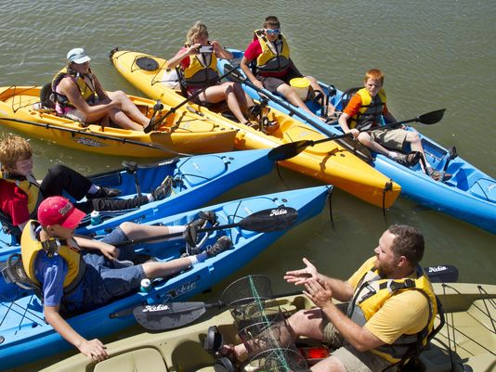Program leader Wendy Lutzke, director of education at the museum, has directed the Camp’s activities for six years. Initially, she offered the outdoor education immersion to grades four through six.

“Even though they loved it, I learned that the Camp is better suited to older kids,” explains Wendy. “I realized we could focus on biology and potential community service work with an older audience. In 2012, Kelly Eskew-Vorron (formerly from Woodland Dunes) and I ran it for two weeks thanks to grant support at the time…the only drawback was we didn’t feel we could give the personal attention we desired. Now with generous support from the FORWARD Foundation and WDNR Surface Water Grants, as well as LNRP, we began offering it for 5 days to 14-16 students.”

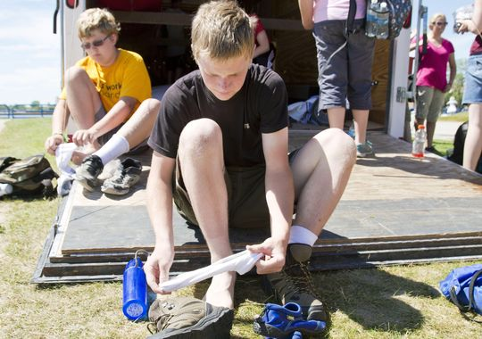After Kelly changed jobs, Wendy partnered with Fisheries Specialist Titus Seilheimer of Wisconsin Sea Grant. “He offers the scientific point of view, a perfect complement to my educational background,” Lutzke stated. ”We start midway up the watershed at Collins Marsh by looking at the stream and wetland ecology, then move downstream towards Lake Michigan, the ultimate recipient of the region’s surface and groundwater,” Seilheimer said.

Titus adds they always tour the Manitowoc Waste Water Treatment Plant (to the groans of the repeat students) to learn about the impacts of what we do with water in our households and lawns, industries and businesses. “This is a great opportunity to compare the similarities and differences between the natural processes we see in wetlands (Collins Marsh) to what we do with our waste in the city,” Seilheimer observed. .

“We also visit the Branch River with the students where the habitat is rocky and cobbly with clear water versus the soft sediment at Mud Creek below Collins Marsh. Our strategy focuses on linking what’s happening on the land to the differences or similarities at each habitat. We now see round gobies moving upstream from Lake Michigan to more inland locations. We see rusty crayfish everywhere. These differences between locations can really drive home the impacts that invasive species can have on the Lake and the Great Lakes system.”

“And, we have fun while learning, canoeing and exploring on the Marsh and fishing,” he emphasizes.

“It is so rewarding to see how this experience builds students’ confidence over time so they can explain exactly what is going on with our water and how what we do upstream impacts the waterways downstream and ultimately Lake Michigan,” Wendy Lutzke added. “We’re striving to help create the next generation of stewards and also push water-based careers with the other science and resource professionals the students interact with during Camp.”

Support from LNRP helped cover part of the program cost in 2014 and 2015 from our Stewardship Investment Fund and DNR River Planning Grants.