**LNRP Newsletter: Summer 2015**

**Restore the Shore**

LNRP first got involved with significant restoration projects more than five years ago with the Centerville Creek Restoration Project in the Village of Cleveland. The project since was expanded to include integrating the Hika Shores property purchased by the Village in 2005 into the existing Hika Park, which offers the only lake-level boat landing between Sheboygan and Manitowoc. Hika Park has long hosted the popular annual Cleveland Fish and Game Fish Derby.

This year, we are finishing Phase 5 of 5 by constructing a pedestrian bridge, a lakefront viewing platform, and a series of strategically-placed interpretive signs throughout the park.

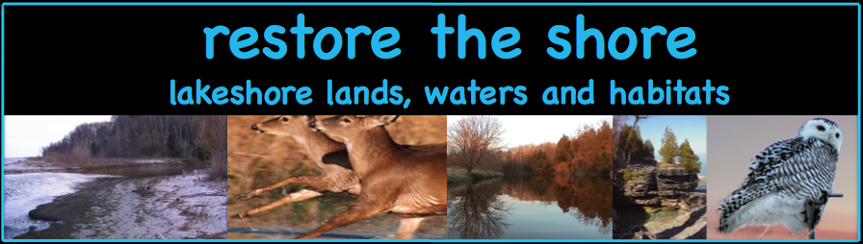Our *Restore the Shore* initiative is now forging ahead with additional enhancements at Fischer Creek Park, collaborative work with the Glacial Lakes Conservancy at the Point Creek Conservation Area, a *Phragmites* Control Grant for Manitowoc County partnering with the Manitowoc County Lakes Association, and the Door County Forest Recovery Project.

What emerged from our multi-year and –faceted experience is the value of creating a local friend group that formally adopts the park to help maintain it through invasive species management, restoration plantings, and general clean up but, most importantly, a committed long-term partner.

This year, Friends of Hika Bay is celebrating the completion of a restoration process that now has expanded Hika Park from its original 2.2 acres to almost 14 acres.

In the last few years, LNRP has helped facilitate a similar process with the Friends of the Manitowoc River Watershed who formally adopted Lower Schuette Park and informally adopted the 10 public beaches in the City of Manitowoc. This community-based Friend group has already completed an invasive species checklist in the park and worked with the Lakeshore Invasive Species Management Area (LISMA) to combat *Phragmites* on the Manitowoc River.

This year, the Friends partnered with the City of Manitowoc to install a kayak canoe launch at the park. Members also conduct two beach clean-ups per year on all 10 beaches in Manitowoc, one centered around Earth Day in April and one completed in association with the Alliance for the Great Lakes annual beach clean-up in September.

In 2015, LNRP began helping build capacity for the Friends of Crescent Beach in Algoma, our newest partner. The Friends formally joined LNRP this spring and already have created an action plan that includes hosting a beach kite flying celebration and a series of outreach activities co-sponsored by the Algoma Chamber of Commerce. The group is already working with the City of Algoma to leverage funding to implement a completed environmentally-engineered beach restoration plan.

These experiences demonstrate how critical citizen involvement is to creating successful public-private partnerships but, perhaps more importantly, how critical this engagement is to sustain the restoration at public parks and natural areas for the long term.

LNRP is now looking to create a similar community-based partnership with the further development of the Little Manitowoc River Partnership. LNRP has helped leverage significant funding to restore the Little Manitowoc’s coastal wetland with an overall design that incorporates management of what could become the Little Manitowoc Conservancy. The nearly 250-acre conservancy would bring under one management umbrella the Little Manitowoc Prairie, the Little Manitowoc Walkway, Lincoln Park Zoo, and Indian Creek Park. The conservancy would have inter-linked trails that would connect to the heavily used Mariner’s Trail.

If you are interested in helping form a local community-based friend group for the Little Manitowoc, please contact Jenn Hansman at [jenn@lnrp.org](mailto:jenn@lnrp.org) or 920-726-1799.

A second call to action is for partners looking to engage a stronger youth presence in stewardship activities.

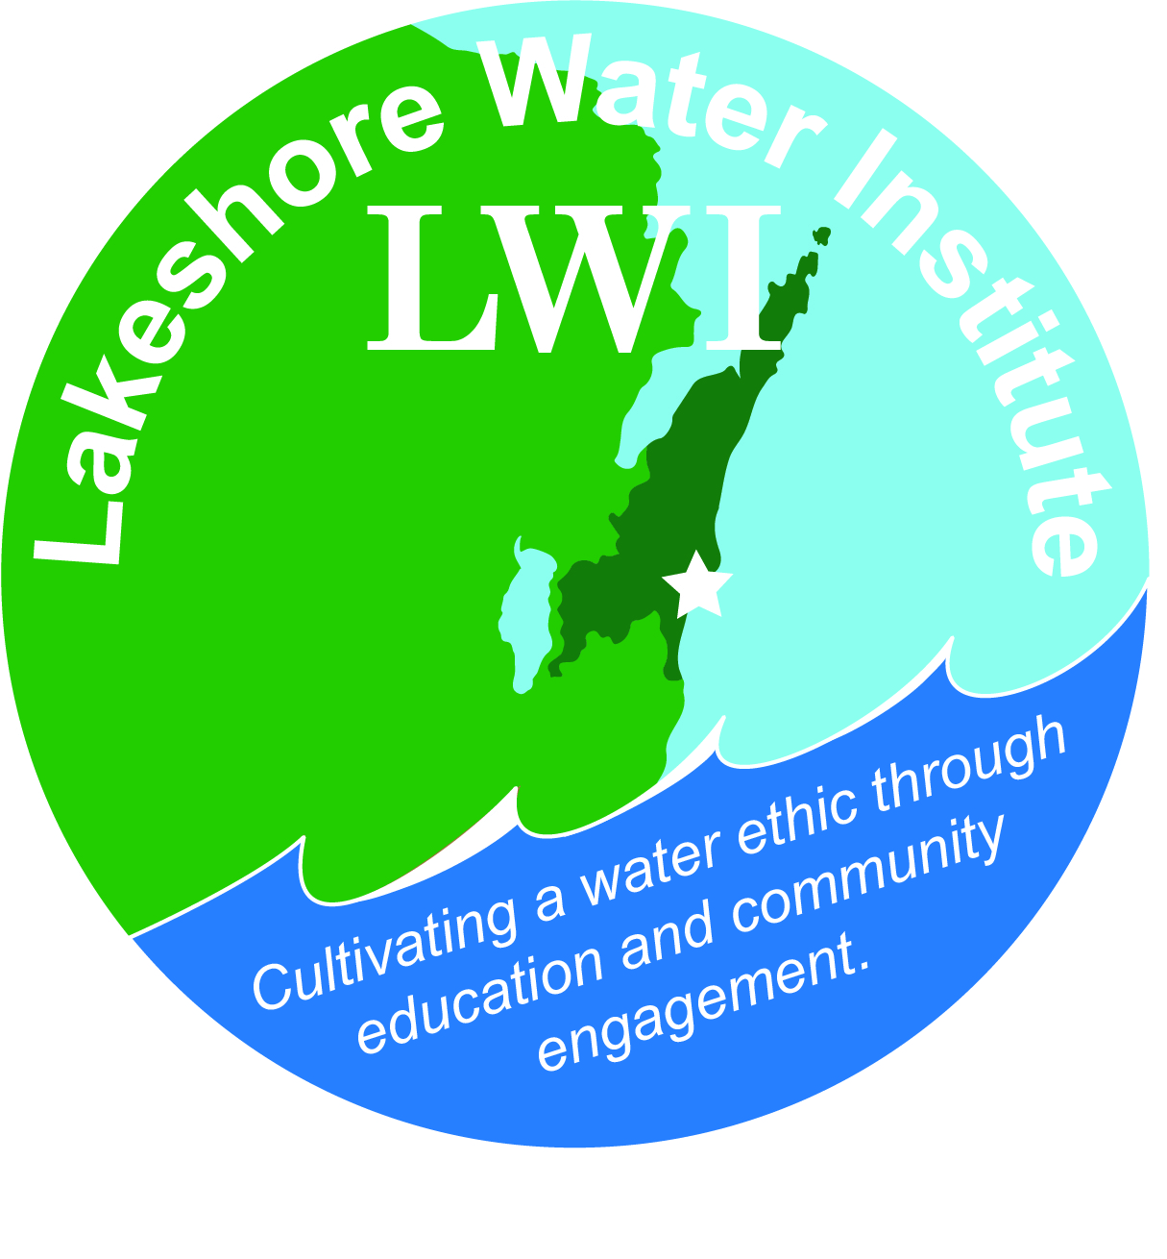Toward this goal, LNRP is working with partners throughout the lakeshore to better engage our youth to cultivate a land and water ethic. Through a process that combines hands-on activities with opportunities for education, we’re hoping to better prepare the next generation for the challenges that will arise to help sustain a high quality of life.

Over the last few years, LNRP helped create the Lakeshore Water Institute with UW-Manitowoc which hires 3-5 interns each year to focus on water quality monitoring and reporting their findings back to the public through an annual Water Summit each fall.

In Door County, we are forging ahead with plans to celebrate stewardship and the good works being done by the county’s significant number of active community groups. We are planning a spring 2016 event to create an opportunity for youth to engage with these groups in a day of interactions, chronicled through storytelling via song, painting, and other forms of artistic expression.

The Vickie Mayer Youth Conservation Program hosted by the Friends of the Branch River Watershed has created a curriculum designed to advance students through three steps of awareness, stewardship, and action.

The Friends of Twin Rivers are engaging four area schools to train teachers with Water Action Volunteers (WAV) and helping coordinate the water quality monitoring on the East Twin River and West Twin River.

And just recently, LNRP has initiated conversations with partners in Sheboygan County to host a celebration of stewardship that focuses on conservation priorities and mobilizes a network of community volunteers aspiring to engage youth groups in the area as part of our collaborative work in protecting and conserving the special places we will collectively prioritize.

If interested in learning more about LNRP’s youth initiatives or to get involved, please contact Jenn Hansmann at [jenn@lnrp.org](mailto:jenn@lnrp.org) or 920-726-1799.