**LNRP Newsletter: Fall 2015**

**Coastal Wetland Restoration in Manitowoc**

The Little Manitowoc River Partnership formed in 2012 as an affiliate of Lakeshore Natural Resource Partnership (LNRP) to address restoration of a coastal wetland following an extreme storm on June 12, 2008, in the City of Manitowoc. The Little Manitowoc River, which flows into Lake Michigan, rose approximately 4-1/2 feet in less than 24 hours, reaching record levels. Its coastal wetland drained and became an exposed mud flat that later filled in with invasive species of cattails, reed canary grass, *Phragmites* and Japanese knotweed, inhibiting native vegetation and reducing biological diversity.

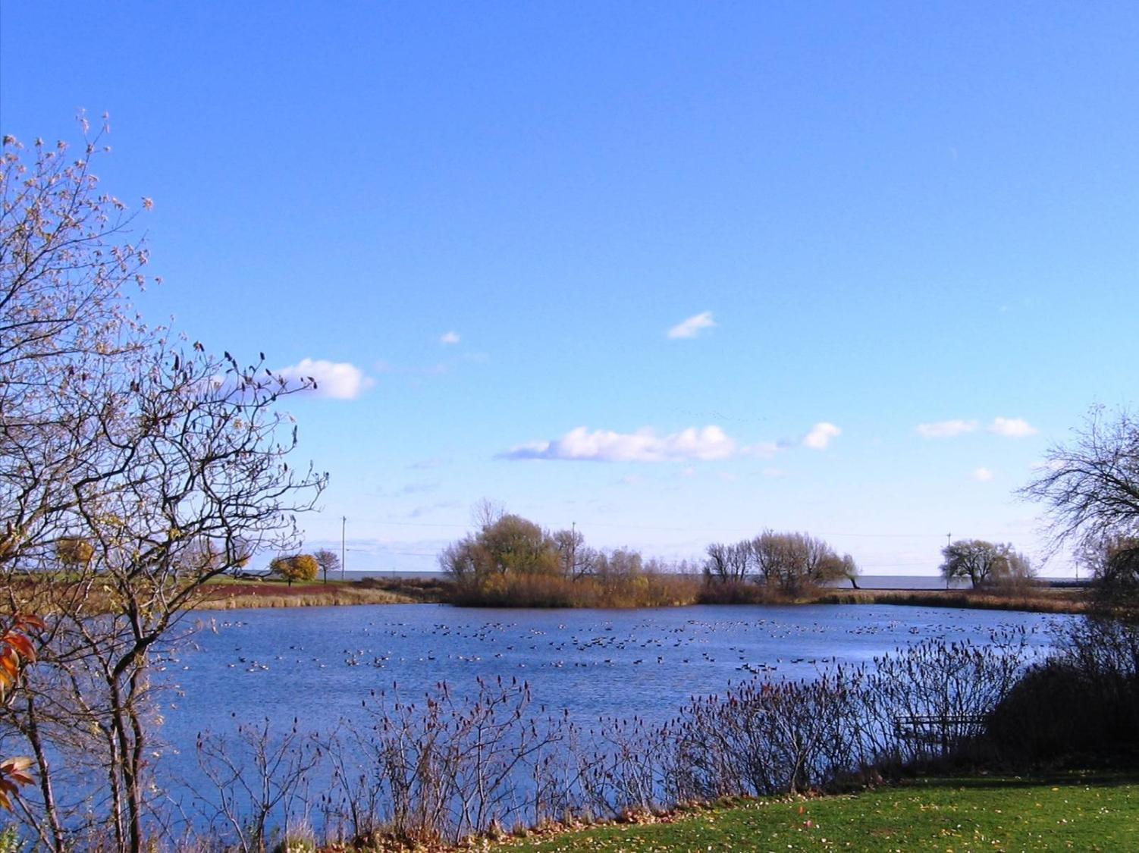

Project partners include LNRP, City of Manitowoc, UW-Manitowoc Lakeshore Water Institute, Friends of the Manitowoc River Watershed, the Lakeshore Invasive Species Management Area, the Wisconsin Waterfowl Association, Ducks Unlimited, the Wisconsin Department of Natural Resources, the US Fish and Wildlife Service, and Stantec Consulting Services.

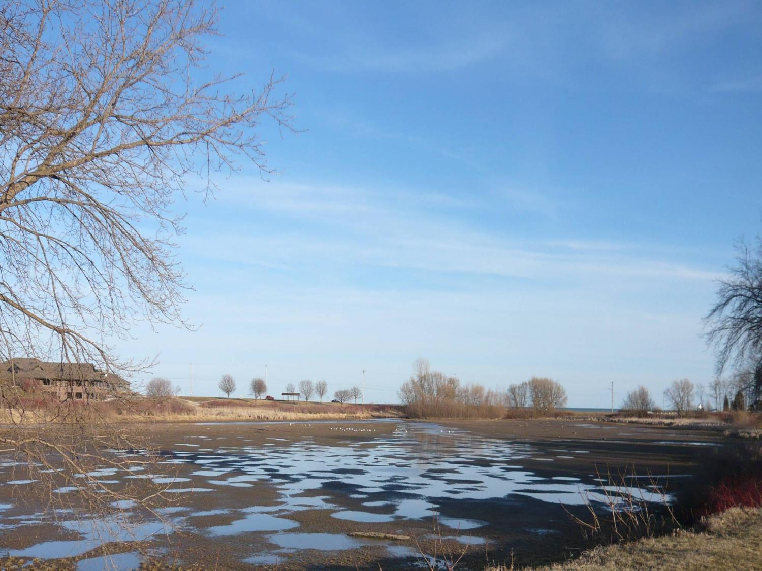The Great Lakes coastal wetlands function as essential transition zones providing many critical habitats for fish, birds, and plant life. Coastal wetlands also help maintain Lake Michigan’s water quality and aid in preventing erosion. This project is focused on recreation, education and conservation goals.

*Before (above) and after (below) 2008 Flood*

Conservation projects include restoring the meandering stream and shallow open water connection lost in 2008 between the Little Manitowoc River and adjacent coastal wetland along the shore of Lake Michigan. Our goal, based on the finding in the city’s 2011 Conceptual Design Report, is to restore 38.5 acres of the Little Manitowoc River coastal wetlands (Lake Michigan to Reed Avenue) to a more historic mix of approximately 50% open-water and 50% native emergent vegetation with a flat sedge shoreline.

The partnership facilitates coordination between government agencies, organizations and residents to conserve these valuable coastal wetlands in Manitowoc. LNRP assists with collaborative planning, outreach and securing project funding.

In 2013, 2014, and 2015, the partnership completed a habitat assessment of the entire 240-acre planned conservancy, completed three years of water quality and macro-invertebrate analysis sampling four sites on the river, completed a full topographical and hydrology analysis of the coastal wetland, produced an invasive species management plan complete with photos of invasives projected onto maps with GIS coordinates, and finished one year of bird and fish monitoring data. We also have treated *Phragmites* for three years with plans for follow up through an Aquatic Invasive Species grant in collaboration with Stantec Consulting Services.

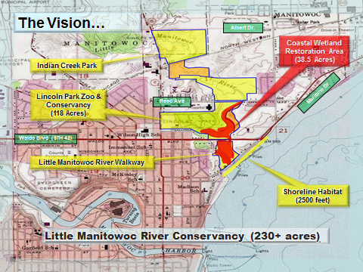The habitat assessment shows 15 unique habitat types within the conservancy that are described and mapped in GIS as they change from the lakeshore inland. The conservancy will have 2500 feet of Lake Michigan Shoreline bordering the mouth of the River, with plans to enhance shorebird habitat. The City of Manitowoc is part of the Bird City Wisconsin program formed by Wisconsin Bird Conservation Initiative (WBCI), making quality shorebird habitat a project priority. The *U.S. Shorebird Conservation Plan 2004 (USFWS)* identifies 54 high priority shorebirds, 35 documented in the Manitowoc lakefront area. In all, an average of 215 different species of birds is observed here annually.

LNRP helped facilitate meetings with adjacent landowners in August and September of 2015 and has launched the process of further developing the conceptual restoration plan into a permit-ready engineered design. Stay tuned for further information on this important wetland restoration project.