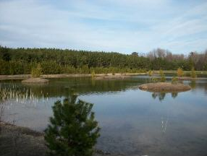

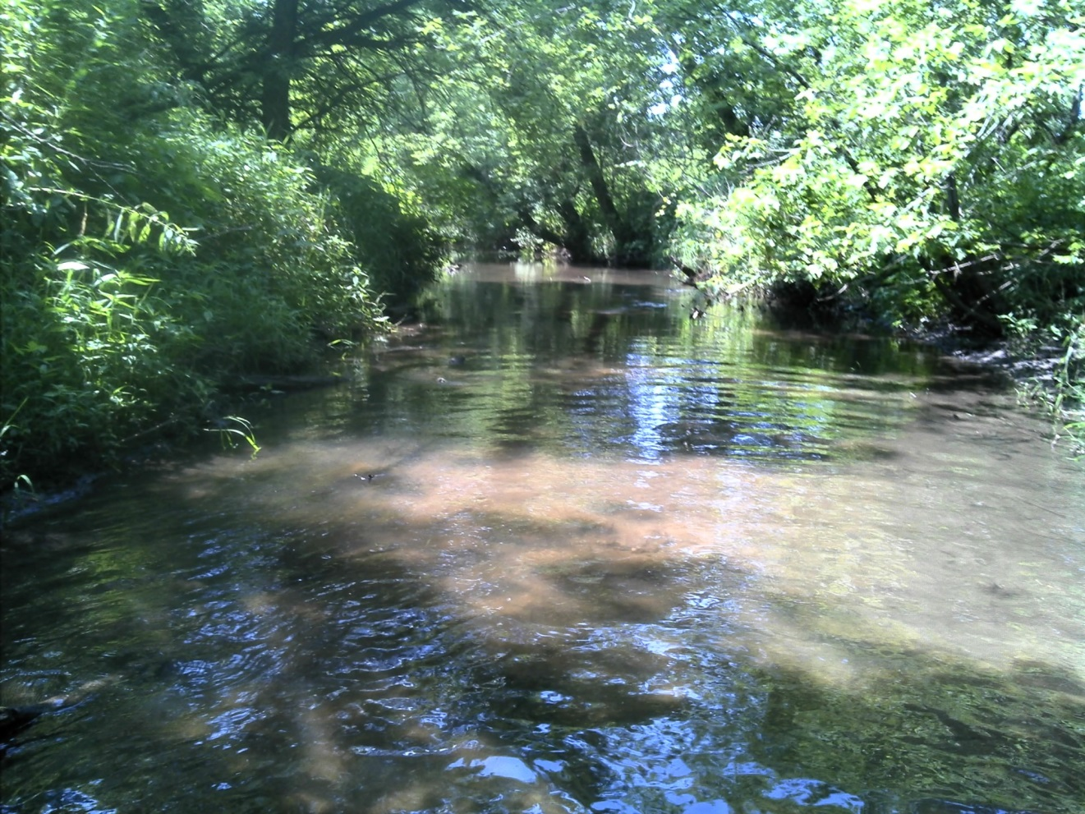

Garner’s Creek Assessment 2015  
***Garner’s Creek TWA  
HUC: 040302040205, Monitored 2016***

A Watershed Report created by the Bureau of Water Quality in support of the Clean Water Act.

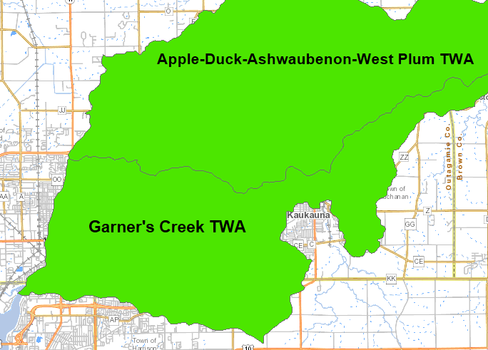

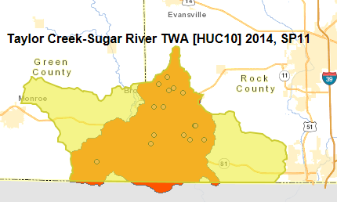

Figure 1 Map goes here - Lisa will provide



Table of Contents

Watershed Discussion & Management Recommendations 2

Watershed Overview 2

Population, Land Use, Site Characteristics 2

Hydrology 3

Study Summary 3

Management Recommendations 3

Ecological, Aquatic Resources 4

Outstanding and Exceptional Resource Waters 4

Impaired Waters 4

Species of Special Concern 5

Monitoring Project Discussion 5

Purpose of Project 5

Site Selection and Study Design 5

Methods, Equipment and Quality Assurance 5

Project Results 6

Data Tables 6

Discussion 10

River/Stream Health 10

Management Actions 13

Management Priorities 13

Recommendations 13

Basin/Watershed Partners 14

Report Acknowledgements 14

Appendices 14

References 15

Stream Narratives 16

Temperature Graphs 21

Monitored Waters 23

# Watershed Discussion & Management Recommendations

## Watershed Overview

**SUMMARY OF WATERSHED STUDY AREA**

The “Lower Sugar River” Watershed HUC 10 (0709000407) is a subset of the larger “Lower Sugar River Watershed” and includes a portion of the Sugar River and its’ tributaries from the confluence with Sylvester Creek downstream to the Illinois border. As Figure 1 shows, it encompasses a 110 square mile drainage area and is part of the larger, 214 square mile watershed that includes the HUC 10 0709000315 (Raccoon and East Fork Raccoon) watershed and HUC 10 0709000406 (Juda and Sylvester Creek). The latter was sampled in 2013.

## Population, Land Use, Site Characteristics

Pie chart of land use (get 2011 NLCD) updated  **DESCRIBE LAND USE IN PROJECT WATERSHED**

**Figure 2** Land Use 2011 NLCD Land Cover in Watershed

## Hydrology - Update text to match your watershed

The entire basin is also characterized by the lack of natural lakes and wetlands; wetland complexes are few in the driftless region and there are only 13 named lakes in the basin – most of them impoundments on streams. The water quality of these lakes is marginal due to heavy siltation from upland runoff. This siltation usually leads to shallow, mucky ponds with a low diversity of aquatic macrophytes and fish.  
  
Eastern Green County and the Rock County part of the basin are in the Southeast Glacial Plains ecological landscape. The Southeast Glacial Plains landscape is underlain by dolomite with some limestone and shale. The topography is rolling glacial till and outwash plains dissected by numerous streams. Valleys tend to be broader and streams in this part of the basin do not have the higher gradients of those in the driftless part. The original vegetation of this part of the basin was a mixture of prairie, oak savanna, and mixed hardwood forests. The most significant wetland complexes are located along the Sugar River.

## Study Summary - Update text to match your study

Streams of the Lower Sugar River watershed tend to contain fish resembling a cool-warm thermal regime. The streams typically have 10 to 15 species, many of them transitional or warmwater species. And while there are multiple intolerant species found in certain locations, the majority of the total numbers of fish are tolerant to environmental degradation. The streams themselves have many sections that have been straightened to enhance drainage from agricultural fields. This lends itself to degraded habitat within the individual streams and advanced sediment delivery to larger systems like the Sugar River.

As one attempts to think of ways to improve these streams, it is unrealistic to think that re-meandering of the stream channels is cost-effective or practical, especially in the contemporary agricultural economy. Therefore it is imperative to work with landowners in the watershed to encourage management of woody vegetation to prevent overgrowth along banks, to control regrowth and use management practices that avoid destabilization of banks (i.e. cutting and grubbing of the shoreline with no shaping, sloping or mulching).

This would allow for stabilization in grasses, embrace natural “re-meandering” within the channel footprint, strive to keep some buffers in place. Where possible, encourage landowners to slope banks 3:1 to prevent erosion. It is also important to leave some in-stream woody debris in place to act as natural cover for fish. Control nutrient loading through development and implementation of nutrient management plans and proper manure management.

## Management Recommendations - Provide broadbased management recommendations

* The department should work with watershed organizations such as the Lower Sugar River Watershed Association on outreach efforts with landowners in the watershed, environmental programs in the Juda and Brodhead school districts, and research opportunities for harvestable buffers to provide economic incentives for maintaining buffers along streams.
* The entire length of OK Creek should be added to the state’s 303(d) list of impaired waters due to habitat degradation caused by excessive sediment deposition and channel straightening. It should also be added for total phosphorus as concentrations exceed the WisCALM (WDNR, 2013) guidance. The department should review land use and nutrient management efforts in this sub-watershed to determine if any improvements can be made to reduce phosphorus delivery to the stream.
* Swan Creek should be added to the 303(d) list of impaired waters for phosphorus that exceeds the criteria.
* Taylor Creek, from Swan Creek downstream to the Sugar River and Willow Creek should be added as a watch waters as total phosphorus concentrations are near the criteria for listing.
* Monitoring of phosphorus and nitrate concentrations in the streams of the Lower Sugar River should continue as funding and volunteer efforts allow.

# Ecological, Aquatic Resources

## Outstanding and Exceptional Resource Waters - Update text to match your watershed

Wisconsin has designated many of the state’s highest quality waters as Outstanding Resource Waters (ORWs) or Exceptional Resource Waters (ERWs). Waters designated as ORW or ERW are surface waters which provide outstanding recreational opportunities, support valuable fisheries and wildlife habitat, have good water quality, and are not significantly impacted by human activities. ORW and ERW status identifies waters that the State of Wisconsin has determined warrant additional protection from the effects of pollution.

Most of the entire 81 mile length of the Sugar River within the state’s boundary is designated as Exceptional Resource Water (ERW), save for the area downstream of the Green/Rock county border. Several rare species have been reported in the Sugar River mainstem including the gravel chub, silver chub, pallid shiner, redfin shiner and river redhorse. Wetlands are rare in the basin, but significant and regionally important wetland complexes do occur along the Sugar River.

Table 2 Watershed Outstanding/Exceptional Resource Waters

| WADRS ID | Official Waterbody Name | Local Waterbody Name | WBIC | ORW/ERW | ORW/ERW ID | Start Mile | End Mile |
| --- | --- | --- | --- | --- | --- | --- | --- |
|  |  |  |  |  |  |  |  |

## Impaired Waters - Update text to match your watershed

Table 2 Watershed Impaired Waters

| WADRS ID | Official Waterbody Name | Local Waterbody Name | WBIC | Start Mile | End Mile | Pollutant | Impairment |
| --- | --- | --- | --- | --- | --- | --- | --- |
|  |  |  |  |  |  |  |  |
|  |  |  |  |  |  |  |  |

## Species of Special Concern

Gravel chub, silver chub, pallid shiner, redfin shiner and river redhorse have been reported in the mainstem of the Sugar River. Least darters were found in Willow Creek.

# Monitoring Project Discussion

## Purpose of Project - Update text to match your project

## The purpose of this study was to monitor the contemporary status of a subwatershed (HUC 12) in the Mineral Point Branch watershed. The department collected fish, habitat, macroinvertebrate and water chemistry data for streams in this watershed. The data help determine whether these streams are achieving their attainable use in order to update the watershed tables, list waters that are not meeting their attainable use, and assess the overall health of the watersheds as required by Section 305(b) of the Clean Water Act. The data, used in conjunction with observations about watershed health, are also used to guide planning for improvements where needed. This subwatershed, and the adjoining subwatersheds that make up the HUC 10 were identified as one of the top group watersheds for nutrient input by the WI Nutrient Reduction Strategy. The follow are outcomes of this study:

* Watershed was monitored with a baseline survey
* Watershed was monitoring to understand its status and any presence of and sources of impairments.
* Streams in the system were monitored to assess condition.
* Waters are subject of watershed planning.

## Site Selection and Study Design - Update text to match your watershed

## This sub watershed’s 2015 study involved collection of data on fish assemblage, qualitative habitat, and macroinvertebrates at 11 sites in the targeted HUC 12. Phosphorus data was collected 6 times during the growing season from the pour point of the subwatershed. Data was collected during the field season of the 2015 calendar year and was entered into the Fish Database and SWIMS. Updated streams narratives and watershed reports are entered into SWIMS and WATERS. Methods, Equipment and Quality Assurance - Update text to match your project

The fisheries assemblage was determined by electroshocking a section of stream with a minimum station length of 35 times the mean stream width (Lyons, 1992). A stream tow barge with a generator and two probes was used at most sites. A backpack shocker with a single probe was used at sites generally less than 2 meters wide. All fish were collected, identified, and counted. All gamefish were measured for length. At each site, qualitative notes on average stream width and depth, riparian buffers and land use, evidence of sedimentation, fish cover and potential management options were also recorded. A qualitative habitat survey (Simonson, et. al., 1994) was also performed at each site. Macroinvertebrate samples were obtained by kick sampling and collecting using a D-frame net at these same sites in the watershed in fall, 2014 and sent to the University of Wisconsin-Stevens Point for analysis.

Additionally, water samples were collected once per month throughout the growing season (May through October) by volunteer monitors in 2013 and/or 2014 and 2015 at 6 sites in the watershed. Three of these sites (Spring Creek, Taylor Creek at Smith Road and Willow Creek) are at the pour point of the HUC 12’s which make up the HUC 10 because it was practical to do so. Two sites – on Swan and O.K. creeks - were near the pour point of these major tributaries. An additional site was collected in 2014 on Taylor Creek at W. Keesey Road for comparison with upstream/downstream of the confluence with Swan Creek. These samples were analyzed for total phosphorus. Continuous water temperature loggers were also placed at sites on Swan, Taylor, and Willow creeks and programmed to take hourly water temperatures throughout the “summer” (June – August) period.

# Project Results

## Data Tables

* [See table folder where example tables are available](../../Guidance/2016/tables/)

**Fish Taxonomy Count Table**

**Habitat Data by Station**

**Macroinvertebrate and Fish IBI Values**

**Total Phosphorus by Station**



**Macroinvertebrate and Fish IBI Values**

**Total Phosphorus by Station**

|  |  |  |
| --- | --- | --- |
| **Site (Years of data)** | **Total Phosphorus (mg/l)** | |
| **Median** | **Mean** |
| OK Creek - Mt. Hope Road (3) | 0.160 | 0.172 |
| Spring Creek - Mt. Hope Road (3) | 0.075 | 0.079 |
| Swan Creek - W. Keesey Road (1) | 0.186 | 0.168 |
| Taylor Creek - W. Keesey Road (1) | 0.045 | 0.042 |
| Taylor Creek - Smith Road (3) | 0.089 | 0.096 |
| Willow Creek - STH 81 (2) | 0.068 | 0.072 |

|  |  |  |  |  |  |  |  |  |  |  |
| --- | --- | --- | --- | --- | --- | --- | --- | --- | --- | --- |
| Summary values for physical, chemical, and biological measures from Yellow River stream sampling sites. - **Update** | | | | | | | | | | |
|  | **Detection Limit** | **WI Criteria or Guidance** | **Sample Count** | **% Non-detect** | **% Exceed Criteria** | **Min.\*** | **Max.\*** | **Mean\*** | **SD\*** | **Median\*** |
| **Physical Measures** | | | | | | | | | | |
| **Drainage Area** (mi2) |  |  | 60 |  |  | 0.10 | 212.60 | 29.90 | 54.81 | 4.71 |
| **Flow volume** (m3/s) |  |  | 47 |  |  | 0.00 | 2.10 | 0.21 | 0.45 | 0.02 |
| **Stream gradient** (ft/mi) |  |  | 60 |  |  | 2.33 | 26.30 | 11.83 | 6.49 | 11.18 |
| **Water temperature** (° C) |  |  | 343 |  |  | 6.00 | 27.70 | 15.96 | 5.08 | 15.20 |
| **pH** |  |  | 344 |  |  | 5.92 | 9.52 | 7.56 | 0.46 | 7.59 |
| **Conductivity** (µS/cm) |  |  | 331 |  |  | 27.90 | 1665.00 | 235.37 | 179.90 | 198.45 |
| **Transparency** (cm) |  |  | 335 |  |  | 8.00 | 120.00 | 83.34 | 30.58 | 90.00 |
| **Dissolved O2 conc** (mg/L) |  | 5 | 344 |  | 17% | 0.06 | 16.98 | 7.63 | 2.83 | 7.69 |
| **QHEI** |  |  | 60 |  |  | 22.50 | 91.00 | 56.87 | 18.42 | 54.75 |
| **WI Qualitative habitat** |  |  | 60 |  |  | 5.00 | 87.00 | 51.78 | 18.43 | 53.00 |
| **Water Column Chemistry Measures** | | | | | | | | | | |
| **TP** (mg/L) | 0.005 | 0.075 | 262 | 0% | 90% | 0.0 | 27.7 | 0.4 | 1.8 | 0.2 |
| **TKN** (mg/L) | 0.014 |  | 262 | 0% |  | 0.2 | 8.6 | 1.3 | 0.8 | 1.1 |
| **NH3 (**mg/L) | 0.015 | 19.89 | 262 | 8% | 0% | 0.0 | 1.5 | 0.1 | 0.2 | 0.0 |
| **NO3NO2-N** (mg\L) | 0.019 |  | 262 | 16% |  | 0.0 | 5.2 | 0.5 | 0.7 | 0.2 |
| **BOD** (mg\L) | no data |  | 262 | n/a |  | 0.05 | 19.90 | 1.72 | 2.32 | 0.97 |
| **TSS** (mg/L) | 2.0 |  | 262 | 4% |  | 1.00 | 152.00 | 10.61 | 17.40 | 5.00 |
| **TDS** (mg\L) | 50 |  | 262 | 0% |  | 52.00 | 970.00 | 176.76 | 123.59 | 146.00 |
| **SSC** (mg\L) | 2.0 |  | 262 | 7% |  | 1.00 | 159.00 | 11.62 | 21.69 | 5.00 |
| **Chloride** (mg\L) | 1.0 | 757 | 262 | 0% | 0% | 1.40 | 308.00 | 31.48 | 42.77 | 20.95 |
| **Chlorophyll-a** (µg/L) | 0.26 |  | 60 | 5% |  | 0.13 | 104.00 | 10.25 | 18.73 | 3.31 |
| **Biological Measures** | | | | | | | | | | |
| **Hilsenhoff’ s Biotic Index** |  |  | 59 |  |  | 3.67 | 8.45 | 6.42 | 1.22 | 6.76 |
| **Macroinvertebrate IBI** |  |  | 59 |  |  | 1.53 | 8.10 | 3.83 | 1.41 | 3.80 |
| **Percent EPT** |  |  | 59 |  |  | 0.00 | 73.00 | 20.07 | 21.37 | 12.00 |
| **Fish Index of Biotic Integrity** |  |  | 56 |  |  | 0.00 | 100.00 | 65.91 | 29.13 | 71.00 |
| ***E. coli*** (colonies/100mL) |  |  | 59 |  |  | 2.00 | 2400.00 | 542.05 | 557.04 | 280.00 |

# Discussion

## River/Stream Health - Update text to match your findings [TEXT IN YELLOW]

A watershed’s fishery is a long-term gauge of conditions in the stream and is therefore most important for bioassessment. That’s not to say measured water temperatures aren’t useful, but for natural community determination and IBI purposes, and in the absence of moderate to severe environmental perturbation, the fishery assemblage trumps water temperature data (Lyons, personal communication).

**Natural Community Analysis**

Most of the streams in this HUC 10 are modelled to be cool-cold transitional headwaters or mainstems (Lyons, 2008). The department has recently developed a draft method to determine whether or not the modeled natural community is accurate based on the fishery assemblage and climate conditions (Lyons, 2013). In most cases, the thermal composition of species (cold, warm, or transitional) indicated these streams resemble cool-warm systems rather than cool-cold systems. There is a fair amount of diversity of nongame species in most of the streams and coldwater species are absent for all intents and purposes.

Environmental degradation can sometimes explain the discrepancy between the modelled and actual community where there is a lack of intolerant species and a dominance of tolerant ones (Ibid). For most systems in this HUC 10, the percentage of tolerant fish fall with expected ranges for cool-cold transitional systems, and therefore a degraded community is not the principle reason for the discrepancy.

**Stream Temperatures versus Natural Community**

Actual water temperature data collected in the watershed shows summer temperatures to be within the realm of cold to cool-cold transitional systems (Lyons et. al., 2009). The discrepancy between the temperature data and the fishery community can happen for several reasons: either the year of the thermal measurement wasn’t representative of the long-term average, the modeled thermal values were inaccurate, or both (Lyons, personal communication). In this case, air temperatures during the 2014 “summer” season over which the thermisters were deployed were not considered abnormal save for a one week period at the end of July and beginning of August when temperatures were considered abnormally cool. However, it is unlikely this weather affected the fish assemblage because the species found favored transitional and warm water systems despite the cool temperatures. The fishery assemblage encountered in 2014 is similar to that found in other years dating back to 2001 (WDNR, unpublished data), and therefore can also be considered representative of the stream.

**Fish Species Found**

Compared to streams in the northwest portion of the Lower Sugar watershed and the Lower Middle Sugar watershed which were sampled in 2013 (WDNR, 2015), these streams had a greater diversity of darters, and in particular Iowa and rainbow darters. There were also a greater number of intolerant species, but the percentage of tolerant species was similar.

The great majority of the transitional species (brook stickleback, creek chubs, and white sucker) found in these streams are tolerant to low dissolved oxygen and/or disturbed habitat. These particular species tend to be more widespread throughout the state, including south central Wisconsin, as opposed to other more intermediate or low tolerance species which are not found in this area (Becker, 1983).

One interesting occurrence from this study was the discovery that Iowa darters, an intolerant warmwater species, were quite prevalent in the 2014 sampling and found at 13 of the 23 sites. When looking back at historic fisheries data back to 1875, there are scant reports of an individual or two being found in Willow Creek and O.K. Creek. They have historically been reported in this area of the Sugar River (Ibid). Iowa darters do well in sandy bottomed streams. They prefer submerged fibrous roots or filamentous algae for spawning and will only occasionally spawn on gravel. Their population size tends to be dependent the territorial society in that males can fertilize and care for only a limited number of eggs. Under crowded conditions, territories are not maintained and spawning is usually not successful (Ibid). The reason for the increase in incidence of Iowa darters in the 2014 surveys is unknown. Southern Wisconsin is near the southern edge of the species range. It is likely the Sugar River always harbors small populations of them. It can be surmised that weather conditions over the past several years just happened to be favorable for increased populations and expansion of their range into the Taylor Creek system.

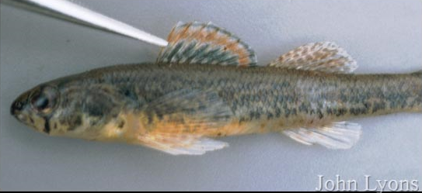

Gamefish and/or panfish were virtually absent despite the proximity of several of the sites to the Sugar River. One could hypothesize the cool water temperatures limit the number of these species which generally inhabit the warmer waters of the Sugar River. However, there was a number of other (nongame) warmwater species present in these systems. The size of the streams may have been a limiting factor, but it is likely the general lack of fish cover and deeper pools that these species prefer plays a greater role.

Iowa Darter Photo by John Lyons

**Index of Biological Integrity Findings**

The fishery is only one environmental indicator and for this reason, the quality of the resources should be looked at in the context of overall conditions including habitat and macroinvertebrates.

The cool water IBIs (Lyons, 2012), when applied to the natural community indicated by the fishery assemblage, rates the fishery of most of these systems to be “good” to “excellent”, despite the prevalence of species that are tolerant to habitat disturbance and lower water quality. This prevalence of transitional tolerant species may be a factor of water temperature and/or environmental disturbance, but likely influenced by both.

**Habitat Scores**

Given the land use, hydrologic modifications, and biologists’ observations of conditions in this watershed, there are suggestions of environmental disturbance. Overall habitat scores were fair to good, but were buoyed by several metrics that were favorable in this watershed. The buffer width was favorable at many sites although it must be acknowledged that some of this is coincidental with the streams being deeply entrenched with steep banks, making farming up to the stream edge impractical if not impossible. There is also very limited grazing along the banks of the streams. There are sites with a riparian wooded corridor, which acts as a buffer, but also exacerbates bank erosion. The width-to-depth ratio of these channelized systems was also generally good. Conversely, many of the stream sites contained a predominance of silt and sand on the bottom which inhibited the percent fines metric. This was very dependent on the gradient at a particular site. Fish cover was variable, but 70% of sites had only “poor” to “fair” fish cover. Because of the straightening and dredging of the stream channels to augment drainage from agricultural fields, the pool area and riffle/bend ratio were depressed. OK Creek and Spring Creek had the lowest overall scores, followed by Swan Creek and Taylor Creek. Willow Creek was good save for the site at Lee Road. The overall scores for the unnamed tributaries ranged from 35 (fair) to 50 (good).

For streams that feed into the Sugar River from the west (Spring and OK Creeks), their gradients are good on the western (headwaters) areas and tend to have more gradual slopes as they near the Sugar River. These lower gradient areas are also most likely to be channelized to promote drainage from fields. These streams tend to be wider and shallower than a natural condition. However, numerous blowdowns have created small holes, narrowing, and scouring to create some habitat for non-game fish. In spring, 2014, several severe storms hit the area and created fresh blowdowns across some of the streams. This decreased sampling efficiency at several sites and even forced biologists to truncate station length at a few of the sites. While blowdowns can create habitat for fish, they also exacerbate bank erosion, and cause further widening of the stream channel. Not surprisingly, species diversity increased at sites closer to the Sugar River.

Streams that lie to the east of Sugar River (Swan, Taylor, and Willow) have fairly low gradients. Many sections have been channelized to augment drainage of the wet meadows which they flow through. In contrast to streams on the west side of the Sugar River, these streams tend to have more channelization in the mid to upper portion of their thread, with more meandering occurring closer to the Sugar River. Sand dominates the bottom composition with a few areas of gravel, particularly toward the headwaters. Similarly to other streams in the area, species diversity gradually increases as one goes from the headwaters downstream toward the Sugar River.

**Macroinvertebrate Data**

The macroinvertebrate data was very consistent throughout the watershed, with macroinvertebrate IBIs generally in the “fair” range. The macroinvertebrate IBI has shown the combination of watershed land cover and local riparian and instream conditions strongly influence one another (Weigel, 2003). While watershed and local variables explain a significant portion of variance among sites, Weigel found that in the driftless region, localized stressors were of greater importance to explain the IBI than in other parts of the state. The similarity amongst scores in this watershed as well as the adjacent watershed (WDNR, 2015) reflects the overall condition of the watershed in that these streams are highly modified systems flowing through an intensive agricultural landscape. The HBIs indicate there is little organic loading to these streams.

**Phosphorus Concentrations**

Growing season phosphorus concentrations varied amongst the streams and the sites. The department’s listing methodology for impaired waters (WDNR, 2013) recommends listing sites where the median phosphorus concentration exceeds 0.075 mg/l on wadable streams and 0.1 mg/l on rivers. The impairment listing protocol uses a 95% confidence interval about the median for listing streams and rivers. This guidance was exceeded on Swan Creek at Keesey Road and OK Creek at Mt. Hope Road. For all intents and purposes, the criteria was also exceeded at Taylor Creek at Smith Road, but was not exceeded upstream at W. Keesey Road. It is likely the phosphorus concentrations on Swan Creek and Taylor Creek at Smith Road are influenced by the wastewater discharge from Orfordville. OK Creek had a median concentration which was over double the criteria and all but 1 of the 18 samples taken over 3 years exceeded 0.075 mg/l. These concentrations are similar to Swan Creek, which receives a wastewater discharge. It is unknown why the phosphorus concentrations of OK Creek are almost double that of other streams in the area. A review of land use and nutrient management plans is warranted. The median concentration did not exceed the criteria nor data exceed the 95% confidence interval on Spring Creek and Willow Creek, but each of these systems had individual samples which exceeded the criteria and bare further monitoring.

It is interesting to note that the yearly median concentration increased at most sites in successive years from 2013 to 2015 at those sites where multiple years of data were available. The exception was on Taylor Creek at Smith Road, where it decreased in successive years (Figure 2). When compared to the long-term trend site on the Sugar River, the 3 year median also increased, indicating a more basin-wide phenomenon.

It is unknown what caused this trend. The precipitation was not considered extreme - below 10th percentile or above 90th percentile – for the sample dates over this period (WDNR, 2013). This 3 year trend may be short-term as the 10 year median growing season phosphorus concentration on the Sugar River decreased (WDNR, unpublished data).

# Management Actions

## Management Priorities Update

Working with landowners in the watershed to encourage management of woody vegetation to prevent overgrowth along banks, to control regrowth and use management practices that avoid destabilization of banks (i.e. cutting and grubbing of the shoreline with no shaping, sloping or mulching) is a high priority.

Management of woody vegetation to reduce overgrowth along stream banks is critical, and use of pracitces that avoid destabilizationof banks is also important.

## Management Goals Update

Management of woody vegetation to prevent overgrowth along banks, to control regrowth and use management practices that avoid destabilization of banks are optimal goals for resource improvement.

## Recommendations - Sample recommendations

* The department should work with ____watershed organizations (counties, schools, business, federal agencies) on outreach efforts with landowners in the watershed, environmental programs in ____ watershed, and ­­­­­­research opportunities for harvestable buffers to provide economic incentives for maintaining buffers along streams.
* The entire length of _____ should be added to the state’s 303(d) list of impaired waters due to habitat degradation caused by excessive sediment deposition and channel straightening. It should also be added for total phosphorus as concentrations exceed the WisCALM (WDNR, 2013) guidance.
* The department should review land use and nutrient management efforts in this sub-watershed to determine if any improvements can be made to reduce phosphorus delivery to the stream.
* Swan Creek should be added to the 303(d) list of impaired waters for phosphorus that exceeds the criteria.
* Taylor Creek, from Swan Creek downstream to the Sugar River and Willow Creek should be added as a watch waters as total phosphorus concentrations are near the criteria for listing.
* Monitoring of phosphorus and nitrate concentrations in the streams of the Lower Sugar River should continue as funding and volunteer efforts allow.

## Basin/Watershed Partners Update

* Lower Sugar River Watershed Association
* Green County Conservation League
* Juda and Brodhead School Districts

# Report Acknowledgements Update

Jim Amrhein, Southern District, Wisconsin DNR

# Appendices Update

* References
* Water Narratives
* Assessment Results

This document is available electronically on the WDNR’s website.

The Wisconsin Department of Natural Resources provides equal opportunity in its employment, programs, services, and functions under an Affirmative Action Plan.

******If you have any questions, please write to Equal Opportunity Office, Department of the Interior, Washington, D.C. 20240. This publication is available in alternate format (large print, Braille, audio tape, etc.) upon request. Please call 608-267-7694 for more information.

***Wisconsin Department of Natural Resources***

101 S. Webster Street • PO Box 7921 •

Madison, Wisconsin 53707-7921 608-266-2621

## **References** - Update

Becker, George C. 1983. Fishes of Wisconsin. The University of Wisconsin Press. 1051 pp.

Hilsenhoff, William L. 1987. An Improved Biotic Index of Organic Stream Pollution. The Great Lakes Entomologist. 20: 31-39.

Lyons, John. 1992. Using the Index of Biotic Integrity (IBI) to Measure Environmental Quality in Warmwater Streams of Wisconsin. United States Department of Agriculture. General Technical Report NC-149.

Lyons, John. 2006. A Fish-based Index of Biotic Integrity to Assess Intermittent Headwater Streams in Wisconsin, USA. Environmental Monitoring and Assessment 122: 239-258.

Lyons, John. 2008. Using the Wisconsin Stream Model to Estimate the Potential Natural Community of Wisconsin Streams (DRAFT). Wisconsin Department of Natural Resources Fish and Aquatic Life Research Section. November, 2008.

Lyons, John. T. Zorn, J. Stewart, P Seelbach, K Wehrly, and L. Wang. 2009. Defining and Characterizing Coolwater Streams and Their Fish Assemblages in Michigan and Wisconsin, USA. North American Journal of Fisheries Management. 29:1130-1151.

Lyons, John. 2012. Development and Validation of Two Fish-based Indices of Biotic Integrity for Assessing Perennial Coolwater Streams In Wisconsin, USA. Ecological Indicators 23 (2012) 402-412.

Lyons, John. 2013. Methodology for Using Field Data to Identify and Correct Wisconsin Stream “Natural Community” Misclassifications. Version 4. May 16, 2013. IN DRAFT.

Simonson, Timothy D., J. Lyons, and P.D. Kanehl. 1994. Guidelines for Evaluating Fish Habitat in Wisconsin Streams. U.S. Department of Agriculture. Forest Service. General Technical Report NC-164.

WDNR. 1980. Surface Water Resources of Green County. By D. Bush, R. Cornelius, D. Engel, C. Brynildson. Wisconsin Department of Natural Resources. Madison, WI.

WDNR. 2003. The State of the Sugar and Pecatonica River Basins. Wisconsin Department of Natural Resources.

WDNR. 2013. Wisconsin 2014 Consolidated Assessment and Listing Methodology (WisCALM). Clean Water Act Section 305(b), 314, and 303(d) Integrated Reporting. Wisconsin Department of Natural Resources. Bureau of Water Quality Program Guidance. September, 2013.

WDNR. 2015. An Assessment of Water Quality in the Lower Middle and Lower Sugar River Watershed (HUC 0709000406). 2013. Project SCR_20_CMP13. February, 2015. By James Amrhein, Water Quality Biologist – South District. http://prodoasint.dnr.wi.gov/wadrs/viewWatershedDetail.do?id=924722

Weigel, Brian. 2003. Development of Stream Macroinvertebrate Models That Predict Watershed and Local Stressors in Wisconsin. Journal of the North American Benthological Society. 22(1): 123-142.

## Stream Narratives- Update TEXT IN YELLOW] [downloads from WATERS]

***Oakley Branch***

This small, 2 mile long stream has its source near the Illinois border and flows northward and converges with Spring Creek near the unincorporated community of Oakley. It historically flowed entirely through pasture and experienced the severe bank erosion associated with heavy grazing (WDNR, 1980). Near Oakley, a 0.5 acre spring pond discharges a small flow to the stream.

Very little monitoring data exists for this stream. It harbors about a dozen non-game species, predominately creek chubs and white sucker. In the 2014 survey, 1 Iowa darter, an intolerant warmwater species was found along with 1 largemouth bass – most likely a stray from the spring pond – were also found. The stream has good gradient which scours down to the gravel and rubble cobble bottom. However, there is 6-8 inches of silt in the small pools. The moderate bank erosion is testament to its flashy nature. Much of the upper half of the stream runs through fields, while the middle portion is now more wooded. The stream is adjacent to several barnyards and feed lots which may contribute sediment and nutrients to the stream. Despite this, the fishery community represents a good, cold-cool transitional community.

***OK Creek***

Several springs in a small upland area form the headwaters of OK Creek. It flows 5 miles easterly until it joins the Sugar River. Like many streams in the area, the western headwaters area has higher gradient, but then gives way to lower gradient as it nears the Sugar River. Most of the lower half of OK Creek has been ditched to drain the large wetland complexes of the lower Sugar River (WDNR, 1980).

Three sites were sampled in 2014. At Preston Road, near the headwaters, only brook stickleback and fathead minnows were found. Historic sampling showed a more diverse fishery with creek chubs, stoneroller, johnny darters, and white sucker present. This site scored “poor” from a fishery IBI standpoint even though the habitat was good.

Further down at CTH G, diversity increased with creek chubs being most prevalent, followed by johnny darter, stoneroller, bluntnose minnow, and fathead minnow also common. Here the stream flows through a wooded corridor which exacerbates bank erosion, contributing to a shallow, wide stream with a silty bottom. Habitat scores were modest. Tree blowdowns from recent storms in the area made shocking difficult.

At Mount Hope Road, the stream is channelized and highly entrenched. Several tile lines drain the fields and add cold water to the stream. The monotypic habitat of this site is typical of the channelized sections of this stream. Still, species diversity was good with 15 species being represented. This may be due in part to the closer proximity with the Sugar River. Creek chubs and bluntnose minnows, both species tolerant of habitat disturbance were the most prevalent. This section is modelled to be a cold-cool mainstem, but the fishery assemblage more closely resembles a cool-warm mainstem that is excellent. Habitat was considered “fair” at this site, although the metrics of pool area, riffle/bend ratio and fine sediments were “poor”. Water samples were also collected from 2013 through 2015 and analyzed for phosphorus. The median concentration was 0.17 mg/l, which exceeds the state’s water quality criteria of 0.075 mg/l.

O.K Creek should be added to the state’s list of impaired waters for phosphorus as well as habitat degradation due to sedimentation and channelization. The department should review land use and nutrient management efforts (plans) in this sub-watershed to determine if any improvements can be made to reduce phosphorus delivery to the stream.

## **Temperature Graphs** - Update graphs from SWIMS and WATERS

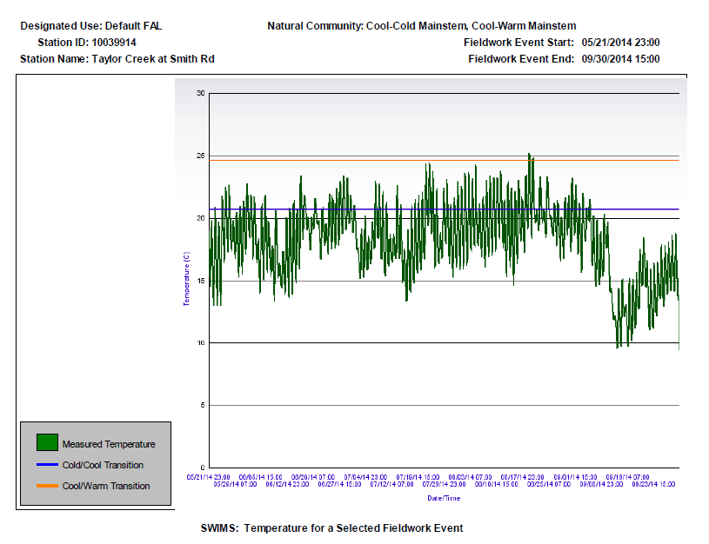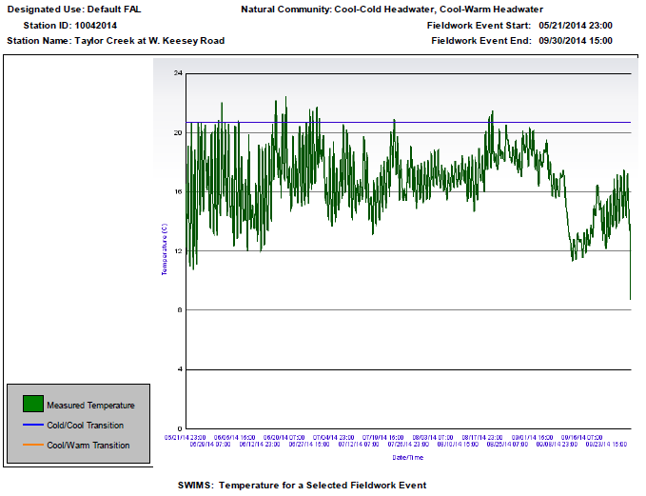

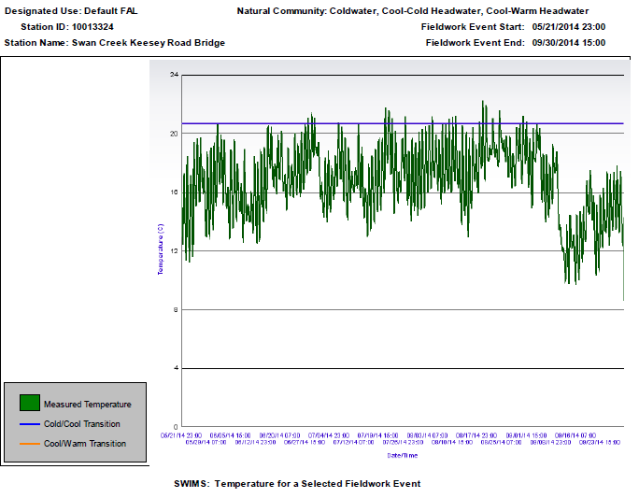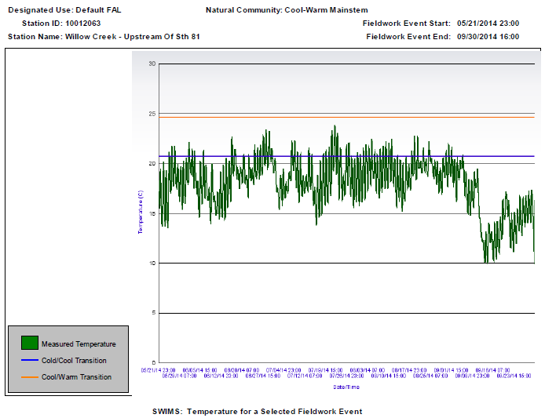

## **Monitored Waters** Update

|  |  |  |  |  |  |  |  |
| --- | --- | --- | --- | --- | --- | --- | --- |
| **Monitoring Station Report: Lower Sugar River Stream Data Collection** | | | | | | | |
| **WADRS ID** | **WBIC** | **Official Waterbody Name** | **Station Id** | **Station Name** | **Earliest Fieldwork Date** | **Latest Fieldwork Date** | **Map Link** |
| 13651 | 875300 | Sugar River | 233001 | Sugar River at Ten Eyck Rd Near Brodhead WI | 07/26/1988 | 09/22/2016 | [Map Link](http://dnrmaps.wi.gov/sl/?Viewer=SWDV&layers=16,0,1,0&attributeSearch=Station%20Points%20with%20Recent%20Data%20(10%20years),MONIT_STATION_SEQ_NO,4205) |
| 18518 | 877400 | Sylvester Creek | 10038073 | Sylvester Creek at CTH OK | 08/20/2012 | 09/17/2016 | [Map Link](http://dnrmaps.wi.gov/sl/?Viewer=SWDV&layers=16,0,1,0&attributeSearch=Station%20Points%20with%20Recent%20Data%20(10%20years),MONIT_STATION_SEQ_NO,65748863) |
| 18518 | 877400 | Sylvester Creek | 10010908 | Sylvester Creek - Sylvester Creek At Ten Eyck Rd | 11/07/2006 | 09/17/2016 | [Map Link](http://dnrmaps.wi.gov/sl/?Viewer=SWDV&layers=16,0,1,0&attributeSearch=Station%20Points%20with%20Recent%20Data%20(10%20years),MONIT_STATION_SEQ_NO,103037) |
| 13614 | 877500 | Juda Br | 10014241 | Juda Branch-US of CTH OK | 10/28/1987 | 09/17/2016 | [Map Link](http://dnrmaps.wi.gov/sl/?Viewer=SWDV&layers=16,0,1,0&attributeSearch=Station%20Points%20with%20Recent%20Data%20(10%20years),MONIT_STATION_SEQ_NO,151593) |
| 13614 | 877500 | Juda Br | 10044726 | Juda Branch at Hwy KS | 08/12/2012 | 09/09/2016 | [Map Link](http://dnrmaps.wi.gov/sl/?Viewer=SWDV&layers=16,0,1,0&attributeSearch=Station%20Points%20with%20Recent%20Data%20(10%20years),MONIT_STATION_SEQ_NO,126235453) |
| 13615 | 877500 | Juda Br | 10044726 | Juda Branch at Hwy KS | 08/12/2012 | 09/09/2016 | [Map Link](http://dnrmaps.wi.gov/sl/?Viewer=SWDV&layers=16,0,1,0&attributeSearch=Station%20Points%20with%20Recent%20Data%20(10%20years),MONIT_STATION_SEQ_NO,126235453) |
| 5562590 | 877500 | Juda Br | 10044726 | Juda Branch at Hwy KS | 08/12/2012 | 09/09/2016 | [Map Link](http://dnrmaps.wi.gov/sl/?Viewer=SWDV&layers=16,0,1,0&attributeSearch=Station%20Points%20with%20Recent%20Data%20(10%20years),MONIT_STATION_SEQ_NO,126235453) |
| 18519 | 877600 | Riley School Br | 10020957 | Riley School Br at Bagley Rd | 08/12/2012 | 09/09/2016 | [Map Link](http://dnrmaps.wi.gov/sl/?Viewer=SWDV&layers=16,0,1,0&attributeSearch=Station%20Points%20with%20Recent%20Data%20(10%20years),MONIT_STATION_SEQ_NO,18753481) |
| 13615 | 877700 | North Fork Juda Br | 10007870 | Juda Branch N Fork at CTH S | 04/10/1989 | 09/09/2016 | [Map Link](http://dnrmaps.wi.gov/sl/?Viewer=SWDV&layers=16,0,1,0&attributeSearch=Station%20Points%20with%20Recent%20Data%20(10%20years),MONIT_STATION_SEQ_NO,8649908) |
| 5562586 | 877500 | Juda Br | 10044726 | Juda Branch at Hwy KS | 08/12/2012 | 09/09/2016 | [Map Link](http://dnrmaps.wi.gov/sl/?Viewer=SWDV&layers=16,0,1,0&attributeSearch=Station%20Points%20with%20Recent%20Data%20(10%20years),MONIT_STATION_SEQ_NO,126235453) |
| 13615 | 877700 | North Fork Juda Br | 10037204 | North Fork Juda Branch in Juda Park 20m US of discharge | 05/10/2012 | 09/09/2016 | [Map Link](http://dnrmaps.wi.gov/sl/?Viewer=SWDV&layers=16,0,1,0&attributeSearch=Station%20Points%20with%20Recent%20Data%20(10%20years),MONIT_STATION_SEQ_NO,61901385) |
| 26815 | 875300 | Sugar River | 10010767 | Sugar River At Nelson Rd Boat Launch | 05/25/2010 | 09/06/2016 | [Map Link](http://dnrmaps.wi.gov/sl/?Viewer=SWDV&layers=16,0,1,0&attributeSearch=Station%20Points%20with%20Recent%20Data%20(10%20years),MONIT_STATION_SEQ_NO,102896) |
| 1855695 | 875300 | Sugar River | 10010767 | Sugar River At Nelson Rd Boat Launch | 05/25/2010 | 09/06/2016 | [Map Link](http://dnrmaps.wi.gov/sl/?Viewer=SWDV&layers=16,0,1,0&attributeSearch=Station%20Points%20with%20Recent%20Data%20(10%20years),MONIT_STATION_SEQ_NO,102896) |
| WADRS ID | WBIC | Official Waterbody Name | Station Id | Station Name | Earliest Fieldwork Date | Latest Fieldwork Date | Map Link |
| **WADRS ID** | **WBIC** | **Official Waterbody Name** | **Station Id** | **Station Name** | **Earliest Fieldwork Date** | **Latest Fieldwork Date** | **Map Link** |
| 13601 | 874000 | Raccoon Creek | 10031035 | Beckman Mill Pond (Raccoon Creek) County Park Canoe Launch | 05/25/2010 | 08/01/2016 | [Map Link](http://dnrmaps.wi.gov/sl/?Viewer=SWDV&layers=16,0,1,0&attributeSearch=Station%20Points%20with%20Recent%20Data%20(10%20years),MONIT_STATION_SEQ_NO,33481792) |
| 13609 | 877000 | Spring Creek | 10037514 | Spring Creek at Union Road | 06/12/2012 | 07/10/2016 | [Map Link](http://dnrmaps.wi.gov/sl/?Viewer=SWDV&layers=16,0,1,0&attributeSearch=Station%20Points%20with%20Recent%20Data%20(10%20years),MONIT_STATION_SEQ_NO,62787652) |
| 13609 | 877000 | Spring Creek | 10044735 | Spring Creek at Mill Road | 05/10/2016 | 07/10/2016 | [Map Link](http://dnrmaps.wi.gov/sl/?Viewer=SWDV&layers=16,0,1,0&attributeSearch=Station%20Points%20with%20Recent%20Data%20(10%20years),MONIT_STATION_SEQ_NO,126363218) |
| 13609 | 877000 | Spring Creek | 10014328 | Spring Creek -Us Cth G 226 M To End Gps | 05/10/2016 | 07/10/2016 | [Map Link](http://dnrmaps.wi.gov/sl/?Viewer=SWDV&layers=16,0,1,0&attributeSearch=Station%20Points%20with%20Recent%20Data%20(10%20years),MONIT_STATION_SEQ_NO,151646) |
| 13609 | 877000 | Spring Creek | 10037929 | Spring Creek at Mount Hope Rd | 09/10/2010 | 07/10/2016 | [Map Link](http://dnrmaps.wi.gov/sl/?Viewer=SWDV&layers=16,0,1,0&attributeSearch=Station%20Points%20with%20Recent%20Data%20(10%20years),MONIT_STATION_SEQ_NO,65293911) |
| 13618 | 879400 | Decatur Lake | 10002694 | Decatur Lake - Sugar River | 07/19/2005 | 07/08/2016 | [Map Link](http://dnrmaps.wi.gov/sl/?Viewer=SWDV&layers=16,0,1,0&attributeSearch=Station%20Areas%20with%20Recent%20Data%20(10%20years),MONIT_STATION_SEQ_NO,42065) |
| 4701075 | 879400 | Decatur Lake | 10002694 | Decatur Lake - Sugar River | 07/19/2005 | 07/08/2016 | [Map Link](http://dnrmaps.wi.gov/sl/?Viewer=SWDV&layers=16,0,1,0&attributeSearch=Station%20Areas%20with%20Recent%20Data%20(10%20years),MONIT_STATION_SEQ_NO,42065) |
| 13651 | 879400 | Decatur Lake | 10002694 | Decatur Lake - Sugar River | 07/19/2005 | 07/08/2016 | [Map Link](http://dnrmaps.wi.gov/sl/?Viewer=SWDV&layers=16,0,1,0&attributeSearch=Station%20Areas%20with%20Recent%20Data%20(10%20years),MONIT_STATION_SEQ_NO,42065) |
| 13615 | 877700 | North Fork Juda Br | 10037206 | North Fork Juda Branch at Balls Mills Rd | 05/10/2012 | 07/07/2016 | [Map Link](http://dnrmaps.wi.gov/sl/?Viewer=SWDV&layers=16,0,1,0&attributeSearch=Station%20Points%20with%20Recent%20Data%20(10%20years),MONIT_STATION_SEQ_NO,61903329) |
| 18515 | 874100 | East Fork Raccoon Creek | 10009956 | East Fork Raccoon Creek at Beloit Newark Rd | 10/23/1987 | 06/29/2016 | [Map Link](http://dnrmaps.wi.gov/sl/?Viewer=SWDV&layers=16,0,1,0&attributeSearch=Station%20Points%20with%20Recent%20Data%20(10%20years),MONIT_STATION_SEQ_NO,102085) |
| 13602 | 874100 | East Fork Raccoon Creek | 10009956 | East Fork Raccoon Creek at Beloit Newark Rd | 10/23/1987 | 06/29/2016 | [Map Link](http://dnrmaps.wi.gov/sl/?Viewer=SWDV&layers=16,0,1,0&attributeSearch=Station%20Points%20with%20Recent%20Data%20(10%20years),MONIT_STATION_SEQ_NO,102085) |
| 13601 | 874000 | Raccoon Creek | 10013075 | Raccoon Creek - Hwy 81 Bridge | 10/28/1987 | 06/29/2016 | [Map Link](http://dnrmaps.wi.gov/sl/?Viewer=SWDV&layers=16,0,1,0&attributeSearch=Station%20Points%20with%20Recent%20Data%20(10%20years),MONIT_STATION_SEQ_NO,151125) |
| 13611 | 877200 | Ok Creek | 10039915 | OK Creek at Mt Hope Rd | 05/21/2013 | 10/31/2015 | [Map Link](http://dnrmaps.wi.gov/sl/?Viewer=SWDV&layers=16,0,1,0&attributeSearch=Station%20Points%20with%20Recent%20Data%20(10%20years),MONIT_STATION_SEQ_NO,80817711) |
| 13605 | 876300 | Taylor Creek | 10039914 | Taylor Creek at Smith Rd | 05/21/2013 | 10/31/2015 | [Map Link](http://dnrmaps.wi.gov/sl/?Viewer=SWDV&layers=16,0,1,0&attributeSearch=Station%20Points%20with%20Recent%20Data%20(10%20years),MONIT_STATION_SEQ_NO,80817694) |
| 13606 | 876400 | Willow Creek | 10013320 | Willow Creek Hwy 81 Bridge | 05/10/2014 | 10/19/2015 | [Map Link](http://dnrmaps.wi.gov/sl/?Viewer=SWDV&layers=16,0,1,0&attributeSearch=Station%20Points%20with%20Recent%20Data%20(10%20years),MONIT_STATION_SEQ_NO,151277) |
| **WADRS ID** | **WBIC** | **Official Waterbody Name** | **Station Id** | **Station Name** | **Earliest Fieldwork Date** | **Latest Fieldwork Date** | **Map Link** |
| 5476700 | 878400 | Sugar River -East Channel | 10039969 | Sugar River at Mill Race | 05/18/2013 | 10/17/2015 | [Map Link](http://dnrmaps.wi.gov/sl/?Viewer=SWDV&layers=16,0,1,0&attributeSearch=Station%20Points%20with%20Recent%20Data%20(10%20years),MONIT_STATION_SEQ_NO,80834995) |
| 13601 | 874000 | Raccoon Creek | 10016373 | Raccoon Creek - St Lawrence Rd | 05/23/1994 | 09/28/2015 | [Map Link](http://dnrmaps.wi.gov/sl/?Viewer=SWDV&layers=16,0,1,0&attributeSearch=Station%20Points%20with%20Recent%20Data%20(10%20years),MONIT_STATION_SEQ_NO,50656) |
| 13610 | 877100 | Oakley Br | 10042243 | Oakley Br at CTH K | 06/09/2014 | 07/21/2015 | [Map Link](http://dnrmaps.wi.gov/sl/?Viewer=SWDV&layers=16,0,1,0&attributeSearch=Station%20Points%20with%20Recent%20Data%20(10%20years),MONIT_STATION_SEQ_NO,99914708) |
| 13608 | 876700 | Swan Creek | 10013324 | Swan Creek Keesey Road Bridge | 05/10/2014 | 10/11/2014 | [Map Link](http://dnrmaps.wi.gov/sl/?Viewer=SWDV&layers=16,0,1,0&attributeSearch=Station%20Points%20with%20Recent%20Data%20(10%20years),MONIT_STATION_SEQ_NO,151281) |
| 18516 | 876300 | Taylor Creek | 10042014 | Taylor Creek at W. Keesey Road | 05/10/2014 | 10/11/2014 | [Map Link](http://dnrmaps.wi.gov/sl/?Viewer=SWDV&layers=16,0,1,0&attributeSearch=Station%20Points%20with%20Recent%20Data%20(10%20years),MONIT_STATION_SEQ_NO,99297361) |
| 13611 | 877200 | Ok Creek | 10042232 | OK Creek at Preston Rd | 06/05/2014 | 10/09/2014 | [Map Link](http://dnrmaps.wi.gov/sl/?Viewer=SWDV&layers=16,0,1,0&attributeSearch=Station%20Points%20with%20Recent%20Data%20(10%20years),MONIT_STATION_SEQ_NO,99824267) |
| 13609 | 877000 | Spring Creek | 10042419 | Spring Creek at CTH OK | 10/09/2014 | 10/09/2014 | [Map Link](http://dnrmaps.wi.gov/sl/?Viewer=SWDV&layers=16,0,1,0&attributeSearch=Station%20Points%20with%20Recent%20Data%20(10%20years),MONIT_STATION_SEQ_NO,101093780) |
| 13610 | 877000 | Spring Creek | 10042419 | Spring Creek at CTH OK | 10/09/2014 | 10/09/2014 | [Map Link](http://dnrmaps.wi.gov/sl/?Viewer=SWDV&layers=16,0,1,0&attributeSearch=Station%20Points%20with%20Recent%20Data%20(10%20years),MONIT_STATION_SEQ_NO,101093780) |
| 5719997 | 5042398 | Unnamed | 10042233 | Unnamed Trib (5042398) to Spring Cr at Gerber Rd | 06/05/2014 | 10/09/2014 | [Map Link](http://dnrmaps.wi.gov/sl/?Viewer=SWDV&layers=16,0,1,0&attributeSearch=Station%20Points%20with%20Recent%20Data%20(10%20years),MONIT_STATION_SEQ_NO,99824298) |
| 13609 | 877000 | Spring Creek | 10042453 | Spring Creek at Town Center Rd | 07/18/2014 | 10/09/2014 | [Map Link](http://dnrmaps.wi.gov/sl/?Viewer=SWDV&layers=16,0,1,0&attributeSearch=Station%20Points%20with%20Recent%20Data%20(10%20years),MONIT_STATION_SEQ_NO,101254881) |
| 5693220 | 877300 | Unnamed | 10042234 | Unnamed Trib (877300) to OK Cr at Giese Rd | 06/05/2014 | 10/09/2014 | [Map Link](http://dnrmaps.wi.gov/sl/?Viewer=SWDV&layers=16,0,1,0&attributeSearch=Station%20Points%20with%20Recent%20Data%20(10%20years),MONIT_STATION_SEQ_NO,99824323) |
| 13611 | 877200 | Ok Creek | 10009520 | Ok Creek Upstream Of Cty G | 11/15/2002 | 10/09/2014 | [Map Link](http://dnrmaps.wi.gov/sl/?Viewer=SWDV&layers=16,0,1,0&attributeSearch=Station%20Points%20with%20Recent%20Data%20(10%20years),MONIT_STATION_SEQ_NO,101649) |
| 13607 | 876400 | Willow Creek | 10013322 | Willow Creek - Avon North Town Line Road | 06/04/2014 | 10/01/2014 | [Map Link](http://dnrmaps.wi.gov/sl/?Viewer=SWDV&layers=16,0,1,0&attributeSearch=Station%20Points%20with%20Recent%20Data%20(10%20years),MONIT_STATION_SEQ_NO,151279) |
| 18517 | 876700 | Swan Creek | 543079 | Swan Creek - Above Orfordville Stp | 04/15/1975 | 10/01/2014 | [Map Link](http://dnrmaps.wi.gov/sl/?Viewer=SWDV&layers=16,0,1,0&attributeSearch=Station%20Points%20with%20Recent%20Data%20(10%20years),MONIT_STATION_SEQ_NO,9776) |
| 18516 | 876300 | Taylor Creek | 10042220 | Taylor Creek at W. Gempler Rd | 05/23/2014 | 10/01/2014 | [Map Link](http://dnrmaps.wi.gov/sl/?Viewer=SWDV&layers=16,0,1,0&attributeSearch=Station%20Points%20with%20Recent%20Data%20(10%20years),MONIT_STATION_SEQ_NO,99765124) |
| **WADRS ID** | **WBIC** | **Official Waterbody Name** | **Station Id** | **Station Name** | **Earliest Fieldwork Date** | **Latest Fieldwork Date** | **Map Link** |
| 5693252 | 876600 | Unnamed | 10042236 | Unnamed Trib (876600) to Willow Cr at W. Avon-N. Townline Rd | 06/04/2014 | 10/01/2014 | [Map Link](http://dnrmaps.wi.gov/sl/?Viewer=SWDV&layers=16,0,1,0&attributeSearch=Station%20Points%20with%20Recent%20Data%20(10%20years),MONIT_STATION_SEQ_NO,99824410) |
| 5693322 | 876500 | Unnamed | 10042508 | Unnamed Trib (876500) to Willow Cr at W. Skinner Rd (west crossing) | 07/30/2014 | 10/01/2014 | [Map Link](http://dnrmaps.wi.gov/sl/?Viewer=SWDV&layers=16,0,1,0&attributeSearch=Station%20Points%20with%20Recent%20Data%20(10%20years),MONIT_STATION_SEQ_NO,101388125) |
| 5693322 | 876500 | Unnamed | 10042235 | Unnamed Trib (876500) to Willow Cr at W. Skinner Rd (east crossing) | 06/04/2014 | 10/01/2014 | [Map Link](http://dnrmaps.wi.gov/sl/?Viewer=SWDV&layers=16,0,1,0&attributeSearch=Station%20Points%20with%20Recent%20Data%20(10%20years),MONIT_STATION_SEQ_NO,99824400) |
| 5693286 | 5040595 | Unnamed | 10042775 | Unnamed Trib (5040595) to Swan Cr at Lang Rd | 10/01/2014 | 10/01/2014 | [Map Link](http://dnrmaps.wi.gov/sl/?Viewer=SWDV&layers=16,0,1,0&attributeSearch=Station%20Points%20with%20Recent%20Data%20(10%20years),MONIT_STATION_SEQ_NO,103060960) |
| 13607 | 876400 | Willow Creek | 10042454 | Willow Creek at Lee Rd | 07/21/2014 | 10/01/2014 | [Map Link](http://dnrmaps.wi.gov/sl/?Viewer=SWDV&layers=16,0,1,0&attributeSearch=Station%20Points%20with%20Recent%20Data%20(10%20years),MONIT_STATION_SEQ_NO,101254946) |
| 18516 | 876300 | Taylor Creek | 10014327 | Taylor Creek-Ds 141m Of Footville-Brodhead Rd | 05/22/2014 | 10/01/2014 | [Map Link](http://dnrmaps.wi.gov/sl/?Viewer=SWDV&layers=16,0,1,0&attributeSearch=Station%20Points%20with%20Recent%20Data%20(10%20years),MONIT_STATION_SEQ_NO,151645) |
| 13608 | 876700 | Swan Creek | 10016727 | Swan Creek - Immediately Downstream From Dickeyroad | 10/21/2002 | 09/30/2014 | [Map Link](http://dnrmaps.wi.gov/sl/?Viewer=SWDV&layers=16,0,1,0&attributeSearch=Station%20Points%20with%20Recent%20Data%20(10%20years),MONIT_STATION_SEQ_NO,51010) |
| 13606 | 876400 | Willow Creek | 10012063 | Willow Creek - Upstream Of Sth 81 | 10/29/2004 | 07/18/2014 | [Map Link](http://dnrmaps.wi.gov/sl/?Viewer=SWDV&layers=16,0,1,0&attributeSearch=Station%20Points%20with%20Recent%20Data%20(10%20years),MONIT_STATION_SEQ_NO,104192) |
| 13615 | 877700 | North Fork Juda Br | 10040530 | Juda Branch at N Fork in Juda Park 10 m DS | 04/20/2008 | 10/15/2013 | [Map Link](http://dnrmaps.wi.gov/sl/?Viewer=SWDV&layers=16,0,1,0&attributeSearch=Station%20Points%20with%20Recent%20Data%20(10%20years),MONIT_STATION_SEQ_NO,81877372) |
| 13612 | 877400 | Sylvester Creek | 10040782 | Sylvester Creek at STH 59 | 10/09/2013 | 10/09/2013 | [Map Link](http://dnrmaps.wi.gov/sl/?Viewer=SWDV&layers=16,0,1,0&attributeSearch=Station%20Points%20with%20Recent%20Data%20(10%20years),MONIT_STATION_SEQ_NO,82796898) |

|  |  |  |  |  |  |  |  |
| --- | --- | --- | --- | --- | --- | --- | --- |
| **WADRS ID** | **WBIC** | **Official Waterbody Name** | **Station Id** | **Station Name** | **Earliest Fieldwork Date** | **Latest Fieldwork Date** | **Map Link** |
| 18518 | 877400 | Sylvester Creek | 10014325 | Sylvester Creek-Upstream Cth S 161 M To End | 10/14/2004 | 10/09/2013 | [Map Link](http://dnrmaps.wi.gov/sl/?Viewer=SWDV&layers=16,0,1,0&attributeSearch=Station%20Points%20with%20Recent%20Data%20(10%20years),MONIT_STATION_SEQ_NO,151643) |
| 13612 | 877400 | Sylvester Creek | 10014324 | Sylvester Creek -Upstream Balls Mill Rd 191 M To End | 03/09/2006 | 10/09/2013 | [Map Link](http://dnrmaps.wi.gov/sl/?Viewer=SWDV&layers=16,0,1,0&attributeSearch=Station%20Points%20with%20Recent%20Data%20(10%20years),MONIT_STATION_SEQ_NO,151642) |
| 18518 | 877400 | Sylvester Creek | 10014324 | Sylvester Creek -Upstream Balls Mill Rd 191 M To End | 03/09/2006 | 10/09/2013 | [Map Link](http://dnrmaps.wi.gov/sl/?Viewer=SWDV&layers=16,0,1,0&attributeSearch=Station%20Points%20with%20Recent%20Data%20(10%20years),MONIT_STATION_SEQ_NO,151642) |
| 18518 | 877400 | Sylvester Creek | 10040850 | Sylvester Creek at Greenbush Road | 10/09/2013 | 10/09/2013 | [Map Link](http://dnrmaps.wi.gov/sl/?Viewer=SWDV&layers=16,0,1,0&attributeSearch=Station%20Points%20with%20Recent%20Data%20(10%20years),MONIT_STATION_SEQ_NO,82839688) |
| 5693179 | 876000 | Unnamed | 10040739 | Unnamed Trib (876000) to Sugar R at Hopkins Rd | 07/11/2013 | 10/08/2013 | [Map Link](http://dnrmaps.wi.gov/sl/?Viewer=SWDV&layers=16,0,1,0&attributeSearch=Station%20Points%20with%20Recent%20Data%20(10%20years),MONIT_STATION_SEQ_NO,82416731) |
| 13614 | 877500 | Juda Br | 10014240 | Juda Br Upstream Bagley Rd | 10/08/2013 | 10/08/2013 | [Map Link](http://dnrmaps.wi.gov/sl/?Viewer=SWDV&layers=16,0,1,0&attributeSearch=Station%20Points%20with%20Recent%20Data%20(10%20years),MONIT_STATION_SEQ_NO,151592) |
| 13615 | 877700 | North Fork Juda Br | 10040731 | North Fork Juda Br at STH 11 (furthest dwnstrm crossing) | 10/08/2013 | 10/08/2013 | [Map Link](http://dnrmaps.wi.gov/sl/?Viewer=SWDV&layers=16,0,1,0&attributeSearch=Station%20Points%20with%20Recent%20Data%20(10%20years),MONIT_STATION_SEQ_NO,82405395) |
| 13605 | 876300 | Taylor Creek | 10021931 | Taylor Creek At Avon North Townline Rd. | 05/24/2007 | 10/08/2013 | [Map Link](http://dnrmaps.wi.gov/sl/?Viewer=SWDV&layers=16,0,1,0&attributeSearch=Station%20Points%20with%20Recent%20Data%20(10%20years),MONIT_STATION_SEQ_NO,19621568) |
| 18519 | 877600 | Riley School Br | 10040073 | Riley School Br at Giese Rd | 10/08/2013 | 10/08/2013 | [Map Link](http://dnrmaps.wi.gov/sl/?Viewer=SWDV&layers=16,0,1,0&attributeSearch=Station%20Points%20with%20Recent%20Data%20(10%20years),MONIT_STATION_SEQ_NO,81526735) |
| 1855695 | 875300 | Sugar River | 10018566 | Sugar River -- Access | 09/30/2013 | 09/30/2013 | [Map Link](http://dnrmaps.wi.gov/sl/?Viewer=SWDV&layers=16,0,1,0&attributeSearch=Station%20Points%20with%20Recent%20Data%20(10%20years),MONIT_STATION_SEQ_NO,21145) |
| 13651 | 875300 | Sugar River | 10042642 | Sugar River at CTH F | 09/30/2013 | 09/30/2013 | [Map Link](http://dnrmaps.wi.gov/sl/?Viewer=SWDV&layers=16,0,1,0&attributeSearch=Station%20Points%20with%20Recent%20Data%20(10%20years),MONIT_STATION_SEQ_NO,102101101) |
| 13602 | 874100 | East Fork Raccoon Creek | 10009953 | East Fork Raccoon Creek - N. Of Hwy 81 | 05/30/2012 | 05/30/2012 | [Map Link](http://dnrmaps.wi.gov/sl/?Viewer=SWDV&layers=16,0,1,0&attributeSearch=Station%20Points%20with%20Recent%20Data%20(10%20years),MONIT_STATION_SEQ_NO,102082) |
| **WADRS ID** | **WBIC** | **Official Waterbody Name** | **Station Id** | **Station Name** | **Earliest Fieldwork Date** | **Latest Fieldwork Date** | **Map Link** |
| 13601 | 874000 | Raccoon Creek | 10012055 | Raccoon Creek at Beloit Newark Rd | 10/29/2004 | 10/14/2011 | [Map Link](http://dnrmaps.wi.gov/sl/?Viewer=SWDV&layers=16,0,1,0&attributeSearch=Station%20Points%20with%20Recent%20Data%20(10%20years),MONIT_STATION_SEQ_NO,104184) |
| 13602 | 874100 | East Fork Raccoon Creek | 10009952 | E. Fork Raccoon Creek at Lawrence St. | 10/28/1987 | 10/14/2011 | [Map Link](http://dnrmaps.wi.gov/sl/?Viewer=SWDV&layers=16,0,1,0&attributeSearch=Station%20Points%20with%20Recent%20Data%20(10%20years),MONIT_STATION_SEQ_NO,102081) |
| 13601 | 874000 | Raccoon Creek | 10013074 | Raccoon Creek - Upstream Of Cth 'H' Bridge | 10/28/1987 | 09/29/2011 | [Map Link](http://dnrmaps.wi.gov/sl/?Viewer=SWDV&layers=16,0,1,0&attributeSearch=Station%20Points%20with%20Recent%20Data%20(10%20years),MONIT_STATION_SEQ_NO,151124) |
| 18518 | 877400 | Sylvester Creek | 233046 | Juda Branch - Drain Ditch Health Val A Juda Br | 08/31/2011 | 08/31/2011 | [Map Link](http://dnrmaps.wi.gov/sl/?Viewer=SWDV&layers=16,0,1,0&attributeSearch=Station%20Points%20with%20Recent%20Data%20(10%20years),MONIT_STATION_SEQ_NO,4243) |
| 13651 | 877400 | Sylvester Creek | 233046 | Juda Branch - Drain Ditch Health Val A Juda Br | 08/31/2011 | 08/31/2011 | [Map Link](http://dnrmaps.wi.gov/sl/?Viewer=SWDV&layers=16,0,1,0&attributeSearch=Station%20Points%20with%20Recent%20Data%20(10%20years),MONIT_STATION_SEQ_NO,4243) |
| 18515 | 874100 | East Fork Raccoon Creek | 10009957 | East Fork Raccoon Creek - East Raccoon West Cleophas Road | 01/01/1994 | 07/25/2011 | [Map Link](http://dnrmaps.wi.gov/sl/?Viewer=SWDV&layers=16,0,1,0&attributeSearch=Station%20Points%20with%20Recent%20Data%20(10%20years),MONIT_STATION_SEQ_NO,102086) |
| 33331 | 5580135 | Unnamed | 10041378 | Unnamed Open Water | 07/04/2011 | 07/04/2011 | [Map Link](http://dnrmaps.wi.gov/sl/?Viewer=SWDV&layers=16,0,1,0&attributeSearch=Station%20Areas%20with%20Recent%20Data%20(10%20years),MONIT_STATION_SEQ_NO,85673873) |
| 13651 | 5580135 | Unnamed | 10041378 | Unnamed Open Water | 07/04/2011 | 07/04/2011 | [Map Link](http://dnrmaps.wi.gov/sl/?Viewer=SWDV&layers=16,0,1,0&attributeSearch=Station%20Areas%20with%20Recent%20Data%20(10%20years),MONIT_STATION_SEQ_NO,85673873) |
| 13606 | 876400 | Willow Creek | 10013323 | Willow Creek Upstrm Of Avon Store Rd | 05/24/2007 | 09/24/2009 | [Map Link](http://dnrmaps.wi.gov/sl/?Viewer=SWDV&layers=16,0,1,0&attributeSearch=Station%20Points%20with%20Recent%20Data%20(10%20years),MONIT_STATION_SEQ_NO,151280) |
| 5720034 | 875900 | Unnamed | 10021223 | Unnamed Tributary To Sugar River At Nelson Rd | 08/02/2007 | 11/01/2007 | [Map Link](http://dnrmaps.wi.gov/sl/?Viewer=SWDV&layers=16,0,1,0&attributeSearch=Station%20Points%20with%20Recent%20Data%20(10%20years),MONIT_STATION_SEQ_NO,19017500) |
| 18516 | 876300 | Taylor Creek | 10021080 | Taylor Creek At Sth 11 | 07/01/2007 | 11/01/2007 | [Map Link](http://dnrmaps.wi.gov/sl/?Viewer=SWDV&layers=16,0,1,0&attributeSearch=Station%20Points%20with%20Recent%20Data%20(10%20years),MONIT_STATION_SEQ_NO,18897406) |
| 1855695 | 875300 | Sugar River | 543282 | Sugar River at Nelson Road | 07/14/2005 | 09/21/2006 | [Map Link](http://dnrmaps.wi.gov/sl/?Viewer=SWDV&layers=16,0,1,0&attributeSearch=Station%20Points%20with%20Historic%20Data,MONIT_STATION_SEQ_NO,9876) |
| 13612 | 877400 | Sylvester Creek | 10012119 | Sylvester Creek - Upstream Of Prien Rd | 03/09/2006 | 03/09/2006 | [Map Link](http://dnrmaps.wi.gov/sl/?Viewer=SWDV&layers=16,0,1,0&attributeSearch=Station%20Points%20with%20Historic%20Data,MONIT_STATION_SEQ_NO,104248) |
| **WADRS ID** | **WBIC** | **Official Waterbody Name** | **Station Id** | **Station Name** | **Earliest Fieldwork Date** | **Latest Fieldwork Date** | **Map Link** |
| 13605 | 876300 | Taylor Creek | 10012061 | Taylor Creek - Upstream Of Sth 81 | 10/29/2004 | 10/29/2004 | [Map Link](http://dnrmaps.wi.gov/sl/?Viewer=SWDV&layers=16,0,1,0&attributeSearch=Station%20Points%20with%20Historic%20Data,MONIT_STATION_SEQ_NO,104190) |
| 13609 | 877000 | Spring Creek | 10009521 | Spring Creek Upstream Cty G | 11/15/2002 | 11/15/2002 | [Map Link](http://dnrmaps.wi.gov/sl/?Viewer=SWDV&layers=16,0,1,0&attributeSearch=Station%20Points%20with%20Historic%20Data,MONIT_STATION_SEQ_NO,101650) |
| 18517 | 876700 | Swan Creek | 543083 | Swan Creek - Bl Orfordville Stp Chanl | 04/15/1975 | 10/21/2002 | [Map Link](http://dnrmaps.wi.gov/sl/?Viewer=SWDV&layers=16,0,1,0&attributeSearch=Station%20Points%20with%20Historic%20Data,MONIT_STATION_SEQ_NO,9780) |
| 13602 | 874100 | East Fork Raccoon Creek | 10009955 | East Fork Raccoon Creek - East Raccoon Spring Road | 01/01/1994 | 05/23/1994 | [Map Link](http://dnrmaps.wi.gov/sl/?Viewer=SWDV&layers=16,0,1,0&attributeSearch=Station%20Points%20with%20Historic%20Data,MONIT_STATION_SEQ_NO,102084) |
| 13601 | 874000 | Raccoon Creek | 10016301 | Raccoon Creek - Skinner Rd Crossing | 05/23/1994 | 05/23/1994 | [Map Link](http://dnrmaps.wi.gov/sl/?Viewer=SWDV&layers=16,0,1,0&attributeSearch=Station%20Points%20with%20Historic%20Data,MONIT_STATION_SEQ_NO,50584) |
| 13601 | 874000 | Raccoon Creek | 10012056 | Upstream Of Cleophas Rd-Intersection W/Racoon Ck | 10/28/1987 | 05/23/1994 | [Map Link](http://dnrmaps.wi.gov/sl/?Viewer=SWDV&layers=16,0,1,0&attributeSearch=Station%20Points%20with%20Historic%20Data,MONIT_STATION_SEQ_NO,104185) |
| 13614 | 877500 | Juda Br | 233041 | Juda Branch at Sth 11-81 | 10/28/1987 | 09/04/1991 | [Map Link](http://dnrmaps.wi.gov/sl/?Viewer=SWDV&layers=16,0,1,0&attributeSearch=Station%20Points%20with%20Historic%20Data,MONIT_STATION_SEQ_NO,4238) |
| 338132 | 874900 | Unnamed | 10016705 | Unnamed Trib. To Raccoon Cr. - Hwy 81 | 10/28/1987 | 10/28/1987 | [Map Link](http://dnrmaps.wi.gov/sl/?Viewer=SWDV&layers=16,0,1,0&attributeSearch=Station%20Points%20with%20Historic%20Data,MONIT_STATION_SEQ_NO,50988) |
| 13608 | NA | null | 543080 | Swan Creek - Orfordville Stp | 06/03/1975 | 07/15/1982 | [Map Link](http://dnrmaps.wi.gov/sl/?Viewer=SWDV&layers=16,0,1,0&attributeSearch=Station%20Points%20with%20Historic%20Data,MONIT_STATION_SEQ_NO,9777) |
| 13608 | NA | null | 543081 | Swan Creek - Orfordville Stp Effl To Dr Ditch | 04/15/1975 | 07/15/1982 | [Map Link](http://dnrmaps.wi.gov/sl/?Viewer=SWDV&layers=16,0,1,0&attributeSearch=Station%20Points%20with%20Historic%20Data,MONIT_STATION_SEQ_NO,9778) |
| 13608 | NA | null | 543082 | Drainage Channel At Swan Creek - Orfordville Stp Effl At Swan Cr | 04/15/1975 | 07/23/1979 | [Map Link](http://dnrmaps.wi.gov/sl/?Viewer=SWDV&layers=16,0,1,0&attributeSearch=Station%20Points%20with%20Historic%20Data,MONIT_STATION_SEQ_NO,9779) |
| 13608 | 876700 | Swan Creek | 543084 | Swan Creek at Hanson Rd Bl Orfdvlle | 04/15/1975 | 01/29/1976 | [Map Link](http://dnrmaps.wi.gov/sl/?Viewer=SWDV&layers=16,0,1,0&attributeSearch=Station%20Points%20with%20Historic%20Data,MONIT_STATION_SEQ_NO,9781) |