# SCOPE OF WORK

***Project Title:*** Milwaukee Estuary Area of Concern Baseline Wildlife Population Assessment

***Project Manager:***

Julia Robson – Assistant Natural Areas Coordinator

Milwaukee County Department of Parks, Recreation and Culture

9480 Watertown Plank Road

Wauwatosa, WI 53226

Office Phone: (414).257.8081

Cell Phone: (414).659.4229

Email: [Julia.Robson@milwcnty.com](mailto:Julia.Robson@milwcnty.com)

***Project Signatory Name:***

John Dargle, Director

Milwaukee County Department of Parks, Recreation and Culture

**NOTE: Send project agreement to Project Manager (Julia Robson), but John Dargle as signatory**

**DUNS #:** 172896383

***Project Description and Background:***

This is the second year of a three year project to conduct wildlife surveys to support setting habitat restoration priorities within the Milwaukee Estuary Area of Concern (AOC). The project area (Figure 1) is home to a wide variety of wildlife occupying a densely urban setting, with more than 50 species listed by the State of Wisconsin as endangered, threatened or special concern.

Work will build upon data mining activities conducted during the target refinement study completed by Dr. Gary S. Casper (UWM Field Station) and baseline wildlife assessments implemented during 2014 . The year 1 baseline surveys targeted areas with known data gaps, while years 2 and 3 will target areas with data gaps found through the data mining component. This project will lead to identification of specific projects that, once implemented, will lead to the eventual removal of the wildlife component of the Degraded Fish and Wildlife Populations impairment for the AOC.

Baseline data collection is essential for first understanding existing conditions in order to plan for restoration of appropriate species richness. Inadequate biotic inventories can and do result in real harm, as sensitive species existing on parcels can be overlooked, populations impacted during restoration activities and species fail to recolonize restored habitats. Therefore it is of utmost importance that the baseline surveys be conducted in a statistically rigorous fashion to reduce the possibility of false negatives.

The baseline data collection effort, combined with the historical data review will allow the Milwaukee AOC Wildlife Subcommittee to identify focal species for habitat restoration planning and spatial analysis of how wildlife populations can best be recovered and persist through restoration work and/or recolonization.

***Project Location:***

The project area for this three-year effort is defined as suitable habitat on land owned by Milwaukee County Parks along portions of the Little Menomonee River, Menomonee River,Milwaukee River and their tributaries. A half-mile buffer surrounding these waterways defines the general lateral extent of the survey area, (see Figure 1).

***Proposed Work***

The Milwaukee County Park Natural Areas Program will conduct specific surveys using standardized protocols as described below and in Table 1:

1. Ephemeral pond inventories (gathering dimensional data, looking for aquatic invertebrates present, surrounding habitat) of approximately 107 potential ponds within the project area;
2. Aquatic funnel trapping for salamanders at 6 sites;
3. Visual encounter surveys for salamanders and other amphibians at 5 sites;
4. Aquatic egg mass surveys at 5 sites;
5. Aquatic funnel trapping for crayfish at 6 sites;
6. Cover object surveys for snakes at approximately 3 sites;
7. Turtle basking surveys at approximately 2 sites;
8. Turtle trapping surveys at approximately 3 sites;
9. Breeding and migratory bird surveys at approximately 10 sites;
10. Camera surveys for mammals at approximately 2 sites.

The number and location of survey sites are subject to change based on the results of the historical literature and data review and availability of suitable habitat for surveys.

***Documentation Requirements***

* For all field work, accurate location information for survey sites, boundaries, species occurrence, etc. must be collected using GPS with 95% accuracy, so data can be used in geographic information systems, including ArcGIS 10.0. The referencing system and datum (i.e. WGS84, WTM 83/91) must be documented for all data collected.
* Species identification (with the exception of birds) must be verified through collections of voucher specimens, recordings, or photographs with minimum of 2 mega pixel resolution to the extent allowable by local, state, and federal regulations. The recordings and photographs must provide the needed information for species identification purposes (i.e. identifying marks, size, etc). This verification must be linked to collection date, time and specific location.

***Tasks and Required Deliverables***:

* Quality Assurance Project Plan (QAPP) documenting site selection decisions, all survey protocols and methods for data evaluation.
* Quarterly reports identifying amount expended this quarter, activities conducted, and planned activities for the following quarter, along with identification of any issues encountered (including delays or deviations from the original schedule or other setbacks) during the time and how they were addressed (timetable for reports will be determined depending in timing of award of the contract) Reports should be submitted to WDNR and the Milwaukee County Department of Parks, Recreation and Culture.
* Survey data in electronic format, which includes location information (i.e. lat/long, decimal degrees, etc.). Acceptable formats include, Microsoft Access or ArcGIS geo-database.
* Completed data sheets, photographs, recordings and other documentation. Species identification verification through voucher specimens, recordings or photographs. Recordings and photographs should be of the highest available resolution and provide needed information for species identification purposes.
* Documentation showing that rare, threatened or endangered species observed have been reported to the WDNR Natural Heritage Inventory Program.
* Prepare a presentation and report interim and final findings in person at a minimum of two meetings to the Wildlife Subcommittee or the Milwaukee AOC Fish and Wildlife Technical Team
* Prepare a final report including the following elements:
  + - * + survey results
        + series of maps showing plant and animal communities and survey points/transects for specific survey areas
        + Per the approval of the grantor in the “Final Report: Wildlife Population Target Refinement for the Milwaukee Estuary AOC”, this deliverable was agreed to be a work in progress with development continuing into Phase 2 funding. In order to avoid the production of multiple versions, and potential use of preliminary data by other partners which could result in confusion and errors, metadata are delivered here describing the databases. Final tabular and GIS data will be made available at the end of 2016

***Timetable:***

March 1, 2015 – February 28, 2016

Survey start times are weather dependent. General timetable listed below is subject to change depending on weather and other environmental conditions. Any changes to timing below will be through written notification from County Parks Project Manager to WDNR Project manager (email acceptable).

March 2015

* Prepare draft quality assurance project plan

March 2015 – May 2015

* Ephemeral pond inventories
* Aquatic funnel trapping for amphibians and crayfish
* Visual encounter and egg mass surveys for salamanders and other amphibians
* Spring migratory bird transects (April – May)

July 10, 2015 – first quarterly report due (for period March through June 30, 2015)

May 2015 – July 2015

* Turtle basking surveys
* Turtle trapping surveys
* Snake cover object surveys
* Continue aquatic funnel trapping for crayfish
* Breeding bird point count surveys (June)

September 2015 – October 2015

* Fall migratory bird transect surveys (late August – September)
* Camera surveys for mammals

October 10, 2015 – Second quarterly report due (for July-September 2015)

November 2015-January 2016

* Prepare draft report for review

January 10, 2016 – Third quarterly report due (for October-December)

March 2016 – Submit final report

***Project Budget***

|  |  |  |  |
| --- | --- | --- | --- |
|  | **Milwaukee County DPRC AOC Wildlife Assessment Project Budget** |  |  |
|  | **Item** |  | **Cost** |
|  |  |  |  |
|  | **County Staff Labor** |  | **$41,500** |
|  |  |  |  |
|  | **Supplies** - aquatic funnel traps, specimen collection equipment, hip waders, thermometers, polarized sunglasses, binoculars, turtle hoop net traps, wildlife cameras, cautery pens, calipers |  | **$3,500** |
|  |  |  |  |
|  | **Project Total:** |  | **$45,000** |

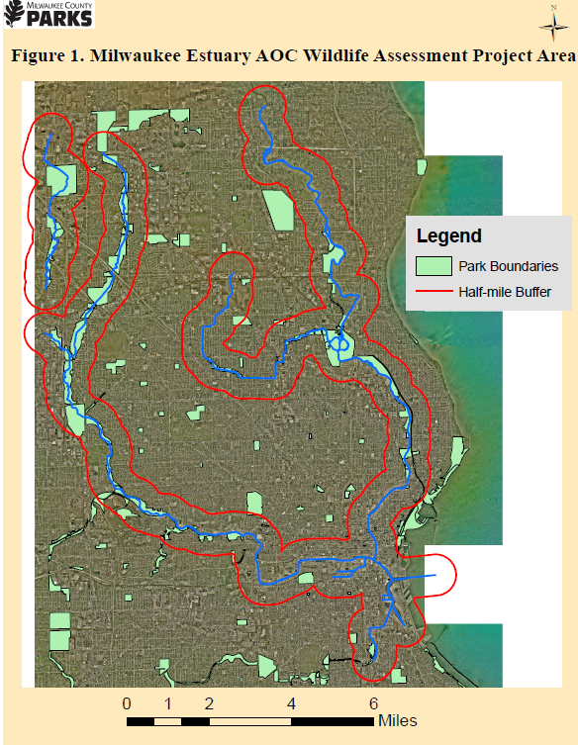

**Table 1. DPRC AOC Assessment Deliverables**

